Lumbar Puncture (s. Spinal Tap)
Last updated: March 10, 2022
Indications 1
Contraindications 1
Studies before LP 1
Procedure Details 1
Anatomy 1
Equipment 2
Patient positioning 2
Technique 2
Opening pressure 3
CSF collection 4
Procedure end 4
Postprocedure 4
Complications 4
Lumbar Drain (s. Lumbar Subarachnoid Drain, Spinal Drain) 5
Indications 5
Procedure Details 5
Maintenance 5
Complications 5

When possible, CT is advised prior to lumbar puncture!

Indications
- CSF collection for analysis:
  - infection (meningitis, meningoencephalitis)* – absolute indication overriding any other considerations! *exceptions – brain abscess, parameningeal process
examples: neonatal sepsis (25% will have meningitis, infection with no apparent source)
  - subarachnoid hemorrhage (CT-negative cases)
  - carcinomatous meningitis
  - inflammatory diseases (esp. Guillain-Barré syndrome, vasculitis, multiple sclerosis)
- LP is no longer important in diagnosis of intracranial mass lesions (replaced by CT & MRI)!
- Opening pressure measurement (but correlation with ICP is not always good) - pseudotumor cerebri diagnosis.
- Therapeutic CSF drainage.
- Intrathecal administration of medications (e.g. for meningeal malignancies, fungal meningitis), contrast (e.g. for myelography), radioisotopes (e.g. for CSF leak).
- Preliminary step for lumbar drain insertion.

Contraindications
- Intracranial mass (known or suspected)
Papilledema (ICP) should not be used as sole criteria to determine if LP is safe
- papilledema absence does not ensure normal ICP (papilledema takes 6-24 hours to develop).
- papilledema presence (ICP↑) is not absolute contraindication to LP, because ICP↑ may be due to diffuse process, not mass lesion (e.g. pseudotumor cerebri) – do CT before LP!
N.B. absolute contraindication is head trauma (LP adds no pertinent information + LP is potentially lethal in case of intracranial hematoma)!
Posterior fossa mass is strong contraindication to lumbar puncture!
- Noncommunicating (s. obstructive) hydrocephalus (H: direct ventricular drainage of CSF); vs. in communicating hydrocephalus - LP may provide symptomatic relief.
- Infection in LP region
- Coagulopathy (risks of epidural hematoma or SAH)
  - platelet count should be > 50,000 (H: platelet transfusion).
  - PT / aPTT should be hemostatic.
  - patient should not be on heparin or warfarin (H: protamine or vit. K + FFP).
  - aspirin should be discontinued for 48 hours before LP.
- Tethered spinal cord
- Complete spinal block (relative contraindication) – most commonly due to spinal tumor – LP may cause shifts of nervous tissue.
Spinal tumor is relative contraindication to LP! (except suspected leptomeningeal metastases – CSF cytology is key diagnostic test)

Suspected meningitis overrides any contraindications - CSF examination is always indicated (imaging before LP is advisable); if suspected pressure > 350 mmH₂0:
- use 24G needle.
- minimum required sample is obtained
- administer IV bolus of mannitol 1 g/kg (ideally 20 min before LP)
- dexamethasone (unless contraindicated).

Studies before LP
  - Funduscopy for papilledema (if present → CT)
  - Blood studies:
    - thrombocyte count, coagulation studies
    - glucose (to compare with CSF glucose)

Procedure Details
Anatomy
Why lumbar spine:
- spinal column grows faster than spinal cord – spinal cord (conus medullaris) ends at L₁₋₂ disc, thecal sac ends at S₂ – needle displaces freely floating roots of cauda equina.
- horizontal processus spinosi, in addition patient flexes lumbar spine.

Puncture at L₃₋₄ or L₄₋₅ or L₅-S₁ interspace
Puncture above L₃ is absolutely contraindicated – in 1% people (esp. short) spinal cord ends at L₂₋₃ interspace!
- line between iliac crests (intercristal line) goes through L₃₋₄ or L₄₋₅ interspace.
- repeated taps are done at higher interspace.
- midline is avascular!

Structures that must be pierced:
- Three ligaments (supraspinal, interspinal, flavum*)
*lig. flavum is absent at midline? – not pierced during LP
- Dura mater

Equipment
- Standard LP kit:
- sterile (fenestrated) drapes
- 1% lidocaine (20-50 ml) or 2% procaine
- 10 ml syringe
- needles (25 and 22G)
- spinal needle with stylet:
20G 3.5-in. – for adults;
22G 2.5-in – for children;
25G 1.5-in. – for infants.
- 60 cm manometer with 3-way stopcock
- numbered sterile centrifuge tubes with caps (minimum three; better four)
- gauze and Band-Aid.
- Sterile prep solution
- Sterile gloves (± cap, mask)

Patient positioning
  - left lateral decubitus fetal position (neck & knees brought to chest; craniospinal axis parallel to floor; posterior aspect of pelvis at edge of table and perpendicular to floor; pillow under neck for comfort) - this flexes lumbar spine and opens spaces between spinous processes; assistant helps maintain patient as flexed as possible.
- avoid prolonged severe neck flexion in infant → airway obstruction; airway should be checked if infant suddenly stops crying.
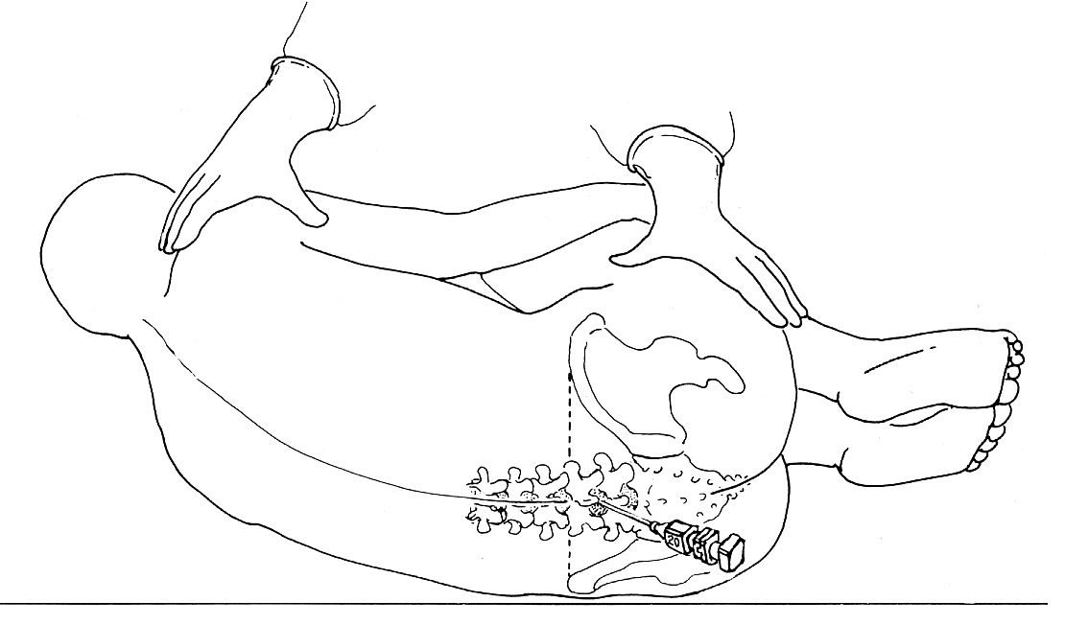

  - Sitting with legs dangling over bed side (head and arms rest on grasped pillow; patient leans forward as far as possible).
- indications:
- obesity
- difficult anatomy (incl. scoliosis)
- large volumes of CSF are to be collected.
- advantages:
- midline is much easier to determine
- more comfortable (than fetal position) for some patients
- gravity assists CSF flow.

If severe anatomical restrictions preclude LP (e.g. severe spondylosis, previous spinal surgery, morbid obesity) → obtain CSF under fluoroscopic / CT guidance:
  - lumbar puncture
  - cisternal puncture see p. Op5 >>
  - lateral cervical puncture see p. Op5 >>

Technique
- first developed by Quincke in 1891.
- sterile prep (antiseptic solution is applied in circular motion - circumference of cleansed area should increase with each motion).
- sterile towel is placed between patient's hip and bed; drape lumbar back (drapes extend over iliac crests).
- identify intercristal line and palpate in midline for spinous process (usually L₄) and L₄₋₅ interspace below it; mark puncture site by thumbnail indentation to skin.
- anesthesia (≈ 1 cm below spinous process) - 1% lidocaine: SC (25G needle) → into lumbodorsal fascia, interspinous ligament (22G needle).
- some operators also apply local anesthesia in vertically fanning distribution on both sides of spinous processes near lamina (field block for recurrent spinal nerves that innervate interspinous ligaments and muscles).
- as anesthetic is taking effect, assemble manometer with stopcock and set up CSF collection tubes so they are easily accessible.
- puncture anesthetized skin with spinal needle & stylet
- needle is always advanced with stylet in place (to avoid introducing epidermal cells→ iatrogenic epidermoid tumor).
- needle is held between both thumbs and index fingers.
- needle is aimed slightly rostrally (≈ 15°, with umbilicus as target) - path approximately parallel to spinous processes.
- needle bevel is turned parallel to length of spinal column i.e. parallel to longitudinally running fibers of dura* (to minimize post-LP headaches); once in thecal sac, needle is turned cranially (to optimize CSF flow).
*e.g. in sitting position, needle is inserted with bevel facing laterally; in decubitus position - bevel facing up.
- advance needle deeper, carefully maintaining midline trajectory; needle will encounter slight resistance, then "pop" will be felt (thecal sac penetration – patient experiences twinge of pain*).
*must be felt strictly in midline posteriorly
- if bone is encountered, it is more often due to deviation from midline than to failure to aim correctly in rostral-caudal direction; needle direction cannot be changed - pull needle back to just beneath skin and redirect it:
- if bone is struck at shallow depth, redirect needle more cephalad;
- if at deeper depth – more caudally.
- withdraw stylet - check for CSF flow; allow patient to relax (to extend hips and knees).
- if no CSF is seen, reinsert stylet and advance needle little farther;
- if still no CSF is seen, withdraw needle to just below skin surface, reassess landmarks, and attempt another trajectory;
- failure to enter subarachnoid space after 2-3 trials → reposition patient to sitting position;
- if blood is seen, allow moment for blood to drain and see if it clears, because blood may represent traumatic tap; if it does not clear, withdraw needle and attempt another trajectory.

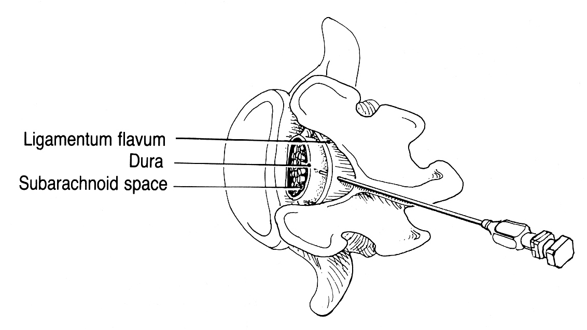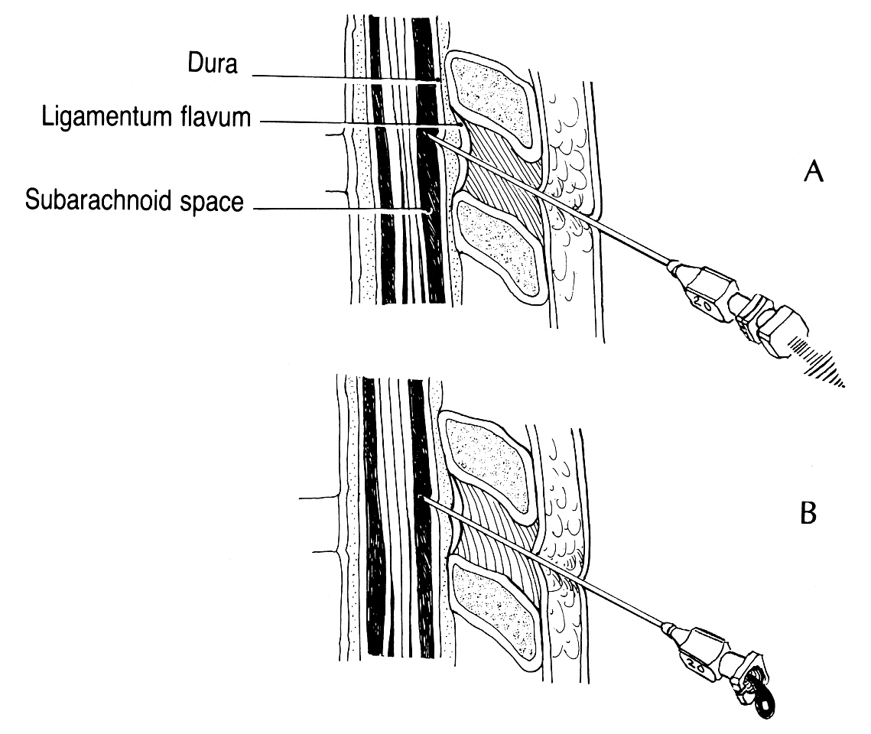
Source of picture: Paul W. Roberts “Useful Procedures in Medical Practice” (1986); Lea & Febiger; ISBN-13: 978-0812109856 >>

Causes of "dry tap":
- improperly placed needle (most often)
- pathologic obliteration of subarachnoid space (compressive lesion of spinal cord or chronic adhesive arachnoiditis)

Lateral Approach
- used if supraspinal ligament is calcified in older persons.
- needle is directed slightly cephalad to miss lamina (lower lamina rises upward from midline) and slightly medially to compensate for lateral approach.
- needle bypasses supraspinal and interspinal ligaments.

Opening pressure
about causes of elevated / lowered opening pressure → see p. D40 >>
- once CSF flow is established (lose as little CSF as possible – this spuriously lowers pressure), place stopcock and attached manometer on end of needle.
- keep "zero" mark at level of spinal needle.
- adjust stopcock to allow CSF to flow up manometer – wait for steady state – record opening pressure.
- intermediate tubing may be used to minimize movement of needle while manipulating manometer and collecting CSF.
- patient should be lying down fully relaxed (not in forced fetal position - legs should be straightened when measuring open pressure or falsely elevated pressure will be obtained)!!!
- look for normal pressure oscillations with pulse and respirations.

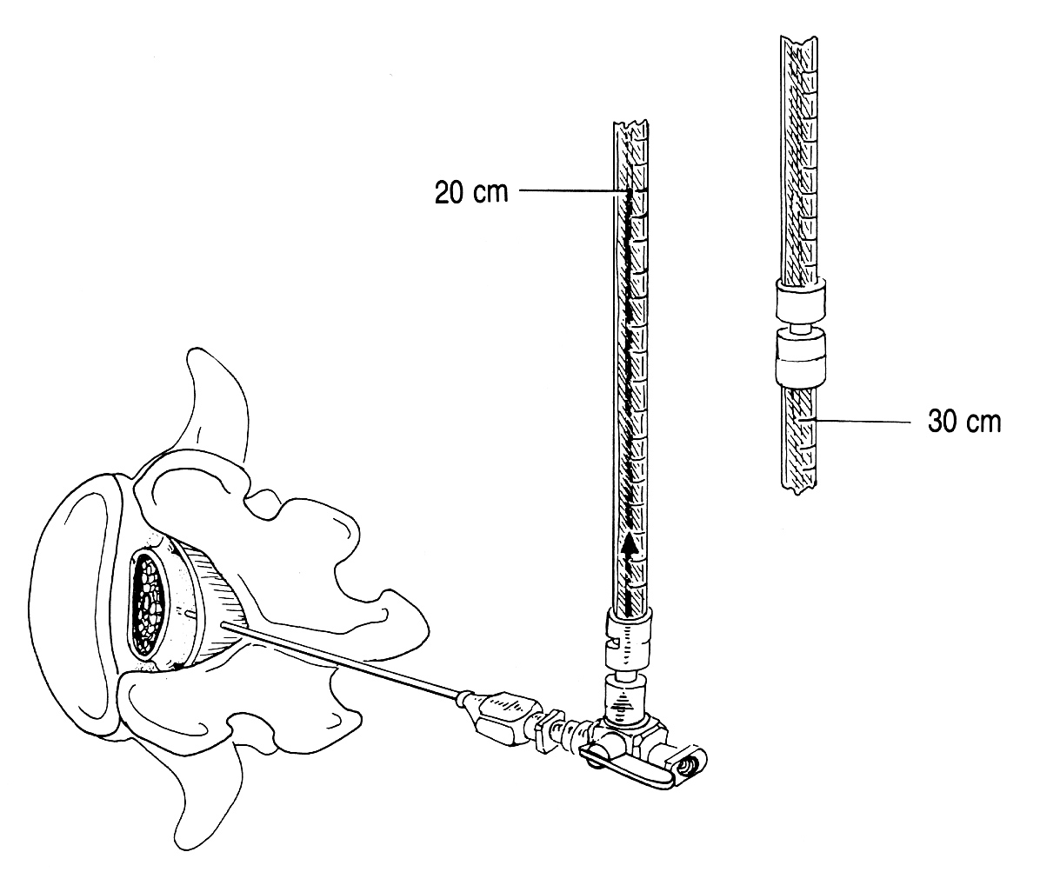
Source of picture: Paul W. Roberts “Useful Procedures in Medical Practice” (1986); Lea & Febiger; ISBN-13: 978-0812109856 >>

Norma: 65-200 mmH₂O* (5-15 mmHg) with patient lying down (or at level of foramen magnum in sitting position).
*50 mmH₂O in neonates, 85 mmH₂O in young children, 250 mmH₂O in extremely obese subjects

Opening pressure is artificially elevated with patient in sitting position!
- opening pressure of 500 mmH₂O is normal for sitting position.
- if anatomy precludes LP in lateral decubitus but opening pressure is critical: spinal needle inserted in sitting position → needle withdrawn just out of thecal sac → patient placed in relaxed, lateral decubitus position → needle readvanced slightly into thecal sac.

If pressure is very high (esp. > 350 mmH₂O) – remove needle at once! (fluid in manometer is used for analysis!); although change in intracranial dynamics caused by LP has occurred already and premature needle removal changes nothing.

Queckenstedt test (seldom performed today – replaced by myelography and MRI) - demonstrates spinal block (spinal subarachnoid space does not communicate with cranial subarachnoid space):
- patient in lateral recumbent position.
- 10-12 seconds of bilateral internal jugular vein compression (by assistant) → decreased venous return to heart → distended cerebral veins → ICP rise → CSF pressure↑:
  - norma: CSF pressure rises 150 mmH₂O (or ≥ twice) over initial reading; CSF pressure returns to baseline in 10-12 seconds after release.
  - spinal block: delayed rise and fall (incomplete block) or no change (complete block) in CSF pressure at all.
N.B. inject Pantopaque before needle removal - to facilitate subsequent myelogram (because lumbar dural sac may collapse, making it impossible to reenter canal).
- contraindications: elevated opening pressure, suspected intracranial mass lesion.
- modifications:
- suspected cervical cord disease - test repeated with neck in neutral position, hyperextended, and flexed.
- suspected lateral sinus obstruction - unilateral jugular venous compression (Tobey-Ayer test).

CSF collection
Collect four tubes (extra tubes may be required for additional studies if indicated, e.g. cytology) – 5 ml each:
- cell count
- chemistries (glucose & protein)
- bacteriologic studies (Gram stain, culture, a/b sensitivities)
- for future use (e.g. sample may be lost, unexpected chemistry value may require repeat determination, or new test may be wanted) or to compare cell count with first tube
N.B. if CSF is bloody, cells are counted in both 1st and 4th (clearest) tubes. see p. D40 >>

- remove only minimum volume of CSF needed for diagnostic studies (e.g. in aneurysmal SAH, excessive CSF pressure lowering increases transmural pressure across aneurysm wall → rebleed).
  - 10-12 ml may be withdrawn from adult (3-5 ml from neonate);
  - identification of tumor cells, TB, some fungi depends on large CSF volume examined or cultured (as much as 30-50 cc of CSF from serial lumbar punctures may be required).
- if CSF flow ceases (nerve root abutted against needle aperture), rotate needle 180°.
- if CSF pressure is too low for collection → elevate patients head, ask assistant to press on abdomen.

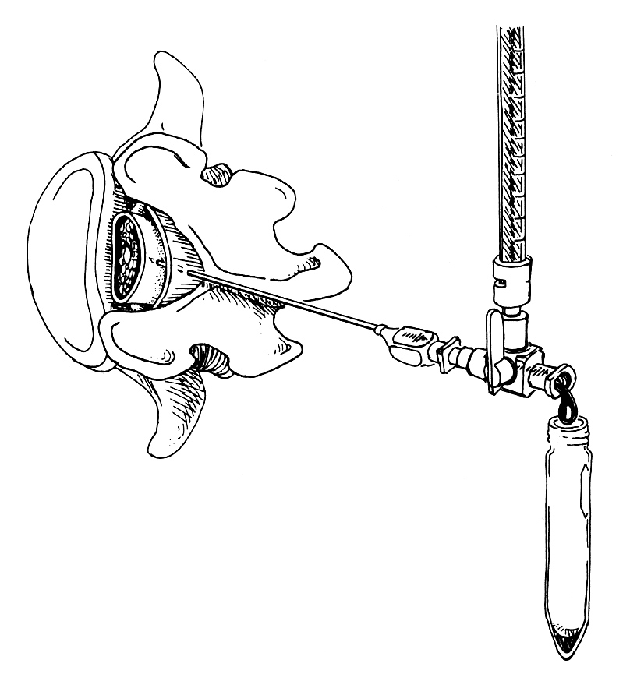
Source of picture: Paul W. Roberts “Useful Procedures in Medical Practice” (1986); Lea & Febiger; ISBN-13: 978-0812109856 >>

Procedure end
- reattach manometer to record closing pressure if indicated (e.g. therapeutic LP for increased ICP).
- replace stylet and withdraw needle.
- massage puncture region for a moment to break up needle tract.
- small sterile dressing or adhesive on puncture site.
- routinely observe for cord / spinal nerve compression from developing hematoma after traumatic taps.

Postprocedure
Prone bed rest for 6-24 hrs, hydration – see post-LP headache prevention! see below >>

Complications
- Post-LP headache (5-35%; risk is greater in young females) – due to CSF leakage through dural puncture site.
  - onset 15 minutes ÷ 4 days following LP.
  - usually lasts only few hours (untreated can last for 14 days). see p. S58 >>
  - prevention:
    - use smaller-gauge spinal needles (20 or 22G; 25G for small children).
    - use atraumatic needle (vs. cutting type).
    - orient needle bevel parallel to longitudinally running dura fibers.
    - avoid multiple punctures.
    - remove as little CSF as possible.
    - turn patient prone (if LP is done in sitting position) before removing needle.
    - bed rest (better prone than supine) after procedure for 6-24 hrs (no studies support usefulness of this!!!).
    - post-lumbar puncture hydration.
  - treatment: bed rest (up to Trendelenburg), hydration, caffeine-containing analgetics, autologous epidural blood patch.

- Herniation (1.2-3%) – transtentorial or cerebellar tonsillar: see p. S54 >>
  - inject 5 mL of NS and withdraw needle immediately → elevate head of bed → intubate & hyperventilate → mannitol, steroids.
  - most important risk factor - signs of mass effect (hemiparesis and anisocoria).

- Nerve-root injury - sudden onset pain radiating down.
  - withdraw needle immediately → if pain persists → start short course of dexamethasone.

- Spinal epidural / subdural hematoma (usually only with coagulopathy)
  - heparin therapy should not commence for at least 1 hour after bloody tap!

- Epidermoid tumor - pain in back and lower extremities developing years after LP.

- Spinal meningitis - leakage of blood containing bacteria into subarachnoid space.
Suspected bacteremia is not contraindication for LP!

- Intracranial subdural hygroma or hematoma (extremely rare)

- In aneurysmal SAH (when aneurysm is unsecured), excessive lowering of CSF pressure increases transmural pressure across wall of aneurysm → rebleed (remove only minimum volume of CSF needed for diagnostic studies).

Lumbar Drain (s. Lumbar Subarachnoid Drain, Spinal Drain)
Indications
- Intraoperative brain relaxation (e.g. for aneurysm or tumor exposure)
- CSF leak prevention* or treatment
*typically after posterior fossa or transsphenoidal procedures
- Assessment of potential response to shunting in normal-pressure hydrocephalus

Procedure Details
- 14G Tuohy needle* is inserted with bevel facing laterally.
*needle with a lateral opening at the distal end, designed to cause a catheter passing through the needle's lumen to exit laterally at a 45° angle; used to place catheters into the subarachnoid or epidural space
- once brisk CSF flow is obtained, bevel is turned superiorly.
- lumbar drainage catheter (± with wire stylet) is inserted until resistance is met (20*-40 cm)
*4 dots on the drain
- pursestring suture is placed around the catheter exit on the skin while Tuohy needle is still in place (avoids injuring catheter).
- Tuohy needle is withdrawn.
- catheter stylet is withdrawn.
- catheter is attached to supplied Luer-Lok connector and sutured to skin; coil rest of drain and cover with large Tegaderm / OpSite.
N.B. it is easy to kink the catheter or tie suture too tight – check CSF flow often!

N.B. once catheter tip is past the tip of the needle, do not rotate the needle – may share the catheter!
N.B. once catheter tip is past the tip of the needle, do not withdraw the catheter from the needle (“only forward movement”) – may share the catheter!
N.B. if resistance is met during stylet withdrawal, pull entire catheter out and investigate (else – may share the catheter!)

Maintenance
- keep drain clamped if patient is ambulatory.
- unclamp as needed to drain CSF (e.g. certain amount of CSF per hour), or keep drain open at shoulder level in recumbent patients for continuous drainage.
- normal drainage rate – 5-15 mL/hr (may use electronic pump for that).
- drain is removed / changed every 5-7 days.
N.B. inspect removed drain for integrity!

Complications
- Infection
- Overdrainage → transforaminal brain herniation (potentially lethal)
Integra LimiTorr™ Volume Limiting External CSF Drainage and Monitoring System - used for - ventricular or lumbar catheter - volume limiting valve mechanism reduces chance of excessive CSF drainage by halting drainage when pre-determined volume (20 mL or 30 mL) is reached.
- Retained catheter fragment – causes variable (catheter shear during placement, catheter entrapment between spinous processes*)
*N.B. flex lumbar spine during removal, esp. if resistance is met.

Viktor’s Notes℠ for the Neurosurgery Resident
Please visit website at www.NeurosurgeryResident.net

