External Ventricular Drainage (EVD, Ventriculostomy)
Last updated: May 19, 2019
Indications 1
Contraindications 1
Planing Prior to Procedure 1
Equipment 1
Cranial Access Kit 1
Catheter 1
CSF collection 1
Codman EDS 3™ CSF External Drainage System 1
Intraparenchymal ICP Monitor 1
Codman ICP EXPRESS® Monitoring System 1
Continuous ICP monitoring and CSF drainage 1
Anesthesia and Antibiotics 2
Anterior (Frontal) Approach 2
Entry site 2
Direction of catheter insertion 3
Depth of catheter insertion 3
Intraoperative ventriculostomy 4
Posterior (Occipital) Approach 4
Entry Point 4
Trajectory 4
Transorbital approach 5
Secure drain to scalp 5
Further Maintenance, Drainage height 5
Replacement of catheter 5
Complications 5

Indications
- ICP monitoring (EVD ia gold standard)
Before leaving OR, ventriculostomy should be placed in all patients with initial GCS score of 8 or less because raised ICP requiring treatment develops in at least 80% of these patients; it may also be placed under direct vision before closure of bone flap.
- CSF drainage in:
- intracranial hypertension
- shunt infection
- SAH (↑ risk of bleeding if aneurysm is unsecured)
- intraoperative brain relaxation

Contraindications
- Hemostasis disorder
- Mass lesion in catheter path
- Extensive midline shift – both hard to pass catheter and EVD can cause further shift

Planing Prior to Procedure
- review imaging studies (CT or MRI) for ventricular size and any shifts.
- make sure coagulation parameters are acceptable and patient is not on antiaggregants.
- if long duration of external drainage is suspected, perform procedure in OR with tunneled distal system.
- plan ventriculostomy such that future shunt requirements are considered in effort to maintain clean shunt tract.

Equipment
- hair clipper
- marking pen with ruler
- sterile prep swabs, sterile gloves
- sterile towels, gauze, and clear plastic drape
- 25G and 22G needles
- sterile saline solution
- scalpel
- handheld cranial twist drill
- 3.0 nylon sutures
- needle driver, forceps, scissors
- standard ventricular catheter
- external drainage collection kit

Cranial Access Kit
Codman: https://www.depuysynthes.com/hcp/codman-neuro/products/qs/Cranial-Access-Kit

Catheter
Becker (white in color) – for TBI, no blood in CSF.
DePuy Codman® Bactiseal (orange in color) - has 0.15% clindamycin and 0.054% rifampicin infused into silicone matrix at molecular level. >>

CSF collection
Codman EDS 3™ CSF External Drainage System
https://www.depuysynthes.com/hcp/codman-neuro/products/qs/EDS-3-CSF-External-Drainage-Syst

Intraparenchymal ICP Monitor
Codman ICP EXPRESS® Monitoring System
https://www.depuysynthes.com/hcp/codman-neuro/products/qs/ICP-EXPRESS-Monitoring-System

Continuous ICP monitoring and CSF drainage
Integra Camino Flex – safe in MRI 3.0 T; pressure sensor inside ventricle (at catheter tip):

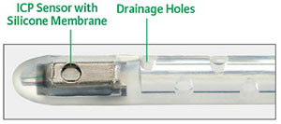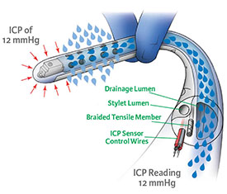

InnerSpace Neuro Hummingbird Ventricular System – MRI Conditional 1.5T/3.0T; pressure sensor intraparenchymal:
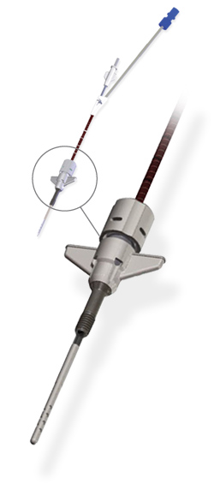
Anesthesia and Antibiotics
- 1 % lidocaine
- Short-acting IV sedation (Versed or propofol if intubated)
Avoid paralytics if possible to make neurological exam post EVD placement meaningful!
- Not routine - IV antibiotics covering routine skin flora; some experts continue while EVD is in place.

Anterior (Frontal) Approach
- EVD is placed on right side to minimize risk of injury to dominant hemisphere, unless left-sided intracerebral hemorrhage patient.
- patient supine with head of bed slightly elevated (20°) and neck in neutral position.
- appropriate side of head is liberally clipped to allow for adequate subgaleal tunneling of catheter
- entry point on scalp is marked with pen and ruler.
- clear drape is placed, taking care to clearly define midline.
- 1% lidocaine is injected subcutaneously at planned incision site; make large bleb – will help for subgaleal tunneling anesthesia.
- drill-bit depth guide is set to allow penetration of inner and outer calvarial tables.

Entry site
Anterior or frontal location – Kocher's point (most commonly used site) – lies anterior to motor strip, is posterior enough to avoid incisions on forehead, and is lateral to both superior sagittal sinus and large bridging veins draining frontal lobes into sinus; location:
- measure 10-12 cm in sagittal line posteriorly from nasion (it should be 1-2 cm anterior to coronal suture) then 3-4 cm laterally – mark entry point here (should more or less coincide with sagittal plane going through midpupil);
- at posterior part of incision must see coronal suture (extend incision appropriately) – burr 1-2 cm anterior to coronal suture!

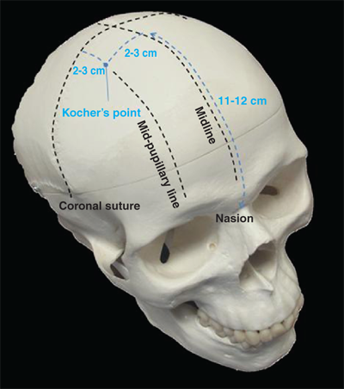

- 1-3 cm parasagittal stab incision is made with scalpel at marked site just large enough to permit passage of drill bit (in order to minimize scalp bleeding); incision is taken down to bone.
- scrape to sides pericranium with scalpel handle.
- twist drill is held perpendicular to skull to make hole in skull; irrigate away bone chips!!!
- use drill to puncture dura (by turning handle back and forth for several times), but take care not to plunge into brain parenchyma; if dura still intact – use drill bit spinned in your fingers or #11 blade or catheter tunneling needle.
- drill wrench or spinal needle is inserted through burr hole to determine if dural opening is large enough to pass catheter (if attempt is made to pass catheter and wire stylet with dura intact, epidural hematoma may develop from dura stripping; furthermore, if dural opening is too small, catheter may drag on dura, allowing stylet to puncture catheter and protrude into brain parenchyma).

Direction of catheter insertion
In bilaterally symmetric plane crossing entry point and (point 2 cm anterior* to) tragus. Keep catheter in this plane and aim towards ipsilateral nasion / glabella / medial canthus (check this on coronal CT).
*2 cm anterior to tragus might be too anterior.
N.B. most common mistake – inserting too anterior and too lateral.
- practically, aim catheter towards anterior to tragus then move in plane towards medial canthus.
- ask helpers to watch from side (that you still stay in plane) and from end of bed (to make sure that you entering skull perpendicularly to surface).
- drawing lines (from entry point to tragus; another line from entry point to medial canthus) with pen on scalp is very helpful to orient catheter once landmarks are covered by drapes; another trick – place ECG pad at nasion – can palpate through drapes.
- ventricular catheter with stylet is inserted perpendicular to brain surface to depth of 6 cm:
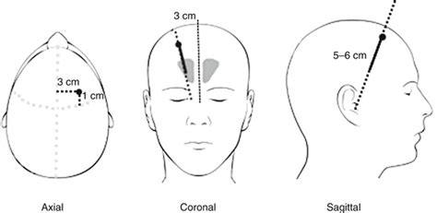

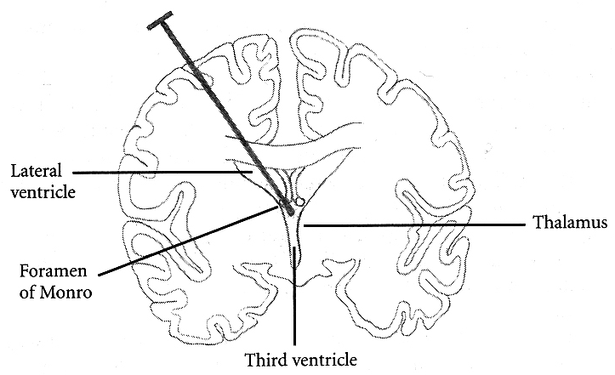

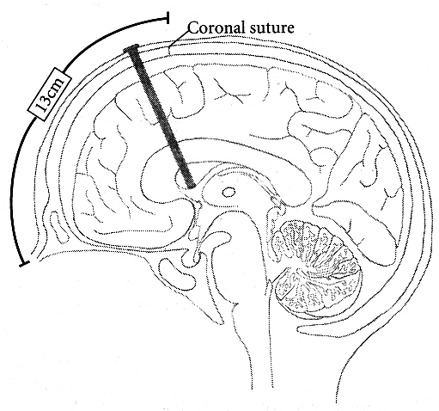

Depth of catheter insertion
Adults – 6* cm from outer table of skull; no need to insert catheter > 6 cm; if properly directed, catheter will encounter CSF at 4 cm depth (even if you encounter CSF, advance to 6 cm, so collapsing ventricle won’t dislodge catheter).
* if CSF flow is obtained prior to 6 cm, may advance further (up to 10 cm) without stylet – so catheter “finds way” (soft pass) to foramen of Monro
Pediatric patients - estimated from CT.

- stylet is withdrawn to ensure CSF flow.
- if CSF flow does not start immediately after catheter insertion, problem may be air lock in catheter lumen; it can be eliminated by gentle irrigation with small quantity of saline, and distal end of catheter may then be lowered in order to siphon ventricular CSF; if CSF flow is established only transiently, catheter may be in temporal horn, interhemispheric fissure, third ventricle, sylvian fissure, or even basal cisterns.
- unsuccessful attempt: if no CSF flow is obtained at 6 cm, tendency to insert catheter further must be resisted
- catheter should be removed without stylet and flushed with saline
- landmarks and trajectory should be confirmed.
- stylet is reinserted, and catheter redirected (aiming catheter slightly more medially is usually safe and effective way to establish CSF flow).
- tunneling device is attached to distal end of catheter; while stabilizing catheter proximally as it enters skull, tunnel distal portion under galea medially* to exit site at least 5 cm distant from entry site; CSF flow is confirmed after catheter is pulled flush against skull.
*i.e. towards midline – if patient will need shunt, it will go laterally from burr hole
N.B. frequently (after every step) check for CSF flow but otherwise keep catheter always clamped!
- distal end of catheter is connected to adapter and then to pressure transducer and/or drainage system; fixed level for drainage is set using external auditory meatus as reference point.
- suture to scalp – see below >>

Intraoperative ventriculostomy
Paine's point (during pterional craniotomy) - creation of 2.5-cm isosceles right triangle:
anterior limb starts on dura overlying sphenoid ridge (lateral orbital roof) and goes superiorly 2.5 cm;
posterior limb starts from sylvian fissure and goes anteriorly 2.5-4.5 cm;
hypotenuse overlies sylvian fissure.
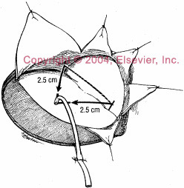
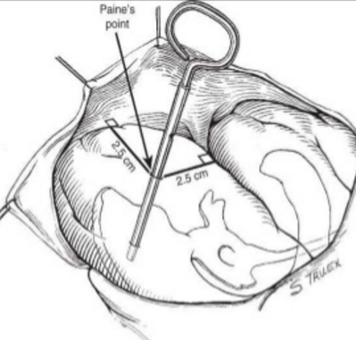
- Silastic brain catheter is used to enter frontal cortex perpendicularly at vertex of triangle.

Posterior (Occipital) Approach
Patient position:
- supine with ipsilateral shoulder roll and head turned fully toward contralateral shoulder; head of bed can be elevated 15- 20°
- prone (i.e. suboccipital craniotomy)

Entry Point
Adults:
- flat portion of parietoocciput.
- Frazier burr hole: 6-7 cm superior to inion (might be too difficult to locate it) and 3-4 cm off midline - this places burr hole approximately 1 cm anterior to lambdoid suture and allows insertion of catheter down length of body of lateral ventricle.
- Dandy’s point: 3 cm superior to inion and 2 cm off midline – higher risk of visual pathway damage.
- 4-5 fingerbreadths above and 4-5 posterior to auricle tip.
- 3 cm above and 3 cm posterior to auricle tip.

Kids:
- 3 fingerbreadths above and 3 posterior to auricle tip.
- Keen’s point (most common point for tapping cerebral abscesses arising from otitis media) – 2.5-3 cm above and 2.5-3 cm posterior to auricle tip.

Trajectory
Always check imaging for individual anatomy!
- glabella or higher (middle of forehead) and/or more contralateral (to opposite medial canthus) serve as a target in sagittal plane; there is natural tendency to cross midline with this approach, so care should be taken to aim at ipsilateral medial canthus in axial plane (but this may deflect to temporal horn – high chances of choroid plexus obstruction here, plus, temporal horns normally collapse upon successful drainage of hydrocephalus).
- ventricular catheter with stylet is passed perpendicular to skull base, aiming for middle of forehead above eyebrows, to depth of 6 cm → if there is CSF flow, stylet is held still, and catheter alone is passed to depth of 10-12 cm (8 cm for kids) - tip should be in frontal horn just in front of foramen of Monro (to place catheter holes anterior to choroid plexus to prevent hole plugging).
N.B. stylet to 6 cm, then soft pass!
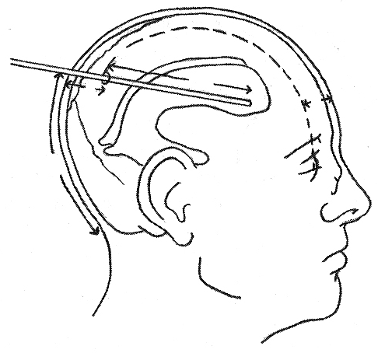

Transorbital approach
For herniating kids in ED: use 18G 3.5 inch spinal needle – enter at the superior medial orbital roof corner and aim towards the opposite parietal bossing.

Secure drain to scalp
- using multiple interrupted sutures (don’t use silk – very proinflammatory).
- adapter is secured to catheter using 3.0 silk suture; incision is sutured and catheter secured to scalp in at least three places using 3.0 nylon (purse string 3.0 nylon suture at catheter exit site to prevent CSF leak).
- for unreliable patients – make pigtail loop with catheter on scalp – if patient pulls on it, it will clamp the catheter but will not pull it out.
- suture connector hub to scalp directly.
- sterile dressing (Tegaderm).

Further Maintenance, Drainage height
Units
- EVD monitoring display shows in mmHg.
- all studies done in mmHg.
- most attendings at VCU (except Dr. Simon) use cmH₂O – because, if patient needs shunt, valve settings are in cmH₂O.

According to pathology
Do not overdrain!
SAH (unsecured aneurysm) – drain at 10 (if lower – transmural pressure gradient↑ in aneurysm wall may provoke rebleeding).
SAH (secured aneurysm) – drain at 0.
Trauma – “20 pop down to 10” – i.e. monitor ICP and, if ICP goes above 20, open and drain at 10 until ICP drops.
IVH – may drain at 0 to encourage CSF clearance.
posterior fossa mass – drain at 15-20 (to prevent upward herniation).

CSF output relevance to challenging
When < 100/8hr shift – may start challenging (i.e. rising); don’t challenge EVD until > 6-7 days post SAH
When < 100/24hr – may clamp → CT after 24 hours – if ventricles of normal size (can be slightly larger than when EVD was open), may D/C EVD.

Dr. JRC challenges: 0 → 10 → 20

Replacement of catheter
- use stylet (soft pass may fail).

Dr. Villanueva – if within 24 hrs, use same tract; if after 24 hrs, drill new skull hole.

Complications
- Overdrainage
Integra LimiTorr™ Volume Limiting External CSF Drainage and Monitoring System - used for ventricular or lumbar catheter - volume limiting valve mechanism reduces chance of excessive CSF drainage by halting drainage when pre-determined volume (20 mL or 30mL) is reached.
- Obstruction – check whole tubing for kinks, etc. Flush with sterile saline distally (may also flush proximally very gently). If no success → CT.
- Infection – risk factors: ↑duration of EVD, bloody CSF, frequent flushes
- Hemorrhage (7%, clinically significant 0.8%)
Bauer DF “Meta-analysis of hemorrhagic complications from ventriculostomy placement by neurosurgeons.” Neurosurgery. 2011 Aug;69(2):255-60

Viktor’s Notes℠ for the Neurosurgery Resident
Please visit website at www.NeurosurgeryResident.net

