Peripheral Neuropathies (GENERAL)
Last updated: December 19, 2020
Classifications 1
Etiology 1
Pathophysiology, Pathology 1
Segmental Demyelination 2
Axonal Degeneration 3
Clinical Features 3
Phenomena 3
Deficit (s. negative) phenomena 3
Irritative (s. positive) phenomena 3
Diagnosis 4
Electrophysiology 4
Neuroimaging 4
Other 4
Treatment 4
Prognosis 5
Polyneuropathy 5
Etiopathology 5
Clinical Features 5
Mononeuropathy 6
Mononeuropathy multiplex (MM) 7
Radiculopathy 7
Etiology 7
Clinical Features 7
Diagnosis 9
Differential 9
Treatment 9
Dorsal Root Ganglion Syndromes (Sensory Ganglionitis) 9
Etiology 9
Clinical Features 9
Differential 9
Diagnosis 9
Treatment 9
Plexopathy → see p. PN9 >>

Classifications
N.B. diabetes can cause any type / category of neuropathy!!!
- Motor neuropathies (e.g. lead, dapsone, tick bite, porphyria, diphtheria, some cases of Guillain-Barré syndrome, anti-GM₁ antibodies = motor axonal neuropathy associated with multiple conduction blocks).
- Sensory neuropathies (e.g. dorsal root ganglionitis, leprosy, HIV, chronic vit.B₆ intoxication or deficiency, arsenic, thallium, hypothyroidism).
- Autonomic neuropathies (e.g. pure autonomic failure, pure adrenergic neuropathy, amyloidosis).
- Mixed neuropathies

  - Axonal neuropathies
  - Demyelinating neuropathies:
    - inflammatory neuropathies
    - neuropathies associated with paraproteinemias
    - inherited disorders of myelin
- many neuropathies have admixture of both axonal degeneration and demyelination.

N.B. clinically axonal and demyelinating neuropathies may be identical; differentiated only by nerve conduction studies & EMG. see below >> and p. D22 >>

Polyneuropathy
Mononeuropathy
Mononeuropathy multiplex

Neuritis - inflammatory disorder (infection or autoimmunity).

Acute (days): Guillain-Barré syndrome, porphyria, diphtheria, toxins.
Subacute (weeks): most toxins, nutritional neuropathies, carcinomatous neuropathies, uremic neuropathy.
Chronic (months ÷ years): many neuropathies (e.g. diabetic).
Very chronic (childhood onset): heritable neuropathies.

Etiology
- Trauma - most common cause of mononeuropathy.
- Toxic & metabolic disorders - usually affect many nerves (mononeuropathy multiplex, polyneuropathy):
  - diabetes
  - alcohol
  - amyloid – small fibers suffer first!
  - uremia
  - porphyria
  - heavy metals, industrial solvents
  - diphtheria toxin
  - group B vitamin deficiency
  - drugs (amiodarone, nitrofurantoin, isoniazid, vincristine are common offenders)
- Inflammatory / immunologic - Guillain-Barré, postimmunization, collagenoses.
- Direct infection - e.g. leprosy, CMV (esp. in HIV patients).
- Hereditary disorders - course protracted over several years!
- Ischemia (occlusion of vasa nervorum).
- Malignancy:
    - direct tumor invasion / compression
    - monoclonal gammopathy (e.g. monoclonal IgM against myelin-associated glycoprotein)
    - amyloid deposition
    - nutritional deficiencies
    - paraneoplastic syndrome.
- Radiation (e.g. plexopathy after ≥ 1 yr latent period).

Pathophysiology, Pathology
Pathologic Reactions of Neurons (wallerian degeneration, chromatolysis, etc) → see p. A5 >>
Normal & Abnormal Motor Units → see p. A46 (5a) >>
Three main responses of peripheral nerve to injury (based on target of insult):
  - Diseases that affect primarily Schwann cell → segmental demyelination.
  - Diseases that affect primarily axon → wallerian degeneration.
  - Diseases that affect primarily neuron body → distal degeneration (s. distal axonopathy, “dying back”).

Segmental Demyelination
- no primary abnormality of axon.
- process affects some Schwann cells and their corresponding internodes while sparing others (segmental pattern).
- disintegrating myelin is engulfed initially by Schwann cells and later by macrophages.
- axon and myocytes remain intact!

Remyelination
- denuded axon provides stimulus for remyelination.
- population of cells within endoneurium has capacity to replace injured Schwann cells.
- newly formed myelinated internodes are shorter than normal (several are required to bridge demyelinated region); new myelin sheath is also thin in proportion to axon diameter.

Sequential episodes of demyelination - remyelination.
- accumulation of tiers of Schwann cell processes (on transverse section appear as concentric layers of Schwann cell cytoplasm and redundant basement membrane that surround thinly myelinated axon - onion bulbs); superficial cutaneous nerves may be thickened and visibly enlarged.
- in time, many chronic demyelinating neuropathies give way to secondary axonal injury.

electron micrograph of single, thinly myelinated axon surrounded by concentrically arranged proliferating Schwann cells, forming onion bulb (inset: light microscopic appearance of onion bulbs):
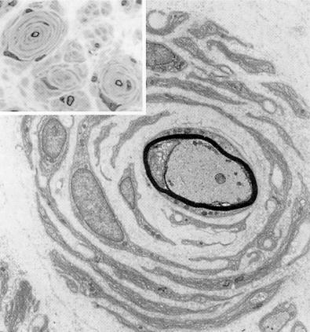
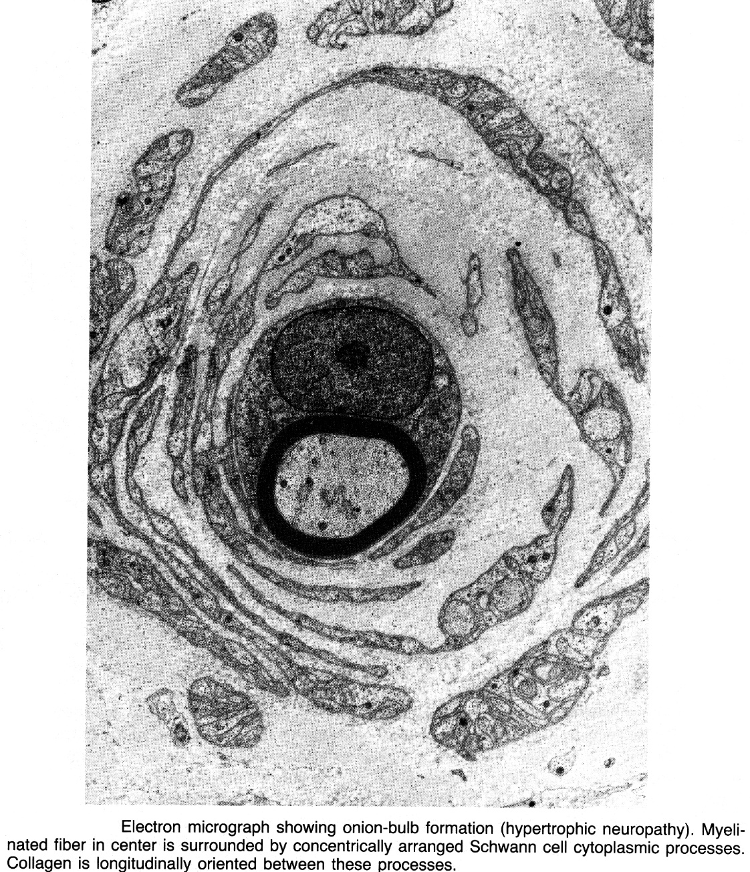

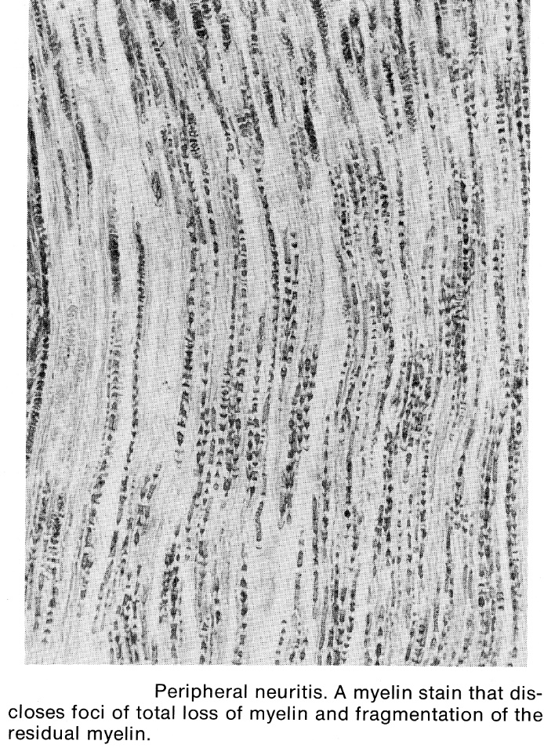

Axonal Degeneration
- primary destruction of axon (with secondary myelin disintegration):
- focal event (e.g. trauma or ischemia); distal axon may undergo wallerian degeneration.
- generalized abnormality - affecting neuron cell body (neuronopathy) or its axon (axonopathy); most distal part of axon is affected first, and axonal degeneration ascends proximally.

- in slowly evolving neuropathies, evidence of myelin breakdown is scant because only few fibers are degenerating at any given time.
- myocytes within affected motor unit undergo denervation atrophy. see p. D30 >>

Axonal regeneration and reinnervation see p. A5 >>, p. D30 >>
- axon regeneration is slow process (vs. remyelination – quite rapid!).
- atrophic muscle fibers may be reinnervated also by normal neighboring axons (newly adopted reinnervated fibers assume fiber type of their neighboring new siblings - "fiber type grouping").
- if axon (which adopted denervated myocytes) also degenerates - group atrophy.

Clinical Features
Clinical manifestations of PNS lesion depend on:
- Anatomical site (root ÷ terminal distribution)
anatomic localization of sensory symptoms → see p. S22 >>
anatomic localization of motor symptoms → see p. Mov3 >>
radiculopathy – segmental distribution (dermatome, myotome, sclerotome).
plexopathy – distribution of > 1 peripheral/spinal nerve.
mononeuropathy – distribution of 1 peripheral nerve.
mononeuropathy multiplex - distribution of ≥ 2 major named nerves in ≥ 2 limbs
polyneuropathy – distribution of > 1 peripheral/spinal nerve (symmetrical; distal before proximal; legs before arms).
- Functional type of neuron affected (motor / sensory; somatic / autonomic)
- Phenomena (deficit / irritative)

Phenomena
Deficit (s. negative) phenomena
- result from interruption of nerve impulse flow:
Somatomotor system – weakness, paralysis (→ atrophy in chronic cases).
see p. Mov3 >>
Visceromotor system (affected in small fiber neuropathies)
- Atony of visceral walls (peristalsis↓)
- Vasomotor paralysis (vasodilation)
- Anhidrosis
- Trophic changes (hair loss, skin thinning, nail dystrophy, etc) - more common when sensory or mixed nerve is injured (vs. motor nerve).
N.B. skin ulceration, poor healing, tissue resorption, neurogenic arthropathy, and mutilation are result of recurrent, unnoticed, painless trauma - avoidable with proper care of insensitive parts!
Sensory system (all sensory modalities may be impaired; however, one modality may predominate):
small (unmyelinated and myelinated) fibers – temperature & pain sensation↓ + autonomic dysfunction + burning pain;
large fibers – position & vibratory sensation↓ + somatomotor dysfunction.
- Numbness, anesthesia. p. S22 >>
  - area of sensation loss is usually smaller than anatomic distribution of nerve.
- Hyporeflexia. see p. Mov3 >>
N.B. if one cannot elicit reflexes, patient usually has neuropathy!

Uhthoff symptom - transient temperature-dependent neurological dysfunction (numbness, weakness, loss of vision);
- conduction stops in any nerve if temperature gets too high;
- in damaged nerve (e.g. demyelinated), this shutdown temperature is lowered, and may approach normal body temperature - transient neurological dysfunction may appear with hot shower, exercise, fever.

Irritative (s. positive) phenomena
- result from excessive nerve impulse flow:
Somatomotor system – fasciculations (more common in LMN and root lesions).
see p. Mov3 >>
Visceromotor system – hyperhidrosis, vasoconstriction (episodic hypertension), diarrhea, tachycardia or bradycardia.
Sensory system:
- Paresthesias, hyperesthesia, dysesthesia. p. S22 >>
- Pain & hyperpathia (after incomplete interruption of nerve). see p. S20 >>
N.B. in irritation of somitic nerve (spinal root, spinal nerve), pain can be felt not just in dermatome, but also in miotome, sclerotome!
e.g. disc hernia compresses L5 root → pain in L5 dermatome (foot) and L5 sclerotome (hip and femur).
Worst pain is in:
- small-fiber neuropathies of diabetes
- axonal degenerations (particularly alcoholic and uremic)
- nerve infarction
- metal intoxications
- some drugs (e.g. gold, vincristine)
- Fabry's disease

Cranial nerves may also be involved (e.g. Guillain-Barré syndrome, Lyme disease, diabetes mellitus, diphtheria).
Palpation of nerve trunk is frequently forgotten part of neurologic examination:
  - focal or diffuse thickening
  - presence of neurofibroma
  - point tenderness
  - Tinel's phenomenon (tapping along course of nerve trunk → tingling sensation in nerve territory)
  - pain elicited by stretching of nerve trunk.
- hypertrophic nerves (Schwann cell proliferation and collagen deposition as result of repeated episodes of demyelination-remyelination or deposition of amyloid or polysaccharides):
  - demyelinating form of Charcot-Marie-Tooth disease (type I)
  - Dejerine-Sottas neuropathy
  - Refsum disease
  - neurofibromatosis
  - leprous neuritis
  - amyloidosis
  - chronic demyelinating polyneuritis
  - sarcoid
  - acromegaly.

Diagnosis
Electrophysiology
- key test in all neuropathies!
- sensory evoked potentials – for lesions at and proximal to dorsal root ganglion. see p. D25 >>
- nerve conduction studies (sensory, motor): see p. D22 >>
- conventional (surface) – for large nerve fibers (motor, touch, proprioception).
- microneurography – for small nerve fibers (pain, temperature, autonomic).
- EMG see p. D20 >>
axon-loss lesions - amplitude reduction; EMG shows denervation
myelin-loss lesions - conduction slowing*; normal EMG
*severe demyelination may cause conduction block!
uniform (vs. differential) conduction slowing per se does not seem to have clinical correlate!

Neuroimaging
MRI or CT myelography – for radiculopathy (compression of nerve root by disc or bony spur).
MRI – for plexopathy (infiltrating mass).

Other
- CBC (e.g. megaloblasts of vit.B₁₂ deficiency, stippled RBCs of lead poisoning)
- nerve biopsy – special indications. see p. D32 >>
- CSF protein↑ – in demyelinating neuropathies.
- spirometry (in rapidly progressing acute polyneuropathies).
- urine (e.g. porphobilinogen & δ-ALA↑ in acute intermittent porphyria).

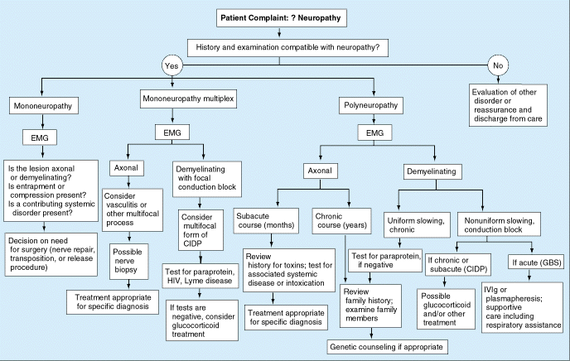

Treatment
In many instances there is no specific treatment for particular type of neuropathy!

- Eliminate cause – remove toxins, treat systemic illness, vitamin supplements, etc.
- Symptomatic therapy (e.g. amelioration of pain, bed – feet hygiene).
Avoid chronic compression on diseased nerves!
- Rehabilitation measures should commence immediately:
    - massage & passive range-of-motion exercises for paralyzed muscles
    - re-educative exercises for weak muscles.
Patients should not attempt to walk before muscle testing indicates they are ready!
    - electrical stimulation for preventing permanent weakness (unproven value).
    - splints, braces, etc (should be removable for regular physiotherapy) – to prevent contractures or when lesion produces deformity.
    - food supplements.

Treatment of painful neuropathies
Pain can be most distressing part of disease!
Neuropathic pains often do not respond well to conventional analgesics!
Mild symptoms:
- soaking extremities in cool water (≈ 15°C) for 20 min late in evening + aspirin 600-900 mg.
- capsaicin creams (0.025-0.075%) applied sparingly 3-4 / day.
More severe symptoms – anticonvulsants (phenytoin, carbamazepine), antidepressants (amitriptyline), mexiletine, TENS. see p. S20 >>

Food supplements for reversing neuropathies (esp. diabetic and HIV-related):
- Acetyl-L-carnitine (500-1000 mg, three times per day); note that higher end of this is probably better; success seen in reversing neuropathy caused by antiretroviral drugs occurred with doses of 1500 mg twice daily (3000 mg total daily dose);
- Alpha-lipoic acid (200-400 mg, 3 times per day);
- Vit. B₆ (50-100 mg/day in form of pyridoxal-5-phosphate, or combination of pyridoxine hydrochloride with pyridoxal-5-phosphate would probably be appropriate starting dose, although higher dosages, of perhaps 100 mg, three times per day, might be required for treatment of some neuropathies);
- Vit. B₁₂ (1000 mcg of B-12, 3-7 times per week; oral forms can work for some but for those with absorption problems nasal gel or subcutaneous / intramuscular injection may be required);
- Vit. B₁ in form of Benfotiamine (450-600 mg daily [taken as four 150 mg capsules spread throughout the day] appears to be most effective dosage for neuropathy for diabetics; it has not been studied for HIV-associated neuropathy and it’s not clear if it would be useful for this; available online at www.benfotiamine.net; information and lengthy list of abstracts of studies showing its benefit are available at www.benfotiamine.org);
- Biotin (5-20 mg/day may be necessary; note that this is usually found in “mcg” strengths in which case this dose would be 5000 mcg to 20,000 mcg daily);
- Folic acid (1600 mcg, 3 times per day);
- Niacin (25-50 mg, 3 times per day);
- Choline (400-800 mg of choline citrate or 1000-3000 mg of phosphatidylcholine, 3 times per day);
- Gamma linolenic acid (GLA) (240 mg, 2-3 times per day; least expensive source is usually borage oil);
- Inositol (500-2000 mg of myoinositol, three times per day);
- Lecithin (one tablespoon, two or three times daily);
- Magnesium (500-600 mg/day with one meal per day may be useful; best to take magnesium separately from calcium as they compete for absorption);

Prognosis
- axon injury: nearer injury to CNS, lower probability of regeneration of completely severed nerve (esp. cranial nerves); recovery is slow! see p. A5 >>
Neuromas may form!
Recovery may fail to occur at all!
- myelin injury: recovery is complete within few days or weeks.

Polyneuropathy
- diffuse lesions of peripheral nerves:

Etiopathology
Mostly metabolic / toxic causes (esp. diabetes mellitus, alcoholism, uremia).
60% patients have diabetes mellitus or inherited neuropathy!
- most are caused by primary axonal degeneration - involves ends of long nerve fibers first; with time, degenerative process involves more proximal regions of long fibers, and shorter fibers are affected (distal axonal degeneration or "dying back").
- primary demyelination likes to manifest as polyradiculoneuropathy.
- most are subacute (evolve over weeks) or chronic (evolve over months to years).
- acute polyneuropathies (evolve over days) - relatively uncommon:
Acute Axonal Polyneuropathy:
- porphyric neuropathy
- massive intoxications (e.g. arsenic)

Acute Demyelinating Polyneuropathy:
- Guillain-Barré syndrome
- buckthorn berry intoxication
- diphtheritic polyneuritis.

Clinical Features
symmetric
legs > arms
extensors > flexors
distal → proceeds centripetally in graded manner*
*nerve fibers are affected according to length (without regard to root or nerve trunk distribution).

- primarily sensory (diabetes, AIDS, paraneoplastic)
- primarily motor (inflammatory demyelinating neuropathies, hereditary motor sensory neuropathy, porphyria)
- mixed (most often type)

First symptoms tend to be paresthesias (tingling, burning, etc).
- in balls of feet or tips of toes (or in general distribution over soles).
- symmetric and graded distally (occasionally dysesthesias appear in one foot shortly before other or are more pronounced in one foot).
If symptoms first appear in individual digital nerves (involve only half of digit at time, and then gradually spread and coalesce) – it is sign of mononeuropathy multiplex.
- if polyneuropathy remains mild, no objective motor or sensory signs may be detectable.
In some instances, process begins with feet weakness (without sensory symptoms).

With progression:
- sensory loss moves centripetally in graded "stocking" fashion;
- pansensory loss over both feet (feet have "wooden" feeling - "I feel as though I'm walking on stumps").
- by time sensory disturbance has reached upper shin, dysesthesias are usually noticed in tips of fingers.
- when sensory disturbance reaches elbows and mid-thighs, tent-shaped area occurs on lower abdomen (its apex will extend rostrally toward sternum).
- scalp crown may be affected (may spread radially into CN5 and C₂ distribution).
- in profound sensory loss → repeated traumatic injury* → painless ulcers on digits, Charcot's joints. *avoidable by proper care!
- proprioceptive loss → gait unsteadiness, ataxia (out of proportion to muscle weakness).
- spontaneous pain is often considerable (worse at night); light stimuli to hypesthetic areas, once perceived, may be extremely uncomfortable (hyperpathia).
Burning feet pain is typical for diabetic and alcoholic neuropathies!
- motor deficit is also graded, distal, and symmetric:
- loss of reflexes: ankle jerk → knee jerk → arm reflexes.
N.B. hyporeflexia / areflexia often precedes any overt motor or sensory symptoms.
- motor component begins as weakness and atrophy in intrinsic feet muscles* →→→ quadriplegia, impaired ventilation, sphincteric dysfunction.
*atrophy of extensor digitorum brevis is often first helpful clue - weakness of toe dorsiflexion
- autonomic nervous system may be additionally involved (postural hypotension!!!, anhidrosis!, nocturnal diarrhea, urinary and fecal incontinence, impotence, smooth and shiny skin, pitted or ridged nails, osteoporosis, etc).

N.B. variations are common → diversity of clinical syndromes.

Exceptions to distal distribution (i.e. predominantly proximal distribution):
- lead neuropathy (tends to affect upper extremities first, esp. radial nerve)
- Guillain-Barré syndrome
- familial amyloidosis type 2
- adult-onset Tangier disease
- porphyria (occasionally).

Temperature-related distribution – leprosy.

Major fluctuations (over weeks or months) in course raise two possibilities:
  - relapsing form of neuropathy (esp. chronic inflammatory demyelinating type, porphyria).
  - repeated toxic exposures (e.g. lead, alcohol).

Differentiate from ischemic paralysis - paralysis of extremity due to occlusion of large arteries: anesthesia extends in glove-like distribution; hand is held extended and fingers are slightly flexed; fibrous consistency of tissues, absence of peripheral pulsations.

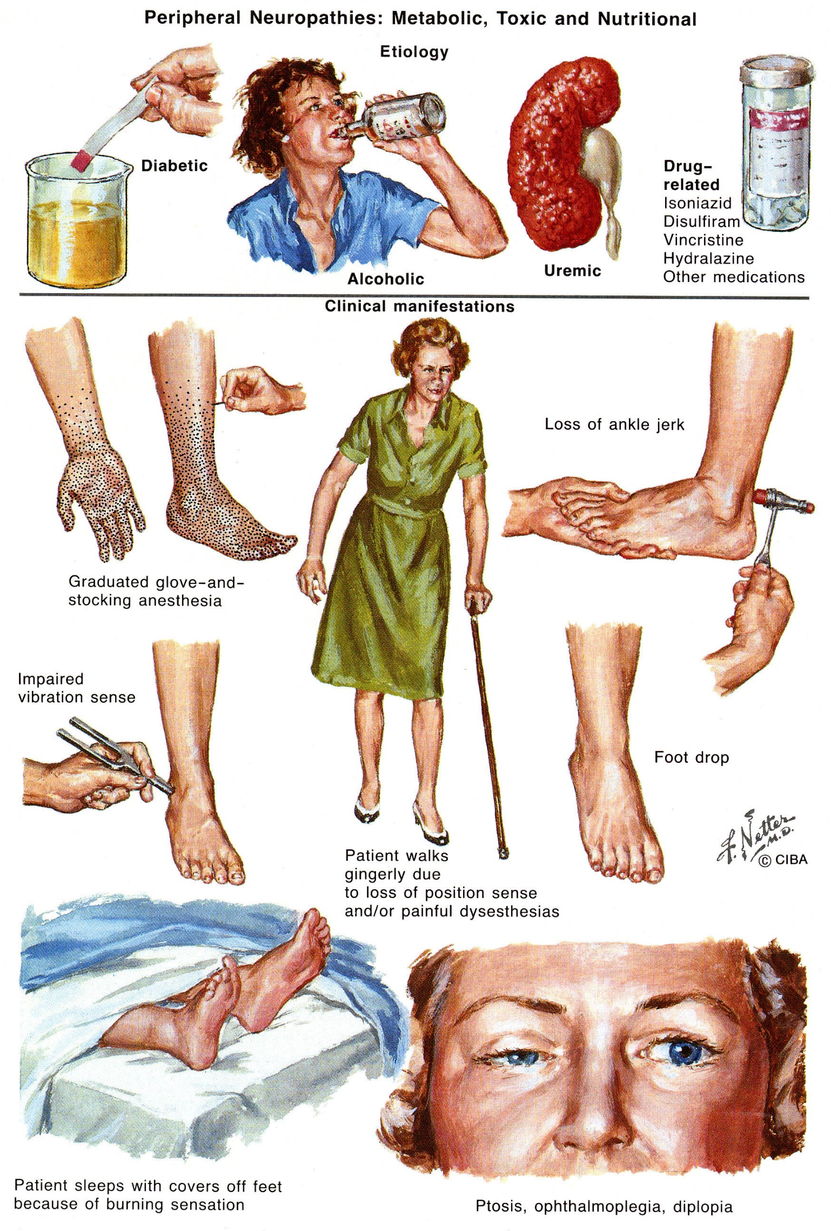

Mononeuropathy
- disorder of single nerve.
- most commonly due to local cause:
  - trauma - most common cause!
  - entrapment
  - nerve infarction (diabetes, vasculitis).
- clinical examination - negative & positive phenomena restricted to nerve territory. see p. D1 >>
- factors favoring surgical treatment (in absence of history of trauma):
    - chronicity
    - worsening neurologic deficit (particularly if motor)
    - electrodiagnostic evidence of wallerian degeneration (i.e. axonal neuropathy)

Mononeuropathy multiplex (MM)
- simultaneous or sequential focal involvement of ≥ 2 major named nerves in ≥ 2 limbs (i.e. nerves from individual noncontiguous nerve trunks).
- most commonly due to generalized disorder:
- ≈ 30% cases are due to demyelination - multifocal demyelinating neuropathy (part of chronic acquired demyelinating neuropathy).
- vasculitis of vasa nervorum (polyarteritis nodosa!!!, RA!!, SLE!, Sjögren syndrome, Wegener granulomatosis, progressive systemic sclerosis, Churg-Strauss allergic granulomatosis, hypersensitivity angiitides) – may cause acute MM!
- compression by sarcoidosis
- metabolic diseases (diabetes, amyloidosis)
- infections (Lyme disease, HIV, leprosy).
- disease progression involves additional nerves (neurologic deficits: patchy and multifocal → confluent and symmetric*).
* patients may present with distal symmetric neuropathy - attention to pattern of early symptoms is important!

Radiculopathy
Etiology
- Disk herniation - commonest cause!
  - most common radiculopathies affect C₅₋₆ roots and L₅-S₁ roots, since those are roots most often compressed by herniated discs. see p. Spin11 >>
- Compression by osteophyte: aging* spine degeneration aka spondylosis (second commonest cause), osteoarthritis of spine or sacroiliac joint.
*normal anatomic changes should only be considered pathological if they are etiologically related to specific clinical syndrome.
- Compression / irritation by abscess.
- Compression / invasion by tumor.
- Leptomeningitis, meningeal carcinomatosis (meningeal sheath follows roots).
- Trauma, root avulsions (e.g. stretching accidents in cervical region).
- Compression by cysts (synovial, meningeal).
- Vascular: dural arteriovenous fistulae, tortuous vertebral arteries.
- Herpes zoster.
- Diabetes mellitus.

Clinical Features
Posterior spinal root:
- Pain - prominent in root compression and inflammation.
  - pain is poorly localizing (radicular pain may follow dermatomal pattern but more typically is deep and aching and only roughly corresponds to involved dermatome).
  - pain is radiating (e.g. back or neck pain radiating into extremity – sciatica, etc).
  - pain is precipitated by:
    - moving spine
    - Valsalva maneuver (transmits pressure to nerve root through subarachnoid space).
    - root stretching maneuvers (e.g. straight leg rising).
    - root compression maneuvers (e.g. Spurling’s test).
  - pain is relieved by eliminating root stretch (e.g. arm abduction)
- Dermatomal sensory loss of all modalities (numbness is more localizing than pain!).

Anterior spinal root → myotomic muscle weakness & tendon reflexes↓; rarely fasciculations; eventually, atrophy.
  - “weakness” may be due to unsustained effort (breakaway weakness) associated with radicular pain.

- tendon reflexes (segmental hyporeflexia) are affected by either anterior or posterior spinal root.
- muscles are innervated by more than one spinal root! (actual motor innervation is multisegmental)
  - difficult to differentiate C₅ from C₆ or C₆ from C₇ root injury (C₆ may depress either biceps or triceps reflex).
  - differentiating C₅ from C₇ is easier (C₅ reduces biceps jerk, whereas C₇ reduces triceps).
  - differentiation of L₅ from S₁ is most readily made by watching patient walk on heels and toes; ankle jerk may be affected by either lesion (more often by S₁).

TOPOGRAPHY
N.B. signs may not be as distinct in actual practice as table implies!
¹root function normally varies somewhat from patient to patient;
²overlap in function between roots is common;
³distribution of symptoms and signs often occupies only part of associated root territory
Pain location is most variable of clinical features!
Root | Muscle weakness  See also p. D1 >> | Pain  See also p. D1 >> | Reflex
C₂ |  | Neck | None
C₃ | Trapezius, levator scapulae, strap muscles, sternocleidomastoid, diaphragm | Supraclavicular, suboccipital, and  posterior auricular regions | None
C₄ | Trapezius, rhomboids, levator scapulae, diaphragm | Infraclavicular and posterior  cervical regions, posterior shoulder | None
C₅ | Deltoid – shoulder abduction (15-90°)  Clavicular head of the pectoralis major  Supraspinatus – shoulder abduction (0-15°)  Infraspinatus – humerus external rotation  Biceps (C₅₋₆), brachialis, brachioradialis – elbow flexion  Diaphragm | Lateral shoulder (deltoid area)  Superolateral upper arm  Lateral epicondyle | Pectoralis,  Biceps (C₅₋₆)
Most common mimickers (of C5 radiculopathy):
- Rotator cuff tear – also gives shoulder abduction weakness but starts from 0 degrees and is not associated with weakness of other C5 innervated muscles (C5 radiculopathy is not associated with painful shoulder movement or significant tenderness). Check Neer and Hawkins’ tests for impingement. see p. Exam5 >>
- Suprascapular nerve entrapment - not associated with weakness of other C5 innervated muscles (such as the deltoid, biceps, and pectoralis major).
C₆ | Biceps (C₅₋₆), brachialis – elbow flexion  Brachioradialis (C₅₋₇) – elbow flexion in semipronation  Pronator teres (C₆₋₇) – pronation  Supinator  Extensor carpi radialis (C₆₋₇) – radial wrist extension  Flexor carpi radialis | Posterior shoulder  Lateral arm and forearm  1-2 fingers | Biceps (C₅₋₆)  Brachioradialis  (C₅₋₇)
Most common mimickers (of C6 radiculopathy) – see C7 root
C₇ | Triceps (C₆₋₈) – elbow extension  Pronator teres (C₆₋₇) – pronation  Extensors carpi ulnaris (C₆₋₇) – wrist extension  Extensor digitorum (C₇₋₈) – finger extension  Flexor carpi radialis  Abductor pollicis longus, extensor pollicis brevis and longus, extensor indicis | Posterolateral arm and forearm, middle finger | Triceps (C₆₋₈)
Most common mimicker (of C6-7 radiculopathies):
Carpal tunnel syndrome - associated with nocturnal dysesthesias, and the hypoesthesia is present distally, over the palmar side of the hand and over the first three to three and one half digits. There can be weakness and atrophy of the thenar and first two lumbrical muscles, which are innervated by C8 and T1. Phalen’s test may be positive, and Tinel’s sign may be present.
Posterior interosseus nerve compression - not associated with sensory findings, does not affect the triceps, pronator teres, and flexor carpi radialis.
C₈ | Flexor pollicis longus – thumb flexion  Flexor digitorum superficialis & profundus – finger flexion  Intrinsic hand muscles (C₈ damage is disabling!) | Interscapular  Medial arm and forearm  4-5 fingers | Finger flexors (C₇-T₁) – test hand grip
Most common mimickers (of C8 radiculopathy):
- Anterior interosseus nerve entrapment - no sensory loss, pain over the proximal forearm, positive “pinch sign” (weakness of flexion at the interphalangeal thumb joint and at the distal interphalangeal joint of the index).
- Ulnar entrapment at the elbow - tenderness along the medial aspect of the elbow; positive Tinel’s sign, no weakness of the pronator quadratus and flexor digitorum superficialis and of the first two flexor digitorum profundus muscles (innervated by the median nerve), sensory change does not extend proximal to the wrist.
T₁ | Interossei – finger abduction  Lumbricals 1-2  Abductor digiti minimi – 5th finger abduction  Adductor pollicis, abductor pollicis brevis, opponens  pollicis, flexor pollicis brevis  Horner’s syndrome may be present | Axillary and pectoral region  Medial arm and proximal medial forearm | Hand intrinsics - test finger abduction
L₁ |  | Inguinal crease | Cremaster (L₁₋₂)
L₂₋₄ | Quadriceps (L₂₋₄) - knee extension | Upper anterolateral thigh (L₂)  Lower anteromedial thigh and knee (L₃)  Medial lower leg & malleolus (L₄) Exacerbated by femoral stretch test | Knee jerk (L₂₋₄)
 | Iliopsoas (L₂₋₃) - hip flexion
 | Adductor group (L₃₋₄) - hip adduction
 | Tibialis anterior (L₄₋₅) - foot dorsiflexion
L₅ | Gluteus medius - hip abduction | Posterior thigh  Anterolateral lower leg  Dorsum of foot  Big toe  Exacerbated by straight-leg raising* | Hamstring jerk?  Tibialis anterior – test walking on heels
 | Thigh hamstrings - knee flexion
 | Peronei - foot eversion
 | Tibialis anterior (L₄₋₅) - foot dorsiflexion
 | Tibialis posterior - foot inversion
 | Extensor hallucis / digitorum longus & brevis - toe extension
S₁ | Gluteus maximus - hip extension | Lateral heel  Sole of foot  Little toe  Exacerbated by straight-leg raising* | Ankle jerk (S₁₋₂)  Test walking on toes
 | Biceps femoris - knee flexion
 | Gastrocnemius, soleus - foot plantar flexion
 | Flexor digitorum brevis - toe flexion
S₂₋₄** | Sphincter muscles | “Bull’s eye” around anus, genitalia | Anal (S₂₋₄)  Bulbocavernosus
 | Abductor hallucis / digiti quinti pedis

*passive straight-leg raising (Lasègue sign) → ischiadic nerve traction → L₅-S₁ root traction → sciatica;
  - smaller angle of elevation required to elicit pain, greater chance of root compression.
  - characteristic pain on opposite leg elevation (crossed Lasègue sign) may be even stronger evidence of root compression.
  - pain may also be elicited by having patient walk on heels; some patients avoid full weight bearing on heel of involved side (stand with knee flexed and heel off floor).
**often bilateral, because sacral fibers are situated medially in cauda equina - liable to midline compression.

Reflex | Roots | “going from ankle to triceps, roots are numbered consecutively from 1 to 8”.
Ankle | S₁
Knee | L₂₋₄
Biceps | C₅₋₆
Triceps | C₇₋₈

Quickest screening for radiculopathy:
knee-jerk (L4)
great toe dorsiflexion (L5)
ankle-jerk (S1).

Diagnosis
Neuroimaging:
- plain X-rays – sagittal balance, instability on dynamic studies.
- CT
- MRI
- myelography
EMG & evoked potentials - localize level + determine severity of root lesions.
Nerve conduction velocities – normal (vs. in peripheral neuropathies), but spontaneous activity (positive waves, fibrillations) and decreased motor recruitment occur in muscles innervated by injured roots.
CSF – seek for etiology

Differential
Cervical:
- upper extremity nerve entrapment (compressive neuropathy)
- primary shoulder disease
- brachial plexus disorders
- peripheral neuropathies

Treatment
Symptomatic relief - muscle relaxants, analgesics, transdermal electrical nerve stimulation, topical modalities.
Specific therapy - depends on etiology:
- epidural or meningeal tumor → radiation to affected cord segments + corticosteroids, intrathecal methotrexate → surgical decompression.
- bony deformity → surgical decompression.
- epidural / subdural abscesses → immediate surgical drainage + antibiotics.
- herpes zoster → antiviral drugs + corticosteroids.

Dorsal Root Ganglion Syndromes (Sensory Ganglionitis)
- inflammatory changes and loss of neurons in dorsal root ganglion with associated degeneration of their central and peripheral processes (i.e. neuronopathy).

Etiology
- idiopathic sensory neuronopathy - no associated systemic disease.
- neoplasia!!! (most frequent associations - small cell carcinoma of lung, breast carcinoma, ovarian carcinoma)
- Sjögren syndrome
- arsenic poisoning
- diphtheria
- monoclonal gammopathies
- tabes dorsalis

Clinical Features
– (sub)acute rapidly progressive sensory symptoms:
- severity is variable.
- asymmetrical numbness, paresthesias, lancinating pains in different body segments (incl. face).
- loss of proprioception & vibration (sensory ataxia, areflexia) > loss of pain & temperature.
- sensory loss is not strictly length dependent - may be more pronounced in upper extremities than lower extremities (vs. polyneuropathy).
- Adie's pupils (pupils that react to accommodation but not to light) are common in Sjögren syndrome.
- autonomic dysfunction may be present.
- muscle strength is normal.
- idiopathic disease may be self-limiting or chronic (with relapses or slow progression).

Differential
- sensory loss is similar to radiculopathies and dorsal horn lesions.
- dorsal horn lesions tend to have dissociated loss - as dorsal root fibers separate into medial (large myelinated) and lateral (thinly myelinated and unmyelinated) bundles as they enter dorsal horn.

Diagnosis
- sural nerve biopsy - loss of large myelinated fibers.
- sensory nerve action potentials↓↓↓
- normal EMG.
- check for Sjögren syndrome (anti-Ro and La antibodies, antisulfatide antibodies).
- presence of anti-Hu antibodies strongly suggests underlying carcinoma!

Treatment
idiopathic disease - poor response to plasmapheresis or immunosuppression.

Occipital neuralgia – see p. S20 >>

Bibliography for ch. “Peripheral Neuropathies” → follow this link >>

Viktor’s Notes℠ for the Neurosurgery Resident
Please visit website at www.NeurosurgeryResident.net

