Trauma of Peripheral Nerves
Last updated: December 19, 2020
Pathophysiology, Classification 1
Mechanisms of injury 3
Traumatic Neuroma 3
Clinical Features 3
Time course 3
Evaluation 3
Electrophysiologic Testing 4
EMG 4
Nerve conduction studies 4
Optional Testing 4
Medical Treatment 4
Surgical Treatment 4
Treatment of (Painful) Traumatic Neuroma 4
Research Aspects 4
Brachial Plexus Trauma 5
Etiology 5
Clinical Features 5
Diagnosis 5
Treatment 5
Brachial plexus birth trauma → see p. Ped9 >>

neurotization - nerve regeneration after its division

- most common injury is from blunt trauma and penetrating missiles.

Pathophysiology, Classification
reaction to injury & regeneration → see p. A5 >>
Important quality of PNS (vs. CNS) is remarkable ability to recover after injury through axon regeneration and remyelination!

Mechanical nerve injuries are classified:
Seddon (1943) | Sunderland (1951) | Myelin | Axon | Endo- | Peri- | Epi- | Recovery
Neurapraxia | 1° | ± |  |  |  |  | Within days-weeks
Axonotmesis | 2° | + | + |  |  |  | 1 mm / day (s. 1 in / mo) *
Neurotmesis | 3° | + | + | + |  |  | No spontaneous recovery**
 | 4° | + | + | + | +
 | 5° | + | + | + | + | +

*rate decreases with increasing distance from cell body:
above elbow/knee - 3 mm/d
between elbow and wrist or knee and ankle - 1.5 mm/d
below wrist or ankle - 0.5 to 1 mm/d
**after successful surgery, recovery proceeds as in axonotmesis, but time to pass scar can be prolonged!

- nerves that do not regenerate well:
- long nerves
- nerves to fine muscles (high axon-to-myocyte rate)

Classification according to Seddon (1943):
- neurapraxia - myelin damage, axon intact* - conduction block at site of lesion**; distal fibers do not degenerate (no denervation!); conduction block is fully & rapidly reversible.
*no histological abnormality or segmental demyelination
**but proximal & distal conduction is normal
N.B. proximal and distal recovery is simultaneous!
    - examples: Saturday night palsy, tourniquet paralysis.

- axonotmesis - axons are interrupted but endoneurium, Schwann cell tubes, connective tissue are intact.
    - neuron cell body undergoes either apoptosis or chromatolysis (preparation for regeneration).
      - incidence of apoptosis in dorsal root ganglion neurons following axonotmesis is 20-50%
    - axon:
      - distal segment: wallerian degeneration (starts in a few hours).
      - proximal stump: die-back (to at-least next node of Ranvier) → regenerative response see p. A5 >>
        - axon invariably returns to end organ it originally innervated; recovery will proceed proximal → distal at 1 mm / day.
        - obstacles to regeneration: ¹⁾collapse and ultimate obliteration of Schwann cell endoneurial tubes* , ²⁾end-organ “loses” ability to receive nerve fiber input (e.g. muscle atrophy)
*starts in weeks (even with axon regeneration, axon caliber and myelination smaller than before)

- neurotmesis - axon, myelin, and connective tissue components are damaged:
  - preserved continuity of epineurium (→ intraneural fibrosis, neuroma in continuity).
  - nerve severed completely (→ stump neuroma).
    - at site of injury – traumatic degeneration; distally wallerian degeneration occurs; recovery occurs only if nerve ends are brought together!

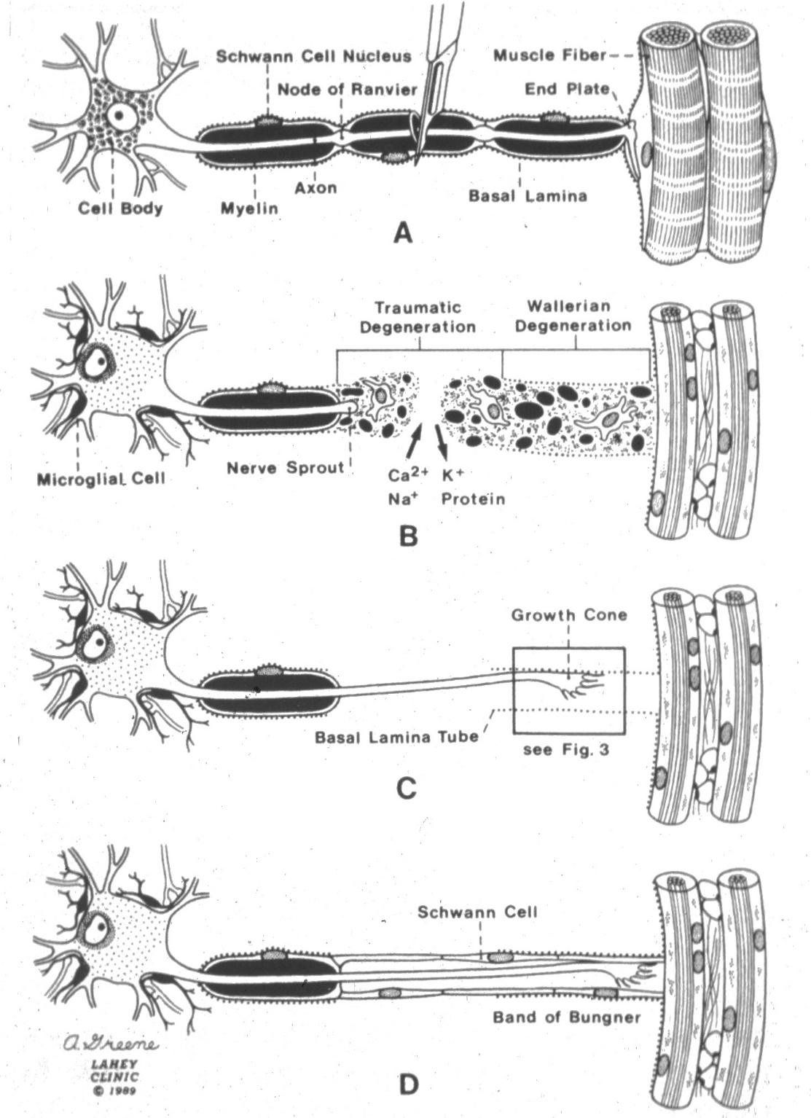
N.B. unlike cellular repair in other areas, response of peripheral nerve to injury does not involve mitosis and cellular proliferation.

Sunderland (1951) further categorized nerve injuries according to degree:
1° injury = neurapraxia.
2° injury = axonotmesis.
3-5° injury = neurotmesis:
3° injury - some disorganization of internal structure of fascicles (loss of continuity of endoneural tubes, perineurium intact) - some regenerating axons are no longer confined to tubes they originally followed → new anomalous patterns of innervation, intrafascicular fibrosis; recovery may be incomplete.
4° injury - continuity of nerve trunk (epineurium) persists, but its internal structure (perineurium) is severely disrupted - organized regeneration is unlikely (involved segment is converted into tangled strand of connective tissue, Schwann cells, and regenerating axons → neuroma in continuity).
5° injury - epineurium disrupted → perineural scarring, stump neuroma.
6th category (MacKinnon and Dellon, 1988) - combination of above injuries.

Caricature of nerve injury levels related to train (rails = nerve fiber, track = endoneural tube, train = electric impulse traveling along fiber, electric wire = micro-vessels providing blood supply to nerve):
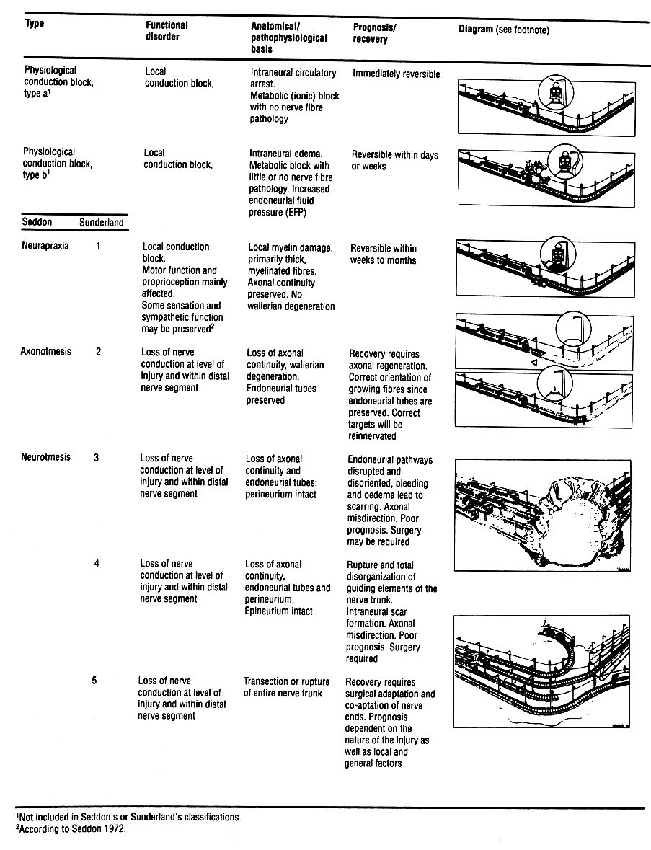
- physiological conduction block - local energy supply is interrupted: train cannot move in spite of intact nerve fiber; moment energy supply is restored (electric wire repair), train starts moving again; if electric wire system is more severely damaged (falling tree) - repair takes longer, still, rail is intact.
- neurapraxia - train is stopped because of local damage to rail (demyelinating block), while more distal parts of rail, as well as energy supply system, remain intact; local repair takes up to 6-8 weeks.
- axonotmesis - rail is damaged and has disappeared distal to level of injury; track is still intact and new rails can easily be laid in correct position.
- neurotmesis - rail as well as track are destroyed; result is great deal of misdirection.

Mechanisms of injury
  - Compression (e.g. carpal tunnel syndrome, disk herniation).
  - Contusion.
  - Laceration - may divide whole nerve or only portion of fascicles.
  - Stretching; internal anatomy of nerves permits nerve to stretch 10-20% before structural damage occurs; in severe cases nerve root(s) may be avulsed from spinal cord.
  - Thermal injury
- transient freezing → mild conduction blocks ÷ wallerian degeneration.
  - Ischemic injury (e.g. due to swelling of muscles); PNS is relatively resistant to ischemia.
  - Injection injury (esp. radial nerve in arm, sciatic nerve in buttock); if injection is not aborted when patient reports pain with needle introduction, serious injury with painful neuroma may result.

- GSW to thigh – if sciatic nerve is damaged, typically it is peroneal distribution (tethered at fibular head) with tibial distribution spared.

Traumatic Neuroma
- axons, even in absence of correctly positioned distal segments, continue to grow; if scar tissue blocks their entrance into distal nerve portion → mass of tangled randomly oriented axonal processes (neuroma).  N.B. neuroma is not neoplasm!  - macroscopically – oblong, gray, firm, unencapsulated mass.  - each axon is surrounded by organized layers containing Schwann cells, fibroblasts, and perineurial cells.  - clinically – persistent hyperesthesia, tenderness. | Traumatic neuroma showing disordered orientation of nerve fiber bundles (purple) intermixed with connective tissue (blue):  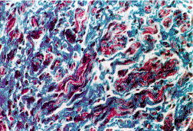  Source of picture: R. S. Cotran “Robbins Pathologic Basis of Disease”, 6th ed. (1999); W. B. Saunders; ISBN: 9780721673356 >>

Neuroma in continuity:
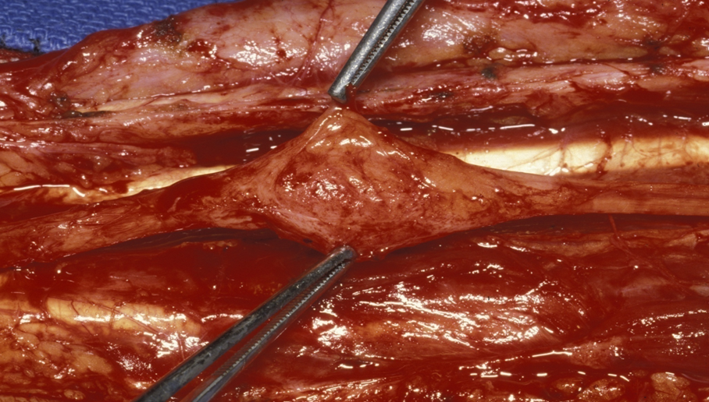

Clinical Features
Injury to peripheral nerve may result in:
- Loss of function supplied by nerve.
N.B. deficits after injury may not be present immediately (e.g. may present months after crush injury - when scarring renders nerve dysfunctional).
- Painful sequelae:
  - pressure-sensitive traumatic neuroma.
  - entrapment syndromes.
  - causalgia (after incomplete nerve injury). see p. S20 >>
  - neuropathic deafferentation pain

Time course
All degrees of injury initially clinically appear the same!
    - if neurological deficit is incomplete - injury is most likely neurapraxic.
    - if neurological deficit is complete - injury may be neurapraxic, axonotmetic, or neurotmetic.
neurapraxia - complete recovery in hours ÷ weeks.

Recovery:
    - pure motor or sensory nerves recover better than mixed nerves.
    - recovery is better in radial and musculocutaneous nerves (coarse muscles) than in median or ulnar nerves (fin muscles); tibial division fares better than peroneal division.
    - high injury of sciatic nerve – muscles always degenerate before reinnervation – functional results are always bad!
    - sign of recovery - distally migrating Tinel's sign (lightly tapping along nerve → paresthesias in sensory distribution of nerve) is evidence of functional recovery of C fibers (but does not guarantee good functional recovery).
- if distal aspect of nerve is percussed progressively proximally, level at which sign is first elicited marks most distal point of small fiber regeneration.
- absence of Tinel’s sign distal to injury site 3-4 months post-injury suggests need for nerve exploration.
- Tinel’s sign demonstrates unstable regenerating axon.
N.B. tapping over injury site itself is meaningless!
N.B. distally migrating Tinel's sign or recovery of autonomic function in absence of sensory or motor recovery requires surgical exploration!!!

Evaluation
Determine:
- type of injury
- time injury occurred
- clinical condition at time of examination - legal and clinical implications (did nerve lesion occur at time of accident, or was it iatrogenic lesion that occurred during repair of patient's other injuries?).
- sensory and motor components must be evaluated separately.
- motor function suffers most!
- damaged nerve initially may appear normal in neurological examination!

Electrophysiologic Testing
- can support clinical suspicion of nerve injury or to evaluate nerve function if reliable neurological examination is impossible.

EMG
– the only clinically useful diagnostic test!
Neurapraxia – EMG always normal!
- denervation changes (fibrillations and positive sharp waves) appear only after 2-5 weeks.
- early EMG signs of reinnervation - decreased insertional activity, decreased fibrillation, nascent polyphasic potentials.
Nascent polyphasic potentials - early return of solitary / few MUPs (indicative of muscle reinnervation); interpret with caution - can see with few muscle fibers reinnervated, but clinical recovery requires reinnervation of many to several hundred motor units
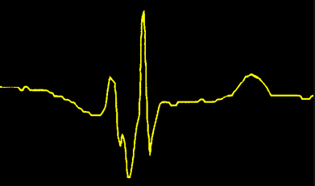

Nerve conduction studies
– not helpful clinically! (initially, all injuries have conduction block and intact distal portion)
Early:
Proximal stimulation:
neurapraxia – slowing or conduction block.
≥ axonotmesis – conduction block.
Distal stimulation – normal (intact axons distal to any injury site - normal amplitude of compound muscle action potential CMAP)
Late:
Proximal stimulation:
neurapraxia – normal (correspond to clinical recovery).
≥ axonotmesis – conduction block.
Distal stimulation:
neurapraxia – normal (correspond to clinical recovery).
≥ axonotmesis – conduction block.
- reduced CMAP amplitude is observed by 7 days (wallerian degeneration).

Optional Testing
- to rule out bony and ligamentous injuries → radiographs.
- for fine anatomic detail of soft tissue, MRI is much more effective than CT.
- MRI can detect signal changes in denervated muscle as early as 4 days after injury! (useful differentiation of neurapraxic from axonotmetic injury).
- MR neurography can visualize both normal and abnormal peripheral nerves.

Medical Treatment
- initial treatment of choice in all cases except when nerve discontinuity is known (→ surgery).
- analgesics to control pain.
- measures to decrease endoneurial edema:
  - antivirals
  - steroids
  - hyperbaric oxygen (HBO)
- ciliary neurotrophic factor (CNTF) enhances motor neuron survival - continues to undergo research.

Surgical Treatment
See p. Op450 >>

Treatment of (Painful) Traumatic Neuroma
stump neuroma:
- daily ultrasound for 5-10 sessions
- injection of corticosteroids or analgesics into neuroma or surrounding area
- cryotherapy
- continuous tight bandaging of stump.
- sharply sectioning nerve proximal to neuroma → embedding freshly sectioned nerve end in adjacent deep soft tissue (surrounded by muscle).

N.B. most common cause of stump pain is poorly fitted prosthetic socket;
other common cause is spur formation at amputated end of bone; diagnosed by palpation and x-ray; H: surgical resection

neuroma in continuity:
- complete loss of motor function of 3-12 mo duration + intraoperative nerve action potentials show no regeneration across site of injury: neuroma excised → primary neurorrhaphy (or cable grafting).
- intraoperative nerve action potential show recovery of function: external or internal (interfascicular) neurolysis.

Research Aspects
Experimental Lesion Paradigms:
    - Axonotmesis - crush injury without discontinuing nerve; easy to perform; main disadvantage: fastness of regeneration process in animals.
    - Neurotmesis - complete transection of whole nerve; need for technically challenging microsurgical nerve reconstruction.

Brachial Plexus Trauma
Brachial plexus birth trauma → see p. Ped9 >>

Etiology
- clavicle fractures with disruption of the peripheral brachial plexus
- avulsion of cervical roots by traction on the brachial plexus

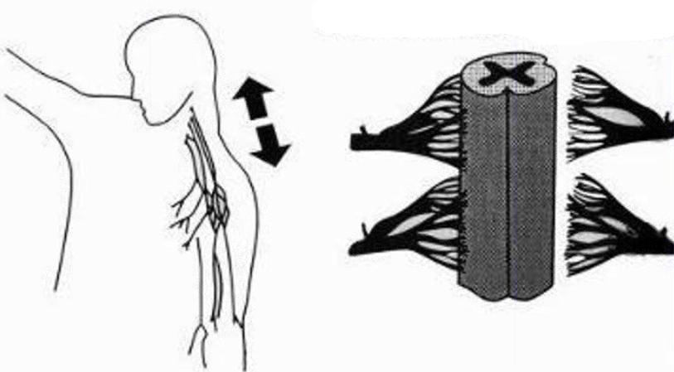

Clinical Features
- intractable long-term pain of the upper limb in 20-30% of patients (much more common [up to 90%] in avulsions than in peripheral injuries).
- pain may begin immediately after the trauma or can be delayed up to months later.
- pain projection depends primarily on the extent of the injury and the number of avulsed roots involved; it may include the whole upper limb.
- pain is debilitating, burning, electrical, or sharp.
- pathophysiology and treatment of pain: afferent input deprivation, caused by the lack of inhibitory effects of the large-caliber sensory fibers after division of the dorsal rootlets, results in spontaneous discharges in DREZ – rationale for DREZ myelotomy procedure. see p. S20 >>

Diagnosis
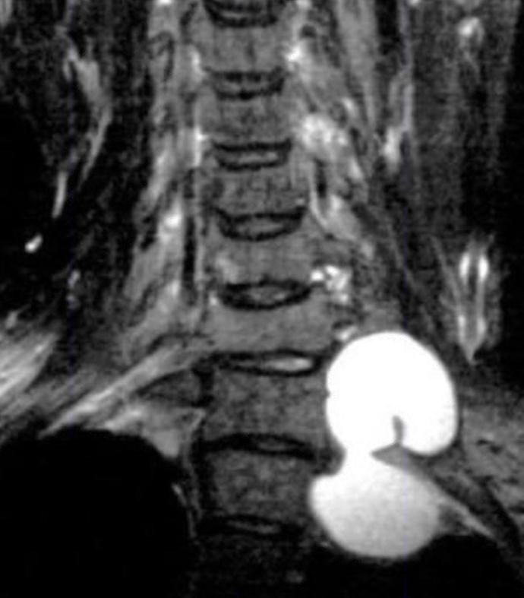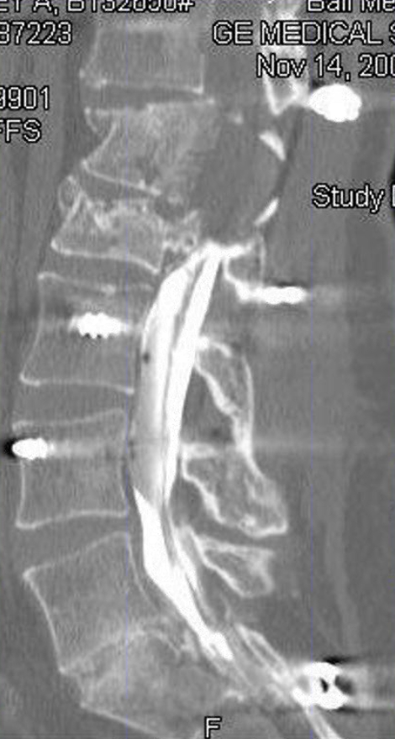

Treatment
Only effective procedure – DREZ myelotomy!

Bibliography for ch. “Peripheral Neuropathies” → follow this link >>

Viktor’s Notes℠ for the Neurosurgery Resident
Please visit website at www.NeurosurgeryResident.net

