Neurofibromatosis

Last updated: April 17, 2019

Neurofibromatosis type 1 (von Recklinghausen’s disease) 1

Genetics 1

Epidemiology 1

Pathology, Clinical Features, Management 1

Nerve sheath tumors 1

Brain tumors 4

Spinal cord tumors 6

Abdominal tumors 6

Abnormalities of melanocytes 6

Other lesions 7

Clinical diagnostic criteria 7

Diagnosis 7

Treatment 9

Prognosis 9

Neurofibromatosis type 2 (s. Central Neurofibromatosis) 9

Genetics 9

Epidemiology 9

Pathology & Clinical Features 9

Tumors 9

Types 10

Other Lesions 10

Clinical diagnostic criteria 11

National Neurofibromatosis Foundation Criteria 11

Diagnosis 11

Treatment 13

Prognosis 13

Schwannomatosis (neurilemomatosis) 13

Diagnostic criteria 13

Clinical Features 13

Schwannomas 13

Other lesions 13

**Neurofibromatosis** - most common phacomatosis!

|  |  |  |
| --- | --- | --- |
| **Feature** | **NF1** | **NF2** |
| **Proportion** | 85-90% | 10% |
| **Gene - product** | NF1 (17q11.2) - **neurofibromin** | NF2 (22q12) - **merlin** |
| **Skin** | *frequent cutaneous findings* | *relative paucity of cutaneous findings* |
| **Tumor type** | primarily *neurofibromas* | primarily *schwannomas* |
| **Malignization** | 3-10% to MPNSTs | - |
| **CNS** | *lower incidence of CNS tumors*  Optic nerve, brainstem, cerebellar gliomas! | *higher incidence of CNS tumors*  Bilateral CN8 schwannomas!  Multiple meningiomas! |
| **Eye** | *Lisch nodules* in iris (90-95%) | *Posterior subcapsular (juvenile) cataracts* |
| **Prognosis** | better | worse |

Neurofibromatosis type 1 (von Recklinghausen’s disease)

* first described by von Recklinghausen in 1882.

Genetics

- *autosomal dominant* inactivation of NF1 gene (17q11.2).

* penetrance is 100%; expression variable even within families.
* > 300 mutations having been identified.
* gene product (**neurofibromin**) serves as tumor suppressor - inactivates **p21-Ras pathway** (pivotal role in many growth factor signaling pathways)

**Constitutive Ras activation** → increased cell proliferation and survival.

Epidemiology

incidence - 1 in 3000* (2190-7800) - one of most common autosomal dominant genetic disorders in humans!

*higher in Arab-Israeli subpopulations

* ½ cases appear sporadically (new mutations)

*Mutation rate in NF1 gene (1 case per 10,000 population) is among highest known for any human gene!*

* males = females.

Pathology, Clinical Features, Management

- appear slowly over many years (although genetic change is present at conception):

Multisystemic involvement is common!

Nerve sheath tumors

* 1. Multiple *neurofibromas* (few ÷ thousands) - may affect any organ in body (esp. cutaneous & subcutaneous).
* occur in all patients
* appear at any time in life (*infrequent before puberty*).
* histology: [further see p. Onc60 >>](http://www.neurosurgeryresident.net/Onc.%20Oncology\Onc60.%20Nerve%20Tumors%20(GENERAL).pdf)
* **Schwann cells** (***progenitor cells*** of neurofibromas) and **fibroblasts** (plus, perineural cells, endothelial cells, mast cells, pericytes, and other intermediate cell types)
* breakdown of perineural layer and disorganization of supporting cells (Schwann cells in increased number and with reduced association with axons)
* clinically: indolent and benign course - most are asymptomatic.
* deep lesions may be detected only through palpation.
* number & growth↑ in puberty or pregnancy (large pelvic / genital neurofibromas can complicate delivery).
* dermal and plexiform variants are characteristic of NF1 (vs. sporadic counterparts).
* ***dermal neurofibroma*** - well-circumscribed, non-encapsulated benign tumor variably composed of Schwann cells and fibroblast-like cells, with admixture of endothelial cells, lymphocytes, and *unusually large number of mast cells*.
* ***plexiform neurofibromas*** - almost pathognomonic of NF1
  + locally invasive and quite deep;
  + extend across length of nerve and involve multiple nerve fascicles or multiple branches of large nerve → sizable ropelike mass of diffusely thickened nervous tissue
  + overlying hyperpigmentation or hypertrichosis.
  + may cause bony erosion and pain + disfiguring elephantoid overgrowth of skin and subcutaneous tissue + tumors in head or neck region can impair vital functions.
  + *appear early* (plexiform neurofibromas of face and neck rarely appear after age 1 year, and plexiform neurofibromas of other parts of body rarely develop after adolescence).
  + present in **thoracic region** (20% of all patients), **abdomen/pelvis** (44% of all patients).
  + frequently involve nerve roots at multiple levels → extensive compression myelopathy; not amenable to cure (H: multilevel laminectomies* for debulking; loss of neurological function is rare after surgery; regrowth → secondary reoperation)

*progressive kyphosis may require subsequent spinal fusion; most authors, do not advocate fusion at time of initial resection (rather use osteoplastic laminotomy)

* may undergo *malignant degeneration* (esp. *plexiform neurofibromas*) to malignant peripheral nerve sheath tumors (MPNSTs) see [p. Onc60 >>](http://www.neurosurgeryresident.net/Onc.%20Oncology\Onc60.%20Nerve%20Tumors%20(GENERAL).pdf#MPNST)
* management - **careful observation**; surgical intervention only for symptomatic cases (no routine spinal imaging because symptoms, not imaging characteristics, ultimately determine surgical management):

1. spinal cord / intracranial tumors see [p. Onc60 >>](http://www.neurosurgeryresident.net/Onc.%20Oncology\Onc60.%20Nerve%20Tumors%20(GENERAL).pdf), [p. Onc62 >>](http://www.neurosurgeryresident.net/Onc.%20Oncology\Onc62.%20Schwannomas%20of%20Cranial%20Nerves.pdf)
2. cosmetic indications
3. compressive neuropathies
4. painful / irritating neurofibromas - on scalp, along hairline, around waist (where clothes rub).
5. neurofibromas that press on vital structures (e.g. obstructive uropathy), obstruct vision, or grow rapidly.
6. plexiform neurofibromas

* ***pruritus*** due to cutaneous neurofibromas → avoid hot showers and baths, diphenhydramine.

Multiple neurofibromas of spinal roots and brachial plexus in patient with NF1:

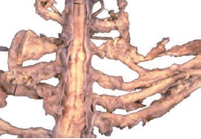

[Source of picture: “WHO Classification of Tumours of the Central Nervous System” 4th ed (2007), ISBN-10: 9283224302, ISBN-13: 978-9283224303 >>](http://www.amazon.com/gp/product/9283224302)

Plexiform neurofibroma of right thigh:

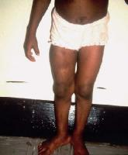

Flesh-colored cutaneous neurofibromas:

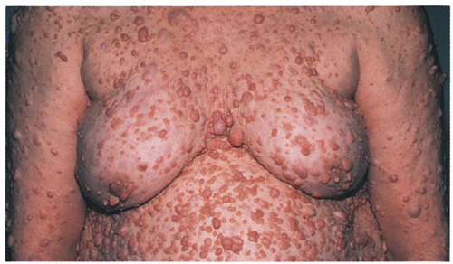

Large, soft, ill-defined, subcutaneous nodules on right lower back and on right posterior axillary line are plexiform neurofibromas:

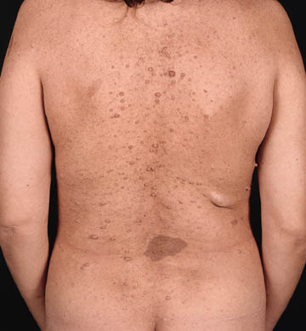

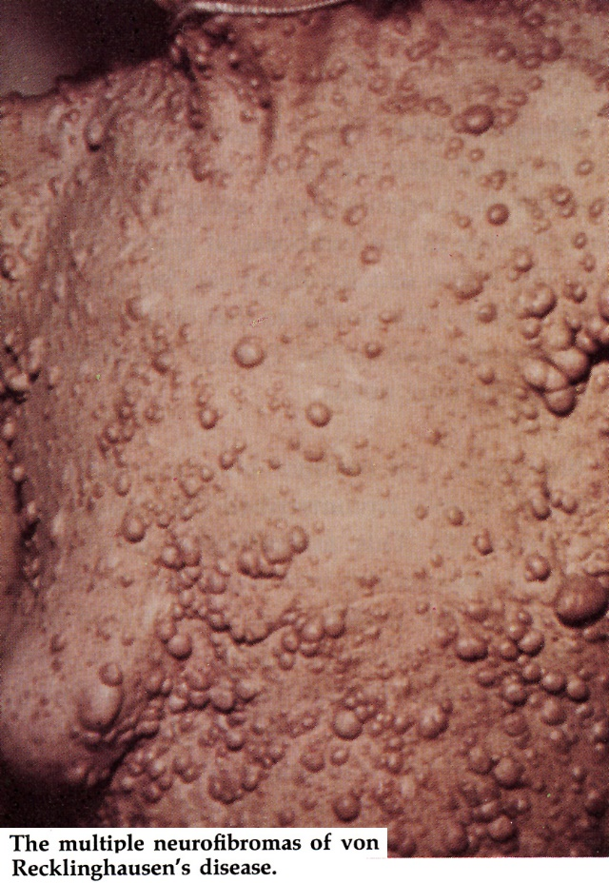 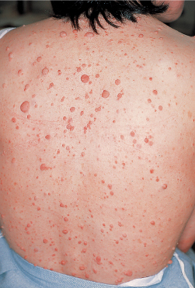

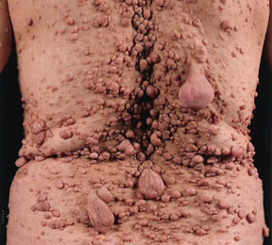 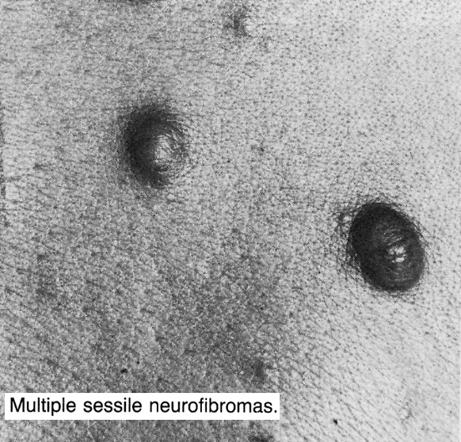

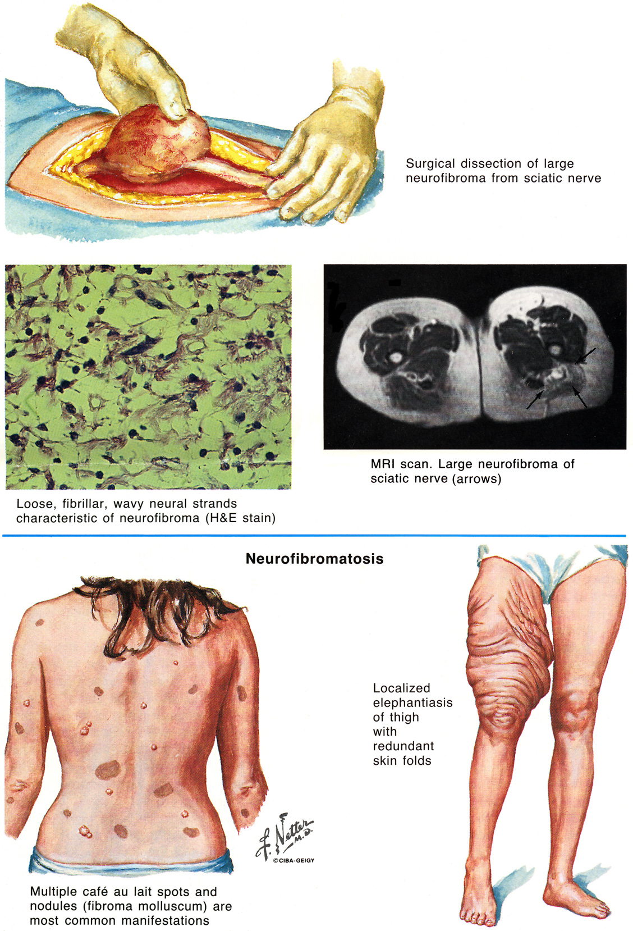

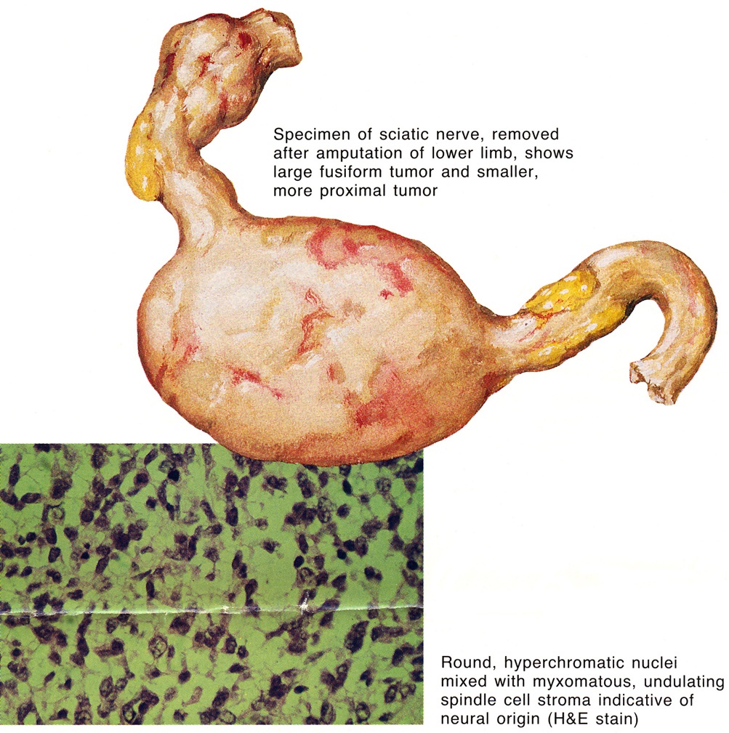

Plexiform neurofibroma affecting every nerve root



[Source of picture: H. Richard Winn “Youmans Neurological Surgery”, 6th ed. (2011); Saunders; ISBN-13: 978-1416053163 >>](http://www.amazon.com/gp/product/1416053166)

* 1. *schwannomas* of cranial nerves (CN8 in 5% patients), dorsal sensory roots - solitary and sporadic (vs. NF2 - multiple schwannomas).
  2. *malignant peripheral nerve sheath tumors (neurofibrosarcomas)* - not uncommon (lifetime risk 10%).
* arise from large plexiform neurofibromas or extensive peripheral nerve lesions.

Brain tumors

(incidence of **CNS tumors** ≥ 10%):

Majority of gliomas in NF1 patients are optic pilocytic astrocytomas!

1. *optic glioma* - most common (12-20%) intracranial tumor (incidence lower in African Americans);

* usually WHO grade I astrocytomas.
* occur in 15% patients.
* may occur at any time* (75% occur in *first decade of life*).

*vs. sporadic cases are seen almost exclusively in children < 7 yrs

* asymmetric, noncorrectable visual loss is most common presenting symptom.
* less aggressive than optic nerve tumors in general population.
* bilateral in 4%.
* affect optic nerve or chiasm, hypothalamus → headache, visual complaints, proptosis, endocrine disturbances (esp. precocious puberty).
* nonenhancing optic gliomas (60% cases) do not progress!!!

Potential for lesion stability or even regression!

* management: much more indolent clinical course than in sporadic cases (*may remain static for many years* and some may regress) - **conservative monitoring** until:

1. **MRI progression / atypical appearance** → biopsy
2. **symptomatic** → debulking → adjuvant chemotherapy (vincristine and carboplatin); radiation therapy carries risks of radiation necrosis, cognitive problems, visual loss, secondary malignancy, moyamoya disease

Macroscopic preparation of bilateral optic nerve glioma in patient with NF1.

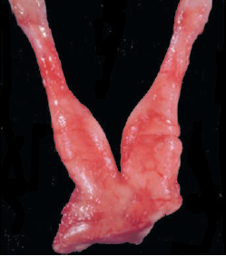

[Source of picture: “WHO Classification of Tumours of the Central Nervous System” 4th ed (2007), ISBN-10: 9283224302, ISBN-13: 978-9283224303 >>](http://www.amazon.com/gp/product/9283224302)

Bilateral optic nerve glioma - enlargement of compartments of optic nerves and collar-like extension into subarachnoid space.

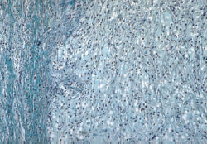

[Source of picture: “WHO Classification of Tumours of the Central Nervous System” 4th ed (2007), ISBN-10: 9283224302, ISBN-13: 978-9283224303 >>](http://www.amazon.com/gp/product/9283224302)

Pilocytic astrocytoma of the optic nerve (optic nerve glioma):

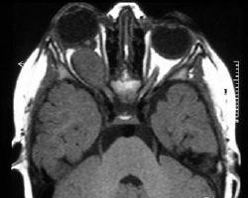

[Source of picture: “WHO Classification of Tumours of the Central Nervous System” 4th ed (2007), ISBN-10: 9283224302, ISBN-13: 978-9283224303 >>](http://www.amazon.com/gp/product/9283224302)

1. *brainstem glioma*

* indolent course (neurofibromatosis is favorable prognostic indicator for brainstem gliomas):
* radiographic progression in < 50% of cases and clinical progression in < 20% of cases (irrespective of intervention with surgery, chemotherapy, or radiation therapy)
* look for synchronous tumors at other CNS locations
* differentiate from **“unidentified bright objects” (UBOs)** *see below*
* management: serial MRIs → treat only clear progression.



[Source of picture: H. Richard Winn “Youmans Neurological Surgery”, 6th ed. (2011); Saunders; ISBN-13: 978-1416053163 >>](http://www.amazon.com/gp/product/1416053166)

1. *cerebellar glioma*

* 10% of pediatric cerebellar gliomas are associated with NF1
* pilocytic astrocytoma > anaplastic astrocytoma, ganglioglioma, pleomorphic xanthoastrocytoma
* NF1 cerebellar gliomas (vs. sporadic cerebellar gliomas):

1. occur in subependymal white matter of fourth ventricle (vs. vermian or hemispheric location)
2. more malignant phenotype? – **radically resect** whenever clinically feasible!!! (vs. wait-and-see approach for optic or brainstem gliomas); pathologic grade dictates need for further adjuvant therapy
3. *medulloblastomas*
4. *meningioma*
5. *hamartomas*

Spinal cord tumors

(dumbbell-shaped) – *neurofibromas*, *meningiomas*.

Abdominal tumors

– neurofibromas, leiomyomas, adenocarcinomas with neuroendocrine function.

* within liver, mesentery, retroperitoneum, GI tract.
* often ***multiple***, predilection for *proximal small bowel*.

Abnormalities of melanocytes

1. Multiple **café-au-lait spots** (aggregation of neural crest-derived melanoblasts in basal layer of epidermis)

* ***earliest clinical finding*** (present in *infancy* in > 95% patients)
* increase in size and number throughout childhood → tend to fade in adults.
* more common on trunk than on limbs; not found on scalp, face, soles, palms.
* ratio *melanocytes : keratinocytes* is higher in unaffected skin of NF1 patients, and this is more marked in café-au-lait spots.

Several > 1.0 cm café-au-lait spots on upper chest and multiple small macules in axillae (axillary "freckling"); myriads of early, small, pink-tan neurofibromata on chest, breasts, and neck:

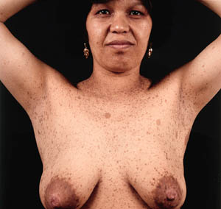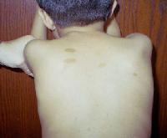

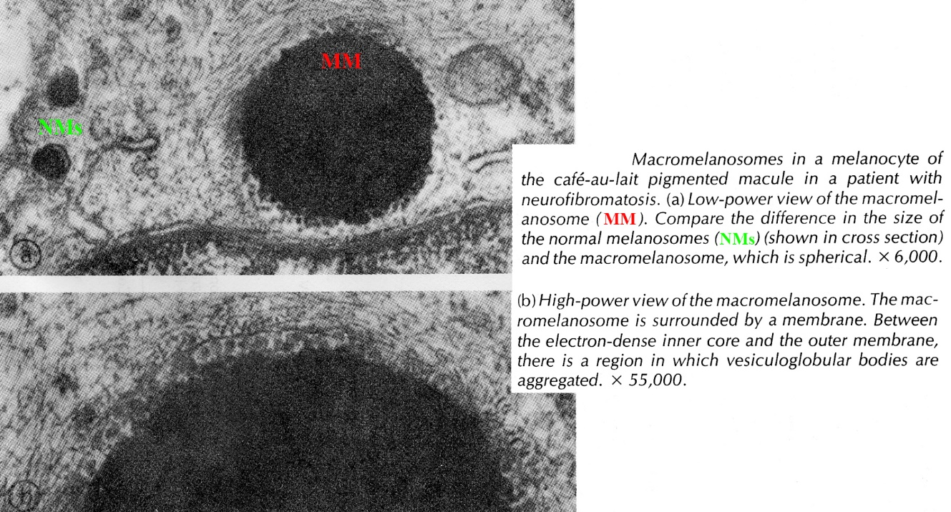

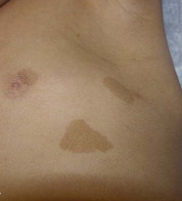

[Source of picture: H. Richard Winn “Youmans Neurological Surgery”, 6th ed. (2011); Saunders; ISBN-13: 978-1416053163 >>](http://www.amazon.com/gp/product/1416053166)

1. Axillary or inguinal **freckles** (*Crowe sign*) - multiple hyperpigmented 2-3 mm areas - appear during *childhood ÷ adolescence* in 2/3 of patients.

* histopathologically indistinguishable from café-au-lait spots.

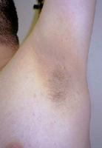 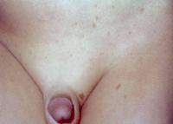

1. **Iris hamartomas** (*Lisch nodules*) – small, elevated pigmented melanocytic hamartomas on surface of iris (“iris nevi”)

* usually not readily visible without slit lamp
* ***particularly useful diagnostic criterion*** - present in > 95% patients *aged > 10 yrs*; asymptomatic.

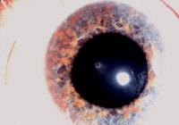

Other lesions

1. **Bony abnormalities** (may be clinically silent):
   1. long-bone abnormalities (esp. tibia) may be evident at birth (*congenital*) - thinning of cortex, bowing, pseudarthrosis (in past, congenital tibial pseudarthrosis led to below-the-knee amputation).
   2. sphenoid bone dysplasia (absence of greater wing of sphenoid bone → pulsating exophthalmos).
   3. kyphoscoliosis (40%), especially severe in young girls.
   4. macrocephaly with normal-sized ventricles (should not cause alarm, unless rapid crossing of ≥ 2 percentiles)
   5. short stature
2. Learning disabilities (± attention deficit hyperactivity disorder) - in 40% patients (5% patients have mild ÷ moderate mental retardation); association with bright MRI lesions in thalamus!
3. Indolent symmetric sensory axonal neuropathy (1%); some cases of polyneuropathy occur due to diffuse nerve root lesions.
4. Chiari type 1 malformations
5. Moyamoya disease.

* no association with intracranial aneurysms

1. Seizures (4-7%)
2. Arterial hypertension; causes (BP should be checked during every clinical visit):
   * + - 1. essential hypertension
         2. pheochromocytomas (not rare in NF1)!
         3. renal artery stenosis secondary to fibromuscular dysplasia!

* also 10-fold increase in congenital heart defects (pulmonary valve stenosis, atrial septal defect, ventricular septal defect).

1. Increased risk of **other tumors**: rhabdomyosarcomas, juvenile chronic myeloid leukemia, juvenile xanthogranulomas, gastrointestinal stromal tumors (GIST), duodenal carcinoids, C-cell hyperplasia/medullary thyroid carcinomas, pheochromocytomas.
2. **GI tract** vasculopathy, bleeding, pseudoobstruction, protein-losing enteropathy.

Clinical diagnostic criteria

Diagnostic Criteria (National Institutes of Health (NIH) Consensus Development Conference Statement) - presence of ≥ 2 criteria:

* 1. ≥ 6 café-au-lait spots (largest diameter ≥ 5 mm in children < 10 years and ≥ 15 mm in adults)
  2. ≥ 2 neurofibromas of any type or one plexiform neurofibroma
  3. Axillary or inguinal freckles (Crowe sign)
  4. Optic glioma (pilocytic astrocytoma of optic pathway)
  5. ≥ 2 iris hamartomas (Lisch nodules)
  6. Bony dysplasia (sphenoid wing dysplasia/absence, bowing/thinning of long-bone cortex ± pseudarthrosis)
  7. First-degree relative (parent, sibling, offspring) with NF1.

N.B. cutaneous manifestations may develop late (younger patients may appear free of NF1 stigmata)

* children of affected parent can be diagnosed within first year of life because diagnosis requires presence of only 1 feature in addition to family history for NF1.
* if at-risk individual reaches age of 10 years without meeting diagnostic criteria for NF1, he or she is unlikely to be affected!

Mean ages of onset for common clinical manifestations (estimated frequencies for each manifestation within NF1 population are given in parentheses):

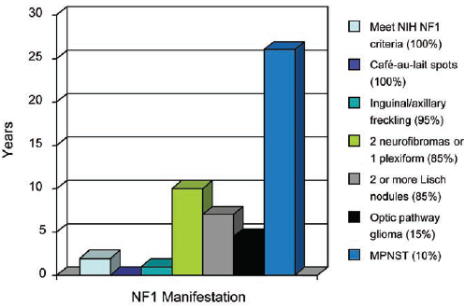

[Source of picture: “WHO Classification of Tumours of the Central Nervous System” 4th ed (2007), ISBN-10: 9283224302, ISBN-13: 978-9283224303 >>](http://www.amazon.com/gp/product/9283224302)

Diagnosis

**Genetic tests** (allow prenatal diagnosis):

**linkage analysis**

**protein truncation assay (PTA)** - low sensitivity (65-70%).

**sequencing of NF1 gene** - sensitivity 95%.

Annual **ophthalmologic examinations** - optic nerve pallor, visual acuity changes, visual field defects; **slit-lamp examination** - Lisch nodules.

**X-ray**

* **long bones** - intramedullary fibrosis, cortical thinning, pseudoarthrosis.
* bony erosion secondary to adjacent *plexiform neurofibroma*.
* *other* - unilateral defects in posterior superior wall of orbit, defect in lambdoid with underdevelopment of ipsilateral mastoid, dural ectasia with enlargement of spinal canal and scalloping of posterior portion of vertebral bodies, "twisted ribbon" rib deformities.

|  |  |
| --- | --- |
| Radial and ulnar bowing and obliteration of intramedullary spaces:  Click to see larger picture | Dysplasia of left sphenoid bone - orbit is enlarged, with elevation of left side of planum sphenoidale; sphenoid ridge and superior orbital fissure are absent (*arrow* = innominate line which, unrelated to orbit, is normal):  D:\Viktoro\Neuroscience\Pha. Phacomatoses, Neurocutaneous disorders\00. Pictures\Dysplasia of sphenoid bone (X-ray).jpg  [Source of picture: Ronald G. Grainger, David J. Allison “Grainger & Allison’s Diagnostic Radiology: A Textbook of Medical Imaging”, 4th ed. (2001); Churchill Livingstone, Inc.; ISBN-13: 978-0443064326 >>](http://www.amazon.com/gp/product/0443101639) |

Severe dysplasia of right sphenoid bone:

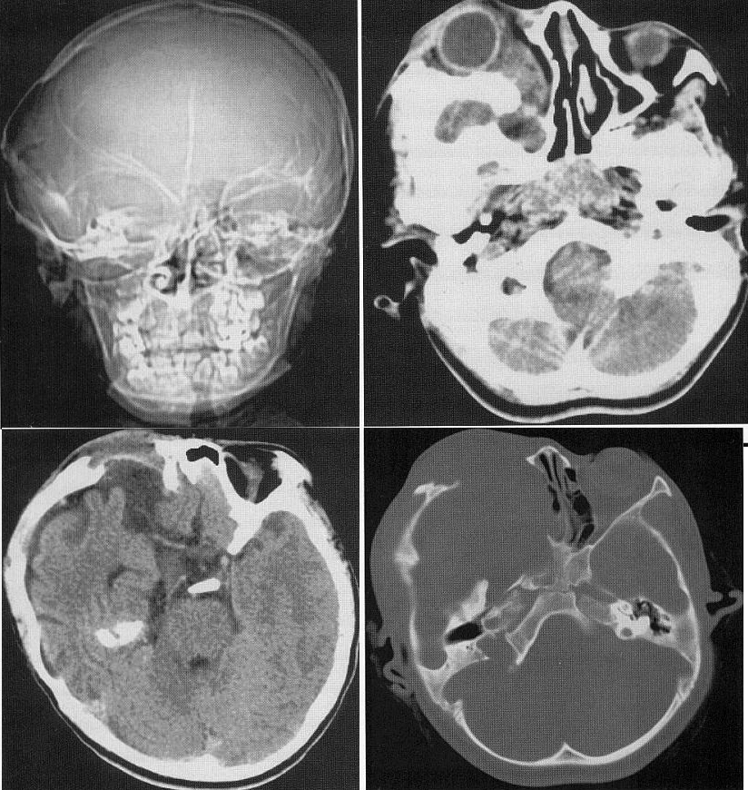

**Head MRI / CT** – only for specific indications (if neurological / ophthalmological problems arise); some clinicians prefer baseline CT / MRI at time of diagnosis.

* T2-MRI frequently detects unidentified bright objects (UBOs) – in cerebellar white matter, dentate nucleus, basal ganglia, periventricular white matter, optic nerve and pathways;
* isointense on T1.
* ***do not enhance, cause no mass effect*** (do not expand gyri, vs. tubers in tuberous sclerosis).
* occur in > 50% NF1 patients

UBOs ar the most common imaging findings in NF1 patients!

* no apparent predilection for evolving into gliomas*

* UBOs might pose risk for malignant transformation - serial MRI

* resolve as individual gets older (almost never seen at age > 20 years).
* believed to represent *benign hamartomas* or (more probably) *demyelinations*.

Unidentified bright object (UBO) within brain parenchyma:

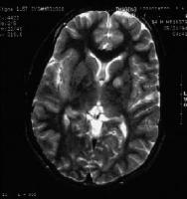

**Thoracic / abdominal / pelvic CT**

**Ultrasound** - diagnosis of nerve sheath tumor depends on depiction of mass along presumed course of nerve (i.e. definite relationship between mass and nerve origin).

Treatment

**Observation vs. Removal** of tumors – see individual tumors.

**Orthopedic care** for scoliosis, severe bony defects.

Prognosis

Many patients are functionally indistinguishable from normal!

Overall life expectancy is reduced by 15 years – malignancy, hypertension, sequelae of spinal cord lesions.

Neurofibromatosis type 2 (s. Central Neurofibromatosis)

- *relative paucity of cutaneous findings* but *higher incidence of CNS tumors* → worse prognosis (than NF1).

Genetics

- *autosomal dominant* mutation (rarely deletion) of NF2 gene (22q12).

* gene product (**merlin**\*) serves as **cytoskeletal protein** - senses intercellular contact and regulates mitogenic signaling (so functions as **tumor suppressor gene**).

*name comes from similarity to cytoskeletal proteins called moesin, ezrin, and radixin-like; taking first letters of those words and adding -in (for ending of "protein")

* type of mutation dictates disease severity
* numerous mutations have been identified - most result in production of truncated protein (loss of function).
* 99% penetrance by age of 60 yrs

Epidemiology

incidence of NF-2 is not known (≈ 1 in 25,000 to 40,000 individuals).

* **≈ 50% are de novo** case in family (new genetic event; high rate of somatic mosaicism ≈ 25% - molecular testing to detect mutation must include tumor tissue).
* males = females.

Pathology & Clinical Features

- variable age of onset (mean 20-22 years; range 2-70 years) and severity of symptoms:

Paucity of cutaneous features!!!

Tumors

Only* *schwannomas* (vs. NF1 – *neurofibromas*)

*on histological review, many ‘neurofibromas’ prove to be schwannomas, including plexiform schwannomas misdiagnosed as plexiform neurofibromas

NF2-associated schwannomas differ from sporadic schwannomas in number of ways:

1. present at age < 40 (non-NF2 CN8 schwannomas typically present at age > 40 yrs).
2. higher proliferative activity → multiple schwannomatous tumourlets along individual nerves (particularly on spinal roots)
3. affect ***any nerves***: sensory (incl. spinal dorsal roots), motor (e.g. CN12)
4. may appear ***multilobular*** (“cluster of grapes”) on both gross and microscopic examination
5. ***cutaneous*** schwannomas are common (may be plexiform)

4% patients develop *gliomas* (70% are ependymomas; others are diffuse and pilocytic astrocytomas) - 80% are **spinal** (intramedullary or cauda equina); 10% are in **medulla**.

**Brain tumors:**

1. Bilateral *vestibular schwannomas* (> 95%) - **most common feature**!; hallmark/prototypical and pathognomonic finding
   * unilateral hearing loss is number one presenting symptom; eventually - bilateral deafness.
   * WHO grade I
   * NF2-associated schwannomas differ from sporadic schwannomas in number of ways.
   * management:

Large tumors causing brainstem compression → resect microsurgically.

Smaller asymptomatic tumors (or only audiologic symptoms) - natural history somewhat unclear (growth rates tend to decrease with increasing age); refer patient and family for education in sign language.

* + schwannomas also can involve any CN (CN3÷12, with CN5 as next most frequently involved).

Bilateral vestibular schwannomas:

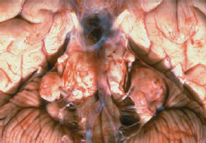

[Source of picture: “WHO Classification of Tumours of the Central Nervous System” 4th ed (2007), ISBN-10: 9283224302, ISBN-13: 978-9283224303 >>](http://www.amazon.com/gp/product/9283224302)

1. *Meningiomas* - **second hallmark of NF2** (50% patients) - difference from sporadic forms:

* multiple in 40%.
* occur earlier in life
* higher mitotic index and greater nuclear pleomorphism

1. *Ependymomas*

**Spinal cord tumors:**

1. *Schwannomas* (dumbbell-shaped)
2. *Meningiomas* (often multiple)
3. *Ependymomas* (in most cases, as multiple intramedullary masses)

Numerous schwannomas of the cauda equina in a patient with NF2.

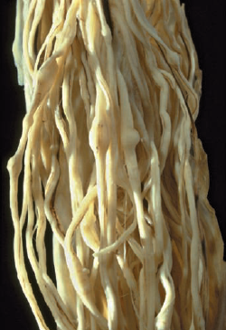

[Source of picture: “WHO Classification of Tumours of the Central Nervous System” 4th ed (2007), ISBN-10: 9283224302, ISBN-13: 978-9283224303 >>](http://www.amazon.com/gp/product/9283224302)

**A.** Multiple schwannomas of spinal roots. **B.** Nodular schwannoma in NF2 patient.

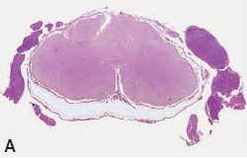 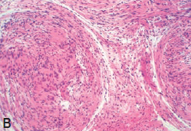

[Source of picture: “WHO Classification of Tumours of the Central Nervous System” 4th ed (2007), ISBN-10: 9283224302, ISBN-13: 978-9283224303 >>](http://www.amazon.com/gp/product/9283224302)

Luxol fast blue staining of section of cauda equina with multiple early stages of schwannomas (tumourlets) and characteristic absence of myelin:

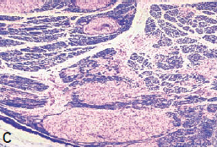

[Source of picture: “WHO Classification of Tumours of the Central Nervous System” 4th ed (2007), ISBN-10: 9283224302, ISBN-13: 978-9283224303 >>](http://www.amazon.com/gp/product/9283224302)

60% incidence of **skin tumors** (schwannomas, neurofibromas, mixed tumors)

Malignant transformation of benign growths is almost unheard! (vs. NF1)

Types

**Wishart type** - families with early onset with diverse tumors and high tumor load.

**Gardner type** – families that present later with only vestibular schwannomas.

Other Lesions

* 1. **Posterior subcapsular (juvenile) cataracts** (40-80%) - can predate CNS symptomatology.
  + may progress over time.
  + preservation of vision is paramount in patients for whom hearing will probably be imperiled!
  1. **Schwannosis** (vs. schwannomatosis) - proliferation of Schwann cells, sometimes with entangled axons, but without frank tumour formation.
  + often found in ***spinal dorsal root entry zones***, sometimes associated with schwannoma of dorsal root, or in ***perivascular spaces of central spinal cord***, where nodules appear more like small traumatic neuromas.
  + less robust, but otherwise identical, schwannosis has been reported in reactive conditions.
  1. **Meningioangiomatosis** - intracortical lesion - plaque-like proliferation of meningothelial and fibroblast-like cells surrounding small vessels.
  + may be predominantly ***vascular*** (resembling vascular malformation) or predominantly ***meningothelial*** (sometimes with associated meningioma).
  + occurs both sporadically and in NF2:

1. **sporadic** - single lesion in young adults or children who present with seizures or persistent headaches
2. **NF2-associated** - may be multifocal and is often asymptomatic (diagnosed only at autopsy)

Meningioangiomatosis with predominance of meningothelial cells

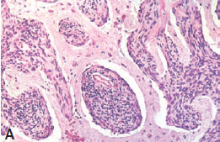

[Source of picture: “WHO Classification of Tumours of the Central Nervous System” 4th ed (2007), ISBN-10: 9283224302, ISBN-13: 978-9283224303 >>](http://www.amazon.com/gp/product/9283224302)

Diffuse cortical meningioangiomatosis (trichrome stain).

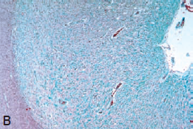

[Source of picture: “WHO Classification of Tumours of the Central Nervous System” 4th ed (2007), ISBN-10: 9283224302, ISBN-13: 978-9283224303 >>](http://www.amazon.com/gp/product/9283224302)

* 1. **Glial hamartias (s. microhamartomas)** – intracortical* circumscribed clusters of cells with medium-to-large atypical nuclei and scant, sometimes stellar, eosinophilic cytoplasm.

*predilection for molecular and deeper cortical layers

* + cells stain strongly for S-100 protein, but only focally for GFAP.
  + common in and pathognomonic of NF2.
  + not associated with mental retardation or astrocytomas.

**A** and **B** Distribution of cerebral microhamartomas in a patient with NF2. These lesions are scattered throughout the cortex and basal ganglia and show strong immunoreactivity for S-100 (**B**). Reproduced from Wiestler *et al.* {2410}.

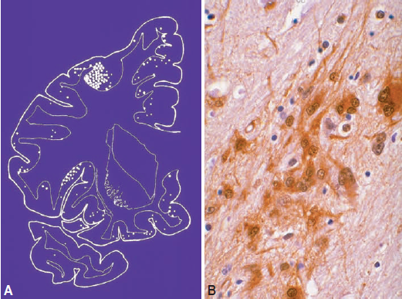

[Source of picture: “WHO Classification of Tumours of the Central Nervous System” 4th ed (2007), ISBN-10: 9283224302, ISBN-13: 978-9283224303 >>](http://www.amazon.com/gp/product/9283224302)

* 1. Retinal hamartomas, epiretinal membranes - may or may not be visually significant.
  2. Sensory motor neuropathies - not related to tumor masses
  + ***mononeuropathies*** may be presenting symptom in *children*, while progressive ***polyneuropathies*** are more common in *adults*.
  + mostly axonal
  + may be secondary to focal nerve compression by tumourlets or onion-bulb-like Schwann cell or perineurial cell proliferations without associated axons
  1. Cafe-au-lait spots (1/3 patients).
  2. Cerebral calcifications - cerebral and cerebellar cortices, periventricular areas and choroid plexus

Clinical diagnostic criteria

**1991 NATIONAL INSTITUTES OF HEALTH criteria**

**A** Bilateral vestibular schwannomas

**B** First-degree family relative with NF2 plus:

1. unilateral vestibular schwannoma
2. any **one** of following: meningioma, schwannoma, glioma, neurofibroma, juvenile posterior subcapsular lens opacity

**MANCHESTER criteria**

**A** Bilateral vestibular schwannomas

**B** First-degree family relative with NF2 plus:

1. unilateral vestibular schwannoma
2. any **two** of following: meningioma, schwannoma, glioma, neurofibroma, juvenile posterior subcapsular lens opacity

**C** Unilateral vestibular schwannoma +any two of following: meningioma, schwannoma, glioma,

neurofibroma, juvenile posterior subcapsular lens opacity

**D** Multiple meningiomas plus:

1. unilateral vestibular schwannoma
2. any **two** of following: meningioma, schwannoma, glioma, neurofibroma, juvenile posterior subcapsular lens opacity

National Neurofibromatosis Foundation Criteria

Confirmed / definite NF2:

**A** Bilateral vestibular schwannomas

No biopsy is necessary for diagnosis!

**B** First-degree family relative with NF2 plus:

1. unilateral vestibular schwannoma at age < 30 yrs
2. any **two** of following: meningioma, schwannoma, glioma, juvenile (posterior subcapsular) lens opacity

Presumed / probable NF2:

**A** Unilateral vestibular schwannoma at age < 30 yrs + **at least one** of following: meningioma, schwannoma, glioma, juvenile lens opacity

**B** ≥ 2 meningiomas plus:

1. unilateral vestibular schwannoma at age < 30 yrs
2. schwannoma
3. glioma
4. juvenile lens opacity

* patients > 60 years with bilateral CN8 masses are unlikely to have NF2 (NF2 usually presents before age of 40 years).

Diagnosis

Early detection of tumors improves long-term outcome!

**Genetic testing**

**Molecular analysis** to detect mutation (if mutation unknown, detection rate only ≈ 65%).

* + when mutation is known → offer screening for family members* (if mutation unknown, use **linkage analysis**). *only after vigorous informed consent process
  + *prenatal diagnosis* is possible! (if mutation is found or linkage analysis is successful in positive family); e.g. in vitro fertilization → preimplantation genetic diagnosis → transfer of unaffected embryos.

Annual **eye examinations** (start in children).

Annual **BAER** screening - identification of early hearing loss (*latency abnormalities* before mass is detectable on MRI).

* + once vestibular schwannoma is identified → full audiometry testing.

**MRI** is preferred technique for monitoring NF2 patients (in addition to annual **neurologic exam**).

[See MRI protocol recommendations – p. Onc62 >>](../Onc.%20Oncology/Onc62.%20Schwannomas%20of%20Cranial%20Nerves.pdf#NF2_MRI)

* + annual monitoring with ***head MRIs*** begin in teens → through late 50s.
  + ***spinal MRI*** only for symptomatic cases.

**A** Bilateral acoustic schwannomas (arrows), the diagnostic hallmark of NF2. **B** Multiple meningiomas presenting as contrast-enhanced masses

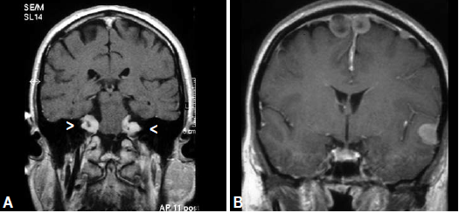

[Source of picture: “WHO Classification of Tumours of the Central Nervous System” 4th ed (2007), ISBN-10: 9283224302, ISBN-13: 978-9283224303 >>](http://www.amazon.com/gp/product/9283224302)

|  |  |  |
| --- | --- | --- |
| Contrast T1-MRI - bilateral internal auditory canal-enhancing masses (CN8 schwannomas) + en plaque meningioma anterior to brainstem:  Click to see larger picture | Contrast T1-MRI - 2 midline meningiomas (*arrowheads*), one over convexity and one along vein of Galen; enhancing mass in medulla (*arrow*) most likely is ependymoma:  Click to see larger picture | |
| Contrast T1-MRI – large enhancing sellar meningioma (*black arrows*) surrounding both internal carotid arteries; enhancing tissue in ethmoid air cells also represents meningioma extending through cribriform plate; small, round, enhancing extra-axial mass posterior to tectum (*white arrow*) – CN4 schwannoma:  Click to see larger picture | | Contrast T1-MRI – enhancing extra-axial meningioma (*arrow*) anterior to cord; complex enhancing mass (*arrowheads*) represents conus ependymoma filling spinal canal:  Click to see larger picture |

Contrast T1-MRI – large left cerebral convexity meningioma with meningeal thickening over falx cerebri + bilateral CN8 schwannomas (*arrowheads*):

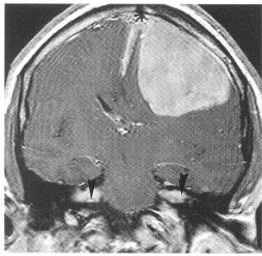

**A**. T1-MRI – extraaxial mass that extends into widened internal auditory canal, displacing pons (*arrows*).

**B**. Contrast T1-MRI – intense enhancement of CN8 schwannoma (*white arrow*); left CN5 schwannoma - abnormal enhancement (*black arrow*):

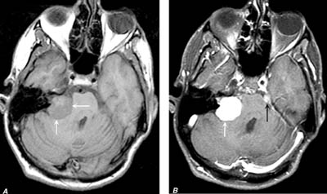

Treatment

- see specific tumors [p. Onc60 >>](http://www.neurosurgeryresident.net/Onc.%20Oncology\Onc60.%20Nerve%20Tumors%20(GENERAL).pdf), [p. Onc62 >>](http://www.neurosurgeryresident.net/Onc.%20Oncology\Onc62.%20Schwannomas%20of%20Cranial%20Nerves.pdf)

* *radiotherapy has additional risks*!

N.B. be aware of risk associated with stereotactic radiosurgery for treating benign lesion in patients genetically predisposed to malignancy

* erlotinib - therapeutic activity for progressive vestibular schwannoma in NF2.
* if patient lost hearing on one side → consider ***internal auditory canal decompression*** for hearing maintenance.

Prognosis

* risk factors for mortality:

1. care not at tertiary centers
2. young age at diagnosis
3. presence of intracranial meningiomas
4. type of NF2 mutation

Schwannomatosis (neurilemomatosis)

- sporadic (sometimes autosomal dominant*) disorder - multiple schwannomas (spinal, cutaneous and cranial nerve) without vestibular schwannomas or other manifestations of NF2 or NF1.

* familial cases represent only 10–15%; gene unknown (different than NF2 but still on chromosome 22)

* associated with inactivation of NF2 gene in tumours but not in germline.
* almost as common as neurofibromatosis type 2.

Diagnostic criteria

Essential is exclusion of NF2 by clinical criteria and by imaging of vestibular nerves (challenging in paediatric patients, as vestibular schwannomas may develop only later in course of NF2)

**Definite schwannomatosis**

1. ≥ 2 (pathologically proven) schwannomas + lack of vestibular schwannomas on MRI at age > 30 years + no known constitutional NF2 mutation
2. Pathologically proven 1 schwannoma + first degree relative with schwannomatosis.

**Probable schwannomatosis**

1. ≥ 2 (pathologically proven) schwannomas + lack of vestibular schwannomas on MRI at age < 30 years + no known constitutional NF2 mutation
2. Radiographic evidence of 1 schwannoma + first degree relative with schwannomatosis.
3. ≥ 2 schwannomas at age > 45 years + no symptoms of cranial nerve VIII dysfunction + no known constitutional NF2 mutation

Clinical Features

Schwannomas

- multiple schwannomas but not in vestibular nerves.

* cutaneous schwannomas may be plexiform.
* tumors have ***segmental distribution*** in 30% patients.
* difference from NF2: often severe pain but neurological deficits and polyneuropathy are rare
* histology: prominent myxoid stroma and intraneural growth pattern (sometimes misdiagnosed as neurofibromas)

Marked myxoid stroma:

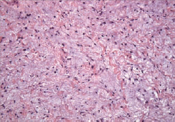

[Source of picture: “WHO Classification of Tumours of the Central Nervous System” 4th ed (2007), ISBN-10: 9283224302, ISBN-13: 978-9283224303 >>](http://www.amazon.com/gp/product/9283224302)

MRI (STIR) - multiple, bright, discrete tumors:

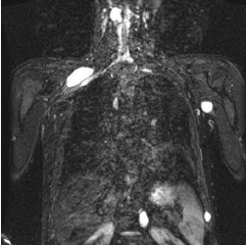

[Source of picture: “WHO Classification of Tumours of the Central Nervous System” 4th ed (2007), ISBN-10: 9283224302, ISBN-13: 978-9283224303 >>](http://www.amazon.com/gp/product/9283224302)

Other lesions

* rare association with single or multiple **meningiomas**.
* no extraneural manifestations!

Bibliography for ch. “Phakomatoses” → follow this [link >>](http://www.neurosurgeryresident.net/Pha.%20Phacomatoses,%20Neurocutaneous%20disorders\Pha.%20Bibliography.pdf)

[Viktor’s Notes℠ for the Neurosurgery Resident](http://www.neurosurgeryresident.net/)

[Please visit website at www.NeurosurgeryResident.net](http://www.neurosurgeryresident.net)