Tuberous Sclerosis (Bourneville’s disease)

Last updated: December 19, 2020

[Genetics 1](#_Toc58061852)

[Epidemiology 1](#_Toc58061853)

[Pathology, Clinical Features 1](#_Toc58061854)

[Diagnostic criteria 9](#_Toc58061855)

[Diagnosis 9](#_Toc58061856)

[Treatment 10](#_Toc58061857)

[mTOR inhibitors 10](#_Toc58061858)

[Antiepileptics 10](#_Toc58061859)

[SRS 10](#_Toc58061860)

[Oncological Surgery 10](#_Toc58061861)

[Epileptic Surgery 11](#_Toc58061862)

[Resective Surgery 11](#_Toc58061863)

[Vagus nerve stimulation 12](#_Toc58061864)

[Corpus callosotomy 12](#_Toc58061865)

[Follow Up 12](#_Toc58061866)

[Prognosis 12](#_Toc58061867)

**Tuberous Sclerosis** - variety of hamartomas that may affect ***every organ system*** at different stages in course of disease.

* first described by von Recklinghausen in 1862.
* in 1880, Bourneville coined term *sclerose tubereuse* for potato-like lesions in brain.

Genetics

- autosomal dominant mutation:

* 1. 10-20% - TSC1 gene (9q34) - product (**hamartin**) is tumor suppressor.
  2. 80-90% - TSC2 gene (16p13) - product (**tuberin**) is tumor suppressor.

N.B. clinical-pathologic features caused by these different genes are indistinguishable!

* both **hamartin** and **tuberin** have “coiled-coil” domains that interact with each other - *hamartin and tuberin form tumor suppressor complex* that inhibits protein complex mTOR (mammalian target of rapamycin)\* via GTPase-activating protein Rheb (Ras homolog enhanced in brain).

\*mTOR serves as major effector of cell growth (vs. cell proliferation) - when mTOR is constitutively activated (through mutations in either hamartin or tuberin) this results in hamartomatous lesions

* *high spontaneous mutation rate* (50-80% cases are sporadic).
* TSC1/TSC2 complex plays an important role in cortical development and growth control
* asymptomatic parents of affected child, have increased risk (≈ 2% overall) of having additional affected children - result from parental mosaicism for one of TSC genes limited to germ line cells (true failure of penetrance is rare!).

Epidemiology

birth incidence 1 in 5800

prevalence - 1 case per 10,000-170,000 population

Age distribution of subependymal giant cell astrocytoma (SEGA) at the time of clinical manifestation:

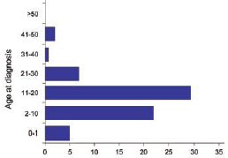

Pathology, Clinical Features

Long time, hallmark of tuberous sclerosis complex (TSC) was **Vogt triad** (29% of patients; 6% lack all three):

***Seizures***, ***Mental Retardation***, and ***Adenoma Sebaceum***

N.B. only < 1/3 affected persons fit this classic constellation of symptoms!

* TSC2 mutation is associated with more severe clinical disease!

Different organ systems are affected in different ways at different times (most patients manifest before age 10 years) - skin, kidneys, brain, heart, and vasculature

Brain (90-95%)

* clinical significance - epileptogenic foci (surgery may be beneficial).
* seizures (80-90%, mostly within 1st year of life; up to third will suffer infantile spasms)

TSC is one of the leading causes of genetic epilepsy!!!

1. **Tubers** (hamartomas):
   1. **cerebrum** – typically as hard nodules projecting slightly above cortex surface
   2. **cerebellum** (may be only microscopic).
   3. rarely - **brain stem**, **spinal cord**.
      * tubers arise developmentally: mutated neural progenitor cells in subependymal germinal matrix give rise to abnormally migrating daughter cells\* that in turn produce tubers.

\*seen on MRI as neuronal migration streaks in white matter

* + - white and firm to touch.
    - number, size, and location of tubers vary widely.
    - tubers may undergo ***cystic degeneration*** or ***calcification*** (do not necessarily imply malignant transformation).
    - neurological findings (formal neurologic examination is typically nonfocal) - abnormalities in cognition (either global severe ***mental retardation*** or specific location-related deficits like language delays), autism, (intractable) ***epilepsy***\*.

\**infantile spasms* are characteristic; seizures may disappear in adult life

N.B. close relationship: onset of seizures at younger age → more severe mental retardation!; mental retardation rarely occurs without seizures, but intellect may be normal, despite seizures.

30-50% patients have normal intelligence!

1. **Subependymal** **nodules (SENs)** (hamartomas) - ***discrete*** or roughly ***confluent areas*** of firm, rounded hypertrophic tissue in wall of lateral ventricles (esp. at caudothalamic groove in vicinity of foramen of Monro)
   * + present at birth.
     + size 2-25 mm; typically ***calcify*** (seen on CT!!!)
     + on MRI, appear as enhancing localized projections into ventricular cavity ("candle-dripping" or "candle-guttering" appearance).
     + 5-15 % degenerate into *subependymal giant cell astrocytoma*.

SENs → migration streaks in white matter → cortical tubers

i.e. abnormality in radial glial–neuronal unit between germinal matrix and cortex

1. **Subependymal giant cell tumors (SGCTs)** (old name - **subependymal giant cell astrocytomas (SEGAs)** - benign (grade I) tumors near foramen of Monro.
   * + WHO grade I mixed glioneuronal cell tumors
     + SGCT is continuum of SENs (histopathologically identical mixed glioneuronal lineage) - serial imaging of SENs is strongly recommended

* any lesion exhibiting growth on serial imaging or causing hydrocephalus is called SGCT

SEGA exhibits growth vs. hamartomas (SENs, tubers) do not grow

* + - grow often in extremely indolent fashion → marked ***obstructive hydrocephalus***.

1. **White matter linear migration lines**, **transmantle cortical dysplasia**

Microscopic examination of tubers and SENs:

1. decreased number of normal neurons, disturbed cortical architecture.
2. giant cell clusters (large, bizarre, and sometimes vacuolated "monster" cells with phenotype intermediate between glia and neurons)
3. proliferation of fibrillary astrocytes (well-marked fibrillary gliosis)
4. areas of demyelination.

Tuber – enlarged, firm, whitened gyrus (*arrow*):

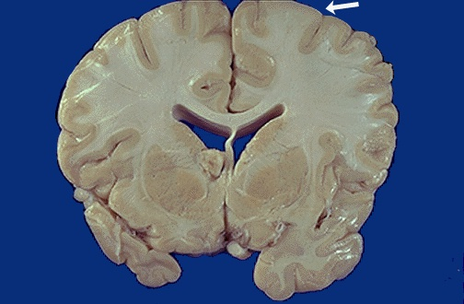

[Source of picture: “WebPath - The Internet Pathology Laboratory for Medical Education” (by Edward C. Klatt, MD) >>](http://library.med.utah.edu/WebPath/webpath.html" \t "_blank)

Multiple small subependymal giant cell astrocytomas at the walls of the lateral ventricles

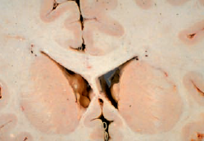

[Source of picture: “WHO Classification of Tumours of the Central Nervous System” 4th ed (2007), ISBN-10: 9283224302, ISBN-13: 978-9283224303 >>](http://www.amazon.com/gp/product/9283224302)

Coronal section of the left hemisphere of patient with tuberous sclerosis, showing subependymal giant cell astrocytoma (arrowheads) and multiple cortical tubers.

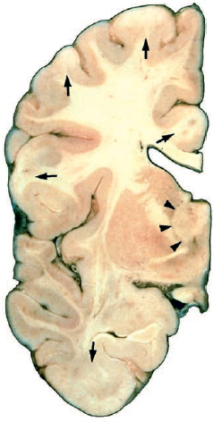

[Source of picture: “WHO Classification of Tumours of the Central Nervous System” 4th ed (2007), ISBN-10: 9283224302, ISBN-13: 978-9283224303 >>](http://www.amazon.com/gp/product/9283224302)

Tuber (*arrow*) - lost distinction between grey and white matter:

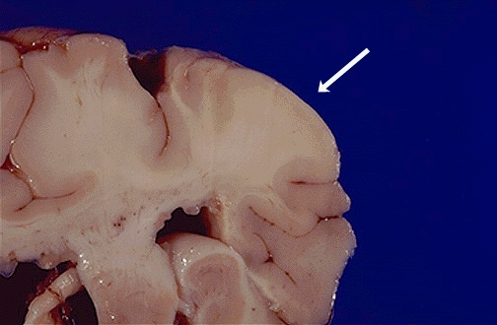

[Source of picture: “WebPath - The Internet Pathology Laboratory for Medical Education” (by Edward C. Klatt, MD) >>](http://library.med.utah.edu/WebPath/webpath.html" \t "_blank)

Firm, whitened gyri that are broader than surrounding normal gyri:

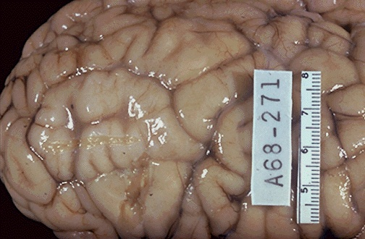

[Source of picture: “WebPath - The Internet Pathology Laboratory for Medical Education” (by Edward C. Klatt, MD) >>](http://library.med.utah.edu/WebPath/webpath.html" \t "_blank)

SEGA. **A** Pleomorphic multinucleated eosinophilic tumour cells. **B** Elongated tumour cells forming streams

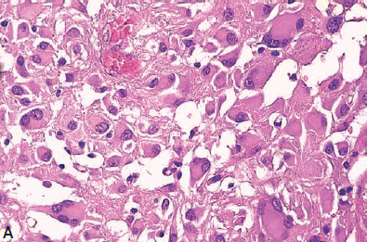

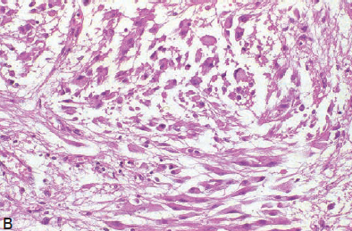

[Source of picture: “WHO Classification of Tumours of the Central Nervous System” 4th ed (2007), ISBN-10: 9283224302, ISBN-13: 978-9283224303 >>](http://www.amazon.com/gp/product/9283224302)

SEGA: CT of typical subependymal calcifications in a patient with tuberous sclerosis. **B** A T1-weighted MRI showing mixed iso- and hypodense mass

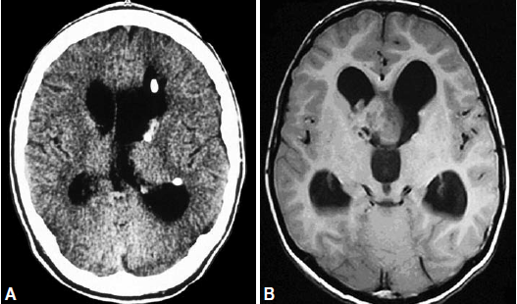

[Source of picture: “WHO Classification of Tumours of the Central Nervous System” 4th ed (2007), ISBN-10: 9283224302, ISBN-13: 978-9283224303 >>](http://www.amazon.com/gp/product/9283224302)

|  |  |  |  |
| --- | --- | --- | --- |
| Multiple tubers (MRI): | | Few but larger tubers (MRI): | |
| Enhancing subependymal nodules + probable giant cell astrocytoma in region of foramen of Monro: | | Subependymal giant cell astrocytoma: | |
| CT – subependymal nodules; hypointense right frontal lesion represents tuber (extends from lateral ventricle through cerebral cortex): | | | Proton density–weighted MRI - bilateral isointense transcortical linear streaks (neuronal migration anomalies): |
| T2-MRI - multiple low-signal-intensity SENs and cortical tubers: | | CT and contrast T1-MRI - large right retinal tuber: | |
| T1-MRI in infant - multiple hyperintense cortical tubers and subependymal nodules: | Proton density and T2-MRIs - multiple cortical and subcortical hyperintensities represent tubers, with associated demyelination; single hyperintense subependymal nodule in right trigone: D:\Viktoro\Neuroscience\Pha. Phacomatoses, Neurocutaneous disorders\00. Pictures\Tuberous sclerosis (MRI).jpg | | |
| Several calcified subependymal nodules (CT):  D:\Viktoro\Neuroscience\Pha. Phacomatoses, Neurocutaneous disorders\00. Pictures\Subependymal nodules (CT).jpg | Cortical tubers + associated abnormal signal radiating out from periventricular tissue to surface (migration abnormality):  D:\Viktoro\Neuroscience\Pha. Phacomatoses, Neurocutaneous disorders\00. Pictures\Tuberous sclerosis (MRI) 3.jpg | | |

(A) T2-MRI and (B) T1-MRI - multiple subcortical areas (tubers) with abnormal signal; small irregular subependymal nodules protruding into lateral ventricles:

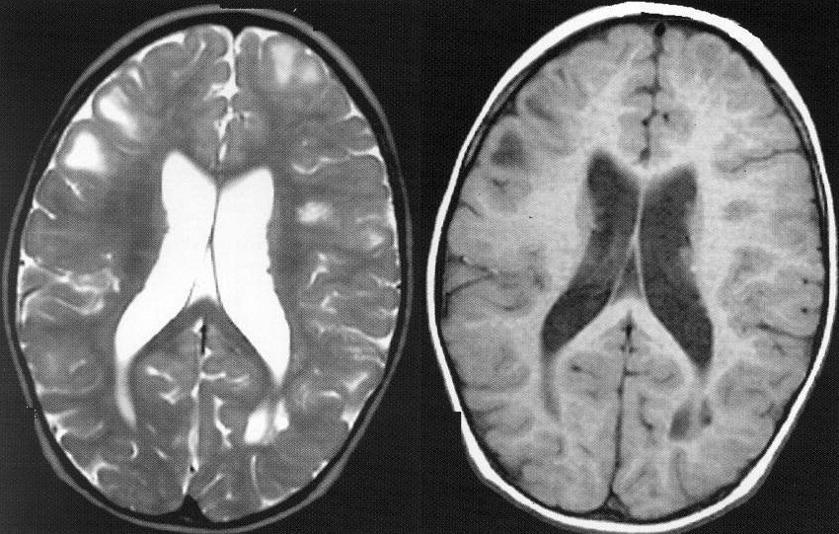

Subependymal giant cell tumor in patient with tuberous sclerosis



[Source of picture: H. Richard Winn “Youmans Neurological Surgery”, 6th ed. (2011); Saunders; ISBN-13: 978-1416053163 >>](http://www.amazon.com/gp/product/1416053166)

Skin (90-95%): facial angiofibromas (i.e., adenoma sebaceum), hypopigmented macules (“ash leaf spots”), shagreen patches, subungual fibromas,

1. **Adenoma sebaceum** (archaic misnomer), s. **angiofibroma**, **Pringle disease** (best-known cutaneous manifestation!) - cutaneous hamartoma of face, not related to excessive sebum or acne.
   * + - * appears after age 4 yrs.
         * distributed symmetrically on nose and cheeks in ***butterfly distribution***; spares upper lip!
         * typically progress: flat, reddish macules → increasing size, erythematous and papulonodular with friable surface that may bleed easily; may become disfiguring.

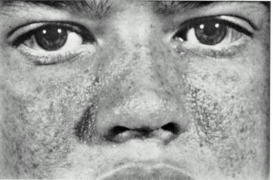

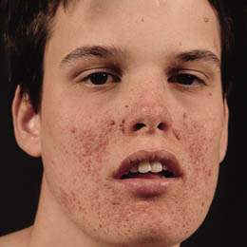

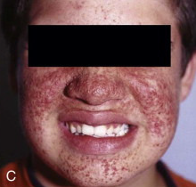

[Source of picture: H. Richard Winn “Youmans Neurological Surgery”, 6th ed. (2011); Saunders; ISBN-13: 978-1416053163 >>](http://www.amazon.com/gp/product/1416053166)

1. **Hypomelanotic** (“ash leaf”) **macules** (few mm ÷ 5 cm) – nonspecific!
   * + difficult to visualize in light-skinned individuals H: Wood lamp (ultraviolet light)!
     + appear at birth ÷ late life.
     + vary widely in location and number.
     + round or oval (resembling leaf of European mountain ash tree); sometimes irregular, reticulated appearance, as if white confetti paper had been strewn over skin (“confetti lesions”).
     + in scalp → area of poliosis (melanin amount↓ in hair).

Confetti lesions:

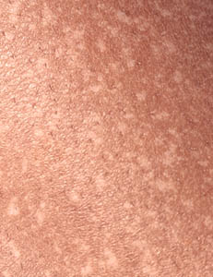 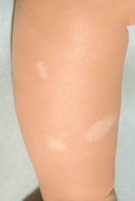

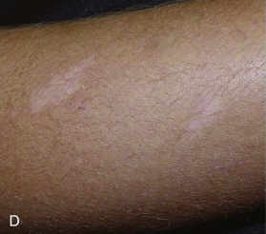

[Source of picture: H. Richard Winn “Youmans Neurological Surgery”, 6th ed. (2011); Saunders; ISBN-13: 978-1416053163 >>](http://www.amazon.com/gp/product/1416053166)

With Wood lamp:



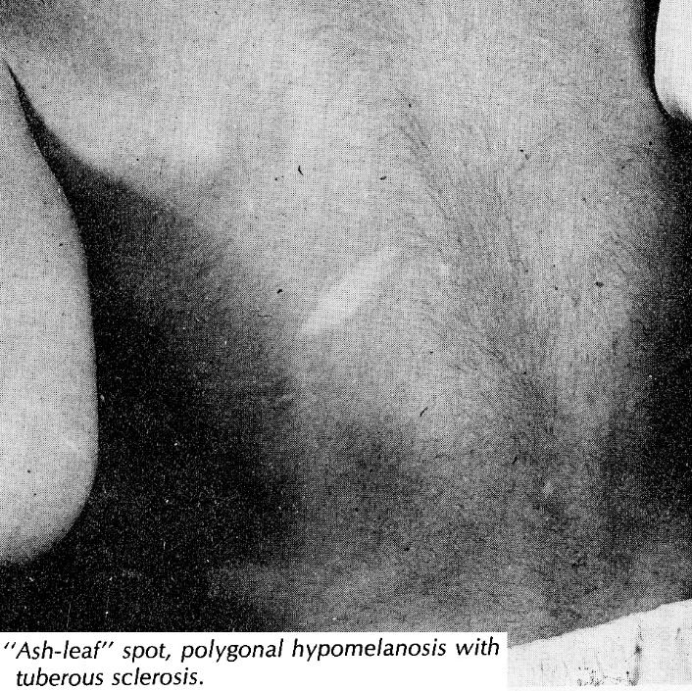

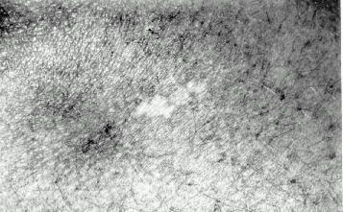

1. **Fibromas** - potentially anywhere in cutaneous or mucosal tissues:
   1. periungual (*Koenen's tumors*) - may cause erosions of tufts of distal phalanges.
   2. gingival [see below >>](#Mouth)
   3. lower back (*shagreen patch*); appears after age 10 yrs; yellowish brown elevated plaques that have texture of pig skin; associated with dysraphism, osseous lesions, or mass effects on neural structures; occasionally itch or are associated with dysesthesia (patients wonder if "it is pinching nerve").
   4. forehead and face (fibrous plaques)
      * symptoms result from local irritation.

|  |  |
| --- | --- |
| Dysplastic periungual fibroma: | Typical ash leaf macules; reddish, nodular area at upper lumbar area is shagreen patch: |

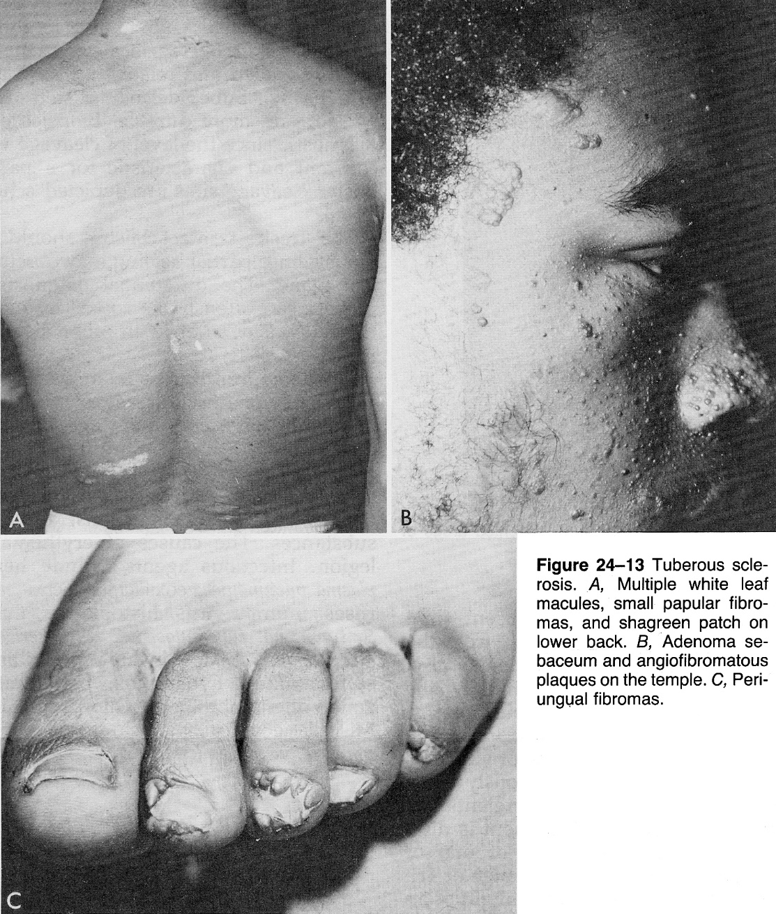

Heart (50-60%) - develop during intrauterine life - present at birth ÷ early life (may be presenting sign of TSC) - mostly **rhabdomyomas**:

* + - focal or diffuse and infiltrating.
    - spontaneous regression in first few years!!!
    - clinically (majority are asymptomatic!) - hydrops fetalis (fetal death), outflow tract obstruction, interference with valvular function, decreased contractility and cardiomyopathy.

N.B. lesions can involve conducting system → arrhythmias (even later in life).

* + - treatment - inotropic support, surgery.

|  |  |
| --- | --- |
| Atrial rhabdomyoma: | Ventricular rhabdomyomas diffusely infiltrate myocardium: |
| Nonobstructive ventricular rhabdomyomas: | T1 cardiac-gated MRI - hyperintense left ventricular mass: |

eyes (50-80%):

1. Congenital **retinal hamartomas** (**phakomas**) that calcify over time; rarely produce symptoms or require intervention:

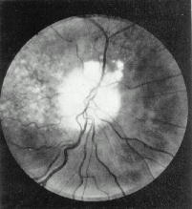 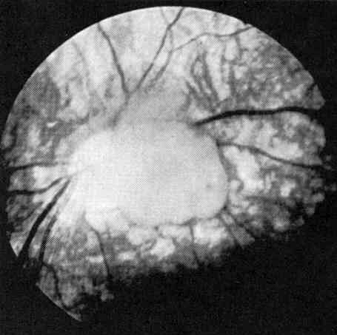

1. **Hypopigmented areas** (retina, iris, eyelashes) are analogous to hypomelanotic macules of skin:

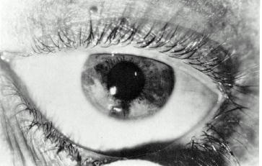

Lungs (40%) – symptomatic almost exclusively in women ≥ 30 yrs.

1. **Multifocal micronodular pneumocyte hyperplasia (MMPH)** - hyperplasia of type II pneumocytes; men = women; asymptomatic; CT - nodular densities.
2. **Pulmonary cysts** (single or multiple); rupture → ***pneumothorax*** (50% patients with pulmonary involvement); multiple cysts → respiratory insufficiency, pulmonary hypertension with cor pulmonale.
3. **Lymphangioleiomyomatosis (LAM)**
   * + abnormal proliferation of smooth muscle cells → compromise of bronchioles, venules, and lymphatic structures → alveolar destruction → pulmonary elasticity is lost (progressive restrictive lung disease) → pulmonary hypertension → cor pulmonale.

Inexorably progressive - *ultimately results in death*!

* + - most sensitive diagnosis - high-resolution CT (interstitial thickening, alveolar destruction, honeycomb lung).
    - treatment - lung transplantation (LAM occasionally has recurred in transplanted lungs).

LAM - multifocal pulmonary cysts:

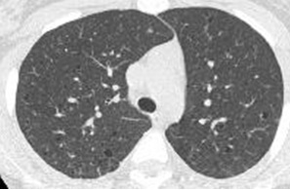

Kidneys

1. **Autosomal** **dominant polycystic kidney disease** (2-3%) - result of genetic abnormality affecting both *TSC2* gene and *PKD1* gene adjacent to it - presents in infancy ÷ early childhood: hypertension, hematuria, renal failure.
   * + highly susceptible to UTI or nephrolithiasis.
     + treatment - renal transplantation
2. Isolated **renal cyst(s)** (20% males, 10% females) - rarely if ever symptomatic.
3. **Angiomyolipomata (AML)** (50-90%) – hamartomas – abnormal smooth muscle, fat, and blood vessels.
   * + either multiple small AMLs studding kidney surface or few larger lesions.
     + bilateral.
     + may give hematuria, flank pain (larger lesions).
     + rupture of dysplastic, aneurysmal blood vessels (highest risk in large AMLs > 6-8 cm) → destruction of adjacent normal renal parenchyma (renal failure), life-threatening *retroperitoneal hemorrhage*.
     + treatment of bleeding AML - ***selective embolization*** (pretreatment with steroids – to prevent "postembolization syndrome"); standard surgical resection can result in excessive bleeding, with nephrectomy being end result.
4. **Renal cell carcinoma** (AML is much more common – serial MRIs can differentiate between two to avoid unnecessary nephrectomy).

|  |  |
| --- | --- |
| Massive bilateral angiomyolipomas: | CT – right renal cell carcinoma: |

Mouth

1. **Pitting** **of dental enamel** (100% in permanent teeth; 30% in deciduous teeth), esp. numbers > 14.
2. **Gingival fibromas** (70% adults, 50% children, 3% children with only deciduous teeth) → local irritation, interfere with dental alignment; treatment - surgical resection.

|  |  |
| --- | --- |
| Enamel pitting (red dye is used to enhance recognition) - pinpoint size pitting (A) and crater size pitting (B): | Gingival fibromas (*arrows*); stain outlines dental pits and craters: |

digestive system - seen primarily in adults:

1. **Hamartomas & polyposis** of stomach, intestine, colon.
   * + occasionally minimal bleeding.
2. **Hepatic** **cysts, racemose angiomas, and AMLs** (24%; female-to-male ratio 5:1) - asymptomatic and nonprogressive.

Bone - **sclerotic & hypertrophic lesions** seen primarily in adults.

* + - found incidentally on X-ray; occasionally palpable, aching pains.
    - some patients develop ***neurogenic scoliosis*** (from asymmetric weakness or intractable partial seizure activity) - typically “dominant” tuber is present contralateral to scoliosis or supratentorial tuber burden is asymmetrical.
    - ***cystic defects*** may involve phalanges.

Diagnostic criteria

Major features:

1. Facial angiofibromas or forehead plaque
2. Nontraumatic ungual or periungual fibroma
3. Hypomelanotic macules (> 3)
4. Shagreen patch (connective tissue nevus)
5. Multiple retinal nodular hamartomas (phakomas)
6. Cortical tuber (when cerebellar cortical dysplasia and cerebral white matter migration tracts occur together, they should be counted as one rather than two features of tuberous sclerosis).
7. Subependymal nodule
8. Subependymal giant cell tumor
9. Cardiac rhabdomyoma (single or multiple)
10. LAM\*
11. Renal AML\*

\*When both are present together, other features are also required for diagnosis.

Minor features:

1. Multiple randomly distributed pits in dental enamel
2. Hamartomatous rectal polyps (histologic confirmation is suggested).
3. Bone cysts (radiographic confirmation is sufficient).
4. Cerebral white matter radial migration lines (radiographic confirmation is sufficient).
5. Gingival fibromas
6. Nonrenal hamartoma (histologic confirmation is suggested).
7. Retinal achromic patch
8. "Confetti" skin lesions (hypopigmented spots in groups)
9. Multiple renal cysts

Definite TSC:

1. two major features\*
2. one major feature + two minor features

Probable TSC: one major feature + one minor feature

Possible TSC:

1. one major feature
2. ≥ 2 minor features

\*when both LAM and renal AMLs are present, other features of tuberous sclerosis should be present before definite diagnosis is assigned (60% non-TSC women with sporadic LAM have renal or other AMLs).

Diagnosis

**Genetic testing** identifies 75-80% mutations (negative genetic test does not exclude diagnosis).

* + - genetic testing is useful in uncertain cases, for prenatal diagnosis, for screening family members.
    - genetic counseling is of paramount importance in familial cases!

Three routine imaging procedures:

1. **Brain CT / MRI**:
   * + ***fluid-attenuated inversion recovery (FLAIR) sequence*** is superior for identification of tubers.
     + cortical **tubers** appear as broad cortical gyri with abnormalities in adjacent white matter.

N.B. tubers expand gyri (vs. unidentified bright objects of NF1)

* + - **tubers** and **SENs** may enhance (do not necessarily imply malignant transformation!!!).
    - **tubers** and **SENs** are:

in neonates (unmyelinated white matter) - T1 hyperintense and T2 hypointense;

older children - T1 hypointense and T2 hyperintense.

* + - **SEGAs** – diagnostic criteria: tumor location near the foramen of Monro, > 0.5 cm in diameter, with any documented growth, and intense gadolinium enhancement

1. **Renal ultrasounds** (to assess change in AMLs or cysts) - repeated every 5 years if no or small lesions are seen → every 2-3 years in late adolescence through adulthood (cysts and AMLs usually start grow significantly after puberty).
2. **Echocardiograms** - not repeated if no lesions are seen (if rhabdomyomas are seen, echocardiography is repeated as indicated clinically).

**SPECT** or **PET** with *α-methyltryptophan* - identifying epileptogenic tubers before epilepsy surgery.

* usually preoperative SEEG is needed (if suspect that one tuber likely will need ablation, may use larger SEEG bolt that will admit laser probe after SEEG is done).

**ECG** (to detect cardiac arrhythmias) - at diagnosis and every 2-3 years until puberty.

Treatment

mTOR inhibitors

1. Rapamycin (s. sirolimus) - *subependymal giant cell astrocytomas* may regress!!!
2. Temsirolimus (CCI-779)
3. Everolimus (Afinitor, Novartis) - FDA approved for TSC-associated subependymal giant cell astrocytoma (SEGA) – for **patients ≥ 2 yo** who require therapy but are not candidates for surgical resection.

* appears to reduce brain lesions (results in a rapid initial reduction in tumor volume, followed by a phase of slower reduction or stabilization of residual mass; dose de-escalation strategy seems to be logical in long-term SEGA treatment to reduce the risk of adverse effects while maintaining the therapeutic effect)
* reduces seizure frequency (EXIST-3 - EXamining everolimus In a Study of TSC) – epilepsy-modifying drug!
* may alleviate hydrocephalus

Moavero R Everolimus Alleviates Obstructive Hydrocephalus due to Subependymal Giant Cell Astrocytomas. Pediatr Neurol. 2017 Mar;68:59-63. doi: 10.1016/j.pediatrneurol.2016.11.003. Epub 2017 Jan 3.

* FDA also approved for advanced renal cell carcinoma, neuroendocrine tumors of GI or lung origin, TSC-associated renal angiomyolipoma.

Antiepileptics

- mainstay of therapy for most patients – drugs are selected according to seizure type (vigabatrin is drug of first choice).

* TSC epilepsy is focal – many AEDs may work.
* only 1/3 of patients achieve seizure freedom with AEDs.
* 2020-08-03 FDA approved cannabidiol (CBD) (Epidiolex) for patients ≥ 1 yo; based on GWPCARE6 trial (placebo vs. 25 mg/k vs. 50 mg/kg CBD):

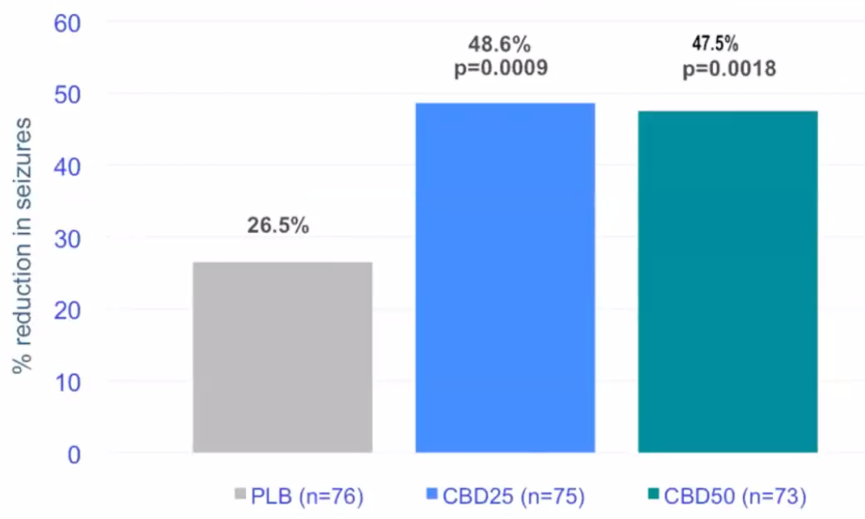

* good results with **ketogenic diet**.

SRS

* for SEGA
* not currently recommended as data on efficacy and safety are limited.

Oncological Surgery

* no need to remove SGTC if it is asymptomatic - may stabilize or stop growing spontaneously after puberty!
* first line treatment in **symptomatic** SEGA (hydrocephalus, worsening seizures) or SEGA with **documented growth**.
* often large and difficult to resect by time they produce clinical symptoms, so lesions fulfilling criteria for SEGA should be removed as soon as growth has been confirmed.
* operative approach to SGCT:

1. simple shunt placement
2. *early tumor resection at first symptoms or documented growth* \* (modern approach)

\*(1) shunts can in some cases be avoided, (2) smaller lesions may lend themselves to easier operative resection, (3) cases of sudden death associated with SGCTs have been reported, (4) excessive morbidity and mortality is associated with delayed therapy.

* transcallosal or transcortical (potentially epileptogenic in already susceptible patient) or endoscopic or LITT.
* perioperative mortality related to acute hydrocephalus remains catastrophic but potentially avoidable.

Epileptic Surgery

Resective Surgery

(tuberectomy ÷ lobectomy ÷ hemispherectomy)

(open vs LITT)

* particular challenges in presurgical workup - multiple tubers\*, high frequency of multiple seizure types, and multifocal scalp electroencephalographic abnormality; SEEG is indicated.

\*even when multiple tubers are present, epileptogenic activity can often be localized to 1 or 2 tubers (usually the most “angry” looking tuber) – enough to address that dominant tuber and keep observing others

N.B. EZ often includes the ***perituberal surrounding area*** - successful resections/ablations may need to include this area.

* majority of patients (despite bilateral tubers) have a single epileptogenic zone.
* tubers are not isolated – they have connections (“large lobular mass”) but one tuber tends to be most offending.
* ***tuber tissue has zero function*** ***but often originate seizure*** (Kannan et al, Brain 2016); main surgical issue – insult to margin of normal brain – subpial dissection immediately around tuber (tubers have more defined margin and safer surgery than focal cortical dysplasias)

N.B. sometimes tubers have complex organization with nearby cortex being epileptogenic – some experts propose multistage surgery: resection → icEEG → additional resection → icEEG → etc

* ***seizure often recur*** – palliative result – but often times seizures are less severe and patient’s development trajectory is much improved! – need personalized outcome evaluation and not just bland Engel class (paradigm shift from cure to disease modification)

N.B. European Experts Clinic Recommendations 2018: consider surgery immediately after failure of 2 medications! Multifocal and bilateral tubers are not a contraindication!

Outcomes in children (surgery at age < 19 yrs):

Fallah A. “Resective Epilepsy Surgery for Tuberous Sclerosis in Children: Determining Predictors of Seizure Outcomes in a Multicenter Retrospective Cohort Study” Neurosurgery, October 2015 - Volume 77 - Issue 4 - p 517–524

* Engel Class I achieved in 65% - 50% - 45% - 43% patients at 1 – 2 – 3 – 4 year follow-up, respectively.
* median time to seizure recurrence - 24.0 ± 12.7 months.
* earlier surgery is favored – positively impacts neurodevelopment (even if seizure freedom is temporary but it helps for neurodevelopment).
* invasive monitoring is needed if hypothesis is unclear (otherwise, straightforward resection).
* factors associated with longer duration of seizure freedom – now in clinical recommendations
  + 1. younger age at seizure onset\* (HR: 2.03, 95% CI: 1.03-4.00, *P* = .04);
    2. larger size of predominant tuber\* (HR: 1.03, 95% CI: 0.99-1.06, *P* = .12); multiple tubers do not preclude surgery;
    3. **resection larger than tuberectomy (tuberectomy plus)** (HR: 2.90, 95% CI: 1.17-7.18, *P* = .022) - epileptogenic zone may include cortex surrounding presumed offending tuber! - this limits the role of tuberectomies! Partial resections do not work!

\*those were not predictors of seizure freedom in the multivariate analysis

* using invasive recording via depth electrodes, Major et al (2009) demonstrated electrical silence within tubers while surrounding cortex demonstrated epileptiform activity.

vs. Australian experts think that it is enough to resect/ ablate the center of tuber (esp. important if tuber is in eloquent area) –not supported by meta-analyses!

N.B. prepare patient for the need of multiple surgeries! (incl. invasive monitoring)

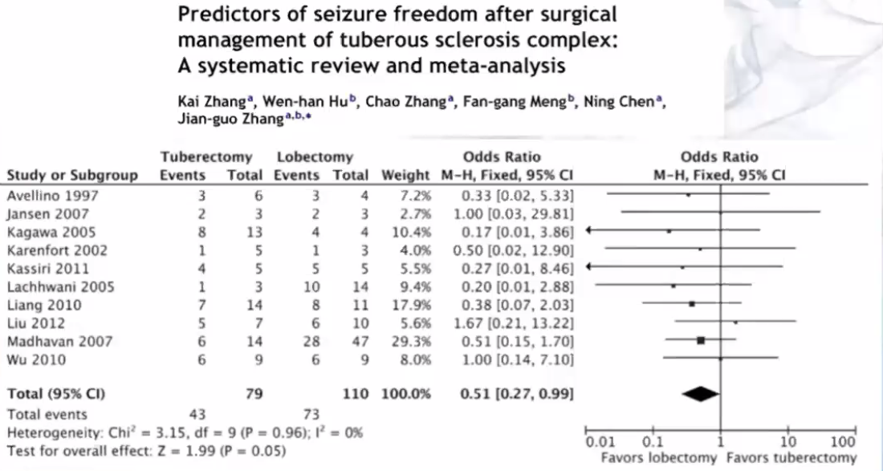

Biomarkers to guide extent of resection:

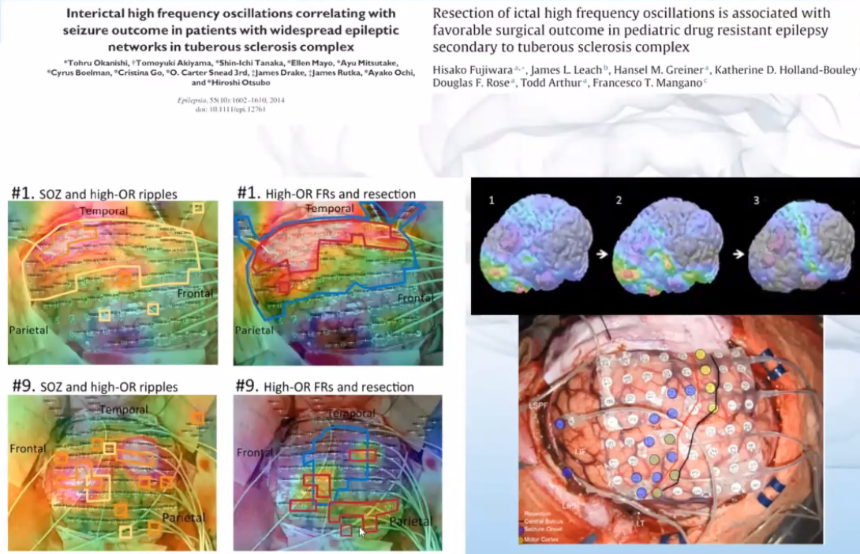

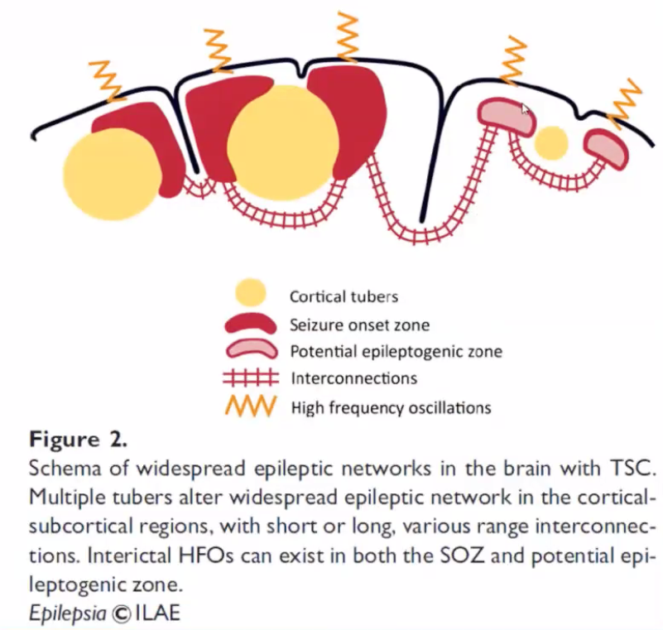

Vagus nerve stimulation

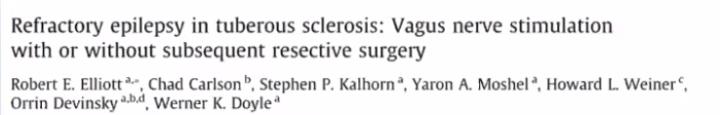

Corpus callosotomy

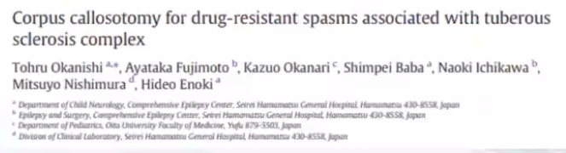

Follow Up

**Age-dependent SEGA monitoring**: every 2 years before the age of 20 years; from the third decade onwards (SEGA is less frequent in adults and there is a lower potential for existing SEGA growth):

stable SEGA - no monitoring

growing SEGA - continued monitoring

**Size-dependent SEGA monitoring**: MRI repeated after 6 months for tumours > 1 cm.

Prognosis

Long-term outcome is not universally poor, as has been classically thought!

Causes of death (in decreasing order of frequency):

1. renal disease
2. intracranial tumors
3. hemorrhage (such as from aortic aneurysms or lymphangiomyomatosis of lung)
4. status epilepticus
5. cardiac rhabdomyomas

Bibliography for ch. “Phakomatoses” → follow this [link >>](http://www.neurosurgeryresident.net/Pha.%20Phacomatoses,%20Neurocutaneous%20disorders\Pha.%20Bibliography.pdf)

[Viktor’s Notes℠ for the Neurosurgery Resident](http://www.neurosurgeryresident.net/)

[Please visit website at www.NeurosurgeryResident.net](http://www.neurosurgeryresident.net)