Benzodiazepines
Last updated: April 21, 2019
Mechanism of action 1
Pharmacologic Actions 1
Pharmacokinetics 1
Therapeutic uses 2
Adverse effects 2
Benzodiazepine Overdose 2
Benzodiazepine Antagonists 3

Benzodiazepines are most widely used anxiolytics (s. minor tranquilizers).
N.B. since all anxiolytics also cause some sedation, same drugs often function clinically as both anxiolytics and hypnotics.

Mechanism of action
Benzodiazepines bind to specific, high affinity benzodiazepine receptors (found only in CNS) - sites on cell membrane, which are separate from but adjacent to GABA_{A} receptor (allosteric sites of GABA_{A} receptor).
- binding of benzodiazepines enhances GABA_{A} receptor affinity for GABA* → more frequent opening of adjacent Cl⁻ channels → enhanced hyperpolarization → inhibition of neuronal excitability.
*benzodiazepines and GABA mutually increase affinity of their binding sites.
- clinical effects of various benzodiazepines correlate well with each drug's binding affinity for GABA_{A} receptor-Cl⁻ channel complex.

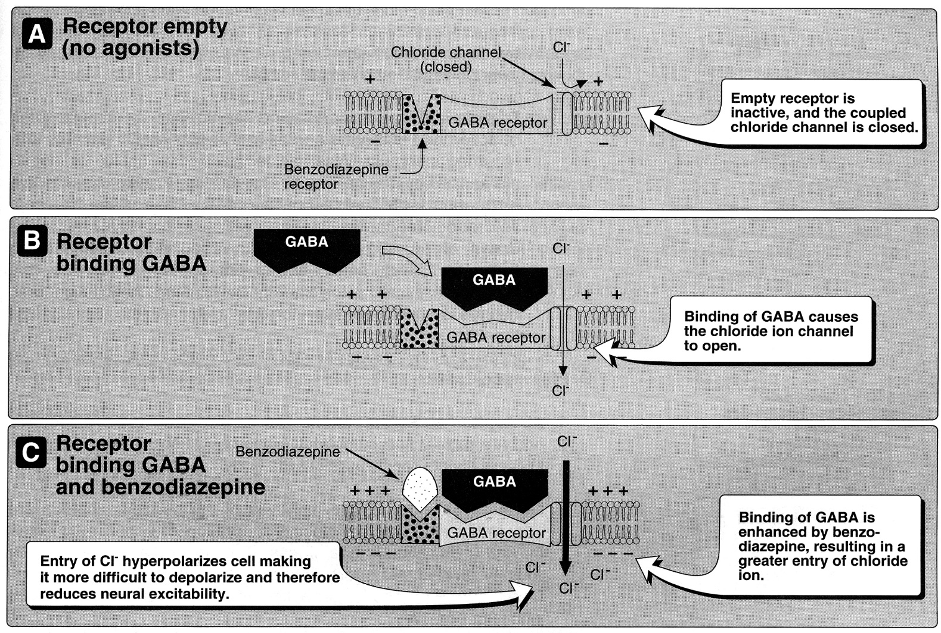

Pharmacologic Actions
Benzodiazepines have no antipsychotic activity, no analgesic activity, and do not affect autonomic nervous system (e.g. minimal effect on c/v system).
All benzodiazepines exhibit following actions (to greater or lesser extent):
- Anxiety reduction (by selectively inhibiting neuronal circuits in limbic system) - at low doses.
- Sedative & hypnotic; at higher doses, certain benzodiazepines produce hypnosis (artificially-produced sleep), but not general anesthesia (safe drugs!).
  - benzodiazepines supress REM sleep (as do barbiturates); after drug discontinuance - rebound of REM sleep (usually in form of nightmares).
  - antianxiety effect is less subject to tolerance than sedative-hypnotic effect!
- Anticonvulsant (by increasing seizure threshold) - only several benzodiazepines. see p. E3 >>
- Skeletal muscle relaxant (by increasing presynaptic inhibition in spinal cord) - relax muscle spasticity.

Pharmacokinetics
- benzodiazepines are lipophilic - rapidly and completely absorbed after oral administration → widely distributed throughout body, cross BBB (plasma levels reflect brain levels).
  - highly lipid-soluble benzodiazepines produce more rapid effect (experienced as “high”).
- metabolized by hepatic microsomes; long-acting benzodiazepines form active metabolites (prolong drug effect duration).
- excreted in urine as glucuronides or oxidized metabolites.
- duration of action is very important clinically - determines therapeutic use.

long-acting benzodiazepines (T_{1/2} – 1-4 days)
  - have active metabolites with long half-lives.
  - may accumulate.
  - usually administered ×2/d (to minimize oversedating peaks).
chlordiazepoxide (T_{1/2} – 2-4 days) – low potency; first developed benzodiazepine.
diazepam (T_{1/2} = 2-4 days) – intermediate potency.
flurazepam (T_{1/2} = 2-3 days ≈ 40-100 hours) – classical hypnotic.
clonazepam (T_{1/2} = 2-3 days ≈ 20-80 hours) – classical antiepileptic. see p. E3 >>
clobazam (T_{1/2} = 10-50 hours) – non-standard benzodiazepine (80% reduced anxiolytic activity + 10-fold decreased sedative effects) – used as antiepileptic. see p. E3 >>
clorazepate (T_{1/2} = 2-4 days)*
halazepam (T_{1/2} = 2-4 days)*
prazepam (T_{1/2} = 2-4 days)*
nitrazepam (T_{1/2} = 1-1,5 days)
quazepam (T_{1/2} = 1-2 days) - benzodiazepine derivative selective for subtype 1 of benzodiazepine receptor.
*diazepam prodrug (must be metabolized to diazepam, to become active)

intermediate-acting benzodiazepines (10-20 hours)
lorazepam (T_{1/2} = 10-20 hours) see also p. Rx3 >>
temazepam (T_{1/2} = 8-15 hours) – classical hypnotic

alprazolam (T_{1/2} = 14 hours) – high potency; high lipid solubility, no active metabolites.

estazolam (T_{1/2} =16-18 hours)
oxazepam (T_{1/2} = 6-10 hours)

short-acting benzodiazepines (3-8 hours)
triazolam (T_{1/2} =1,5-3 hours) – classical hypnotic
midazolam – shortest acting (T_{1/2} =1.5-2.3 hours), high potency; used as amnestic in premedication. see also p. Rx3 >>

Therapeutic uses
- individual benzodiazepines show small differences in their relative anxiolytic-anticonvulsant-sedative properties; variable pharmacokinetic features are important in drug choice.  Any benzodiazepine can be used to treat insomnia as well as anxiety!!!  - benzodiazepines have largely replaced barbiturates and meprobamate, since benzodiazepines are more effective and safer. | 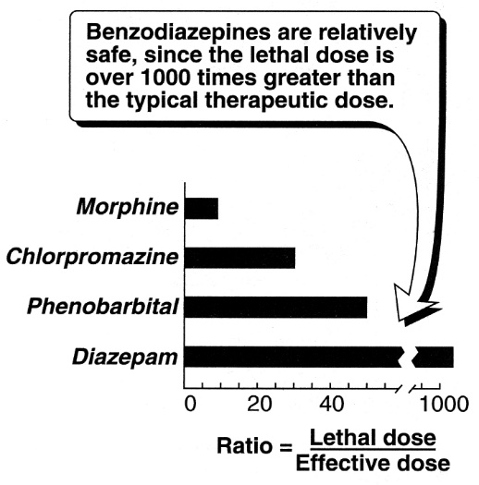
- Anxiety disorders – benzodiazepines are most effective anxiolytics!!!
- do not use to alleviate normal stress of everyday life.
- use only for short periods (addiction potential).
- longer acting agents (e.g. diazepam) at low doses are preferred.
- alprazolam is most effective for panic disorders.

- Sleep disorders - benzodiazepines are preferred drugs (not all of benzodiazepines are useful as hypnotics, although all have sedative effects) – drug should be given for only limited time (usually < 2-4 weeks); use higher doses than for anxiety; most commonly prescribed:
short-acting benzodiazepines (e.g. triazolam*) - useful for sleep induction.
*tolerance develops within few days (drug withdrawal → rebound insomnia!!!).
intermediate-acting benzodiazepines (e.g. temazepam) - useful for frequent awakenings; do not affect sleep latency.
long-acting benzodiazepines – useful for sleep induction and frequent awakenings; also increase sleep duration; may result in daytime sedation;
flurazepam causes less suppression of REM sleep (than other benzodiazepines), no rebound insomnia; with continued use, maintains effectiveness for up to 4 weeks.

- Seizures:
chronic treatment of epilepsy – clonazepam, clobazam, clorazepate;
terminating grand mal epileptic seizures and status epilepticus - diazepam (drug of choice), lorazepam.

- Muscular disorders (skeletal muscle spasms in muscle strain, spasticity from neurodegenerative disorders) - diazepam.

- Acute treatment of alcohol withdrawal - chlordiazepoxide, clorazepate, diazepam, oxazepam, lorazepam.

Adverse effects
- Drowsiness - most common side effect.  - Cognitive impairment (esp. memory problems - decreased long-term recall and acquisition of new knowledge); may cause or aggravate depression!  - Impaired psychomotor performance; cause falls in elderly; ataxia occurs at high doses.  - Tolerance to sedative effects (but not to anxiolytic or impaired performance effects).  - Dependence (psychological and physical) – generally rare; develops if high doses are given over prolonged period; abrupt discontinuation → withdrawal symptoms: confusion, anxiety, agitation, rebound insomnia, influenza-like muscle aches, seizures.  N.B. in long-acting benzodiazepines, withdrawal may not occur until number of days after discontinuation and abstinence symptoms may last up to 1 year! (leading to prolonged use of benzodiazepine to suppress withdrawal);  short-acting benzodiazepines induce more abrupt, more severe, but shorter withdrawal reactions.  Do not prescribe benzodiazepines for patients with history of substance dependence!  - Potentiation of other CNS depressants (incl. alcohol).  N.B. benzodiazepines per se are very safe. | 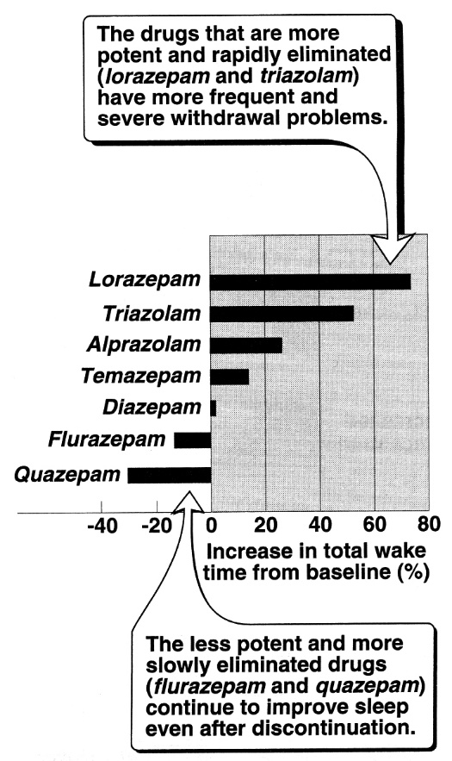

Benzodiazepine Overdose
- frequent, but very rarely fatal unless other CNS depressants are taken concurrently (benzodiazepines have high therapeutic index).
- CNS depression (up to coma ≈ ethanol intoxication) is hallmark. also see p. Psy23 >>
- diagnosis:
  - ECG
  - EEG - widespread high-voltage beta activity
  - serum levels are unhelpful.
  - always screen for CNS depressant co-ingestions!
- treatment: (most people recover without intervention)
  - activated charcoal.
  - specific antidote – flumazenil (see below) – has adverse effects, so indicated not in every case!
  - dialysis ineffective (benzodiazepines have high protein binding).

Benzodiazepine Antagonists
Flumazenil - GABA receptor antagonist (competitively blocks benzodiazepine receptors) - can rapidly reverse effects of benzodiazepines.
- available only for IV administration. see p. S30 >>
- rapid onset but short duration (T_{1/2} ≈ 1 hour);
- in benzodiazepine overdose, flumazenil will reverse coma within 1-2 minutes.
- frequent administration may be necessary for reversal of long-acting benzodiazepines.
- adverse effects:
  - dizziness, nausea & vomiting, agitation - most common side effects.
  - may precipitate withdrawal in dependent patients.
  - may cause seizures if benzodiazepine is used to control seizure activity or if patient co-ingested epileptogenic agents (e.g. cyclic antidepressants).
  - ICP↑ in head trauma
- contraindications:
- epilepsy controlled with benzodiazepine
- benzodiazepine dependency
- co-ingestion of epileptogenic agents (e.g. cyclic antidepressants)
- anticholinergic or sympathomimetic toxidrome.

Bibliography for “Benzodiazepines” → follow this link >>

Viktor’s Notes℠ for the Neurosurgery Resident
Please visit website at www.NeurosurgeryResident.net

