Other Sedatives-Anxiolytics
Last updated: April 21, 2019
Sedatives in Critical Care 1
Dexmedetomidine (Precedex®) 1
Propofol 1
Etomidate 1
Midazolam (Versed®) 1
Lorazepam (Ativan®) 2
Ketamine 2
Others 2
Clomethiazole (s. chlormethiazole) 2
Buspirone (BuSpar®) 2
Chloral hydrate 2
Paraldehyde 3
Glutethimide 3
Ethanol (ethyl alcohol) 3
Meprobamate 3
Methocarbamol (Robaxin®) 3
Nonbenzodiazepine Hypnotics 3
Zolpidem (Ambien®, Zolpimist®) 3
Zaleplon (Sonata®) 3
Zopiclone 3
Eszopiclone (Lunesta®) 3
Ramelteon (Rozerem®) 3
Antihistamines 3

Sedatives in Critical Care
Muscular blockers – see p. 3905 >>
Opioids, neuroleptanalgesia – see p. 3905 >>

Sedation holidays – to evaluate ability to wean from ventilation.

Dexmedetomidine (Precedex®)
- relatively selective α₂-adrenoceptor agonist with sedative properties.
- used for sedation of intubated (mechanically ventilated) patients in ICU
- does not affect respiratory drive – can easily extubate! (helps patients tolerate endotracheal tube without sedatives/narcotics to facilitate extubation)
- no effect on neuro examination – ideal in awake neurosurgery!
- administered by continuous IVI not to exceed 24 hours (longer use may cause withdrawal* if stopped abruptly). *similar to clonidine withdrawal
- may cause bradycardia & hypotension (hypertension during loading dose may be observed).

Propofol
- exact mechanism of action unknown.
- short half life with no active metabolites.
- popular for ambulatory surgery and in neurointensive care – rapid-acting (30-40 sec), short-acting (5-10 min), with smooth, nausea-free emergence and clarity of mental status thereafter.
- excellent bronchodilation (via block of vagally mediated bronchoconstriction).
- decreases cerebral metabolism.
- disadvantages:
- pain on injection.
- dose dependent BP↓ (caution in severe CAD, hypovolemia).
- poor analgesia (add opioids).
- if administered for > 48 hours – great risk of PRIS (propofol-induced syndrome) - rhabdomyolysis
- contraindications: liver injury.
- propofol infusion syndrome:
- first identified in children but can occur in adults as well.
- hyperkalemia, metabolic acidosis, hepatomegaly, lipemia, myocardial failure, rhabdomyolysis, and renal failure, resulting in death.
- extreme caution must be taken when using doses greater than 5 mg/kg/hour, or when usage of any dose exceeds 48 hours in critically ill adults

Etomidate (Amidate®)
- benzodiazepine derivative - anesthetic and amnestic but no analgesic properties
- rapid onset of action (30-60 sec); ultra-short duration of action (4-6 min)
- absent hemodynamic changes – useful in cardiovascular disease.
- cerebrovasoconstrictor - reduces CBF and ICP. Does not suppress brainstem activity.
- initial hopes for use as a cerebral protectant were abandoned based on experimental studies.
- disadvantages:
- burning pain on injection
- no analgesia → abnormal muscular movements (myoclonus – may be confused with seizures)
- adrenal suppression (when given as prolonged sedation for critically ill patients).
- impairs renal function
- contraindicated in children & pregnancy (embryocidal), renal failure

Midazolam (Versed®)
- benzodiazepine with rapid onset of action (1-5 min); duration of action much shorter (≈ 30 min) than diazepam.
N.B. catabolism in elderly may take 2-3 days!
- minimal hemodynamic changes - often selected in cardiovascular surgery.
- powerful anxiolysis & antegrade amnesia (3-4 times more potent than diazepam) – used:
    - to premedicate anxious patients
    - for anesthesia induction
    - as component of multidrug anesthetic.

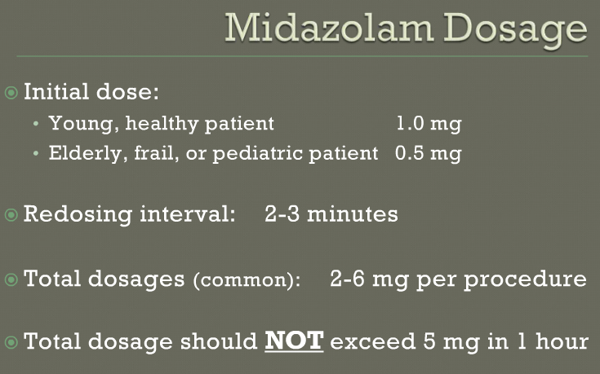

Lorazepam (Ativan®)
- adverse effects: propylene glycol (1,2-propanediol) toxicity (esp. in doses > 5-7 mg)
- propylene glycol is solvent used to deliver lorazepam and diazepam IV.
- incidence unknown
- manifestations: unexplained anion gap / metabolic acidosis / hyperosmolality.

Ketamine
- onset in ≈ 1 min; duration 10-20 min.
- the only intravenous induction agent that:
  - increases sympathetic tone → BP & heart rate↑ - useful in hypovolemic patients; avoid in CAD, hypertension, stroke.
  - increases cerebral blood flow → ICP↑.
- no respiratory depression, bronchomotor tone↓ (via block of vagally mediated bronchoconstriction) - appropriate agent for asthmatics, respiratory failure patients (administer drying agent [e.g. glycopyrrolate] or premedicate with atropine because of copious oropharyngeal secretions).
- NMDA receptor antagonist - produces dissociative anesthesia (catalepsy, catatonia, profound amnesia and potent somatic analgesia, but not necessarily complete unconsciousness) – patient appears awake but is unconscious, immobile (muscle tone↑) and feels no pain.
- can be used as sole anesthetic for brief, superficial procedures (esp. in children and young adults).
- laryngeal reflexes are maintained.
- produces no muscular relaxation, does not control visceral pain, and may not completely control patient movement - not useful for abdominal cases or delicate surgery.
- clinically important side effect - emergence delirium (H: supplemental benzodiazepines or volatile agents); contraindicated in psychiatric disorders.

Others
Clomethiazole (s. chlormethiazole)
- structurally related to thiamine (vit. B1) but acts like sedative, hypnotic, muscle relaxant and anticonvulsant.
- mechanism of action:
- positive allosteric modulator at barbiturate/picrotoxin site of GABA-A receptor.
- inhibits alcohol dehydrogenase - helps to relieve sudden effects of alcohol withdrawal in alcoholics.
- uses:
- widely used in treating and preventing symptoms of acute alcohol withdrawal.
- management of agitation, restlessness, short-term insomnia and Parkinson's disease in elderly.
- forms: 192 mg capsule, syrup.
- adverse effects: tolerance and physical dependence (abrupt withdrawal → apnoeic-tonic seizures).
- overdose (particularly toxic) - potentially fatal.

Buspirone (BuSpar®)
- unique chemically azaspirone (not chemically and pharmacologically related to benzodiazepines or barbiturates or other sedatives!).
- partial agonist at serotonin 5-HT_{1A} receptors; some affinity for D₂ and 5-HT₂ receptors.  - used as anxiolytic in long-term therapy of generalized anxiety disorders (efficacy comparable to benzodiazepines!).  - only minimal sedation! (+ does not potentiate CNS depression of ethanol) – most useful anxiolytic in elderly patients!  - effectively eliminates episodic outbursts of aggression and agitation in brain-damaged patients.  - minimal psychomotor and cognitive dysfunction.  - no respiratory depression.  - because higher doses cause dysphoria, patients do not escalate dose (dependence is unlikely, low addiction potential).  N.B. buspirone is not CNS depressant - cannot be directly substituted for benzodiazepines and does not suppress benzodiazepine withdrawal.  - at doses > 45 mg/d has antidepressant effect (but also at high doses may cause dysphoria).  - no anticonvulsant, hypnotic-sedating, myorelaxant properties.  - disadvantageous slow onset of action – must be given for 1 month before it is effective. | 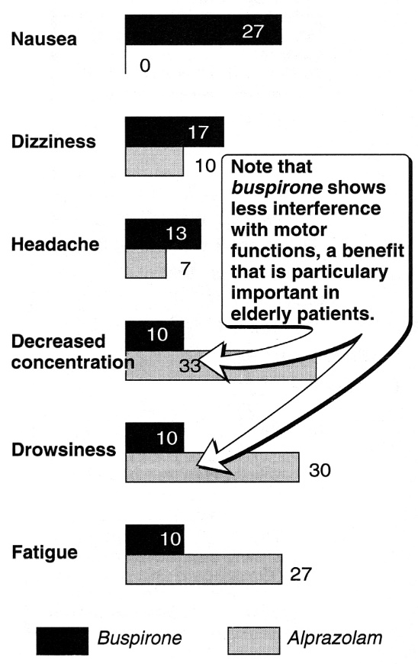
- adverse effects (rare) - headaches, nervousness, dizziness, lightheadedness.
Little potential for abuse!

Chloral hydrate
- trichlorinated derivative of acetaldehyde.
- must be metabolized by alcohol dehydrogenase to active metabolite trichloroethanol.
- weak but safe sedative-hypnotic - induces sleep in 30 minutes and lasts 6 hours (T_{1/2} = 4-10 hrs).
  - relatively safe;
  - little reduction in REM sleep;
  - has anticonvulsant properties;
  - mostly used for 1-3 nights to treat transient insomnia.
- adverse effects - unpleasant taste, GI tract irritation.
- CNS depressant effect potentiated by ethanol (combination chloral alcoholate is dubbed “Mickey Finn”); addiction can occur!
- also used externally as rubefacient, anesthetic, and antiseptic.
- chloral betaine is slowly hydrolyzed in GI tract to chloral hydrate.

Paraldehyde
- trimer of acetaldehyde (resembles chloral hydrate).
- potent sedative-hypnotic - induces sleep in 15 minutes and lasts 4-8 hours.
- has anticonvulsant properties.
- can be administered orally (strong offensive odor and disagreeable taste + GI tract irritation!), parenterally, rectally.
- eliminated via lungs – does not depend on liver / kidney status!
- used exclusively for alcoholics undergoing withdrawal from alcohol.
Do not use with disulfiram!

Glutethimide
- very narrow therapeutic index - formerly used as hypnotic and as daytime sedative.

Ethanol (ethyl alcohol)
- CNS depressant* with anxiolytic & sedative effects.
*synergizes with many other sedative agents and can produce severe CNS depression!
N.B. toxic potential outweighs benefits!
- shallow dose-response curve (sedation occurs over wide dosage range with ultimately hypnosis and coma).
- about metabolism and disulfiram – see p. 702 >>

Meprobamate
- propyl alcohol derivative (propanediol carbamate): hypnotic, muscle relaxant
- depresses CNS as shorter acting barbiturates (≈ phenobarbital).
- was widely used antianxiety agent → largely been replaced by benzodiazepines.
- well absorbed from GI tract.

Methocarbamol (Robaxin®)
- carbamate derivative of guaifenesin (expectorant).
- CNS depressant with musculoskeletal relaxant properties (related to sedative properties, because drug has no direct action on contractile mechanism, motor end plate or nerve fiber).
- indication - as adjunct to rest, physical therapy, and other measures in acute painful musculoskeletal conditions.
- mode of action - not been clearly identified.
- may inhibit effect of anticholinesterase agents (pyridostigmine) - use with caution in myasthenia gravis.

Nonbenzodiazepine Hypnotics
Zolpidem (Ambien®, Zolpimist®)
- imidazopyridine.
- selective for subtype 1 of benzodiazepine receptor (as quazepam).
- used as sedative-hypnotic (advantageous over benzodiazepines!)
- preserves sleep architecture!
- does not cause memory disturbances (as benzodiazepines do);
- minimal rebound insomnia;
- no tolerance, no withdrawal effects with prolonged use.
- no anticonvulsant, no myorelaxant properties.
- rapidly absorbed from GI tract, rapid onset of action, T_{1/2} ≈ 1,5-3 hours.
Zolpimist® - FDA approved oral spray for short-term treatment of difficulty with sleep initiation.
- adverse effects - nightmares, agitation, headache, GI upset, dizziness, daytime drowsiness.

Zaleplon (Sonata®)
- pyrazolopyrimidine; ≈ zolpidem.
- rapid onset of action with ultra-short duration.

Zopiclone
- cyclopyrrolone.

Eszopiclone (Lunesta®)
- cyclopyrrolone.
- mechanism of action - interaction with GABA-receptor at binding domains close to (or allosterically coupled to) benzodiazepine receptors.
- used as hypnotic; likely to become first choice agent for treatment of insomnia.
- shows continued efficacy at 12 months of continued use.
- less addictive than benzodiazepines.
- T_{1/2} ≈ 6 hr.
- higher doses (2-3 mg) are more effective for sleep maintenance, whereas lower doses (1-2 mg) are suitable for difficulty in falling asleep.

Ramelteon (Rozerem®)
- chemically related to melatonin.
- melatonin receptor agonist (high affinity and selectivity for MT₁ and MT₂ receptors, vs. MT₃ receptors).
- T_{1/2} ≈ 1-2,6 hrs.
- metabolized by liver.
- decreases [testosterone] and increases [prolactin] in serum.
- used as hypnotic for sleep-onset insomnia (8 mg within 30 minutes of going to bed).
- does not cause rebound insomnia.
- does not cause dependence (drug is not controlled substance!).
- adverse effects: headache, somnolence, etc.
- should not be used with fluvoxamine (ramelteon concentration↑↑↑).

Antihistamines
Nonprescription sedating antihistamines (diphenhydramine, doxylamine) are effective only in mild forms of situational insomnia.
- anticholinergic side effects make them less useful than benzodiazepines.
hydroxyzine - antihistamine with antiemetic activity.
- low tendency for habituation - useful for anxiety with history of drug abuse.
- also used for sedation prior to dental procedures.

Bibliography for “Sedatives, Hypnotics” → follow this link >>

Viktor’s Notes℠ for the Neurosurgery Resident
Please visit website at www.NeurosurgeryResident.net

