Language, Speech
Last updated: May 8, 2019
pediatric development stages 1
anatomical basis 1
Disorders 3

language is brain's use of symbols for communication; i.e. cognitive aspect of symbolic communication.

- animal models have limited role (in study of human language).
- anatominės struktūros, reikalingos kalbai, atsirado jau prieš 500.000 metų, tačiau kalba per se turbūt atsirado prieš 100.000 metų rytų Afrikoje.

- language is one of fundamental bases of human intelligence and key part of human culture.
- humans receive language through listening / reading.
humans express language through speaking / writing;
N.B. speech is vocal expression of language.

pediatric development stages
6 months – beginning of distinct babbling.
1 year – 1-word speaker (language understanding, 1 or more poorly pronounced words).
2 years – 2-word (telegraphic) speaker (žodynas > 50 žodžių, kalba dvižodėmis frazėmis).
3 years – 3 word sentences (žodynas ≈ 1000 žodžių).
4 years – close to adult speech competence.

anatomical basis
- localized to neocortex! (vs. memory and learning are functions of large parts of brain).
- human neocortical mantle is highly developed → speech and other intellectual functions.
- primary language areas are in parasylvian area of dominant (categorical) hemisphere:
Wernicke center – auditory association cortex - memory of images that represent word as heard / seen (receptive speech), i.e. comprehension of auditory / visual information (visual information prieš tai turi būti apdorota in angular gyrus).
Planum temporale (superior surface of temporal lobe posterior to Heschl's gyrus and extending to posterior end of sylvian fissure), is slightly larger on left (Wernicke center).
Arcuate fasciculus – projection from Wernicke to Broca.
Broca center – motor association cortex - memory for word articulation (expressive speech);
processes information received from Wernicke area into detailed coordinated pattern for vocalization → projects pattern (via speech articulation area in insula) to motor cortex → appropriate movements of lips, tongue, larynx → speech.
Angular gyrus (behind Wernicke area and connected to it) processes information from read words in such a way that they can be converted into auditory forms of words in Wernicke area.
- į angular gyrus patenka informacija iš unimodal association cortices (tiek iš visual, tiek iš auditory); jei išgirstą / pamatytą žodį tereikia pakartoti, informacija iš Wernicke / visual association cortex į Broca eina aplenkdama angular gyrus.
- angular gyrus is heteromodal association cortex - semantic interpretation (meaning) and integration with other sensory modalities and passed experiences.

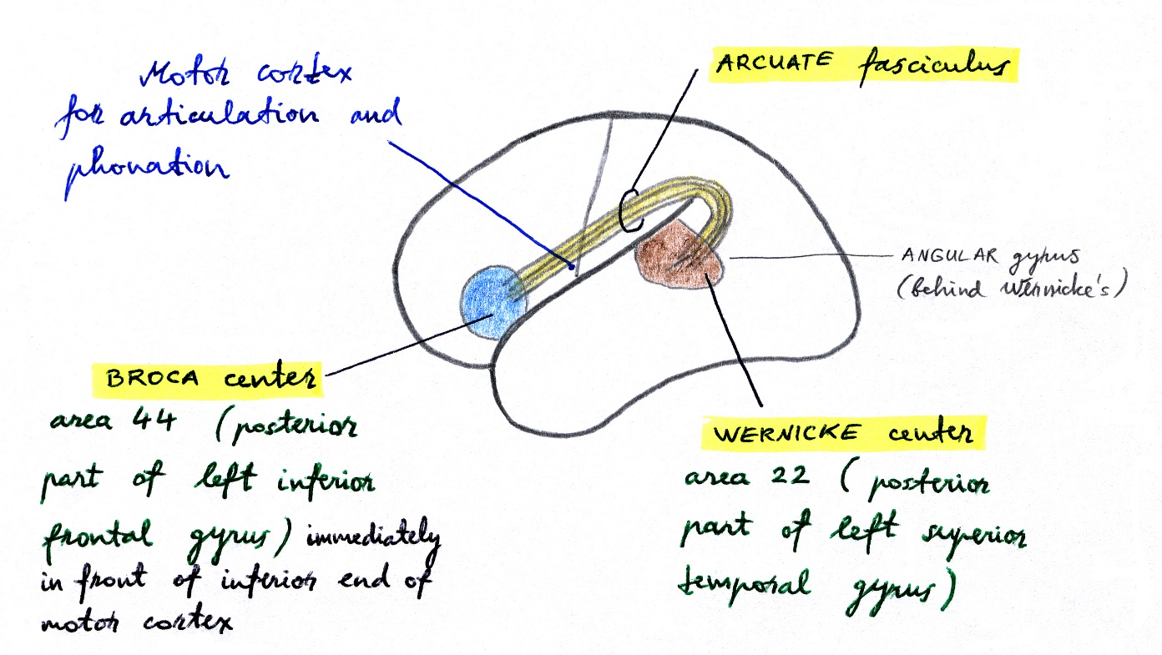

Second language & Broca area
- if individual learns second language in adulthood, portion of Broca area associated with it is adjacent to but separate from area associated with native language.
- in children who learn two languages early in life, there is only single area involved with both (children acquire fluency in second language more easily than adults!).

Wernicke-geschwind model for language & gestures
Person names visual object:
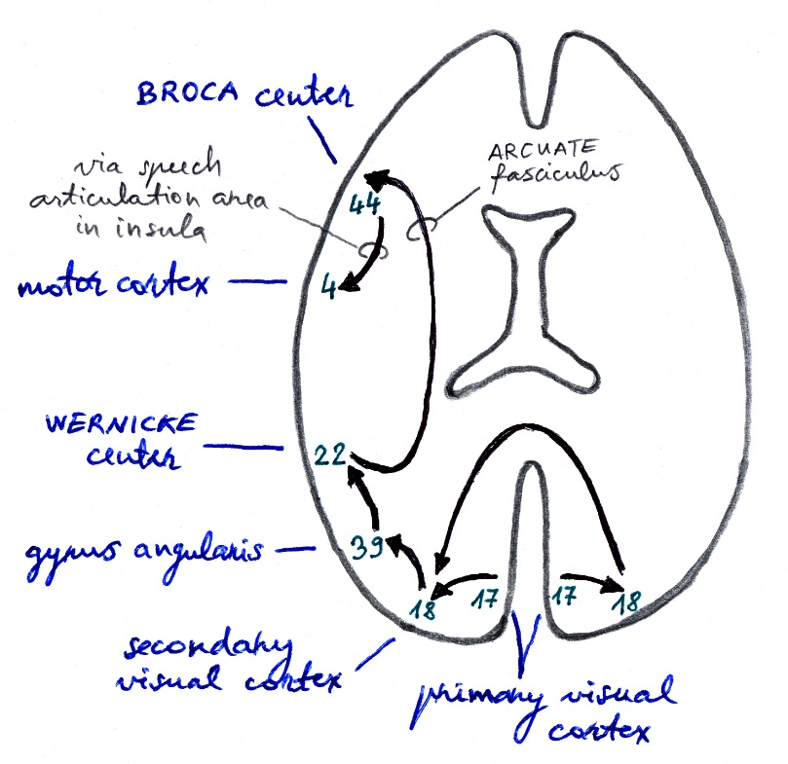

Person is asked to raise right hand: | Person is asked to raise left hand:
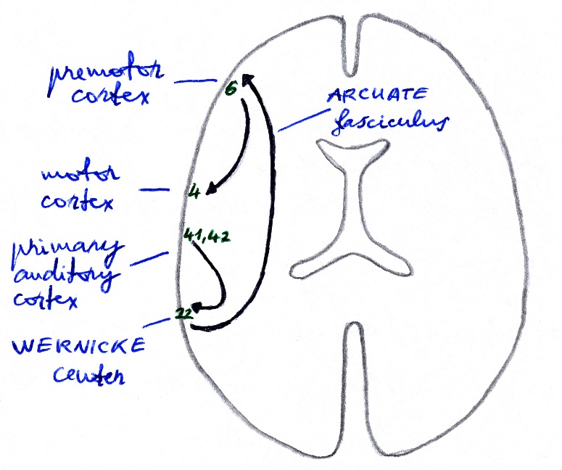 | 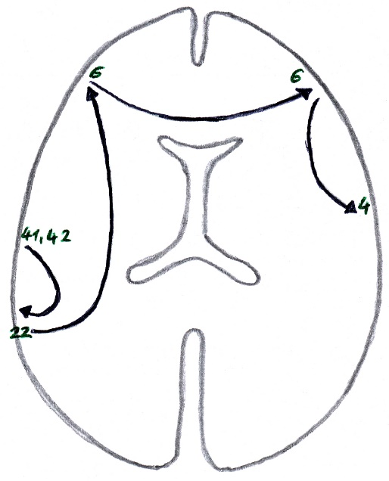

N.B. norint pagal komandą pakelti kairę ranką, reikalingas corpus callosum
(jei jis pažeistas → kairės rankos ideomotorinė apraksija).

PET of left cerebral hemisphere:
A: Looking at words activates primary visual cortex and part of visual association cortex.
B: Listening to words activates area at junction of temporal and parietal cortex.
C: Speaking words activated Broca's area and adjacent frontal lobe.
D: Thinking about words activates large areas (including much of frontal lobe).

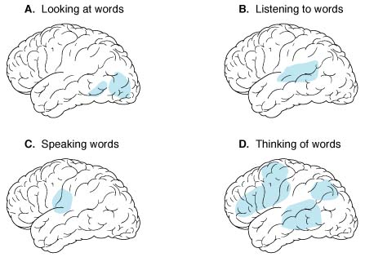

Disorders
If patient cannot talk properly consider five Ds:
- Deafness
- Dementia
- Dysphasia
- Dysarthria
- Dysphonia.

- Language disorders – kalbos, kaip bendravimo priemonės, sutrikimas. see S2 p.
- Speech disorders – mechanical disorders of oral communication: see S3 p.
dysphonia – disturbance in phonation-vocalization (voice production).
dysarthria – disturbance in articulation of individual sounds.

Bibliography
NMS Neuroanatomy 1998
Ganong “Review of Medical Physiology”, 2002
“The Merck Manual”, 17th ed., 1999
Goldman “Cecil Textbook of Medicine”, 21st ed., 2000 (2040-2042 p.)
McPhee, Lingappa, Ganong “LANGE Pathophysiology of Disease”, 2002
Weiner “Neurology (House Officer Series)”, 5th ed., 1994 (P9-P15 p.)
Goetz “Textbook of Clinical Neurology”, 1st ed., 1999 (70-89 p.)
Rowland “Merritt's Textbook of Neurology”, 9th ed., 1995 (8-10 p.)

Viktor’s Notes℠ for the Neurosurgery Resident
Please visit website at www.NeurosurgeryResident.net

