Amnestic syndrome
Last updated: May 8, 2019
Definitions, Clinical Features 1
Anatominis substratas 2
etiology 3
diagnosis 3
treatment 5
DBS 5
Age-associated memory impairment 6
Korsakoff syndrome (s. psychosis) 6
Transient Global Amnesia 7
Factitious (Psychogenic) Amnesia 8

Definitions, Clinical Features
Amnesia - syndrome with disturbance of recent memory (but not immediate memory!) – i.e. disturbance of learning new information.
Amnesia - disorder of declarative memory that cannot be accounted for by nonmnemonic deficits (attention, perception, language, motivation, etc).
- minimum it interferes with daily activities & quality of life.
- many patients have other cognitive difficulties as well, but they must be mild and do not account for memory deficit! (otherwise, patient would be classified as demented, with memory being one of multiple deficits).
N.B. pure amnesia is quite rare!

Nukenčia ryšys tarp memory store ir cognitive system:
  - neįmanomas declarative learning, kuriam reikalingas cognitive system tarpininkavimas (t.y. informacija neužkoduojama į short-term memory).
  - galimas reflexive learning (classic conditioning, skill learning, priming), kuriam nereikalingas cognitive system tarpininkavimas (patients learn very slowly, but once material is learned, they appear to forget at normal rate).
N.B. motor skill learning is intact, regardless of sensory channel in which it is presented!
  - cognitive system intact – unimpaired intelligence; preserved judgment – patients are aware of having memory problem (but they underestimate problem severity because they are aware only of memory difficulties at present moment).
  - immediate memory nenukenčia! (pvz. parodžius “7”, po to liepus pakartoti, jis pasakys “7”; bet jei nors trumpam nukreipiamas dėmesys, pacientas skaičiaus nebeprisimena).
  - remote memory (previously learned information) is more or less preserved.

Anterograde amnesia - inability to learn new information (i.e. acquire new declarative memories).
Retrograde amnesia - loss of already learned information (i.e. memories acquired prior to amnesia onset):
- flat retrograde amnesias - extend back uniformly through individual's life.
- temporally graded retrograde amnesias (more common) - more recent memories most vulnerable and remote memories most likely to be spared.

- amnesia by definition is anterograde amnesia (inability to learn new information), but retrograde loss of memories is frequently (but variably) present.
N.B. most amnesic disorders are primarily anterograde! (exception – psychogenic amnesia)
- in general, severity of anterograde and retrograde amnesias are correlated.

Global amnesia - extends to both verbal and nonverbal information (i.e. all sensory channels).
Modality specific amnesia (for events processed by single sensory channel).

Associated clinical features:
- confusion & total disorientation (except for self) → repetitive questioning.
N.B. confusion simply reflects response to amnesia (e.g. if amnesic patient asks what the date is, he will forget any answer provided within moments).
absence of confusion & repetitive questioning in chronic amnesia patients reflects eventual accommodation to amnesic state.
- confabulation – patients spontaneously describe events that never occurred ("honest lying") – filling time periods that cannot be recalled (false "filling in" of memory gaps); pacientas kalba taip įtikinamai (nes pats tuo neabejoja), kad gydytojas net gali patikėti.
- various subtle emotional changes.

Anatominis substratas
– bilateral lesion of “corridor” (mediotemporal & diencephalic structures):
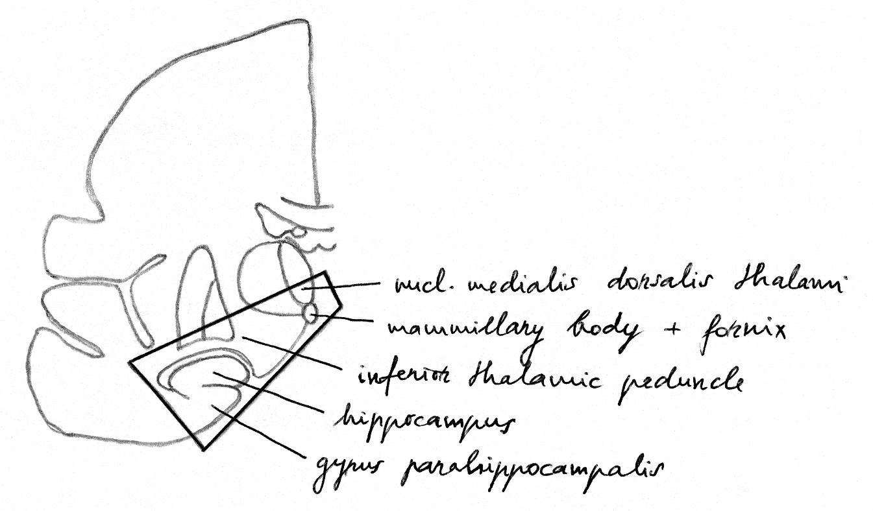

Amnesia mainly implies injury to:
- bilateral mediotemporal (temporolimbic) structures.
greater injury to left structures → predominant verbal amnesia;
greater injury to right structures → predominant visual amnesia.
- diencephalic (midline limbic) structures.

Anatomic Site of Damage | Memory Finding
Frontal lobe (frontal-subcortical circuit) | Working memory (lateralized deficits) - retrieval deficit syndrome: impaired recall with spared recognition.
Basal forebrain | Domain-independent declarative memory deficits.
Ventromedial cortex | Frontal lobe-type declarative memory deficits.
Hippocampus and parahippocampal cortex | Bilateral lesions - global amnesia.  Unilateral lesions - lateralization of deficits (left: verbal deficits; right: spatial deficits).
Fornix | Global amnesia.
Mammillary bodies | Declarative memory deficits, confabulation.
Dorsal and medial dorsal nucleus thalamus | Declarative memory deficits, confabulation.
Anterior thalamus | Declarative memory deficits.
Lateral temporal cortex | Autobiographical memory deficits.

etiology
Most common causes of reversible (treatable) memory disturbances:
- intracranial masses (involving limbic system)
- normal pressure hydrocephalus
- thyroid dysfunction
- vitamin B₆ deficiency
- depression
- epilepsy (medial temporal-lobe epilepsy causes most memory problems).
- drugs, acute or chronic alcohol intoxication

Other causes:
- Dementias (amnesia is often initial symptom!)
- Strokes (esp. posterior cerebral artery, anterior communicating aneurysm)
- Head injury
- Anoxic/ischemic encephalopathy (e.g. cardiopulmonary resuscitation), hypoglycemia
- Encephalitides
- Temporal lobe surgery
- Electroconvulsive therapy
- Transient global amnesia
- Psychogenic

diagnosis
see also examination techniques
N.B. patients are limited to provide information about their history (especially demented patients) - requires considerable cooperation from patient's family or caregivers.
- patients with high levels of premorbid functioning:
- may mask severity of current problems (can effectively compensate for memory loss).
- may be most sensitive to and concerned about memory disturbances (they may interpret age-associated disturbances as Alzheimer's harbingers).
- patient performs well on tests of attention, reasoning, and general information as long as tests do not make demands on declarative memory.
N.B. many tests of cognition require some degree of declarative memory - intelligent amnesic patients may earn poor score on standard dementia rating scale.

- First goal - determine whether memory impairment is secondary to specific perceptual, motor, cognitive disability or broad impairment of mental status.
- Second goal - characterize nature of primary memory problem - by use of brief tests of immediate, long-term, and remote memory.
    - immediate memory (s. working memory, attention) is relatively spared even in most severe amnesias and moderate dementias; capacity is 7 ± 2 bits (i.e. 5-9 bits) - failure to immediately repeat 5 digits suggests problem in attention or orientation!
    - long-term memory (s. short-term memory, learning) tests assess ability to learn new material and evaluate possibility of anterograde amnesia.
    - remote memory (s. long-term memory, intelligence) - evaluates possibility of retrograde amnesia.

Neuropsychological Tests – differentiate "pure" memory deficit vs. general cognitive dysfunction.
anterograde memory
most widely used test is Wechsler Memory Scale, Revised (WMS-R); criteria for amnesia diagnosis - normal attention-concentration score + impaired delayed recall score.
retrograde amnesia is more difficult to assess:
- culturally, geographically, and temporally specific to individual.
- difficult to ascertain what person knew years ago.
e.g. Boston Retrograde Amnesia Battery (BRAB).
Simulated memory disorders (esp. when amnesia would result in financial or legal gain).
- often patients mimic psychogenic amnesia (as shown in movies) and report total retrograde amnesia without any anterograde amnesia.
- true retrograde amnesias are highly selective in terms of what is forgotten (e.g. true psychogenic amnesia patients forget their identity & personal history, but they often remember public events, vs. lesion-induced retrograde amnesia patients remember their identity and forget personal and public experiences).
- approaches to distinguishing real from feigned anterograde memory loss:
  - easy multiple-choice recognition tests - pseudoamnesic patients perform less well than chance if they systematically avoid selecting correct response.
  - implicit memory tests (e.g. Colorado Malingering Tests) - yield normal results in true amnesic patients!

- Third goal - determine etiology:
  - neurological disease in any relatives or possibility of consanguinity should be pursued - uncovering genetic etiology (e.g. Huntington's disease, atypical early-onset Alzheimer's disease).
  - detailed drug history:
alcohol may lead to memory dysfunction through Wernicke-Korsakoff psychosis or hepatorenal encephalopathy;
many medications directly or indirectly (e.g. via lethargy) reduce memory performance.
  - refined volumetric assessment of deep cortical structures (such as hippocampal formation and amygdala) are better visualized by MRI.
diffuse atrophy typifies Alzheimer's disease, vs. prominent frontal or parietal atrophy is characteristic of Pick's disease.

Differential diagnosis:
- acute decline to chronic level of memory dysfunction - stroke or anoxic episode.
- abrupt onset with stepwise progression - vascular-based memory problem (multi-infarct dementia).
- insidious, slowly progressive, chronic decline - alcohol-related dementia, Alzheimer's disease.
- more rapid progression (over weeks to months) - depression-related memory loss, primary or metastatic tumors, encephalitis.

- dementia - chronic and substantial decline in ≥ 2 areas of cognition, i.e. amnesia + at least one of following: aphasia, agnosia, executive function disturbance.
- dementias marked by memory loss (e.g. Alzheimer's disease).
- dementias marked by relative memory sparing (e.g. Pick's disease).
- acute confusional states = amnesia + alterations in arousal, disruption of sleep-wake cycle, impairment in stream of logical thought.

treatment
- primary consideration is patient safety (patients have limited ability to take care of themselves).
- informing patient involves judgment about what information is useful to patient:
- it is desirable to have patient feel that he / she is at management center.
- patients remember little of what is told to them, and discussions may produce distress with no benefit.
- if patient is still working, retirement plan should be initiated.
- plan for daily supervision of patient;
- family must have as clear picture as possible about patient's abilities & disabilities;
- remind family members that patients retain many intellectual and emotional capacities;
N.B. patients and family members are often surprised by contrast between anterograde amnesia and relative preservation of memory for remote periods.
- even severe patients can slowly adapt to regular, well-structured schedule in familiar environment.
- in progressive diseases, hospitalization is inevitable.
- legal issues (such as conservatorships) arise at some stage of disease;
- chronic amnesia - patient's judgment may remain intact.
- dementia - judgment typically declines considerably.
- patients with mild / moderate amnesias (and without other major cognitive deficits) can use notes or computers to keep record of goals and appointments; vs. patients with severe amnesia or substantial additional cognitive deficits cannot use external memory devices effectively (they cannot even remember to use devices).
- large burden on family - monitor mental health of family members and encourage to use of appropriate resources (incl. social services and support groups).
- memory loss may be modestly improved with cognitive rehabilitation techniques.
- medications (acetylcholinesterase inhibitors – tacrine, donepezil) can enhance memory function in Alzheimer's disease.

DBS
- stimulation of the fornix (when attempting to modulate appetite in an obese patient) evoked detailed autobiographical memories (Hamani et al., 2008).
- direct low-frequency stimulation to the hippocampus acutely impairs recognition memory in normal human subjects (Coleshill et al., 2004), particularly disrupting the encoding phase (Lacruz et al., 2010).
- low-frequency stimulation to neighboring entorhinal cortex enhances spatial memory in cognitively normal human subjects when applied during the learning phase (Suthana et al., 2012) - stimulation here increased theta power and theta-phase resetting in the ipsilateral hippocampal EEG (which is associated with new memory formation as described above); it does not appear to address other cognitive deficits such as problems with attention, perception and executive function.
- trials of stimulation to the NBM are ongoing.

Age-associated memory impairment
- it is not amnesia or dementia!
- it is still unclear whether it is only preclinical forms of age-related diseases (e.g. Alzheimer's disease) or independent process.
- age-associated changes vary considerably for different kinds of cognition and memory:
- Selective impairment of recent memory (tačiau tai dažnai maskuoja demencija, depresija).
- Working memory capacity declines constantly across life span (aging affects strategic memory).
- Semantic memory is affected only in very old age (names → events → spatial)
- Nondeclarative memory:
few, if any, changes in priming;
severe declines in conditioning.
Criteria for age-associated memory impairment:
- memory difficulty sufficient to impair daily functioning
- otherwise adequate intellectual background
- absence of causative medical or psychiatric condition (e.g. dementia).

Korsakoff syndrome (s. psychosis)
- described by S.S. Korsakoff, Russian psychiatrist, in series of articles from 1887-1891; he termed this syndrome psychosis polyneuritica (believing that memory deficits and alcoholic polyneuropathy represented different facets of same disease).

Etiology
- Thiamine deficiency (sergant chroniniu alkoholizmu!!!).
- Hemorrhage (subarachnoid, thalamic)
- Neoplasms (paramedian posterior thalamic region)
- Head injury
- Epilepsy
- Anoxia
- often develops after severe / repeated attack of postalcoholic delirium tremens.
- frequently coexists with (or is preceded by) Wernicke syndrome (Korsakoff occurs in 80% Wernicke patients).

Anatomical lesion
  - diencephalon (mammillary bodies, nucl. medialis dorsalis thalami)
  - medial temporal lobes
  - connecting pathways of these regions.

Clinical Features
- very severe memory impairment - anterograde and retrograde (esp. for recent events!!!).
- resultant confusion - general disorientation to time, place, and purpose (esp. to time).
- compensatory confabulations (filling in of memory gaps with data patient can readily recall; fabrications may be so convincing that underlying disorder is not detected) - striking early feature!
- emotional changes usually develop - apathy, blandness, mild euphoria with little / no response to events (even frightening ones).

- remote memory may be less affected - patient's previous experience can guide his actions so that there may be little apparent intellectual loss.
- stupor or coma can be observed in more severe cases.

Treatment
  - thiamine supplementation
  - adequate hydration (special attention to vitamin and caloric requirements).
Early treatment can prevent persistent amnestic state!

Prognosis
- often irreversible (esp. in alcoholics); improvement may occur for as long as 12-24 mo after onset (patient should not be prematurely institutionalized!).
- prognosis is fairly good in head injury, SAH.
≈ 20% patients recover completely from amnestic deficit!; others leave in Korsakoff amnestic state.

Transient Global Amnesia
- rare syndrome of sudden onset of severe anterograde amnesia; immediate registration of events (e.g. serial digits) is intact.
    - retrograde amnesia is also common - usually extensive and temporally graded (can extend back for several years).
    - attack is accompanied by confusion → patients classically ask many questions repeatedly, total disorientation (except for self! – can answer questions about job, address, etc).
    - physical and neurologic examination (incl. mental status) is otherwise normal.
    - duration ranges minutes ÷ day (typically lasts for hours).
    - during gradual recovery, retrograde amnesia clears in forward fashion, but patient retains amnesia for attack period ± for a few hours preceding it; total recovery is the rule!
Permanent memory loss is rare!
    - attacks recur in < 25% patients (< 5% experience > 3 attacks).
    - etiologic theories:
- transient ischemia in posterior circulation (posteromedial thalamus or hippocampus bilaterally) – most common!
N.B. reduced blood flow to thalamus is documented during attack (but could be secondary to thalamic dysfunction rather than its cause)
- medial temporal lobe seizure activity
- migraine attacks.
- patients are usually otherwise healthy middle-aged or elderly.
- seems to be association with strenuous exertion, sexual intercourse, emotional stress.
- no special treatment is indicated (benign natural history); antiplatelet agents could be helpful for prophylaxis?

Factitious (Psychogenic) Amnesia
- retrograde amnesia (remote ≥ recent!).
- highly selective in terms of what is forgotten - patients forget their identity & personal history (maximal for emotional crises), but remember public events.
vs. organic retrograde amnesia patients remember their identity (never disoriented to self!).
- patients are able to learn new information (no antegrade amnesia!) - sharp contrast to true (organic) amnesia!

Bibliography
NMS Neuroanatomy 1998, Psychiatry 2001, Behavioral Sciences in Psychiatry 1995
Ganong “Review of Medical Physiology”, 2002
McPhee, Lingappa, Ganong “LANGE Pathophysiology of Disease”, 2002
“The Merck Manual”, 17th ed., 1999 (1382-1384 p.)
Goldman “Cecil Textbook of Medicine”, 21st ed., 2000 (2038-2040 p.)
Goetz “Textbook of Clinical Neurology”, 1st ed., 1999 (56-69 p.)
Rowland “Merritt's Textbook of Neurology”, 9th ed., 1995 ch. 136 (872-873 p.)
Marshall B. Allen, Ross H. Miller “Essentials of Neurosurgery: a guide to clinical practice”, 1995 (59-70 p.); Publisher: McGraw-Hill, Inc.; ISBN-10: 0070011168; ISBN-13: 978-0070011168

Viktor’s Notes℠ for the Neurosurgery Resident
Please visit website at www.NeurosurgeryResident.net

