Delirium (Acute Confusional State, Acute Organic Brain Syndrome)
Last updated: May 8, 2019
etiology 2
clinical features 2
diagnostic evaluation 3
DSM-IV diagnostic criteria 4
CAM (Confusion Assessment Method) diagnostic algorithm 4
treatment 4
Prognosis 5

Delirium - changed level of consciousness + clouding of consciousness (confusion) → inability to maintain attention* → global change in cognition.
*main difference from dementia.
Lot. delirare – “išeiti iš vėžių”.
Delirium tremens – see p. Psy21 >>

level of consciousness (wakefulness-alertness-arousal) - maintained by ARAS (upper brainstem RF, thalamus).
- diminished level of consciousness (drowsiness, stupor, coma) results from depression of both cerebral hemispheres or ARAS. see p. S30 >>

content of consciousness (awareness-thinking) - depends on integrated and organized thoughts, subjective experiences, emotions, and mental processes, each of which resides (to some extent) in anatomically defined cerebral cortex regions.
- clouding of consciousness (confusion) - is behavioral state of reduced mental clarity (inability to maintain coherent sequence of thoughts).
N.B. confusion is disorder of content of consciousness.
- inattention and disorientation are main early signs.
- as acute confusional state worsens there is global change in cognition (deterioration in memory, perception, comprehension, problem solving, language, praxis, visuospatial function, various aspects of emotional behavior).
encephalopathy = confusion + element of drowsiness.
Delirium is toxic / metabolic encephalopathy!

Organic brain syndrome - global cognitive impairment states whose unifying and defining feature is confusion:
acute organic brain syndrome = delirium
chronic organic brain syndrome = dementia
- organic brain syndromes are secondary to CNS disease, systemic disorders, or substance-related disorders.
- DSM-IV no longer classifies delirium & dementia as "organic" mental disorders that erroneously imply that other (primary) mental disorders are nonorganic.
- if delirium is superimposed on preexisting dementia, it is considered associated feature of dementia, not separate diagnosis.

Levels of mental status: | delirium (circle shows primary area of dysfunction):
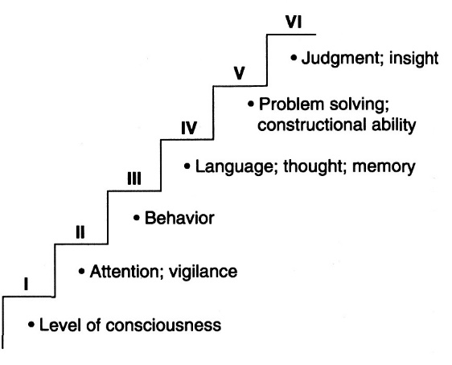 | 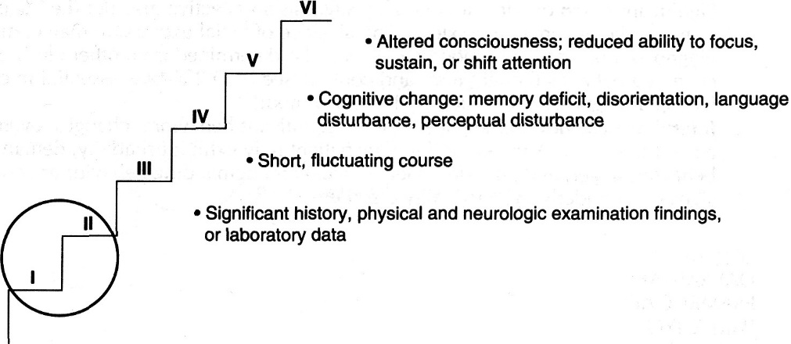

- 10-15% patients admitted to acute care hospitals have delirium!

etiology
- delirium is direct physiological consequence (nonspecific CNS manifestation) of acute disorder with diffuse effect on brain:
  - brain disorders (head injury, stroke, ICP↑, infection, epilepsy).
- delirium occurs in 80% patients at end of life.
  - medical systemic illness (respiratory failure, fever, MI or heart failure, hepatic, renal, endocrine, metabolic disorders, infections!!!).
- diabetes mellitus is most common metabolic cause!
- immobilization and immobilizing devices (e.g. indwelling bladder catheters, physical restraints) are important factors in precipitating delirium!
  - substance intoxication or substance withdrawal (alcohol, drugs)
- psychoactive drugs (esp. with anticholinergic or sedative-hypnotic properties) in standard adult dosages are particularly common causes of drug-induced delirium in elderly! (risk increases directly with number of drugs prescribed).
- diagnosis of “substance-induced delirium” should not be made unless symptoms exceed those that would be expected during typical intoxication or withdrawal.
Almost any severe acute medical / surgical condition can cause delirium!
- environmental factors (unfamiliar surroundings, sleep deprivation, deranged schedule, frequent room changes, sensory overload / sensory deprivation) may aggravate delirium in hospital.
- in patients with predisposing (vulnerability) factors, even relatively benign insult (such as single dose of sleeping medication) may cause delirium; predisposing (vulnerability) factors:
- preexisting dementia (2-5-fold increased risk for delirium)
- advanced age (geriatric / degenerative cerebral cell loss, concomitant diseases → more vulnerable brains)
Relatively mild systemic illness (esp. in combination with new medications, fever, sleep deprivation) may produce delirium in elderly / demented patient!
Delirium is more common herald of onset of physical illness in elderly than fever, pain, and tachycardia!
- severe underlying illness, high levels of comorbidity, functional impairment
- chronic renal insufficiency
- dehydration, malnutrition
- vision or hearing impairment

clinical features
- develops over short period of time (hours ÷ days).
- fluctuates during day course! (often worsening at night – “sundowning”)
- main features: inattention & disorientation (time > place > person*) → difficulty with memory and all mental activities** (distinction from dementia depends simply on acute nature of condition).
Disturbance in attention is central to diagnosis of delirium! (indicated by inability to repeat five digits forward or recitation of months backward)
disproportionate (!) difficulty with immediate recall (e.g. of list of three items) suggests depression, while difficulty with recalling items 5 min later suggests dementia
Delirium may be present in patient who is completely oriented to person, place, and time ("mental status examination" that solely assesses orientation may not detect delirium!).
*only in the most severe cases person is unable to identify self!
**to establish diagnosis (of delirium or dementia), physician must show that there has been decline from patient's baseline cognitive functioning.
- associated features: patient's behavior is unpredictable!
- sleep-wake cycle disruption / reversion
- level of consciousness is ↓ or ↑ - drowsy-somnolent or restless-agitated (hypoactive or hyperactive delirium).
- irritability, emotional lability
- some autonomic system abnormalities (pulse, BP, temperature, perspiration, respiratory rate, etc) vs. dementia.
- illusions and hallucinations – visual ± auditory (vs. only auditory in acute psychosis).
- some delusions - transient, poorly organized (vs. systematized in acute psychosis).
- most pertinent sign of metabolic encephalopathy is asterixis.
- language is disorganized and rambling, even paraphasic + impaired comprehension (due to inattention) - may be mistaken for aphasia.
- psychiatrists use term “delirium” interchangeably with “confusion”; neurologists prefer to reserve it as description for agitated, hypersympathotonic, hallucinatory state most often due to alcohol / drug withdrawal or to hallucinogenic drugs.

Characteristic | Delirium | Acute psychosis
Vital signs | Abnormal (fever, tachycardia) | Normal
Prior psychiatric history | Uncommon | Common
Course | Rapid fluctuating | Stable
Involuntary activity | Possible asterixis, tremor | Absent
Orientation | Usually impaired | Occasionally impaired
Attention | Globally impaired | May be disorganized
Concentration | Globally impaired | Impaired
Hallucinations | Visual ± auditory | Primarily auditory
Delusions | Transient, poorly organized | Systematized
Speech | Pressured, slow, possible incoherent | Usually coherent

diagnostic evaluation
- dictated by findings during history and physical examination.
Evidence of drug ingestion should be sought on examination!
First-line investigations: electrolytes, CBC, liver and thyroid function tests, ESR, toxicology screen, syphilis serology, blood cultures, urine culture, chest x-ray, ECG.
Additional investigations to consider: neuroimaging, CSF analysis, EEG, HIV antibody titer, cardiac enzymes, blood gases, autoantibody screen.
- characteristic EEG changes (accompany fluctuating state of awareness) - diffuse symmetric slowing of background EEG rhythm (5-7 cycles/sec; due to reduced cerebral metabolic activity) ± triphasic waves (e.g. in hepatic or renal encephalopathy)
    - normal EEG is incompatible with severe delirium!
    - recovery from delirium is accompanied by EEG rhythm acceleration.
    - in delirium tremens, cerebral blood flow is normal rather than reduced - low-voltage fast activity predominates in EEG.
- any patient with fever & cognitive dysfunction, even without meningismus (esp. if immunocompromised), should have lumbar puncture in ED to rule out meningitis!

DSM-IV diagnostic criteria
- Disturbance of consciousness (i.e. reduced clarity of awareness of environment) with reduced ability to focus, sustain, or shift attention.
- Change in cognition (e.g. memory deficit, disorientation, language disturbance) or development of perceptual disturbance (that is not better accounted for by preexisting, established, or evolving dementia).
- Disturbance develops over short period (hours ÷ days) and fluctuates during course of day.
- Evidence from history, physical examination, or laboratory findings indicates that disturbance is caused by direct physiologic consequences of general medical condition.

CAM (Confusion Assessment Method) diagnostic algorithm
- diagnosis requires presence of features 1 and 2 and either 3 or 4:
Feature 1. Acute onset and fluctuating course
Feature 2. Inattention
Feature 3. Disorganized thinking
Feature 4. Altered level of consciousness

treatment
General supportive & symptomatic measures + treatment of underlying condition (after elimination of cause, delirium is reversed, sometimes slowly)!
Nonpharmacologic approaches should be used!
Delirium is medical emergency - disease or drug intoxication may be fatal if untreated (esp. in elderly patient)!
- successful delirium treatment eliminates much of this excess mortality.
- two best predictors of fatal outcome are advanced age and presence of multiple physical diseases.

Minimize disruptive influences of environment (to minimize confusion):
- quiet, low but well-lighted room.
- frequent reassurance and orientation (by relatives and personnel) with simple instructions and explanations, and frequent eye contact.
- same staff in attendance.
- clocks and calendars should be provided.
- eyeglasses and hearing aids may reduce sensory deficits.
- allow uninterrupted period for sleep at night!!!
- nonpharmacologic approaches to relaxation (music, relaxation tapes, massage) can be highly effective!
- minimize immobilizing equipment (e.g. bladder catheters)

Review medication list (incl. OTC); psychoactive medications should be discontinued (in elderly, these medications may cause psychoactive effects even at doses and measured drug levels that are within “therapeutic range”).

agitated patients (may interrupt needed medical therapies [e.g. intubation, intravenous lines] or may endanger safety of patient or other persons):
- pharmacologic control (end point should be awake but manageable patient):
- haloperidol is drug of choice (0.5-1 mg IM - optimal duration of action; repeat q30 min until sedation is achieved) - lacks serious respiratory, cardiac, or other organ system effects!; may becombined with lorazepam; taper dose in next few days as agitation resolves.
- droperidol is preferable when both sedative and antiemetic properties are indicated.
- diazepam should be avoided (oversedation → confusion↑, respiratory depression, long half-life, risk of drug accumulation), but benzodiazepines are drugs of choice for withdrawal from alcohol or sedative hypnotics where long half-life of action is desirable.
- physical restraints (not advisable) - increase agitation, have been associated with significant patient injuries and even death by asphyxiation.

Prognosis
- mortality 25-33%!
- delirium typically persists for ≥ 30 days.
- only 20% patients have complete resolution at 6-month follow-up.

Bibliography
Goetz “Textbook of Clinical Neurology”, 1st ed., 1999 (3 p.)
Rowland “Merritt's Textbook of Neurology”, 9th ed., 1995 (1-8 p.)
“Cecil Textbook of Medicine” 2007 section IV (ch. 21-26)
Marshall B. Allen, Ross H. Miller “Essentials of Neurosurgery: a guide to clinical practice”, 1995 (63-64 p.); Publisher: McGraw-Hill, Inc.; ISBN-10: 0070011168; ISBN-13: 978-0070011168
“Harrison's Principles of Internal Medicine”, 1998
Weiner “Neurology (House Officer Series)”, 5th ed., 1994 (170 p.)
“Washington Manual of Medical Therapeutics”, 29th ed., 1998 (479 p.)
Rosen “Emergency Medicine: Concepts and Clinical Practice”, 4th ed., 1998 (2132-2141 p.)
“Stedman’s Medical Dictionary”, 27th ed., 2000
“Oxford Handbook of Clinical Medicine” 1994 (446 p.)
“Oxford Handbook of Clinical Specialties” 1995 (350-351 p.)
NMS Medicine 2000, Emergency Medicine 1997, Psychiatry 2001, Behavioral Sciences in Psychiatry 1995
“The Merck Manual”, 17th ed., 1999

Viktor’s Notes℠ for the Neurosurgery Resident
Please visit website at www.NeurosurgeryResident.net

