Posterior reversible encephalopathy syndrome (PRES), s. Reversible posterior leukoencephalopathy syndrome (RPLS)
Last updated: May 8, 2019
Causes 1
Diagnosis 1
Treatment 3

PRES - syndrome characterized by headache, confusion, seizures and visual loss. It may occur due to a number of causes, predominantly malignant hypertension, eclampsia and some medical treatments. On magnetic resonance imaging (MRI) of the brain, areas of edema (swelling) are seen. The symptoms tend to resolve after a period of time, although visual changes sometimes remain. It was first described in 1996.

Causes
PRES occurs due to the use of drugs like tacrolimus and cyclosporine, hence it may occur in people who have undergone an organ transplant, in which these drugs may be used to suppress transplant rejection. It also occurs due to eclampsia, severe high blood pressure and hypercalcemia. Low magnesium levels can augment PRES.

Diagnosis
T2-MRI - hyperintense densities.
Cerebral angiography may provide a more definite diagnosis.

Differential of radiologic appearance (probably due to shared underlying pathophysiology): eclampsia, hypertensive encephalopathy, thrombotic thrombocytopenic purpura.

Posterior reversible encephalopathy syndrome visible on MRI as multiple cortico-subcortical areas of T2-weighted hyperintense (white) signal involving the occipital and parietal lobes bilaterally and pons:
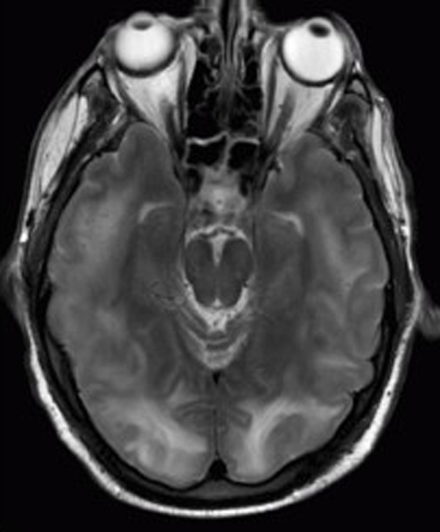

CT (A and C) and FLAIR MRI (B and D): subtle CT hypoattenuation is noted within the bilateral parietal (A) and occipital and posterior temporal (C) gray matter and subcortical white matter, corresponding to abnormal T2 hyperintensity seen on MRI (B and D). No diffusion abnormality or evidence of hemorrhage is present:
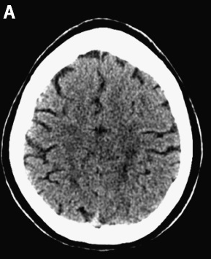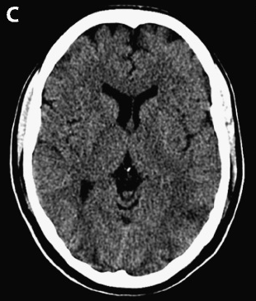
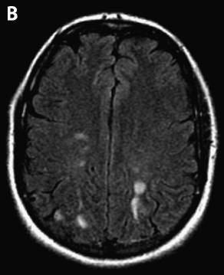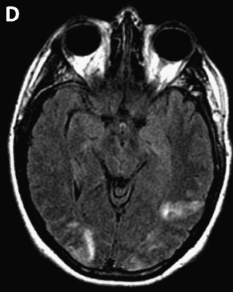

Treatment
- depends on underlying cause.
- if main problem is high BP, it control will accelerate resolution
- if likely cause is medication, withdrawal of drug in question is needed.

Bibliography see p. S11 >>

Viktor’s Notes℠ for the Neurosurgery Resident
Please visit website at www.NeurosurgeryResident.net

