Opioids
Last updated: May 8, 2019
Definitions 1
Therapeutic and Side Effects 1
Overdose 2
Drug interactions 3
Therapeutic use of opioids 3
MED (morphine equivalent dose) 4
Storage, Disposal 7
Urine Drug Testing 7
Tapering 8
Strong Agonists 8
Moderate Agonists 10
Opioid + Nonopioid action 11
Mixed Agonists-Antagonists 12
Antagonists 12
Abuse & Dependence – see p. Psy23 >>
Opioid receptors, endogenous opioids – see p. A4b >>
Opioid role in pain transmission – see p. S20 >>
Opioids in pain treatment – see p. S20 >>
Opioids in terminal patients – see p. S20 >>

Definitions
Opium – air-dried milky exudation obtained by incising unripe capsules of Papaver somniferum (or its variety, P. album); contains some 20 alkaloids, incl. morphine (9–14%), noscapine (4–8%), codeine (0.8–2.5%), papaverine (0.5–2.5%), thebaine (0.5–2%).

Opiates – opium derivatives, i.e. drugs obtained from juice of opium poppy: morphine, codeine.

opioids – any (natural / synthetic)* compounds that produce morphine-like effects.
*originally, term denoted only synthetic narcotics

Therapeutic and Side Effects
N.B. patient develop tolerance to all side effects except constipation!
- strong dose-related analgesia; consciousness is not lost* (vs. in anesthesia) – patient can locate painful stimulus.
*in doses 10-20 times analgesic dose, opioids act as complete anesthetics – provide hypnosis and amnesia – may be used as sole anesthetic agents!
- powerful euphoria - high addiction potential.
- sedation (if undesirable → methylphenidate or dextroamphetamine).
- respiratory center sensitivity↓ to CO₂ → dose-dependent respiratory depression → apnea (most common cause of death in overdosage!).
N.B. due to pCO₂↑ cerebral vessels dilate → ICP↑ (harmful in brain injury!)
- nucleus tractus solitarii suppression → cough reflex suppression (antitussive effect).
- stimulation of Westphal-Edinger nucleus → pinpoint pupils.
N.B. little tolerance to miotic effect develops – all addicts demonstrate pinpoint pupils (important diagnostically – most other causes of coma / respiratory depression produce pupil dilation); miosis can be blocked with atropine.
- direct stimulation of area postrema → emesis (without unpleasant sensation); usually tolerance develops after 1st dose.
Most profound in morphine!
H: hydroxyzine, metoclopramide, prochlorperazine.
- GI smooth muscle motility↓ & tone↑ (spasmodic nonpropulsive contractions) → constipation, pressure in pancreatic & biliary tree↑ (contraindicated in biliary colic).
N.B. little tolerance to this effect develops!
H: fibers, stool softeners, laxatives (stimulant → osmotic);
methylnaltrexone (Relistor) – FDA approved for opioid-induced constipation in patients with advanced illness who are receiving opioids on continuous basis.
Lubiprostone - also effective for opioid-induced constipation.
naloxegol (Movantik) – FDA approved oral treatment for opioid-induced constipation in adults with chronic non-cancer pain.
naldemedine (Symproic) - FDA approved 0.2 mg tablets as a once-daily oral peripherally-acting mu-opioid receptor antagonist (PAMORA) medication for the treatment of opioid-induced constipation (OIC) in adult patients with chronic non-cancer pain.
- at large doses hypotension & bradycardia may occur (due to vasomotor center depression, histamine release, venule dilation).
N.B. in general, opioids have minimal cardiac suppression!
- hormonal actions:
GnRH↓ (→ FSH↓, LH↓), CRH↓ (→ ACTH↓)
GH↑, ADH↑, prolactin↑
- biphasic effect on body temperature: low doses → temperature↓, high doses → temperature↑.

Overdose
Risk increases with increasing of doses patient uses routinely: (expressed in MED >>)
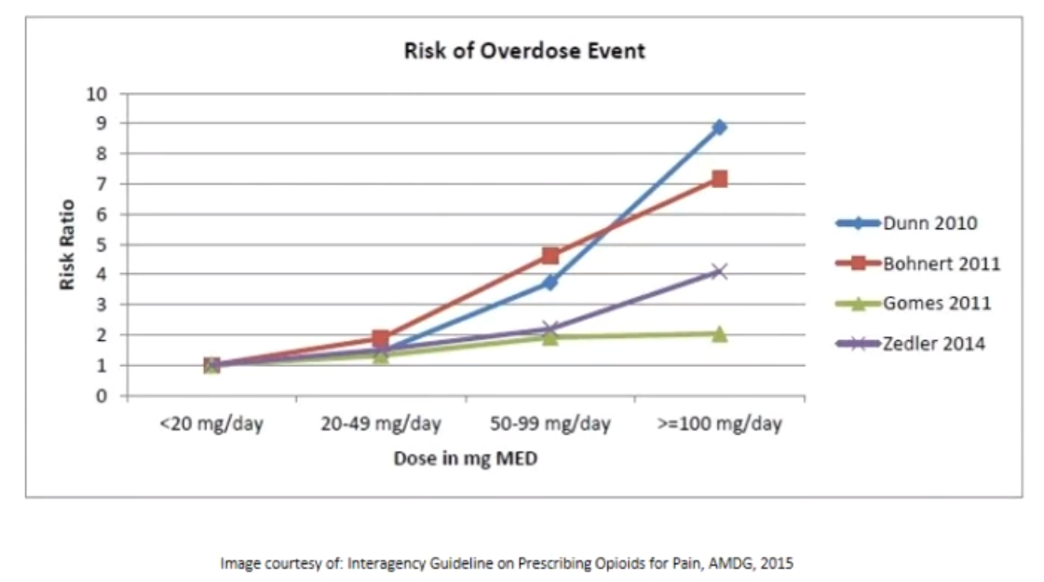

Treatment – see below >>

Drug interactions
tricyclic antidepressants, neuroleptics → sedation↑
sedative-hypnotics → respiratory depression↑
MAO inhibitors – risk of hyperpyrexic coma (MAO inhibitors are absolute contraindication for meperidine!)

Therapeutic use of opioids
- obtain well documented informed consent ("opioid agreement") for every patient on chronic opioid treatment.
- conduct face-to-face interview, obtain old records and medical history, inquire about prior experience with recreational drugs in nonconfrontational manner.
- periodic review of course of treatment: follow-up visits should include "4 A's":
    - analgesia (scale of 1-10) compared with prior visit.
    - activities of daily living (such as walking a dog, driving, cooking, etc.).
    - adverse effects (such as constipation).
    - aberrant drug-related behaviors (such as asking for early refill).
- use correct language in charts;
"narcotic" is law-enforcement term → use "opioid" or "controlled medication".
patients should be "tapered" off opioids, not "detoxed" or "weaned".
- according to US Drug Enforcement Agency (DEA) policy, healthcare professionals prescribing controlled substances have "obligation to take reasonable measures to prevent diversion" (use of controlled substances by someone other than patient).

Dosage guidelines for analgesia also see p. S20 >>
guidelines for analgesia in addicted patients – see p. Psy23 >>
- drug potency to bind to receptor correlates with analgesia.
- when starting long-term opioids, obtain:
- written informed consent >>
- written medical agreement >>
- opioid sensitivity is increased in elderly; they require smaller initial dose (25-50%) and smaller dose increments and are predisposed to side effects.
- initially, drug may be given at patient's request (most opioids need to be given at least q 3 h and many q 2 h).
- dose titration technique - "rescue doses" (treat breakthrough pain while guiding dose escalation): in addition to regular doses around the clock or use of long-acting drugs, extra dose of drug with short half-life is offered q 2 h prn; rescue dose is based on standing dose (usually 5-10% of total daily dose); standing dose can be increased daily by total amount of rescue dose used if many rescue doses continue to be needed.
- need to increase doses usually reflects progressive pain;
      - although tolerance* to analgesic effects may develop concurrently, it is seldom the only reason for increasing doses.
*tolerance is defined as taking ≥ 60 mg oral morphine/d, ≥ 25 mcg transdermal fentanyl/hour, ≥ 30 mg oxycodone/d, ≥ 8 mg oral hydromorphone/d, etc.
      - possible cause is also drug-drug interactions (e.g. P450 enzyme inducer carbamazepine lowers effective dose of fentanyl).
- dosing rules:
  - if any dose will seriously depress respiratory function, it is usually much more than twice stable tolerated dose.
  - reestablishing pain control (when stable dose becomes inadequate) ordinarily requires ≥ 1.5 times previous dose.
- intolerable adverse effects or inadequate benefit despite dose increases → consider opioid rotation.
      - start new opioid with equianalgesic dose reduced by 25-50% (exceptions: methadone [reduce up to 95%], transdermal fentanyl [do not reduce at all])

MED (morphine equivalent dose)

Drug | Equianalgesic (mg) Doses
Morphine | 10 IM/IV/SC  60 PO
Hydromorphone | 1.5 IM/IV/SC  7.5 PO
Oxycodone | 20–30 PO
Oxymorphone | 1 IM/IV/SC  10 PR  15 PO
Levorphanol | 2 IM/IV/SC  4 PO
Methadone | 10 IM/IV/SC  20 PO
Meperidine | 450-600 mg PO
Fentanyl | 50–100 mcg IV/SC

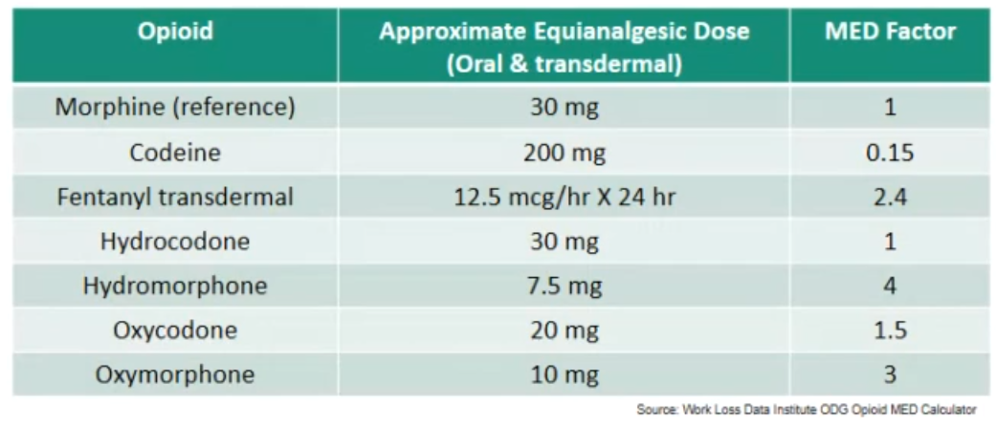

Opioid Morphine Equivalent Conversion Factors (Centers for Disease Control and Prevention, Atlanta, GA, May 2014):
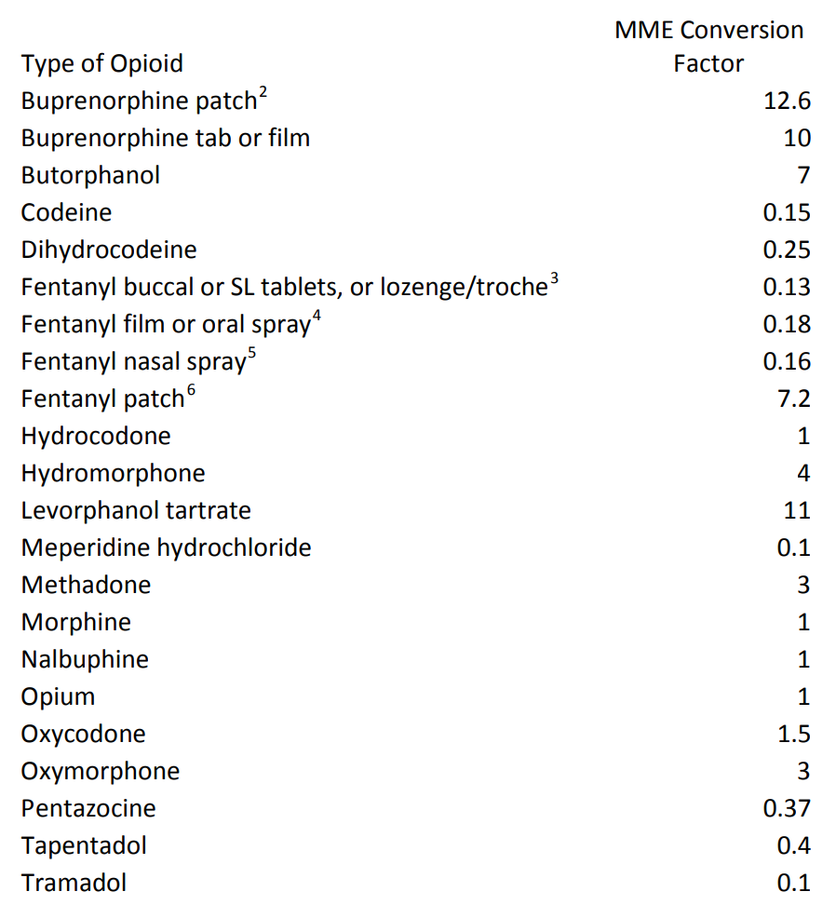

Equivalency Table (Stanford School of Medicine):
Drug | Oral/Rectal Route | Parenteral Route | Conversion Ratio to  Oral Morphine | Equianalgesic Dose of Oral Morphine
Morphine sulfate | 30 mg Oral morphine | 10mg of parenteral morphine | Parenteral morphine is 3 times as potent as oral morphine | 30 mg Oral morphine
Oxycodone | 20 mg of oral oxycodone | NA | Oral Oxycodone is roughly 1.5 times more potent than oral morphine | 30 mg Oral morphine
Hydrocodone | 20 mg of oral hydrocodone | NA | Oral hydrocodone is roughly 1.5 times more potent than oral morphine | 30 mg Oral morphine
Hydromorphone | 7 mg of oral hydromorphone | 1.5mg of parenteral hydromorphone | Oral hydromorphone is about 4-7 times as potent as oral morphine  Parenteral hydromorphone is 20 times as potent as oral morphine | 30 mg Oral morphine
Fentanyl | NA | 15 micrograms/hr | Transdermal fentanyl is approximately 80 times as potent as morphine  (This is based on studies converting from Morphine to fentanyl. Currently, there are no empirical studies converting fentanyl to morphine). | 30 mg Oral morphine
Meperidine  Meperidine is not a recommended drug in a palliative care setting and is to be avoided.  If a patient with chronic pain is on meperidine, convert patient to an equianalgesic dose of one of the other opioids listed in this table. | 300mg of oral meperidine | 75mg of parenteral meperidine | Oral Morphine is about 10 times more potent than oral meperidine and about twice more potent as parenteral meperidine (mg for mg) | 30 mg Oral morphine

Analgesic potency (per weight basis): sufentanil, alfentanil > fentanyl (50-100) > oxymorphone (10) > hydromorphone (6-10) > butorphanol (5-6) > levorphanol (5) > heroin (3) > nalbuphine (1-2) > hydrocodone (1), morphine (1), methadone (1) > dezocine, oxycodone > pentazocine (1/5) > meperidine (1/8-1/10) > codeine (1/12)
e.g. 3 mg of heroin are equivalent to about 10 mg of morphine
- cross-tolerance between drugs is incomplete - when one drug is substituted for another, equianalgesic dose should be reduced by 50% (only exception is methadone - should be reduced by 75-90%).

Storage, Disposal
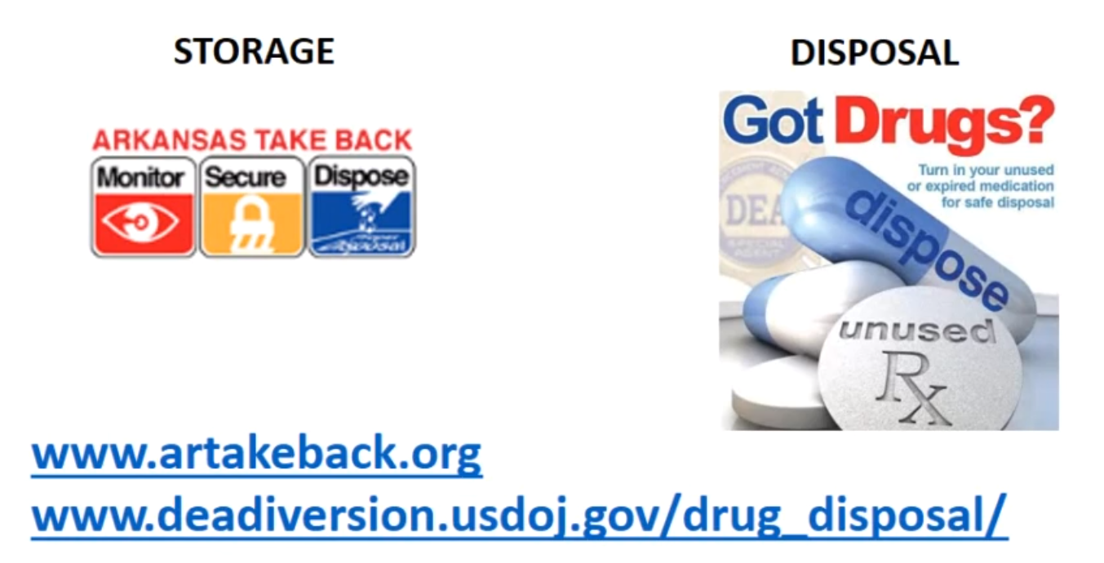

- keep medication in locked box inaccessible to children, visitors, pets.
- sharing opioids in illegal.
- do not flush down the toilet unused opioids.

Urine Drug Testing
- explain to the patient at the first visit about it; emphasize that explained results* may mean violation of agreement and may lead to termination of opioid treatment (rapid stop is safe if urine drug test is negative).
*urine negative for prescribed opioid, urine positive for nonprescribed controlled substances or alcohol
- some synthetics (e.g. fentanyl, methadone) may not show positive on screening tests and need confirmatory tests.

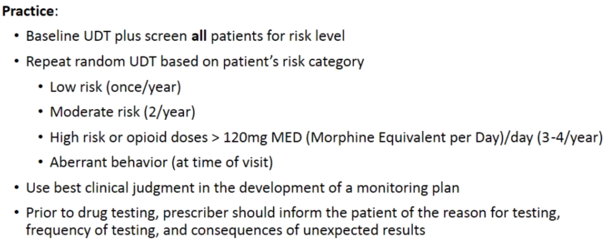

Tapering
- goal is to taper ≤ 10% dose per week; if patient is not tolerating it – refer to psychiatrist.
- rapid taper (over 2-3 weeks) is reserved if patient had episode of overdose.
- if there are signs of inappropriate opioid use (such as diversion), may stop immediately (confirm safety with negative urine drug test).

Strong Agonists
- mainly act at μ receptors (but some actions on other receptors: κ, δ > σ):

Morphine – prototype agonist.
- releases histamine from mast cells → pruritus, hypotension, bronchospasm (contraindicated in asthmatics!).
- in prostatic hypertrophy may cause acute urinary retention.
- has vagolytic action (ventricular response↑ in supraventricular tachycardias).
- repeated use produces tolerance (except to myotic and constipating effects).
- psychological & physical dependence readily occur; withdrawal produces incapacitating, unbearable autonomic-motor-psychologic symptoms (but very rarely severe enough to cause death).
- clinical use:
- analgesia with sedation
- severe diarrhea
- acute treatment of pulmonary edema (dilates venules)
Pharmacokinetics:
- acutely is administered parenterally (morphine sulfate):
    - i/m (usual starting morphine dose is 10 mg i/m q4h) – painful!!!
    - i/v (preferred over i/m)
    - s/c (preferred over i/m)
    - epidural
    - intrathecal (intraspinal, intraventricular) see p. S20 >>
- parenteral administration (except i/m) can be connected to patient-controlled analgesia (PCA) pumps
- absorbed per os; significant first pass metabolism in liver (glucuronidation - very weekly developed in neonates! N.B. morphine does not require cytochrome P-450!) → glucuronides excreted in urine (can accumulate in kidney failure)
10 mg parenteral morphine = 60 mg* oral morphine
*20-30 mg for repetitive dosing
- controlled-release (q 8-12 h) and sustained-release (q 24h) oral morphine preparations are most commonly used drugs to treat chronic pain!
- duration of action:
i/v in naive individuals - 4 hours;
epidurally or intrathecally - up to 24 hours.
- least fat-soluble of all opioids – poor penetration to CNS!
- passes placenta; neonatal withdrawal in addicted mothers!
- may be abused by inhalation of burning crude opium.

Meperidine (Demerol®) – synthetic opioid (structure unrelated to morphine); particularly stimulates κ receptors.
- clinical use – potent acute analgesia; preferred opioid during labor!
75-100 mg meperidine ≈ 10 mg morphine
- can be administered orally.
- duration of action (i/v) 2 hours.
- less effect on smooth muscles than morphine.
- dilates pupils (atropine-like activity!!!), activates reflexes* (large doses cause tremors, twitches, convulsions – not reversible with naloxone!; with MAO inhibitors can cause convulsions with hyperthermia)!
*due to active metabolite normeperidine (accumulates in renal failure)
Some specialist are against use of meperidine and don’t see any indications for it!

Methadone – synthetic, orally effective opioid.
- potency ≈ morphine, but less euphoria, longer duration of action (up to 24 hours).
- clinical use – controlled withdrawal of opioid addicts (methadone causes much milder & much slower withdrawal) – in appropriate doses, satisfies craving for heroin without producing euphoria.
- very problematic drug - interacts with so many different foods, herbs, and other medications - you really need to know what co-ingestions may raise effects of methadone, raise level of methadone (which may dampen effect).

Fentanyl – meperidine derivative.
- analgesic potency 80-200 times of morphine.
- highly lipophilic - good CNS penetration.
- rapid onset (in ≈ 5 min) and short duration (≈ 15-60 min) of action.
- clinical use – analgesia during anesthesia; narcotic of choice for conscious sedation (easy to titrate, easily and quickly reversed by naloxone).
when combined with neuroleptic droperidol (e.g. Innovar), it produces dissociative anesthesia / neuroleptanalgesia.
- only opioid available in controlled-release transdermal formulation (for chronic pain conditions in opioid-tolerant patients) – q 2-3 d;
24 h is needed to attain maximum analgesia; once patch is removed, it takes 18 h for serum levels to decline 50%.
- buccal tablets (Fentora™) - for breakthrough pain in patients with chronic cancer pain who are already receiving and who are tolerant to opioid therapy; contraindications (risk of respiratory depression): acute pains, opioid non-tolerant patients.
- minimal-to-no associated histamine release (vs. morphine) - less hypotensive effects, safer in hyperactive airway disease.

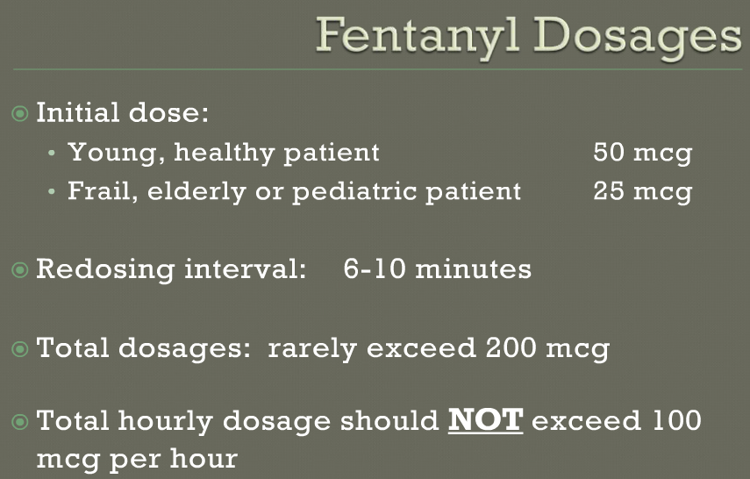

Sufentanil – more rapidly & shorter acting, more potent than fentanyl.
alfentanil ≈ sufentanil.
remifentanil - particularly short-acting, but most expensive narcotic in clinical use.

Heroin (diacetylmorphine) – produced by morphine diacetylation → 3-fold potency increase.
- good CNS penetration (intense “rush” of euphoria).
- in vivo converted to morphine.
- not accepted for clinical use!

hydromorphone (Dilaudid®) – 7-10 times more potent than morphine (but less nauseating, less constipating, shorter or similar duration of action).

oxymorphone (Opana®, Numorphan®) 10 mg rectally = 10 mg morphine i/m
- metabolite of oxycodone
- virtually no cytochrome P-450 or other metabolic issues to consider!!!

levorphanol ≈ morphine (but less nauseating).

Moderate Agonists
Codeine – metabolized by cytochrome P450 isoenzyme 2D6 to morphine;
- patients may be low, intermediate, or fast metabolizers (→ little codeine is converted to morphine ÷ too much morphine).
patients with CYP2D6 genotype metabolize more rapidly and more completely → higher morphine levels in blood → risk of adverse events! (FDA approved test for determining CYP2D6 genotype)
FDA alerts of ultra-rapid metabolism!!!
Why would you want to use a drug not reliably knowing whether it's going to work or if it is going to cause toxicity?
- well absorbed per os
- short acting (duration of effect ≈ 3-4 h).
- less euphoria, low abuse potential!
  - clinical use:
- strong cough suppression (in OTC drugs replaced by dextromethorphan*)
*less constipating, nonaddictive, nonanalgetic.
- moderate analgesia (analgesic potency ≈ 1/12 of morphine).
30-65 mg oral codeine = 600 mg aspirin

codeine derivatives (good oral potency):
hydrocodone (combined with acetaminophen - Norco, Vicodin, Lortab)
oxycodone (combined with acetaminophen - Percocet)
- long acting (up to 12 hours – depends on individual speed of P-450 metabolism)
20-30 mg per os = 10 mg morphine i/m
- portion of hydrocodone is metabolized to hydromorphone
- Xtampza ER – oxycodone with abuse-deterrent properties.

Propoxyphene – methadone derivative.
- clinical use:
levo isomer – antitussive.
dextro isomer – mild-moderate analgesia; frequently combined with aspirin, acetaminophen (Darvon, Darvocet) – synergistic effects.
oral 65 mg (p. HCl) or 100 mg (p. napsylate) = 650 mg aspirin
November 19, 2010 FDA notified that propoxyphene is withdrawn from the U.S. market due to data showing that drug can cause serious cardiotoxicity (even at therapeutic doses).

diphenoxylate – meperidine derivative.
- used to control diarrhea.
- frequently combined with atropine (e.g. Lomotil) – atropine adverse effects (dry mouth, blurred vision, etc) prevent abuse.

Opioid + Nonopioid action
tramadol – double action:
- agonist at μ₁ receptors.
- norepinephrine serotonin reuptake inhibition.
- potency ≈ oral meperidine or codeine.
- dosing begins at 50 mg bid (maximal doses - 100 mg qid).
- side effects - GI disturbances, dizziness, agitation, sweating, ↓libido.

Tapentadol – double action:
- agonist at μ receptors.
- norepinephrine serotonin reuptake inhibition.
- potency between morphine and tramadol.
- immediate release oral tablets: 50 mg, 75 mg, 100 mg.
- equianalgesic effect with lower incidence of side effects compared to oxycodone and morphine.
- FDA approved for both acute and chronic pain* management.
*tapentadol extended-release 100-250 mg q12hrs (50 mg twice daily for patients not currently taking opioid analgesics), with a maximal daily dose 500 mg
- potentially life-threatening serotonin syndrome may occur (esp. with concomitant use of SSRIs, SNRIs, tricyclic antidepressants, MAOIs, triptans).

Mixed Agonists-Antagonists
- effects depend on previous exposure to opioids:
opioid naive patient – mainly agonist activity (analgesia);
opioid dependent patient - mainly antagonist activity (withdrawal, pain worsening).
- cause dysphoria (vs. euphoria) due to σ receptor activation.
Less potential for abuse!!!

Pentazocine – agonist at κ, σ receptors + weak antagonist at μ, δ receptors.
- clinical use – moderate analgesia (1/5 of morphine) – least potent of all partial agonists, but the only available as oral formulation!
- may increase BP and cardiac work.
- antagonist to morphine (μ) analgesia! precipitates withdrawal in morphine addicts, but does not antagonize respiratory depression!

Buprenorphine – agonist at μ receptors + antagonist at κ receptors.
- long duration of action (up to 6 h); respiratory depression not fully reversible with naloxone!
- increasingly used for opiate dependence treatment.
- BuTrans® - FDA approved once-weekly buprenorphine transdermal system for moderate to severe chronic pain in patients requiring continuous, around-the-clock opioid analgesic for an extended period; patches will be available in 5, 10, and 20 μg/hour strengths

nalorphine

nalbuphine – analgesia ≈ morphine; does not increase cardiac work.

butorphanol

dezocine

Antagonists
- antagonists at μ, κ, δ, σ receptors.
- no effects in opioid naive individuals.
- in opioid addicts rapidly induce withdrawal!

Naloxone
- clinical use – rapid (within 30 sec. ÷ 2 min.) reversal of opioid overdose.
- administered i/v 40-100 μg (with total dosing of up to 1 mg)
Do not to administer too rapidly if there is no crisis - drug causes profound agitation, hyperventilation in patient rapidly and completely reversed from morphine sedation and analgesia!
- in morphine-dependent patient, naloxone is used only when absolutely necessary and only 1/10-1/5 usual dose (normal doses produce profound withdrawal reactions!).
- T_{1/2} ≥ 1 hour – repeated doses are necessary!!!
- tolerance (to antagonistic effects) does not develop.
- antagonist at μ >> κ, δ (readily reverses coma & respiratory depression, but not analgesia) .
- does not antagonize σ receptors.

Naltrexone
- antagonist primarily at μ.
- pure antagonist - not addicting.
- potency 2 times of naloxone.
- duration of action – up to 48 hours!
- can be administered orally!
- clinical use:
  - opiate-dependence maintenance programs
  - alcoholism maintenance treatment. see p. Psy21 >>

nalmefene - longer-acting opioid antagonist.
- blocks μ, δ, κ receptors.
- clinical use:
  - opiate-dependence maintenance programs
  - alcoholism maintenance treatment. see p. Psy21 >>

Bibliography
Lippincott’s Pharmacology Review, 2nd ed., 2000
NMS Pharmacology 1994
“The Merck Manual”, 17th ed., 1999 (167 ch)
“Sabiston Textbook of Surgery”, 16th ed., 2001
“Harrison's Principles of Internal Medicine”, 1998
Ganong “Review of Medical Physiology”, 2002

Viktor’s Notes℠ for the Neurosurgery Resident
Please visit website at www.NeurosurgeryResident.net

