Tension-Type Headache (TTH)
Last updated: May 8, 2019
Pathophysiology 1
Etiology 1
Epidemiology 2
Clinical Features 2
Episodic TTH 2
Chronic TTH 2
Evaluation 5
Management 5
Preventive therapy 6

TTH - most common primary headache disorder!

Past synonyms - tension headache, stress headache, muscle contraction headache, ordinary headache, psychomyogenic headache, psychogenic headache.

Pathophysiology
- not well understood and defies single or simple pathophysiologic explanation.

Likely cause is abnormal neuronal sensitivity & pain facilitation, not abnormal muscle contraction.

TTH is not result of sustained contraction of pericranial muscles* with subsequent ischemic pain in response to emotion / stress. *although many patients have muscle tenderness.
- muscle ischemia is not present during headache.
- EMG activity is increased in some muscles (independent of tenderness and pain).

"Myofascial-supraspinal-vascular" model – headache is viewed as sum of nociceptive input onto brain stem neurons from vascular structures, myofascial and muscular sources, and descending supraspinal modulation.
Contributions from both central and peripheral factors!
  - relative importance of these three factors varies among attacks and among patients.
  - neurotransmitter abnormalities (5-HT, norepinephrine, dopamine, enkephalins) in hypothalamus, brain stem, and spinal cord.
- CNS [5-HT]↓ may be responsible for abnormal pain modulation (decreased pain thresholds).
- in presence of pain facilitation, normal subthreshold stimuli may produce significant pain (even if myofascial nociceptor hypersensitivity is not present).

State of cranial hyperalgesia - reduced endogenous pain modulation + enhanced pain potentiation.

Etiology
- many causes!
- co-morbid migraine, mood disorders, sleep dysfunction, anxiety states contribute.

Epidemiology
- can begin at any age (most commonly – 2nd decade - adolescence or young adulthood); uncommon before puberty.
- lifetime prevalence – 69% men, 88% women - one of most costly diseases!!!
- prevalence declines with increasing age (severity decreases in women but does not change in men).
- socioeconomic factors do not contribute to risk.
- genetic factors are not prominent (vs. migraine or other headache syndromes).
- 25% patients also have migraine!

Clinical Features
- relatively featureless, mild headache.
- no prodrome.
- often during or after stress, anxiety.
- may be associated with menstruation, hunger, eyestrain, uncomfortable stressful position and/or bad posture.
- pain (gradual onset):
  - nagging, tight, bandlike, constricting bilateral pressure (discomfort).
  - located in forehead, temples, or occipital area.
  - may radiate to neck and shoulders (patient may feel that posterior neck muscles are tight*). *± EMG changes
  - severity fluctuates (typically worse late in day).
  - may persist for days.
  - often improved by physical activity or alcohol!
- normal general & neurologic examinations; some patients may have tender spots or taut bands in pericranial or cervical muscles (trigger points).
- no associated autonomic or GI symptoms (occasional anorexia).

Episodic TTH
IHS criteria - at least 10 headaches fulfilling following criteria:
- each lasting 30 minutes ÷ 7 days (82% last < 24 hrs; median - 12 hours).
- at least 2 of following characteristics:
  - bilateral
  - nonpulsating (pressing, tightening) quality
  - mild ÷ moderate intensity (may inhibit but does not prohibit activities)
  - no aggravation with routine physical activity (e.g. climbing stairs)
- no nausea, vomiting, photophobia*, phonophobia*, osmophobia!!!
*photophobia or phonophobia may be present but not both!
- number of days with headache < 15 days / month.
- secondary headache excluded.

- patients are no different from controls in terms of depression, stress, anxiety, emotional conflicts, sleeping problems, fatigue.
- benign recurrent condition that usually improves with time (some patients with analgesic overuse may progress to chronic TTH).

Chronic TTH
IHS criteria
- at least 2 characteristics (as in episodic TTH).
- no vomiting!
- no more than one of following: nausea, photophobia, phonophobia.
- secondary headache excluded.
- number of days with headache > 15 days / month for > 6 months.

- patients are often depressed!
- prognosis is controversial.

N.B. criteria have high specificity but low sensitivity - experienced clinicians often make presumptive diagnosis based on fewer criteria and proceed with treatment!

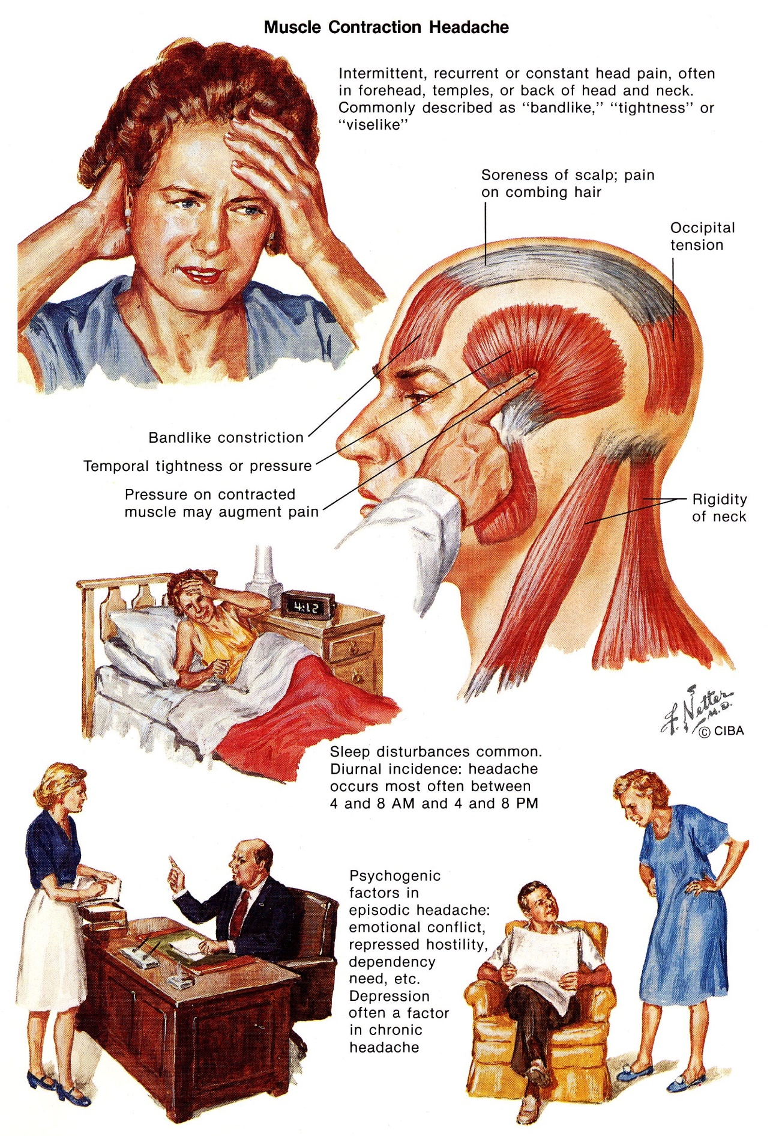
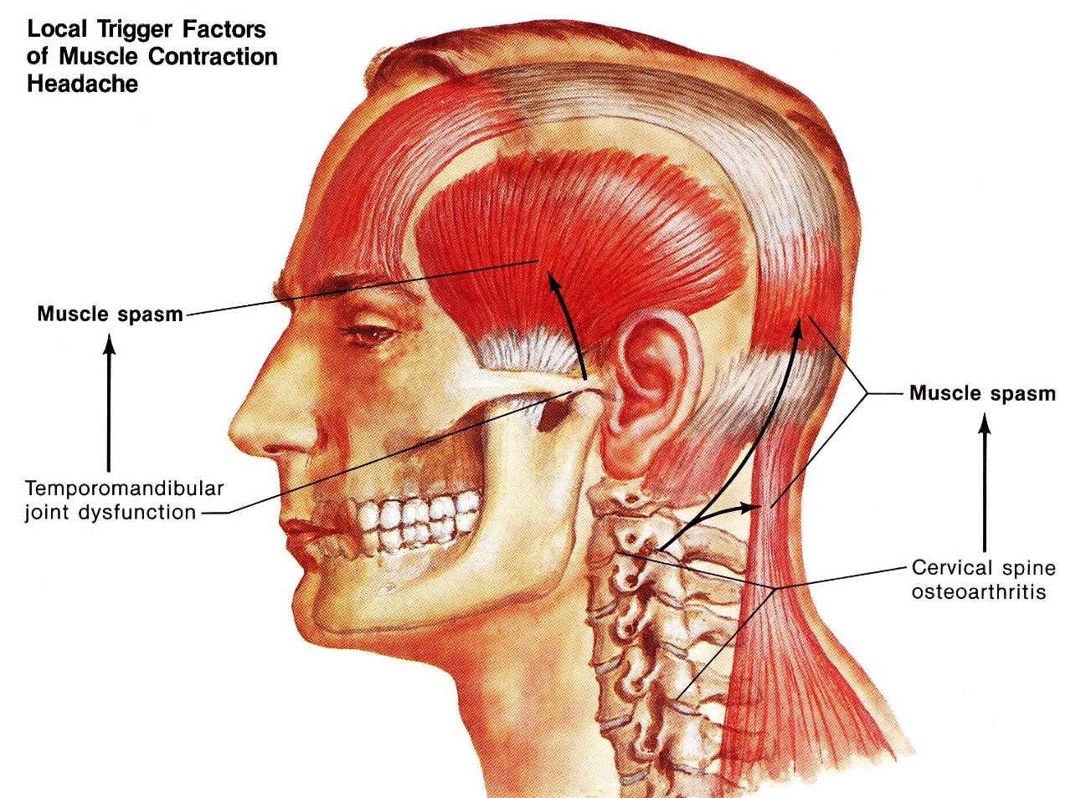

Evaluation
Episodic TTH: long stable history + normal neurological examinations → no further evaluation.

Chronic TTH → CT/MRI (even if general and neurological examinations are normal!) ± metabolic screen, CBC, electrolytes, kidney & thyroid function studies, psychiatry consultations.

Management
N.B. symptomatic medication overuse can convert episodic TTH to chronic TTH!
- patients usually self-medicate with over-the-counter analgesics (aspirin / acetaminophen / NSAIDs ± caffeine).
- if OTC are not effective:
  - prescription NSAIDs (ibuprofen, ketoprofen, naproxen)
  - combination analgesic (with isometheptene mucate, butalbital)
  - physical therapy - neck massage and heat, stretching exercises, traction, manipulations, ultrasound therapy, TENS.
  - psychophysiologic therapy - relaxation techniques, biofeedback techniques.
  - minimally invasive techniques - trigger point injections, nerve blocks (greater or lesser occipital nerve, auriculotemporal nerve, supraorbital nerve), botulinum toxin* injection in pericranial muscle.
*probably ineffective by American Academy of Neurology report
N.B. overuse of analgesics that contain narcotics / sedatives / caffeine may cause dependence!

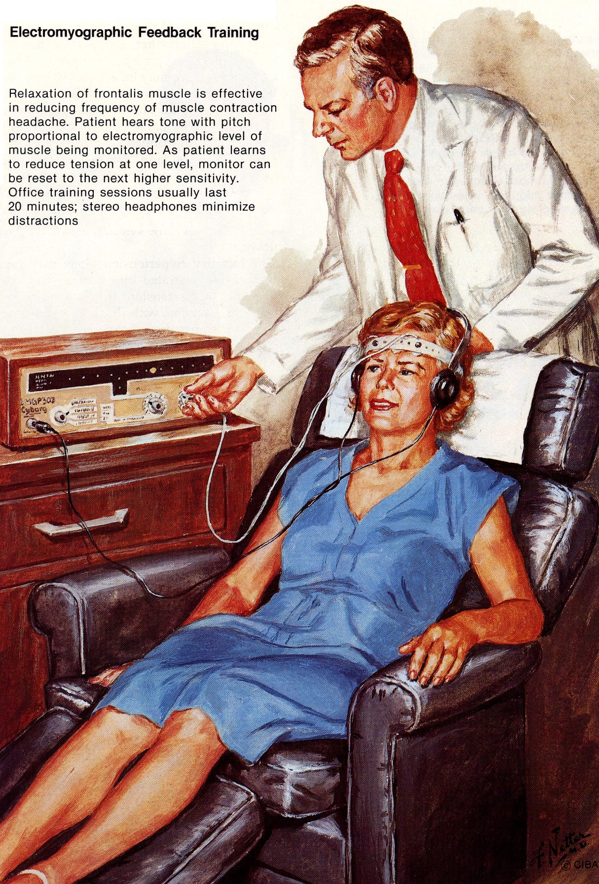

Preventive therapy
- indicated if frequent headaches produce disability or may lead to symptomatic medication overuse.

- tricyclic antidepressants - first choice! (esp. amitriptyline)
Adequate trial period of at least 1-2 months must be allowed!
- β-blockers
- anticonvulsants (valproate)
- biofeedback therapy.
- peripheral nerve blocks see p. S24 >>

Bibliography see p. S24 >>

Viktor’s Notes℠ for the Neurosurgery Resident
Please visit website at www.NeurosurgeryResident.net

