Alterations in Consciousness, Coma
Last updated: May 8, 2019
Definitions 1
Pathophysiology 2
Anatomy of Arousal 2
Substrate of Coma 4
Anatomy of Awareness 4
Anatomy of Attention 5
Etiology 5
Initial Examination and Stabilization 5
Short History 6
Glasgow Coma Scale 7
Glasgow-Liege scale 10
Sedation Scale 10
Children Coma Scales 10
FOUR score 11
Further Medical Examination 11
Further Neurological Examination 12
Clinical Findings with Different Levels of CNS Dysfunction 20
Instrumental Neurologic Examination 21
Management 23
Prognosis 24
Etiologic Categories 24
Coma-like states 26

Definitions
Consciousness - set of neural processes that allow individual to perceive, comprehend, and act on internal and external environments; consciousness has two parts:
- Arousal - describes degree to which individual is able to interact with environments; waking and sleeping are two different states of arousal; generally, awake = aroused = alert.
- Awareness - depth and content of aroused state (i.e. individual is not only alert but is cognizant of self and surroundings, so some authors use term cognition).
  - awareness depends on arousal (one who cannot be aroused lacks awareness).
  - awareness is not modality specific (i.e. equal for all types of stimuli).
  - attention - ability to respond to particular types of stimuli (modality specific); attention depends on awareness.
In general use, consciousness = awareness
To diagnose awareness, one must demonstrate response to various stimuli - several modalities (typically, verbal, visual, and somatosensory) presented from both sides of patient.
N.B. inattention to stimuli chosen could be misinterpreted for unawareness (e.g. failure to respond to verbal commands on part of deaf patient).

Gradations of consciousness:
N.B. many terms lack consistent definitions; physician should clearly describe what patient does spontaneously and in response to various stimuli.
Occasionally, true level of consciousness is difficult to determine (e.g. in catatonia, severe depression, curarization, akinesia plus aphasia).

Coma - profound unconsciousness from which patient cannot be aroused ("nesužadinama, nekontaktinė būsena su užmerktomis akimis").
- patient lies still (when not stimulated).
- patient does not make attempt to avoid noxious stimuli!
If patient responds to noxious stimuli by any defensive maneuver, patient is not truly comatose (noxious stimulus powerfully evokes arousal response).
- eyes are closed! (except vertical eye movements that may accompany suppression-burst EEG pattern).
- cerebral oxygen uptake is abnormally reduced (vs. normal in sleep or even increased during REM stage).

Stupor - impaired consciousness when only continual intense stimulation arouses patient.
Obtundation, lethargy, sopor - unnaturally deep sleep; patient appears to be asleep much of time when not being stimulated (i.e. patient can be aroused but immediately relapses into sleep).
N.B. it is not EEG sleep!
Drowsiness - simulates light sleep - patient can be easily aroused (by touch or noise) and can maintain alertness for some time.

After period of coma, CNS may re-establish consciousness - patient enters vegetative state (unresponsive wakefulness) – state of arousal without awareness; see p. S32 >>
- do not respond to any stimuli (auditory, painful, hunger, or other).
If some response is preserved - minimally responsive state (minimally conscious state):
"MRS-minus" - patients show low-level behavioral responses, such as reacting to pain or following with the eyes.
"MRS-plus" - patients are additionally able to follow commands, to verbalize intelligibly, and/or to communicate nonfunctionally.
- eyes open and close, appear to track objects about room.
N.B. spontaneous eye opening is sign of arousal, not awareness!
- may chew and swallow food placed in mouth.
- patient manifests sleep-wake cycling.
- histopathology - loss of cortex with preservation of ARAS.

Delirium - state of awareness without attentiveness, i.e. disturbance of consciousness (ARAS dysfunction) + clouding of consciousness* (cortex dysfunction) → inability to maintain attention → global change in cognition. see p. S15 >>
* reduced mental clarity, altered mental content (confusion)
- patient may be hyperactive (rather than lethargic) with heightened alertness.
- may alternate with obtundation, stupor, coma.

Pathophysiology
Anatomy of Arousal
Reticular Activating System (RAS)
- complex polysynaptic pathway in rostral* reticular formation of brainstem. see p. A57 (2-5) >>
* paramedian tegmental gray matter of midbrain & diencephalon (pontine RF is not necessary for arousal!)
- collaterals funnel into RAS from all long ascending sensory tracts and also from trigeminal, auditory, visual, and olfactory systems.
RAS receives collaterals from and is stimulated by every major somatic and sensory pathway directly or indirectly.
- degree of convergence abolishes modality specificity - reticular neurons are activated with equal facility by different sensory stimuli (nonspecific system).
- RAS projects to thalamic nuclei (intralaminar and related) → projected diffusely & nonspecifically to whole neocortex:  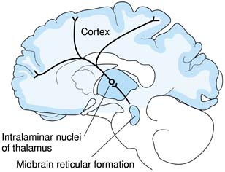  activation of these areas is shown by PET during shift from relaxed awake state to attention-demanding task. | 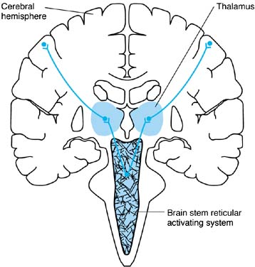
- part of RAS bypasses thalamus to project to cortex:
  - via hypothalamus → basal forebrain and limbic system.
  - via brain stem median raphe & locus caeruleus → diffuse cortical projections.

Ascending activity responsible for EEG alerting response following sensory stimulation:
specific sensory systems → midbrain → enters RAS via collaterals → interlaminar thalamic nuclei → nonspecific thalamic projection to cortex
- stimulation of specific sensory systems up to level of midbrain produces arousal, but stimulation of these systems above midbrain (or stimulation of specific sensory relay thalamic nuclei, or stimulation of cortical receiving areas) does not produce alerting response.
- stimulation of midbrain reticular formation produces EEG alerting response - midbrain RF is driving center for higher structures.
- large bilateral lesions of superior lateral midbrain (interrupt ascending specific sensory systems after collaterals to RAS) fail to prevent EEG arousal by sensory stimulation; patients are awake.
- lesions in midbrain tegmentum (disrupt RAS without damaging specific systems) produces state in which cortex appears to be waiting for command or ability to function – patients are somnolent / comatose; EEG shows slow-wave pattern (≈ normal resting electrical activity) that cannot be affected by sensory stimulation (so called alpha coma).

Arousal requires interplay of RAS with cerebral cortex.

Role of diencephalon
- diencephalon plays more active role in arousal control than simply that of conduit.
- role of thalamic reticular nucleus:
  - information from midbrain RF passes to thalamic reticular nucleus.
  - thalamic reticular nucleus inhibits cerebral cortex via outflow tracts that traverse numerous other thalamic nuclei (reticular nucleus receives numerous fibers from cerebral cortex but it has no cortical projection!).
  - by increasing or decreasing thalamic inhibitory mechanisms on cortex, midbrain RAS provides gating mechanism to enhance or diminish neuronal activation.
- fatal familial insomnia (prion disorder) - dysfunction of anterior and ventral thalamic nuclei - diminished or even completely absent sleep.

Arousal neurochemistry
- because of diffuse anatomical substrate, little is known of specific neurochemistry.
- systems that receive most attention:
  - acetylcholine; cholinergic receptors exist at many levels of this system;
    - antimuscarinic drugs often depress consciousness;
    - centrally active cholinesterase inhibitor physostigmine reverses anticholinergic encephalopathy.
  - monoamines (noradrenaline and serotonin) - neurotransmitters in numerous areas of brain stem reticular formation.

Substrate of Coma
Two primary types of lesions that depress level of arousal:
    - Direct midbrain-diencephalic ARAS dysfunction:
- displacement; e.g. horizontal diencephalon displacement by lateralized masses.
- compromised perfusion; e.g. ¹diffuse supratentorial brain swelling or ²caudal brain stem displacement separating it from basilar artery (which remains fixed to clivus).
    - Bilateral cerebral hemisphere dysfunction.
N.B. unilateral cortical lesions should not impair arousal, unless there is secondary compression or compromise of other hemisphere or reticular structures (e.g. in herniation syndromes), i.e. lesions rostrad to midbrain must be bilateral to cause coma!
- over days to weeks following severe global cortical injury (e.g. hypoxia), CNS re-establishes some degree of arousal (clinically apparent as vegetative state).

Anatomy of Awareness
awareness is primarily function of cerebral cortex (vs. arousal - brainstem).
RAS interaction with cerebral cortex is required for arousal & awareness.
RAS function in absence of cerebral cortex (e.g. vegetative state, anencephalic infants) → arousal without awareness.
Cortical function in absence of RAS control - difficult to study:
- almost all lesions damaging midbrain / thalamic reticular structures also impair motor output.
- although cortex appears electroencephalographically to be idling, there is no electrical technique to determine whether cortex is aware;
  - few case reports suggest that olfactory stimulation (which does not require transit through midbrain or thalamus to reach cortex) may produce EEG change, and patients in alpha coma due to midbrain lesion will rarely alter this EEG pattern – this suggests that external stimuli can alter cortical function in absence of RAS driving.
  - current techniques cannot examine whether patient with RAS lesion is able to perceive any internal stimuli (e.g. hunger).

Anatomy of Attention
Attention depends on both:
- Awareness (as general property)
- Specific sensory pathways & structures that mediate sensory phenomena involved.
e.g. visual system must carry information from retina to occipital cortex for visual attention to occur.
- each primary sensory modality has principal cortical regions that must function in order to attend to stimulus, but presence of these areas alone is not sufficient* for attention!
*e.g. lesions of posterior portion of nondominant parietal lobe produce extinction of contralateral stimulus when stimuli are presented simultaneously on each side of body; lesion at occipitoparietal junction produces similar defect in visual perception of bilateral stimuli.
N.B. with larger lesions, patients have increasingly more substantial deficits in awareness of contralateral half of universe, including self!

Etiology
Anatomic classification:
- supratentorial structural lesions
- infratentorial structural lesions
- diffuse metabolic diseases.

Physiologic classification:
- bilateral hemisphere dysfunction - structural or metabolic (incl. seizures, meningeal inflammation)
- unilateral hemisphere disease with compression of brainstem
- brainstem dysfunction - structural or metabolic (incl. seizures, meningeal inflammation)

about etiologic categories – see below.

Initial Examination and Stabilization
Examination of altered consciousness begins by ensuring that vital signs and basic biochemistry are adequate to support brain function!
Immediate goal is prevention of further nervous system damage!

- ABC - laisvi kvėpavimo takai, kvėpavimo judesiai, a.carotis pulsas?
  - jei ne - pradėti cardiopulmonary resuscitation. further see p. 3901 >>
  - iškvepiamo oro kvapas - acetone, alcohol, fetor hepaticus?
- External bleeding? - stabdyti išorinį kraujavimą.
- Imobilizuoti kaklą, kol X-ray neekskliudavo lūžimo!!!
- Kateteris į veną (kad neužkrešėtų - 0.2 ml heparino); paimti kraują cito tyrimui – glikemija!!!, CBC, Ht, BUN/Cr, elektrolitai, pH, osmoliariškumas, liver enzymes and ammonia, PT and aPTT, blood or urine toxicology (incl. sedative drugs and ethanol).
N.B. [glucose] should be obtained in obvious cases of ethanol intoxication (chronic ethanol abuse may deplete glycogen storage and precipitate coma!).
- Shock? - plazmos pakaitalai srove i/v (atsargiai, jei įtariamas MI – plaučių edemos pavojus).
- dextrose 50% 50 ml i/v (D25 2 ml/kg in children); nereikia, jei užtikrintas, kad [glucose] norma (bet šiaip [glucose] prastokai koreliuoja su sąmonės lygiu).
N.B. hypoglycemia is very common - represents 8.5% of prehospital encounters for altered mentation; hypoglycemia mortality is 11-27% !!!
  - glucose alone may precipitate Wernicke-Korsakoff syndrome to thiamine-deficient patient – prieš leidžiant gliukozę, suleisk thiamine 100 mg i/v or i/m in deltoid muscle!!! (adverse reactions to thiamine are extremely uncommon)
- Vyzdžių forma; jei abipusė miozė - naloxone 0.01 mg/kg (0.4-1.2 mg) i/v.
  - in ED, naloxone is used almost routinely to reverse any putative effects of opiates, but selective use (respirations < 13 breaths/min + miotic pupils + circumstantial evidence of opiate abuse) is more effective.
- flumazenil i/v (0.2 mg → 0.2 mg → 0.1 mg →.... up to 1-3 mg total) is indicated in benzodiazepine intoxication or hepatic coma; routine empirical use in all patients is controversial (high cost + risk of provoking seizures, esp. in mixed benzodiazepine and tetracyclic antidepressant overdoses); contraindicated in anticholinergic or sympathomimetic “toxidromes”. see also p. Rx1 >>
- Komos gylio įvertinimas pagal Glasgow Coma Scale.
- Paguldyti pusiau kniūbsčią (komos pozicija) iki bus atlikta trachėjos intubacija.

Short History
- iš lydinčių asmenų (draugų, giminių, paramedikų):
- Premonitory signs that occurred just before loss of consciousness (e.g. vomiting, altered speech, confusion, hemiparesis, chest pains)
  - headache (meningitis, encephalitis, intracranial hemorrhage).
  - confusion or delirium (diffuse process meningitis or endogenous or exogenous toxins).
  - lateralized symptoms, e.g. hemiparesis, aphasia (hemispheric masses).
  - chest pains, diaphoresis, palpitations, pallor, tremor (arrhythmias, hypoglycemia).
  - vomiting, bleeding esp. GI (hypovolemia)
  - fever
- Kaip neteko sąmonės (ką pacientas veikė?):
  - trauma?
  - ilgai stovėjo?
  - stressful, painful, or claustrophobic experience
  - kokiu greičiu neteko sąmonės? if suddenly (apoplectic onset), consider cardiac / neurovascular* event!
*e.g. stroke affecting brain stem, SAH, intraventricular hemorrhage
- Tongue biting, movements, urinary / fecal incontinence, residual weakness & confusion - seizure.
N.B. if LOC was unwitnessed, urinary / fecal incontinence signifies unwitnessed seizure.
- Kokioje padėtyje rastas?
- Preexisting medical condition? esp. epilepsija, diabetas, astma, narkomanija, alkoholizmas & narkomanija, depresija [bandymai nusižudyti], insomnia [migdomųjų perdozavimas], diarėja [dehidratacija], hipertenzija [vaistų perdozavimas], širdies ligos / aritmijos [embolija, hipotenzija], seizure disorder [failure to take anticonvulsants], chronic liver disease [decompensation with GI bleeding], renal failure [decompensation with infection]
- patient's wallet may contain clues to medications and medical history.
- patient should be checked for identifiers (e.g. Medi-Alert bracelet).

Glasgow Coma Scale
Teasdale G , Jennett B . Assessment of coma and impaired consciousness. A practical scale. Lancet 1974 ; 2 : 81 – 84
- standardized semiquantitative method of measuring level of consciousness.
- applied to all patients with altered mental status from any cause (esp. head trauma).
- high concordance among different observers.
- provides guide to prognosis.

If patient is not aroused by conversational voice, sequence of increasingly intense stimuli is used:
Eye Opening | E | commentary
Spontaneous | 4 | Intact RAS; patient is aroused, but may not be aware (e.g. in vegetative state)!  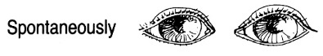
To speech | 3 | Tinka bet koks garsinis stimulas (t.y. nebūtina liepti “atsimerkite!”)  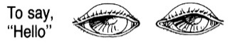
To pain | 2 | Netinka supraorbitalinis spaudimas!  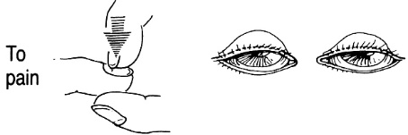
Nil | 1 | Neatsimerkia į jokį stimulą  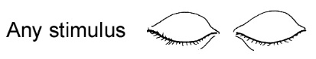
Eyes closed by swelling | C | - by convention scored 1 point  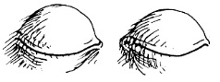
Motor Response | M | commentary
Obeys | 6 | Vykdo paliepimus, žodines komandas (nesupainioti su griebimo refleksu!); jei hemiplegija, vertink sveikąją pusę.  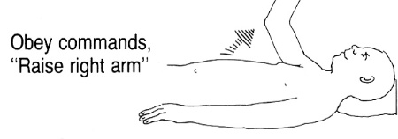
Place arms in semiflexed posture and apply noxious stimulus:
- nasal tickle with cotton wisp (strong arousal stimulus and most humane!);
- pressure on knuckles or bony prominences (preferred and humane form of noxious stimulus) - spausti orbitos viršutinį kraštą, sternum, piršto galą [makes interpretation of upper limb movement difficult!];
- pinching skin (causes unsightly ecchymoses and is not necessary) - sužnybti spenelį, žasto ar šlaunies vidinį paviršių, kaklo šonus.
Localizes | 5 | Skausmo lokalizacija (kryptingi galūnių judesiai siekiant pašalinti skausminį stimulą; tinkamiausia - spausti orbitos viršutinį kraštą) - sakoma “ligonis ginasi”  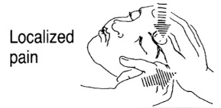
Withdraws (flexion withdrawal) | 4 | Prasmingas galūnės atitraukimas nuo skausminio stimulo, bet nesistengia pašalinti pačio stimulo – veikia žievė.  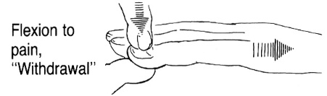
Abnormal flexion (decortication) | 3 | Stereotipinis fleksorinis atsakas į skausmą – pažeista žievė ar diencephalon.  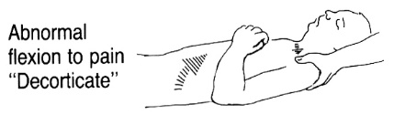
Extension response (decerebration) | 2 | Stereotipinis ekstenzorinis atsakas į skausmą – pažeista diencephalon ar midbrain.  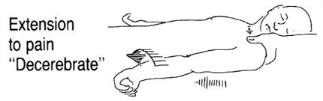
Nil | 1 | Jokių judesių, hypotonia, flaccid – pažeista pons, medulla ar spinal cord.  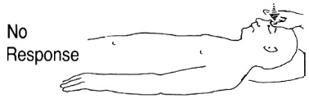
Under paralytic agents | P
Verbal Response | V | commentary
Oriented-converses | 5 | Pilnai orientuotas (laike, vietoje, savyje) - relatively intact CNS  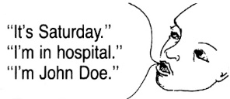
Confused conversation | 4 | Atsakinėja į klausimus, bet dezorientuotas  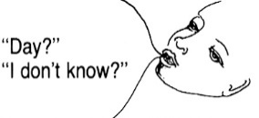
Inappropriate words | 3 | Nerišli artikuliuota kalba – žievė vis dar veikia  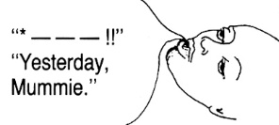
Incomprehen-sible sounds | 2 | Nesuprantami garsai  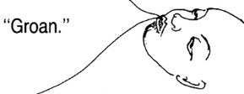
Nil | 1 | Jokių garsų  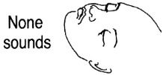
Endotracheal tube or tracheostomy | T | - by convention scored 1 point  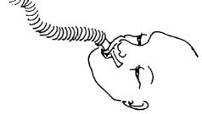
N.B. missing eye or vocal responses are by convention scored 1 point!
Simplified form:
Eye opening | Verbal | Motor | Score
Nil | Nil | Nil | 1
To pain | Incomprehensible sounds | Decerebrate* | 2
To load noise | Inappropriate words | Decorticate* | 3
Spontaneous | Confused | Withdraws | 4
 | Oriented | Localizes | 5
 |  | Follows motor commands | 6
*main difference between “decorticate” and “decerebrate” is tonic upper extremity position - flexion or extension;
N.B. record the “best response” and the best total score!

Coma Score = E + M + V
- paprastai užrašoma taip: GCS 9 (E2 + M5 + V2) arba GCS 10T (E4 + M5 + V1T)
15 balų – aiški sąmonė
13-14 balų – obtundation
9-12 balų – stupor
4-8 balai – coma
3 balai – brain death
- balų suma praktiškai yra svarbi tik galvos traumos sunkumui įvertinti (score 3-8 indicates severe trauma, 9-12 moderate trauma, 13-15 mild trauma).
- jei GCS naudojama dinamikos sekimui, tai svarbu nurodyti ir kiekvieno komponento balus.
- GCS has limited utility in focal neurological dysfunctions.
- automatically assigning 1 point to verbal response because patient is intubated, overestimates the severity of TBI.

Praktiniai patarimai:
- early in examination, ask patient to open eyes and look up - this will detect locked-in syndrome (that prevents all other somatic motor output).
- jei ligonis atsimerkia į nors kokį dirgiklį (reiškia veikia RAS) - jis sąmoningas.
- limb flexion / extension / adduction to pain are low-level reflexes; abduction (of shoulder or hip) indicates purposeful higher level response (intact corticospinal system to that limb).
N.B. brief clonic limb twitching occur at end of extensor posturing (not to be mistaken for convulsions!).
N.B. triple flexion withdrawal of lower extremity (flexion of hip, knee, and ankle) is spinal reflex and implies nothing about status of brain stem and cortex!
N.B. any motor response that crosses midline indicates higher cortical functioning.
- GCS score should be assessed in field or by first responders, then reassessed frequently, esp. after specific treatment interventions (results may vary from minute to minute!).
- pokytis 2 balais - change in neurologic status; sumažėjimas 3 balais → prompt treatment (e.g. enlarging hematoma evacuation).
- recall that patient may be capable of sensing and remembering (although noxious stimuli may be required for adequate examination, minimum necessary stimulation should be employed, and examiner should always be cognizant of need for explanation of procedures, esp. painful ones).

Factors that may invalidate (falsely lower) Glasgow score (do not use GCS, use alternative scales):
  - children, non-English-speaking patients
  - aphasia, deafness (ligonis gali nekalbėti dėl afazijos, ligonis gali nereaguoti į garsinius stimulus dėl deafness).
  - shock, hypoxia, intoxication* – main factors that limit acute (< 6 hours) GCS application in head-injured patients.
  - orbital, spine, extremity injuries.
  - postictal state.
  - suleisti raminantys* – naudok sedation scale see below

*GCS is heavily weighted toward higher cognitive function - presence of drug / alcohol intoxication can greatly lower scores in eye opening and verbal categories, even in absence of brain injury; motor component of GCS is most predictive of serious anatomic brain injury!

    - if formal GCS is not possible, patient's mental status should be described in as much detail as possible.
    - GCS may miss subtle mental status changes that may be first sign of brain injury!

Glasgow-Liege scale
- GKS papildymas kamieniniais refleksais ( ¹⁾frontoorbikuliarinis, ²⁾vertikalus ir ³⁾horizontalus okulocefalinis, ⁴⁾okulokardialinis refleksai ir ⁵⁾vyzdžių reakcija į šviesą) - kiekvienas šis refleksas vertinamas vienu balu – taigi, šios skalės galimas balų skaičius 3-20 balų.

Sedation Scale
Scale proposed by Ramsay and colleagues - allows to report level of sedation.
Level | Patient's State
1 | Awake | anxious and agitated, or restless
2 |  | cooperative, oriented, and tranquil
3 |  | responds to commands only
4 | Appears asleep (this is not true sleep!) | responds briskly to stimuli
5 |  | responds sluggishly to stimuli
6 |  | no response to stimuli
Standard stimuli - light glabellar tap or loud auditory stimulus.

Children Coma Scales
- for patients < 3 yrs (may be unable to communicate or follow commands needed for GCS).

Ocular Response
Fixed pupil and EOM paralyzed | 1
Fixed pupils or EOM impaired | 2
EOM intact, reactive pupils | 3
Pursuit | 4
Verbal Response
Apneic | 1
Spontaneous respirations | 2
Cries | 3
Motor Response
Flaccid | 1
Hypertonic | 2
Withdraws from painful stimuli | 3
Flexes and extends | 4
EOM = extraocular muscles.
Maximal score = 11; minimal score = 3.

Activity | Score | Infants | Children (< 4 yrs)
Eyes | 4 | Spontaneous
opening | 3 | To speech
 | 2 | To pain
 | 1 | No response
Verbal response | 5 | Coos, babbles, cries appropriately | Oriented - social, smiles, follows objects, converses, interacts with environment
 | 4 | Irritable cry | Confused, disoriented, aware of environment, uncooperative interactions, consolable cries
 | 3 | Inappropriate crying/screaming | Inappropriate words, persistent cries, inconsistent awareness of environment, inconsolable
 | 2 | Moans / grunts to pain | Incomprehensible sounds, agitated, restless, inconsolable, unaware of environment
 | 1 | No response
Motor | 6 | Normal spontaneous movements
response | 5 | Withdraws to touch | Localizes pain
 | 4 | Withdraws to pain
 | 3 | Abnormal flexion (decorticate)
 | 2 | Abnormal extension (decerebrate)
 | 1 | No response

FOUR score
- new scale proposed by the European Task Force on Disorders of Consciousness.
- added advantage of including nonverbal signs of consciousness, such as visual pursuit.

Further Medical Examination
I. Measuring vital signs
II. Detecting evidence of trauma (patient completely exposed, visually inspected, and manually palpated).
III. Clues to systemic disorders that may alter consciousness (e.g. hepatic disease, cardiac arrhythmias).

- Rectal temperature
- Fever in comatose patient suggests:
- infection (meningitis, encephalitis, cerebral falciparum malaria)
- drugs (anticholinergics, sympathomimetics, neuroleptics)
- endocrine disorders (thyroid storm)
- hypothalamic hemorrhage disrupting thermoregulation.
- heat stroke (core temperature > 42° C in appropriate environmental setting).

- Oda - spalva, prakaitas, nubrozdinimai, petechijos ir hematomos (meningococcemia, hemostasis disorders → CNS hemorrhage), adatų žymės (diabetikas ar narkomanas), uremic frost, scars.

- Širdis (EKG, Holter monitoring – for arrhythmias; echocardiography - mechanical causes of syncope)
- Plaučiai (karkalai, chest X-ray)
- Pilvas (melena per rectum).
- Laboratory:
- kraujas - dujos, pasėlis, alkoholio / toksinų koncentracija.
- šlapimo - toksinai.

Monitor
  - BP and ECG
  - pulse oximetry (in all patients!), respiratory rate, blood gases
  - serum [Na⁺], [glucose], osmolarity

Hypertension (esp. > 200/130) suggests intracranial structural lesion (most commonly intracerebral hemorrhage); also consider primary hypertensive encephalopathy.
Hypotension is strongly suggestive of systemic disease* rather than isolated CNS injury.
*shock; anaphylaxis; acute adrenal insufficiency; poisonings, etc.

Further Neurological Examination
Three critical issues that any examination must try to answer:
    - Does patient have meningitis?
    - Are there signs of mass lesion?
    - Is there diffuse metabolic syndrome (exogenous or endogenous)?
This task is accomplished by focusing on such features:
      - meningeal signs - indication of meningitis.
      - motor response to painful stimulus - indication of mass lesion vs. diffuse metabolic syndrome.
      - pupillary function – integrity of midbrain; normal in diffuse metabolic syndrome.
      - reflex eye movements – integrity of brainstem (mainly pons); normal in diffuse metabolic syndrome (but usually lost in drug-induced coma!).

- Resistance to passive neck movement - should be carried out in all comatose patients (unless head trauma is likely to have occurred).
- resistance only to neck flexion (may be absent early in course or in deep coma) - meningitis, SAH, cerebellar tonsillar (foramen magnum) herniation - in absence of lateralized signs (indicating superimposed mass lesion), lumbar puncture should be performed immediately! (time required for CT may cause fatal therapeutic delay); alternative - obtain blood cultures and immediately initiate antibiotic therapy with subsequent lumbar puncture.
- resistance in all directions - bone or joint disease, including fracture!

- Traumos požymiai galvoje:
- apžiūra – bruises, swellings, lacerations, kraujas ar likvoras nosyje ir ausyse, Battle sign, sukandžiotas liežuvis (seizures).
- čiuopti veido ir skliauto lūžimus.
- echoencefaloskopija - M-echo signalo dislokacija.
N.B. jei įtariama kaklo trauma → kaklo X-ray

- Judesiai, kūno padėtis (before and during examination) – especially check for asymmetry!
N.B. poza gali būti spontaninė (e.g. rigidity) arba išryškėja tik pastimuliavus (e.g. posturing).
- if patient is yawning, sneezing, swallowing, licking lips - coma is not very deep and brainstem is intact.
- purposeful movements (e.g. shifts in posture, reaching toward face or crossing midline with arm, or crossing legs) are indicative of lighter coma.
- decorticate rigidity (abnormal flexion): see p. A61 >> (Postural Control)
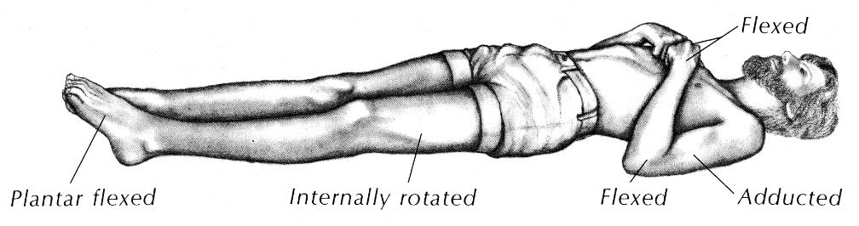

- decerebrate rigidity (abnormal extension): see “A61. Postural Control”
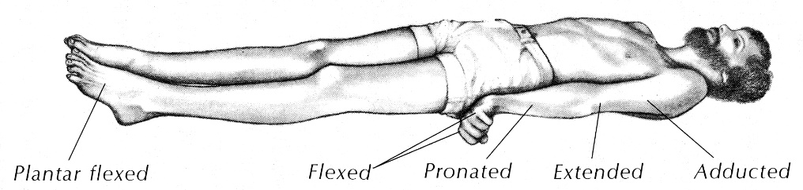

Stereotyped* posturings indicate that cerebral cortices are no longer in command of motor system!
*vs. purposeful movements
- when stereotyped postures occur spontaneously, there may be unrecognized stimulus (e.g. airway obstruction, bladder distention).
- progressive rostro-caudal deterioration with lateral mass lesions: hemiparesis → + decorticate posturing on other side of body → decerebrate posturing (asymmetry tends to be lost; pupillary reactivity and eye movements are lost) → arm extension with minimal leg flexion → flaccid unresponsiveness (lower brain stem destruction).
N.B. acute lesions of any type frequently cause limb extension that becomes flexion as time passes, so posturing alone cannot be utilized to make anatomic localization.
N.B. lack of motor response to any stimulus, should always raise possibility of limb paralysis (e.g. cervical trauma, Guillain-Barre neuropathy, locked-in state).
- metabolic lesions do not cause progressive rostrocaudal deterioration or asymmetrical motor signs.
  - metabolic coma may produce vigorous decerebrate rigidity! (again, posturing alone cannot be utilized to make anatomic localization).
  - multifocal myoclonus is almost always indication of metabolic disorder.
- minor facial or extremity twitching may be only physical finding in status epilepticus.

- Motor asymmetry (lateralized cerebral lesions may affect consciousness by shifting diencephalon) - signifies either focal seizures or hemiparesis.
N.B. if patient is not alert enough to cooperate with strength testing, motor examination is limited to assessment of motor asymmetry!
- galūnių tonusas, spontaniniai judesiai, refleksai.
- in mild hemiparesis, paretiškos galūnės judinamos gerokai rečiau.
- deep tendon reflexes reflect spinal cord function only at particular level (i.e. not helpful in detecting structural lesions of brain stem or cerebral cortex).
- Babinski reflexes are of little use unless asymmetric.
- if it is not possible to perform formal motor testing (patient is not cooperative or is comatose), motor movement should be elicited by application of painful stimuli – record any movement of extremities (kuriomis galūnėmis ginasi nuo skausmo, ant kurio šono spontaniškai gulasi).
N.B. voluntary purposeful movement must be distinguished from abnormal motor posturing (decorticate, decerebrate)!
- jei dirginant abi puses reaguoja tik viena - hemiplegia; jei viena pusė neduoda reakcijos - hemianesthesia.
- galva (ir akys) pasukti, kai pažeidimas: see also below
pusrutulyje - į židinio pusę;
smegenų kamiene - į paralyžiaus pusę.
- ankstyvoje paralyžiaus stadijoje, kol neišsivystė spastiškumas:
  - paimti už riešo (dilbis vertikaliai) - paralyžuota plaštaka nudrimba 90° kampu;
  - pakelti ranką ir paleisti žemyn arba po pakinkliais pakišti ranką, pakelti vieną blauzdą už čiurnos ir paleisti - pakenkta galūnė nudrimba kaip negyva;
  - pritraukti kulną prie sėdmenų ir paleisti - paralyžuota koja greit išsitiesia su išorine rotacija, sveika koja išsitiesia lėčiau;
  - let patient's hand fall toward his face and see if he resists (check for malingering).
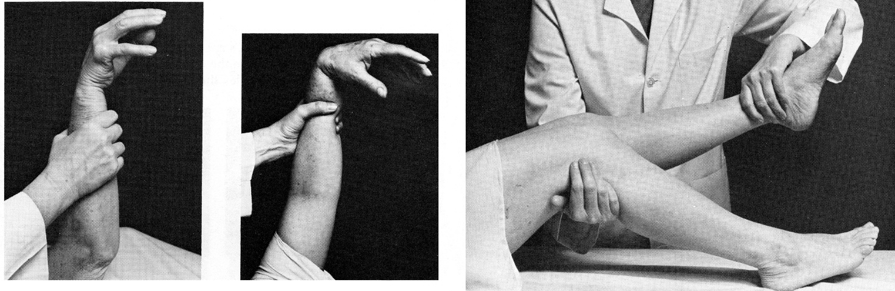
  - Vernike-Mano poza: leg lies externally rotated (exclude hip dislocation/fracture!); paralyzed one side of lower face (cheek puffs out on expiration); eyes may be turned away from paralyzed side; vėliau išsivysto paralyžuotos pusės spastiškumas.
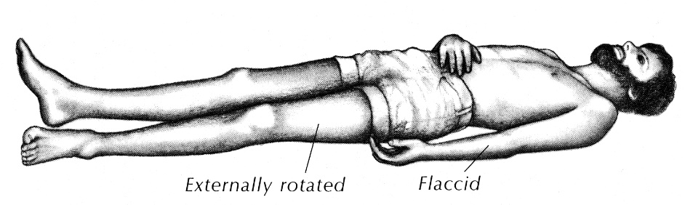

False localizing motor examination - can be caused by:
- contralateral cerebral parenchymal injury occurring simultaneously with expanding mass lesion.
- Kernohan's notch syndrome (hemiparesis ipsilateral to mass lesion – due to compression of contralateral cerebral peduncle).
- occult extremity trauma (painful immobilization or nerve lesion).

- Akys:
- pupil size, shape, symmetry, and reaction to light;
see p. D1eye >>, p. Eye64 >> (pupillary syndromes)
  - vyzdžius reikia monitoruoti kas 15 min.
Jei gilioje* komoje vyzdžiai simetriški & išlikusi r-ja į šviesą – komos priežastis metabolinė (džn. barbiturate poisoning).
*kai sutrikę akių judesiai ir kvėpavimas
Bilateral fixed pupils in midposition (4-6 mm diameter) – ominous finding! - midbrain lesion adjacent to superior pole of midbrain RAS - unless etiology can be reversed quickly, coma is usually irreversible.
Newly dilated fixed pupil in comatose patient with suspected intracranial lesion (mass lesion, ruptured aneurysm) - surgical emergency!!!
  - rarely – ipsilateral SAH from internal carotid aneurysm that compresses CN3 at origin of posterior communicating artery (patient also may be fully conscious!)
  - rarely – ipsilateral intrinsic midbrain lesion.
  - most commonly – ipsilateral* mass lesion that has shifted diencephalon laterally;
    - older view – CN3 compression by herniating temporal lobe;
    - modern view – traction on CN3 produced when diencephalon, being pushed away from expanding lateral mass, pulls midbrain with it (CN3 is tethered anteriorly at cavernous sinus, so nerve ipsilateral to mass is subjected to stretching).
    - early in compression/traction, pupil may be oval and slightly eccentric.
*occasionally contralateral (midbrain / CN3 compression against opposite tentorial margin).

- eye movements see below
- dugnai (nenaudoti midriatikų!!! – could mask important pupillary signs) – detecting:
- ICP↑ (papiloedema, kraujosruvos, absent venous pulsations)
N.B. papilledema develops slowly; when present, underlying disease is likely to be subacute (e.g. intracranial neoplasm, hypertensive encephalopathy).
- SAH (layered subhyaloid blood)
- diseases that affect CNS vasculature (e.g. hypertensive or diabetic retinopathy, retinal ischemia).
- vokai
  - closed eyelids mean that lower pons is intact.
  - blinking means that reticular activity is taking place.
  - lid tone (tested by lifting eyelids, palpating resistance to opening, speed of closure) is reduced progressively as coma deepens; eye closure (that follows passive eyelid opening) is slow, incomplete, and often asymmetrical.

Effect of CNS depressant drugs on eyes in orderly fashion (with increasing intoxication severity):
- paralyzed eye movements
- eliminated corneal response
- pupils unreactive to light.

- Smegenų kamieno intaktiškumas, galviniai nervai:
  - if brainstem damage is found, you may guess that coma is due to RAS damage (vs. bilateral cerebral hemisphere damage).
  - most convenient brainstem reflexes are ¹pupillary light responses (mainly midbrain), ²eye movements (mainly pons), and ³respiratory pattern (mainly medulla):

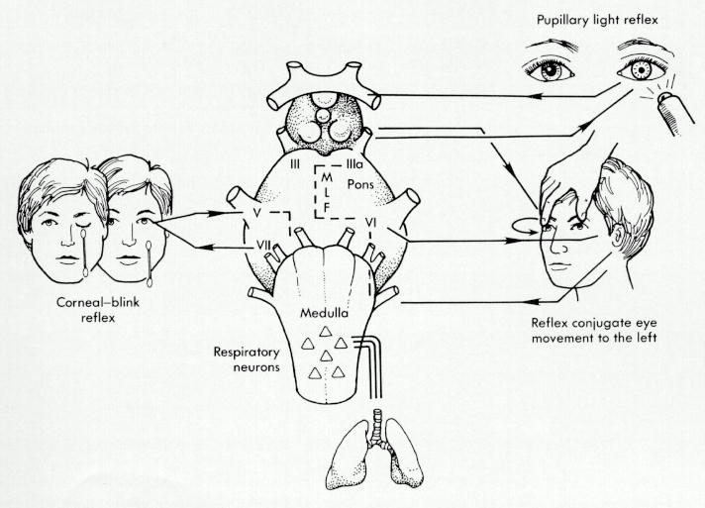

Pupillary responses (Edinger-Westphal nucleus in midbrain, CN3) see above
Eye movements, spontaneous and elicited (CN3, CN6, MLF, PPRF, vestibular nuclei)
Corneal reflex (CN5 and CN7, pons integrity)
Facial symmetry (CN7) can be assessed if patient grimaces with noxious stimuli; “burės simptomas”.
Gag reflex (CN10)
Respiratory pattern (CN10)

Testing eye movements is of vital concern in comatose patients!
see p. Eye64 >> (saccade, smooth pursuit, vertical gaze syndromes)
N.B. extraocular muscles have nicotinic receptors and are therefore susceptible to neuromuscular blocking agents!
  - median longitudinal fasciculus (conjugate horizontal gaze) overlaps in space with midbrain reticular formation.
    - Spontaninė akių padėtis, spontaniniai akių judesiai (if possible)
  - horizontal eye divergence at rest is normal in drowsiness (as patients either awaken or coma deepens, ocular axes become parallel again).
  - vertical eye divergence (skew deviation) - lesions of cerebellum or pontine tegmentum.
  - conjugate horizontal roving (from side to side with slow, smooth velocity) in coma = intact brain stem!!!
  - jerky movements suggest saccades and relative wakefulness.
  - deviation of eyes toward hemiparetic limbs:
- pontine lesion
- aversive seizure
- "wrong-way" gaze paresis - eyes turn paradoxically away from deep hemispheral lesion (e.g. thalamic hemorrhage).
  - deviation of eyes away from hemiparetic limbs - frontal lesion on side toward which eyes are directed.
eyes look toward hemispheral lesion and away from brainstem lesion
  - sustained downward eyes deviation – poor localizing value:
- midbrain pretectum lesion (Parinaud syndrome)
- metabolic coma (esp. barbiturate poisoning); N.B. lateral deviation or disconjugate eyes argue against metabolic disturbance!
- after seizure.
  - sustained upward eyes deviation – hypoxic encephalopathy with intact brain stem.
  - persistently adducted / abducted eye - CN VI / III paresis (nonlocalizing - either pontine lesion or elevated ICP causing extrinsic compression).
  - spontaneous nystagmus is rare in coma (except convergence nystagmus with midbrain lesions).
  - “ocular bobbing” – classic for bilateral pontine damage (but also in metabolic derangements).
  - “ocular dipping” denotes diffuse anoxic cortical damage.

    - If patient cannot follow verbal commands, two tests for reflex eye movements can determine brain stem integrity.
- these tests check integrity of brainstem circuit for conjugate gaze (includes vestibular nuclei, PPRF, CN3, CN6, MLF – structures along pons and midbrain) not by cortical stimulation but by vestibular alterations; i.e. tests do not depend on frontal eye field status.
- “doll’s eyes” reflex also depends on input from cervical proprioceptors (thus testing integrity of high cervical spinal cord and medulla).
- “Doll’s eyes” (s. oculocephalic, oculogyric, cervico-ocular) reflex:
N.B. atliekama tik įsitikinus, jog nelūžęs kaklas!
laikyti vokus atmerktus ir greitai pasukti galvą į šonus, sulenkti, ištiesti: | - sąmoningas - akys nei lieka fiksuotos, nei pasisuka su galva (stovi tarpe):
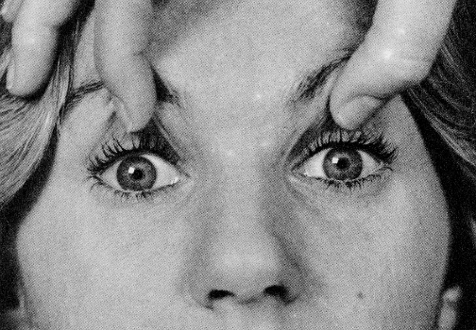 | 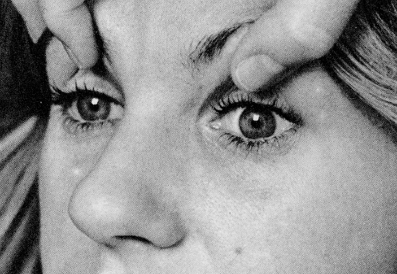
- intaktiškas sm. kamienas - "lėlės akys", t.y. akys lieka fiksuotos į tą patį tašką erdvėje*: | - pažeistas sm. kamienas, gili koma - akys keliauja su galva („negative doll's eyes”):
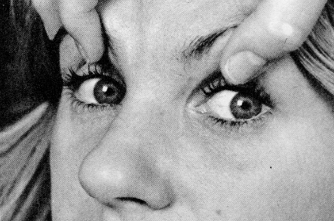 | 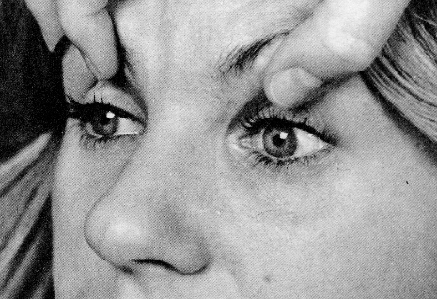

*if pontine (horizontal) or midbrain (vertical) gaze centers are intact, eyes should move in orbits in direction opposite to rotating head; the ease with which globes move is reflection of brainstem disinhibition by damaged cerebral hemispheres.

- Oculovestibular reflex (caloric stimulation) - tinka ir kai lūžęs kaklas!
- įsitikinus, kad ¹būgnelis nekiauras + ²landoje nėra sieros ar krešulių, į landą su mažu kateteriu (kateteris neturi kliudyti vandeniui išbėgti iš landos) suleisti 10-200 ml ledinio vandens (geriausiai, jei galima - galvą pakėlus 30° kampu – horizontalusis pusratinis kanalas atsistoja vertikaliai); response must occur within 60 seconds:
- sąmoningas - prasideda nistagmas (lėtas komponentas į dirginamą pusę).  - intaktiškas sm.kamienas - abi akys nukrypsta į dirginamą pusę (horizontali toninė deviacija) – “žiūri, kas čia pila šaltą vandenį į ausį”; jei pažeistas frontal eye field, akys iki testo „žiūri į pažeidimo pusę“, bet pats testas normalus.  - pažeistas sm.kamienas (pontine-midbrain dysfunction) – akys kartais „žiūri į kitą pusę“, o testo metu nėra jokio atsako (bet gali būti ir dėl ekstraokulinių raumenų patologijos, sunkios metabolinės encefalopatijos ar intoksikacijos barbituratais / fenitoinu / tricyclic antidepressantais – visais šiais atvejais vyzdžiai esti ≈ normalūs!*).  * very high serum levels of barbiturates may cause small nonreactive pupils | 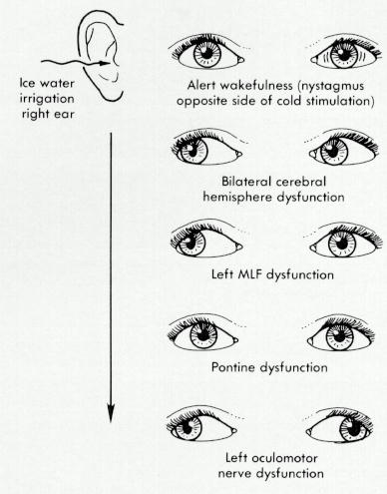
if eyes move to side of cold water infusion, brain stem from medulla to midbrain must be functioning!
- vėliau (palaukus 5 min.) viską pakartoti kitoje ausyje (palyginamas simetriškumas).
- responses cannot be voluntarily resisted!
- only hemispheric pathology - responses should not be altered (if damaged frontal eye field → just loss of nystagmus, but deviation normal).
- dysconjugate movements:
  - normal movement of ipsilateral eye (toward irrigated ear) but no movement of contralateral eye suggests abnormality of contralateral MLF.
  - loss of abduction or adduction in one eye – lesion of CN3 or CN6, respectively.
  - skew deviation (dysconjugate in vertical direction) – lesion in brainstem, but exact location is not known.
- alternatyva – galima naudoti warm water (+ 44°C) – viskas vyksta priešingai (toninė deviacija į nedirginamą pusę); esmė – vandens temperatūra turi skirtis nuo kūno temperatūros – tai sukelia endolimfos konvekciją pusratiniuose kanaluose.
- if tympanic membrane is perforated – use air at 2°C and 44°C.
- mechanism: irrigating ear with cold water → temperature of endolymph falls → downward current in horizontal semicircular canal → tonic vestibular output↓ to contralateral PPRF (as if stimulating ipsilateral PPRF) → nystagmus to opposite side; warm water produces nystagmus to same side.
COWS = Cold to Opposite and Warm to Same
- simultaneous bilateral irrigation causes vertical deviation (upward after warm water and downward after cold water).

“Doll's eyes” maneuver is relatively weak stimulus for horizontal eye movements (vs. ice water);
- if doll's eyes reflex is present, it is not necessary to continue with caloric testing.
- if doll's eyes reflex is lacking, caloric testing should be performed.

Intact reflex lateral eye movements = intact brainstem, no mass lesion in posterior fossa!
Lack of reflex lateral eye movements + preserved pupillary reactivity = drug toxicity.

Breathing pattern (by bedside observation) ≈ localizing significance in patient with altered consciousness. see also 2115 (4-5) p.
be certain that upper airway is intact! If not → endotracheal intubation → reassess breathing pattern (recognizing confounding effects of drugs and increased breathing work required by smaller diameter of new airway).
determined respiratory pattern is interpreted in light of arterial blood gas results.
  - tachypnea is interpreted differently in hypoxia and in normoxia.
  - brain stem is primarily concerned with maintenance of pH and PaO₂, not PaCO₂.

Pattern | Level of dysfunction | Comments
Posthyperventilation apnea  - apnea for > 10 seconds after 5 deep breaths. | Bilateral hemispheric | Normally, cerebral cortex triggers another breath within 10 seconds regardless of PaCO₂
Cheyne-Stokes respiration  - rhythmic waxing and waning of respiratory amplitude. | Bilateral hemispheric / diencephalic (incl. metabolic causes);  brain stem intact! | Periods of "apnea" are actually times when respiratory amplitude is too low to measure, but respiratory rhythm is unchanged; “hyperpneic” phase is usually longer → respiratory alkalosis.
 | Non-neurogenic causes: 1. Congestive heart failure (without any neurologic dysfunction) - prolongs reflex arc (blood leaving lungs takes longer to reach brain stem); 2. Uremia; 3. Normal sleep arrhythmia; 4. Chemoreceptor hypersensitivity to pCO₂↑.
Central reflex hyperpnea (CRH, formerly called central neurogenic hyperventilation)  - continuous deep breathing. | Bilateral hemispheric, lower midbrain ÷ upper pons, possibly medulla | Most commonly due to hypoxia that accompanies neurogenic pulmonary edema (in brain stem lesions, SAH, etc)  True CRH is rare.  Leads to severe alkalosis!
Apneustic respiration (gasping) - prolonged inspiratory time ("inspiratory cramp"). | Pons | Does not support adequate ventilation, but isolated lesions at this levels do not produce coma.
Cluster respiration
- clusters of breaths punctuated by apnea.
Ataxic (Biot’s) respiration  - infrequent, irregular breaths (continually variable rate and depth). | Lower pons ÷ upper medulla (lesions in respiratory centers! – impending respiratory arrest) | “
Ondine's curse  - failure of involuntary respiration with retained voluntary respiration. | Reticulospinal tract lesion in medulla (sagittal cut through obex) or C₁₋₂ (transverse bilateral cut in ventromedial quadrants) | “
Apnea  - no respiration. | Medullocervical junction (medulla ÷ C₄); peripheral nerve, neuromuscular junction, muscle | “
Hyperventilation (Kussmaul’s respiration) – deep ventilation (hyperpnea) | Compensation for metabolic acidosis, fever | Common causes of coma with acidosis: diabetic ketoacidosis, uremia, acidic poisons*; salicylates, sepsis, hepatic failure also directly stimulate respiratory center
Hypoventilation |  | Common causes of coma with hypoventilation: CNS depressants **, chest co-trauma
*ethylene glycol, methanol
**alcohol, barbiturates, benzodiazepines, opioids.
Iš esmės, pažeidimai rostraliau pons palieka pakankamą ventiliaciją!

- Autonomic nervous system dysfunction - can be both cause and effect of coma.
  - lesions affecting descending sympathetic pathways from hypothalamus to brain stem → Horner's syndrome.
  - diencephalic lesions are particularly associated with erratic changes in autonomic stability.
  - most common causes of coma with marked dysautonomia are intoxication / drug overdose.

Clinical Findings with Different Levels of CNS Dysfunction
Dysfunction level | Response to Noxious Stimuli | Pupils | Eye Movements | Breathing
Both cortices | Withdrawal / decorticate posturing | Small, reactive | Spontaneous conjugate horizontal movements; if none, “doll’s eye” / caloric reflexes can be elicited | Posthyperventilation apnea or Cheyne-Stokes respiration
Thalamus | Decorticate / decerebrate posturing | “  (if damaged optic tracts → unreactive to light) | “ | “
Midbrain | Decerebrate posturing | Midposition (!!!), fixed | Loss of adduction (CN3 damage); eyes deviated laterally (“wall-eyed”) | “  (potential for central reflex hyperpnea)
Pons | Decerebrate posturing or none (differentiate from locked-in) | Small, reactive;  midline pontine lesion → pinpoint pupils*; lateral lesions → Horner's syndrome | Loss of conjugate horizontal movements (PPRF damage); retained accommodation and vertical movements (may cause bobbing); eyes often deviated medially (CN6 damage); loss of corneal reflex | central reflex hyperpnea, cluster or apneustic breathing
Medulla | None or weak leg flexion | Small, reactive;  lateral lesions → Horner's syndrome | Usually no effect on spontaneous eye movements; may interfere with reflex responses; rarely, nystagmus | ataxic (Biot’s) respiration; apnea if respiratory centers involved
* damage to intra-axial descending sympathetic pathways or RF lesion that dysinhibits Edinger-Westphal nucleus.

Instrumental Neurologic Examination
- Laboratory tests (chemical-toxicologic analysis of blood and urine) see 2769 p.
- unexplained bilateral hemispheric dysfunction → battery of screening tests (at minimum, CBC with differential, platelets, prothrombin time, partial thromboplastin time, serum sodium / potassium / bicarbonate / chloride, serum osmolality, serum BUN, serum & urinary screening for drugs of abuse & alcohol).
- if diagnosis remains unclear → spectroscopy for sulfhemoglobin and methemoglobin.
- postictal prominent anion gap acidosis (lactic acid) will normalize within 1 hour (vs. in metabolic cases).
N.B. presence of exogenous toxins (esp. alcohol) does not ensure that other factors (particularly head trauma) may not also contribute to clinical state.
N.B. urosepsis is common cause of altered mental status in elderly!

- Neuroimaging – performed promptly whenever coma is metabolically unexplained - may demonstrate lesions, displacements.
- imaging should precede lumbar puncture (unless meningitis is suspected & patient is clinically deteriorating).
- skull X-rays are usually useless!
- CT is usually faster and more readily available in emergent circumstances than MRI (for technical reasons, MRI is difficult to perform in comatose patients).
- emergency head CT should be unenhanced - directed toward hemorrhage;
- contrast-enhanced CT is desirable when tumors, infections, or other inflammatory conditions are suspected.
- MRI may be indicated if CT is negative and brainstem lesion is suspected.
- PET may be useful in study of vegetative patients.
- in acute mass lesions - horizontal displacement of pineal body from midline:
3-5 mm corresponds to drowsiness;
5-8 mm corresponds to stupor;
> 8 mm corresponds to coma.
N.B. normal neuroimaging does not exclude primary CNS process (e.g. early small brainstem lesion, encephalitis, meningitis, mechanical shearing of axons in closed head trauma, absent cerebral perfusion, sagittal sinus thrombosis, isodense subdural hematomas).

- Lumbar puncture & CSF analysis in coma is limited to diagnosis of:
- meningitis (if imaging study precedes lumbar puncture, then appropriate antibiotic therapy should be started before patient is sent for imaging study).
- subarachnoid hemorrhage in which CT is normal (pattern of RBCs and various pigments helps in establishing whether SAH patient with new onset of depressed consciousness has rebled or suffered another event like vasospasm).

- EEG – indicated in most patients (because history and examination are inadequate to detect many cases of nonconvulsive status epilepticus):
- if structural lesion has been excluded.
- if supratentorial structural lesions are not adequate to explain patient's state.
Generalized slowing regardless of underlying cause; additional features possible
- triphasic waves (see D27 p.), FIRDA (frontally predominant intermittent rhythmic delta activity) suggest metabolic encephalopathies (esp. hepatic!).
N.B. in metabolic coma, EEG is always abnormal!
- burst-suppression pattern (see D27 p.) indicates severe encephalopathic process.
- epileptiform discharges suggest postictal state or status epilepticus.
- in head injury, EEG is diffusely slowed but focal abnormalities (slowing, spike discharges, or attenuation of activity) may be superimposed - relate to hematoma, cerebral contusion, ischemia, or edema.
- alpha-pattern coma - diffuse invariant alpha-frequency (≈ 10 Hz) activity nonreactive to external stimuli; differentiation from true normal alpha rhythm - frontal predominance, absence of spindles, lack of modulation; poor prognosis!; etiology:
- midbrain lesion
- diffuse cortical damage (hypnosedative drug overdose; anoxia, cardiorespiratory arrest).
- widespread high-voltage beta activity suggests sedative-hypnotic medications.
- psychogenic unresponsiveness - normal EEG with alpha blocking on passive eye opening and normal sleep-wake cycling.
- locked-in state - normal EEG.
- brain death - electrocerebral silence (but exclude hypothermia and sedative intoxication!).

Unlike EEG is performed in controlled laboratory, lighting and sound will cause artifacts!

Dysfunction | Electrophysiology
Bilateral cortical | Diffuse slowing; often, FIRDA.
Diencephalic | Diffuse slowing; rarely, FIRDA; in displacement syndromes - effect of mass (e.g. focal delta activity, loss of faster rhythms).
Midbrain | Diffuse slowing; alpha coma; evoked responses may show conduction failure above lesion.
Pontine | EEG normal; evoked responses (BAER, somatosensory) may show conduction abnormalities.
Medullary

As depth of coma increases:
- EEG becomes nonreactive;
- EEG may show burst-suppression pattern;
- EEG amplitude↓ until eventually electrocerebral activity cannot be detected.
N.B. electrocerebral silence does not necessarily reflect irreversible brain damage, because it may occur in hypothermia or drug overdose.

- Evoked potentials (somatosensory, BAER) – seldom contribute diagnostically or therapeutically; can predict poor / good outcome (serial somatosensory EPs are most sensitive and reliable).
BAER is normal in coma due to metabolic / toxic disorders or bihemispheric disease but abnormal in presence of brainstem pathology
BAER in coma – p. Ear30 >>

- ICP monitoring

Management
All comatose patients should be placed on 100% oxygen and fully undressed!
After stabilization of respiratory and cardiovascular systems, attention is turned to CNS!
see 2769 p. about poisoning treatment
- Position / activity
    - elevate head 30°, keep neck straight.
    - keep eyes closed (either by taping them closed with nonallergenic tape or by covering them with moist dressings).
- if patient is wearing hard contact lenses, they should be removed (may cause damage to cornea) with specially designed suction cup.
- unconscious patient have lost reflexes that normally protect eye (such as blinking reflex).
    - prevention of decubitus ulcers - turn frequently, rub skin with alcohol, etc. see p. 2217 >>
    - urinary bladder catheterization
- catheter should be smallest size consistent with adequate drainage of bladder.
- catheter should be fixed to skin of abdomen or thigh so that it will not erode urethra or produce ulcers in trigone of bladder.
    - bedside physical / occupational therapy is started during 2nd week (to prevent deformity, heterotopic ossification, etc).

- Respiratory care
N.B. hypoxia almost always complicates unconsciousness!
    - endotracheal intubation (esp. if GCS ≤ 8);
- patients with GCS < 8 may still have intact cough reflex (→ difficult & dangerous intubation without paralysis or sedation).
- nasogastric / orogastric tube should be inserted (initial resuscitation often leads to gastric distension that impairs assisted ventilation).
- ligoniai turi būti ekstubuojami, kai tik atgauna sąmonę ir yra užtikrintas kvėpavimo takų praeinamumas.
    - endotrachėjinį vamzdelį saugiai galima laikyti iki 2 savaičių; patients who remain comatose for > 5-10 days usually benefit from tracheostomy (jei numatoma ilgalaikė koma, tracheostoma atliekama 7-10 parą po traumos).
    - pulmonary toilet.

- Management of ICP (as indicated) – see p. S50 >>
    - seizure prophylaxis (e.g. after brain injury).

- GI care:
- antacids / H₂ blockers via nasogastric tube - to keep gastric pH > 3.5 (prevents GI bleeding); gastric coating agents (e.g. sucralfate) are associated with less aspiration pneumonia than other prophylactic agents for GI bleeding.
- start nutrition if patient remains comatose for > 12 hours (by nasal tube or parenterally).
- 2500 kcal/day
- intravenous fluid 125 ml/hr (0.45% normal saline and 5% dextrose).
N.B. hyponatremia (may aggravate cerebral injury) is common complication of IV therapy in comatose patient!
N.B. hyperglycemia exacerbates ischemic brain injury in experimental animals, it appears wise to avoid glucose infusions!
- patients who remain comatose for > 5-10 days benefit from feeding jejunostomy tube (because of gastrostasis).
- bowel movements may be interrupted - periodic checks for impaction may be necessary unless evacuations occur every day or two days (impactions require digital removal, suppositories or laxatives).

- Thromboembolic prophylaxis – if patient has little or no spontaneous extremity movement – start early (e.g. from 2nd day):
- intermittent pneumatic calf compression, pasyvus pedalų mynimas, blauzdos raumenų elektrostimuliacija.
- low-dose heparin SC (5000 UI × 2/d), dextrans.

- Hypothermia: American Heart Association is recommending to chill comatose victims of cardiac arrest (to help prevent brain damage).
- cooling should be started ASAP after successful resuscitation.
- with circulating cold air and ice packs.
- from normal 98.6 F to 89.6-93.2 F.
- continued for 12-24 hours.
- high-dose barbiturates (and other neuronal sparing agents) soon after cardiac arrest are not beneficial.

- Medications
- corticosteroids have no proven value (except in brain tumor).
- stimulants and narcotics should be avoided.

Prognosis
To date, no collection of clinical signs (except those of brain death) assuredly predicts coma outcome.
- young patients have better prognosis.
- Glasgow Coma Scale has predictive value in traumatic coma – see p. TrH1 >>
- prognostication of nontraumatic coma is difficult (heterogeneity of contributing diseases);
  - metabolic coma has more favorable prognosis than anoxic or traumatic coma.
- evoked potentials aid prognostication in head-injured and post-cardiac arrest patients (bilateral absence of cortical somatosensory EPs is associated with death or vegetative state).

Etiologic Categories
- Hemispheric mass lesions result in coma by herniation:
- lateral herniation - across midline laterally to compromise both hemispheres
- transtentorial herniation - impinging on brain stem.
- clinical signs of expanding mass evolve in level-by-level rostral-caudal manner.
- hemispheric lesions of adequate size to produce coma are readily seen on CT.
- acute hydrocephalus may cause coma by acute symmetric enlargement of both lateral ventricles (drowsiness → progress quickly to coma).

- Brain stem mass lesions - produce coma by directly compromising RAS.
- CT is not able to detect all lesions, so testing for lateral eye movements is critical element in diagnosis (pontine gaze center, MLF, CN3 nucleus traverse RAS)
Coma with intact reflex lateral eye movements = no mass lesion in posterior fossa!

- Generalized seizures:
- diffuse abnormal electrical discharges throughout RF and cortex → coma.
- post-ictal state is state of electrical inhibition → coma (until neuronal metabolic balance is restored!).
N.B. prolonged alteration in consciousness (post-ictal state) after unwitnessed seizure may produce diagnostic confusion (seek for bitten /scarred tongue, incontinence)

- Meningeal irritation (infection or blood in subarachnoid space) - among most important early considerations in coma evaluation as it is treatable and may not be diagnosed by CT, so clinical signs of meningeal irritation are critical!
  - coma mechanism is incompletely understood - combination of humoral factors (incl. IL-1, TNF, arachidonic acid metabolites), vasogenic cerebral edema, altered cerebral blood flow, neurotoxic excitatory amino acid neurotransmitters; later, vasculitis and thrombosis of meningeal veins → diffuse cortical & white matter necrosis.

- Metabolic abnormalities - presence of exogenous toxins (e.g. drugs) or endogenous toxins (e.g. organ system failure) → diffuse CNS dysfunction without localized* signs.
"metabolic encephalopathy" - no focal anatomic features in examination / neuroimaging to explain coma.
*metabolic disease can cause both focal seizures and lateralizing neurologic signs, often shifting, but sometimes persisting (as in hypoglycemia and hyperglycemia).
- anoxia (e.g. CO, cyanide poisoning, cardiac arrest) → clinical patterns:
- deep coma with preserved brainstem function* that evolves to vegetative state or dementia.
*brainstem may be suppressed in first hours, thus emulating brain death.
- bilateral infarctions of watershed regions → proximal bibrachial & paraparetic weakness or cortical blindness.
- Korsakoff-amnestic state (selective vulnerability of hippocampal cortex neurons).
- cerebellar syndrome.
- ischemia (e.g. syncope, acute basilar artery occlusion).
CBF < 25 mL per 100 g/min → diffusely slowed EEG;
CBF 15 mL per 100 g/min → brain electrical activity ceases;
CBF < 10 mL per 100 g/min → irreversible brain damage.
N.B. most common stroke (territory of MCA) does not cause coma acutely!
- hypoglycemia (brain glucose stores provide energy for 2 min after blood flow is interrupted, and consciousness is lost within 8-10 s) – preceded by light-headedness, hunger, palpitations, sweating; acute onset ± convulsions; pale & moist skin, hypothermia; deep reflexes↑, positive Babinski, responds promptly to dextrose i/v.
- diabetic ketoacidosis – gradual onset, dry flushed skin, sunken eyeballs, hyperventilation with fruity breath, hyperglycemia & metabolic acidosis
- hepatic coma is result of high brain ammonia (interferes with Na⁺, K⁺-ATPase pump, results in "false" neurotransmitters, binds to benzodiazepine-GABA receptors).
- renal coma is poorly understood - urea itself is not CNS toxic.
- abnormalities of osmolarity;
- [Na] < 125 mmol/L → (sub)acute confusion; < 115 mmol/L → coma and convulsions.
- in hyperosmolar coma serum osmolarity is generally > 350 mOsmol/L.
- drugs (sedative-hypnotics, ethanol, opioids) produce coma by suppression of both RAS and cerebral cortex (combinations of cortical and brainstem signs occur!).
- [ethanol] 2 ‰ in nonhabituated patients → confusion; > 3 ‰ → stupor (responds to noxious stimuli - not coma!); tolerance may allow chronic alcoholic to remain awake at > 4 ‰; hyperemic face and conjunctivae, deep noisy (not stertorous) respirations, alcoholic breath!
- drugs cause 70-80% of acute undiagnosed comas!
- hypothermia itself causes coma only when temperature is < 31°C; hyperthermia.
- hypothyroidism / thyrotoxicosis.
- hypercalcemia (e.g. in malignancies).

Coma-like states
  - Locked-in syndrome see p. Mov3 >>
  - Persistent vegetative state see p. S32 >>
  - Brain death see p. S34 >>
  - Akinetic mutism, incl. abulic state (frontal lobe disease)
  - Catatonia see p. Psy11 >>
  - Psychogenic unresponsiveness (hysteria*, malingering) - diagnosis of exclusion.
*most common cause
Hysterical (conversion) unresponsiveness is clinically indistinguishable from malingering (except by direct statement afterwards by patient); important features of both:
    - normal pupils.
    - eyelids resist passive opening (with Bell's phenomenon) and, when released, close abruptly (rather than with smooth descent);
      - eyes often remain tonically deviated toward bed and away from examiner.
      - if eyes show downward deviation regardless of patient position, it indicates hysterical unconsciousness.
      - blinking occurs to visual threat when lids are held open.
      - lightly stroking eyelashes causes lid fluttering.
    - eyes move with saccadic jerks (roving movement cannot be imitated!).
    - no reflex posturing to pain; limbs offer no resistance to passive movement, yet demonstrate normal tone. Normal posture and tone!
    - patients will avoid self-injury if raised arm is dropped toward face.
    - normal EEG with alpha blocking on passive eye opening and normal sleep-wake cycling.
    - normal COR and VOR responses (characteristic of awake patients) - develop nystagmus and vomiting to cold caloric challenge – most objective (but uncomfortable) diagnosis!!!
    - try to “awaken” patient with minimally provocative maneuvers:
- nasal tickle may cause patient to raise hand to nose voluntarily.
- act of opening patient's eyes may establish visual contact and be comfortable (for patient’s dignity) opportunity to "reverse problem"
- raising patient to sitting position (if no potential for spinal injury) makes it difficult to preserve pseudounconscious state.
- if all above unsuccessful, patient should then be allowed time to reverse "psychogenic coma".
N.B. do not use painful stimuli (patients may be very resistant to painful stimuli!!!) – may destroy tenuous therapeutic alliance between patient and physician; reassuring and comforting discussion indicating willingness to help patient establishes better therapeutic alliance than painful and provocative procedures!

Bibliography
Goetz “Textbook of Clinical Neurology”, 1st ed., 1999 (2-16 p.)
Rowland “Merritt's Textbook of Neurology”, 9th ed., 1995 (12-16, 19-27 p.)
Weiner “Neurology (House Officer Series)”, 5th ed., 1994 (46-51 p.)
Goldman “Cecil Textbook of Medicine”, 21st ed., 2000 ch. 444-447 (2023-2030 p.)
“Harrison's Principles of Internal Medicine”, 1998, ch. 24
Behrman “Nelson Textbook of Pediatrics”, 15th ed., 1996 (1700-1701, 1716-1719 p.)
“The Merck Manual”, 17th ed., 1999 (ch. 170)
McPhee, Lingappa, Ganong “LANGE Pathophysiology of Disease”, 2002
NMS Medicine 2000, Pediatrics 2000, Emergency Medicine 1997, Neuroanatomy 1998, Physiology 2001
Ganong “Review of Medical Physiology”, 2002
“Oxford Handbook of Clinical Medicine” 1994
“Stedman’s Medical Dictionary”, 27th ed., 2000
“Washington Manual of Medical Therapeutics”, 29th ed., 1998 (475-478 p.)
Rosen “Emergency Medicine: Concepts and Clinical Practice”, 4th ed., 1998 (2106-2118 p.)

Viktor’s Notes℠ for the Neurosurgery Resident
Please visit website at www.NeurosurgeryResident.net

