Idiopathic (Benign) Intracranial Hypertension

(s. Pseudotumor Cerebri)
Last updated: December 19, 2020
IIH with papilledema 1
Pathophysiology 1
Etiology 1
Clinical Features 2
Diagnosis 3
Treatment 7
IIH without papilledema 9

IIH with papilledema
Typical patient - healthy-looking, fully mentally alert, obese woman of childbearing age (15-44 yrs) with chronic daily headaches, normal neurological examination (except for papilledema ± CN6 palsy), normal laboratory studies, and empty sella.

Incidence – 1-2 cases per 100,000 per year (19-21 in obese women aged 20-44).
- female-to-male ratio 8:1 (for mean weight 38% over ideal weight).
- 37% of cases are in children (90% of these are age 5-15 years)

Pathophysiology
- unknown!
Postulated mechanisms - disturbances of CSF hydrodynamics:
- Decreased CSF absorption at arachnoid villi.
          - CSF production rate equals reabsorption rate; however, higher than normal pressure is required to achieve absorption at arachnoid granulations.
- Decreased venous outflow (in superior sagittal and proximal transverse sinuses) – due to:
  - partial venous outflow obstruction (e.g. narrowing of transverse dural venous sinus)
  - elevated central venous pressure (despite absence of signs or symptoms of heart failure).
- Increased CSF production.

Chronically elevated ICP → papilledema → progressive optic atrophy → blindness.

N.B. despite persistently elevated CSF pressure, patients do not become hydrocephalic.

Theories that also explain high prevalence in obese females:
- Mechanical theory: obesity → ↑ intraabdominal pressure → ↑ central venous pressure → ↓ CSF resorption → ↑ ICP
- Hormonal theory: adipocytes convert androstenedione → estrone → ↑ CSF production

Etiology
- absence of any structural CNS abnormality or CSF flow obstruction.

- idiopathic
- venous sinus occlusion, radical neck dissection
- severe iron deficiency anemia
- hypoparathyroidism, vitamin A* intoxication
- SLE, renal disease
- chronic hypoxic hypercapnia
- drugs (nalidixic acid, fluoroquinolones, outdated tetracycline, Danocrine, minocycline, steroid withdrawal**).
*retinol is converted to all-trans-retinoic acid (ATRA) in the meninges and choroid plexus and overexpression increases expression of aquaporin-1 which, in turn, increases CSF secretion
**e.g. pediatric patient treated for asthma
      - retrospective population-based case-control study found no association with hormonal contraception.

Clinical Features
    - Symptoms of generalized ICP↑:
- headache
      - occurs in most, but not all, patients.
      - varies in type, location, and frequency (e.g. chronic daily bifrontotemporal, pulsatile retro-orbital exacerbated by eye movements)
      - headache resembles brain tumor and may be extremely severe!
- nausea

    - Visual symptoms
      - TVO (transient visual obscurations) (e.g. visual clouding in one or both eyes lasting ≈ 1 second); predominantly or uniformly orthostatic
      - horizontal diplopia (false-localizing CN6 palsy)
      - constriction of visual fields; progressive vision loss can occur.
N.B. visual loss related to optic nerve dysfunction causes major morbidity (term benign intracranial hypertension is improper)!
- early: usually constriction of fields and loss of color (perimetry is the best test for following vision)
- blindness may occasionally develop rapidly (i.e. in < 24 hours); risk of blindness is not reliably correlated to duration of symptoms, papilledema, headaches, visual acuity, or number of recurrences; only parameter associated with worsening vision is recent weight gain
- pathomechanics: increased ICP is transmitted along optic nerve sheath → circumferential compression of retinal ganglion cell axons at lamina cribrosa level.

    - Other symptoms:
      - pulsatile tinnitus (or other intracranial noises) can occur; exacerbated by supine or bending position, reduced by ipsilateral jugular vein compression + ipsilateral head rotation.
      - some report radicular shoulder & arm pain (secondary to nerve root dilatation).
      - menstrual irregularity or amenorrhea is common.

Worsening of any of the above symptoms with postural changes that increase ICP (bending over, Valsalva) is characteristic in idiopathic intracranial hypertension.

Course
- high rate of spontaneous remission within some months (usually 1 year).
      - ICP may remain asymptomatically elevated
      - papilledema persists in 15%.
      - permanent visual loss occurs in 2-24%.
      - persistent HlA may occur in some.
      - 5-43% recurrences

Diagnosis
Pseudotumor cerebri is diagnosis of exclusion!
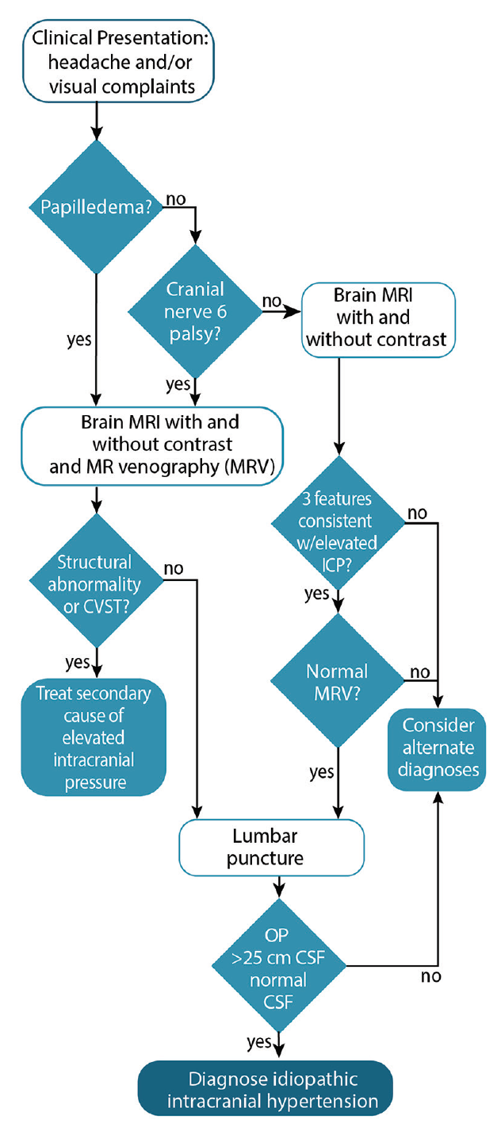
CP, cranial pressure; CSF, cerebrospinal fluid; CVST, cerebral venous sinus thrombosis; ICP, intracranial pressure.

Modified Dandy's criteria:
- signs and symptoms of ICP↑
- neurological examination: normal (except CN6 palsy).
- neuroimaging: normal to small ventricles + no mass lesion or other cause of ICP↑
- CSF: normal parameters (except opening pressure > 25 cm H₂O).

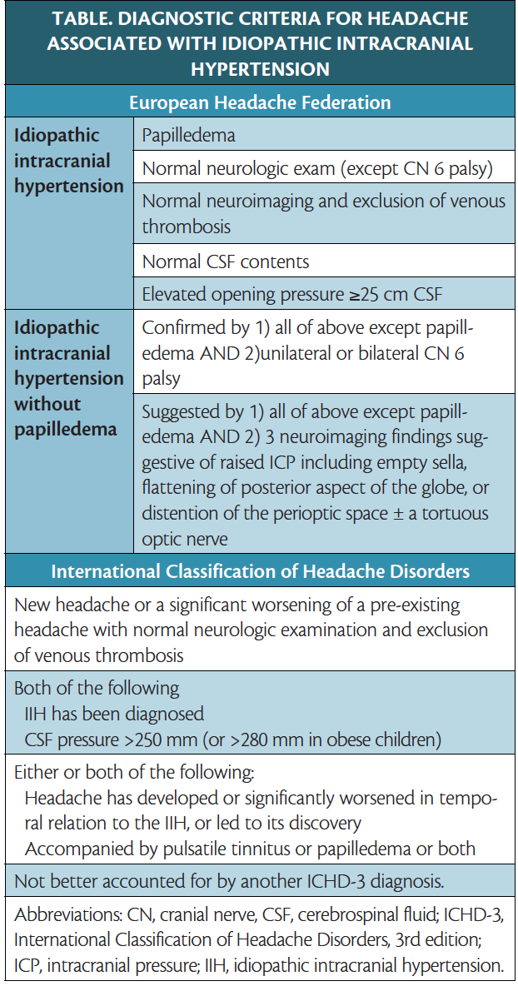

Neuroimaging
MRI with & without gadolinium + MRV
        - look for hydrocephalus, tumor, major venous sinus thrombosis/stenosis.
N.B. imaging should be normal; allowed exceptions:
- Slit-like ventricles
- Partially empty sella
- MRI intraorbital findings:
  - Flattening of the posterior sclera: occurs in 80%
  - Enhancement of the prelaminar optic nerve: in 50%
  - Distention of the perioptic subarachnoid space: in 45%
  - Vertical tortuosity of the orbital optic nerve: in 40%
  - Intraocular protrusion of the prelaminar optic nerve: in 30%

AHA/ASA Scientific Statement on Cerebral Venous Thrombosis (2011): In patients with the clinical features of idiopathic intracranial hypertension, imaging of the cerebral venous system is recommended to exclude cerebral venous thrombosis (Class I; Level of Evidence C).

MRI with fat suppression and gadolinium: elevation and enhancement of both optic nerve heads; each optic nerve sheath is dilated by excess subarachnoid fluid:
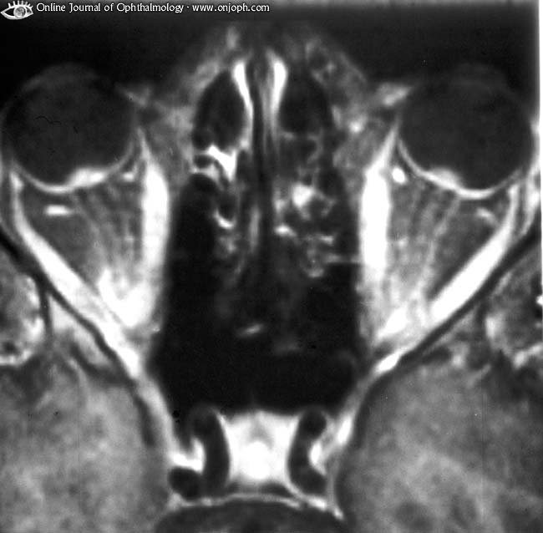
Source of picture: “Online Journal of Ophthalmology” >>

Imaging findings in idiopathic intracranial hypertension include a partially empty sella (A), dilated perioptic spaces and tortuous optic nerves (B), and transverse venous sinus stenosis (C and D):
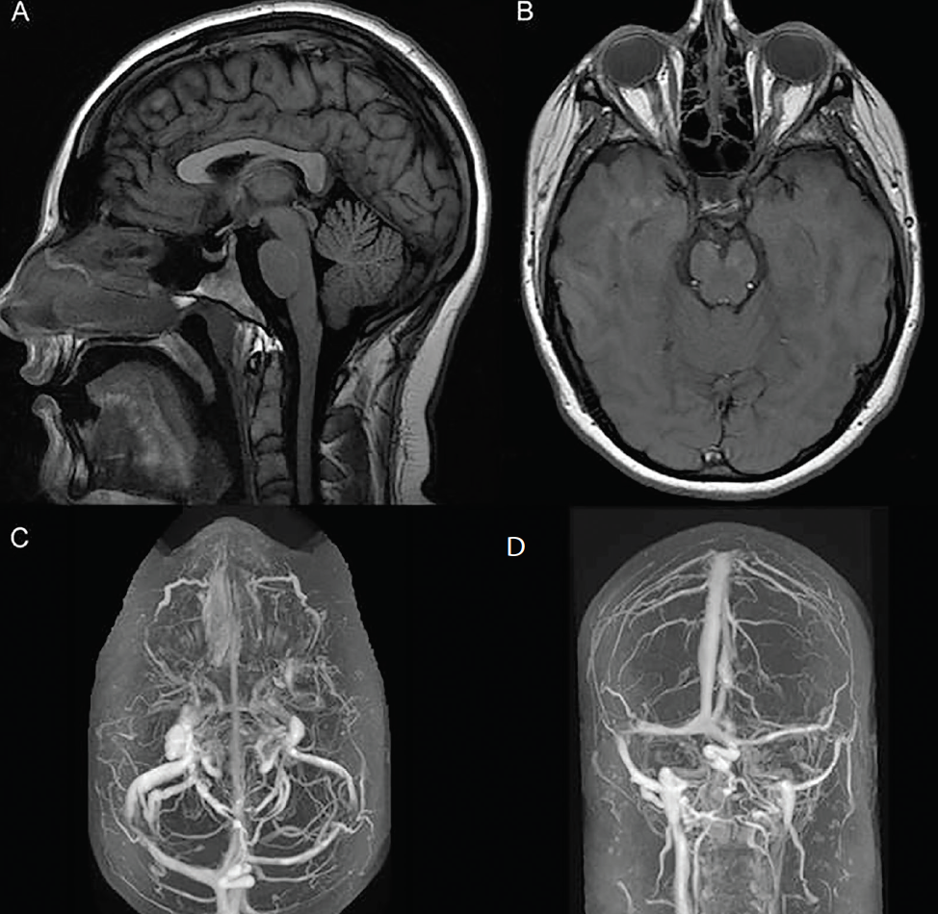
Source of picture >>

Lumbar puncture
ICP↑ (> 20-25* cm H₂O; 25-30 is a “gray zone”) + normal CSF parameters (protein even may be lower than normal).
*in obesity, normal upper limit of CSF pressure is 25 cm H₂O; 28 in obese children
Pressures 40-60 cm H₂O are not uncommon
Do not miss chronic fungal meningitis!

Ophthalmologic examination
- papilledema – present in ≈ 100%; best objective reproducible exam - Ocular coherence tomography (OCT). see p. Eye62 >>
- optic nerve-related visual field defects (starts with inferior nasal field loss → enlarged blind spots → generalized constriction) – present in > 90%.
Perimetry is the best means to detect and follow visual loss!
          - visual acuity and color are preserved until late in disease.

Treatment
Asymptomatic cases* are not treated + careful ophthalmological follow-up (visual field, funduscopy, and ocular motility examination).
*it is possible to lose vision without headache or papilledema.
Intervention is recommended in unreliable patients, or whenever visual fields deteriorate.

- Weight loss (if obese) up to gastric stapling or resection.
          - weight loss of 6% usually results in complete resolution of papilledema (but usually not headaches).
          - symptoms recur if weight is regained.
- Standard headache treatment (as for migraine or TTH).
- Drugs aimed at reducing CSF production:
- fluid and salt restriction
- 4-6-week trial of carbonic anhydrase inhibitor :
- acetazolamide 0.5 g BID → up to 4 g/d - evidence-based first-line therapy; paresthesias occurred in 47.7% of participants, 30.2% had nausea, and kidney stones occurred. see p. 2518 >>
- methazolamide: better tolerated but less effective. see p. 2518 >>
- topiramate - anticonvulsant with secondary inhibition of CA; dosage 200 mg PO q 12 hrs; side effects: similar to acetazolamide, but can be used in sulfa allergic patients.
- loop diuretic (furosemide).
- 160 mg/d, adjust per symptoms and eye exam (not to CSF pressure); if ineffective, double (320 mg/d).
- monitor and supplement K+ levels.
- octreotide has been shown to reduce ICP and improve headache; in a small case series of individuals who had tried and failed multiple medical and surgical therapies, octreotide eliminated headache as a symptom of IIH.
- cardiac glycosides have similar effect.
- short course of high dose corticosteroids - maximum medical management when rapid lowering of ICP is required, for patients awaiting surgery.
- options: dexamethasone 12 mg/d, prednisone 40-60 mg/d, methylprednisolone 250 mg IV q6h.
- reduction in symptoms should occur by 2 weeks, after which time steroid should be tapered over 2 weeks.
- headache commonly recurs after withdrawal.
- long-term use is not recommended due to, among other things, associated weight gain.
- Serial lumbar punctures
N.B. some intractable headache patients have dissociation between CSF pressure and headache!
- large-volume (remove up to 30 ml to halve OP), alternate-day until OP < 20 cm H₂0, then decrease to q 1 wk until remission.
- 25% remit after 1st LP.
- use large gauge needle (e.g. 18 G) which may help promote post-LP CSF leak into subcutaneous tissues.
- Surgical treatment (preventing visual loss ± headache):
  - shunt (lumboperitoneal vs ventriculoperitoneal – equal in shunt failure and complication rates!); may need antisiphon valve to prevent low-pressure headaches.
  - optic nerve sheath fenestration (ONSF) - cutting slits or rectangular patches in dura surrounding optic nerve immediately behind globe;
    - performed via medial or less commonly lateral orbitotomy or transconjunctival medial approach.
    - allows egress of CSF into orbital fat where it is absorbed into veins.
    - papilledema in both eyes may regress after fenestration of one optic nerve; if not, contralateral ONSF must be performed.
    - sometimes (but not always) lowers ICP; headache is not relieved!; i.e. ONFS is best for protection of vision and reversal of papilledema.
    - has succeeded in cases where visual loss progressed after LP shunting, possibly due to poor communication between orbital and intracranial subarachnoid spaces.
    - repeat fenestration is needed in 0.6%
    - side effects: pupillary dysfunction, peripapillary hemorrhage, chemosis, chorioretinal scarring, diplopia (usually self-limited) from medial rectus disruption.
  - dural venous sinus angioplasty and stenting – for select patients with dural venous sinus stenosis.
Hasan Asif et al. Idiopathic intracranial hypertension: 120-day clinical, radiological, and manometric outcomes after stent insertion into the dural venous sinus. Journal of Neurosurgery 2017 October 6: 1-9
    - dural venous sinus stenting indication - endovascularly measured gradient > 8 mmHg; poststenting - aspirin and Plavix (same as post arterial stenting).
    - venous sinus stenosis can improve or resolve after reduction of ICP via CSF flow diversion, pointing to elevated ICP as the etiology of the transverse sinus narrowing rather than the narrowing causing elevated venous pressure and CSF outflow obstruction
Markey KA, Mollan SP, Jensen RH, Sinclair AJ. Understanding idiopathic intracranial hypertension: mechanisms, management, and future directions. Lancet Neurol. 2016;15(1):78-91.

  - obsolete treatment - subtemporal (advocated by Dandy) or suboccipital decompression.
    - usually bilateral silver-dollar size craniectomies under temporalis muscle to floor of middle fossa, open dura, cover brain with absorbable sponge, close fascia and muscle watertight, anticonvulsants were started due to risk of post-op seizures.
      - indications: cases refractory to medical treatment, progressive visual loss (or severe initially), unreliable patient.
      - if patient is losing visual field and steroids do not arrest or reverse process promptly within 48 hours → surgery is done in emergency (lumbar CSF drainage may “buy some time”; max. 2-3 days).
Major medicolegal pitfall - poor outcome coupled with perception of delayed treatment!
      - patients should be followed at least two years (with repeat imaging, e.g. MRI) to rule out occult tumor.

specific situations
Weight loss should be attempted in all!
            - IIH with headache and no visual loss: medical therapy to control ICP and H/A. ONSF not recommended. Shunting is an option if medical management fails.
            - IIH with visual loss without H/A:
- mild visual loss: acetazolamide 500-1500 mg/d, follow-up q 2 weeks
- moderate visual loss: acetazolamide 2000-3000 mg/d, follow-up q 1 week
- severe visual loss, moderate visual loss that doesn't respond to acetazolamide, or optic disc at risk:
- methylprednisolone 250 mg IV q 6 hrs + acetazolamide 1000 mg PO BID
- if no improvement: ONSF; consider shunt if ICP > 30 cm H₂0
            - IIH with visual loss AND headache: for patients with surgical indications, either surgical procedure is appropriate.
- shunting may relieve both problems simultaneously.
- ONSF may be more reliable to relieve visual problems (failure rate may be lower than shunt malfunction rate) but is not as good for H/A.
            - IIH in children and adolescents: acetazolamide has been used with success.
Search for and correction of underlying etiology (offending drugs, hypercalcemia, cancer, steroid withdrawal)
            - IIH in pregnancy:
- women who first present during pregnancy: resolution of IIH following delivery is common
- women who become pregnant during therapy:
1st trimester: observation, limitation of weight gain, serial LPs.
N.B. acetazolamide should be avoided because of teratogenicity!
2nd & 3rd trimester: acetazolamide has been used safely, but involvement of high-risk obstetrician specialist is advised.

IIH without papilledema
- identical to IIH with papilledema, except for:
- possible association with prior head trauma or meningitis.
- no transient visual obscurations, no visual loss!!!
- delay in diagnosis (requires lumbar puncture in absence of papilledema)

CN6 palsy is a must for diagnosis!

Bibliography see p. S50 >>

Viktor’s Notes℠ for the Neurosurgery Resident
Please visit website at www.NeurosurgeryResident.net

