Hydrocephalus (s. Hydrocephaly)

Last updated: December 19, 2020

Etiopathophysiology 1

Mechanism of development 1

Classifications 2

Clinical Features 4

Diagnosis 5

Isolated Fourth Ventricle Syndrome (s. “entrapped fourth ventricle”) 10

Treatment 11

Neuroendoscopic Aqueductoplasty 11

CSF diversion procedures 11

Shunt construction & insertion procedure 11

Contraindications 13

Patient selection tests 13

Types 13

Assessment of shunt continuity & patency 14

Complications 15

Abdominal complications 18

Prognosis 19

Special Situations 19

Benign pericerebral effusion 19

Arrested hydrocephalus, s. compensated hydrocephalus, long-standing overt ventriculomegaly of adulthood (LOVA) 19

Treatment 19

**CSF physiology** → [see p. D40 >>](http://www.neurosurgeryresident.net/D.%20Diagnostics\D40.%20CSF\D40.%20Cerebrospinal%20Fluid.pdf)

* first described by Hippocrates.

Etiopathophysiology

**hydrocephalus** - ***state of excessive accumulation of CSF within skull*** resulting in:

1. *dilation of cerebral ventricles* (at expense of periventricular white matter but with relative preservation of gray matter) – the only invariable sign!
2. *raised ICP*; active CSF secretion continues even though ICP increases; ICP frequently is normal in chronic hydrocephalus (e.g. normal-pressure hydrocephalus)
3. enlargement of cranium (infants)
4. brain atrophy.

Mechanism of development

* 1. **Increased CSF production** (rarest form of hydrocephalus) - **choroid plexus papillomas** H: choroid plexectomy
  2. **Obstruction of CSF circulation**; most cases of hydrocephalus!; two types:

1. within ***ventricular system*** (at or proximal to foramina of Luschka and Magendie) = noncommunicating (obstructive) hydrocephalus
   * 1. **tumors** (e.g. posterior fossa tumors, neurofibromatosis, craniopharyngiomas, pituitary macroadenoma).
     2. **hemorrhages** (e.g. cerebellar, intraventricular).
     3. congenital **malformations** (e.g. aqueductal stenosis* [≈ 1/3 congenital hydrocephalus cases], colloid cyst of third ventricle, type II Chiari malformation, Dandy-Walker syndrome, vein of Galen malformation, myelomeningocele**, achondroplasia***).

*normal aqueduct of Sylvius is 3 mm length and 2 mm diameter in child

**children with myelomeningocele have 85-95% incidence of hydrocephalus.

***narrowing of foramen magnum

* + 1. **infections** (e.g. ***aqueductal gliosis*** may be result of neonatal meningitis or SAH in premature infant: interrupted ependymal lining of aqueduct → brisk glial response → complete aqueduct obstruction; ***cysticercus cyst*** lodged inside 4th ventricle can produce valve mechanism on CSF outflow).

1. ***distal to foramina of Luschka and Magendie*** (i.e. at basal cisterns, tentorial hiatus, convexity subarachnoid space, or arachnoid villi) - there is communication between ventricles and subarachnoid space = communicating hydrocephalus
2. **hemorrhages** (e.g. SAH!!!, intraventricular hemorrhage!!! – esp. in premature infants – effects of RBCs on immature arachnoid villi)

Any event resulting in RBCs in CSF may result in com­municating hydrocephalus!

CSF protein > 500 mg/dl also may interfere with CSF absorption.

1. **tumors** (e.g. meningeal carcinomatosis)
2. **infections** (e.g. exudative meningitis [esp. tbc], viral encephalitis, intrauterine infections [esp. cytomegalovirus and toxoplasmosis])
3. **tonsillar elongation/prolapse**, **basilar impression**

* ventricles are dilated proximal to obstruction.
* in experimental obstruction of 4th ventricle in monkeys, ventricular enlargement begins immediately and is grossly evident within 3 hours; after 3 weeks, damage is irreversible!
  1. **Decreased CSF absorption (venous drainage insufficiency)** – rare cause.
     1. **raised cerebral venous sinus pressure**:

1. sinus **thrombosis**

*Otitic hydrocephalus* – due to *lateral sinus thrombosis* in children after chronic otitis media or mastoiditis.

1. **superior vena cava syndrome**
2. **radical neck dissection**.
   * 1. congenital **absence of arachnoid granulations**
   1. **Increased CSF viscosity** secondary to high protein content (e.g., in spinal neurofibromas).

**external hydrocephalus** – CSF accumulation in **subarachnoid spaces** with *macrocrania* and *normal ÷ mildly dilated ventricular system*.

* caused by ***immaturity of CSF absorption system*** (at level of arachnoid villi)
* resolves in virtually every case.

**hydrocephalus** **ex vacuo**– ***replacement of lost cerebral tissue*** with CSF.

* ICP is normal.
* example - Alzheimer disease.

Classifications

N.B. some forms of hydrocephalus cannot be classified clearly.

**Communicating** vs. **Noncommunicating** hydrocephalus - inject tracer dye into one lateral ventricle:

1. *dye appears in lumbar CSF* = **communicating** hydrocephalus = intact continuity between ventricular system and subarachnoid spaces of brain and spinal cord.
2. *dye does not appear in lumbar CSF* = **noncommunicating** hydrocephalus = obstruction within ventricular system.

**I.** **Congenital hydrocephalus** - etiology unknown (usually result of CNS malforma­tion).

* incidence – 0.5-5 cases per 1000 births (one of most common manifestations of developmental disorders!).
* < 2% cases are inherited - **X-linked aqueductal stenosis**:
* Xq28 mutations in gene for L1-CAM, neuronal surface glycoprotein implicated in neuronal migration and axon fasciculation;
* *mental retardation*, *spastic paraparesis*, and *adducted thumbs* may become apparent later in life (even without overt hydrocephalus).

**II. Acquired hydrocephalus**

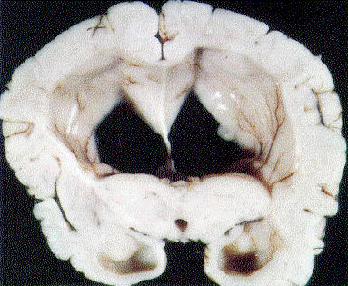

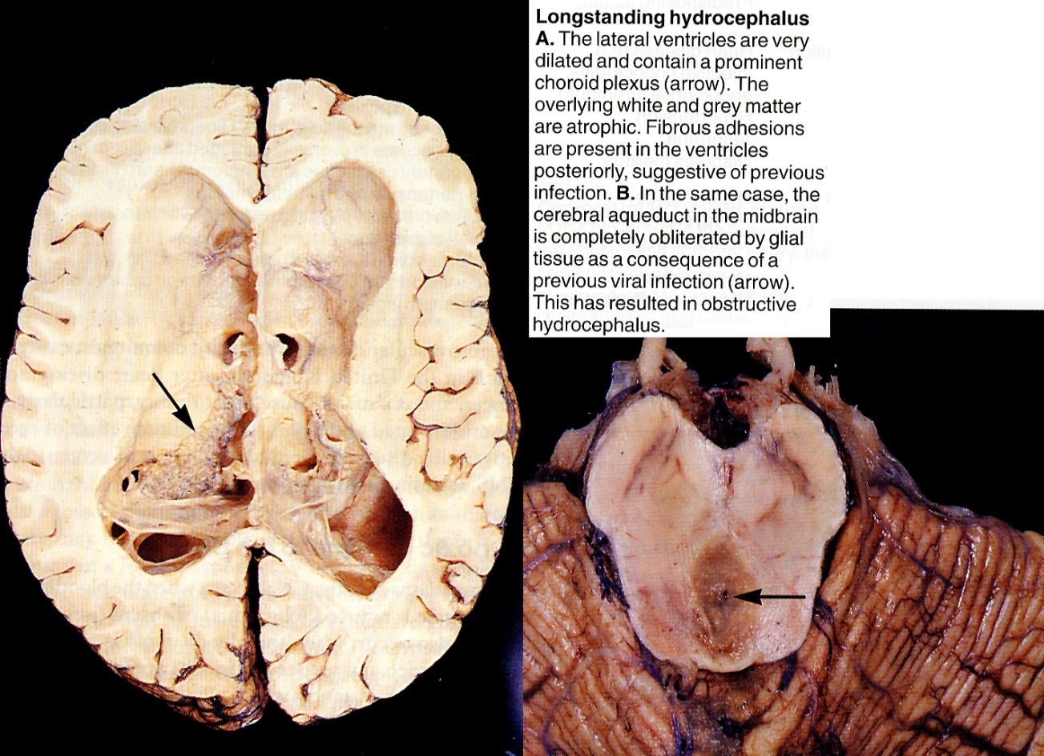

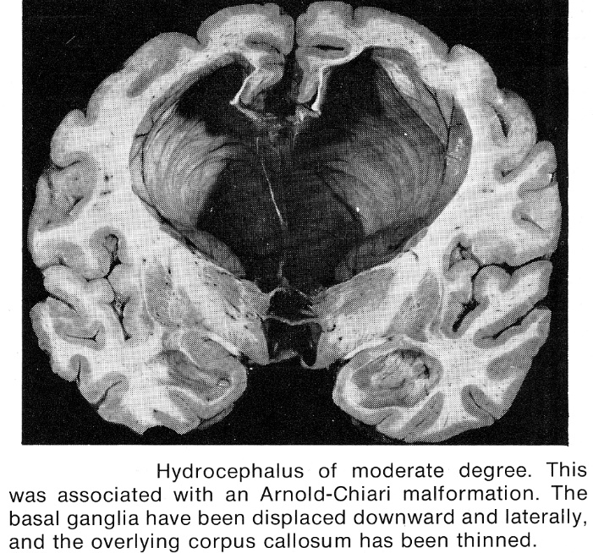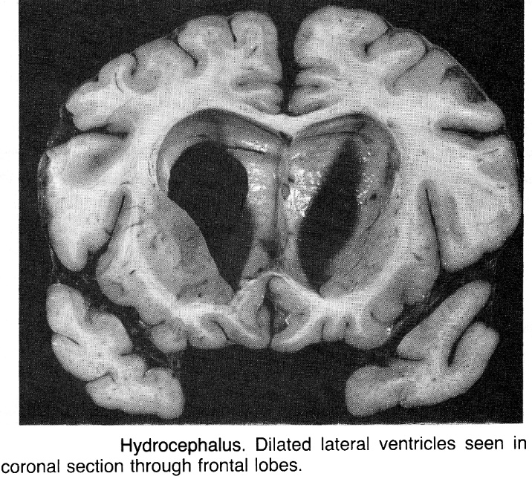

Clinical Features

**Occult hydrocephalus** - no signs / symptoms of intracranial hypertension.

**Arrested hydrocephalus** - stable ventriculomegaly (in absence of functioning shunt) with stable neurologic status. *see below* >>

* careful follow-up (esp. neuropsychological testing) is still required, particularly in children - reported cases of *sudden death*, sometimes years after initial diagnosis.

**Active hydrocephalus** - progressive disease with increased intracranial pressure.

Adults:

1. ICP↑ **- headache** & **vomiting**.
2. **altered consciousness** (in acute cases), progressive **dementia** (in chronic cases).
3. **visual changes**; **papilledema** lags behind symptomatology.
4. stretching and disruption of corticospinal fibers → **corticospinal weakness** (with spasticity, hyperreflexia, Babinski signs), **gait disturbance**, incoordination, urinary **incontinence**.
5. **Parinaud syndrome** (supranuclear upgaze palsy, normal vertical doll’s response); causes:
6. aqueductal distention with compression of periaqueductal structures.
7. pressure on quadrigeminal plate by dilated third ventricular suprapineal recess.
8. occasionally, **focal deficit** (e.g. CN6 palsy – long intracranial course).
9. dilatation of anterior 3rd ventricle → chiasm compression (**bitemporal hemianopia**).
10. enlarged 3rd ventricle may compromise hypothalamus and cause empty sella (**endocrine deficiency**)

Infants (open sutures dissipate increased intracranial pressure – less acute presentation):

1. ***increasing head circumference*** (!!!) with cranial *sutural diastasis*, poor head control → unable to lift enlarged head.
   * cranial sutures begin fusion by 2 years of age; they can be split open if ICP rises before complete skull ossification (8-10 years).
   * absolute head circumference cannot be used as strict diagnostic guide; *crossing of percentiles over few weeks* is potentially relevant.
   * **Macewen sign**: skull percussion → sound similar to ***cracked pot*** (due to separation of sutures).
   * face, although of normal size, appears small relative to enlarged head.
   * downward displacement of orbits → exophthalmos and scleral prominence.
   * scalp necrosis may lead to CSF leakage, infection, and death.
2. ***bulging fontanelles***, ***dilated scalp veins***

|  |  |
| --- | --- |
| 1. irritability, failure to thrive, psychomotor retardation. 2. limbs (particularly legs) show ***progressive weakness*** → wasting of trunk and limb muscles with ***spasticity***, ***Babinski signs***. 3. *seizures* are common (vs. adults)! 4. bradyarrhythmia and apneic spells (in newborn period). 5. **“setting sun” sign** (Parinaud syndrome with lid retraction and increased tonic downgaze - white of sclera is seen above iris): *see above    * may also be seen briefly in some normal newborns. 6. no papilledema!!! (cranial sutures separate to accommodate pressure). 7. visual loss is followed by optic atrophy. | D:\Viktoro\Neuroscience\S. Symptoms, Signs, Syndromes\S50-64. Intracranial pressure, Brain edema, Herniation, Hydrocephaly\00. Pictures\Hydrocephaly - setting sun sign.jpg |

**Advanced or acute untreated hydrocephalus** - brainstem signs, coma, hemodynamic instability.

Diagnosis

|  |  |
| --- | --- |
| **Imaging**  **Skull transillumination** (in infants) – ***uniform transillumination*** of entire head - differentiation from other forms of macrocephaly (e.g. subdural hematoma): | D:\Viktoro\Neuroscience\S. Symptoms, Signs, Syndromes\S50-64. Intracranial pressure, Brain edema, Herniation, Hydrocephaly\00. Pictures\Hydrocephaly (skull transillumination).jpg |

**CT**:

1. ***degree of ventriculomegaly*** (esp. enlargement of temporal horns – first part to dilate!; in young children - occipital horns).

* take into account increase in ventricular volume that accompanies ***normal aging*** and presence or absence of *cerebral atrophy*.
* aqueductal stenosis - enlarged lateral and 3rd ventricles + normal or small 4th ventricle.
* communicating hydrocephalus - dilatation of ventricles and subarachnoid spaces (may be confused with *hydrocephalus ex vacuo*).
* role of suture status:
  1. ***open sutures*** - even moderate increases in pressure can *expand ventricles enormously* and surrounding brain may appear compressed to thin band (dramatic reconstitution of cerebral mantle may be seen after shunting, sometimes with reversion of some preexisting neurological deficits).
  2. ***fixed-volume skull*** - even enormously elevated intraventricular pressures may *only moderately expand ventricular size*.

1. ***periventricular lucencies*** (high T2 signal) - CSF passage through ependymal lining of ventricles into adjacent white matter = periventricularinterstitial edema = transependymal flow phenomenon – misnomer: CSF does not actually penetrate ependymal lining (proven with CSF labeling studies); probably represents stasis of fluid in brain adjacent to ventricles.
2. ***effacement of*** sylvian & interhemispheric ***fissures***, cerebral ***sulci*** (due to dilatation of lateral ventricles), basal cisterns.

* if hydrocephalus develops in utero, cerebral hemispheres show multiple complex small gyri (microgyria, polygyria, stenogyria); differentiate from polymicrogyria.
* in long standing cases, distortion of blood vessels → ischemic white matter damage (esp. in watershed areas) → cerebral atrophy.

Size of both **temporal horns (TH)** **≥ 2 mm** in width (in absence of HCP, temporal horns should be barely visible):

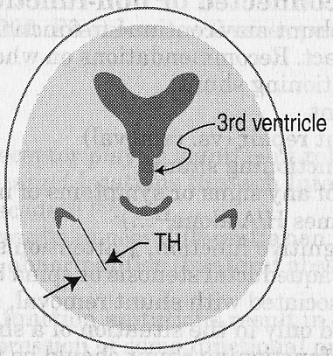

**FH/ID > 0.5** (norma < 0.4)

FH is the largest width of frontal horns

ID is internal diameter from inner-table to inner-table at this level

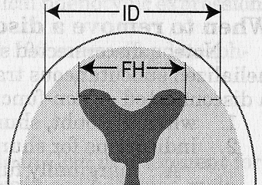

N.B. measurements that rely on frontal horn diameter tend to underestimate hydrocephalus in pediatrics because of disproportionate dilatation of occipital horns in peds!

**Evans' index** ≥ 0.3

**Evans' index** = maximal width of frontal horns (FH) divided by maximal biparietal diameter (BPD):

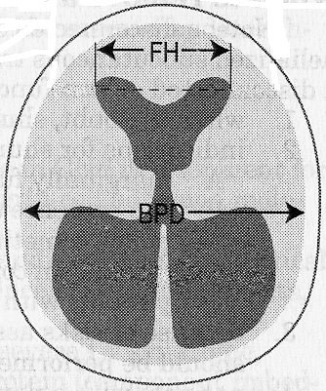

**Bicaudate ratio** ≥ 0.25

**Bicaudate ratio** = minimal intercaudate distance divided by brain width along same line.



Ballooning of frontal horns of lateral ventricles ("Mickey Mouse" ventricles) and/or 3rd ventricle (3rd ventricle should normally be slit-like)



Thinning and/or upward bowing of corpus callosum on sagittal MRI

**MRI**:

* T2-MRI can show ***transependymal CSF flow*** and ***site of CSF flow obstruction***.
* for all cases of congenital hydrocephalus - ***extent of associated brain anomalies***.
* *some tumors* are detected only with MRI (e.g. midbrain tectal gliomas).
* **CINE MRI** - CSF flow (e.g. in basal cisterns, aqueduct)

|  |  |
| --- | --- |
| Arrow indicates dilated third ventricle: |  |
| **D:\Viktoro\Neuroscience\S. Symptoms, Signs, Syndromes\S50-64. Intracranial pressure, Brain edema, Herniation, Hydrocephaly\00. Pictures\Hydrocephaly (CT).jpg** | D:\Viktoro\Neuroscience\S. Symptoms, Signs, Syndromes\S50-64. Intracranial pressure, Brain edema, Herniation, Hydrocephaly\00. Pictures\Hydrocephalus (MRI).jpg |

**Hydrocephalus secondary to aqueduct stenosis**

(A) Axial proton density and T2-MRI: marked enlargement of lateral ventricles, with thin “halo” of interstitial oedema; inhomogeneity of fluid signal within ventricles is due to pulsatile artefact.

(B) T1-MRI: massive enlargement of lateral ventricles, outpouching of suprasellar recesses of third ventricle impinging upon sella, and “ventricularization” of proximal aqueduct just above level of obstruction and above fourth ventricle; note normal size and configuration of fourth ventricle (*arrow*):

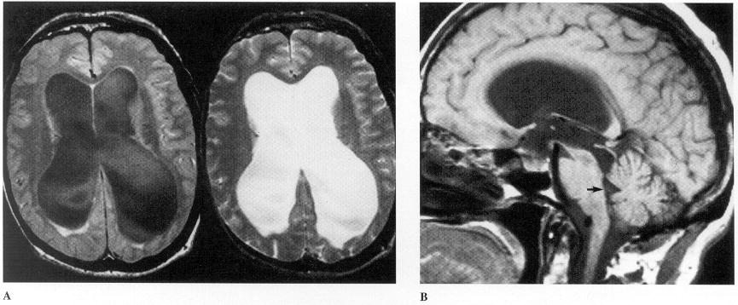

Stenosis of aqueduct:



**Ultrasound** (in children with patent anterior fontanels) - bedside evaluation:

|  |  |
| --- | --- |
| * + ***monitoring ventricular size***   + rounded 4th ventricle with no recognized cisterna magna is sign of noncommunicating dilatation;   + triangular 4th ventricle with wide cisterna magna indicates communicating dilatation.   + subependymal and intraventricular hemorrhage in high-risk premature infants.   **Coronal sonogram of noncommunicating hydrocephalus**  Frontal horns (1), temporal horns (2), 3rd ventricle (3) and 4th ventricle (4) are distended: | D:\Viktoro\Neuroscience\S. Symptoms, Signs, Syndromes\S50-64. Intracranial pressure, Brain edema, Herniation, Hydrocephaly\00. Pictures\Noncommunicating hydrocephalus (sonogram).jpg |

**Plain skull films**:

1. ***separation of sutures***
2. ***erosion of posterior clinoids*** in older child
3. ***increase in convolutional markings*** ("beaten-silver appearance" - irregular, shallow scalloping of inner bone table) with longstanding ICP↑. see p. S50 [>>](http://www.neurosurgeryresident.net/S.%20Symptoms,%20Signs,%20Syndromes\S50-64.%20Intracranial%20pressure,%20Brain%20edema,%20Herniation,%20Hydrocephaly\S50.%20GENERAL%20-%20Intracranial%20Hypertension.pdf#Radiograpph)

**Radionuclide cisternogram** - delayed clearance of radiotracer over cerebral convexities after 48-72 hours

**SPECT-acetazolamide challenge** – see NPH.

**Lumbar puncture**

* perform only after imaging rules out obstructive hydrocephalus.
* measures ***intracranial pressure***; in noncommunicating hydrocephalus (normal lumbar CSF pressure) → monitor **intraventricular pressure** (overnight recording may reveal intermittent waves of elevated pressure).

Isolated Fourth Ventricle Syndrome (s. “entrapped fourth ventricle”)

- fourth ventricle no longer communicates with third ventricle, as well as basal cisterns.

* various etiologies that cause obstructive hydrocephalus.
* may have typical symptoms and signs of hydrocephalus or more atypical symptoms such as lower cranial nerve dysfunction; occasionally, incidental asymptomatic finding on imaging.

Treatment

Treat before permanent neurologic deficits develop!

Cases that should not be treated:

1. *surgery would not affect outcome* (e.g. child with hydranencephaly).
2. ***ventriculomegaly of senescence***.
3. ***hydrocephalus*** ***ex vacuo*** (i.e. brain atrophy)
4. ***arrested hydrocephalus***. *see below* >>
5. ***benign communicating*** ***hydrocephalus of infancy*** – occurs in asymptomatic child 6-18 months of age; during rapid head growth, ventricles and subarachnoid spaces become quite prominent; pediatrician notes rapid increase in head circumference in otherwise healthy child; simply follow-up (if repeat imaging is performed [which is not indicated], by 2 years of age enlargement of CSF spaces will have resolved).

* in *Xq28-linked aqueductal stenosis*, mental retardation and spastic paraparesis are independent of ventricular dilatation per se and does not improve with shunting!
* *fetal ventriculomegaly* - no definite benefit to intrauterine shunting is demonstrated.

Examples of temporary measures:

1. ***drugs*** - acetazolamide (25 mg/kg/d in 3 doses), furosemide (1 mg/kg/d in 3 doses).
2. ***serial lumbar punctures*** (e.g. in premature neonate with intraventricular hemorrhage until blood is absorbed and normal CSF absorption resumes), ***lumbar drain***.
3. ***ventriculostomy*** (e.g. until posterior fossa tumor is resected).

Neuroendoscopic Aqueductoplasty

* high risk of failure during long-term follow-up (88% failure in 10 years) - not recommended as the first choice for aqueductal stenosis - ETV should be done instead (AP may be reserved for a limited number of patients in whom ETV is not feasible but ***should be combined with stenting*** to avoid reclosure of the aqueduct.

Long-Term Reliability of Neuroendoscopic Aqueductoplasty in Idiopathic Aqueductal Stenosis-Related Hydrocephalus. Sascha Marx, MD Joerg Baldauf, PhD Marc Matthes, MSc Michael R Gaab, PhD Henry W S Schroeder, PhD Author Notes Neurosurgery, Volume 85, Issue 1, July 2019, Pages 91–95

CSF diversion procedures

* Kausch first described CSF diversion to peritoneal cavity in 1905.
* goal - *to normalize intracranial pressure* and to allow re-expansion of brain tissue to constitute cortical mantle that is at least 3.5 cm thick.

Shunt construction & insertion procedure

* key feature of all shunt systems - CSF drainage is **controlled by** **valve mechanism**, to prevent overdrainage of CSF (one-way valve developed in 1952).
* catheters are made of *silicon*, have 2-3 mm outside diameter, and have at least 1 type of ***radiopaque component*** (e.g. barium impregnation throughout, radiopaque tantalum dots fixed distance apart, metal springs fixed throughout their length).

Shunt is **3-component system**: *ventricular catheter*, *shunting device*, and *distal catheter*.

Ventricular catheter

* multiple tip perforations (to allow CSF flow) ± flanges (to decrease obstruction).
* *ventricular catheter* is placed into **lateral ventricle** via:

1. *frontal* approach (anterior to coronal suture in midpupillary line)
2. *occipital* approach (inferior and posterior to parietal boss and well away from sensorimotor cortex, with tip being directed toward frontal horn).
   * + shunts are placed on *right side* (to avoid dominant hemisphere areas).
     + catheters which start from posterior burr hole are directed into frontal horn* of ventricle by aiming toward ipsilateral medial eye canthus.

*ideally, cut catheter tip and use endoscope to guide catheter anterior to foramen of Monro

* + - proximal catheter tip should lie anterior to choroid plexus in frontal horn, anterior to foramen of Monro – to avoid catheter obstruction by choroid plexus!
    - catheter is cut to appropriate length and connected to valve and distal tubing.
    - pressure-controlled valve is under scalp, close to burr hole.

|  |  |
| --- | --- |
| Distal catheter   * + - 1. **open**       2. **closed** with ***slit valves*** (as sole device for flow regulation in simple systems and as adjuncts in systems with other unidirectional components): | D:\Viktoro\Neuroscience\S. Symptoms, Signs, Syndromes\S50-64. Intracranial pressure, Brain edema, Herniation, Hydrocephaly\00. Pictures\slit valves.jpg |

Shunting device – components:

1. **reservoir** - allows physician access to CSF or injection of medications.
2. **unidirectional distal flow valve** - regulates flow and prevents reflux
3. **filter** - prevent transfer of cells to ventricles when neoplasm is suspected or known; placed just behind mastoid air cells in order to be exposed to radiotherapy.
4. **anti-siphon device** - closes under negative distal pressure - to negate siphon effect and possible overdrainage in upright position.
5. **pump** - used to determine shunt patency or to manually move CSF through catheter.

N.B. shunt pumping should not be done repeatedly (unless forward flow of CSF is desired for therapeutic purposes) - may lead to retrograde CSF pumping into ventricle or shunt breakage or bleeding.

Classification of shunts – according to pumping chamber:

###### A. Dome devices - serve as pumping chamber, access reservoir, valve:

1. **valveless dome** (e.g. Ommaya or Rickham without attached Holter valve) - usually attached to distal catheter with slit valves.
2. **dome with valve** (e.g. Pudenz).
3. **double domes** (e.g. Uni-Shunt with reservoir, Accu-Flo).

* may lie partially over or in burr hole, or they may be placed in close proximity to it.
* ***multipurpose valve*** contains on-off switch composed of silicon dome containing tantalum-impregnated ball:
  + digital pressure over dome forces ball into cup at dome's base and prevents distal flow;
  + valve is reopened by applying pressure over proximal occluder and pumping reservoir.

###### B. Cylinder devices (e.g. Holter, Hakim) - valved cylindrical pump.

* placed distal to reservoir.

posthemorrhagic hydrocephalus - initially implant **subcutaneous reservoir** that may be tapped intermittently, until CSF is cleared of blood products (that could obstruct shunt system).

compartmentalized hydrocephalus (such as Dandy-Walker syndrome), ventricular loculations – use **multiple ventricular catheters** connected to single-valve system (to equalize pressures in various compartments and avoid dangerous brain shifts).

Contraindications

1. *infection*
2. *high CSF protein* (> 150 mg/dL)? – probably not!!!

Patient selection tests

- selection of **patients likely to benefit from CSF shunting** (tests & criteria are not reliable!):

e.g. untreatable hydrocephalus ex vacuo is almost indistinguishable clinically from treatable communicating hydrocephalus

1. ***dynamic MRI studies*** (flow-sensitive sequences, e.g. CINE) - to determine direction and volume of CSF flow.
2. “***isotope cisternography***” - measure of CSF flow direction, with reflux of CSF from subarachnoid space to lateral ventricles, reversing normal flow and delayed clearance or intraventricular transependymal penetration of isotope.
3. CT / MRI evidence of transependymal diffusion of fluid.
4. CSF compartment infusion or perfusion tests.
5. ICP monitoring to assess high pressure waves.
6. clinical predictors of good response:
   * recent onset;
   * mild dementia;
   * absence of cerebral atrophy;
   * temporary improvement after lumbar puncture.

N.B. not all patients respond! (but response may be delayed for months)

Types

1. **Third ventriculostomy** (ventriculocisternal shunting) – for ***obstructive hydrocephalus*** (e.g. aqueductal stenosis). [see p. Op10 >>](../../Op.%20Operative%20Techniques/001-020.%20CSF-related%20procedures/Op10.%20CSF%20shunting.pdf#ETV)
2. **Ventriculoperitoneal shunting** – most common procedure! (few complications). [see p. Op10 >>](../../Op.%20Operative%20Techniques/001-020.%20CSF-related%20procedures/Op10.%20CSF%20shunting.pdf)
3. **Ventriculoatrial shunting** – for ***contraindicated abdominal distal catheters***. [see p. Op10 >>](http://www.neurosurgeryresident.net/Op.%20Operative%20Techniques\001-020.%20CSF-related%20procedures\Op10.%20CSF%20shunting.pdf#VA_shunt)
4. **Ventriculopleural shunting** – reserved for ***failed peritoneal and atrial shunts***.
5. **Torkildsen (s. internal) shunts** – straight tubes that communicate ventricles to CSF spaces without valve (e.g. occipital horn with cisterna magna)
6. **Lumboperitoneal shunts** – for ***communicating*** ***hydrocephalus*** (esp. with small ventricles).
   * pseudotumor cerebri is classical indication.
7. **Transplantation of vascularized omentum** (to reestablish normal CSF) - could be best method to treat communicating hydrocephalus.

Assessment of shunt continuity & patency

1. **Palpation** throughout shunt length - assessment of shunt continuity and patency.
   * ***fibrous tracts*** may feel, and even perform, like shunt tubing.
   * ***hardening of plastic*** after placement has been described.
   * ***single-dome devices*** may be difficult to palpate due to fibrous or bony encasement.

## Assessing Shunt Patency – with transcutaneous digital pressure:

1. **valveless single-dome** - occlude distal catheter*:
   * easy dome depression = *proximal patency*;
   * difficult depression of dome, lack of prompt refilling = *proximal obstruction*.

*if distal occlusion is not held, CSF will flow both proximally and distally (through path of least resistance); firm, noncompressible dome = *proximal and distal occlusion*.

1. **dome with valve** or **cylinder device**:
   * difficult depression = *distal obstruction*;
   * lack of prompt refilling = *proximal obstruction*.
2. **double domes**:
   * digital occlusive pressure over proximal dome → easy distal dome pumping = *distal patency*.
   * digital occlusive pressure over distal dome → prompt refilling of proximal dome when pressure is released = *proximal patency*.
3. **multipurpose valve**:
   * pressure over proximal occluder → pressing on reservoir → prompt emptying = *distal patency*.
   * releasing pressure off occluder → prompt refilling = *proximal patency*.

N.B. not all shunt obstructions may be determined by simple digital pressure!

1. **Plain radiographs** - AP/lateral skull, chest, supine abdominal – shunt type & position.
2. **Ultrasound** (in infants), **CT** / **MRI** (in adults) - reversion of ventricular size towards normal, disappearance of interstitial cerebral edema.
3. For 3rd ventriculostomy or Torkildsen shunt - **MRI flowstudies** (cardiac gated cine phase contrast MRI).
4. **Shunt tapping** see below >>

Complications

In pediatric population, 90-day shunt complication rate leading to surgery is 16.9% (35% of those cases are preventable - infection (43.6%), malposition of proximal catheter (27%), error in judgment (10%), wound breakdown (9.1%), improperly secured or assembled shunt (7.2%), and malposition of distal catheter (2.9%)

Dave P et al. The Preventable Shunt Revision Rate: A Multicenter Evaluation. Neurosurgery 84:788–798, 2019 DOI:10.1093/neuros/nyy263

1. **Infection** (0–38%) - most feared complication (usually due to *Staphylococcus epidermidis & aureus*):
2. ***internal shunt infections*** - colonization on inner shunt surface ± ventriculitis.
3. ***external shunt infections*** - wound infections around shunt (secondary to operation or erosion of overlying skin).
   * transient bacteremia has not been shown to cause shunt infection.
   * 70% are diagnosed within first month after surgery and 90% within 6 months.

N.B. chance of shunt infection after 6-9 months postop is almost zero!

* + clinical presentation is nonspecific - unexplained fever, lethargy, shunt malfunction or frank meningitis.
  + local shunt tract inflammation may occasionally occur.
  + patient, in general, appears very ill.
  + *morbidity is severe* (single episode lowers IQ by 10-30 points).
  + *mortality* - up to 40%.
  + diagnosis - **shunt tapping** (may per se introduce organisms into CNS* - written informed consent is desirable!), **CRP** > 7. *risk is almost zero

N.B. tap shunt only if other causes of fever are excluded!!!

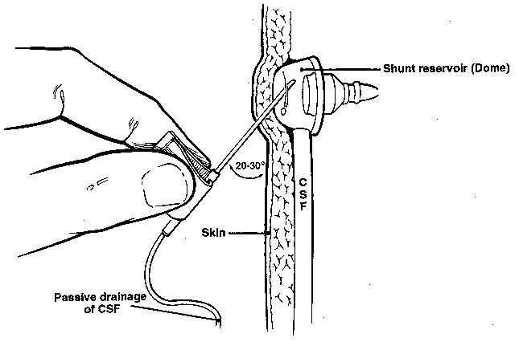

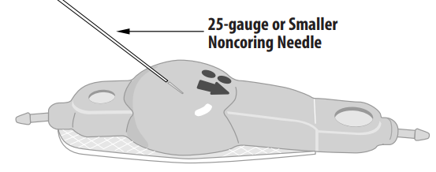

* + optional: standard lumbar puncture tray + 18G needle (to nick scalp).
  + 25G butterfly noncoring needle (to perform actual puncture).
  + find reservoir by palpation and radiographic assessment (*do not puncture anti-siphon devices, filters, or valves!*).
  + place patient prone and restrain him or her, if needed.
  + shave scalp, if necessary, overlying device.
  + meticulous ***sterile technique*** (give povidone-iodine solution 1-2 minutes to fully dry to maximize bactericidal effect).
  + consider sting of local anesthesia (may be as uncomfortable as actual tap).
  + puncture reservoir with short 25G butterfly needle.
  + angle of puncture 20-30° - to avoid placing needle too deep (damage to reservoir floor); exception - Hakim reservoir - may be entered at almost any angle.
  + watch for passive fluid appearance → attach manometer.
  + allow only passive withdrawal of 4-6 mL of CSF (i.e. do not aspirate!).
  + place CSF in sterile tubes, and send for standard CSF analysis → PMN, bacterial cultures.

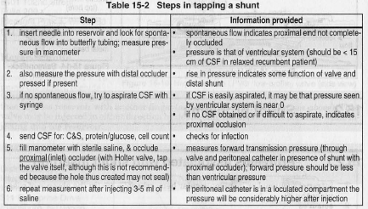

* + treatment: **remove** infected shunt system* → place **external ventricular drain** to control CSF flow → **sterilize** **CSF**\*\*→ place **new shunt** (when CSF culture confirms eradicated infection)***.

*antibiotics alone are not recommended - bacteria are suppressed and resurface once antibiotics are stopped.

**antibiotics same as meningitis/ventriculitis (cefepime + vancomycin; may add rifampin especially if shunt is not removed); continue 7 – 14 days after hardware removal (usually after 2 CSF cultures are negative)

***reshunt:

*S. aureus,* GNR – 10 -14 days of negative cultures.

CoNS - may re-shunt in 3 days if no CSF abnormalities and follow-up cultures negative

CoNS – if CSF abnormal and positive culture, may re-shunt in 7 days (10 days after last negative culture if follow up culture positive *after* shunt removal)

1. **Subdural hematomas** - almost exclusively in *adults* and *children with completed head growth*.
   * cause – overdrainage.
   * prophylaxis - slow postoperative mobilization (allows for brain compliance reduction).
   * treatment - temporary shunt occlusion (e.g. increasing to maximum valve setting).

FLAIR-MRI of postoperative bilateral chronic subdural hematomas secondary to shunt insertion. Outward-facing arrows indicate the bilateral haematomas. Note persistence of areas of periventricular lucency (arrows). This patient with NPH He was managed conservatively by resetting of his programmable valve:



1. **Shunt failure** - most common complication!; manifests as ICP↑ (headache, vomiting, drowsiness → unresponsive patient with bradycardia).

80% proximal, 10% valve, 10% distal

Pediatric patient with shunt comes to ED with headache (and nothing else) → admit for observation!

1. **obstruction** - with choroid plexus, brain parenchyma, protein (esp. in posthemorrhagic hydrocephalus in initial months after shunting; H: intraventricular urokinase), tumor cells.

N.B. acute obstruction with deterioration is neurosurgical emergency; forced pumping may be attempted but provides only temporary relief in a minority of cases!

* + mostly due to *suboptimal* ***proximal*** *catheter placement*.

N.B. if using occipital horn for catheterization, advance ventricular catheter > 10 cm to reach foramen of Monro (i.e. past choroid plexus); therefore, occipital approach is not recommended!

* + occasionally, ***distal*** catheters fail (suspect infection; abdominal pseudocysts are synonymous with low-grade shunt infection) - emergency shunt tap may help.
  + diagnose by attempting to selectively flush valve both ways:

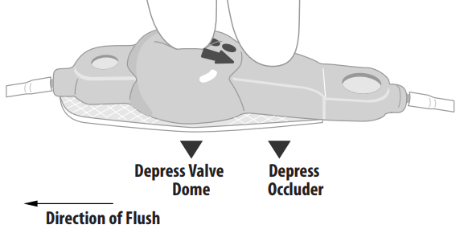

* + as last measure, puncture of entire length of catheter may relieve obstruction, but it will also destroy shunt.

1. **disconnection** - at sites of connection and mobility.
   * suspect by palpation + X-ray (shunt series)
   * some portions of shunts may be radiolucent and appear as disconnections; H: comparison with older radiographs and thorough knowledge of shunt components.
2. **migration** (e.g. out of peritoneal cavity due to patient growth).

Treatment: emergency high volume shunt tap → emergency shunt revision in OR.

1. **Overdrainage (s. overshunting)** (more common in *lumboperitoneal shunts*) → orthostatic headaches; risk of subdural hematoma / hygroma formation.
   * self-limiting process.
   * treatment - **revision** to higher-pressure valve or different shunt system; consider anti-siphon device.
2. **Slit ventricle syndrome** (1-3%).
   * mostly occurs after *ventriculitis* or *shunt infection* → subependymal gliosis → unusually low brain compliance (“unresponsive ventricles”) - patient develops *high ICP without ventricular dilatation*.

N.B. slit ventricle syndrome ≠ overdrainage; symptoms are those of high pressure rather than low pressure.

* + imaging findings falsely reassuring!
  + slit ventricles predispose to ventricular catheter failure (repeated blockage by coapted ventricular wall).
  + progressive neurological deterioration → H: **subtemporal decompression** - creates artificial pressure reservoir and induces slight reenlargement of slit ventricle.

1. **Seizures** (5.5%); incidence declines after first year.
2. **Shunt tubing leak** (e.g. ruptured tubing) – inject *methylene blue* into valve reservoir – helps to detect leak.

Abdominal complications

1. perforation of abdominal organ
2. **CSF-filled pseudocyst** around distal catheter → shunt malfunction, abdominal pain
3. peritonitis
4. hydrocele (in boys).
5. **peritoneal seeding** in drainage of malignant tumor-related hydrocephalus (rare, but well-documented complication); ***filter*** decreases seeding but frequent shunt malfunctions - generally not recommended (third ventriculostomy is a better option).

Prognosis

- outcome is good.

* typical patient returns to baseline after shunting.
* *gait & incontinence* respond to shunting, but *dementia* responds less frequently.
* mortality in ***untreated progressive infantile hydrocephalus***:

50% at 1 year of age

75% at 10 years of age

* mortality in ***optimally treated progressive infantile hydrocephalus***:

50% at 15 years of age (with 15% incidence of mental retardation)

Special Situations

Benign pericerebral effusion

- enlarged pericerebral echo-free (anechogenic) fluid space with widening of cerebral sulci and containing pulsatile vessels, without mass effect.

Note - falx cerebri remains straight (*arrow*):

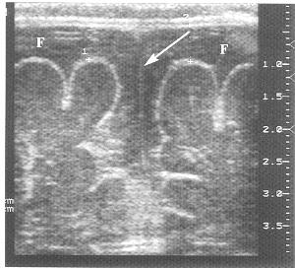

Arrested hydrocephalus, s. compensated hydrocephalus, long-standing overt ventriculomegaly of adulthood (LOVA)

- stable ventriculomegaly (in absence of functioning shunt) with stable neurologic status.

N.B. Despite clinical and radiographic stability, longstanding ventriculomegaly is not benign and may be associated with cognitive decline and even sudden death.

Treatment

* should not be treated if asymptomatic or stable neurological exam (i.e. it important to ascertain before operating that hydrocephalus is progressive)
* careful follow-up (esp. scheduled interval neuropsychological testing) is still required, particularly in children - reported cases of delayed deterioration and *sudden death*, sometimes years after initial diagnosis.

N.B. children can present with very subtle neurological deterioration (e.g. slipping school performance).

Decompensation of arrested hydrocephalus can be sudden and fatal – report of 4 adults with stable hydrocephalus who died unexpectedly and had negative autopsies (no uncal herniation was seen; instead, stretching of axons involved in cardiopulmonary control centers and reflexes was thought to be the terminal injury).

Rickert C.H. et al. Sudden unexpected death in young adults with chronic hydrocephalus. Int. J. Leg. Med. 2001; 114: pp. 331-337

* ETV (with preop CINE MRI) is a treatment of choice because VPS may cause overdrainage and SDH formation.
* case report of 39 yo adult developing increasing headache, memory loss, gait instability and urinary and fecal incontinence after 10 years of F/U on asymptomatic ventriculomegaly 🡪 patient improved after ETV

Bibliography see [p. S50 >>](S50.%20GENERAL%20-%20Intracranial%20Hypertension.pdf#Bibliography)

[Viktor’s Notes℠ for the Neurosurgery Resident](http://www.neurosurgeryresident.net/)

[Please visit website at www.NeurosurgeryResident.net](http://www.neurosurgeryresident.net)