Degenerative Disc Disease
Last updated: December 19, 2020
Anatomy 1
Etiopathophysiology 1
Topography 3
Cervical 3
Lumbosacral 3
Pathology 4
Epidemiology 4
Clinical Features 5
Cervical herniation 5
Lumbosacral herniation 5
Pain 6
Examination 6
Thoracic herniation 6
Diagnosis 6
Plain X-ray 7
Electrophysiology 7
MRI 7
Modic changes 7
Pfirrmann grades 7
Myelography 11
Discography 13
Differential diagnosis 13
Treatment choice 13
Conservative therapy 13
Interventional spine procedures 14
Percutaneous discectomy 14
Endoscopic percutaneous discectomy 14
Automated percutaneous discectomy 14
Chemonucleolysis 15
Surgical treatment 15
Lumbar 15
Cervical 15
Prognosis 15
Outcome measures 15
Cervical 15
Disc Herniation Recurrence 15
Lumbar 15

Anatomy
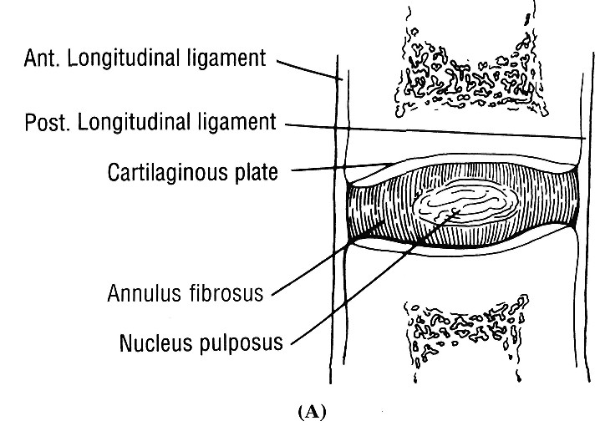

- anterior and posterior longitudinal ligaments blend with and strengthen annulus fibrosis.
- in early childhood, nucleus pulposus is gelatinous, containing hydrophilic polysaccharides (water content > 80%).
- annulus fibrosus is composed of concentric collagenous layers that are attached to adjacent vertebrae; fibers are directed obliquely (at ≈ 55° degrees to horizontal plane) between vertebrae in successive layers that are perpendicular to each other.
N.B. disk elasticity is provided in large measure by annulus fibrosus!

Etiopathophysiology
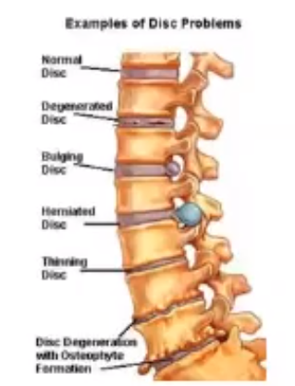

Disk degeneration (acceleration of aging effects):
  - decreasing vascular supply, decreasing H₂O & O₂ content → disc height↓ (desiccation & shrinkage).
  - internal layers of annulus fibrosus progressively grow into nucleus pulposus → disk becomes amorphous, sometimes discolored, and increasingly fibrotic → more compressible, less elastic disk - more prone to tear and rupture.
  - wear & tear (accumulation of axial loading, motion trauma effects) → cracks in inner layers of annulus fibrosus.
N.B. disc degeneration is universal accompaniment of aging! (degeneration is identifiable in virtually everyone over age 60 years)
- propensity to develop degeneration is correlated with ↑mobility of spinal segments:
- cervical region, L4-S1, upper lumbar and lower thoracic spine;
- discs lying above / below fused spinal segments!!!

Reactive vertebral changes
- decreased capacity for shock absorption in degenerated discs → greater forces are transmitted directly onto adjacent vertebral bodies:
- Osteophytes
- End-plate changes:
Type I - edema: ↓signal on T1-MRI, ↑signal on T2-MRI; differentiate from edema seen in infectious discitis/osteomyelitis (with infection, disc is abnormally bright on T2-MRI, whereas degenerated discs are dark).
Type II - end-plate infiltration by fat; marrow is brighter on T1-MRI and dark on T2-MRI; represents burned-out type I.
Type III - degenerative discogenic sclerosis of end-plate: ↓signal on both T1- and T2-MRI.

Possible further changes:
- invasion of cancellous spaces by fibrovascular reactive tissue continuous with that of disc.
- end-plate fracture and displacement into vertebral body.
- very irregular end-plate → destructive diskovertebral lesion (may simulate infective spondylitis) → vertebral malalignment (scoliosis, retrolisthesis, anterolisthesis).

Disc displacements
- Bulge - circumferential extension of disc margin beyond vertebral body margins.
  - identified in 50% asymptomatic persons.
  - annulus normally may bulge diffusely little (< 2-3 mm) beyond vertebral margins, esp. in children.
- Herniation - focal displacement of disc material (nucleus pulposus and/or annulus) beyond margins of disc space; can occur in any direction (most clinically significant – posterolaterally).
- protrusion (hard disc protrusion, spondylosis) – hardened nucleus bulges beneath attenuated annulus; associated osteophytes add to mass effect;
  - identified in 25% asymptomatic persons.
- extrusion (herniation, soft disc protrusion, disc rupture) – soft nucleus extrudes through tear in annulus;
  - identified in < 1% asymptomatic persons.
- sequestered fragment - extruded disc fragment separates entirely from its disc of origin, and may migrate within epidural space (occasionally, penetrates dura and can be seen intrathecally – can simulate neurinoma).
Schmorl node – nucleus pulposus herniation through cartilaginous end plate into vertebral body; usually incidental radiographic or postmortem finding (prevalence in general population ≈ 20%).
  - seen most frequently in lower thoracic and upper lumbar spine.
  - occur through defects of end-plate (e.g. gaps in chondrification formed by vessels arising from vertebral body).
  - may be consequence of trauma.
  - reactive sclerosis forms around herniated cartilage nodule and it becomes easily visible radiographically.
  - thinning of disc space may or may not accompany herniation (caused not so much by actual herniation of disc material but by disc desiccation).

N.B. term “herniation” should be reserved for situations in which more precise classification cannot be made!

Disc degeneration + Traumatization is prime cause of disc herniation.
- genetic predisposition in many cases!
- commonly trauma is trivial.
- major trauma is usually cause in children and young adults.

Time course of herniation:
- development of radial fissure through inner* concentric rings of anulus fibrosus; nucleus pulposus may begin to extend into this fissure; patient may experience low back pain and perhaps some referred pain into buttock or hip.
*outer layers of anulus fibrosus are tightly bound to adjacent vertebral end-plates
- nucleus protrusion causing bulging of outer layers of anulus and of posterior longitudinal ligament (sufficient to pinch adjacent nerve root between protruding disc and lamina or intervertebral facet).
- free disc fragment is completely extruded and becomes wedged anterior to nerve root.
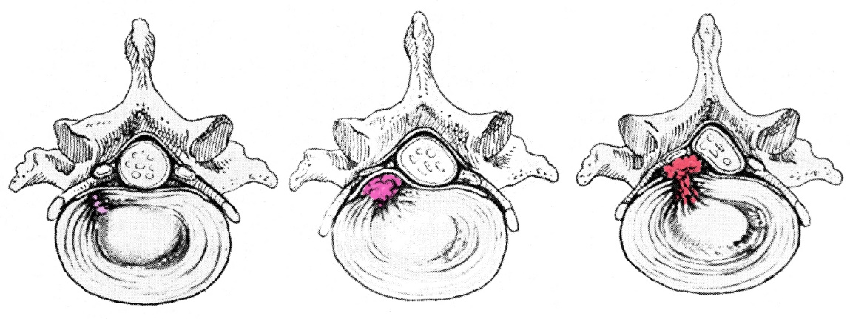

Disc displacement causes symptoms by several mechanisms:
- Local pain (provided by sinuvertebral nerve):
  - mechanical stress on pain-sensitive structures (outer fibrous annulus, ligaments, periosteum, dura).
N.B. intervertebral disks (at least, nucleus pulposus) are not pain-sensitive!
  - exposed disc material has direct toxic effect → local inflammatory response.
  - regional muscle spasm.
- Radiculopathy / myelopathy – due to compression by mass of disc material:
  - herniation into lateral recess or neural foramen (posterolateral herniation) → spinal root compression.
  - herniation into spinal canal (central herniation) → spinal cord compression (in cervical ÷ thoracic region) or cauda equina compression (in lumbosacral region).
N.B. spinal stenosis & spondylosis are major contributors to compression syndromes of cord and cauda equina! (even bulges and small protruding discs may compress neural structures).
- disc extrusion is more likely to be source of symptoms than is disc protrusion (protrusions and annular bulges do cause symptoms, but this depends on additional anatomic factors - proximity of disc material to roots, caliber of bony spinal canal).
- mechanisms by which compression causes neurological dysfunction: mechanical alteration of axonal membranes, impaired axonal flow, ischemia, eventual demyelination.

In many cases, symptoms are self-limited:
- reparative processes
- desiccation (shrinkage) of herniated disc fragment.

Pain – multifactorial:
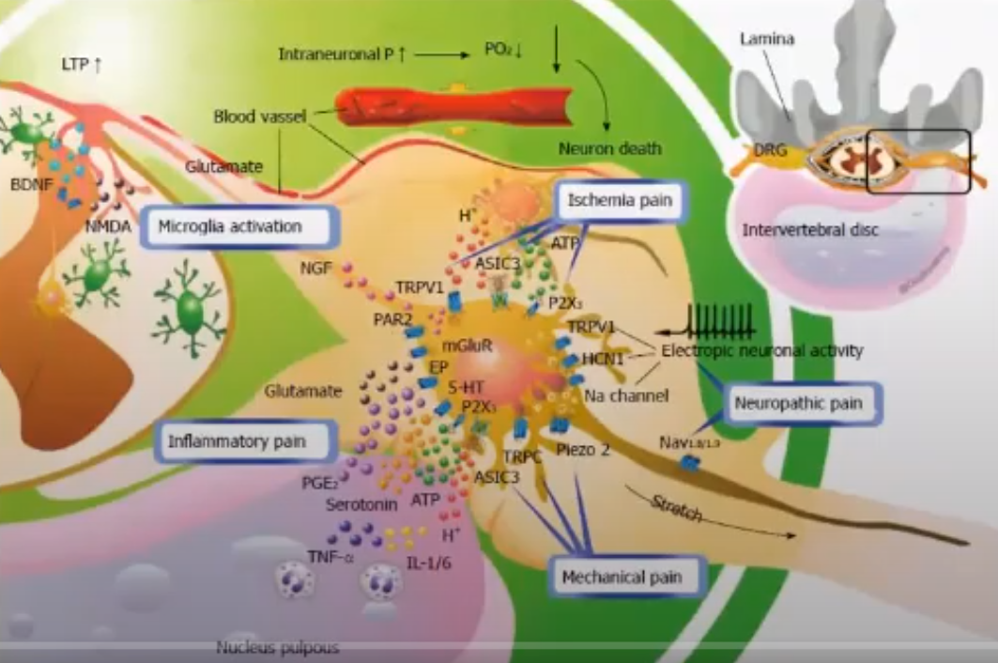

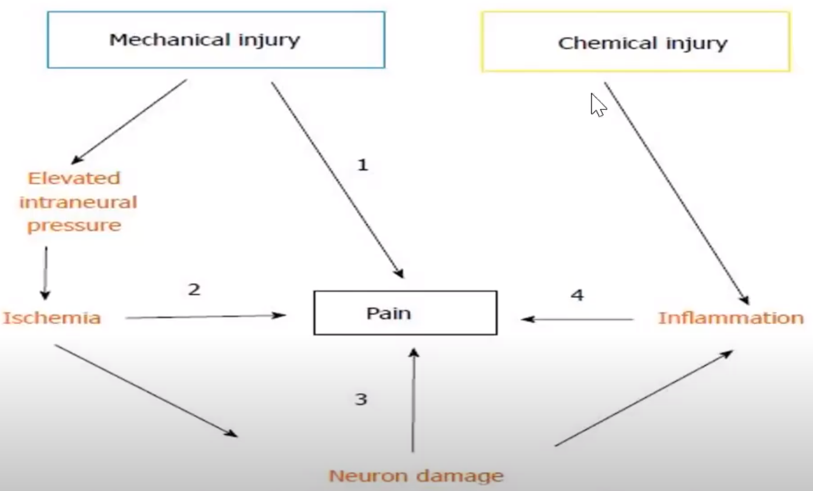

Topography
Absence of C₈ vertebral body but presence of C₈ spinal segment means that:
roots above C₈ exit above corresponding vertebral body;
remaining roots exit below their respective vertebral bodies.

- as spinal nerve exits through intervertebral foramen, it lies between intervertebral disc anteromedially and facet joint posterolaterally.
- roots occupy ≈ 25-30% of space in intervertebral foramina.
- > 2/3 herniations are lumbosacral.

Cervical
Most common sites: C₆₋₇ (55%) > C₅₋₆ (30%) > C₇-T₁ > C₄₋₅.
Roots above C₈ exit above corresponding vertebral body + spinal segment and vertebral levels are roughly aligned:  - posterolateral herniation compresses caudal root (e.g. C₆₋₇ herniation affects C₇ root; C₇-T₁ herniation affects C₈ root) - the same rule as in lumbar region!  - central (midline posterior) herniation compresses ≈ same level spinal segment (rare event, unless spinal stenosis, or massive herniation). | 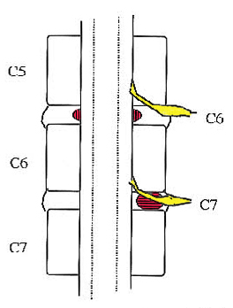
Lumbosacral
Most common sites: L₅-S₁ (80%) > L₄₋₅ > L₃₋₄ (4-5%) > L₂₋₃ & L₁₋₂ (< 1%)

Roots exit below corresponding vertebral bodies + emerging root usually escapes entrapment above protruding disc:
- large central (midline posterior) herniation may compress cauda equina (multiple bilateral roots).
see p. Spin1 >>
- posterolateral herniation compresses caudal root (traveling downward to emerge one level below); e.g. L₄₋₅ herniation affects L₅ root – i.e. the same rule as in cervical region!
Disc annulus is weakest posterolaterally – most frequent lumbar herniations are posterolateral.
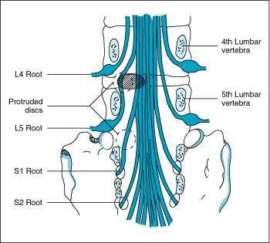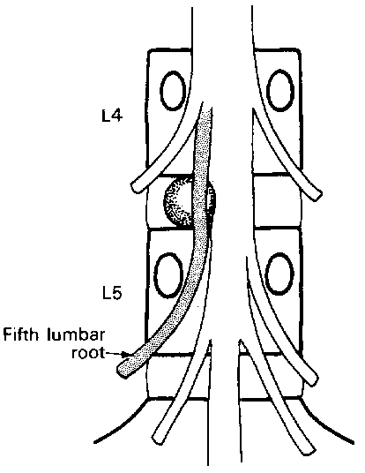

- far lateral (foraminal, lateral extraforaminal) herniation (≈ 10% lumbar herniations; tend to affect higher levels - L₂₋₄) - lateral to spinal canal and root sleeve - compresses rostral root (e.g. L₃₋₄ herniation may compress L₃ root).  Root compression may occur at level of disc space (1) or from rostrally migrated fragment into foramen of upper nerve root (2):  Extraforaminal hernia may even compress root from level above as it descends in paravertebral muscles immediately adjacent to spine! | 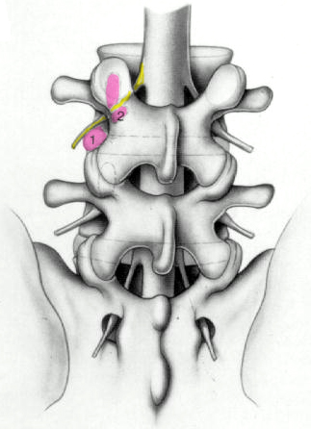

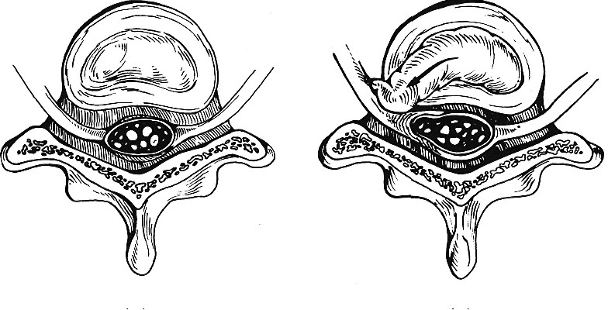
Pathology
- markedly degenerated, gritty calcified deposits; thoracic disc protrusion is more granular and yellowish.
- some surgeons continue to submit disc material for histologic diagnosis - yield is exceedingly low and of questionable benefit (besides medicolegal implictions).

Epidemiology
Women ≥ men (according to other sources: males – 80%).
- 5% males and 2.5% females experience sciatica at some time in their lifetime.

Peak incidence - ages 30-50 yrs (rare before 25 and uncommon after 60):
- accumulated some degenerative changes in annulus.
- preserved expansile gelatinous nucleus.
- job and sports-related activities.
- incidence falls in older population (osteoarthritis becomes more frequent cause of symptoms):
  - ↓mobility of desiccated disc
  - physical activity↓.

Risk factors
    - Congenital spinal anomalies (e.g. fused and malformed vertebrae, lumbar spinal stenosis due to short pedicles) – may cause tendency toward disc herniation in some families.
    - Acquired spinal disorders (e.g. degenerative arthritis, ankylosing spondylitis).
    - Increased weight, heavy lifting
    - Tall stature
    - Physical inactivity (e.g. sedentary occupations)
    - Spinal trauma (repeated occupational)
    - Motor vehicle use, vibration
    - Smoking, diabetes
    - Genetic predisposition
    - In younger women:
      - pregnancy and delivery → lumbosacral herniation.
      - bending and lifting involved in child rearing → cervical herniation.

Clinical Features
Signs & symptoms relate to geometry:
- size and strategic location of disc fragments
- size and configuration of spinal canal (incl. foramina).

- Local pain (s. axial pain) – may be absent, or may precede herniation for weeks or months.
- Compressive lesion:
- radiculopathy see p. PN1 >>
N.B. radicular pain may radiate into extremity episodically, extending further down extremity with each episode.
- myelopathy (may be preceded by spinal shock) - paresis, with loss of pain and temperature sensations below level of lesion; vibration and position sensations are frequently retained (posterior location of dorsal columns). see p. Spin1 >>

Cervical herniation
Onset of symptoms:
- follows trauma (e.g. sudden rotation of head)
- spontaneous.

Symptoms
- begins with stiff neck (reactive splinting of erector capital muscles), discomfort at medial border of scapula.
- local neck pain (axial pain) radiates to interscapular region, shoulders, arms (radicular pain).
- palpation of brachial plexus and supraclavicular fossa is often painful.
- 736 patients with cervical radiculopathy:
arm pain (99.4%)
neck pain (79.7%)
scapular pain (52.5%)
anterior chest pain (17.8%)
headache (9.7%)
only left chest and arm pain - “cervical angina” (1.5%)
pain or paresthesia in a dermatomal pattern (53.9%) vs. pain or paresthesia in a diffuse or nondermatomal pattern (45.5%) vs. no pain or paresthesia (0.6%)
sensory change to pinprick (85.2%)
specific motor deficit (68%)
specific decrease in a DTR (71.2%)
Henderson CM et al. Posterior-lateral foraminotomy as an exclusive operative technique for cervical radiculopathy: a review of 846 consecutively operated cases. Neurosurgery. Nov 1983;13(5):504-512

Symptoms are worsened by:
- Valsalva maneuvers
- stretching dependent arm
- Spurling’s maneuver
- neck movements (esp. extension, lateral flexion to side of herniation – i.e. lateral flexion toward painful side*).
*vs. in trivial muscle spasm – pain on lateral flexion to opposite side (i.e. during stretch of painful muscle)!
vs. cervical spondylosis - exacerbated by any neck movements!
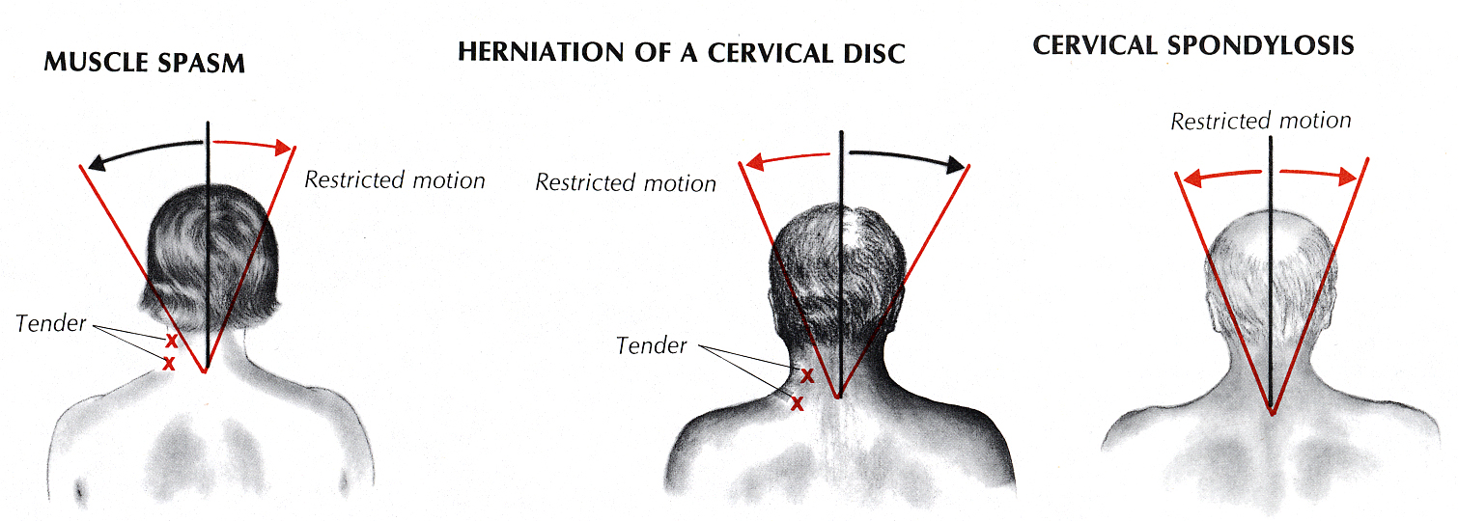
Source of picture: Barbara Bates “A Guide to Physical Examination”, 3rd ed. (1983); J.B. Lippincott Company; ISBN-13: 978-0397543991 >>

- for relief patient adopts recumbent position with arm elevated and flexed behind head (vs. shoulder disease - patient maintains arm in dependent position, avoiding elevation or abduction at shoulder joint).
- axial loading test, Spurling test (support diagnosis of cervical root disease) → see p. D1 >>

N.B. do not omit motor and sensory examination in lower extremities – not to miss myelopathy!

Lumbosacral herniation
- bouts of nonspecific low back pain (usually remittent) already begin in twenties.
- in majority, there is no history of antecedent trauma - herniation follows lifting* / twisting injuries (or may result from accumulated low-level trauma); sneeze, cough, or trivial movement may also be trigger.
N.B. in many cases, inciting event cannot be identified!
*increasing intra-abdominal pressure during heavy lifting even adds to compressive load on vertebrae but otherwise stabilizes spinal column and may prevent twisting injury
- patient appears uncomfortable.
- symptoms are often episodic (remissions are characteristic).

NASS Clinical Guidelines for Lumbar Disc Herniation with Radiculopathy (2012):
Definition of lumbar disc herniation with radiculopathy: localized displacement of disc material beyond the normal margins of the intervertebral disc space, resulting in pain, weakness or numbness in a myotomal or dermatomal distribution.
Diagnosing lumbar disc herniation with radiculopathy (Grade of Recommendation: A): 1) manual muscle testing, 2) sensory testing, 3) supine straight leg raise*, 4) Lasègue’s sign and 5) crossed Lasègue’s sign.
*supine straight leg raise (vs. seated straight leg raise aka Flip Test – less sensitive) is suggested for use in diagnosing lumbar disc herniation with radiculopathy
Insufficient evidence to make a recommendation for or against: cough impulse test, Bell test, hyperextension test, femoral nerve stretch test, slump test, lumbar range of motion, absence of reflexes.

Pain
- pain may be restricted to parasacral area or may radiate to buttocks, thigh, leg, foot.
sciatica – L₅ or S₁ * radicular pain.
*any of L₄-S₃ roots (take part in ischiadic nerve) may produce sciatica to varying degree
- paresthesias are common.
- pain is aggravated by: see p. PN1 >>
- Valsalva maneuvers
- heavy lifting from bent position
- back movement (extension or twisting).
- provocative root stretch maneuver:
  - passive straight-leg rising s. Lasègue sign (for roots L₅ and S₁);
  - femoral stretch test (for root L₄).
- pain is characteristically relieved promptly when patient lies down* (no matter how severe pain is when patient is erect!; vs. spinal tumor - pain is not relieved or even worsens!) on one side with hips and knees flexed.
*some patients are more comfortable standing and some can find no comfortable position
- patient may not be able to stand erect because paraspinal muscles contract so vigorously, yet pain may be relieved as soon as patient lies down, only to return again on any attempt to stand.
- most uncomfortable position is sitting - causes increased intervertebral pressure!
- later, short walks can bring relief, but long walks or extended sitting (especially driving) can aggravate pain.

Examination
Lumbar
- protective splinting of paraspinal muscles:
- asymmetric prominence of long erector muscles.
- loss of lumbar lordosis (flattening of lumbar spine), lumbar scoliosis.
- elevated one iliac crest (list or tilt) – “longer leg on one side” (erroneous assignment of back pain to leg length asymmetry) – often causes patient to raise heel on shoe of “short” leg to level pelvis).
- reduced range of motion of lumbar spine (attempted movement in some planes [esp. flexion] → severe back pain).
  - tenderness of adjacent vertebrae.
  - muscle atrophy and weakness (fasciculation is rare). see p. PN1 >>
e.g. wasted gluteus - one gluteal fold hangs down and shows added skin creases when patient is erect.
  - sciatic tenderness on direct pressure at some point along nerve (e.g. popliteal).
  - with sacral roots involvement, disturbances of bladder & bowel function are common.

Thoracic herniation
- herniations are uncommon! (suspect other underlying lesions – tumor, abscess, etc).
- motion trauma (wear and tear) plays no role (vs. cervical, lumbosacral disc degenerations) - thoracic vertebrae are designed for stability rather than excursion, and heavy rib cage contributes to rigidity of this structure.
- small capacity of thoracic canal → spinal cord compression is more frequent and more critical than root compression - early recognition is important! (to avoid irreversible myelopathy)
- thoracic disc disease may result from Scheuermann disease with later trauma.

Diagnosis
N.B. asymptomatic patients have high incidence of anatomical lesions – try to establish closest possible clinical correlation with anatomical findings!

Question about:
- trauma
- cancer
- infections, recent fever
- bleeding disorders, anticoagulant medications

Immediately establish major deficits that demand rapid diagnosis & surgical treatment (see below – clear indications for surgery).

Findings consistent with ruptured disc + no ÷ moderate deficit → plain X-ray of affected area → no unexpected lesions → conservative therapy.
- this approach is justified by good prognosis for spontaneous recovery of acute radiculopathy with up to moderate deficits.
- if clinical examination leaves doubt about lesion localization (root vs. peripheral nerve or plexus) → EMG, nerve conduction studies (more sensitive if delayed until at least 10-14 days after onset of new deficit).
- if surgery is considered necessary, it should be preceded by MRI or CT myelography.

NASS Clinical Guidelines for Cervical Radiculopathy from Degenerative Disorders (2010):
MRI is suggested for the confirmation of correlative compressive lesions (disc herniation and spondylosis) in patients who have failed a course of conservative therapy and who may be candidates for interventional or surgical treatment.
If MRI and clinical findings are discordant, CT myelogram is suggested.
If diagnosis after MRI remains unclear, insufficient evidence to recommend EMG.
Selective nerve root block may be considered if compressive lesions are identified at multiple levels on MRI / CT myelography to discern the symptomatic level(s) (Grade of Recommendation: C).

NASS Clinical Guidelines for Lumbar Disc Herniation with Radiculopathy (2012):
Cross-sectional imaging is recommended for diagnosis: MRI is the most appropriate noninvasive test; CT or CT myelography are the next most appropriate tests.
Electrodiagnosis: SSEP is suggested as an adjunct to cross-sectional imaging to confirm the presence of nerve root compression but is not specific to the level of compression. EMG, nerve conduction studies and F-waves have limited utility. H-reflexes can be helpful in the diagnosis of an S1 radiculopathy, though are not specific to the diagnosis of disc herniation.
Insufficient evidence for or against: motor evoked potentials, extensor digitorum brevis reflex, thermal quantitative sensory testing, liquid crystal thermography.

Plain X-ray
- Indirect diagnostic information (radiographs cannot show neural tissues or disc itself!):
- isolated loss of disc space height
  - normal cervical ÷ thoracic discs are almost equal in height.
  - normal lumbar discs progressively increase in height from T12-L1 through L4-5; L5-S1 disc has variable height because of its transitional status.
- other degenerative changes: osteophytes, end-plate sclerosis, malalignment (scoliosis, retrolisthesis, anterolisthesis).
Degenerative changes do not mean patient has “arthritis” as many asymptomatic patients (esp. young females) have some changes!
- gas may be visible within degenerated discs (nitrogen drawn from blood by negative pressure generated during spine extension within airtight disc fissures).
- severe degenerative disc disease may progress to spontaneous fusion between adjacent vertebrae.
- Screen for unexpected infection, tumor, bony deformity.
- many disc syndromes are genetic - abnormal skeletal features should be sought throughout spine (spinal stenosis, spondylolisthesis, widespread disc disease, Marfan disease, etc).

Schmorl's node (lateral lumbar X-ray): multiple concave impressions in vertebral end-plates:
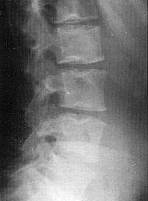

Electrophysiology
Nerve conduction studies - usually normal.
- H reflex alterations (elicited from gastrocnemius and soleus muscles in response to tibial nerve stimulation = electrodiagnostic equivalent of ankle jerk) suggest S₁ radiculopathy.

EMG – evidence of radiculopathy (denervation). see p. D20 >>
N.B. EMG is normal during first few days after herniation! Normal EMG does not rule out radiculopathy!
- radiculopathy - abnormal firings in root distribution in two or more muscles innervated by fibers from same root, preferably passing through different nerves.
- EMG reverts to normal after months to years (reinnervation).

MRI
- preferred imaging choice in most cases:
- earliest detection of disc degeneration (loss of signal intensity within nucleus pulposus = loss of water).
- demonstrates bone and soft tissues directly; specific categorization of disc displacements (e.g. protrusion vs. extrusion); shows tears of disc annulus (not visible on CT); best imaging for far lateral discs.
- multiplanar-multilevel visualization.
- high contrast of epidural fat and CSF-filled thecal sac → accurate assessment of subtle compressions.
- IV gadolinium differentiates enhancing postoperative scar (uniform enhancement) from nonenhancing recurrent / residual disc material (margin enhancement).

- T1 or T2 may be used, as one or other may not allow clear demarcation of thecal sac from extruded disc material (disc signal being quite variable).

Modic changes
N.B. only type 1 causes pain
Type 1 - edema (bright t2, dark t1)
Type 2 - fat (bright on t1 and t2)
Type 3 - sclerosis (dark on t1 and t2)

Pfirrmann grades

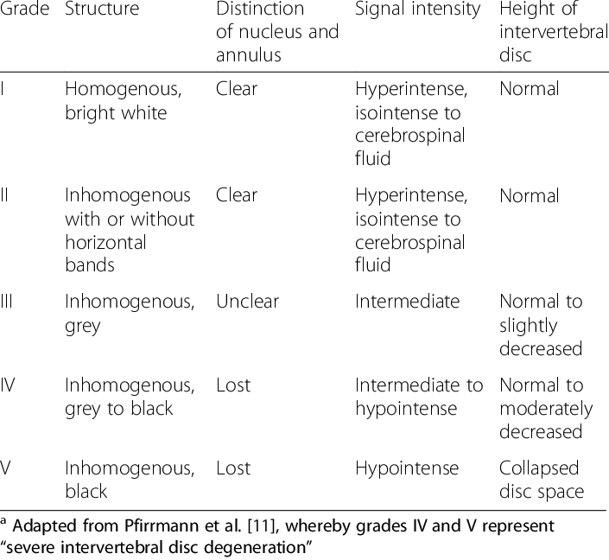
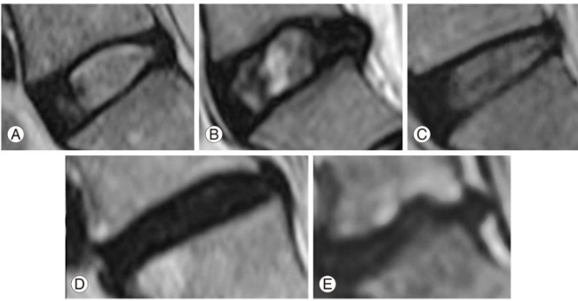

- high-intensity zones (HIZs) - foci of fluid-intensity signal on T2-MRI - annular fissures with reactive inflammation;  - may be source of back pain without disc herniation.  - present in up to 15% asymptomatic individuals.  Annular high-intensity zone (HIZ) (T2-MRI at L4-5 disc) - linear band of high signal intensity in posterior disc annulus (arrow): | 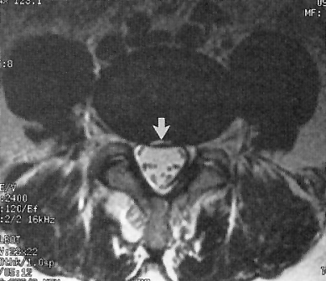

Lumbar recurrent disc herniation (MRI):
    - Precontrast
    - Postcontrast
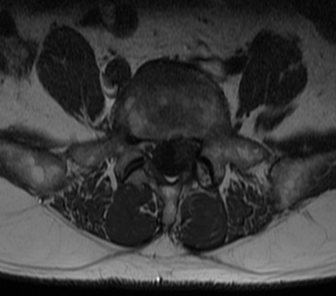
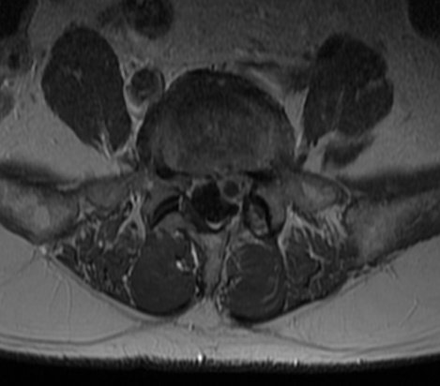
Source of pictures: Viktoras Palys, MD >>

Lumbar degenerative disc changes (MRI):
A: loss of height and fluid-intensity signal in lower three lumbar discs (compare with normal L₂₋₃ disc); punctate foci of bright signal intensity (in posteroinferior disc margin of L₃₋₄ and L₄₋₅ discs) - high-intensity zones [HIZs] (arrows).
B: L₅-S₁ left paracentral disc protrusion; note asymmetric left-sided mass effect on both thecal sac and descending left S₁ root (curved arrow).
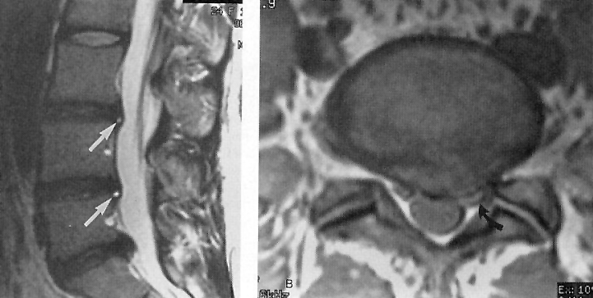

L₅-S₁ disc herniation (sagittal T1 and T2 images):
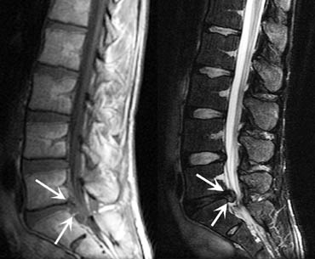

L₅-S₁ disc herniation: sagittal T2 and axial T1 images; note loss of disc height and hydration + focal disc protrusion:
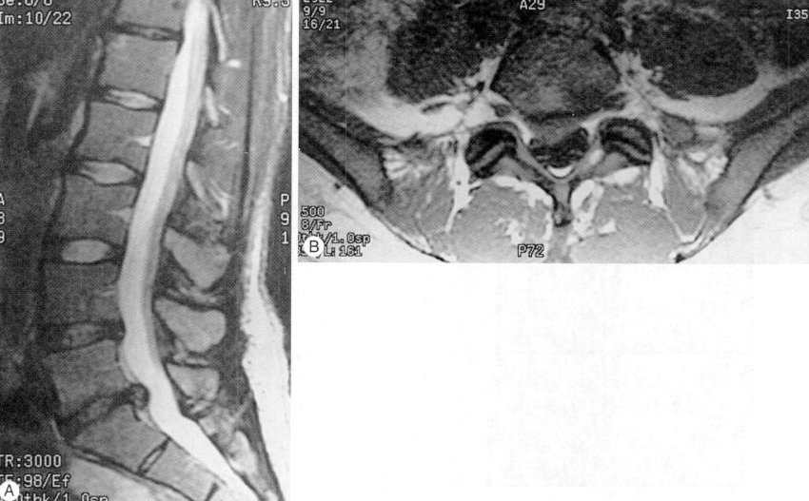

Small, right paracentral L4-5 disc protrusion (proton density-MRI): focal extension of disc material (arrow) beyond vertebral margin, with base against disc margin wider than maximal diameter of protruding disc material; some ventral flattening of adjacent thecal sac.
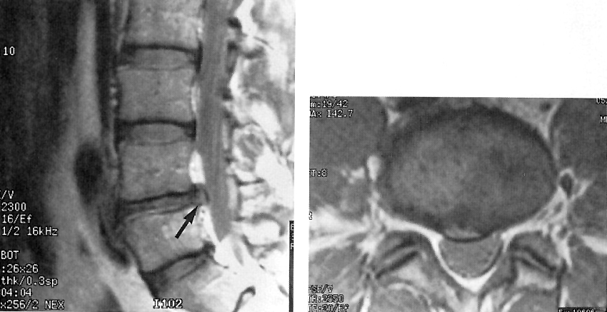

Large far lateral disc herniation (CT):
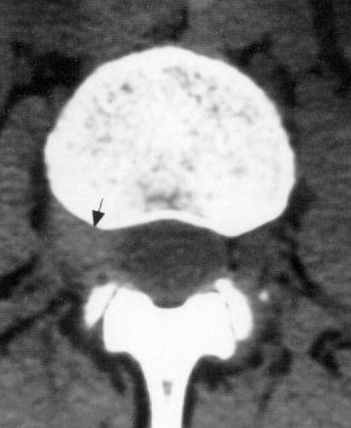

Lateral disc herniation (proton density-MRI): penetration of disc material through focal defect in right lateral annular fibers (black arrowheads); coronal image shows displacement of descending right L₃ root (white arrowheads) by disc material; patient had previous L₄₋₅ fusion.
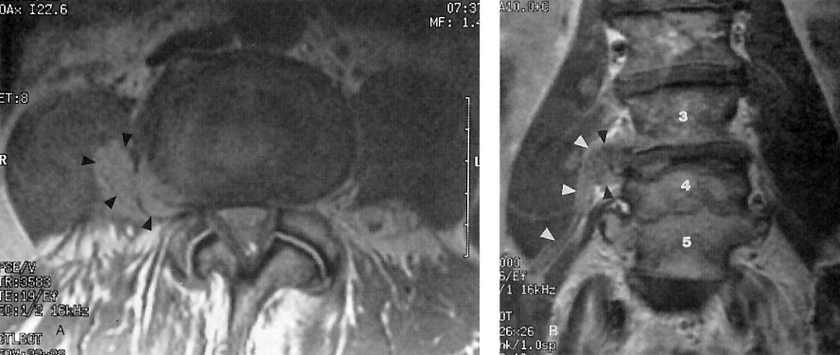

Large L₅-S₁ disc extrusion: loss of disc height, loss of signal intensity.
A - proton density-MRI; nicely demonstrates disruption of outer fibers of disc annulus (curved arrows) and posterior longitudinal ligament.
B - fast spin-echo T2-MRI
C - T2-MRI just above level of disc extrusion
D - T2-MRI at level of disc extrusion: near-complete obliteration of spinal canal space.
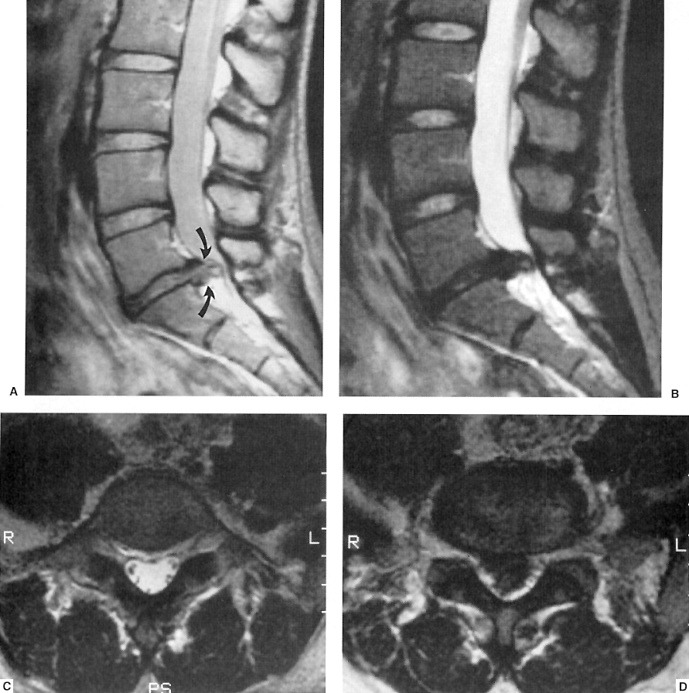

Sagittally reformatted lumbar CT: normal contour of L₃₋₄ disc, small central disc protrusion at L₄₋₅, larger inferiorly projecting disc extrusion at L₅-S₁; note mild displacement of posterior longitudinal ligament (arrowheads).
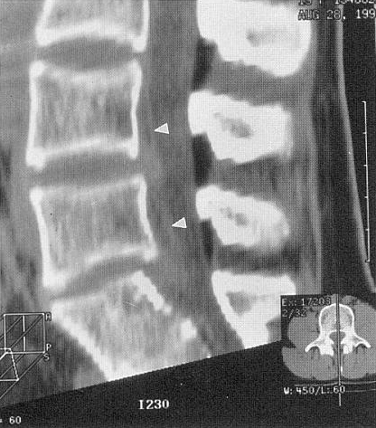

Large L₄₋₅ disc extrusion (15 years after L₅-S₁ discectomy):
A & B (fast spin-echo T2-MRI): large ventral epidural mass with signal intensity of nucleus pulposus; extruded material extends behind L₅ vertebral body in left lateral recess, displacing thecal sac and contacting descending left S₁ root (arrowheads).
T1-MRI (C – precontrast, D – postcontrast) – confirm that extruded material follows L₄₋₅ disc in signal intensity and is contiguous with L₄₋₅ disc space; note epidural enhancement around extruded disc material (arrowheads) + posterior enhancement of operative defect at L₅-S₁ (white arrow).
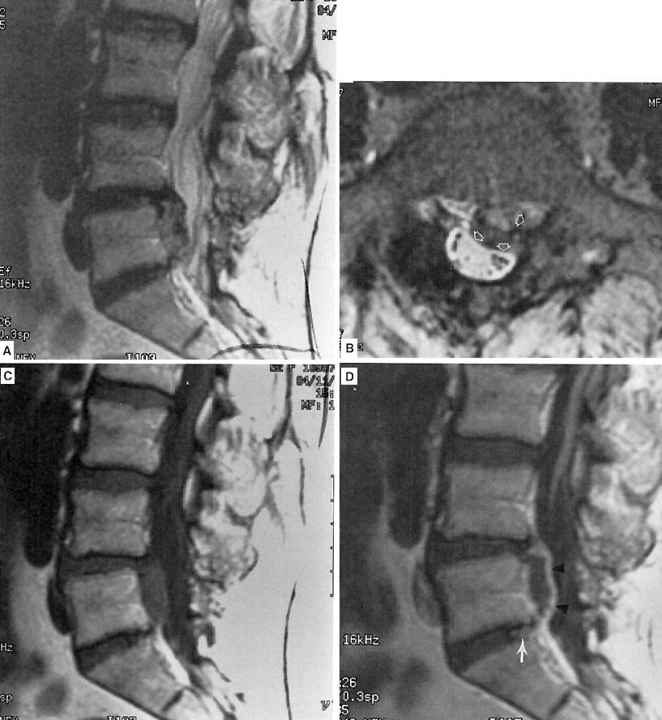

T2-MRI - high signal (black arrow) in degenerated L₂₋₃ disc associated with irregular posterior protrusion.  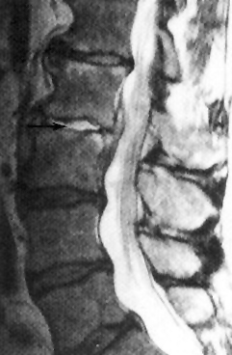 | Posterolateral L₅-S₁ disc protrusion with large extruded migratory fragment (arrow) compressing thecal sac and right S₁ root.  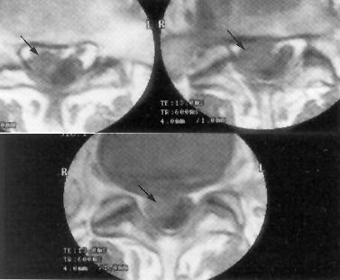

Far lateral disc protrusion:
(A) T1-MRI: far lateral protrusion of L₅-S₁ disc occupying lower part of L₅-S₁ intervertebral foramen (white arrow); L5 root is compressed against L₅ pedicle.
(B) T1-MRI: far lateral protrusion (black arrow) occupying right L₄₋₅ intervertebral foramen and compressing L₄ root.
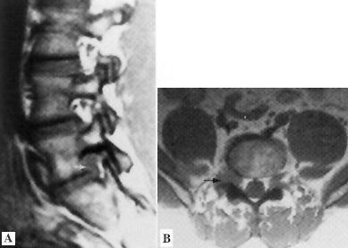

CT sections extending down to L_{4–5} disc - intervertebral foramina and contained L₄ spinal nerves (white arrows); L_{4–5} disc is protruding slightly on left side (black arrowhead):
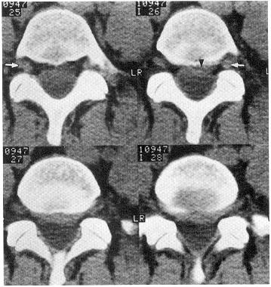

Herniated thoracic disk at T₆₋₇ (MRI):
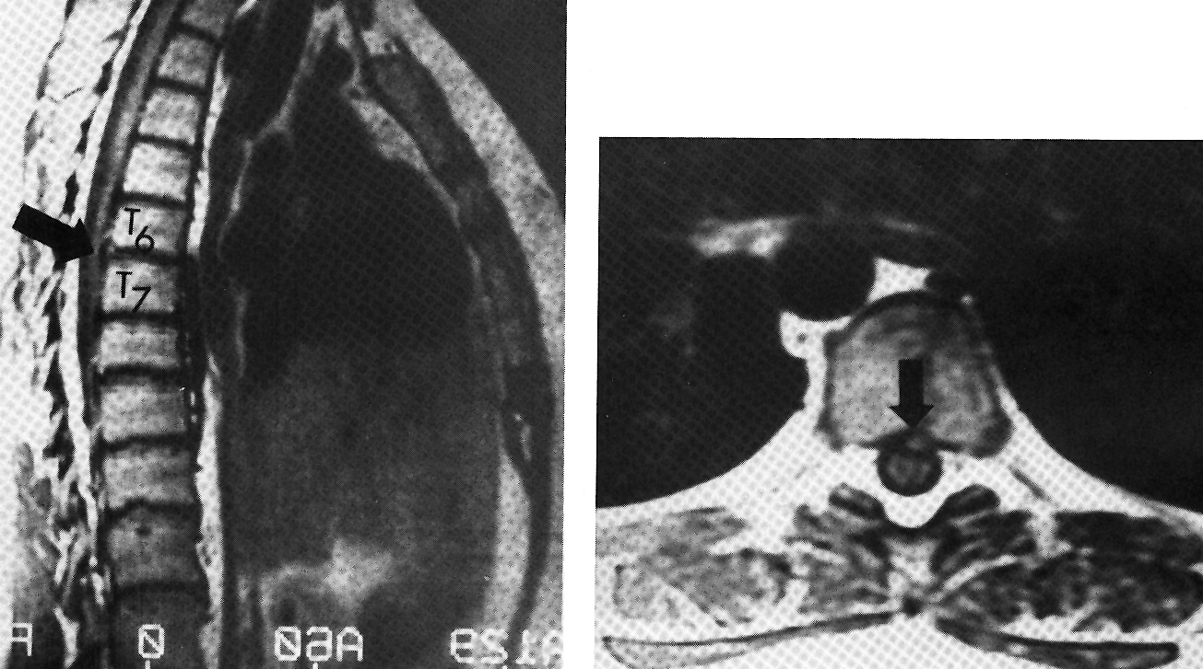

Myelography
- invasive, indirect, nonspecific. see p. D70 >>
- most commonly used to answer specific questions that remain after MRI.
- myelography alone cannot distinguish between osteophytes and herniated disc (H: CT myelography - best visualization of lateral pathology and small osteophytes).

Myelographic signs of disc herniation:
  - thecal sac / nerve root displacement
  - obliteration of axillary root sleeve.
- central herniation is best characterized in lateral projection (defect of ventral subarachnoid space).
N.B. myelography may miss central herniations (H: CT myelography – shows theca indentation in axial plane).
N.B. L₅-S₁ central herniation may be completely invisible at myelography because of considerable ventral epidural fat at this level! H: MRI
- paracentral herniations are profiled tangentially in oblique projections (seen as root sleeve effacements).
- lateral herniation is less likely to be detected because of lack of direct mass effect on thecal sac.
N.B. myelography is unrevealing in far lateral herniations (lateral to spinal canal and root sleeve) - diagnosis is made by CT or MRI.

C₅₋₆ disc herniation (myelogram via posterior C1-2 puncture, shallow oblique frontal projection): amputation of C5-C6 axillary root sleeve, compression of contrast column, slight displacement of spinal cord (arrow):
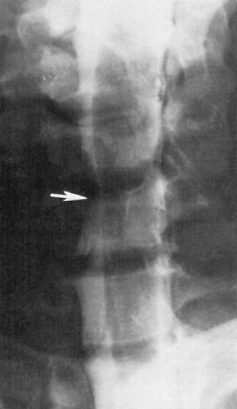

Lumbar myelograms, oblique views:
A: normal myelogram - symmetric caliber and course of exiting lumbar roots and good filling of all axillary root sleeves.
B: paracentral disc herniation - displacement and flattening of exiting S₁ nerve root and nonfilling of its axillary root sleeve (arrow):
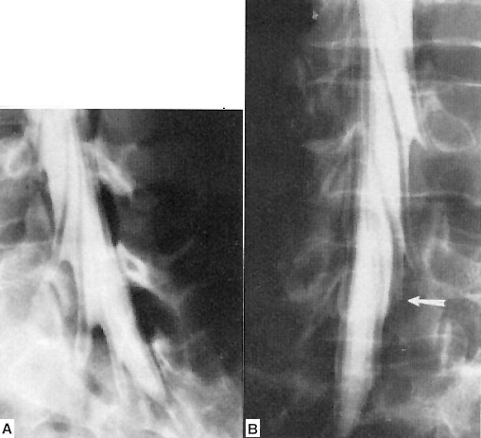

Lumbosacral central disc herniation (CT myelography): abnormal soft tissue (higher density than fat) in ventral epidural space (arrowheads) which effaces anterior aspect of thecal sac and slightly displaces right S₁ root:
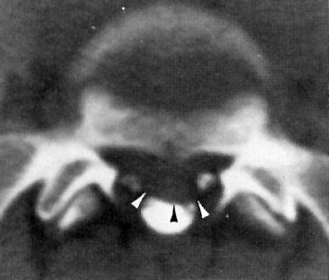

CT myelogram at C5-6 level - cutoff of left C₆ nerve root (disc herniation):
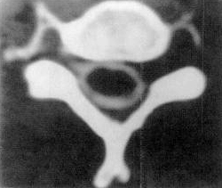

Circumferential disc bulge (arrowheads) beyond vertebral body margins; mass effect on ventral thecal sac is minimal: A - CT myelogram (note additional left psoas abscess from discitis several levels above), B - proton density-MRI:
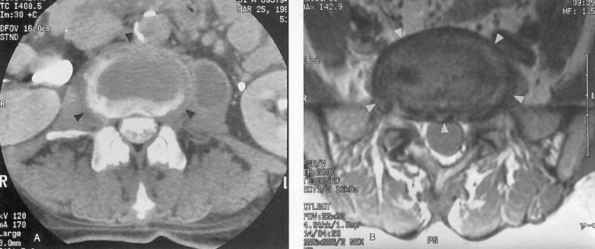

Sequestered disc fragment (CT myelogram through L₅ midbody): abnormal soft tissue in left lateral recess (indistinguishable from descending left L₅ root) causes mass effect on adjacent thecal sac; absence of contrast material in left nerve root sheath is indicative of compression by migrated disc fragment:
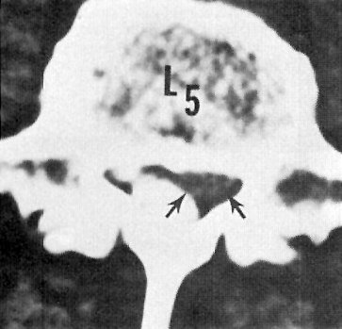

Cervical disc herniation (myelogram + subsequent CT): herniated C₆₋₇ disc compresses left C₇ root and left anterior side of spinal cord (arrow):
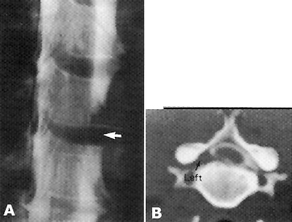

Discography | see p. D70 >>

Differential diagnosis
- Conjoined nerve roots - normal anatomic variant. see p. D70 >>
- Synovial cysts - from degenerated facet joints.

Correct diagnosis is usually apparent on MRI.

Treatment choice
Cervical root syndromes:
- Require early operation – muscles may rapidly irreversibly atrophy: C₅, C₈.
- Tolerate pressure for long periods – may respond to conservative care: C₆, C₇.

NASS Clinical Guidelines for Cervical Radiculopathy from Degenerative Disorders (2010): it is likely that for most patients with cervical radiculopathy from degenerative disorders signs and symptoms will be self-limited and will resolve spontaneously over a variable length of time without specific treatment.

Most lumbar root syndromes can be treated conservatively.
  - for herniated disk, diskectomy gives better short-term outcomes (than conservative management), although outcomes begin to look similar after 3-6 months (i.e. patients are going to improve either way but will improve faster with surgery).

NASS Clinical Guidelines for Lumbar Disc Herniation with Radiculopathy (2012):
The majority of patients will improve independent of treatment - disc herniations will often shrink/regress over time (many, but not all, papers have demonstrated a clinical improvement with decreased size of disc herniations).
Medical/interventional treatment is suggested to improve functional outcomes in the majority of patients; insufficient evidence on the influence of patient age on outcomes.
See also p. Op220 >>

Conservative therapy
- Bed rest in comfort position on firm mattress (for lumbar disease) ± lumbosacral corset;
soft neck collar (for cervical disease).

- PT: early remobilization (after acute period*), gentle exercises; back brace may be worn during waking hours.
*many physicians now recommend rest only for 2-3 days (vs. previously advised 2 weeks).

NASS Clinical Guidelines for Lumbar Disc Herniation with Radiculopathy (2012): insufficient evidence for or against physical therapy/structured exercise programs as stand-alone treatments. In the absence of reliable evidence, it is the work group’s opinion that a limited course of structured exercise is an option.

- Analgesics:
  - NSAIDs - provide little relief in most cases.
  - time-limited use of narcotics.
  - Gabapentin
NASS Clinical Guidelines for Lumbar Disc Herniation with Radiculopathy (2012): insufficient evidence for or against gabapentin.

- Muscle relaxants.

- Brief course of oral steroids (e.g. Medrol Dosepak) – reduce edema (← main cause of radicular pain!!!)
NASS Clinical Guidelines for Lumbar Disc Herniation with Radiculopathy (2012): insufficient evidence for or against single infusion of IV glucocorticosteroids.

- Epidural steroid injection (ESI)
  - not much better than epidural saline injections in relieving leg and back pain in a multicenter, randomized, controlled study of adults with subacute sciatica (epidural steroids provide modest improvement in short-term pain relief but does not prevent surgery).
  - also questionable value in cervical radiculopathies.
  - risk of infection or inflammation.

NASS Clinical Guidelines for Cervical Radiculopathy from Degenerative Disorders (2010): Transforaminal ESI (fluoroscopic or CT guidance) may be considered when developing a medical/interventional treatment plan. Due consideration should be given to the potential complications.

NASS Clinical Guidelines for Lumbar Disc Herniation with Radiculopathy (2012):
Transforaminal ESI is recommended to provide short-term (2-4 weeks) pain relief in a proportion of patients (but insufficient evidence for or against the 12 month efficacy); transforaminal ESI is suggested to improve functional outcomes in the majority of patients; type of lumbar disc herniation does not influence outcomes (but the higher degree of nerve compression, the lower rate of favorable outcome with transforaminal ESI).
Interlaminar ESI may be considered.
Insufficient evidence for or against the effectiveness of one injection approach over another (transforaminal vs. interlaminar vs. caudal) in the delivery of epidural steroids.

- Other modalities:
  - for secondary muscle spasm (e.g. local heat, massage, ultrasound).
  - traction (direction of traction must be comfortable; e.g. traction with neck extended may increase pain).
N.B. traction has no anatomical justification - discontinued in many institutions!
NASS Clinical Guidelines for Cervical Radiculopathy from Degenerative Disorders (2010): Work Group Consensus Statement: no improvement relative to the natural history of cervical radiculopathy has been demonstrated with traction.

NASS Clinical Guidelines for Lumbar Disc Herniation with Radiculopathy (2012): insufficient evidence for or against traction.

  - transcutaneous electrical nerve stimulation (TENS).
  - spinal manipulation.
NASS Clinical Guidelines for Cervical Radiculopathy from Degenerative Disorders (2010): Work Group Consensus Statement: efficacy of manipulation / chiropractics for cervical radiculopathy is unknown; careful consideration should be given to evidence suggesting that manipulation may lead to worsened symptoms or significant complications (premanipulation imaging may reduce the risk of complications, e.g. to detect unrecognized metastatic disease).
N.B. most patients with serious complications of manipulation require emergent surgical treatment.
NASS Clinical Guidelines for Lumbar Disc Herniation with Radiculopathy (2012): spinal manipulation is an option for symptomatic relief; insufficient evidence for or against spinal manipulation to improve functional outcomes;
insufficient evidence for or against spinal manipulation as compared with chemonucleolysis or open discectomy.
  - acupuncture.
  - injection of nerve or epidural space with anesthetic solutions was used quite widely in past but is rarely necessary.
  - antidepressants.
NASS Clinical Guidelines for Lumbar Disc Herniation with Radiculopathy (2012): insufficient evidence for or against 5-HT receptor inhibitors, amitriptyline.
  - Level II therapeutic evidence that a 2-week treatment of agmatine is more effective than placebo.
NASS Clinical Guidelines for Lumbar Disc Herniation with Radiculopathy (2012): insufficient evidence for or against agmatine.
  - epidural etanercept failed to show benefit.
NASS Clinical Guidelines for Lumbar Disc Herniation with Radiculopathy (2012): TNF alpha inhibitors are not suggested to provide benefit.

    - conservative treatment should continue as long as patient improves.
    - if improvement within initial 4-6 weeks is not satisfactory → confirm diagnosis by imaging.

Interventional spine procedures
Percutaneous discectomy
- any discectomy procedure that does not require open dissection of the thoracolumbar fascia.

Disappointing - cannot effectively treat free disc fragments, may even exacerbate pain.
- needle inserted through cannula (introduced ≈ 10 cm lateral to midline, directed toward intervertebral space under fluoroscopic control).
- diskogram (to exclude annulus disruption).
- disk material removed with ultrasonic aspirator.

Endoscopic percutaneous discectomy
- access to the disc herniation is made with a portal
- visualization of the discectomy is done with an endoscope
- removal of disc material is done with micro instruments or laser.

NASS Clinical Guidelines for Lumbar Disc Herniation with Radiculopathy (2012):
Endoscopic percutaneous discectomy may be considered.
Endoscopic percutaneous discectomy is suggested for carefully selected patients* to reduce early postoperative disability and reduce opioid use compared with open discectomy.
*patients < 40 years of age with and a duration of symptoms < 3 months are associated with better outcomes with percutaneous endoscopic discectomy

Automated percutaneous discectomy
- discectomy cannula is inserted into the intervertebral disc space with fluoroscopic guidance
- nuclear material is removed (without direct visualization) by nucleotome, laser or RF.

NASS Clinical Guidelines for Lumbar Disc Herniation with Radiculopathy (2012):
Automated percutaneous discectomy may be considered. In a select group of patients it may achieve equivalent results to open discectomy, however, this equivalence is not felt to be generalizable to all patients (insufficient evidence for or against automated percutaneous discectomy compared with open discectomy).

Chemonucleolysis
Not recommended!
- it is chemical discectomy - uses chymopapain
- success rate has not reached that of surgery + carries significant risks.

Surgical treatment
Lumbar
Philosophy:
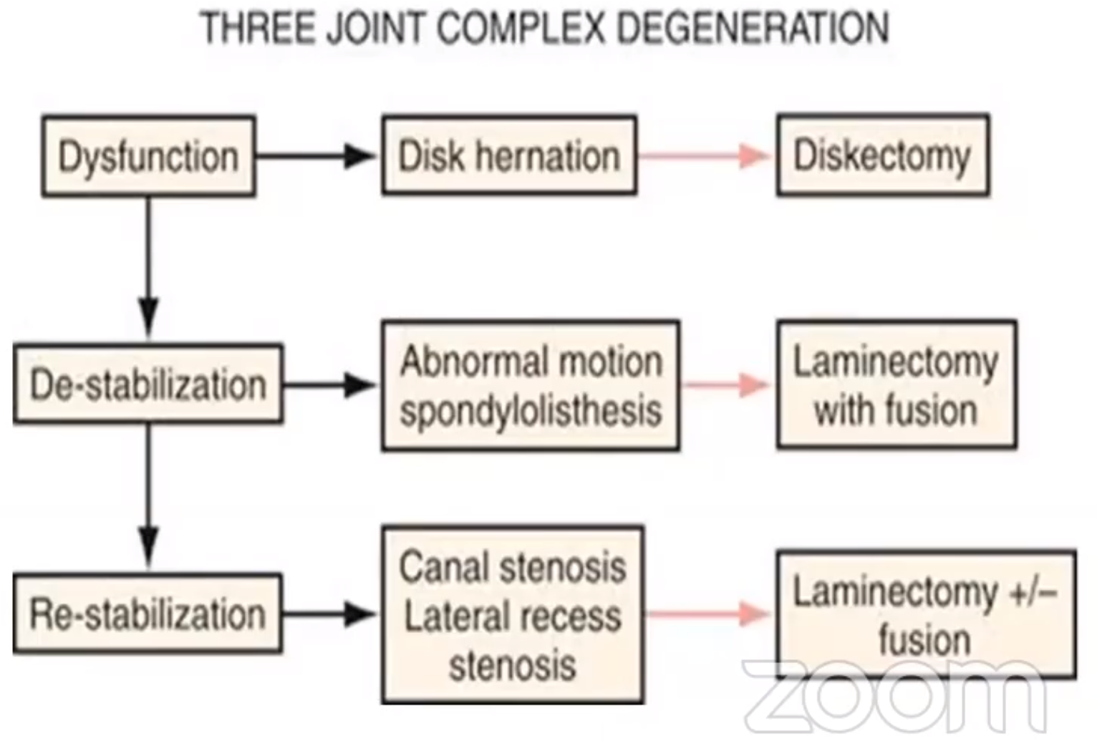

Lumbar discectomy - see p. Op220 >>

Cervical
Cervical discectomy, anterior approach – see p. Op210 >>
Cervical discectomy, posterior approach – see p. Op210 >>

NASS Clinical Guidelines for Cervical Radiculopathy from Degenerative Disorders (2010):
Surgical intervention is suggested for the rapid relief of symptoms when compared to medical/interventional treatment (grade of recommendation: B).
Either anterior surgery (ACDF) or posterior surgery (PLF) are suggested for single level degenerative cervical radiculopathy secondary to foraminal soft disc herniation to achieve comparably successful clinical outcomes (grade of recommendation: B).
ACDF (vs. PLF) is suggested for the treatment of single level degenerative cervical radiculopathy from central and paracentral nerve root compression and spondylotic disease. Work Group Consensus Statement

Prognosis
Prognosis (for pain relief & full functional recovery) is good.
- patients with psychosocial problems tend to do worse.
- sensory dysfunction does not recover as fully as motor function (many retain some sensory deficits).
- good functional recovery within 1 year:
  - with bed rest alone – 70%.
  - with selective surgery – 65-95%.
- residual back pain persists for years in at least 30% patients treated surgically!
- significant proportion (≈ 5% after surgery) of patients experience relapse with chronic low back pain (cervical syndromes are less likely to recur).

Outcome measures
Cervical
NASS Clinical Guidelines for Cervical Radiculopathy from Degenerative Disorders (2010): Neck Disability Index (NDI), SF-36, SF-12 and VAS are recommended outcome measures.

Disc Herniation Recurrence
Lumbar
- mean time to reherniation - 54.4 ± 30.4 months
- one time herniation recurrence – fusion vs. repeat discectomy – same outcome (reoperation rates, incidence of dural tears, functional outcomes).
Comparing outcomes of fusion versus repeat discectomy for recurrent lumbar disc herniation: A systematic review and meta-analysis. Panagiotis Kerezoudis, Sandy Goncalves, Joseph D Cesare, Mohammed Ali Alvi, Dennis P Kurian, Arjun S Sebastian, Ahmad Nassr, Mohamad Bydon. Clinical Neurology and Neurosurgery 2018 May 29, 171: 70-78

Bibliography for ch. “Spinal Disorders” → follow this link >>

Viktor’s Notes℠ for the Neurosurgery Resident
Please visit website at www.NeurosurgeryResident.net

