Spinal Stenosis
Last updated: December 19, 2020
Etiology 1
Pathophysiology 1
Clinical Features 1
Cervical radiculopathy 1
Cervical spondylotic myelopathy 1
Lumbar stenosis 3
Diagnosis 3
Cervical stenosis 4
Lumbar stenosis 4
Studies 4
Medical Therapy 6
Cervical stenosis 6
Lumbar stenosis 6
Surgical Therapy, Outcomes 7
Cervical stenosis 7
Lumbar stenosis 7

Spinal stenosis – anatomical narrowing of spinal canal, root canals, or intervertebral foramina with subsequent neural and vascular compression.

- prevalence ≈ 0.5%.
- usually in cervical and lumbar spine; seldom in thoracic spine.

Etiology
- Primary (congenital) stenosis – relatively uncommon:
- part of skeletal dysplasias (e.g. achondroplasia).
- isolated - most common in lower lumbar spine: short pedicles, narrow interpediculate distance, coronal orientation of articular facets, interlaminar angle < 90°, shortening or thickening of lamina.

- Acquired stenosis:
  - degenerative spondylosis (bulging disks with posterior osteophytes, facet hypertrophy, synovial cysts, ligamentum flavum infolding & hypertrophy, degenerative spondylolisthesis & scoliosis). see p. Spin13 >>
  - ossification of posterior longitudinal ligament see p. Spin13 >>
  - trauma
  - surgery (laminectomy, fusion) complications
  - metabolic / endocrine disorders (epidural lipomatosis, osteoporosis, acromegaly, renal osteodystrophy, hypoparathyroidism)
- according to studies, 10-35% of lumbar stenosis patients have amyloid disease involving transthyretin (consider biopsy?)
  - Paget's disease, diffuse idiopathic skeletal hyperostosis
  - ankylosing spondylitis, RA

Pathophysiology
- monosegmental or multisegmental.
- unilateral or bilateral.
Central canal stenosis can cause:  - myelopathy (cervical, thoracic)  - cauda equina syndrome (lumbar).  Lateral recess stenosis can cause radiculopathy.  Neuroforaminal stenosis can cause radiculopathy.  see p. PN1 >>, p. Spin13 >> | 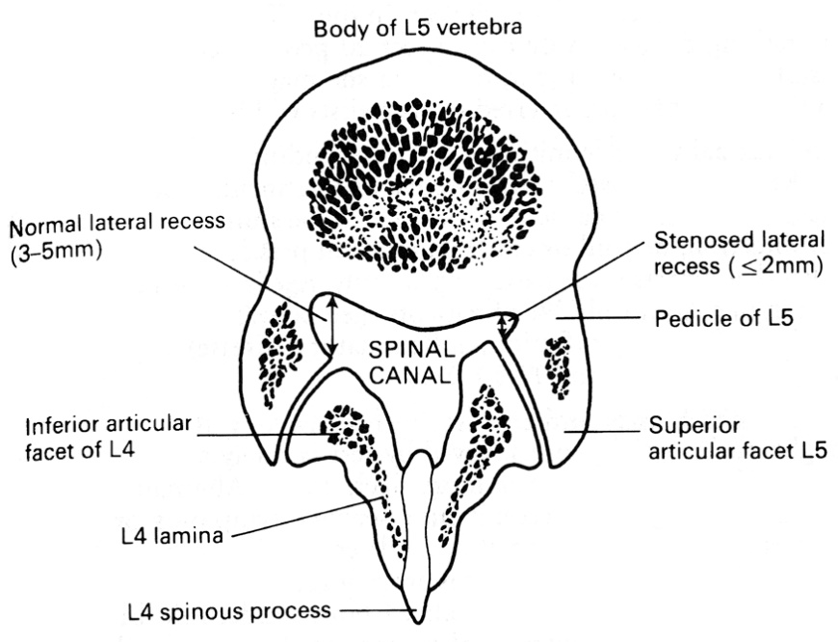
These frequently coexist - failure to recognize and correct one component at decompressive surgery is common cause for “failed back surgery syndrome”!

Disc degeneration → arthrosis of the uncovertebral joints, disc protrusion (central stenosis), ↓height of intervertebral space →:
  - ↓intervertebral foramina (foraminal stenosis) → strain on facet joints → facet joint arthrosis, expanding joint cysts (lateral stenosis)
  - ligamenta flava redundancy forms creases (central stenosis) - characteristic trefoil-shaped narrowing of central canal.

- spondylosis leads to circumferential narrowing of the spinal canal and static compression of the spinal cord.
- movement of the cervical spine places the spinal cord at risk of injury secondary to dynamic forces, such as buckling of the ligamentum flavum in extension and impingement from a disc-osteophyte in flexion.
- congenitally narrowed spinal canal predisposes the degenerating spine to spondylotic myelopathy.

Clinical Features
Cervical radiculopathy
– see p. PN1 >>

Cervical spondylotic myelopathy
Slowly progressive spastic gait disorder + hand numbness and loss of fine motor control in patient > 50 yrs = cervical spondylotic myelopathy until proven otherwise.

- hallmark symptoms are UMN signs in legs - gait abnormalities (stiff, spastic) and (proximal*) weakness / stiffness / proprioceptive loss.
*distal strength is reduced less frequently
    - usually develop insidiously as subtle changes in gait or balance.
    - symptoms are commonly asymmetric.
    - loss of vibratory sense or proprioception can occur in the feet.
- neck stiffness / pain because of the advanced spondylosis.
    - Lhermitte’s sign may be present.
- stabbing pain in the preaxial or postaxial border of the arms, loss of manual dexterity (difficulty writing, difficulty with buttons or zippers) and abnormal sensations (“numb, clumsy hands”).
    - arm weakness typically begins in triceps and/or hand intrinsic muscles (wasting of the intrinsic hand musculature is a classical finding in CSM).
    - have patient make a fist and release it 20 times in 10 seconds - impairment or clumsiness.
    - finger escape sign - patient holds his/her fingers extended and adducted; ulnar digits drift into abduction and flexion within 30 to 60 seconds.
    - sensory abnormalities start in the fingertips, are confined to the hand, and occur in a nonradicular distribution.
- positive jaw jerk may help distinguish upper cervical cord compression from lesions above the foramen magnum.
- loss of sphincter control and urinary incontinence are rare.
- patients may also present acutely with a central cord syndrome (after blow to the forehead → acute hyperextension injury with preexisting acquired stenosis or myelopathy, resulting in acute spinal cord compression): greater upper extremity weakness than lower extremity weakness.

Quantification
- Hand dynamometry
- Nine hole peg test
- 30-meter walk test - measuring time and number of steps taken over 30 meters (objective, reproducible e.g. preop and postop)
- Nurick disability score
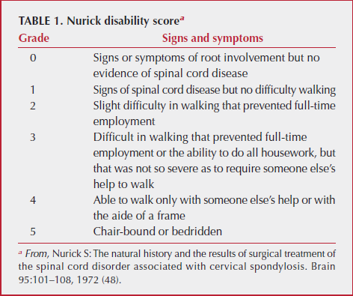

- Modified Japanese Orthopaedic Association functional score (mJOA)
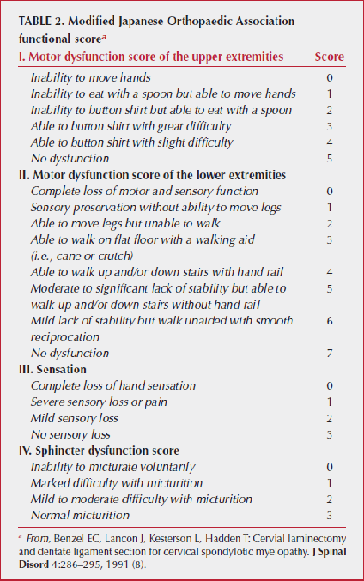

≥ 15 – mild
12-14 – moderate
< 12 – severe

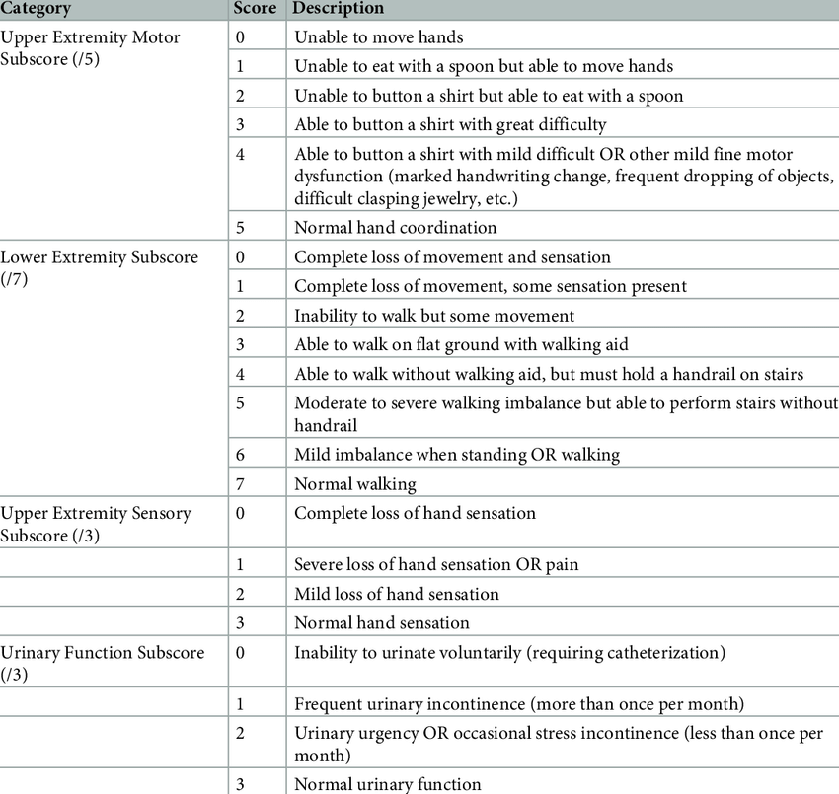

- Neck Disability Index (NDI)
- Berg Balance Scale (BBS)
- Quality of life (nonspecific for CSM) - Medical Outcomes Study Short Form-36 (SF36v2)

Natural history is unclear
Natural course of CSM for any given individual is variable, and a precise prognostication is not possible! Current view is that myelopathy tends to progress
- some experts see it as a steadily progressive disease, others think it is episodic disease with periods of plateaus and worsenings.
- risk factors for progression: older age, motor deficits, long duration of deficits, more severe deficits.
- patients who present with cervical myelopathic findings: 75% demonstrate a slow progression of disease; in 1/3 of patients clinical course stabilizes.
Clarke E, Robinson PK: Cervical myelopathy: A complication of cervical spondylosis. Brain 79:483–510, 1956

Lumbar stenosis
History
Classic presentation of lumbar stenosis is neurogenic claudication see p. Spin13 >>

- patients usually have 4-5-year history of back pain* (lumbago) that becomes progressively worse;
*back pain may be absent
  - pain starts in lower back and eventually begins to radiate to buttock(s), leg(s) or groin(s) because of nerve root compression (radicular pain is most common symptom of spinal stenosis!)
  - spinal stenosis pain is worse with walking and backward extension* and relieved by flexing forward (vs. mechanical back pain or disk herniation) and recumbency!
*walking uphill is usually worse because of associated hyperextension that narrows spinal canal.
  - pain exacerbated further by vertical load (epidural pressure is elevated while standing or walking, and lowered when sitting and in flexion).
  - pain is frequently accompanied by leg hypesthesia / paresthesia and characteristic feeling of “heavy legs” (progressing into leg paresis).
  - symptoms are absent at rest.
Patients whose pain is not made worse with walking have a low likelihood of stenosis
- congenital stenosis is usually asymptomatic; manifests earlier in course of acquired stenosis.
- spinal stenosis predisposes to neurologic dysfunction with superimposed minor disk disease!
- 20% patients exhibit symptoms of depression and 25% are dissatisfied with their life before surgery!

Objective examination
- physical findings (specific motor weakness, "stretch signs" by straight leg raising, abnormal Romberg test, abnormal Achilles tendon reflexes) are often absent!

Physical findings cannot confirm diagnosis of degenerative lumbar spinal stenosis

Natural History
- in mild / moderately symptomatic degenerative lumbar stenosis, rapid or catastrophic neurologic decline is rare
- natural history of clinically or radiographically severe degenerative lumbar stenosis is less clear (o patients agree to stay untreated).

Diagnosis
Imaging is absolutely necessary to establish diagnosis! (no objective physical examination findings can confirm diagnosis)
N.B. radiological degree of stenosis does not necessarily correlate with clinical degree!
Normal spinal canal:
  - widest and almost circular at C₁;
  - narrows in mid cervical levels and slightly widens in lower, becoming more triangular in shape;
  - in thoracic region canal is almost circular and becomes wider and more triangular, especially in lower lumbar spine.

Great individual and regional variation is rule - precise measurements are generally impracticable!

    - soft tissues contribution (in addition to bone) is especially important in acquired stenosis:
thecal sac cross-sectional area < 1 cm² (< 100 mm²) represents stenosis.

Cervical stenosis
Dimensions suggesting stenosis:
sagittal dimension:
< 13 mm – relative stenosis
< 10 mm – absolute stenosis (absence of free CSF space)
transverse interfacet dimension < 10 mm;
lateral recess AP dimension ≤ 2 mm (norma 3-5 mm)
lateral recess is bounded: anteriorly by vertebral body & disc, laterally by pedicles, and posteriorly by superior articular process of adjacent facet joint.

Cervical canal stenosis (best classified on T2-weighted sagittal images):
grade 0 - absence of canal stenosis;
grade 1 - subarachnoid space obliteration exceeding 50%;
grade 2 - spinal cord deformity
grade 3 - spinal cord signal change
Some radiologist do not use numbers to diagnose stenosis as many measurements are relative; regardless, it is known that cervical cord AP diameter is 10 mm, add 1 mm of dura on each side and 1 mm of CSF – anything ≤ 13 mm is stenosis (present in 29% of population and most are asymptomatic; if canal is ≤ 7 mm, 50% chances the patient will have myelopathy in a lifetime)

Lumbar stenosis
Most commonly used measurements:
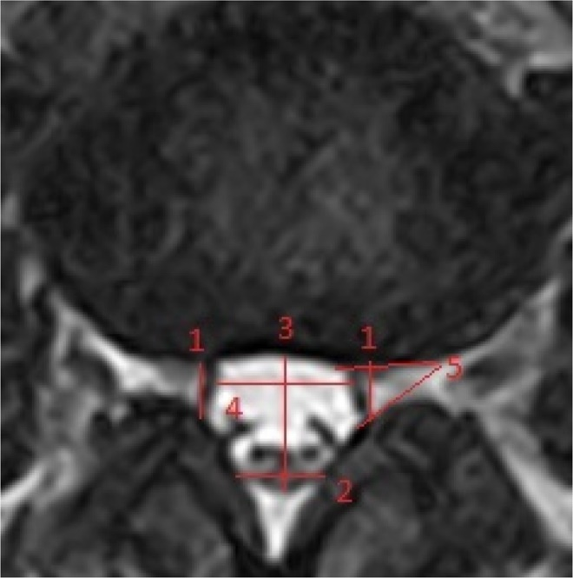
1. Depth of the lateral recess; 2. Ligamentous interfacet distance; 3. AP diameter of dural sac; 4. Transverse diameter of dural sac; 5. Angle of the lateral recess.

Studies
    - currently CT / MRI are performed in supine position (diminished gravity effect on alignment and stenosis); future imaging systems that scan patients in upright weight-bearing position would reveal more profound stenotic changes (criteria for stenosis may need to be refined).

Plain radiograph - for excluding other causes (fracture, spondylolysis, neoplasm).
- flexion-extension views - to show spinal instability.

MRI - imaging study of choice.

Open MRI, conventional functional myelography - functional investigation of spinal flexion and extension during application of axial loading.
- MRI or CT with axial loading is suggested as a useful adjunct to routine imaging in patients who have clinical lumbar spinal stenosis and suspected but not verified central or lateral stenosis on routine unloaded MRI or CT.

CT myelogram – better (than MRI) delineates bony anatomy (esp. lateral recess stenosis) and specific nerve root's involvement; imaging study of choice when MRI is contraindicated.
- thecal sac often has characteristic "trefoil" shape (in axial plane) - anterior indentation by bulging disc and posterolateral indentations by degenerated facet joints and/or hypertrophied ligamenta flava.
- in symptomatic stenosis, contrast medium is usually excluded from involved level.
- redundant tortuosity of roots* (above or below stenosis – “spaghetti” sign) is consequence of focal entrapment and stretching of these roots, which have long intradural course.
*may be confused with large intradural veins

EMG detects neuromuscular diseases that may mimic stenosis.

Retrodental epidural pannus (T2-MRI):
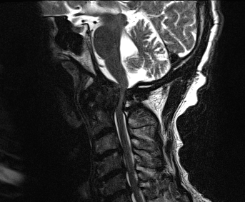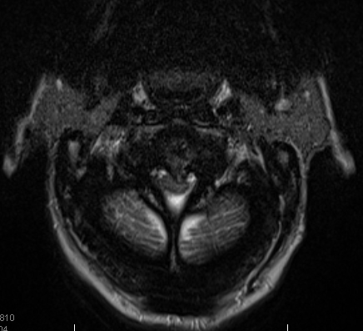
Source of pictures: Viktoras Palys, MD >>

T2-MRI: normal (left) vs. stenotic (right) lumbar spine:
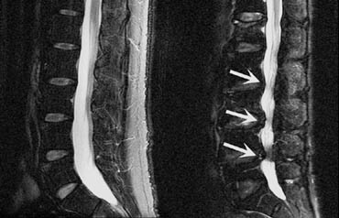

Central lumbar stenosis (congenital + acquired):
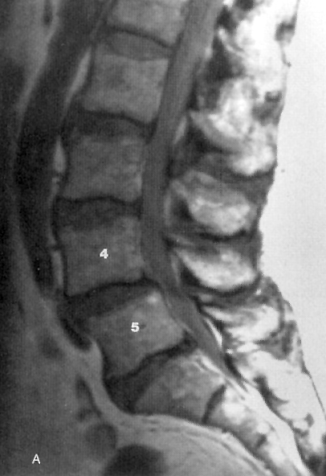 | A) generalized narrowing of sagittal canal diameter (< 10 mm) caudal to L2-3 disc; more severe stenosis at L4-5 (associated with degenerative disc changes, including grade 1 spondylolisthesis).  B) compression of thecal sac ventrally by bulging disc and posterolaterally by degenerated hypertrophied facet joints and ligamentum flavum; thecal sac (arrow) area < 1 cm² and characteristic triangular "trefoil" configuration.  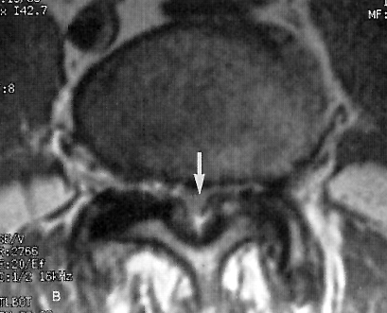

Lumbar lateral recess stenosis (CT myelogram): pronounced narrowing of space between vertebral body and facet joints (lateral recess) caused by degenerative hypertrophic changes at disc space (large arrow) and facet joints (small arrows); central canal is narrowed sagittally & transversely (some contrast is still visible within thecal sac:  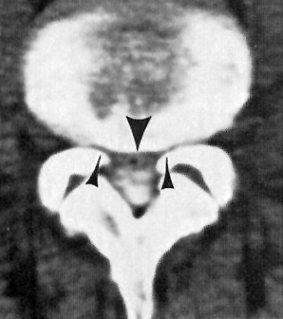 | Congenital + superimposed acquired cervical central stenosis in 44-year-old woman with achondroplasia (T2-MRI); note punctate foci of increased signal within cord below narrowed foramen magnum and at level of C5 (arrows): 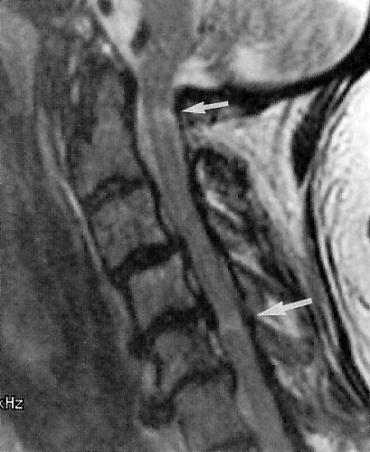

Cervical degenerative changes (CT myelography):
A) hypertrophic uncinate processes (black arrows) project into lateral spinal canal and entrance zone of neural foramina; midline disc herniation (white arrow); effacement of ventral CSF.
B) posterior osteophytic ridge at C5-6 compromises sagittal diameter of canal, flattening ventral aspect of cervical spinal cord.
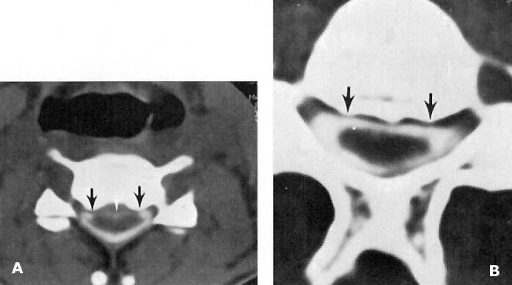

Degenerative lumbar stenosis (T2-MRI): severe stenosis at L4–5 with entrapment of cauda equina (obliteration of CSF signal from thecal sac at site of compression - arrowhead) and redundant coiling of intrathecal spinal roots above:  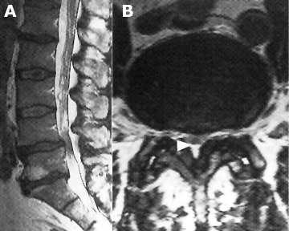 | Lumbar stenosis (myelography) - two patients (note tortuosity of trapped roots):  A) Focal (arrow) posterolateral impression due to hypertrophic posterior joint.  B) Extensive stenosis below L3-4.  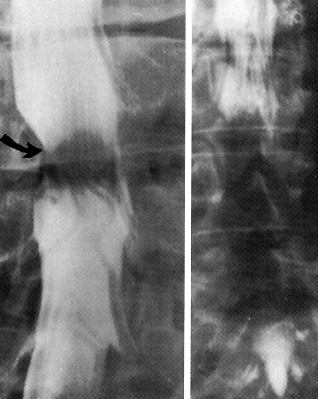

Monosegmental lumbar stenosis at L4-5 (T2-MRI):
a. reductions in disc signal and disc space height; disc bulging and slight ventral listhesis of L4 (arrow)
b. narrowing of neuroforamen (arrow), which affects right L4 radix.
c. hypertrophic facet joint degeneration with intra-articular effusions (arrowheads) and hypertrophy of lig. flavum (arrow):
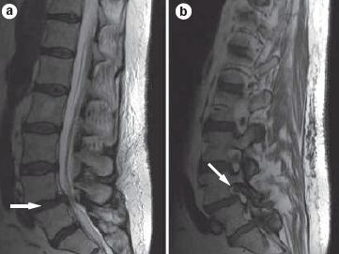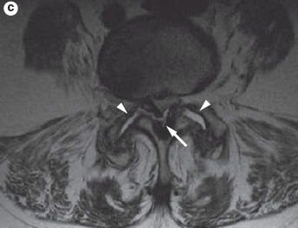
Source of picture: Medscape Neurology from WebMD >>

Medical Therapy
Cervical stenosis
- after a cervical spondylosis patient became symptomatic (myelopathy), they did not return to baseline*
Clarke E, Robinson PK: Cervical myelopathy: A complication of cervical spondylosis. Brain 79:483–510, 1956
*successful surgery may reverse some symptoms (esp. mild ones)

- anti-inflammatory drugs – concern for side effects with chronic use
- analgesics – Tylenol is agent of choice; opioids have no end organ toxicity, no dose ceiling effect.
- muscle relaxants – only for acute episodes.
- antidepressants
- anticonvulsants (gabapentin, etc)
- steroids – systemic (1-2 week courses) or ESI (axial neck pain is a poor indication for ESI)
- facet joint RF ablation – for chronic axial neck pain.
- physical therapy (adequate pain reduction is needed prior to PT to facilitate its utilization)
- cervical immobilization with an external cervical orthosis have been recommended for symptomatic relief in myelopathy (esp. combined with isometric exercises), but no effect on long-term outcomes, including neurological progression, has been demonstrated.
N.B. cervical collars may not prevent deterioration in cervical spondylotic myelopathy (esp. if > 2 yrs duration).
Wilkinson M: The clinical aspects of myelopathy due to cervical spondylosis. Acta Neurol Belg 76:276–278, 1976
- manipulation and traction show some efficacy for axial neck pain and radiculopathies; contraindicated for myelopathy because of the potential for aggravation of neurological injury!

Lumbar stenosis
- for mild to moderate symptoms; also 3-6 months trial for severe symptoms (if no good response → surgery):
- Physical therapy, exercise to reduce lumbar lordosis (delordosing physiotherapy).
- Anti-inflammatory drugs
- Epidural steroid injections with contrast-enhanced fluoroscopy guidance.
  - steroids are used in combination with local anesthetics in epidural, deep paravertebral, pararadicular and facet joint injections.
  - epidural injections have become prerequisite for many spinal surgery insurance authorizations.
  - LESS (Lumbar Epidural Steroid Injections for Spinal Stenosis) trial- epidural steroids should be used sparingly or not at all as steroids give very little on top of local anesthetics and results are temporary.
- Addition of gabapentin to a PT can result in greater short-term improvement.
- PGE₁ IV shows promise in treating neurogenic intermittent claudication.

NASS Clinical Guidelines for Lumbar Stenosis (2011):
There is insufficient evidence to make a recommendation for or against the use of pharmacological treatment.
Medical/interventional treatment may be considered to provide long-term (2-10 years) improvement and has been shown to improve outcomes in a large percentage of patients*.
There is insufficient evidence to make a recommendation for or against the use of physical therapy or exercise as stand-alone treatments. But a limited course of active PT is an option.
Epidural steroid injections: interlaminar injections are suggested to provide short-term (2 weeks to 6 months) symptom relief. Multiple transforaminal injections or caudal injections are suggested to produce medium-term (3-36 months) relief of pain. There is, however, conflicting evidence concerning long-term (21.5-24 months) efficacy.
Lumbosacral corset is suggested to increase walking distance and decrease pain; no evidence that results are sustained once the brace is removed (grade B recommendation).

*20-40% of patients with mild / moderate lumbar stenosis receiving medical/interventional treatment will require surgical intervention within 10 years; of the patients who do not require surgical intervention, 50-70% will have improvement in their pain.

Surgical Therapy, Outcomes
Indications
- Myelopathy, esp. with demonstrated progression and age > 60 yrs (Nurick’s criteria), mJOA ≤ 14 points
- treatment of mJOA ≥ 15 patients remains controversial; experts lean towards surgery for patients with predominance of neck pain, motor symptoms (gait dysfunction and hand weakness), and female gender – surgical intervention results in greater gains.
- Cauda equina syndrome → urgent surgery
- Severe radiculopathy:
  - significant muscle weakness.
  - pain affecting patient's quality of life.
- Prevention of SCI in cervical stenosis
- asymptomatic and mildly symptomatic cervical stenosis patients are commonly recommended to undergo surgery due to risk of SCI after a minor trauma.
Chang, Victor “The Risk of Acute Spinal Cord Injury After Minor Trauma in Patients With Preexisting Cervical Stenosis” Neurosurgery: October 2015 - Volume 77 - Issue 4 - p 561–565
10 patients (18%) experienced a traumatic event during the follow-up, with none sustaining an SCI - it seems that occurrence of SCI in this patient population after minor trauma is likely smaller than many physicians surmise

Extent of radiological findings is generally of little help for identification of surgery indication!

Cervical stenosis
Indications – see above >>

Decompression through:
- posterior approach - laminectomy (CLAM) – for ¹multilevel compression, ²hypertrophied ligamentum flavum.
N.B. wide decompression (pancervical laminectomy) with removal of much of facet joints may result in swan-neck deformity (esp. if patient already has loss of lordosis preoperatively) - spinal cord becomes draped over the dorsal aspect of ventral compressing structures with worsening static cord compression; to avoid this, use PCF or alternative techniques:
- expansive laminoplasty.
- suspension laminotomy - laminae are divided and separated from lateral elements by fragments of bone held in place by sutures.

- anterior approach - ACDF – for anterior compression at few* disc levels.
*some authors report that disease involving > 2 vertebral body levels may be better addressed by a dorsal approach
- if stenosis is also behind vertebral bodies (incl. OPLL*) – need corpectomy (or at least ACDF with Cloward technique).
*OPLL tends to progress after surgery, so need to decompress also levels above and below stenosis

Moderate and Severe Degenerative Cervical Myelopathy
Rafael De la Garza Ramos et al. Predictors of Return to Normal Neurological Function After Surgery for Moderate and Severe Degenerative Cervical Myelopathy: An Analysis of A Global AOSpine Cohort of Patients. Neurosurgery 85:E917–E923, 2019
- although the main goal of surgery is symptom stabilization, a subset of patients achieves remarkable improvements.
- 20.3% (51 out of 251) with moderate or severe baseline myelopathy achieved an mJOA score of 18 (no signs of myelopathy) at 2 yr.
- T1W-hypointensity on MRI and longer walking time (on 30-m walking test) predict a less likelihood of achieving return to normal neurological function after surgery for moderate or severe DCM.
- 9.7% deteriorated within 2 yr after surgery!
- on univariate analysis, male gender (P = .01) was associated with higher odds of deterioration, whereas severe baseline myelopathy was associated with lower odds of deterioration (P = .05); on multivariate analysis, male gender was found to significantly increase the odds of deterioration at 2 yr of follow-up (OR 3.23; 95% CI, 1.29-8.07; P = .01). Crude deterioration rates between males and females were 13.5 vs 4.4% (P = .01).

Lumbar stenosis
Indications – see above >>

laminectomy ± foraminotomy at involved levels.
- for lateral recess decompression – facetectomy (removal of medial part of hypertrophic facet joint).
N.B. wide decompression with removal of much (> 50%) of facet joints may result in spondylolisthesis.
- patients should be aware that benefits of surgery decrease with time but still remain significant till 4 (and possibly 10) years later. However, obtaining improvement for such a period is worthwhile even if it were to fade thereafter.
- "failed back syndrome" (scar, residual stenosis); H: reoperation or spinal cord stimulator.
- dynamic stabilizing device (Coflex) is an adjunct to flavectomy; offloads facet joints and affords spine stabilization without traditional instrumentation; flattens lordosis → worsened sagittal balance.

Spine Patient Outcomes Research Trial (SPORT)
- surgical versus nonoperative treatment for lumbar spinal stenosis; class II evidence.
- exclusions: spondylolisthesis, instability (defined on lateral X-ray).
- surgical patients maintain substantially greater improvement in pain and function through 4 years!!!
Weinstein JN et al. for the SPORT Investigators. Surgical versus nonsurgical therapy for lumbar spinal stenosis. N Engl J Med 2008; 358 : 794 – 810

NASS Clinical Guidelines for Lumbar Stenosis (2011):
Decompressive surgery is suggested to improve outcomes* in moderate to severe lumbar stenosis (grade B recommendation), incl > 75 yo.
Decompression alone** is suggested for leg predominant symptoms without instability*** (grade B recommendation).
There is insufficient evidence for or against an interspinous process spacing device in lumbar stenosis.
*good or excellent results in 80% of patients at 4-year and 70% at 10 years follow-up.
**i.e. without fusion
***i.e. < 5 mm intervertebral translation
N.B. patients who have medical/interventional therapy first but then cross over to surgery will not harm their chances of success with surgery.

Treatment algorithm for symptomatic lumbar spinal stenosis:
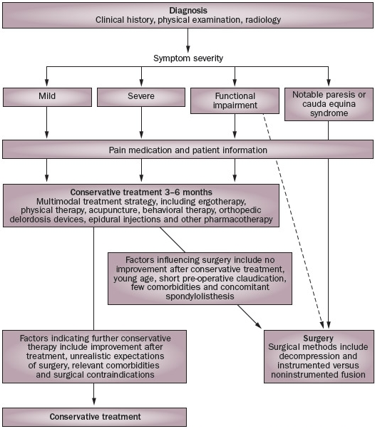

Bibliography for ch. “Spinal Disorders” → follow this link >>

Viktor’s Notes℠ for the Neurosurgery Resident
Please visit website at www.NeurosurgeryResident.net

