Spondylolysis, Spondylolisthesis

Last updated: January 18, 2020

Spondylolysis 1

Etiology 1

Clinical Features 1

Diagnosis 1

Treatment 4

Spondylolisthesis 4

Etiology 4

Clinical Features 5

Diagnosis 5

Treatment 5

Surgery 5

Obesity 5

Conservative 5

Spondylolysis

**Spondylolysis** (“vertebral loosening”) - bony cleft in *pars interarticularis* (segment between superior and inferior articular processes, near junction of pedicle with lamina).

* usually bilateral.
* most frequently in **L5** (occasionally, L4); rarely in cervical spine (C2), usually in association with spina bifida occulta at same level.
* relatively common (prevalence ≈ 7%); frequent in young patients! (50% of chronic back pain in adolescents)
* vertebral body, pedicles, and superior articular facets may slip anteriorly and leave posterior elements behind – **spondylolytic (s. isthmic)** **spondylolisthesis**.

Lumbosacral junction:

A. Anterior translation of L5 on S1 (spondylolisthesis).

B. Defect in pars interarticularis (spondylolysis).

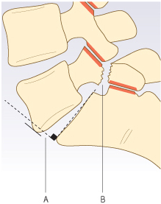

Etiology

1. repeated minor injuries (**fatigue fracture**) – esp. in sports which require spine hyperextension (such as gymnastics!).
2. single **injury**
3. **congenitally** failed fusion of posterior arch ossification centers (rare)
   * often associated with other defects: absent pedicles, absent superior articular facet, hypoplastic laminae with spinous process deviation, hypertrophy of contralateral pedicle.

Clinical Features

- **back pain** not associated with neurological symptoms* (unless severe subluxation is present).

*according to other sources, > 50% of patients develop **radiculopathy**

**“Stork test”** – ask adolescent to stand on one leg and hyperextend back; reproduction of

pain is suggestive of spondylolysis:



[Source of picture: Edward J. Shahady “Primary Care of Musculoskeletal Problems in the Outpatient Setting” (2006); Springer; ISBN-13: 978-0387306469 >>](http://www.amazon.com/gp/product/0387306463)

Diagnosis

1. **axial CT with sagittal reformatted images** - best single test!
2. **standing plain X-ray** (oblique* projection!) - ***irregular lucency***\*\* ***traversing pars interarticularis*** in oblique or horizontal fashion.

*chronic defect often has *thick, sclerotic borders* with reactive hypertrophic bone (hypertrophic pseudarthrosis) - because of bony superimposition, AP and lateral views may not reveal defect!

**described as lucency across "neck of Scottie dog" (referring to appearance of posterior elements in oblique projection).

Pars defect is radiolucent “collar” on “Scottie dog” that is seen on oblique X-ray of lumbar spine:

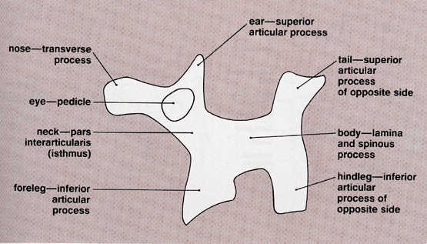

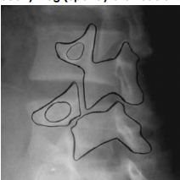

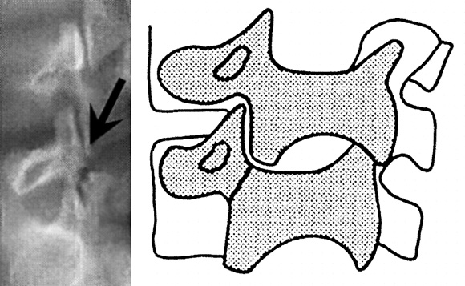

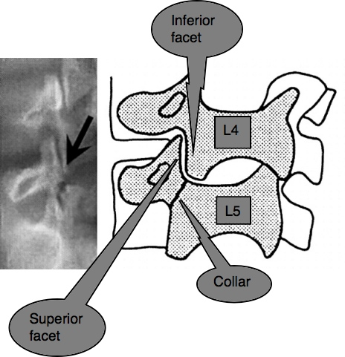

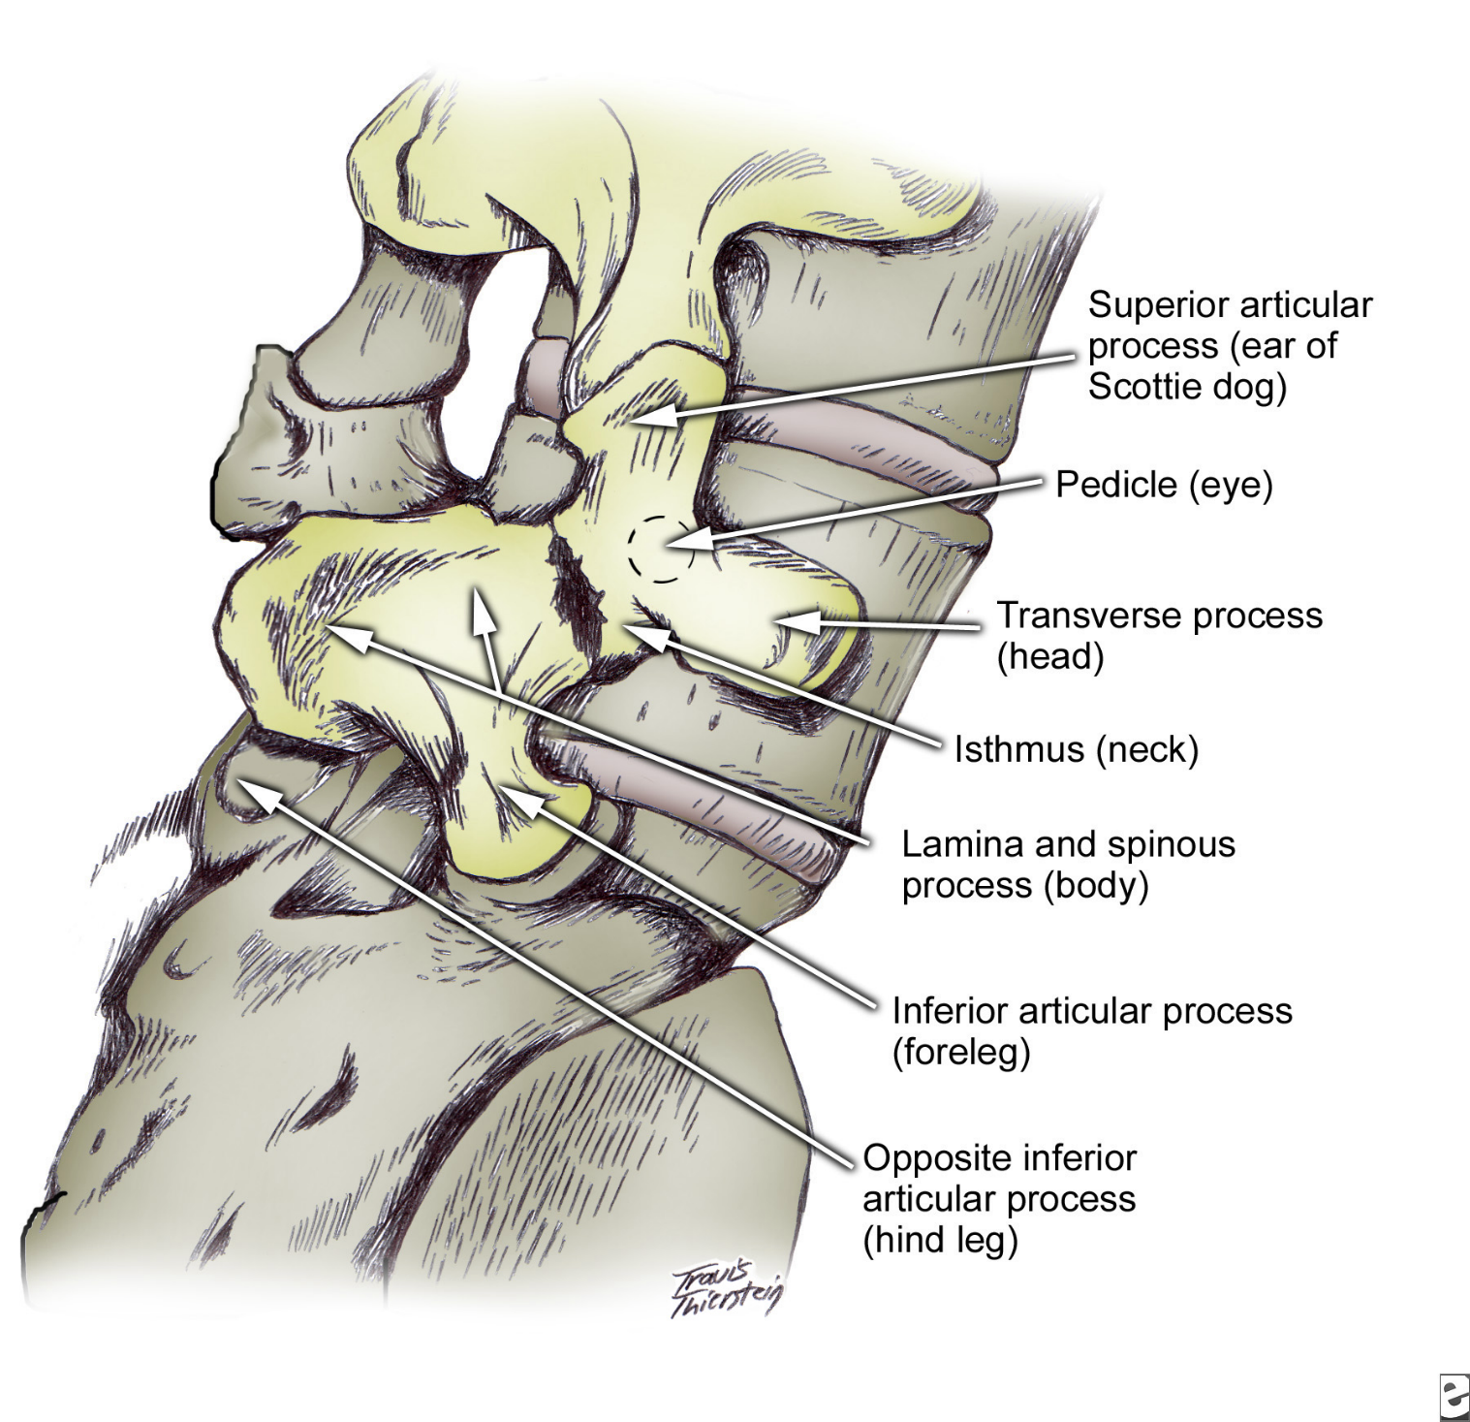

“Scottie dog” with pars interarticularis defect of L5 compared to intact L4 pars interarticularis:

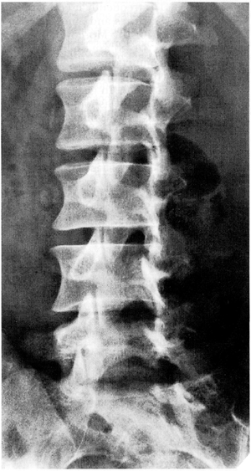

L5 spondylolytic spondylolisthesis:

**A**) gap in bony isthmus (pars interarticularis) between superior and inferior articular processes; grade 2 spondylolisthesis.

**B**) note hypointense borders on both sides of gap in pars interarticularis (*arrows*), indicating chronic spondylolysis; L5-S1 foramen is stenotic.  
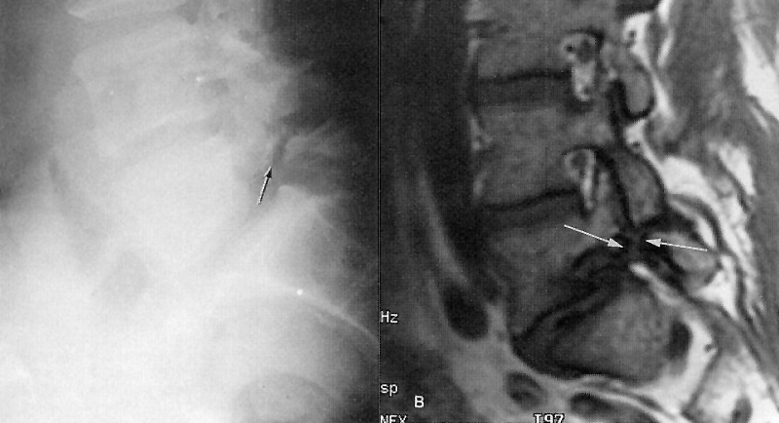

L5 spondylolysis:

**A**) normal L4-5 facet joints.

**B**) slice 8 mm inferior - bulky, irregular, bony mass posterolaterally (mimics degenerated facet joint)

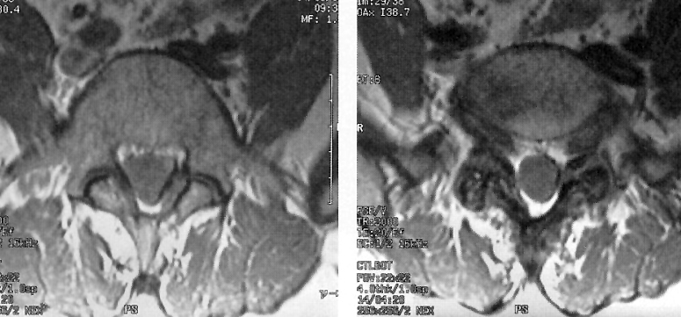

L5 spondylolytic spondylolisthesis (grade 3) and disc degeneration in 18-year-old gymnast (T2-MRI): central canal stenosis at L5-S1 level; compare normally hydrated upper lumbar discs with involved level and with sub-end-plate marrow edema (*arrowheads*):

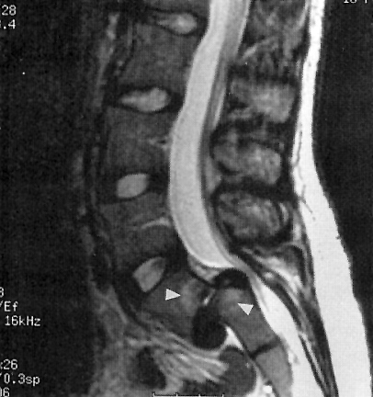

Treatment

Congenital, stress fractures - relative rest from hyperextension, oral pain medications, ± nonrigid brace.

* if spondylolisthesis slips to grades III and IV, pain does not respond to conservative measures, or neurological symptoms appear → fusion surgery.

Traumatic spondylolysis – brace (TLSO often does not work; need SPICA brace).

Spondylolisthesis

**Spondylolisthesis** - displacement (slippage) of vertebra with respect to subjacent vertebra:

1. in anterior direction (**anterolisthesis**) – most commonly!
2. in posterior direction (**retrolisthesis**) – at level above lumbar anterolisthesis.

* most often L5 on S1 (occasionally L4 on L5).
* **Meyerding's classification** - ***degree*** of lumbar spondylolisthesis – in lateral X-ray superior surface of sacrum is divided into four equal parts:  
  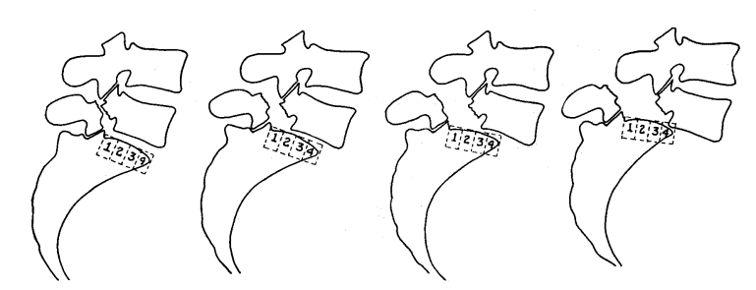

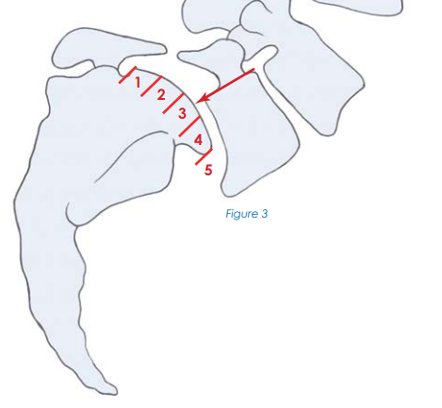

* spondylolisthesis can be **stable (fixed)** or **unstable (dynamic)** – only relevant for surgical indications. [see p. Op220 >>](../Op.%20Operative%20Techniques/200-299.%20Spine/Op220.%20Thoracolumbosacral%20Spine%20Surgery%20(techniques).pdf#Spondy_instability)

Etiology

* 1. **Degenerative** - degenerative changes of facet joints and intervertebral disc.

additional cause in neck – inflammatory softening of transverse ligament of atlas (e.g. RA).

* + - * posterior elements are intact – subluxation degree is low (I or II).
      * prevalence in USA – 11.5%.
      * women : men = 6 : 1.
      * patients > 40 yrs.
  1. **Spondylolytic (s. isthmic)** – spondylolisthesis (most commonly in C6) can be of *high degree*.
     + - patients – young adults.
       - radiographic incidence in general population 3.8-8.0%
       - spondylolisthesis occurs in 40-66% of patients with bilateral spondylolysis; spondylolisthesis is unlikely to occur in patients with unilateral spondylolysis.
  2. **Iatrogenic** (e.g. post-laminectomy if surgeon removed too much of pars or facet*)

*it is safe to remove up to 50% of medial facet

* 1. **Traumatic** – with fractures in structures other than pars interarticularis (e.g. posterior vertebral arch fracture, odontoid fracture); dislocation occurs gradually.
  2. **Congenital (s. dysplastic)** - rare (strong hereditary component) - caused by thin, elongated pars interarticularis.
     + - patients – children.

Clinical Features

May be asymptomatic!

* chronic **pain & tenderness** in low back, with or without positional variance.
* *radiculopathy* may develop (70% sciatica, 30% intermittent neurogenic claudication).
* in *severe degrees* of spondylolisthesis, *cauda equina syndrome* may occur.
* **"step"** on deep palpation of posterior elements.
* in *severe degrees* of spondylolisthesis, trunk may be shortened and abdomen protuberant.

Diagnosis

**Standing lateral X-ray** is the best test to detect spondylolisthesis! – grade often more severe than on MRI

The best test to detect the associated stenosis – **MRI** (second best test – myelography, plain or CT).

* ***facet joint effusion*** > 1.5 mm on supine MRI is suggestive of degenerative lumbar spondylolisthesis.
* insufficient evidence for or against the upright seated MRI (in the diagnosis of degenerative lumbar spondylolisthesis) or axial loaded MRI (to evaluate the dural sac cross sectional area).

Degenerative spondylolisthesis (T1-MRI) - anterior slip of L4 on L5 and degeneration in posterior joints at this level:  
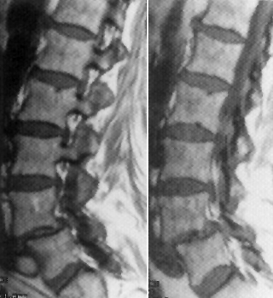

Degenerative spondylolisthesis L4-L5:

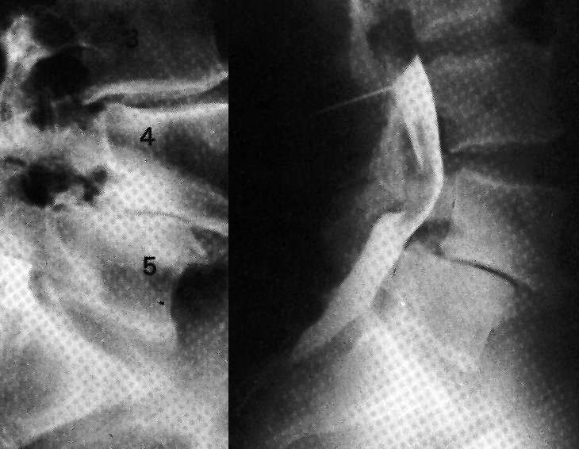

Treatment

Surgery

Indications for therapy: debilitating pain, 3-4 degree, neurologic symptoms.

**Decompression** ± reduction → **fusion** ± PLIF*

see [p. Op220 >>](../Op.%20Operative%20Techniques/200-299.%20Spine/Op220.%20Thoracolumbosacral%20Spine%20Surgery%20(techniques).pdf#Principles_spondylolisthesis_treatment)

*PLIF restores disc height (improved sagittal balance, opens foramina) but prevents reduction of spondylolisthesis

* **decompression without fusion** is a treatment option for ***lumbar stenosis associated with stable low-grade degenerative spondylolisthesis***;
* concern for *destabilizing effect of laminectomy*; minimally invasive unilateral laminotomy for “over the top” decompression might be a less destabilizing alternative to traditional open laminectomy.

K. Schöller et al. Lumbar Spinal Stenosis Associated With Degenerative Lumbar Spondylolisthesis: A Systematic Review and Meta-analysis of Secondary Fusion Rates Following Open vs Minimally Invasive Decompression. Neurosurgery, Volume 80, Issue 3, 1 March 2017, Pages 355–367.

Obesity

A. Chan et al. Obese Patients Benefit, but do not Fare asWell as Nonobese Patients, Following Lumbar Spondylolisthesis Surgery: An Analysis of the Quality Outcomes Database. Obese Patients Benefit, but do not Fare asWell as Nonobese Patients, Following Lumbar Spondylolisthesis Surgery: An Analysis of the Quality Outcomes Database

* obesity (BMI > 30) was associated with inferior perioperative outcomes: higher blood loss, longer operative times, longer hospitalizations, and fewer routine discharges.
* obese patients achieve significant improvements in all PRO metrics at 12 mo.
* obesity is associated with inferior leg pain and quality of life, but similar back pain, disability, and satisfaction —12 mo postoperatively; for *increasing severity of obesity*—via analysis of the continuous variable BMI—outcomes are progressively worse for leg pain and EQ-5D.

Conservative

NASS Clinical Guidelines for Degenerative Lumbar Spondylolisthesis (2nd ed., 2014): *Work Group Consensus Statement*: medical/interventional treatment when the radicular symptoms of stenosis predominate, most logically should be similar to treatment for degenerative lumbar stenosis.

Bibliography for ch. “Spinal Disorders” → follow this [link >>](http://www.neurosurgeryresident.net/Spin.%20Spinal%20Disorders\Spin.%20Bibliography.pdf)

[Viktor’s Notes℠ for the Neurosurgery Resident](http://www.neurosurgeryresident.net/)

[Please visit website at www.NeurosurgeryResident.net](http://www.neurosurgeryresident.net)