Amyotrophic Lateral Sclerosis (ALS)
Synonyms: Charcot's disease (in Europe), Lou Gehrig's disease (in USA)
Last updated: April 22, 2019
Etiopathophysiology, Pathology 1
Genetics 3
Epidemiology 3
Genetics 3
Clinical Features 3
El Escorial World Federation of Neurology criteria 4
Clinical Course & Prognosis 4
Variants 5
Diagnosis 5
Treatment 5
Rehabilitation 6
Lytico-Bodig (Parkinsonism-Dementia-ALS Complex of Guam) → see p. Mov12 >>

ALS - fatal combined degeneration of motoneurons and motor fiber tracts (i.e. combined gray and white matter disease).
Motoneurons of entire neuraxis!
ALS - most devastating neurodegenerative disease of aging CNS that so resembles Alzheimer and Parkinson diseases.

Etiopathophysiology, Pathology
No inflammation!
Neuron degeneration, atrophy, and loss → glial replacement

Degeneration of motoneurons:
- Motor cortex (pyramidal cells in precentral cortex) → loss of large myelinated fibers in anterior & lateral spinal columns (gliotic sclerosis of lateral columns = lateral sclerosis – hardness felt on the spinal cord palpation)
N.B. posterior columns are usually spared in SALS.
- Brain stem - lower nuclei are more often / more extensively involved than upper nuclei (e.g. oculomotor nuclei loss is modest and rarely demonstrable clinically, whereas hypoglossal nuclei are prominently degenerated).
- Spinal anterior horns → loss of myelinated fibers in anterior root → muscle denervation atrophy (amyotrophy); reinnervation is possible (but much less extensive as in poliomyelitis, peripheral neuropathy).

Atrophy of ventral roots:
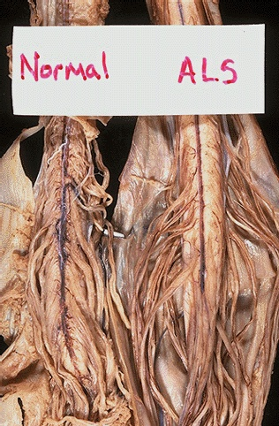
Source of picture: “WebPath - The Internet Pathology Laboratory for Medical Education” (by Edward C. Klatt, MD) >>

Absent anterior horn cells:
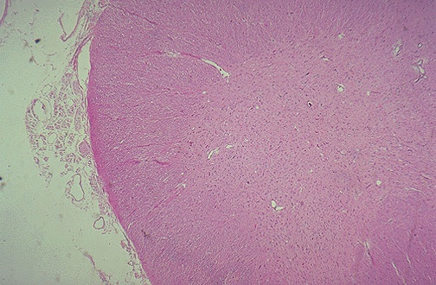
Source of picture: “WebPath - The Internet Pathology Laboratory for Medical Education” (by Edward C. Klatt, MD) >>

Lateral column degeneration with gliosis (Luxol-fast-blue stain):
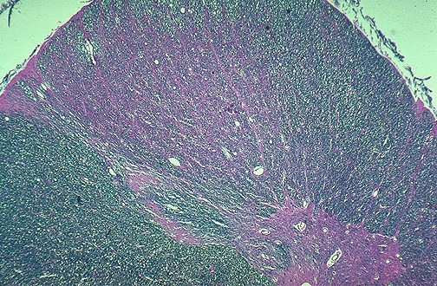
Source of picture: “WebPath - The Internet Pathology Laboratory for Medical Education” (by Edward C. Klatt, MD) >>

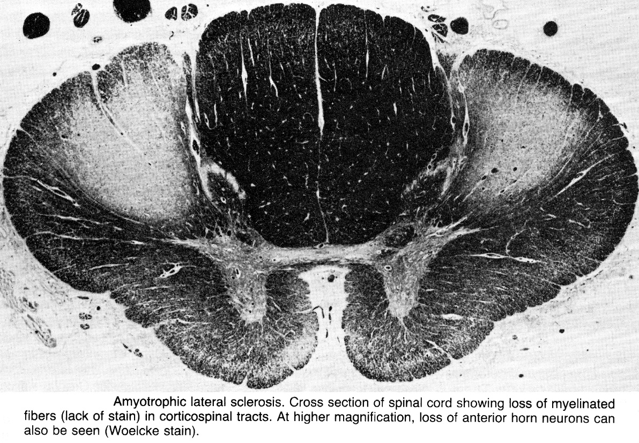

Cytoplasmic ultrastructural abnormalities (cytoskeleton is affected early!):
- in proximal motor axons - strongly argentophilic spheroids (accumulated neurofilament bundles that may contain other cytoplasmic structures, such as mitochondria).
- some patients have mutations in neurofilament heavy chain subunit (22q).
- abnormal neurofilaments interfere with axonal transport, resulting in failure to maintain axonal structure and transport of macromolecules such as neurotrophic factors required for motor neuron survival.
- Bunina bodies - tiny round eosinophilic structures.
- Lewy body-like eosinophilic inclusions (immunoreactive to neurofilaments, ubiquitin*, and gene encoding Cu/Zn superoxide dismutase [SOD1]).
*marker for degeneration
Bunina bodies:
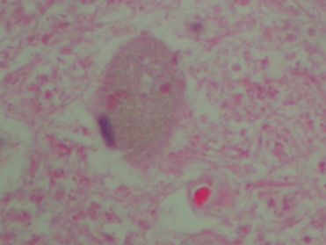
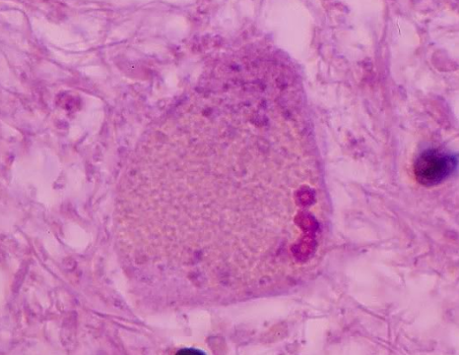
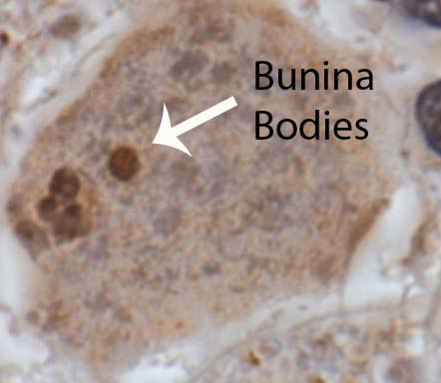

Number of abnormalities in glutamate metabolism have been identified in ALS (incl. alterations in tissue glutamate levels, transporter proteins, postsynaptic receptors) - primary or secondary events?
- 60% patients have large decrease in glutamate transport activity* in motor cortex and spinal cord (but not in other regions of central nervous system) → ↑ extracellular levels of glutamate → excitotoxicity.
*loss of astrocytic glutamate transporter protein EAAT2 (due to defect in mRNA splicing).

Genetics
- Sporadic (SALS) 90-95% - result from genetic predisposition due to multiple small effects (genes for glutamate transporters, calcium homeostasis, apoptosis, or intracellular protein cargo transport are reasonable candidates).
- Familial (FALS) 5-10%; most cases are autosomal dominant.
N.B. both forms are clinically indistinguishable and pathologically very similar!

Repeat expansion of C9ORF72 gene (from normal 3-4 copies to hundreds-thousands in ALS cases) – present in 30% familial and 5% sporadic cases

20% autosomal dominant FALS cases (genetic nomenclature - ALS1) are linked to Cu/Zn superoxide dismutase (SOD1) at 21q22.1 - endogenous free radical scavenger enzyme (superoxide → O₂ + H₂O₂).
  - loss of protective function hypothesis (superoxide free radical↑)
    - in ALS1, there is 35-75% reduction in activity of mutant SOD1 (vs. no reduction in SOD1 activity in non-chromosome 21 FALS).
  - gain of toxic function hypothesis !!! (explains autosomal dominant pattern) - increased peroxidase activity of mutant SOD1.
    - mutant SOD1 has altered substrate specificity - catalyzes reduction of H₂O₂ to yield hydroxyl radicals (directly toxic to cell).
  - metal-mediated cytotoxicity hypothesis - en masse release of zinc from SOD1 aggregates.
    - copper and zinc are potential neurotoxins.
- different SOD1 mutations do not influence age of onset, but do influence progression of disease:
A4V mutation - duration ≈ 1.2 years;
E100G mutation - duration ≈ 4.7 years;
H46R and G37R mutations – duration ≈ 18-20 years.
- < 5% SALS cases show linkage to SOD1 gene.

Variant in the UBQLN4 gene has been associated with ALS.

Recessive ALS (RFALS) – rare, identified in highly consanguineous families; three different phenotypes:
RFALS type 3 (genetic nomenclature - ALS2) - linked to 2q33; begins in childhood, prolonged survival.
RFALS type 1 (genetic nomenclature - ALS4) - linked to another site.

Epidemiology
Risk factors:
- age
- genetic susceptibility
- male gender
- long-term exposure to heavy metals (esp. lead, mercury)
- family history of parkinsonism and dementia

Worldwide incidence 1-2 in 100,000 persons;
Worldwide prevalence 4-6 in 100,000 persons.
- fairly uniform distribution worldwide and equal representation among racial groups.
- greatest incidence - age 40-70 years (10% cases begin before age 40; 5% begin before age 30).
- mean age of onset: SALS - 56 years; FALS - 46 years.
- male : female = 1-2 : 1.

Genetics
- approximately 10% of cases are inherited as dominant traits - of these, approximately 25% arise from mutations in the gene encoding the protein copper/ zinc cytosolic superoxide dismutase (SOD1).
- the fact that this form is dominantly inherited suggests that the disorder arises from some acquired toxic property of the mutant SOD1 protein (exact neurotoxic property of the mutant enzyme remains unclear).

Clinical Features
- UMN & LMN dysfunction at several levels of neuraxis with no involvement of other neurological systems.
- distribution is bilateral, but initially frequently asymmetrical or focal.
upper limbs* > lower limbs > bulbar
*onset - asymmetric weakness of hands
  - this pattern is reversed in FALS.
  - virtually, any muscle group may be first to show signs of disease.
  - eventually, all motoneurons are involved → tracheostomized locked-in state.
- symptomatic painless weakness – general symptom!
  - limb weakness is predominantly distal (prominent weakness of intrinsic hand muscles and footdrop and characteristic), but sometimes proximal muscles are affected first.
  - focal in onset, weakness then spreads to contiguous muscle groups.
- LMN signs: muscle cramping (!), fasciculations (e.g. in tongue!), atrophy – all these may develop before weakness is apparent.
N.B. if there is weakness and wasting of limb muscle, fasciculation is almost always seen!
N.B. motoneuron disease never starts with fasciculations alone!
- UMN signs: clumsiness and stiffness / spasticity, hyperreflexia, Babinski's signs* (may not be present early in disease), clonus*.
Overactive tendon reflexes in weak, wasted, fasciculating limb
*unequivocal UMN signs
- bulbar palsy (dysarthria, hoarseness, speech slurring, choking on liquids, difficulty initiating swallowing → drooling).
Most common bulbar symptoms in ALS: dysarthria (93%), dysphagia (86%), tongue fasciculations (64%).
  - no weakness of eyelids or ocular muscles!
  - facial weakness & wasting can be discerned (esp. in mentalis muscle), but usually is not prominent.
- pseudobulbar palsy see p. Mov3 >>
- no sensory symptoms (pain and paresthesias are impermissible with ALS diagnosis!).
- bowel, bladder, sexual functioning (parasympathetic sacral nuclei) are spared (4% patients experience loss of sphincter control).
- mentation is intact.
- weight loss (combination of muscle wasting and dysphagia).
- diminished skin elasticity (rarely develop bedsores).

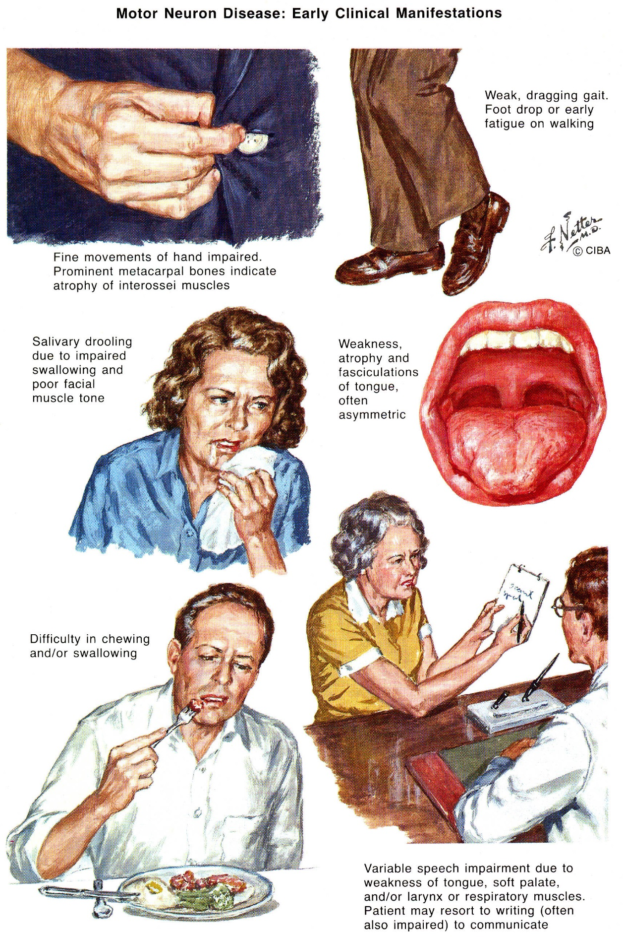

El Escorial World Federation of Neurology criteria
- standardize clinical ALS diagnosis:
- Signs of LMN degeneration (clinical / electrophysiological / neuropathological).
- Signs of UMN degeneration (clinical).
- Progressive spread of these signs within region or to other regions.
- Absence of electrophysiological / neuroimaging evidence of other disease processes that might explain these signs.

Body is divided into four regions:
    - bulbar (jaw, face, palate, larynx, tongue)
    - cervical (neck, arm, hand, diaphragm)
    - thoracic (back & abdomen)
    - lumbosacral (back, abdomen, leg, foot).

Suspected ALS - LMN signs only in at least 2 regions.
Possible ALS:
- UMN & LMN signs in only 1 region.
- UMN signs only in at least 2 regions.
- LMN signs rostral to UMN signs (rule out cervical spondylosis - has sensory signs!)
- Special cases:
  - monomelic ALS
  - progressive bulbar palsy without spinal UMN / LMN signs
  - primary lateral sclerosis without spinal LMN signs.
Probable ALS - UMN signs in at least 2 regions, with some UMN signs above LMN signs.
Definite ALS - UMN & LMN signs in:
- bulbar region and at least 2 spinal regions.
- 3 spinal regions.

Clinical Course & Prognosis
- wide variation in disease progression and duration (neither can be predicted from age or site of onset).
- course is progressive without remissions, relapses, or even stable plateaus →→→ locked-in state.
- mean survival ≈ 3-5 years after onset of symptoms:
50% die within 3 yrs of onset;
20-25% live 5 yrs;
10% live 10 yrs;
exceptional patients die in first year or live longer than 25 years.
  - predominantly bulbar form usually leads to more rapid deterioration and death.
- death cause - aspiration pneumonitis, pulmonary embolism, respiratory failure.

Variants
Syndromes confined to only one type of motor neuron:
N.B. all of these are sometimes produced by same mutation in SOD1 gene!
a) UMN syndromes: primary lateral sclerosis, progressive pseudobulbar palsy.
b) LMN syndromes: progressive spinal muscular atrophy*, progressive bulbar palsy**.
*pure SMA (LMN signs alone) is uncommon - accounts for < 5% cases at autopsy; some authorities doubt that autopsy-proven SMA is also form of ALS.
**term is falling into disfavor - almost all patients with bulbar symptoms already have fasciculations in arms and legs or display upper motor neuron signs (i.e. signs are not restricted to cranial nerves and syndrome is clearly ALS).

Lytico-Bodig (Parkinsonism-Dementia-ALS Complex of Guam) see p. Mov12 >>

FALS with dementia = frontal lobe dementia + parkinsonism + amyotrophy.
- striking variability of clinical symptoms among patients.

Diagnosis
No definitive test that can diagnose ALS! Diagnosis primarily clinical!
Tests necessary to confirm clinical ALS diagnosis:
- EMG – denervation; reinnervation signs are possible.
N.B. electrophysiologic El Escorial criteria are developed!
- nerve conduction velocities – normal.

- CK-MM moderate increase.
- CSF - normal (or mildly elevated protein < 200 mg/dl).
- muscle biopsy - small angulated fibers, small groups of atrophic fibers, type grouping (reinnervation).
- T2-MRI - symmetric abnormal high signal within corticospinal tracts (↑water content in myelin tracts undergoing Wallerian degeneration).

A. T2-MRI through lateral ventricles - abnormal high signal within corticospinal tracts (arrows).
B. T2-MRI through internal capsules - abnormal high signal in posterior limbs of internal capsule (arrows):
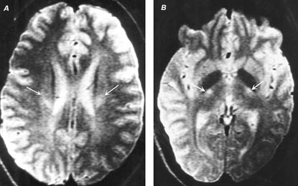

Typical "grouped atrophy" of denervated muscle fibers (trichrome stain):
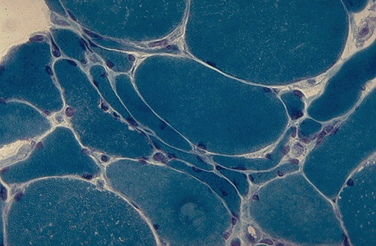
Source of picture: “WebPath - The Internet Pathology Laboratory for Medical Education” (by Edward C. Klatt, MD) >>

Differential tests for all patients:
- serum immunofixation electrophoresis – for monoclonal gammopathy (found in 10% patients).
- tests for lymphoproliferative disease – for asymptomatic bone marrow lymphoma (found in 3% patients).
- anti-GM1 antibodies - for multifocal motor neuropathy with conduction block.

Treatment
Riluzole (Rilutek®) – the only drug shown to extend lifespan (although only 3 months; mortality rates are unaffected).
- mode of action unknown (protects against glutamate toxicity):
  - blocks glutamic acid release
  - voltage-activated Na⁺ channels.
- administered 50 mg × 2/d.
- T_{1/2} = 12 hrs.

Supportive multidisciplinary team (most efficiently in ALS center) significantly improves patient's quality of life
- difference of opinions about exercising weak muscles.
- early in course, patients should try to continue to perform routine activities as long as they can.
- symptomatic drugs:
  - baclofen, tizanidine, quinine, phenytoin - to reduce cramping.
  - amitriptyline - to control pseudobulbar symptoms.
- splints and aids - to extend patient's ability to function independently.
- to stop drooling:
    - anticholinergic agents (not very effective) - transdermal scopolamine patches.
    - botulinum injection into parotid glands.
    - radiation of salivary glands - experimental therapy.
- speech therapist - to prolong patient's ability to communicate and swallow, procuring needed communication tools.
- open, sympathetic discussion of feeding and ventilatory support options is required with patient and family.
inform fully about long-term consequences of life without movement; patients must decide - be kept alive or made as comfortable as possible - two choices that are not identical.
- percutaneous gastrostomy - for nutrition and protection against aspiration.
- bilevel positive airway pressure - at least short-term symptomatic relief of respiratory fatigue and sleep apnea.

Rehabilitation
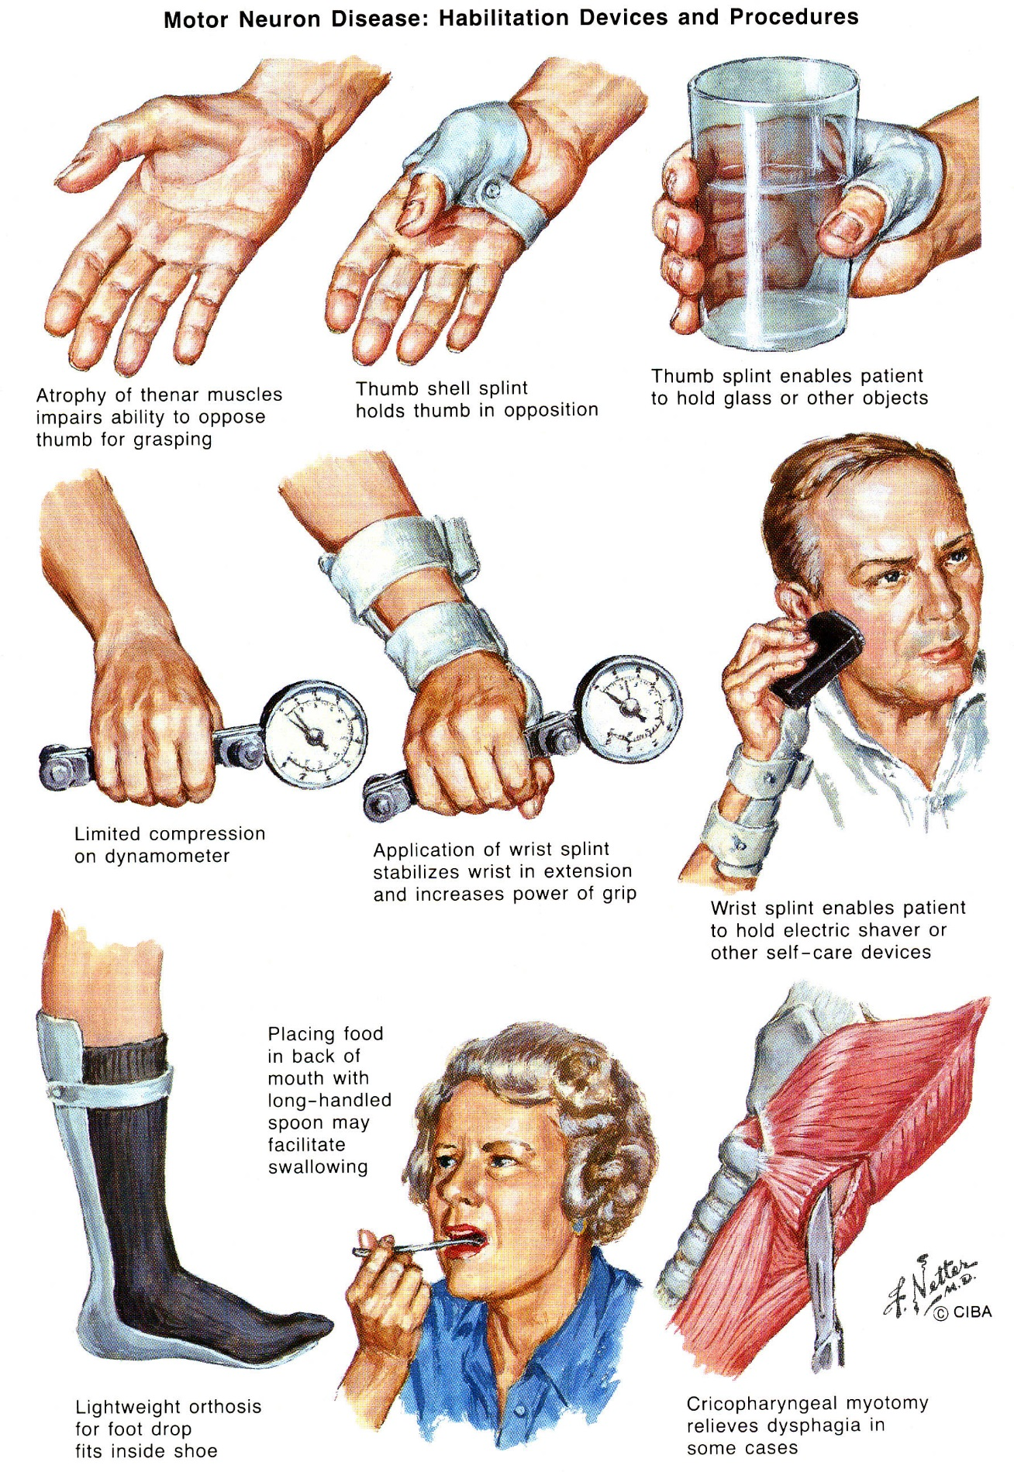

Bibliography for ch. “Spinal Disorders” → follow this link >>

Viktor’s Notes℠ for the Neurosurgery Resident
Please visit website at www.NeurosurgeryResident.net

