Spinal Muscular Atrophies (SMA)
Synonyms: Progressive Spinal Muscular Atrophy, Progressive Spinal Atrophy
Last updated: April 22, 2019
Etiopathophysiology 1
Epidemiology 1
Clinical Features 1
Diagnosis 2
Treatment 3
Prognosis 3
Other Forms of LMN degeneration 3

SMA - progressive degeneration and loss of LMN (midbrain ÷ spinal cord).
- replacement of lost cells by gliosis (e.g. atrophic spinal cord at autopsy).
- UMN is not affected! (vs. in ALS)

Type | Inheritance | Age of Onset | Presenting Symptoms | Prognosis
SMA type I (infantile / acute / fatal SMA, Werdnig-Hoffman disease) | AR | In utero ÷ 6 months | Hypotonia and generalized weakness, problems with sucking, swallowing, and breathing; never able to sit | Average life expectancy - 8 months;  95% dead before age of 18 months
SMA type II (intermediate between type I and type III) | AR | 6 ÷ 15 months | < 25% learn to sit; never able to stand, facial muscles spared | Depends on respiratory complications
SMA type III (chronic SMA, Kugelberg-Welander disease) | AR, AD | 15 months ÷ teen years | Proximal leg weakness, delayed motor milestones
Kennedy's disease (bulbospinal muscular atrophy) | X-linked recessive | After age 40 yrs | Bulbar → distal limb weakness; endocrine dysfunction | Normal lifespan
Fazio-Londe disease (progressive bulbar palsy of childhood) |  | Late childhood ÷ adolescence | Bulbar weakness
SMA type IV (adult-onset SMA) | AD, AR, X- recessive (very rare) | median ≈ 37 years | Proximal weakness, variable within families, more severe in AD | Life expectancy not markedly reduced
Distal SMA (Charcot-Marie-Tooth type-SMA) | AR, AD | AR: birth ÷ infancy;  AD: adulthood | Distal weakness | Very slow clinical progression; does not alter lifespan

Etiopathophysiology
Autosomal recessive SMA types I, II, III (allelic heterogeneity) have been linked to 5q11.3-13.1 - gene for survival of motor neurons (SMN):
Defect in neuronal apoptosis!
  - contains multiple copies of genes and pseudogenes;
  - characterized by instability: deletions (98%), truncations, point mutations.
  - protein product has no known homolog, and its function is not yet known.
  - no correlation between genotype and phenotype! - but most affected siblings exhibit same phenotype - may be additional modifying factors, e.g. another gene tightly linked to pathogenic gene:
    - contiguous deletion of nearby neuronal apoptosis inhibitory protein gene (NAIP) is associated with most severe phenotype (occurs in 45-65% SMA type I and in 20-40% SMA type II and III cases).
    - homozygous deletions in exons 7 and 8 in SMNt (telomeric copy of SMN) → SMA type I; mutations that convert SMNt to centromeric copy (SMNc) → SMA type II and III.

- SMN protein is implicated in the trafficking of RNA in and out of the nucleus and in the formation of complexes that are important in RNA splicing.
- SMN locus on chromosome 5 has two almost identical copies of the SMN gene - one produces a full length SMN protein, whereas the second expresses a small amount of full-length SMN and a shortened SMN; loss of full-length SMN from mutations at the main locus can be mitigated to some degree by the shortened SMN protein expressed at the second locus.

Epidemiology
SMA type I (most common SMA) incidence ≈ 4-10 in 100,000 (2nd most common neuromuscular disease, following Duchenne muscular dystrophy).
- similar numbers are affected with milder forms and forms with later onset.
- carrier frequency of SMNt mutation - 1 in 50.

Clinical Features
Clinical hallmarks:
- Insidious onset of symmetrical weakness.
  - proximal muscles > distal muscles.
  - legs > arms.
  - greatest decline in muscular power occurs at onset* and then slows (i.e. great loss of motoneurons initially, followed by stabilization in any remaining neurons) - difference between SMAs and other neurodegenerative disorders.
*results in large number of complications: scoliosis, contractures (e.g. arthrogryposis multiplex congenita), disuse atrophy, respiratory / nutritional / sleep problems.
- Hypotonia, atrophy, loss of tendon reflexes
After immediate neonatal period, spinal muscular atrophy is most common cause of infantile hypotonia (“floppy infant”)!
- Cranial nerve palsies (CN3, 4, 6 are typically spared!).

No sensory symptoms or loss, no myalgias!
No heart involvement!
Intelligence normal! (children often appear brighter than their normal peers!)

SMA type 1 (Werdnig-Hoffmann) - evident at birth or soon thereafter, always before age 6 months.
- mothers notice decreased intrauterine movements.
- one of most common forms of floppy infant syndrome (infants lie flaccid with little movement, unable to overcome gravity).
- tongue is often seen to fasciculate (rarely in limb muscles - because of ample subcutaneous fat).
- ultimately, complete flaccid quadriplegia results with compromised respiration.
- all dead by age 4 yrs.

SMA type 3 (Kugelberg-Welander) – slowly progressive gait disorder in late childhood or adolescence.
- proximal limb muscle weakness and wasting (simulates muscular dystrophy!); tendon reflexes are lost.
- relative sparing of bulbar muscles.
- course relatively benign - many continue to function socially with normal life span (others may be handicapped); many children are highly intelligent.

Diagnosis
    - genetic test – homozygous SMN deletion (sensitive test in 95% cases!).
      - prenatal testing is available only on research basis.
    - serum CK can be elevated (correlates with illness duration);
      - in SMA 3, may be 20 times normal (in range of many myopathies!).
    - ECG – normal.
    - without DNA diagnosis, it is essential to verify neurogenic process via:
- EMG – denervation.
- nerve conduction studies – normal.
- muscle biopsy (with histochemistry) – denervation & reinnervation: large numbers of atrophic fibers, often only few micrometers in diameter; atrophic fibers often involve entire fascicle (panfascicular atrophy!!!); scattered groups of large fibers that are 2-4 times normal size. also see p. D30 >>

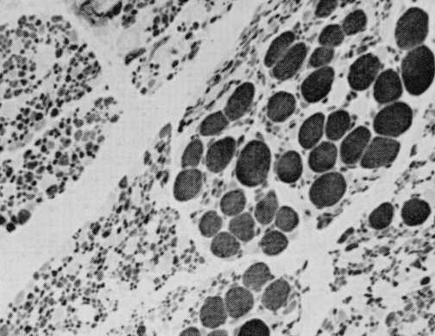

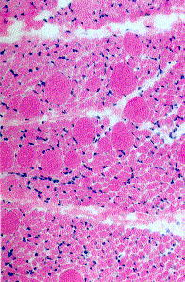
Source of picture: Ramzi S. Cotran “Robbins Pathologic Basis of Disease”, 6th ed. (1999); W. B. Saunders Company; ISBN-13: 978-0721673356 >>

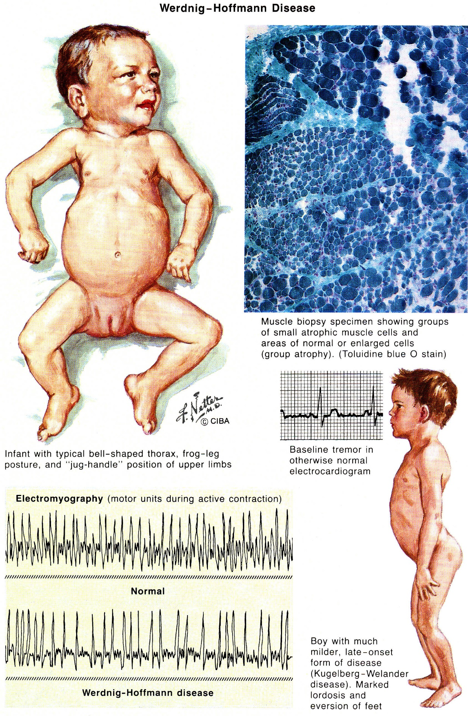

Treatment
- multidisciplinary approach aimed at preventing contractures, skeletal deformities, respiratory complications, and social isolation.

nusinersen (Spinraza®) intrathecal injection - antisense therapy - the first FDA approved drug to treat children and adults with spinal muscular atrophy.
- sham-controlled study in 78 children with infantile SMA showed that treatment with nusinersin leads to a 50% reduction in deaths or early ventilation.
Finkel RS, Mercuri E, Darras BT, et al; ENDEAR Study Group. Nusinersen versus sham control in infantile-onset spinal muscular atrophy. N Engl J Med. 2017;377:1723-1732.

Prognosis
Earlier onset – more rapid decline.

Other Forms of LMN degeneration
Poliomyelitis – viral disease of LMN – see p. 259 (1) >>

- do not map to 5q11.
- most are autosomal recessive.

Fazio-Londe disease (progressive bulbar palsy of childhood) - brainstem LMN degeneration of all brainstem nuclei (vs. most juvenile SMAs).
- presents in late childhood or adolescence with stridor → ptosis, dysarthria, facial palsy, dysphagia.
- weakness of arms & legs may occur later, and respiration may be affected.
- death in early childhood?

Scapuloperoneal and facioscapulohumeral SMA forms
- distinction from muscular dystrophy depends on DNA analysis.

Kennedy's disease - X-linked recessive disorder (expansion of CAG trinucleotide repeats in first exon of androgen receptor gene Xq11-12) - affects males:
  - progressive bulbospinal muscular atrophy (preferentially bulbar* → distal limb muscles) *incl. ocular!
  - endocrine dysfunction – androgen insensitivity (testicular atrophy, gynecomastia, oligospermia), diabetes mellitus.
  - subtle sensory sign in some patients. (e.g. abnormal sensory-evoked potentials, affected spinal sensory tracts, distal degeneration of sensory axons).
- midlife onset, after age 40 yrs. (direct correlation between number of -CAG- repeats and disease severity).
- most common form of adult-onset SMA!
- may be readily screened from blood DNA analysis.
- slowly progressive, normal lifespan.

Adult Tay-Sachs disease (hexosaminidase A deficiency)
- primarily in Ashkenazi Jewish families.
- adult-onset (vs. classical Tay-Sachs disease), very slowly progressive.
- dysarthria and cerebellar atrophy.

Baby with Tay-Sachs disease - enlarged, pale neurons:
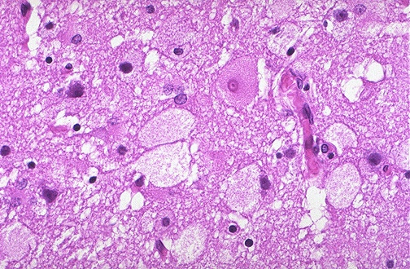
Source of picture: “WebPath - The Internet Pathology Laboratory for Medical Education” (by Edward C. Klatt, MD) >>

Bibliography for ch. “Spinal Disorders” → follow this link >>

Viktor’s Notes℠ for the Neurosurgery Resident
Please visit website at www.NeurosurgeryResident.net

