Epidural Hematoma
Last updated: January 7, 2022
Epidemiology 1
Etiopathophysiology 1
Locations 1
Clinical Features 2
Diagnosis 2
Treatment 4
Surgical treatment 4
Conservative treatment 4
Embolization 4
Prognosis 5

EDH - blood accumulation in space between inner table of skull and stripped-off dural membrane:
acute (58%)
subacute (31%)
chronic (11%)

N.B. outer dural layer serves as inner skull periosteum! (epidural space is the potential space)

Epidemiology
- 1-2% of all patients with head injuries (≈ 10% of patients who present with traumatic coma; ≈ 0.5% of patients with GCS 13-15).
- male-to-female ratio = 4:1.

Risk factors:
- Younger age
  - 60% patients are < 20 yrs (but rare in children < 2 yrs*).
  - only < 10% patients are > 50 yrs; rare at age > 60 yrs** (vs. SDH!)
*very elastic immature skull rarely fractures
**as person ages, dura becomes more adherent to skull
- Alcohol and other forms of intoxication.

Etiopathophysiology
    - Focused blunt blow to head (85-95% results in overlying skull fracture crossing vascular groove*) → bleeding from dural vessel:
- 36-85% cases - high-pressure arterial bleeding from lacerated meningeal artery (most commonly middle meningeal artery**) dissects dura away from skull.
- 15-32% cases - bleeding is venous (torn dural sinuses, diploic veins, meningeal veins) - more benign slower course; usually, venous EDHs form only with depressed fractures (strip dura from bone - create space for blood to accumulate); infant skull is very vascular – any skull fracture may cause venous EDH.
*skull fractures are less common (only ≈ 50%) in children - because of calvarial plasticity (skull bends → damages vessel → springs back).
**lies in outer layer of dura, partially embedded in grove in inner table.
EDH is not generated secondary to head motion or acceleration-deceleration (vs. subdural hematoma); i.e. EDH needs direct blow to the head!

    - Spontaneous (very rare): infectious diseases of skull (mastoiditis, sinusitis), vascular malformations of dura mater, metastasis to skull, skull bone infarctions, coagulopathies.

Delayed (subacute, chronic) EDH may develop as result of temporary intracranial hypotension (but, more commonly, SDH)

Bleeding causes dura separation and progressive brain compression → brain herniation.
      - most EDHs attain maximum size within minutes ÷ few hours of injury (9% demonstrate progression over first 24 hours - rebleeding or continuous oozing, esp. from venous sources).
      - bleeding continues until tamponade by surrounding pressure and ruptured vessel occlusion by clot.
      - hematoma extension is limited by periosteal dural insertions at major sutures (tight attachment of dura at these locations).
- epidural hematoma can extend across midline in frontal region anterior to coronal suture because it is not limited by dural reflections within anterior interhemispheric fissure
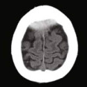
      - body has no mechanism for absorption of extradural hemorrhage - clotted blood remains in epidural space as tumor (until it is removed); if hematoma is chronic, collection may liquefy, but this is rare.

Underlying brain usually is minimally injured (vs. subdural hematomas) → excellent prognosis if treated aggressively!

Locations
- any location:
- 66-80% temporoparietal – low over convexity of hemisphere in middle fossa (source - middle meningeal artery), rare parasagittally (source - superior sagittal sinus).
- 10% frontal - in anterior fossa (source - anterior meningeal artery, anterior ethmoidal artery).
- 5% occipital
- 5% posterior fossa (source - torcular Herophili, transverse or sigmoid sinus); in 80% cases supratentorial hematoma (EDH, SDH, or ICH) is also found.
N.B. posterior fossa EDH may compress venous sinuses and imitate venous sinus thrombosis on imaging – erroneous heparin administration may cause more harm (e.g. EDH expansion).
- vast majority - on side of head injury.
- bilateral – 2-10% (extremely rare in children).

Percentage distribution of site of epidural hematoma:
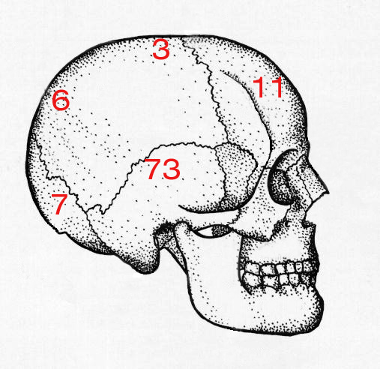

Top of skull is removed to reveal middle meningeal artery which has emerged from foramen spinosum to branch over surface of dura:
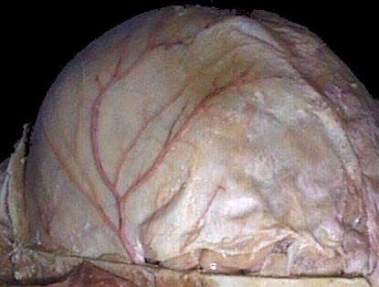
Source of picture: “WebPath - The Internet Pathology Laboratory for Medical Education” (by Edward C. Klatt, MD) >>

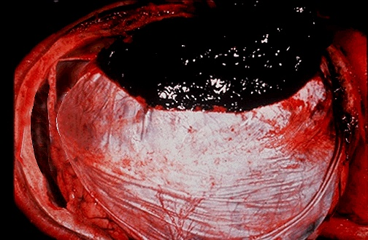
Source of picture: “WebPath - The Internet Pathology Laboratory for Medical Education” (by Edward C. Klatt, MD) >>

Clinical Features
- Following injury, patient may or may not lose consciousness.
  - external evidence of head injury is present.
- ≈ 47% (10-50%) demonstrate classic lucid interval (for several hours); but often no return to completely normal mental status occurs.
  - other patients:
    - ≈ 33% - initial concussion is insufficient to cause any loss of consciousness.
    - ≈ 33% - brain damage at time of injury is so severe that immediate coma lasts long enough to merge with that resulting from brain compression.
- Rapid* development of brain compression:
- increasing ICP (severe headache, vomiting, deterioration in consciousness**) → Cushing response, brain herniation.
- focal neurological signs, seizure (rare).
*course is protracted if bleeding source is venous
**75 ml is critical EDH volume – any volume above → loss of consciousness
  - small EDH may remain asymptomatic.

N.B. posterior fossa EDH may have dramatic rapid delayed deterioration - patient can be conscious and talking and minute later apneic, comatose, and minutes from death.

Diagnosis
For other diagnostic evaluation → see p. TrH1 >>
LP is absolutely contraindicated!!!
CSF pressure > 200 mmH₂O, CSF clear (bloody if there was contusion or laceration of brain)

Skull X-ray may show associated skull fracture (e.g. crossing shadow of middle meningeal artery branches).

Unenhanced CT - classic lens-shaped (biconvex) density:
      - homogenous;
- unclotted blood (active bleeding or coagulopathy) may give focal isodense / hypodense zones within EDH.
- chronic EDH may be heterogeneous (neovascularization and granulation - peripheral contrast enhancement).
      - situated between brain and skull
      - smoothly marginated
      - does not follow sulcal margins
      - may cross midline (external to falx).
      - mass effect (underlying brain is displaced, but often appears intrinsically normal).
        - causes of hematoma density↓: severe anemia, hyperacute hematoma (no clots at all).
        - air in acute EDH suggests fracture of sinuses or mastoid air cells.
        - coronal CT may be required to correctly evaluate vertex EDH.
        - EDHs in posterior fossa may cross midline and extend above tentorium.
        - if patient's condition is rapidly deteriorating → take patient directly to operating room for diagnostic and therapeutic burr holes (practically, with modern rapid availability of CT, such scenario is unlikely).
        - if EDH becomes chronic – all features remain, but attenuation values are reduced and margin shows marked enhancement.

Plain head CT - acute EDH. Postoperative CT shows multiple infarctions, including large left PCA distribution infarction (arrows) from compression of left PCA by epidural hematoma:
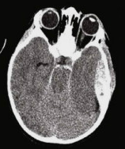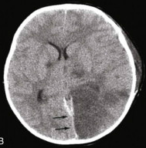
Source of picture: H. Richard Winn “Youmans Neurological Surgery”, 6th ed. (2011); Saunders; ISBN-13: 978-1416053163 >>

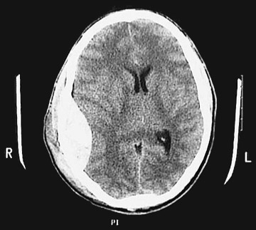
Source of picture: “WebPath - The Internet Pathology Laboratory for Medical Education” (by Edward C. Klatt, MD) >>

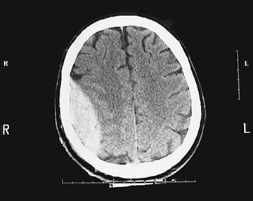
Source of picture: “WebPath - The Internet Pathology Laboratory for Medical Education” (by Edward C. Klatt, MD) >>

Bilateral acute EDHs; extracranial soft tissue swelling on left:  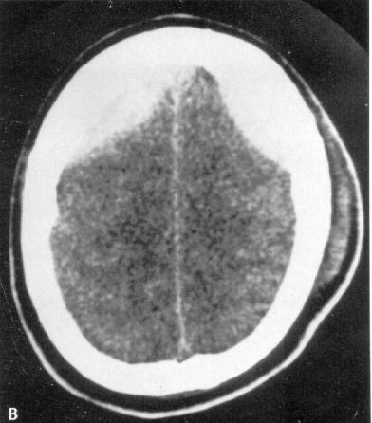 | CT bone window - two adjacent fractures (arrows); anterior fracture is at site of groove for middle meningeal artery:  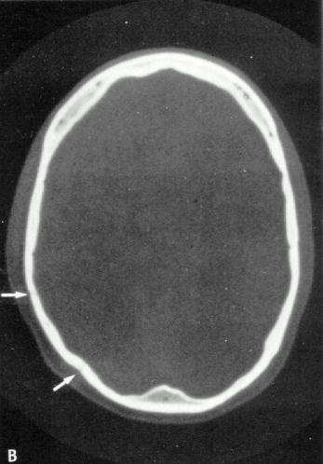
Midline shift is apparent; ill-defined area of blood density in right occipital region - small contusion; increased density in left temporal region - contrecoup contusion; small round density deep within right frontal cortex - shear injury:  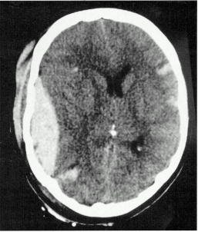 | Large posterior fossa EDH; size of lesion at this high level suggests that it probably crosses into supratentorial compartment:  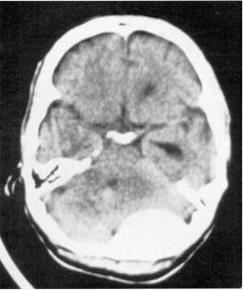
Partially unclotted EDH:  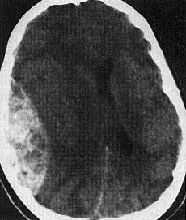 | Right frontal EDH - deep aspect of hematoma is homogeneous, whereas peripheral (outer part) is more isoattenuating relative to brain – due to presence of unclotted blood (dark) within hematoma:  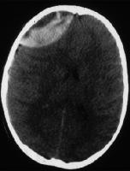
EDH in posterior fossa (thick arrow); crescent of fresh subdural blood spreads over left temporal lobe and tracks along tentorium (arrowhead) - this feature differentiates it from extradural; typical sites of contusions - gyrus recti and temporal lobe:  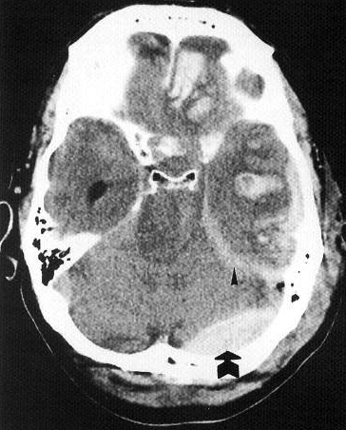 | MRI in neonate with acute EDH:  A) T1- slightly hyperintense epidural collection (arrow).  B) T2 - epidural collection is hypointense and is invisible except for deformation of underlying cortex.  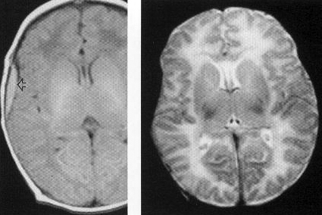

Treatment
EDH is neurosurgical emergency!

Surgical treatment
see also p. TrH1 >>
Guidelines “Surgical management of acute epidural hematomas” in Neurosurgery. 2006 Mar;58(3 Suppl):S7-15
- EDH > 30 mL should be surgically evacuated regardless of the patient's GCS score.
EDH + coma (GCS score < 9) + anisocoria → surgical evacuation ASAP*
*delays of more than 2 h (between clinical deterioration and evacuation) are unacceptable (Mendelow et al. 1979)
- EDH < 30 mL and < 15 mm thickness and < 5-mm midline shift and GCS score > 8 and no focal deficit - can be managed nonoperatively with serial CT* and close neurological observation in a neurosurgical ICU. *first routine repeat CT within 6 hrs after TBI
- craniotomy provides a more complete evacuation of the hematoma than other surgical approaches. see p. Op320 >>

Conservative treatment
- very close serial neurologic examinations (clinical deterioration → repeat CT).
N.B. EDHs tend to expand more rapidly than subdural hematomas!
- general management of head injury (incl. ICP treatment, seizure prophylaxis) → see p. TrH1 >>
- bedrest during initial phase → progressive increase in activity (avoid strenuous activity).

Most dangerous EDH (likely will need surgery):
- location – middle fossa (temporal location), posterior fossa
- volume > 20 cm³
- hyperacute (on CT)
- associated fracture

Embolization
- middle meningeal artery embolization has been described (in early stages of EDH - to arrest further expansion); indication - contrast dye extravasation seen on CT.

Prognosis
EDH with GCS 3-5 → mortality 36% (GCS 6-8 – mortality 9%)

Mortality: 5-50%; risk factors for increased mortality:
- lower GCS score prior surgery (mortality is 0% for awake patients, 9-10% for obtunded patients, 20% for comatose patients).
- age < 5 yrs or > 55 yrs.
- bilateral EDH (mortality 15-20%)
- posterior fossa EDH (mortality 26%)
- temporal location
- intradural lesions
- hematoma volume↑, ICP↑
- rapid clinical progression
- pupillary abnormalities

EDH is least common, but most fatal traumatic hemorrhage!

Bibliography for ch. “Head Trauma” → follow this link >>

Viktor’s Notes℠ for the Neurosurgery Resident
Please visit website at www.NeurosurgeryResident.net

