Subdural Hygroma (s. Subdural Effusion)
Last updated: January 7, 2022
Etiology, Pathophysiology 1
Further course 1
Clinical Features 1
Complications 1
Diagnosis 1
Treatment 3

Subdural Hygroma - excessive CSF collection in subdural space. [Greek hygros – wet]

Etiology, Pathophysiology
- Most common cause - cranial trauma with arachnoid tearing and arachnoid-dura separation (→ CSF escape into subdural space) - traumatic subdural hygroma.
- develops in ≈ 10% severe head injuries.
- skull fractures are found in 39% cases.
- predisposing factors: cerebral atrophy (present in 19% hygromas), vigorous therapeutic dehydration (iatrogenic brain collapse), intracranial hypotension (e.g. in prolonged lumbar drainage), pulmonary hypertension (e.g. in chest trauma, pneumonia).
- CSF is usually xanthochromic.
- may accumulate immediately after trauma or in delayed fashion.
- most likely locations of arachnoid tears: sylvian fissure, chiasmatic cistern.
- "complex hygroma" - associated with other intracranial lesions (subdural hematoma, epidural hematoma, intracerebral hemorrhage, etc).
- Infection of meninges or skull (most commonly – influenzal meningitis or mastoiditis).
- Rupture of arachnoid at basal cistern in communicating hydrocephalus.
- Complication of ventricular shunting; in patients with shunts (esp. if overdrainage occurs), disruption* of arachnoid can lead to hygroma.
*spontaneous or elicited by minor head trauma or previous arachnoid injury (e.g. ventricular tap, intracranial pressure sensor).
- best prevention is use of shunt alternative (third ventriculostomy) or overdrainage-limiting device.
- increasing valve opening pressure or using flow-rate-limiting system can be successful treatment.
- Complication of arachnoid cyst marsupialization or resection.
- Rare complication of spinal anesthesia causing CSF leak.

Further course
A. Spontaneous resolution of subdural collection along with cerebral expansion.

B. Hygroma progression: transudation / further CSF accumulation (flap-valve mechanism) → increasing brain dislocation → rupture of bridging veins* → bleeding into newly formed subdural space (well documented transformation to subdural hematoma) → neomembrane (capsule) formation (chronic subdural hematoma).
*stretch of draining veins by hygroma can cause multiple venous infarcts

Clinical Features
- Asymptomatic
- May increase in size (due to flap-valve mechanism, bleeding) → mass effect with significant morbidity similar (in character and evolution) to subdural hematoma:
- ICP↑ (headaches, nausea, decreased level of consciousness)
- Focal signs

Complications
- Brain herniation
- Transformation into subdural empyema

Diagnosis
Neuroimaging - crescent-shaped extraaxial collection with CSF density (hard to separate from chronic subdural hematoma!!!; H: MRI); commonly bilateral.
- differentiation from brain atrophy:
  - in hygroma gyri are significantly displaced away from calvaria, occasional slight mass effect, no widening of cortical sulci (sulci even may be obliterated due to mass effect).
  - in cerebral atrophy, appearance of bilateral frontal “subdural hygromas” may be seen when patient is supine; similar finding can be seen in young children (benign enlargement of subarachnoid space - should resolve in first 2 years of life).
  - "cortical vein sign" on gadolinium MRI - cortical veins and their branches are seen traversing widened CSF spaces over cerebral convexities - evidence of cerebral atrophy (rules out diagnosis of subdural hygroma*).
*hygroma displaces cortex and cortical veins → cortical veins seen only at margin of displaced cortex, and do not traverse fluid collections over cerebral convexities.

Definitive diagnosis - only by trephine openings in skull:
  - classically chronic subdural hematoma contains dark "motor oil" fluid which does not clot.
  - if subdural fluid is clear, collection is termed subdural hygroma; hygroma fluid (i.e. CSF) contains prealbumin (not present in subdural hematoma) and may be under high pressure.

A. CT - left frontal subdural hygroma (9th day).
B. Enhanced density and heterogeneous appearance (53rd day) – signs of subdural bleeding into hygroma space
C. Reduction of hygroma, with probable neomembrane (117th day).
D. Resolution of subdural collection (730th day).
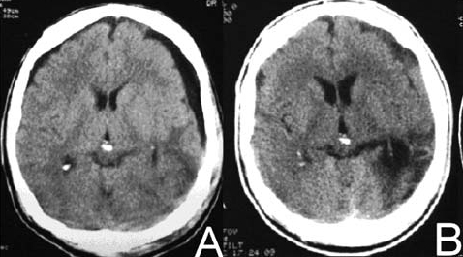
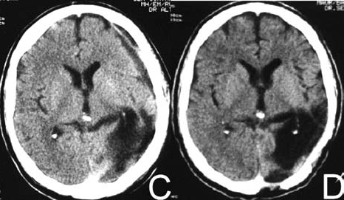
Source of pictures: Marco Antonio Zanini et al. “Traumatic Subdural Hygroma”; Arq Neuropsiquiatr 2007;65(1):68-72 >>

A. CT - bilateral frontal subdural hygroma (12th day).
B. T1-MRI (no contrast) - laminar subdural hematoma, without compression on underlying brain (191st day).
C. T1-MRI (with contrast) - peripheral enhancement (191st day).
D. CT - disappearance of subdural collection (300th day).
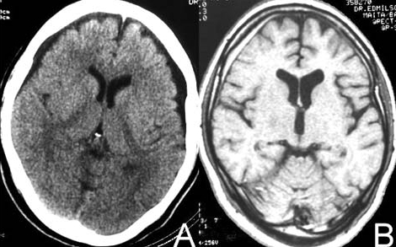
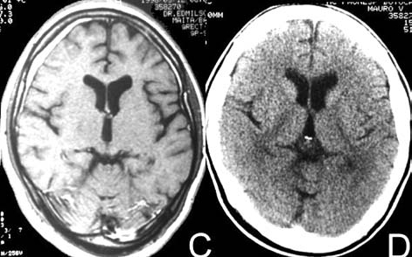
Source of pictures: Marco Antonio Zanini et al. “Traumatic Subdural Hygroma”; Arq Neuropsiquiatr 2007;65(1):68-72 >>

1. CT - bilateral frontoapical subdural hygroma.
2A. MRI - bilateral frontoapical subdural hygroma, more cerebrospinal fluid than CT.
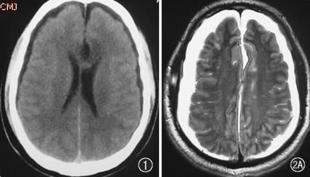

2B. MRI - compressive brainstem deformation.
3. MRI - brainstem morphology has returned to normal.
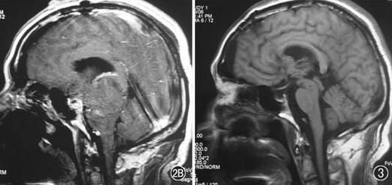
Source of pictures: Wang Ji-sheng, Ji Nan “Compressive brainstem deformation resulting from subdural hygroma after neurosurgery: a case report”

Gadolinium T1-MRI - diffuse, high enhancement of pachymeninges (small black arrows) together with bifrontal hygromas compressing frontal lobes (black arrows):
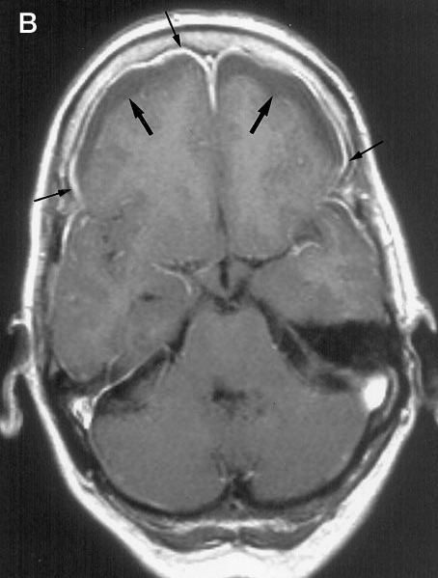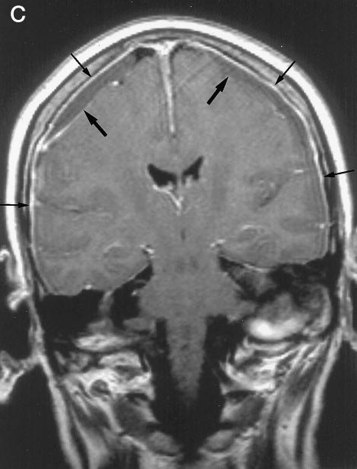
Source of pictures: J. S. P. van den Berg et al. “Subdural Hygroma: A Rare Complication of Spinal Anesthesia” >>

Small, low-density, extra axial collection over right frontal lobe; slight mass effect; adjacent sulci are compressed:  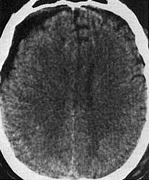 | Benign enlargement of subarachnoid space in child (CT) – no mass effect; normally resolves within first 2 years of life:  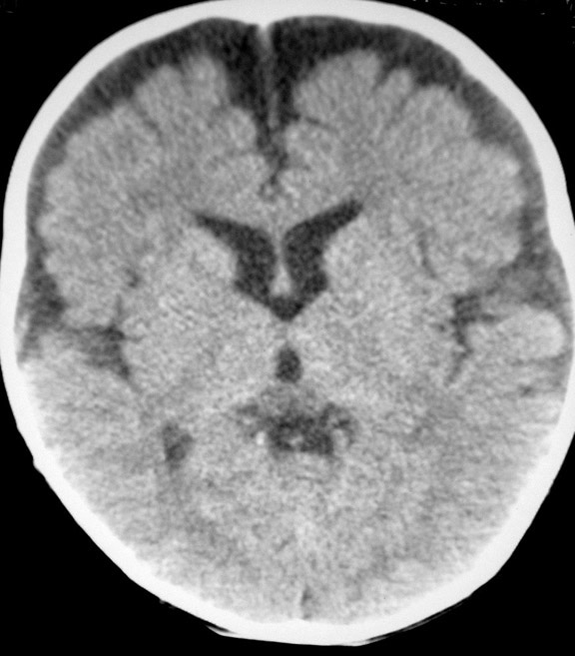  Source of picture: Andrew L Wagner, MD, Subdural Hematoma: Multimedia >>

Postoperative MRI - child with large cystic craniopharyngioma and hydrocephalus; sudden tumor removal and hydrocephalus decompression resulted in subdural hygroma formation (small arrows); hygroma stretched draining veins, causing multiple venous infarcts (open arrow):
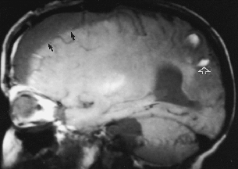
Source of picture: Julian R. Youmans “Youmans Neurological Surgery”, 4th ed. (1997); figure 126-7; Publisher: W.B. Saunders Company; ISBN-10: 0721668453; ISBN-13: 978-0721668451 >>

Treatment
Asymptomatic → observation (usually resolve spontaneously within several months).
N.B. observation leaves risk of transformation into subdural hematoma (which already requires craniotomy).

Symptomatic (esp. deteriorating clinical status accompanied by hygroma volume↑ with brain compression → herniation) → surgery: external burr-hole drainage;
- maintain subdural drain for 24-48 hrs post-op; if satisfactory resorption does not occur → shunting of subdural space.
- recurrence following simple burr-hole drainage is common; for recurrent cases:
  - craniotomy to locate site of CSF leak (may be very difficult)
  - subdural-peritoneal shunt.

Bibliography for ch. “Head Trauma” → follow this link >>

Viktor’s Notes℠ for the Neurosurgery Resident
Please visit website at www.NeurosurgeryResident.net

