Facial Trauma (GENERAL)
Last updated: January 7, 2022
Etiology 1
Clinical Features 1
Diagnosis 2
Prehospital Management 2
Treatment 3
Facial Lacerations 3
Timing 4
Open Care 4
Closure Procedure 4
Facial Fractures 5
Indications for operative repair 5
Timing of operative repair 5
Principles of repair 5
Laceration of parotid duct and gland → see p. 1943 >>

Etiology
- motor vehicle crashes (> 50%)
- personal violence
- home accidents
- athletic injuries
- work-related injuries
- animal bites
- child abuse (major consideration in child with facial trauma!)
- falls (major cause of pediatric facial fractures)

Force of Gravity Impact Required for Facial Fracture:
Bone | Force of gravity (g)
Nasal bones | 30
Zygoma | 50
Angle of mandible | 70
Frontal-glabellar region | 80
Midline maxilla | 100
Midline mandible (symphysis) | 100
Supraorbital rim | 200

Most commonly fractured bones:
- Nasal bones
- Mandible or Zygoma

Amount of energy required to cause face fractures:
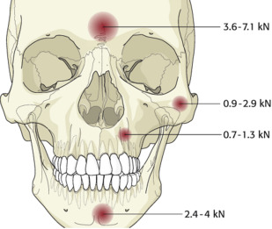

Clinical Features
- associated injuries exist in 60% patients - definitive evaluation of facial injury is best delayed for few hours until more urgent injuries have been treated.
Head, chest, abdominal injuries initially are much less obvious than facial trauma but have much greater threat to patient's well-being!
- evaluation starts with history - special attention to mechanism of injury - indicates which types of facial injury are probable.
- careful documentation is important (incl. drawings; photographic record is ideal).
25% of all significant facial trauma cases result in litigation!
- examination is difficult / impossible if altered mental status.
N.B. patients with suspected facial trauma should not be discharged home from ED without complete, documented examination!

- Inspect - facial asymmetry, deformities, ecchymoses, edema; ocular integrity and position; nasal septal hematoma, CSF rhinorrhea, dental malocclusion, intraoral ecchymoses.
- Motor and sensory function:
  - three branches of CN5 on each side of face
  - CN7 (wrinkle forehead, close eyes tightly, smile, bare teeth)
  - extraocular movements (question about diplopia)
  - visual acuity
- Palpation - tenderness, bony defects, crepitus, false motion.
    - specific attention to: infraorbital & supraorbital ridges, zygoma, nasal bones, mandible, lower maxilla (incl. stability of bite).
    - grasp upper and lower anterior teeth and test for motion (dental integrity).
    - milk parotid gland – observe for salivary / blood flow at parotid duct opening (integrity / disruption of parotid duct).
- Fully explore lacerations for foreign bodies and fractures - by probing [may require local anesthesia*], if in doubt → X-ray.
*only after neurologic evaluation of affected area

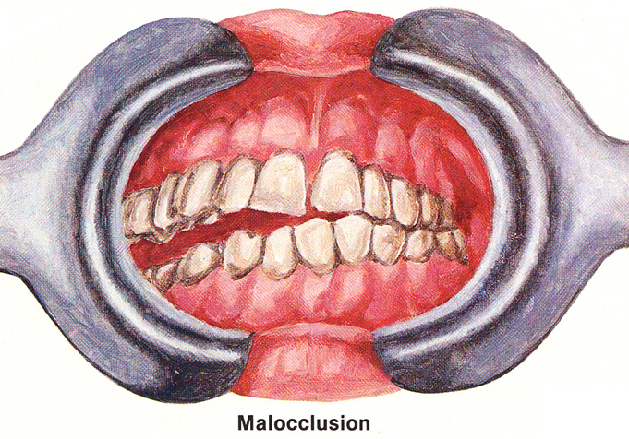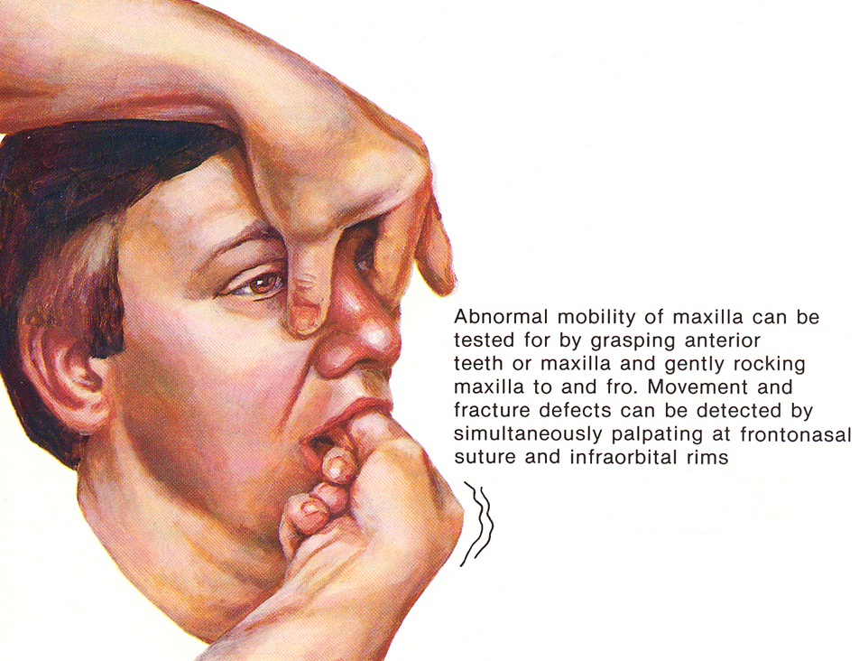
Source of pictures: Frank H. Netter “Clinical Symposia”; Ciba Pharmaceutical Company; Saunders >>

Palpation of bony facial skull:
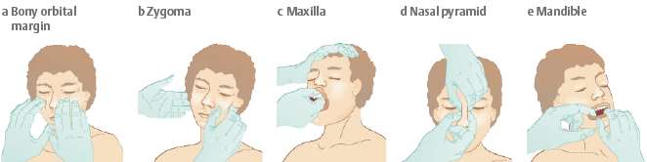

Diagnosis
Thin-section high-resolution CT – preferred initial diagnostic study!
- done in axial plane with reformation in coronal and parasagittal planes.
- done in coronal plane (requires patient to be in prone position with head hyperextended - high degree of patient cooperation + cervical spine free of injury) - very good for horizontal facial structures (e.g. orbital floor).
- 3D reconstruction - mainly for presurgical planning (rather than diagnosis).

Radiography (plain, tomography) – only for very simple fractures: see p. D47 >>
- bony integrity
- fluid-filled sinuses (hemorrhage)
- herniation of orbital contents
- subcutaneous air, orbital emphysema (communication with nasal cavity or paranasal sinus)
- Waters’ projection is usually combined with PA and lateral projections.
- mandibular fractures → panoramic X-ray, Townes’ view (mandibular condyles).
- cervical fracture must be considered when blow has been sufficient to fracture facial bones!

MRI - ancillary diagnostics for specific soft-tissue complications (eye and its associated structures, vascular injuries, etc).

CT of face (axial and coronal views) - complex fractures involving right maxilla as well as lateral, inferior, and medial walls of right orbit; opacification of maxillary and ethmoid sinuses:
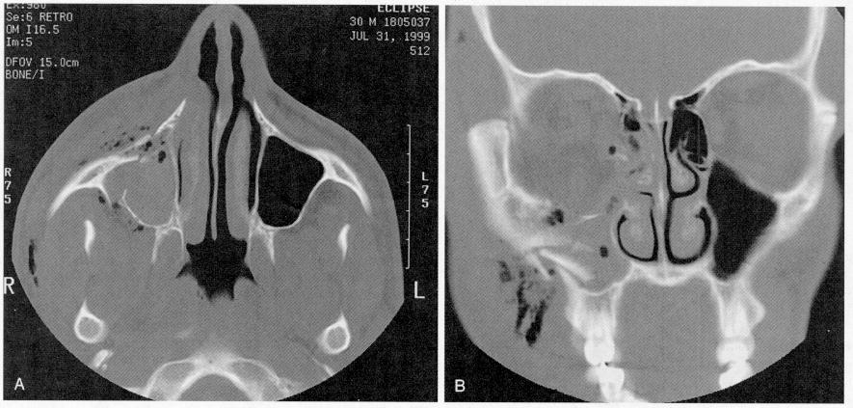

Prehospital Management
Preserving sight and speech and minimizing deformity are important goals but with low priority!
Most patients with massive facial trauma must be assumed to have sustained cervical spine trauma!
Be alert to accompanying brain injury! (assess by GCS)
Facial fractures are much more commonly associated with brain injury (up to 85%) than with cervical injury (1.3-4%)

Airway + bleeding

- Facial trauma frequently compromises upper airway (accumulation of blood, vomitus, avulsed parts, foreign substances + certain maxillofacial and mandibular fractures):
Most important aspect of prehospital care is maintenance of clear airway!
- pull tongue or intact mandible anteriorly, remove any loose material, suction posterior pharynx.
- if patient is alert, not otherwise seriously injured, cervical spine injury not suspected → transport in prone, lateral decubitus, or sitting position.
- if patient is obtunded but breathing well, without hemorrhage into airway → oropharyngeal or nasopharyngeal airway may be adequate.
- if altered sensorium or cervical spine injury is possible → cervical spine immobilization → pass orotracheal, nasotracheal tube;
complications / contraindications:
- nasotracheal intubation is hazardous in midface fractures (ethmoid fractures – risk of injury to base of brain).
- transoral endotracheal intubation is hazardous in cervical spine injury.
H: turn patient to one side on backboard after immobilization or careful intubation with cervical spine in-line stabilization.
- laryngeal derangement may lead to misdirected submucosal intubation (→ complete airway obstruction). Suspect laryngeal injuries in all patients sustaining blunt facial trauma!
H: percutaneous transtracheal ventilation / tracheostomy / cricothyroidotomy - often required in significant facial injuries!

- Facial lacerations bleed readily because of rich blood supply (but shock as result of facial trauma alone is extremely rare); bleeding is controlled by direct pressure with pressure dressings or finger (no facial fractures – press wound edges against bone; facial fractures present – press a. facialis against mandibula edge).
N.B. bleeding is never controlled by "blind" clamping!

- Impaled foreign bodies should be left in place until patient is in surgical theater! (carefully stabilize them before transport!)
- perforating cheek injuries - vienintelė vieta kūne, iš kurios nedelsiant turi būti pašalinti perforavę svetimkūniai - kitaip nesustabdysime kraujavimo į burnos ertmę; o kraujavimas stabdomas spaudžiamaisiais tvarsčiais iš abiejų skruosto pusių: vienas iš vidaus tarp dantų ir skruosto, kitas iš išorės.

- If nerves, vessels, tends are exposed – cover with sterile dressing with sterile saline.

- Susidarę trauminiai audinių lopai gerai nuplaunami fiziologiniu tirpalu ir gražinami atgal į vietą.
- surenkamos net ir smulkios amputuotos dalys (ypač ausų, nosies, vokų gabaliukai) - irrigate with normal saline, and transport in soaked gauze sponge.

- Akys:
- svetimkūnius bandoma išplauti su kriauše, o nuo vokų junginės galima pabandyti pašalinti su drėgnu vatiniu aplikatoriumi; negalima naudoti aplikatoriaus ant ragenos.
- perforavę svetimkūniai turi būti stabilizuoti vietoje: aprenkami svetimkūniai aplink, paimti kelias skareles ir jų viduryje iškirpti skylę, skareles užmauti ant svetimkūnio, ant viršaus uždėti popierinį puodelį (ar ką nors panašaus) kad svetimkūnis būtų pilnai apsaugotas nuo išorės ir nesusidarytų jokio spaudimo į obuolį (išsispaus stiklakūnis). Ant sveikos akies taip pat uždedamas tvarstis - kad ligonis nieko nematytų (kitaip nevalingai sekant aplinkos daiktų judėjimą, kartu juda ir pažeista akis - gali padidėti sužalojimas svetimkūniu); pacientui gulėti labai ramiai ir negalima bandyti stipriai užsimerkti.
- kraujavimas iš vokų būna ypač stiprus - kontroliuoti galima prispaudžiant voką prie akies obuolio. Absoliučiai būtina prieš tai įsitikinti, jog obuolys neperforuotas - kitaip išsispaus stiklakūnis → aklumas.
- akies obuolio avulsija - nebandyti gražinti atgal į orbitą, pridengti skarele su izotoniniu tirpalu, ant viršaus popierinis puodelis ar pan., pacientui gulėti labai ramiai.

- Nosis - epistaxis gali būti profūzinis ir lemti hemoraginį šoką. Kraujavimą galima stabdyti tik kai nėra kaukolės pamato priekinės daubos lūžimo. Pacientas pasodinamas ir palenkiamas į priekį, liepiama lėtai kvėpuoti per burną. Ant nosies šaknies uždedamas šaltas kompresas. Kraujavimas įvykio vietoje stabdomas arba užspaudžiant šnerves arba pakišant marlės volelį tarp viršutinės lūpos ir dantų.

- Ausies landos - negalima kliudyti kraujui ar likvorui ištekėti (netamponuoti!) - prikraujuos intrakranialiai, pateks infekcija - reikia uždėti storą sugerianti tvarstį, apsaugantį nuo infekcijos patekimo, bet netrukdantį skysčiui nutekėti. Negalima bandyti šalinti svetimkūnių ne gydymo įstaigoje. Viskas galioja ir nosiai.

- Burnos ertmė, ryklė:
- greitai pašalinami svetimkūniai, išsiurbiamas skystas turinys.
- kraujavimas stabdomas pakišant marlės volelį tarp lūpos ar skruosto ir dantenų (galima papildomai spaudžiamąjį tvarstį iš išorės - t.y. spaudžiamieji tvarsčiai iš dviejų pusių); jei kraujavimas tęsiasi, ligonis turi sėdėti pasilenkęs arba gulėti ant šono, kraujas turi tekėti laukan. Ryjant kraują, gali prasidėti vėmimas - komplikuos situaciją. Kraujuojant iš ryklės, atliekama intubacija ir standi tamponada.
- išmušti dantys - jie turi būti pašalinti iš burnos ertmės; danties raištis išlieka gyvybingas 30 minučių - tai apsprendžia taktiką:
Nečiupinėti danties šaknies! (handle only by enamel!)
  - jei stomatologo pagalba galima per pusvalandį - dantį pamerkti į pasterizuotą pieną/sterilų fiziologinį tirpalą/seiles (padėti po liežuviu), blogiausiu atveju suvynioti į drėgną nosinaitę;
  - jei pagalba užtruks - gerai išplauti dantį bei jo alveolę (guolį) fiziologiniu tirpalu ir atsargiai neskubant gražinti dantį į normalią padėtį; duoti pacientui stipriai sukasti marlinį volelį (minimum 15 min) ir vykti į stacionarą, kur stomatologas pritaikys specialų įtvarą.

- Apatinis žandikaulis:  - jei nėra kraujavimo į burnos ertmę (!), sulyginamas sąkandis ir žandikaulis imobilizuojamas (Barton‘s bandage); mazgai turi būti užrišti taip, kad juos būtų galima greitai atrišti (pvz. ligoniui vemiant).  - jei kraujuoja į burnos ertmę, žandikaulio imobilizuoti negalima!  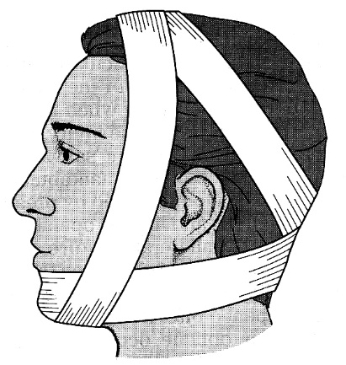 | 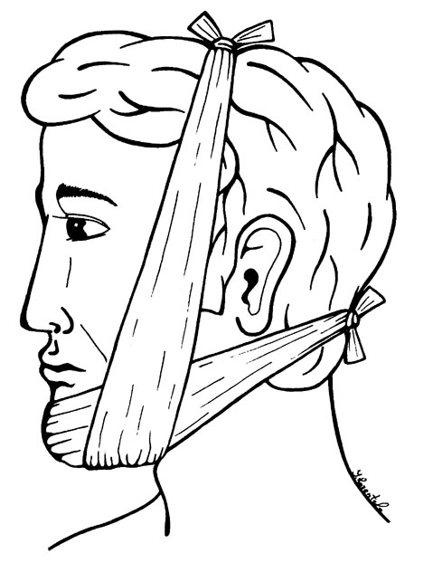

Treatment
Facial Lacerations
- tetanus prophylaxis!
- treat carefully - cosmetic significance + danger to underlying structures (e.g. CN7, parotid duct, nasolacrimal system, tarsal plate in eyelid).

Timing
Most can be repaired by primary closure (even when > 24 hours old).
- if necessary, repair of relatively clean facial wounds may be delayed up to 24 hours.
- wounds that must be definitively dealt as soon as possible:
  - bites (animal and human) - grossly contaminated (irrigate & débride → treat open → delayed closure).
  - foreign body tattooing - material incorporation into tissue through healing.
Indications to delayed closure (wound cannot be safely closed):
- Wound > 24 hours old + severe crushing.
- Foreign body that cannot be removed.
- Severely contaminated wounds:
- wounds containing soil should not be closed primarily (unless < 6 hours old and can be completely débrided).
- human bites best treated open (delayed primary closure after 4 days of wound care and antibiotics).
- Fracture in wound area (delay wound closure until fracture has been reduced).
- Uncooperative patient (observe patient for few hours to achieve cooperation); hemostasis must be achieved at initial evaluation!

Open Care
- initial hemostasis & irrigation.
- temporary rough approximation of wound
- cover with normal saline-soaked gauze, occlusive dressing.
- if wound is contaminated - start antibiotics (e.g. cephalosporin).
- arrange follow-up and eventual wound closure.

Closure Procedure
- pillow under shoulder or neck (tilts injured area of face toward physician).
- use restraints for young children and intoxicated* patients.
*but it is preferable to await sufficient alcohol metabolism
- four-towel drape - place sterile towel under head and shoulders, wrap another around head, place two sterile towels in Y shape around upper neck:  symmetry of entire face may be observed, patients will be less anxious because they can observe their surroundings, patients' level of consciousness and respiratory and airway status may be easily monitored | 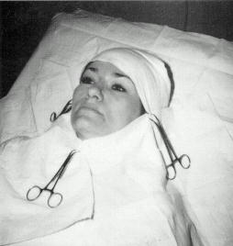
1. Anesthesia:
- local infiltration of lidocaine 1% with 1:100,000 epinephrine.
N.B. in ear, nose, tarsal plate of eyelid, epinephrine is contraindicated!!!
- local anesthesia causes distortion and blanching (esp. important in vermilion border) - mark matched opposite sides of wound with needle scratch or needle dipped in methylene blue before injecting wound.
- infiltrate wound through its edges (rather than through intact surrounding skin).
- extensive injuries may require regional block. see p. Op460 >>
2. Carefully clean wound;
- abrasions require vigorous scrubbing (esp. if traumatic tattooing is present): anesthetize wound with 2% viscous lidocaine or 4% lidocaine solution → scrub wound with sterile scrub brush or toothbrush; material not removed by scrubbing is extracted by no. 11 scalpel blade or 17-gauge needle.
N.B. any embedded material should be carefully removed, otherwise it may be incorporated into dermis, causing permanent discoloration (tattoo)!
- wounds need unroofing of pockets and forceful irrigation.
3. Carefully explore wound before closure.
4. Conservatively débride obviously devitalized or grossly contaminated tissue.
- 1-2 mm of wound edge should be excised from tearing bite wound.
- severely crushed tissue should be sharply excised (unless it involves irreplaceable structure such as columella of nose, upper lip’s philtrum – these structures must be not débrided!).
- beveled lacerations should have their edges débrided to convert to perpendicular edges (→ smoother, less noticeable scar); in case of stellate laceration, however, it is best just to close edges of wound (too much tissue would be lost through correction of bevel).
- lips: loss of up to 20-25% of middle of lip can be closed primarily with surprisingly good results (larger losses should be referred); any debridement must convert wound to one that crosses vermilion border at perfect right angle.
5. Suture in layers:
for deep layers - absorbable suture 4-0 or 5-0 (e.g. Dexon, Vicryl) simple vertical stitches with deeply buried knot; avoid catgut in face – produces intense inflammatory reaction!
- in repairing lacerations containing cartilage (ear or nose), stabilizing stitches of 4-0 chromic or monofilament nylon are used to maintain cartilage in its proper position (only one or two strategically placed sutures are needed);
- layered closure is especially important around orifices if wound extends into subcutaneous and muscular layers.
for skin (as cosmetically as possible) - fine monofilament synthetic nonabsorbable sutures (e.g. Prolene, Ethilon) with either running locked stitch or simple interrupted stitches;
- in unreliable patient, subcuticular closure with absorbable suture may be most appropriate choice).
N.B. approximation of deeper layers not only obliterates potential dead space but also supplies supporting strength to healing wound when skin sutures are removed (skin does not regain adequate tensile strength for 5-6 weeks) - for good cosmetic result, closure of deep layers must achieve excellent dermal approximation, with skin sutures serving only final "leveling" function.
- use natural lines of expression as guide. see p. 2215 >>
- approximate landmarks first with few simple sutures (esp. wrinkles, eyebrows, nasal ala, vermilion border of lips - not maintained line continuity of these structures produces very visible and difficult-to-correct defect).
- if tissue was lost as part of injury, make sure that closing wound will not produce more scarring than just allowing wound to granulate in.
N.B. split-thickness skin grafts are not used in facial injuries - result in significant contracture and color match is often poor (but may be indicated in large defects, where graft can be used as temporary measure).
- significant tissue loss - temporize with simple closure if possible; if scar is unacceptable, it can be revised later (local tissue flaps are susceptible to failure in presence of acute trauma).
- oral mucosal lacerations are loosely sutured in layers to reduce healing time and to avoid scars and permanent clefts; rinse mouth 3-4 times day with mild antiseptic (e.g. half-strength H₂O₂).
- trough-and-through lacerations involving oral mucosa and skin - mucosa is carefully approximated with 4-0 or 5-0 silk (or synthetic absorbable) to give watertight closure (irrigation of wound from outside demonstrates adequacy of this closure); muscularis and subcutaneous layers are then closed from outside.
- tongue lacerations are also loosely sutured* with sutures placed deeply in muscle (to prevent hematoma); use absorbables (3-0 or 4-0 chromic gut, but braided synthetic is more comfortable) or silk (must be removed later); antibiotic ointment applied to suture line reduces inflammation and keeps sutures flexible.
*small superficial tongue laceration need not be closed
Tongue exposure (esp. if laceration is posterior):
  - wrap distal tongue with gauze to allow gently pulling of tongue from mouth.
  - place large suture (after adequate anesthesia) through tongue anterior to wound and use traction on this to extend tongue.
- vermilion component (of lips) is closed with pliable suture (such as 6-0 silk) - to comfort in lip apposition.
6. Most facial lacerations require no dressing other than thin coating of water-soluble ointment (e.g. Neosporin); exceptions:
- large forehead injuries benefit from pressure dressing (to minimize hematoma formation, esp. if injury has violated galea).
- young children should have wounds covered (plastic strip bandages commonly do this best).
7. antibiotics:
  - grossly contaminated wounds require antibiotic (e.g. cephalosporin) coverage.
Significant oral lacerations are contaminated wounds!
  - simple, clean lacerations closed in timely fashion require none.
8. Skin sutures are removed within 3-5 days (to minimize scar cross-hatching) → adhesive retention strips (e.g. Steri-Strips) to give added strength.
N.B. minimize exposure to sun (use sunscreen) to avoid persistent redness (→ hyperpigmentation) of developing scar.
- final result cannot be evaluated until 6-12 months after injury (maximum scar resorption and softening); if cosmetic result is thought to be unsatisfactory at that time → plastic surgeon opinion on scar revision.

Sample Wound Instruction Sheet
General information: wound and laceration care
When body tissues have been damaged by cut, burn, or abrasion, they must be protected and watched carefully for infection. Despite best of care, there is always chance that such wounds may be infected by bacteria or other germs.
Instructions: follow those instructions checked
Elevate injured area. Propping injured area up in air on pillows reduces swelling and therefore pain.
Bandage care. If you have bandage, change it in _____ days or return to have doctor check it in _____ days. Keep your dressing clean and dry.
Cleansing. If your wound was not covered with bandage, keep it clean. Gently wash it as needed with warm water to remove any accumulation of dried blood or ooze from wound.
Stitches. If you have stitches, make appointment to have them removed in _____ days in suture removal clinic.
Wound recheck. Make and keep appointment to have your wound checked in _____ days.
Medicine. If you have been given antibiotics, take all medicine prescribed for full time as directed. If you have been given pain medicines, take them as prescribed for pain; otherwise take aspirin or Tylenol every 4 hours if needed for pain. If you were given ointment for your wound, apply it carefully to wound twice day.
Call doctor or return to hospital if following symptoms appear:
Redness, swelling, or tenderness around wound
Pus draining from wound
Chills or fever

Facial Fractures
Bleeding → fracture reduction + pressure packing.
- bleeding from maxillofacial fractures may be temporary controlled with anterior & posterior nasal packs ± direct packing of oropharynx.
if hemorrhage still not controlled - suspect laceration of internal maxillary artery or basilar skull fracture with ICA involvement → immediate angiographic embolization (preferred over operative ligation - direct surgical approach is difficult).

Indications for operative repair
- functionally significant fractures:
Blowout fracture of inferior orbital floor → entrapment of extra-ocular muscles.
Maxilla, alveolar ridge, mandible fractures → malocclusion.
Depressed zygomatic arch fractures → entrapment of temporalis muscle.
- improved cosmetic outcome - indication cannot be made until significant facial swelling has decreased.
Cosmetic appearance has enormous impact on social interactions!

Timing of operative repair
- early (within 24 hours of injury) - readily accomplished (because of minimal edema); indications:
- large, open lacerations (aid in exposure of fractures).
- needed early neurosurgical repair – attempt synchronous* neurosurgical maxillofacial repair (asynchronous later repair invariably disrupts neurosurgical dural repair!); intraoperative ICP monitoring is required!
*e.g. via same bicoronal flap
- staged - to wait for facial edema resolution, using time for preoperative planning, detailed radiographic analysis, production of operative aids (such as acrylic interocclusal splints); ideal window for staged repair - between 3 and 14 days; frequently performed for cosmetic indications or when severe associated injuries take priority; appropriate use of antibiotics is necessary.

Principles of repair
  - direct exposure of all fractures.
  - meticulous reduction and internal fixation (fine screws and plates).
    - external fixators are occasionally used for mandible fractures.
    - mandible is established as solid base on which all other repairs can be constructed - all fractures of mandible are first reduced and immobilized; then fractured midportion of face is repaired and fixed between stable mandible and next highest stable point on facial skeleton or skull.
    - in some circumstances, intermaxillary fixation alone provides sufficient stabilization of fracture fragments, without need for formal internal fixation.
    - if patient has had previous dental or orthodontic treatment, models may be used to help determine proper occlusal relationships (especially helpful in multiple fractures in alveolar processes and jaws).
    - intermaxillary fixation and suspension wires are left in place for 4-6 weeks in order to ensure proper healing.
    - intermaxillary fixation may be terminated at 4 weeks for certain types of mandibular fractures, such as condylar fractures, to allow mandibular function → training with elastic bands for remaining few weeks of treatment to maintain proper occlusion.
  - primary bone grafting of severely damaged / absent bone.

- facial bones heal by fibrous union (not callus formation) - suture material must remain in place for long period of time (perhaps months) - until fibrous tissue is laid down and remodeled - monofilament surgical steel is ideal for its lack of elasticity.
- some severe complex injuries (panfacial fractures, gunshot wounds to upper and midface) require postrepair tracheostomy.

Bibliography for ch. “Head Trauma” → follow this link >>

Viktor’s Notes℠ for the Neurosurgery Resident
Please visit website at www.NeurosurgeryResident.net

