Facial Trauma (Frontal, Orbital)
Last updated: January 7, 2022
Orbital Rim Fractures 1
Orbital Floor Fracture 1
Etiopathophysiology 1
Clinical Features 1
Diagnosis 2
Treatment 2
Orbital Apex Fractures 3
Orbital Roof (Blow-In) Fractures 3
Frontal Sinus Fractures (i.e. Frontal fractures that extend into paranasal sinuses) 3
Etiology 3
Diagnosis 3
Complications 4
Treatment Principles 4
Anatomy 4
Classification 4
Treatment goals 4
Approaches 5
Treatment - Anterior table fractures 5
Treatment - Posterior table fractures 5
Ocular, Eyelid, Eyebrow Trauma → see p. Eye86 >>
External Ear Trauma → see p. Ear40 >>

Orbital Rim Fractures
Orbital rim is strongest part of orbit - isolated rim fractures are uncommon.

Orbital Floor Fracture
Etiopathophysiology
- part of complex fractures (Le Fort II and III fractures, nasofrontoethmoidal fractures, zygomaticomaxillary complex ["tripod"] fractures).
- isolated (blow-out) fracture - violent impact to anterior globe* → hydraulic force transmission to interior of orbit → orbital contents are incompressible → orbital floor (weakest area) is usually area to give way → herniation of orbital contents down into maxillary sinus.
fractures of orbital roof have also been reported, with herniation of contents into frontal sinus
*only by objects with ≤ 5 cm radius of curvature, i.e. slightly larger than orbital inlet - penetrates orbital space for only short distance (e.g. fist, ball); larger objects cannot compress globe because of protective architecture of orbital rim.
- second weakest part is medial wall (lamina papyracea)!

Clinical Features
- Entrapment of inferior rectus / oblique muscle → impaired upward ocular motility → diplopia.  - Enophthalmos (often obscured by early postinjury edema), periorbital ecchymosis.  - Infraorbital hypoesthesia  - Malar deformity.  - Blowing nose → momentary exophthalmos → periorbital emphysema.  - Ocular injury – hyphema, subconjunctival hemorrhage, lens dislocation, retinal detachment, globe rupture. | 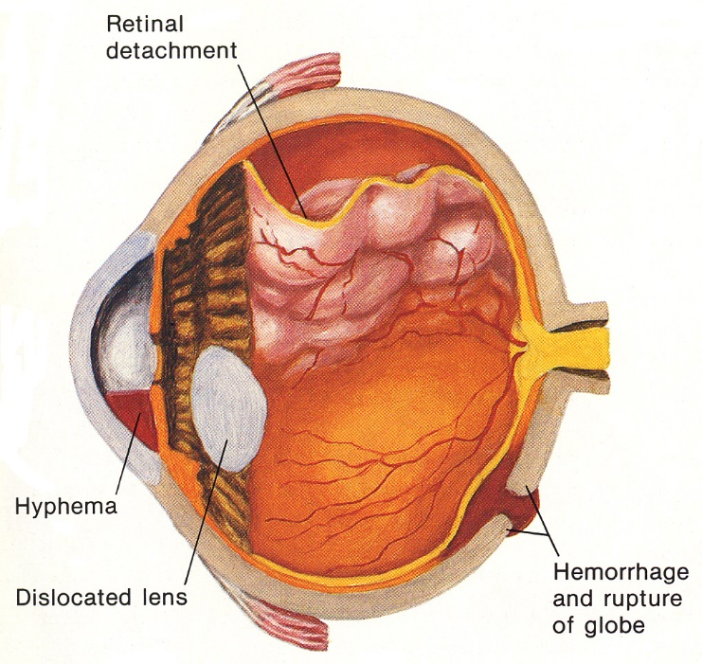

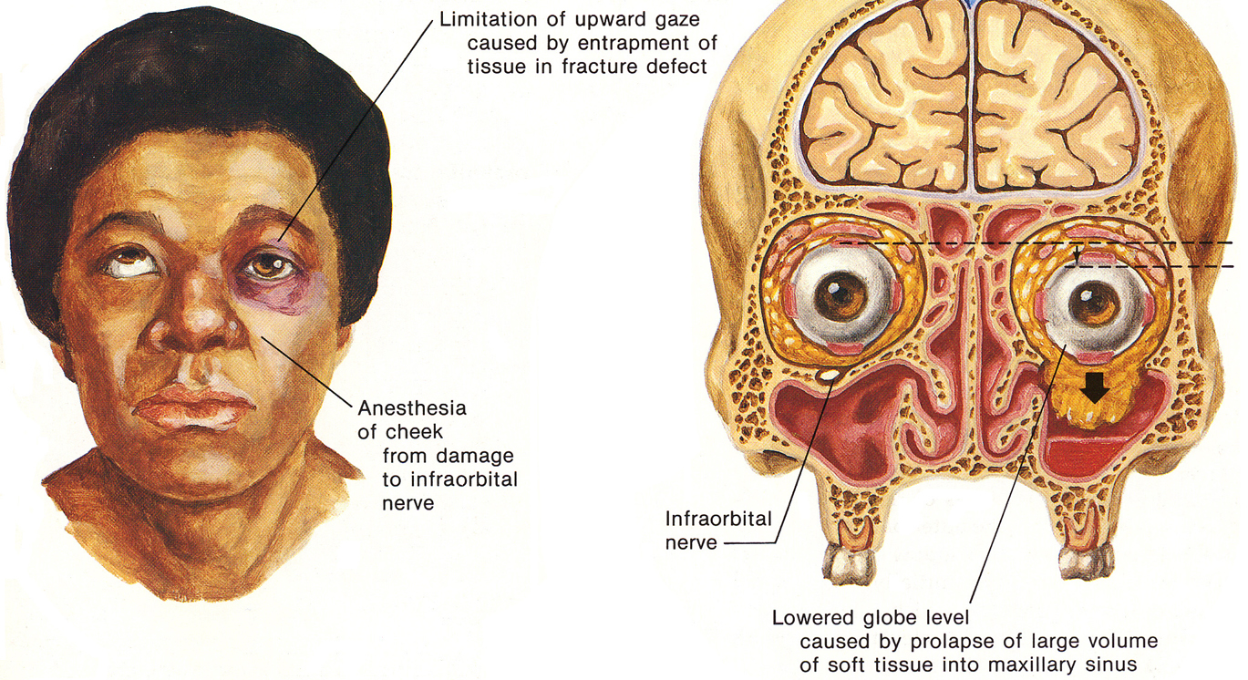
Source of picture: Frank H. Netter “Clinical Symposia”; Ciba Pharmaceutical Company; Saunders >>

Right orbital floor fracture – appearance of eyes and limitation of motion:
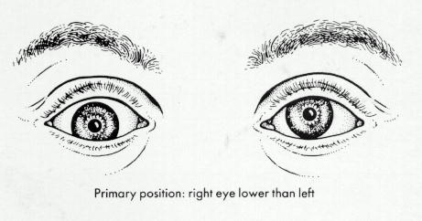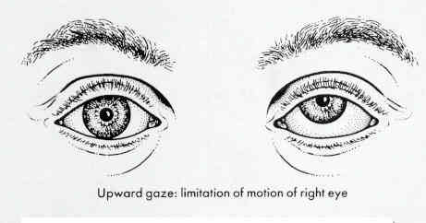

Diagnosis
Thin-section coronal CT:
- herniation of orbital contents through fracture into maxillary sinus ("hanging drop" sign)
  - in some cases, soft tissue is trapped in maxillary sinus by rectangular trapdoor of bone (bony fragment is momentarily displaced, allowing periorbital tissue to extrude into maxillary sinus, and then snaps back into place, catching soft tissue).
  - in rare fractures of medial wall of orbit, orbital contents protrude through lamina papyracea into ethmoidal air cells.
- depression of bony fragments into maxillary sinus
- orbital emphysema (from interruption of adjacent sinus wall)
- clouding (or fluid level on upright films) of maxillary sinus (hemorrhage)

Sonography (alternative if CT unavailable) - sensitivity 92%, specificity of 100%.

X-ray (Waters’ view): disruption & displacement of line representing orbital floor; fluid & herniated mass in maxillary sinus.

MRI is superior in showing soft-tissue herniations!

Waters view - right orbital floor is depressed (medium arrowheads); opacification of right maxillary sinus (large arrowhead); right ethmoid air cells also are opacified (small arrowhead), suggesting medial-wall blowout fracture:  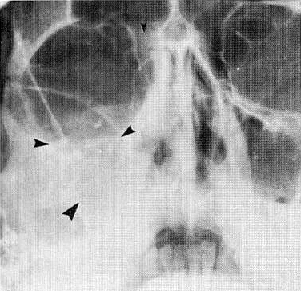 | Coronal CT - trapdoor fragment (arrow), consisting of portion of left orbital floor, is within left maxillary sinus; small amount of herniated orbital fat accompanies fragment:  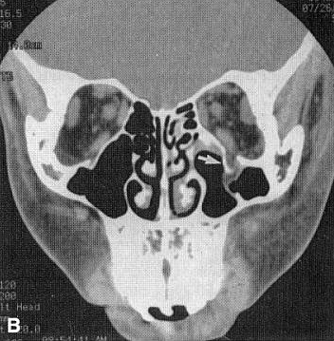
Isolated medial-wall blowout fracture (axial CT) - depression of fracture fragments into adjacent ethmoid air cells, which are opacified (small arrows); no entrapment of medial rectus muscle (medium arrow); orbital emphysema (large arrow):  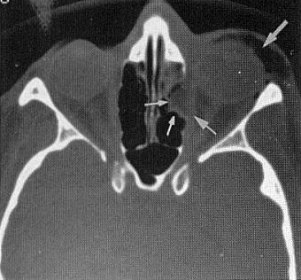 | 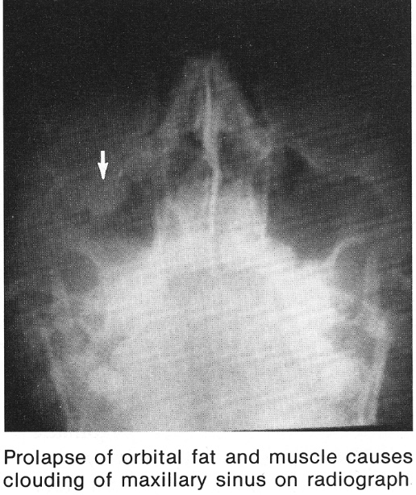

Treatment
Spontaneous resolution may occur!
- (peri)orbital emphysema is usually benign, self-limited condition.
N.B. if patient complains of sudden decrease in visual acuity (esp. after sneezing nose), air may have built up under pressure in orbit (→ cessation of blood flow in central retinal artery);
H: immediate pressure release - via lateral canthotomy with cantholysis or intraorbital needle aspiration of trapped air.

Repair of orbital floor (to relieve restricted extraocular muscle function + elevate lowered globe)
- many consultants delay decision to operate for 10-14 days – if diplopia or enophthalmos are still persistent (cause of impaired eye motility may be only edema of structures surrounding globe).
- infraorbital approach with stepped incision: infraciliary incision or incision in one of most superior natural skin creases of lower eyelid → infraorbital rim and floor of orbit are exposed through incision under skin-muscle flap but external to orbital septum → periosteum is incised 0.5-1 cm below attachment of orbital septum at infraorbital rim (to prevent herniation of orbital fat into surgical field).
- orbital floor reconstruction using alloplastic implant (autogenous bone has no advantage);
  - as thin as will allow proper support of soft tissues.
  - placed over defect subperiosteally and rests passively in place.
  - must cover only anterior portion of orbital floor (rests on anterior, lateral and medial edges of defect).
  - if implant protrudes from orbit without being held in place, it is too large (→ make smaller until it lies passively within orbit).

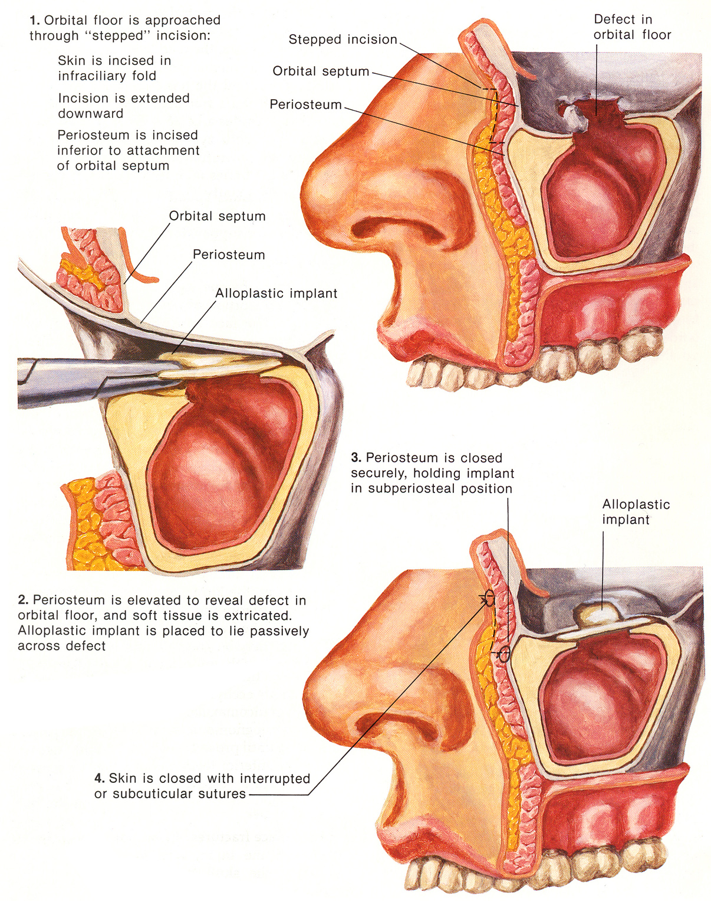
Source of picture: Frank H. Netter “Clinical Symposia”; Ciba Pharmaceutical Company; Saunders >>

- if there is extensive comminution of orbital floor and repair cannot be maintained in reduced position → antral packing. see p. TrH29 >>

Orbital Apex Fractures
- may be linear and undisplaced or comminuted.
- occasionally, entire orbital apex is completely avulsed, with apical fragment containing intact optic foramen.
- complication - orbital apex syndrome: traumatic optic neuropathy + superior orbital fissure syndrome (CN3, 4, 6 injury).

Comminuted right orbital apex fracture (axial CT) - fractured right greater sphenoid wing (large arrowhead), displacement of fragments into superior orbital fissure (small arrowheads):
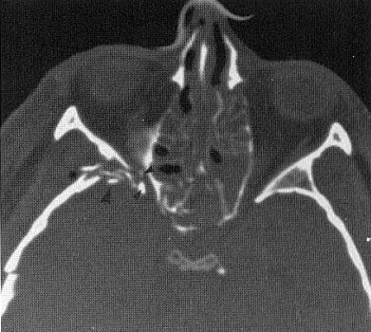

Orbital Roof (Blow-In) Fractures
- frequently associated with frontal sinus and nasoethmoidal fractures.
- involvement of superior rectus (± superior oblique) muscle → loss of upward gaze.
N.B. most common cause of loss of upward gaze is orbital floor fracture! see above
- decreased orbital volume → proptosis, much higher incidence of injury to globe and periorbital contents (than with blow-out fractures).

Frontal Sinus Fractures (i.e. Frontal fractures that extend into paranasal sinuses)
Etiology
- severe blow to forehead.
- considerable force is required to cause these fractures, and thus patients usually have other associated injuries (esp. eye injury – ophtho consult!)
- anterior table can withstand up to 998 kg of force, it serves to protect the posterior table and brain parenchyma; thus, if the posterior table is fractured, there is a higher likelihood of other severe injuries (central nervous system, truncal, and extremity).

Diagnosis
- best by axial high-resolution CT - fluid levels, sinus opacification, orbital emphysema, pneumocephalus.
Posterior wall of sinus must be evaluated (lateral tomograms or CT)
- look for pneumocephalus (extradural vs intradural – risk of CSF leak), fluid in frontal sinuses.

Bone-window CT - fracture of frontal bone; fluid level in frontal sinus (clotted blood is layering out):
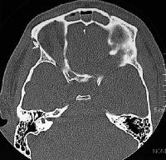

Caldwell view: opacification of frontal sinus (large arrowhead); multiple comminuted fractures (small arrowheads):  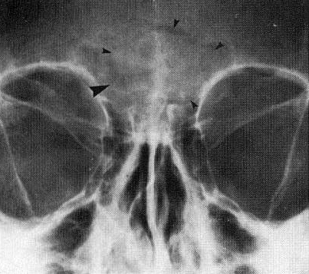 | Axial CT - comminution of both anterior and posterior walls of left frontal sinus (arrowheads), accompanied by sinus opacification and air-fluid level in right frontal sinus:  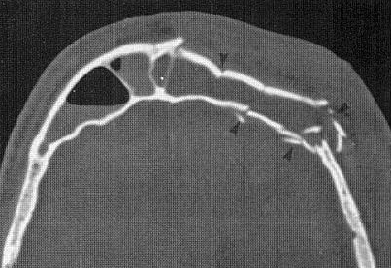

Trauma in Facial Plastic Surgery Irene A. Kim MD, Kofi D. Boahene MD and Patrick J. Byrne MD, FACS, MBA Facial Plastic Surgery Clinics of North America, 2017-11-01, Volume 25, Issue 4, Pages 503-511

Complications
- frontal sinus outflow obstruction can lead to ENT problems (chronic sinusitis, chronic pain, chronic osteomyelitis, Pott puffy tumor, mucoceles, and mucopyoceles) many years after the initial injury.
- other associated problems like meningitis, encephalitis, and brain abscesses may develop as well.

Treatment Principles
More conservative regimen with close follow-up is becoming more mainstream for all types of frontal sinus fractures
- treated as "open fractures" (because of communication with paranasal sinuses) - prophylactic antibiotics!
- anterior table – stronger; only cosmetic problem! → plastic surgery

The optimal management of frontal sinus fractures remains controversial:
- Close life-long follow-up (for symptoms/signs of infection or mucocele) – recent trend; counsel about the importance of follow-up* and the need to seek medical care if any concerning signs or symptoms.
*check CT scans for restoration of sinus ventilation; if obstruction persists, endoscopic frontal sinusotomy or endoscopic Lothrop procedure.
- More morbid and invasive techniques that have been the mainstay for years.

Anatomy
- frontal bone surrounds the sinuses superiorly and laterally, with the frontal outflow tract located medially.
- anterior table provides the forehead contour and is thicker than the posterior table:
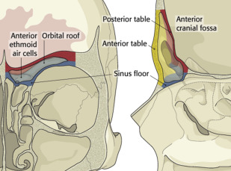

Frontal sinus drainage pathway has an hourglass configuration: infundibulum → ostium (3–4 mm) → frontal recess → small outflow tract into the ethmoid sinus/nasal cavity:
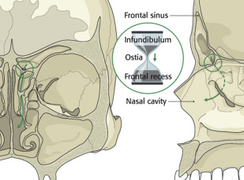

Classification
4 anatomic parameters:
(1) anterior table
(2) posterior table
(3) nasofrontal recess
(4) dural violation with or without CSF leak.

Treatment goals
The most important goal of frontal sinus fracture repair is to create a safe sinus:
- Reestablish frontal bone contour – cosmesis.
- Drainage system:
- Restore patency (if feasible)
- Obliterate sinus cavity if a patent drainage system cannot be reestablished.
- Create a watertight barrier between the intracranial system and nose:
- observation
- endoscopic repair
- open reduction and internal fixation, sinus obliteration, or sinus cranialization.

Approaches
Preexisting lacerations
If a patient has a preexisting laceration over the glabella or forehead, this can be used to access the anterior table. Care should be taken not to extend the laceration.

Endoscopic
- best suited for mildly depressed fractures located at or above the orbital rim. 2 3 A subperiosteal dissection is typically undertaken to the level of the fractures, at which time a percutaneous incision is made over the fracture site to introduce an elevator, which can reduce the depressed fragments. Various biocompatible materials like porous polyethylene 14 can be inserted through the working incision and screwed into place to camouflage the defect. 3 15

Direct brow incision
Although the direct brow incision approach offers direct access to the fracture, it has largely been replaced by other less morbid procedures. Direct brow incisions, however, are still used in patients with deep horizontal forehead rhytids or in men with male-pattern baldness.
Advantages: less soft tissue dissection, quick and direct access to fracture.
Disadvantages: unfavorable scar in patients without deep forehead rhytids.

Extended superior supratarsal lid incision, which dissects the upper lid in the supratarsal plane and reaches the anterior frontal bone
lateral segment of the anterior table is temporarily removed to allow a blunt elevator to be introduced into the sinus and reduce the fracture. Microplates are used to achieve osteosynthesis

Bicoronal incision
- more extensive and reserved for frontal bar and sinus fractures that cannot be managed expectantly or endoscopically.
- to avoid facial nerve injury, dissection in the temporal region should be carried through the temporoparietal fascia and onto the deep temporal fascia, just above the temporalis muscle. The integrity of the temporoparietal fascia should be maintained as flap elevation continues, because the frontal branch resides in this layer.
Advantages: optimal exposure and ability to harvest pericranium, muscle, split calvarial bone grafts, and temporalis fascia.
Disadvantages: large scar, dense paresthesias, headache, facial nerve (temporal branch) injury, temporal wasting, and alopecia.

Treatment - Anterior table fractures
Isolated, nondisplaced (< 2 mm) anterior table fractures
- usually managed nonoperatively: nasal decongestants and sinonasal toilet.

Comminuted, depressed (2-6 mm) fractures
- either acute reduction or delayed camouflage is recommended:
- repaired acutely within 1-10 days
- repaired at 2 - 4 months after the injury - complete resolution of forehead edema, allowing for a more accurate evaluation of the resultant contour deformity.
- if a fracture is not severely comminuted or impacted, an endoscopic approach may be used to reduce the bone fragments and restore contour with mesh.
- more severely comminuted fractures typically require a more invasive approach like a bicoronal incision to obtain optimal exposure.
- it is important to remove any trapped sinus mucosa between the segments, because this could lead to mucocele formation.

Severely impacted fractures
- during the course of trauma to the frontal region, the frontal bone goes through a compression phase before becoming concave; the fragments need to be pulled back through the compression phase before reduction can be achieved – if fragments are unable to be elevated adequately, postage-stamp perforations can be drilled along the edges of bone, releasing the tension and reducing the interfragmentary resistance → bone hook can then be placed between the fragments to help with elevation.
- in cases of severe comminution, attempted reduction of fragments may lead to large bone gaps that need to be replaced with split bone grafts, usually from the calvarium.

Delayed presentation
- fully healed fractures are not amenable to traditional open reduction.
- if aesthetic deformity remains obvious, the defect can be camouflaged - through an endoscopic or coronal incision - biocompatible materials that are malleable and stable over time (titanium mesh, hydroxyapatite cement, methyl methacrylate, and polyether ether ketone implants).

Treatment - Posterior table fractures
- some surgeons use thickness of posterior table (approx. 2 mm) as a metric for determining the acceptable posterior wall displacement for nonsurgical therapy.
  - others believe that all posterior table fractures warrant surgical exploration to rule out dural tears and frontal sinus recess injury.
  - many investigators believe that the amount of displacement of the posterior table is not the main factor in determining whether surgical intervention is required; rather, the presence or absence of a CSF leak (intradural pneumocephalus) and the presence of absence of frontal outflow tract injury* (affected drainage → mucocele → subdural abscess) are key determinants in making treatment decisions.
*direct ostium / nasofrontal duct into middle meatus

Minimally displaced fractures + CSF leak + no frontal outflow tract injury
- may be observed: stool softener, head of bed elevation, and sneezing through open mouth for 1 week.
  - lumbar drain can be considered to lessen the pressure at the level of the dural tear.
  - if there is no spontaneous resolution within 1-2 weeks (posttraumatic meningitis risk), exploration with possible dural repair and/or sinus obliteration is recommended.
- Gassner and colleagues describe a minimally invasive transorbital approach to sealing dural defects through a suprasupratarsal incision, the fractured posterior table is encountered, and sealing material (autologous tissues or sponge, like fibrin sealant patch) can be used to seal the defect:
  - suprasupratarsal incision used to expose the comminuted anterior table and gain access to the lateral posterior table fracture with subsequent placement of fibrin sealant patch to seal the subdural air:
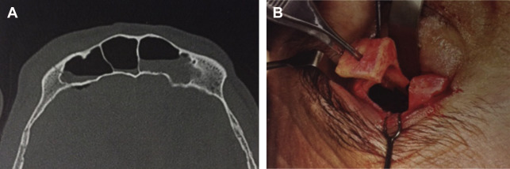
From Gassner HG, Schwan F, Schebesch KM. Transorbital approaches: minimally invasive access to the anterior skull base. Chapter 6. Boahene KD, editor. Minimal access skull base surgery. Philadelphia: Jaypee; 2016. p. 69; with permission

Moderately to severely displaced fractures + CSF leak + frontal outflow tract injury
- severely displaced fractured posterior tables are associated with frontal outflow tract injury and dural violation - sinus cranialization has traditionally been recommended.
- surgical treatment (frontal sinus obliteration, exenteration, and cranialization):
  - open adequate scalp flap (bicoronal incision) → develop pericranial flap (alternatively – make full thickness scalp flap and dissect pericranial flap immediately before using it) - barrier to separate the anterior skull base from the nasal cavity.
  - frontal craniotomy
  - take cultures.
  - sinus is exenterated (mucosa removed and superficial bone layer drilled with heat-generating diamond drill).
  - frontal sinus infundibulum mucosa is elevated and inverted inferiorly to occlude the ostium → plug of temporalis muscle is placed atop this, and the sinus cavity is obliterated with one of many autologous materials (abdominal fat, pericranium, cancellous bone, and/or muscle or Gelfoam soaked in antibiotic solution).
  - complete removal of the sinus mucosa (sinus exenteration) is imperative for successful outcomes, because residual mucosa can lead to chronic sinusitis, mucoceles, and pain.
  - inner bony cortex is burred, to remove mucosal lining invaginations along the channels of Bréchet - because this ensures a clean cavity as well as the potential for vascularization of the fat graft used for obliteration.
  - lacerated dura (thin in this region!) is closed (running silk suture) → reinforced with pericranial flap; graft may be performed on outer surface of dura, but it is frequently easier to perform it from inner surface after dura has been opened and frontal lobe retracted.
  - if posterior wall is comminuted, it may be removed (sinus cranialization).
  - it may be necessary to ligate anterior extent of sagittal sinus if it has been injured.
  - close sinus opening by pericranial flap + fibrin glue.
  - replace bone flap.

Frontal sinus recess / outflow tract injury
- decision to treat these injuries is a challenging one, because high rates of postoperative stenosis have been associated with recanalizing the nasofrontal ostia with mucosal flaps and stents.

Frontal recess injury involves the floor of the frontal sinus and the outflow tract; green arrow delineates the frontal sinus drainage pathway:
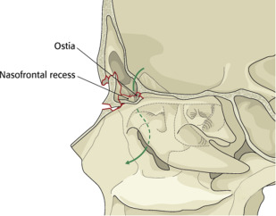
From AO surgery reference cranial vault & skull base. Available at: www.aosurgery.org ; with permission. Copyright by AO Foundation, Switzerland.

- studies have recently come forth examining the role of conservative management in cases of frontal outflow tract injury - study by DeConde and colleagues:
  - most patients with frontal sinus fractures (involving the frontal recess) without significant medial wall blowouts and obstruction may be offered conservative management and close follow up.
  - in fractures with frontal recess involvement and concomitant naso-orbito-ethmoid fractures, there should be stronger consideration to surgically intervene, because obstruction of the frontal recess by orbital contents may impede ventilation.

Bibliography for ch. “Head Trauma” → follow this link >>

Viktor’s Notes℠ for the Neurosurgery Resident
Please visit website at www.NeurosurgeryResident.net

