Facial Trauma (Nasal, Maxillary, Zygomatic)
Last updated: January 7, 2022
Maxillofacial (Middle Face) Fractures 1
Le Fort type I fracture (s. Guérin’s fracture, dentoalveolar dysjunction) 2
Le Fort type II fracture (s. pyramidal fracture of mid-face) 3
Le Fort type III fracture (s. craniofacial dysjunction) 4
Zygomatic Fracture 6
Zygomatic arch fracture 6
Zygomaticomaxillary (Tripod, Trimalar) fracture 6
Antral packing 8
Soft-tissue Injuries of Nose 9
Septal hematoma 9
Nasal Fracture 9
Clinical Features 9
Diagnosis 9
Treatment 10
Naso-Orbital Injuries 10
Clinical Features 10
Diagnosis 11
Treatment 11
Nasofrontoethmoidal Complex Fracture 11
Lacrimal canaliculus trauma → see p. Eye86 >>
External Ear Trauma → see p. Ear40 >>

Maxillofacial (Middle Face) Fractures
- among most frequent injuries! (most are result of motor vehicle collisions)
- Alveolar fractures - run through alveolar portion of maxilla.  - teeth in fractured segment are used to immobilize this part against other stable parts of dental arch (immobilization is accomplished with arch bar and individual tooth ligation or intermaxillary fixation).  - if salvaging teeth is doubtful, alveolar bone should still be immobilized to allow it to heal so that it can serve as base for application of prosthetic device after teeth are removed at later time.  - Antrum fractures - fractures of maxilla at nose base; can be repaired on outpatient basis.  - Le Fort's fractures | 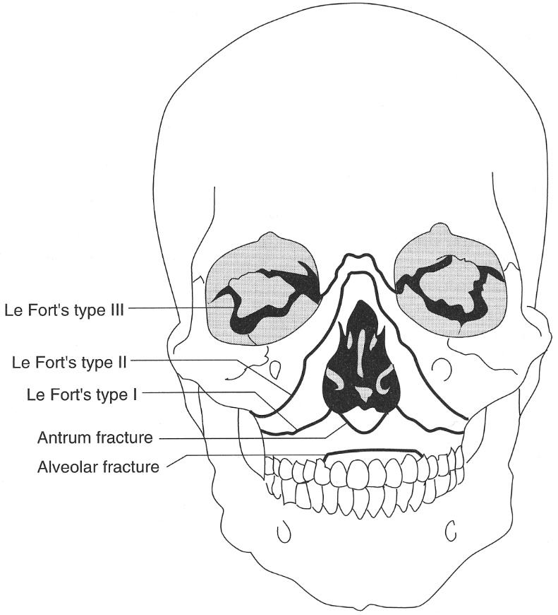

In 1901 professor René Le Fort published results of experiments on human cadavers to determine lines of least resistance in fractures of face.
- Le Fort originally described these fractures as bilateral and symmetrical.
- fractures rarely occur in pure form, but rather most typically present in combination (e.g. Le Fort II on one side with Le Fort III on other); more than one type may occur on same side; 3D CT reconstruction is valuable in planning treatment.

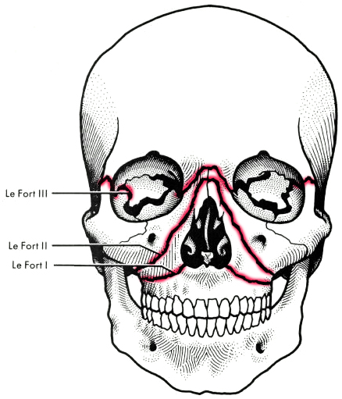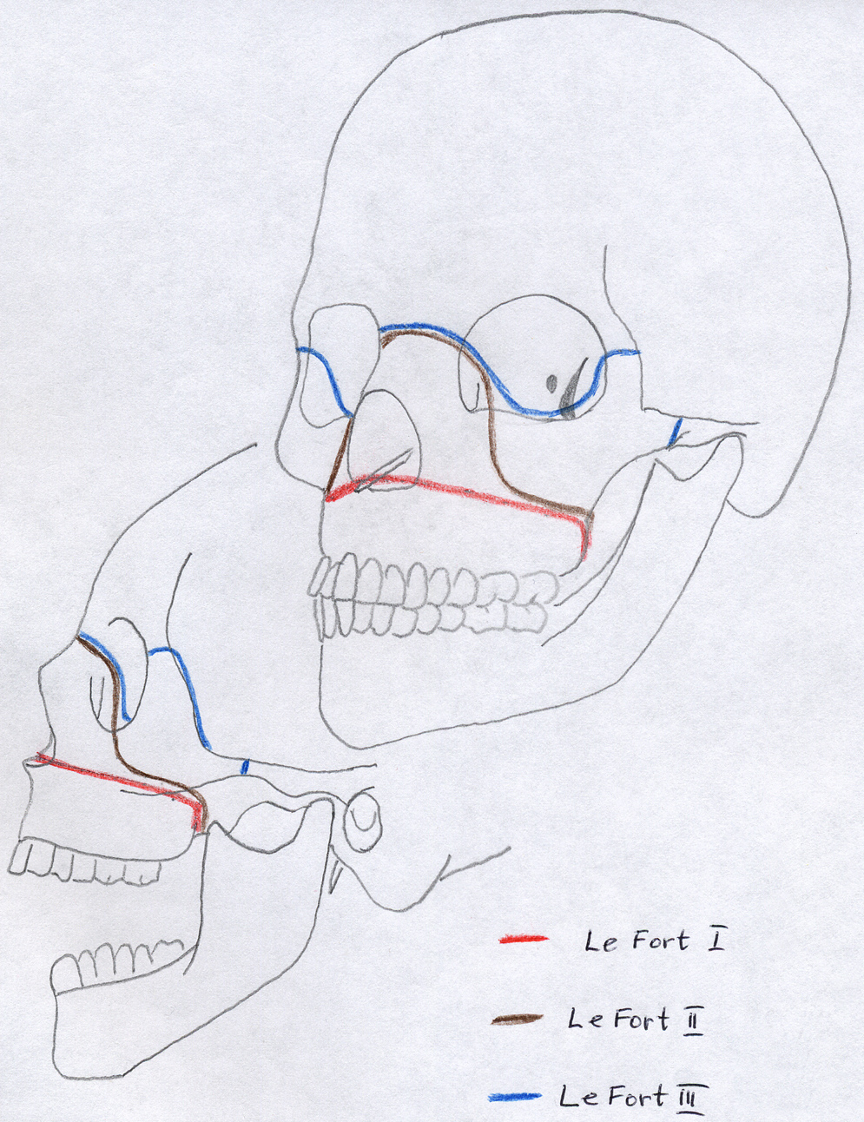

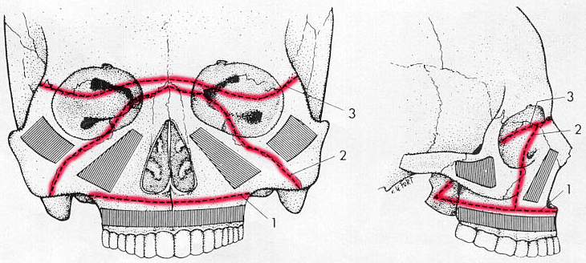

N.B. airway compromise is possible with any of these fractures (esp. Le Fort II and III).
- CSF rhinorrhea is common in Le Fort II and III.
- pterygoid processes are invariably fractured with any of Le Fort type!
- orbital fracture:
Le Fort II - anteromedial portion of orbit;
Le Fort III - both medial and lateral aspects of orbit.

Le Fort type I fracture (s. Guérin’s fracture, dentoalveolar dysjunction)
- fracture line begins at lower lateral edge of pyriform aperture (above alveolar ridge and hard palate), runs posteriorly through wall of maxillary sinus to lower parts of pterygoid plates.  - fracture also transects lower nasal septum.  - dental alveolar bone and hard palate are as single detached block ("floating" palate).  - segmental fractures of alveolar ridge and palate can also occur.  Clinically:  - upper lip lacerations  - malocclusion  - mobility of fracture fragment (on digital manipulation of incisor teeth by examiner's thumb and index finger)  - denervation of upper teeth. | 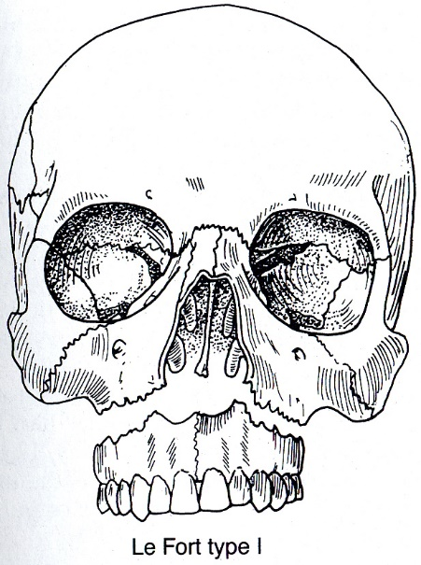

Axial CT - fracture line also extends through anterior nasal spine of maxilla (arrowheads):
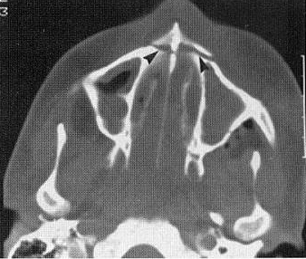

Treatment:
- closed reduction with arch bars → intermaxillary fixation. see p. TrH31 >>
- open reduction with internal fixation (e.g. intraosseous wiring or small plate osteosynthesis ± bone grafting).

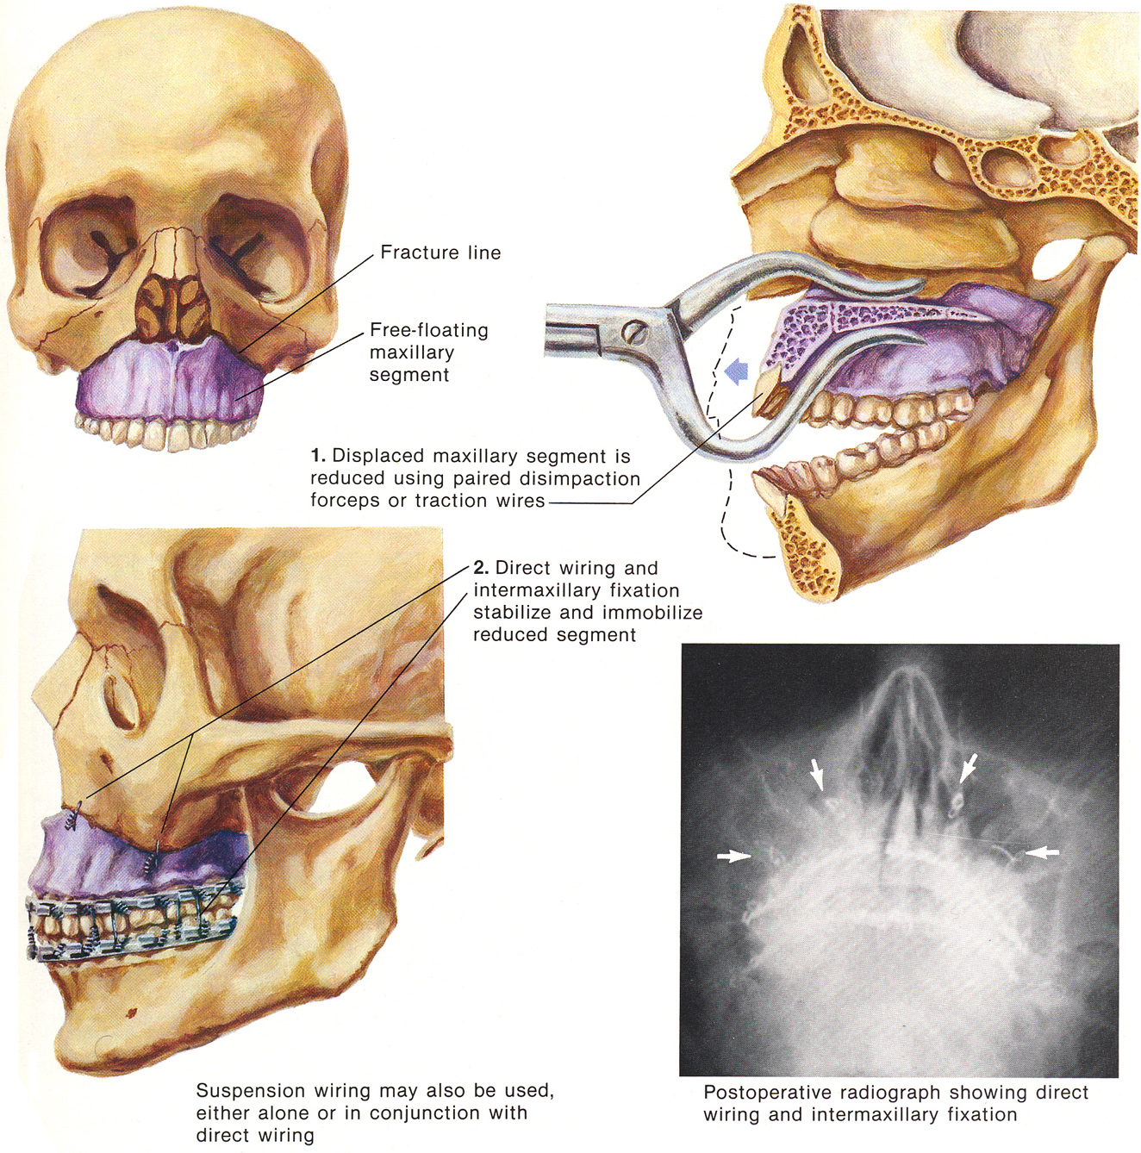
Source of picture: Frank H. Netter “Clinical Symposia”; Ciba Pharmaceutical Company; Saunders >>

Le Fort type II fracture (s. pyramidal fracture of mid-face)
- superior fracture line is transverse through base of nasal bones or through articulation of maxillary and nasal bones with frontal bones; extends laterally into medial orbital wall, through lacrimal and ethmoid bones; exits orbital floor anteriorly at medial / middle portion of infraorbital rim, runs around posterolateral wall of maxillary sinus, ends in midportion of pterygoid plates.  - in midline, fracture extends posteriorly from nasal bones through nasal septum.  - fracture fragment is pyramidal in shape.  Palatal split - right and left maxilla completely separated at midline of hard palate.  Clinically:  - digital manipulation of anterior maxilla → mobility of central triangle (maxilla and nose).  - denervation of upper teeth.  - epistaxis  - periorbital ecchymosis, step-off defect at inferior orbital rim. | 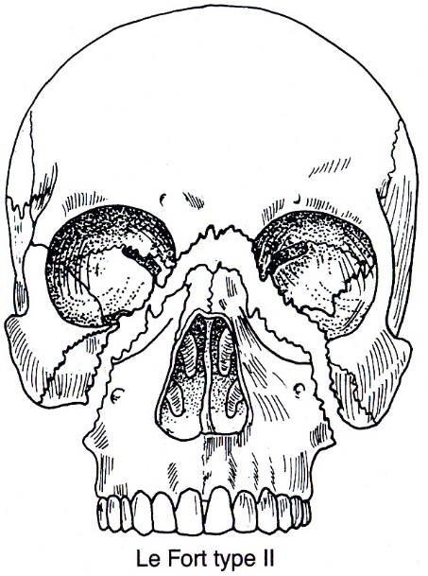

Waters’ view - pyramidal configuration of major fragment (arrows); comminuted nasal fracture (upper white arrow), bilateral fractures of posterolateral walls of maxillary sinuses (lower white arrows); frontal and maxillary sinuses opacified by hemorrhage:  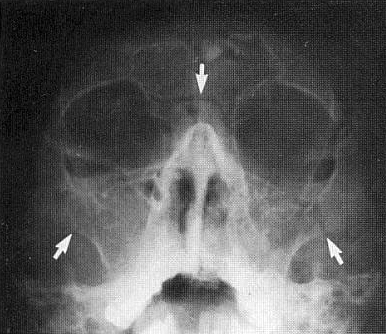 | Axial CT - bilateral comminuted fractures of maxillary sinuses (small arrowheads) and pterygoid processes (large arrowheads).  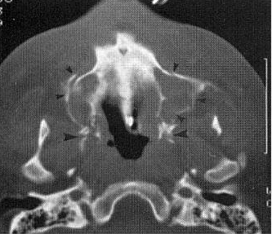
Axial CT - comminuted midpalatal split: main fracture line is diagonal (large arrowheads); left half of hard palate is posteriorly displaced; small comminuted fracture fragments adjacent to intact pterygoid processes (small arrowheads); mildly diastatic palatal fracture on left (white arrow):  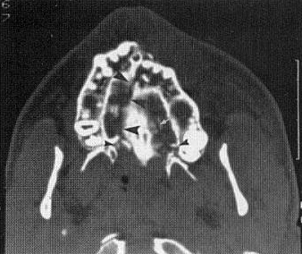 | Axial CT - fracture of anterior wall of left maxillary sinus: minimal anterior displacement of fragment (large arrowhead); adherent blood clot (white arrow) and small fluid level (small arrowhead) in sinus:  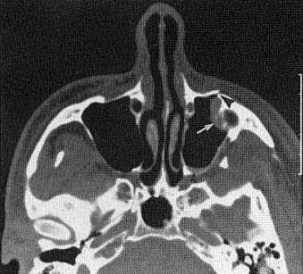

Treatment: reduction of maxilla, fixation in proper position (to cranial base above and to mandible below).
- occlusion with upper jaw is established using intermaxillary fixation.
- repaired midface is secured with 24-gauge suspension wiring to next highest stable point (infraorbital rim on stable zygomatic bone or zygomatic buttress area).
- Le Fort II compromises nasal airway, and if intermaxillary fixation has been done, tracheostomy is best to ensure airway (esp. if patient has cheek edema and full complement of teeth).

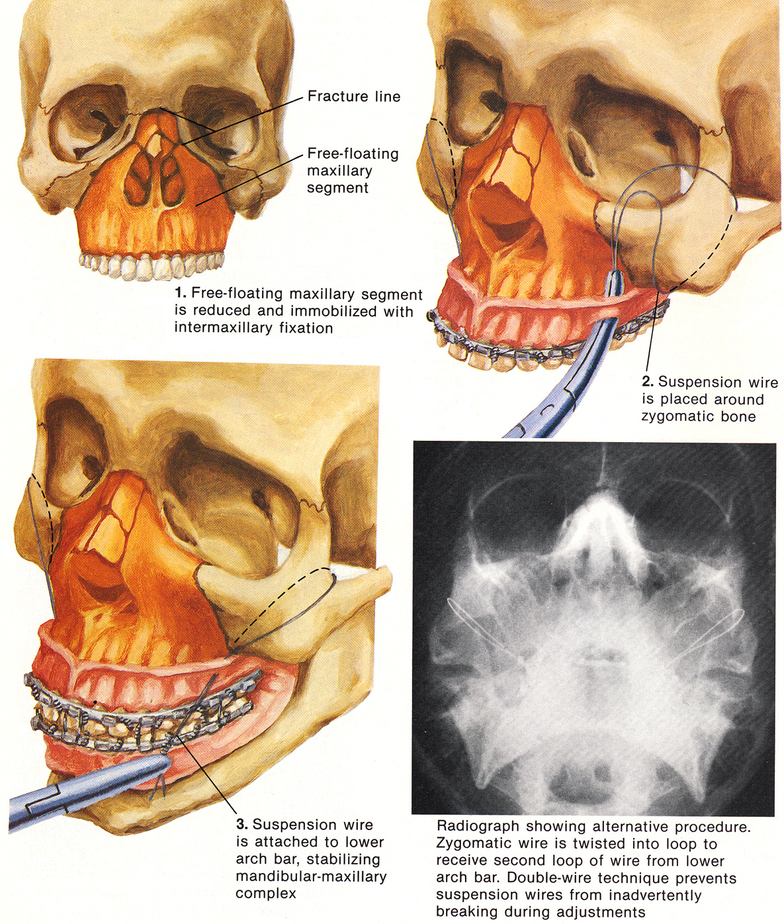
Source of picture: Frank H. Netter “Clinical Symposia”; Ciba Pharmaceutical Company; Saunders >>

Le Fort type III fracture (s. craniofacial dysjunction)
- highest level of midface injury - face is literally displaced from its attachments to cranial base: transverse superior fracture line is similar to Le Fort II, but at medial orbital wall it extends posteriorly or laterally (rather than anteriorly) and continues across orbital floor to inferior orbital fissure → runs through lateral orbital wall and rim (near zygomaticofrontal suture) → zygomatic arch, pterygoid fossa → ends in pterygoid plate bases.  - in midline, fracture goes through nasal spine of frontal bone and nasal septum (may extend into cribriform plate → CSF rhinorrhea).  Clinically:  - massive facial edema & ecchymosis  - elongated face, lateral orbital rim defect  - naso-orbital area appears flattened ("dish-panned")  - digital manipulation of anterior maxilla → mobility of entire middle third of face.  - epistaxis & CSF rhinorrhea.  - gagged (open-bite) occlusion (due to posteroinferior displacement of maxilla) - jamming upper molar teeth against lower.  - occasionally, midface may exhibit marked shortening and loss of mobility. | 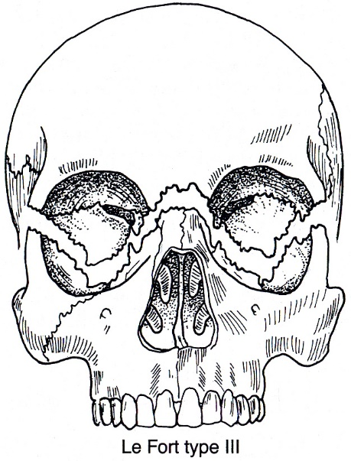

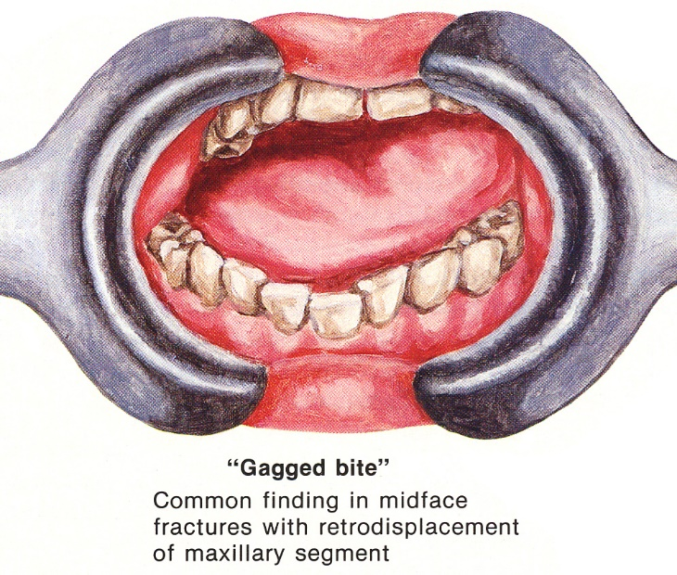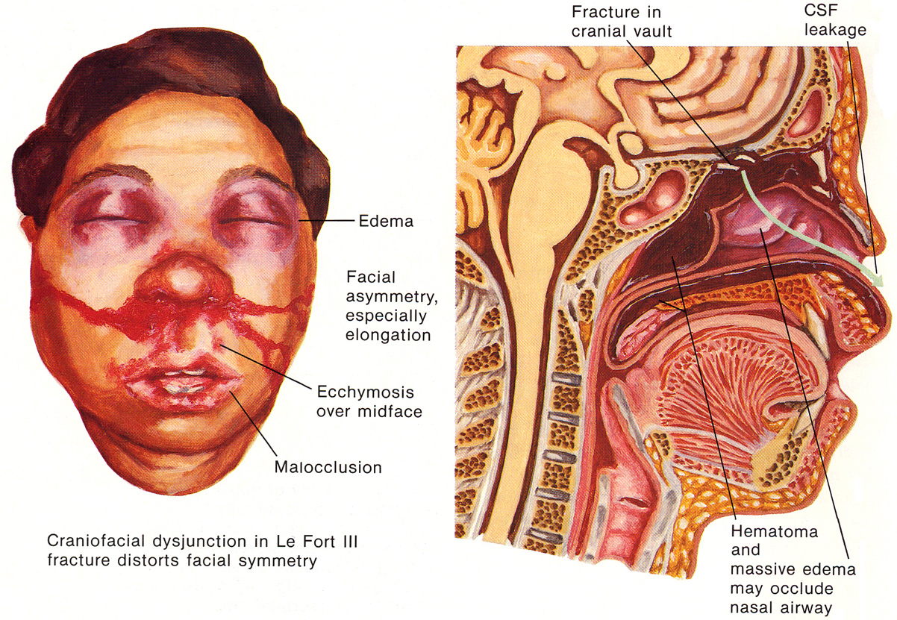

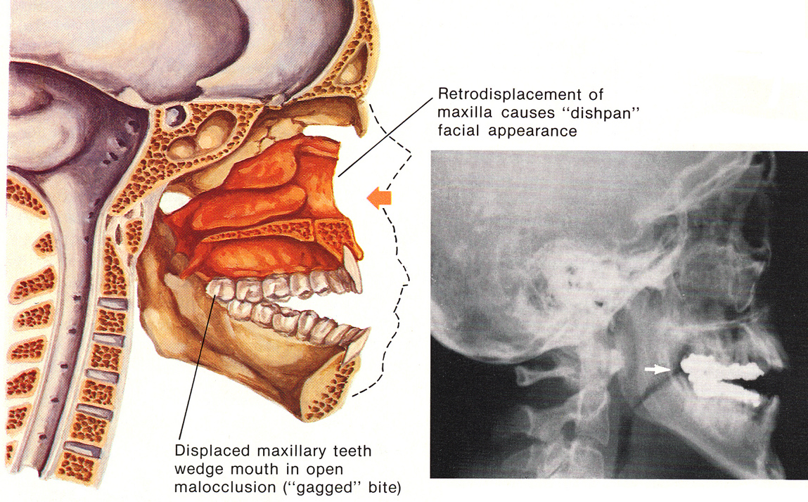
Source of pictures: Frank H. Netter “Clinical Symposia”; Ciba Pharmaceutical Company; Saunders >>

Coronal CT:  Right Le Fort III (black arrowheads) - fractures of both medial and lateral orbital walls.  Bilateral Le Fort II (white arrows) - fractures of inferior orbital floors and posterolateral walls of maxillary sinuses.  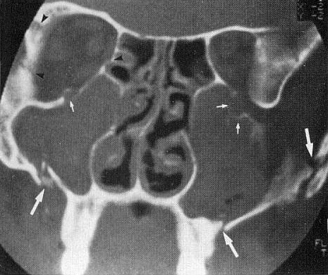 | Coronal CT - bilateral Le Fort II and left Le Fort III: bilateral comminuted inferior orbital-wall and rim fractures (large arrowhead); medial and lateral orbital-wall fractures on left (medium arrowhead); right medial orbital wall is normal (small arrowheads):  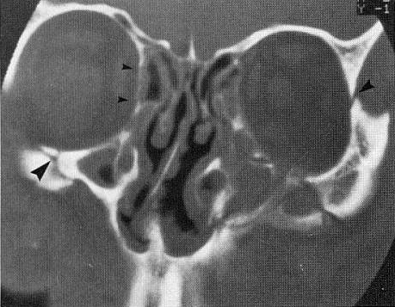
Coronal CT views (15 mm separation) - right Le Fort III and left Le Fort II:
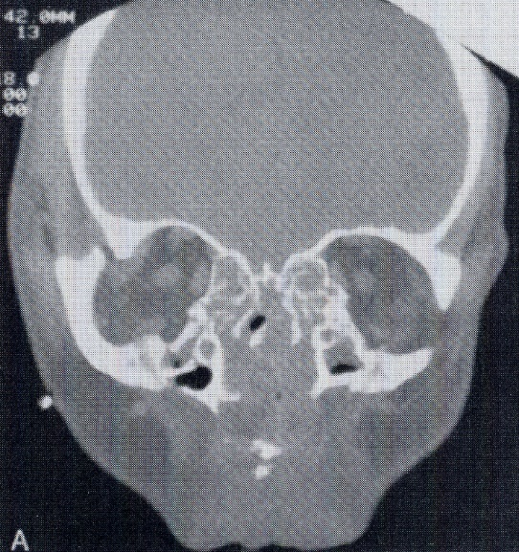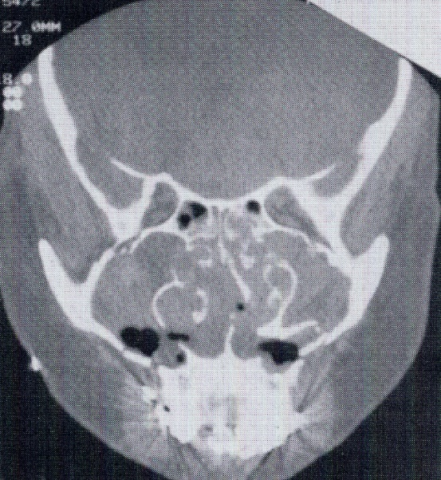

Treatment - reduction and stabilization of midface complex between cranial base and mandible.
- often require open reduction and internal fixation with interosseous wiring or plating of frontal bone medially at nasal root and laterally at orbital rim, repair of associated nasoethmoidal-orbital component, suspension to frontal bone, and intermaxillary fixation.
- most severe cases - bone graft reconstruction of orbital walls and floor.

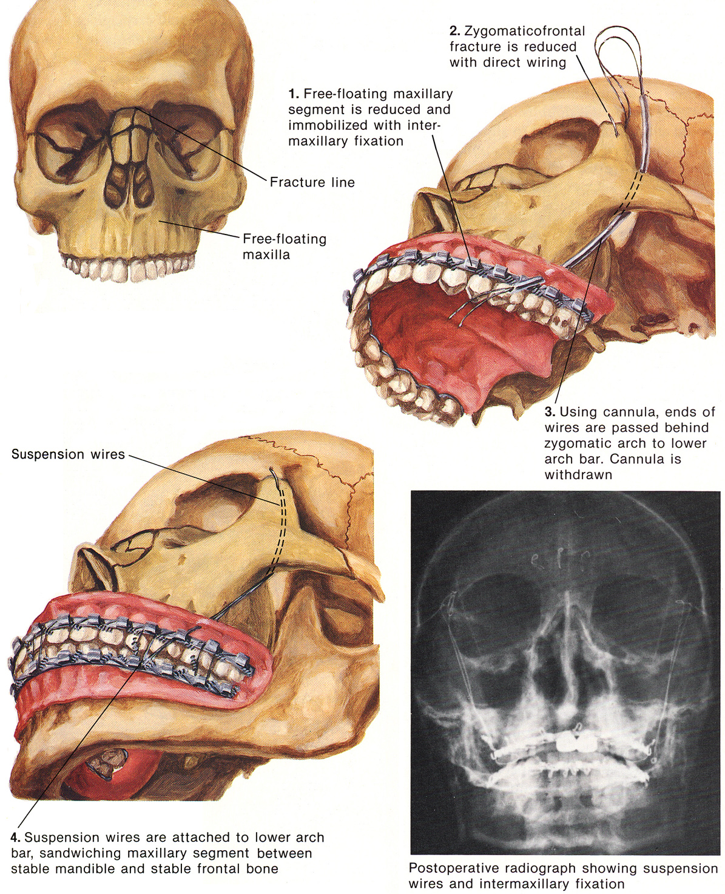
Source of picture: Frank H. Netter “Clinical Symposia”; Ciba Pharmaceutical Company; Saunders >>

Zygomatic Fracture
Zygoma fractures at four main articulations:
  - frontozygomatic suture at superior-lateral rim;
  - zygomaticomaxillary suture at infraorbital rim (may cross infraorbital foramen → sensory loss over cheek, side of nose, upper lip, gum, and teeth);
  - zygomaticotemporal suture at midportion of arch;
  - zygomaticomaxillary buttress (easily palpated intraorally at maxillary buccal vestibule).

Zygoma is 2nd most commonly fractured bone of midface (fractures occur more often at articulations of zygoma rather than in zygoma itself).

zygomatic complex = zygomatic bone and its articulation with frontal, maxillary and temporal bones superficially + articulation with greater wing of sphenoid bone, palatine bone, and other bones in deeper plane.

Zygomatic arch fracture
Clinically:
- palpable bony defect over arch.
- unilateral pain on closing mandible.
- medial displacement of arch fragments may impinge on coronoid process of mandible (can prevent normal motion → trismus).

Diagnosis: X-ray submental-vertex view (or oblique variation - known as "jug-handle" view).

Treatment (not required for undisplaced fracture) – open reduction and internal fixation.

Submentovertical projection of comminuted, depressed fracture of right zygomatic arch - fractures anteriorly, posteriorly, and in midportion of arch (arrowheads and arrow):
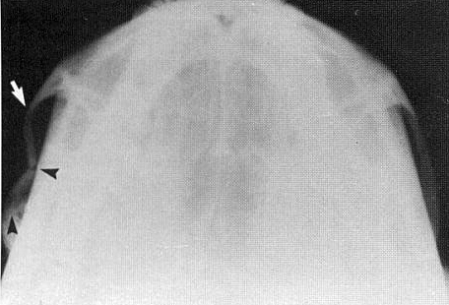

Zygomaticomaxillary (Tripod, Trimalar) fracture
- force striking prominence of zygomatic bone → fracture (or separation) at main attachments with adjacent bones - inferior orbital wall and rim, lateral orbital wall and rim, zygomaticofrontal suture, zygomatic arch, anterior and posterolateral maxillary sinus walls usually are involved.

Clinically:
- flatness of cheek - displacement of zygoma (inferiorly, medially and posteriorly) is very common!
- palpable step defects at infraorbital rim and at zygomaticofrontal suture.
- periorbital ecchymosis, subconjunctival hemorrhage, lowered palpebral fissure.
- limited movement of mandible (displaced zygomatic bone impinges on motion of coronoid process).
- unilateral nosebleed (bleeding from maxillary sinus into nose).
- complications similar to orbital blowout fractures (diplopia in upward gaze, anesthesia in distribution of infraorbital nerve, etc).

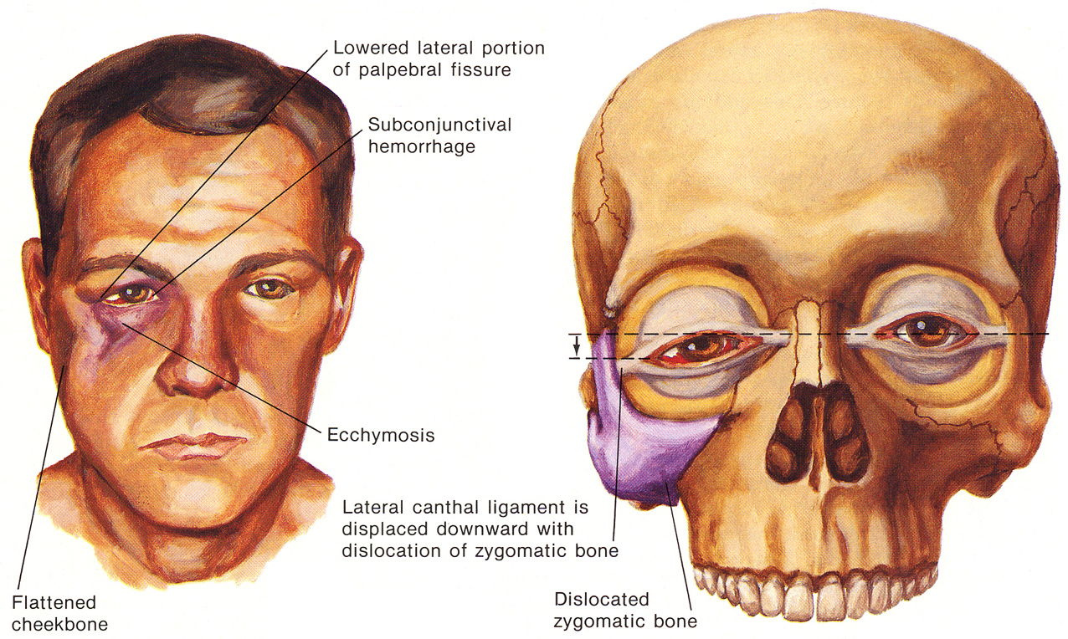
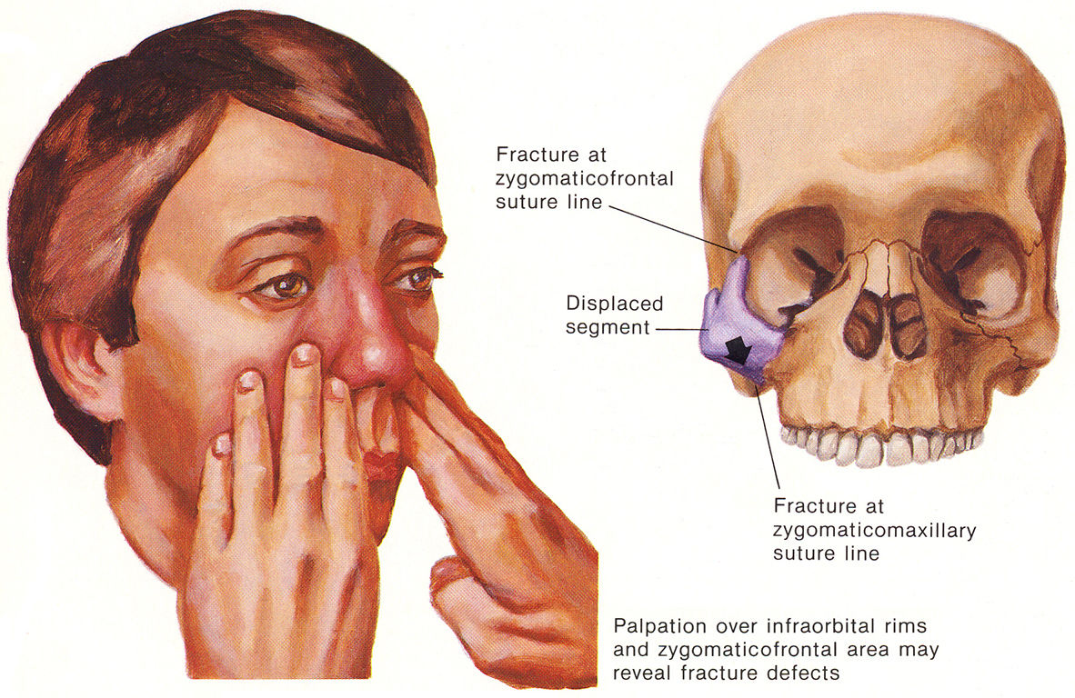
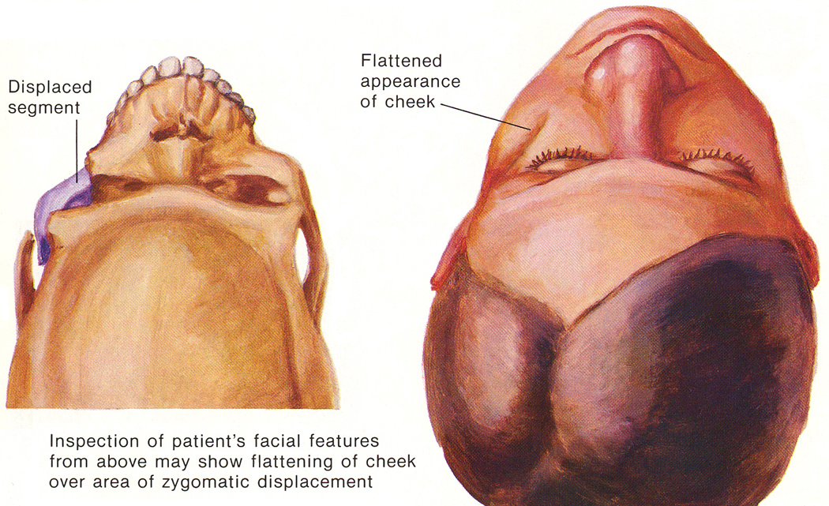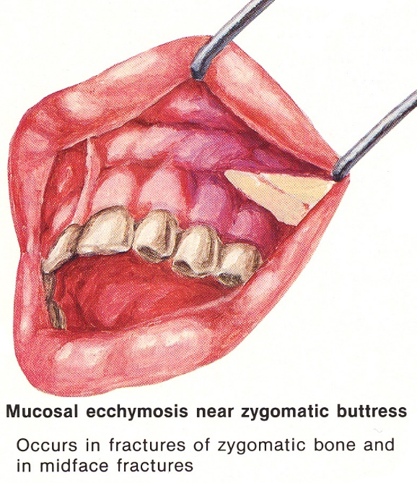
Source of picture: Frank H. Netter “Clinical Symposia”; Ciba Pharmaceutical Company; Saunders >>

Diagnosis:
X-ray Waters' view - on fractured side: orbital inlet is larger, maxillary sinus appears smaller; osseous disruption at infraorbital rim, clouding of maxillary sinus, fracture dislocation at zygomaticofrontal suture line and at buttress with zygomaticomaxillary bone.
CT – best diagnostic test!

Left zygomaticomaxillary fracture (Waters view) - zygomaticofrontal suture separation (upper arrowhead); fracture in area of zygomaticosphenoid suture (middle arrowhead); fracture in lateral wall of maxilla (inferior arrowhead); wire sutures on right are related to old zygomaticomaxillary fracture:
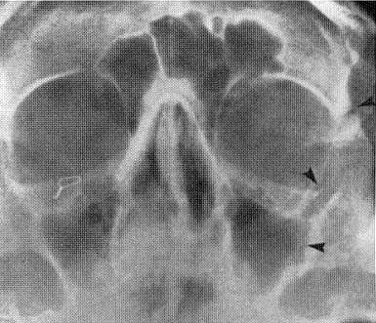

Treatment:
- usually reduced easily - osseous complex is elevated into position (through intraoral or temporal approach), and zygomatic bone snaps into place and remains stable.
- if zygomatic bone does not snap into place or remain reduced (probably soft tissue interposed or osseous comminution) → open reduction and wire fixation in at least two fracture areas (usually at zygomaticofrontal suture and zygomaticomaxillary suture along infraorbital rim):
At zygomaticofrontal suture:  - small holes for wire fixation are drilled through each of zygomatic processes of frontal bone, which are usually stable, approximately 0.5 cm from fracture line.  - holes may be directed either into orbit (orbital contents are protected by surgical instruments such as periosteal elevator or malleable retractor) or posteriorly into temporal space.  - 24-gauge stainless steel wire is passed in simple vertical mattress fashion and zygomatic bone is reduced.  - zygomaticofrontal fracture line is irregular - bony fragments usually interdigitate well when wires are twisted. | 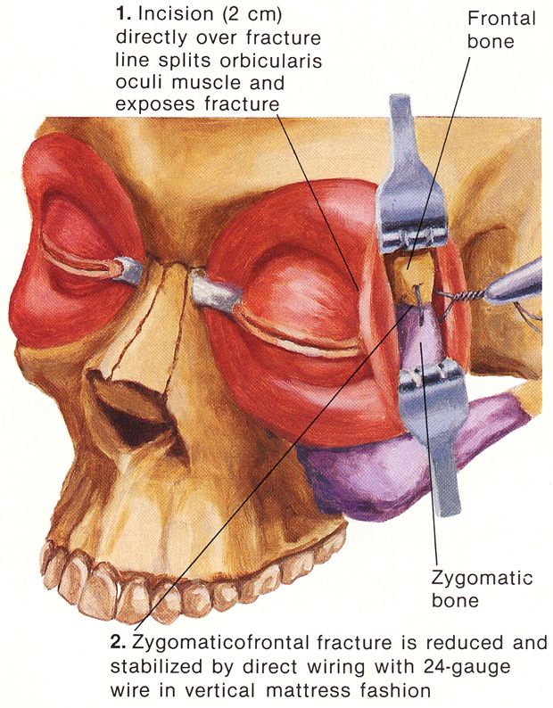
At zygomaticomaxillary suture:
  - stepped incision. see p. TrH27 >>
  - orbital rim is triangular and fairly heavy cortical bone - wiring is placed through this bone (rather than through thin bone of orbital floor or anterior maxillary wall).
  - when figure-of-eight wire is twisted, pressure is brought to bear on stronger osseous cortical rim, not on thin bone, so that reduced zygomatic bone will be firmly supported.
  - in some instances additional vertical wire may be placed through maxillary bone and zygomatic bone at buttress area to act as suspension wire to prevent medial drift of zygoma and maintain it in its proper lateral position.

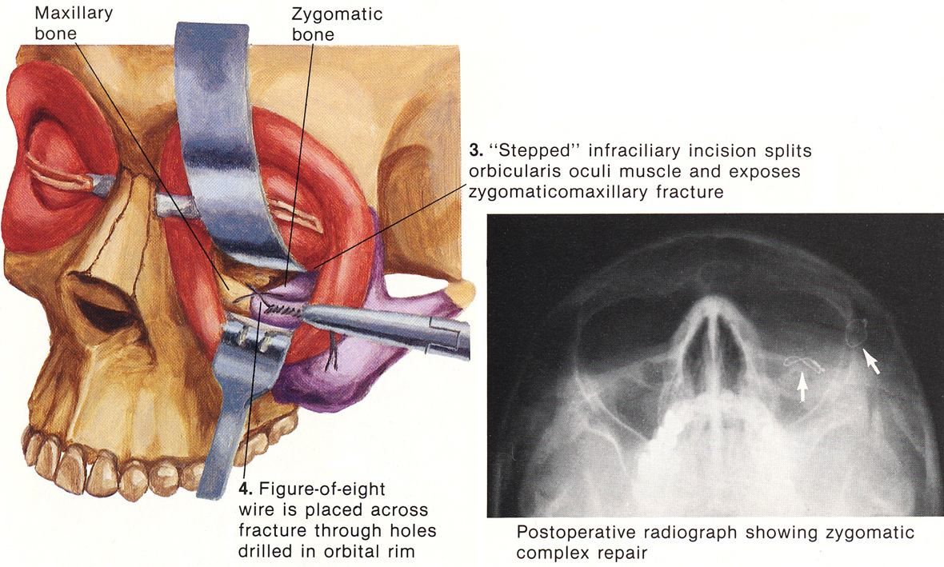
Source of picture: Frank H. Netter “Clinical Symposia”; Ciba Pharmaceutical Company; Saunders >>

Antral packing
– insertion of space-occupying pack in antrum.
  - indication - extensive comminution of zygomaticomaxillary complex or of orbital floor when repair cannot be maintained in reduced position with direct wiring alone.
  - intraoral incision along buccal sulcus.
  - reflection of large mucoperiosteal flap exposes anterior antral wall (usually not intact because zygoma fractures frequently radiate across anterior maxilla; if wall is intact - window is formed with chisel or burr initially, then with rongeurs forceps).
  - finger or instrument is inserted to elevate zygoma and pack maxillary sinus.
  - either gauze or antral balloon is used for packing (gauze is packed systematically for easy removal).
  - it is good practice, but not always necessary, to create antrostomy in medial wall of maxillary sinus, for drainage; after antral packing is removed, this opening closes rapidly.

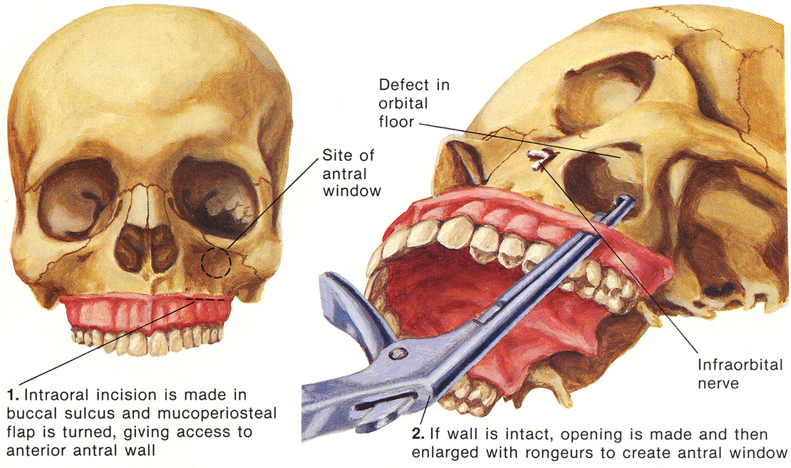
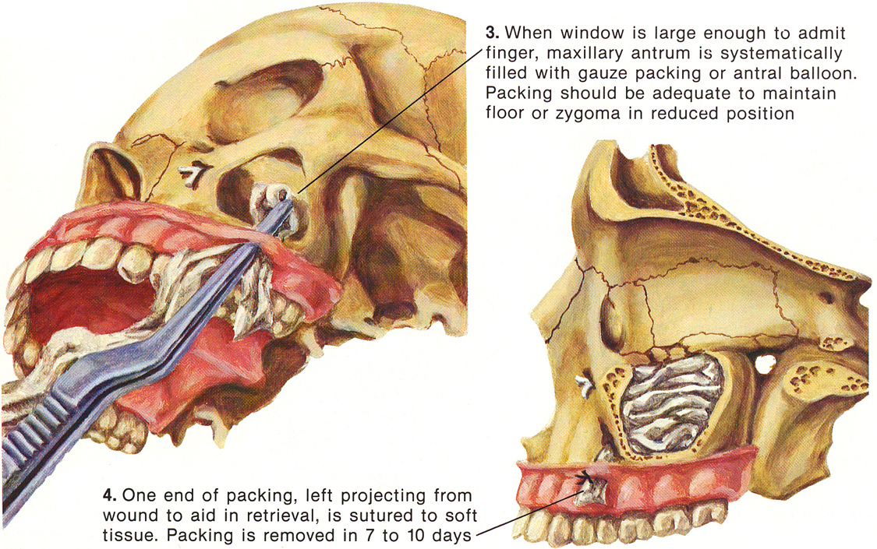
Source of picture: Frank H. Netter “Clinical Symposia”; Ciba Pharmaceutical Company; Saunders >>

N.B. results may not be cosmetically acceptable in cases of massive bone comminution → reconstruct area by alloplastic or autogenous bone augmentation, or perform osteotomy and repair defect with bone graft.

Soft-tissue Injuries of Nose
Anesthesia: wound infiltration + regional block (infraorbital nerve + supratrochlear nerve).
see p. Op460 >>

Through-and-through lacerations require layered closure:
- at first, mucosa is closed with fine absorbable suture.
- approximate any fractured cartilage with similar suture.
- irrigate after closure of each layer (avascular cartilage is susceptible to infection!).
- skin is closed with careful attention to visible landmarks (e.g. rim of ala):
- fine nonabsorbable suture (synthetic or silk)
- running subcuticular absorbable suture – preferable because of high incidence of stitch abscesses and subsequent scarring (resulting from high bacterial content in pores of skin of nose).

Septal hematoma
- should be sought & treated in all cases of nasal trauma!
Failure to treat:
ischemic necrosis of septal cartilage → nasal collapse (“saddle nose”);
abscess formation → drainage into cavernous sinus.
- forms between quadrilateral cartilage and perichondrium.

Clinically (on intranasal examination with speculum; children may need general anesthesia) - large, purple, grapelike swelling over nasal septum totally obstructing nasal passages bilaterally.
N.B. nasal fracture never causes near total bilateral nasal airway obstruction!

Treatment:
  - topical anesthesia (cotton strips moistened with 5% cocaine, well wrung out).
  - palpate with end of forceps to determine which side of septum contains hematoma (fluctuant), and which side is displaced cartilage.
  - infiltrate septal mucosa (on hematoma side) with local anesthetic.
  - simple 1 cm vertical incision;
    - if hematoma is of some duration, blood may be coagulated - longer incision required to evacuate clot.
  - aspirate / express hematoma, collapsing mucosa onto cartilage.
  - insert Penrose drain distance of 3-5 cm.
  - firm anterior nasal pack (to prevent reaccumulation); pack opposite side for counter pressure.
  - antibiotic (e.g. amoxicillin) while packs are in.
  - remove packs in 72 hours → careful follow-up by otolaryngologist / plastic surgeon.

A. Hematoma fluctuates when tested with forceps.
B. Mucosal incision of 1 cm.
C. Insert Penrose drain distance of 3-5 cm:
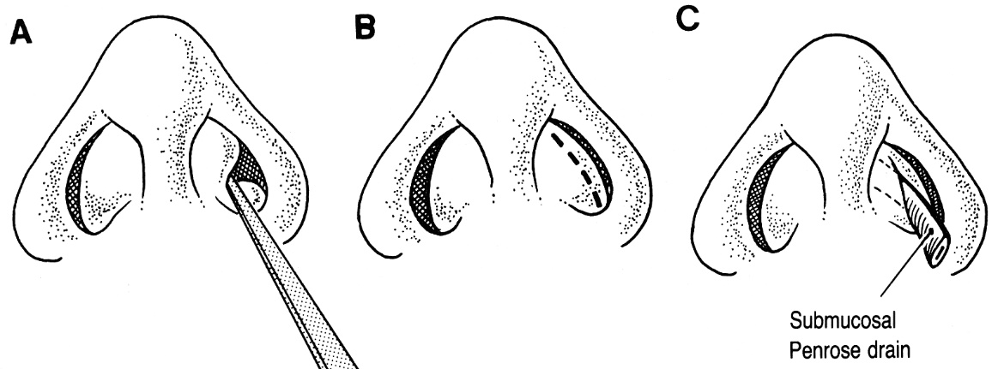

Nasal Fracture
- most common facial fracture!
- ≈ 50% are part of complex facial fracture.
- most fractures are transverse linear (through thinner lower 1/3 of nasal bones).
- distal fragment is depressed and displaced laterally or posteriorly (depending on direction of traumatic force).

Clinical Features
- Ecchymosis & swelling over dorsum of nose
- Pain, tenderness, crepitus
- Epistaxis (usually minor – mucosal edema stops bleeding spontaneously!)
- Instable bony irregularities (may be masked by swelling); history of any previous nasal injury is important in evaluating architecture!
- Intranasal examination – seek for septal hematoma, intranasal lacerations.

Diagnosis
- largely made on clinical evidence!!!
X-ray – of almost no help (esp. in children – immature structures):
- lateral view!!!
- PA view
- Waters' view – septal deviation
- axial view using occlusal film – medial and lateral displacement of fragments.
longitudinal fractures (parallel to long axis of nose) are more difficult to diagnose - confusion with groove for nasociliary nerve or supernumerary suture lines!

Nasal fractures in children are difficult to diagnose - any child with posttraumatic epistaxis / tenderness / swelling should be referred to otolaryngologist / plastic surgeon for reevaluation within 4-5 days.

Lateral view - transverse fracture (top arrowhead) through anterior portion of nasal bones; distal fragment depression (middle arrowhead); intact anterior nasal spine of maxilla (bottom arrowhead).  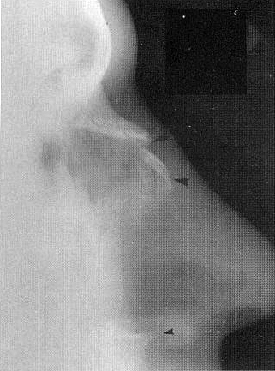 | Lateral view - normal nasal bones; nasofrontal suture (large arrowhead); nasociliary grooves (small arrowheads); nasomaxillary suture (medium-sized arrowhead):  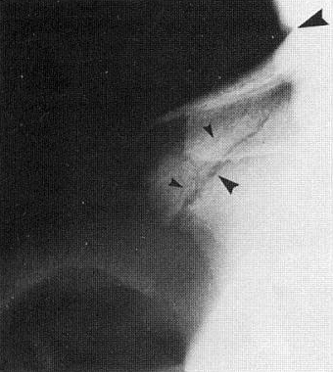
Lateral view - comminuted nasal fracture - multiple displaced fragments (arrowheads):  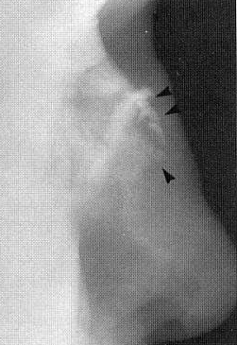 | Waters view - comminuted nasal fracture - considerable lateral displacement of right nasal bone fragments (arrows) - much greater than was suspected from lateral view:  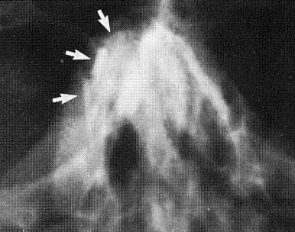

Treatment
A. Closed treatment (after closure of any lacerations)
Anesthesia:  Adults:  - premedication (meperidine or morphine).  - intranasal anesthesia (cotton strips moistened with 5% cocaine).  - local infiltration (½ inch 25G or 27G needle) at root of nose and lateral margin of nose:  Children - general anesthesia. | 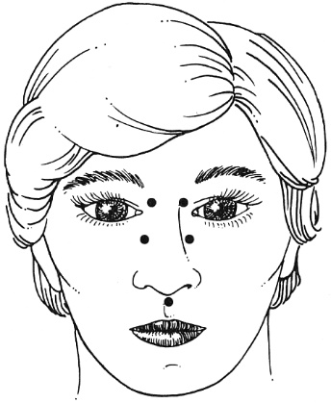
Reduction (must be especially accurate in children - growth potential of nose):
- delayed reduction (up to 7-10 days in adults, versus 3-5 days in children) – vanished edema!
- immediate reduction – when epistaxis is difficult to control or severe deformation.
- malaligned nasal bones are mobilized and reduced into proper position:  - medial displacement – insert instrument (surgical knife handle, Howarth blunt nasal elevator or Walsham nasal forceps) medial to displaced nasal bone → upward and lateral motions are carried out to dislodge bone.  - lateral displacement – reposition by medial pressure using finger tips.  - septum is placed in maxillary groove and manipulated to correct deviations. | 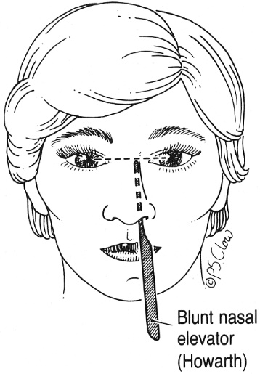

Position is maintained by:
  - internal anterior gauze packing – gauze strip (saturated with antibiotic ointment) is packed systematically with nasal speculum to prevent placing it submucosally (if there is undiagnosed intranasal laceration); remove after 3-4 days. see p. 2174 >>
PLUS
  - external splint (plaster, dental compound or preformed metal) - stabilizes nasal fracture against gauze packing + protects nose from injury; splint remains in place for 7-10 days.
Discharge with analgesics and ice packs (for first 12 hours); sleep with head elevated; sneeze through mouth; do not blow nose; avoid vigorous exercise.
- follow-up after 5-7 days (when swelling is gone); if necessary – rebreak and realign according to photos.

B. Open reduction & wiring
- only when deviated cartilaginous septum cannot be stabilized in maxillary groove.
- acute submucous resection may be required to obtain desired result.
N.B. nasal fractures in children are treated conservatively (growth of nasal septum may be impaired by surgical disruption and septal hematoma!).

Naso-Orbital Injuries
Clinical Features
- triad:
- Widened nasal bridge
- Detachment of medial canthal ligaments → telecanthus of 40-45 mm* (because of resilience of lateral canthal ligaments).
medial canthal ligament is normally attached to anterior and posterior lacrimal crests of lacrimal bone, majority of attachment being to anterior lacrimal crest; between these two leaves of medial canthal ligament nasolacrimal duct passes.
*normal intercanthal distance in white adult is ≈ 34 mm.
- Medial portion of palpebral fissure assumes almond configuration (vs. normal elliptical shape).

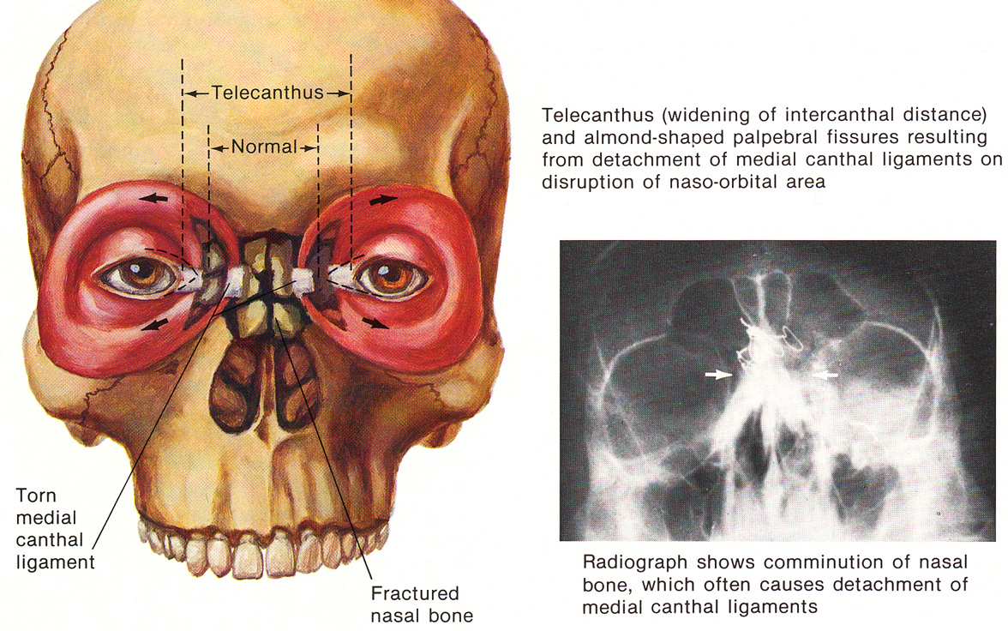
Source of picture: Frank H. Netter “Clinical Symposia”; Ciba Pharmaceutical Company; Saunders >>

Diagnosis
X-ray Waters' projection

Treatment
- telecanthus is best repaired immediately (later reconstruction is difficult).
Open reduction and internal fixation:
- temporary nasal packing (at beginning of reparative procedure) helps align disrupted anatomy.
- multiple interosseus wires are required in comminuted fractures to restore normal configuration.
- medial canthal ligament is best approached subperiosteally.
- nasal packing or intranasal suturing of lacerations, or both, is required to maintain soft tissue adapted to bone and cartilage.
- lead nasal compression plates support reduction.
- plates should be large enough to encompass frontal process of maxilla, nasal bones, portion of frontal bone.
- large curved Mayo needle is used to place stainless steel 24-gauge wires (± small holes can be drilled to allow passage).
- lower transnasal wire used to secure plates should pass beneath or through frontal processes of both maxillae to hold these structures up and forward when wires are tightened.
- compression plates are snugly tightened to maintain open reduction position of medial canthal ligaments and osseous skeleton.
- plates remain in place for 10-14 days (wire is periodically tightened if plates loosen); ulceration sometimes occurs despite plates are well contoured (but usually heals without cosmetic defect).
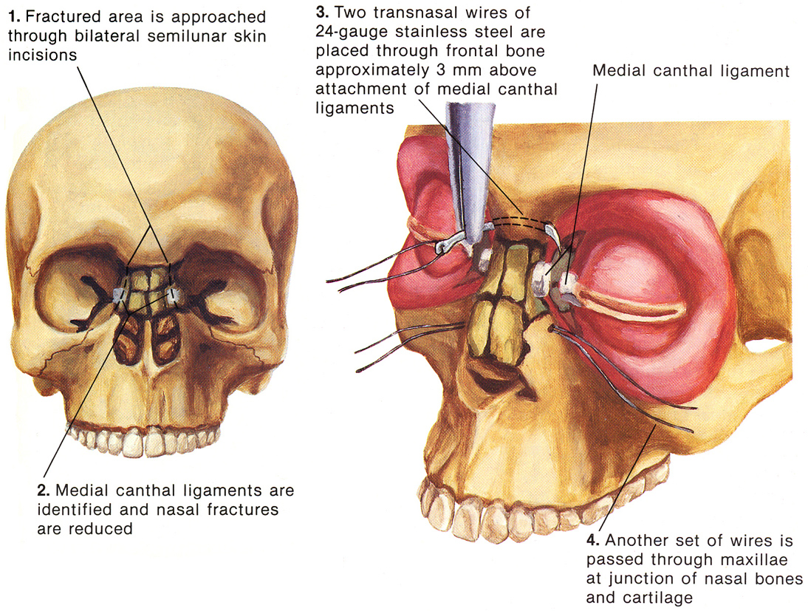
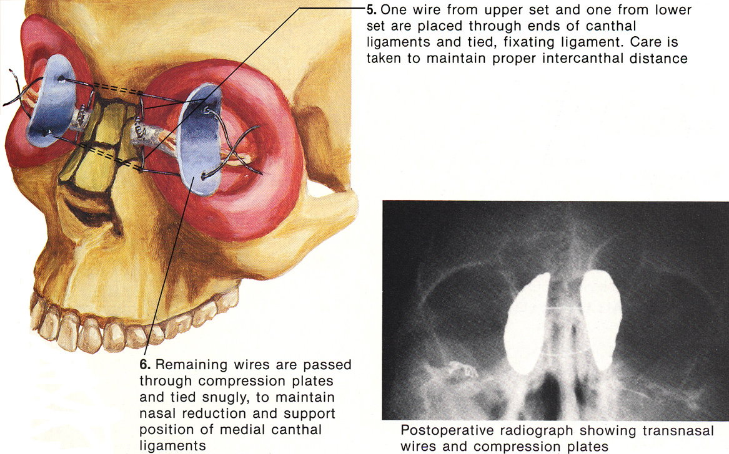
Source of picture: Frank H. Netter “Clinical Symposia”; Ciba Pharmaceutical Company; Saunders >>

Nasofrontoethmoidal Complex Fracture
- direct blow to upper nasal region.
- typically involve medial walls of orbit (lamina papyracea) - displaced into medial aspect of orbit.
- structures most frequently injured are medial rectus muscles, optic nerves, and frontal sinus drainage pathways.
- CSF rhinorrhea (±persistent epistaxis) is common complication.
- CT is necessary.

Axial CT - nasal bones displaced posteriorly, with telescoping into ethmoid sinuses (inside arrows); walls of ethmoid sinuses (lamina papyracea) displaced laterally into orbits (long arrows); lateral walls of orbits also fractured:
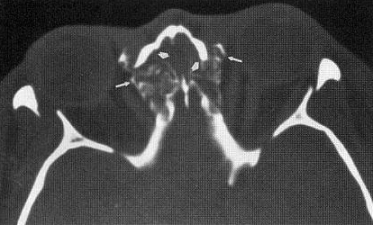

Bibliography for ch. “Head Trauma” → follow this link >>

Viktor’s Notes℠ for the Neurosurgery Resident
Please visit website at www.NeurosurgeryResident.net

