Facial Trauma (Mandibular, Dental)
Last updated: January 7, 2022
Mandibular Fracture 1
Clinical Features 1
Diagnosis 2
Treatment 2
Temporomandibular Joint Dislocation 4
Etiology 4
Clinical Features 4
Diagnosis 4
Treatment 4
Dental Trauma 4
Tooth Fracture 4
Diagnosis 5
Therapy 5
Tooth Avulsion 5
Therapy 5
Tooth Subluxation (Partial Avulsion) 5
Tooth Intrusion 5

Mandibular Fracture

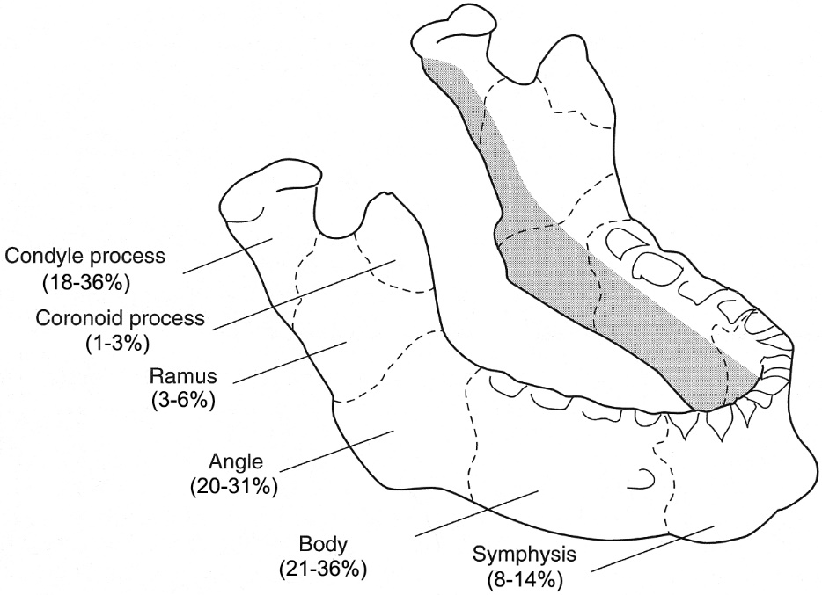

- in > 50% cases, mandible is broken in ≥ 2 places.
- mandible is U-shaped - traumatic force radiates around mandible to point opposite area where blow was received → multiple fractures (coup & contrecoup).

Common combinations:
  - cuspid area (less bone because of length of cuspid tooth root) + opposite angle in 3rd molar area (esp. if 3rd molar is only partially erupted)
  - cuspid area + opposite condyle.
  - symphysis + angle.
  - symphysis + one or both condyles.

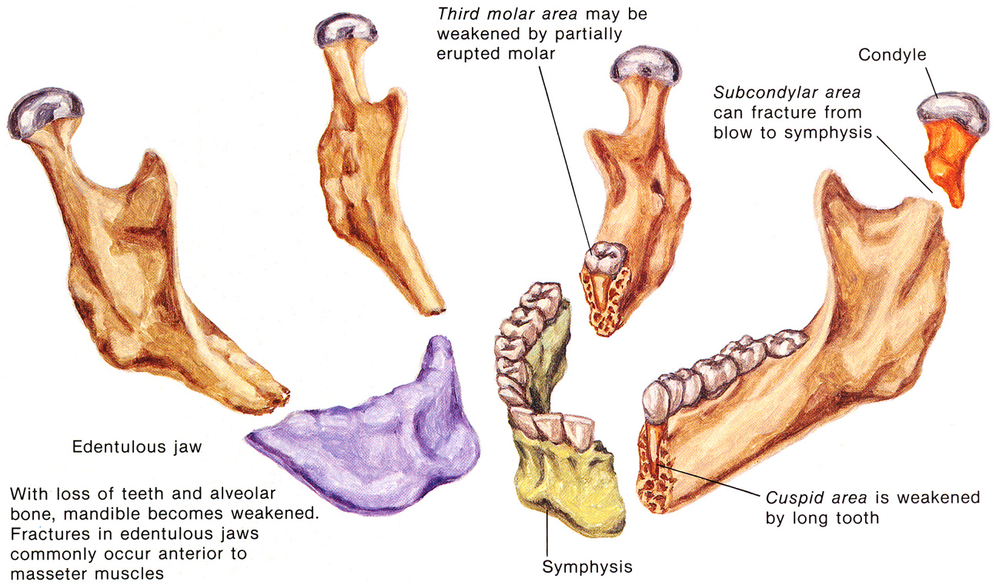
Source of picture: Frank H. Netter “Clinical Symposia”; Ciba Pharmaceutical Company; Saunders >>

Clinical Features
    - Dental malocclusion (“teeth do not come together properly”); gently manipulate bimanually - to detect false motion or palpable fracture lines ("step" defect).
symphyseal fracture – malocclusion between left and right sides.
    - Mouth floor ecchymosis - almost pathognomonic to mandibular fractures.
external bruising without fracture does not produce mouth floor ecchymosis - because mylohyoid muscle attachments extend around entire medial surface of mandibular body, and any bleeding would have to migrate superiorly past attachments to appear in floor of mouth, which is impossible).
    - Pain, contusion and laceration over affected area; in inferior border.
    - Restriction or deviation when mouth is opened;
unilateral condylar fracture - jaw deviates to affected side when mouth is opened;
bilateral condylar fractures - anteriorly opened bite.
    - Inferior lip & chin tingling (inferior alveolar nerve).
    - Bleeding at tooth base signifies open fracture through socket.
    - Palpate condylar movement by placing little fingers in patient's external ear canals and opening jaw – nonpalpable / asymmetric condylar movements ± blood in external ear canal (condylar fracture).
    - Day after injury, strong odor of blood and stagnant saliva may be present.

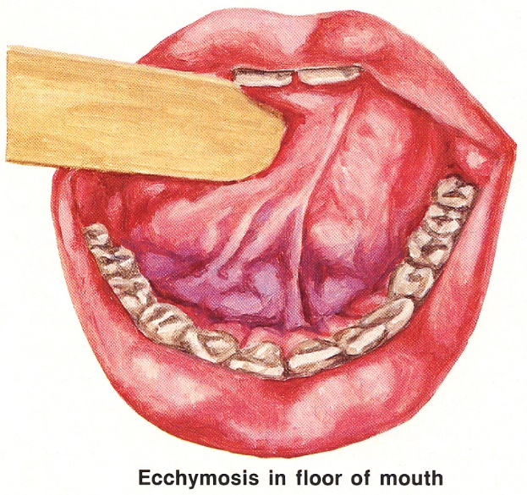
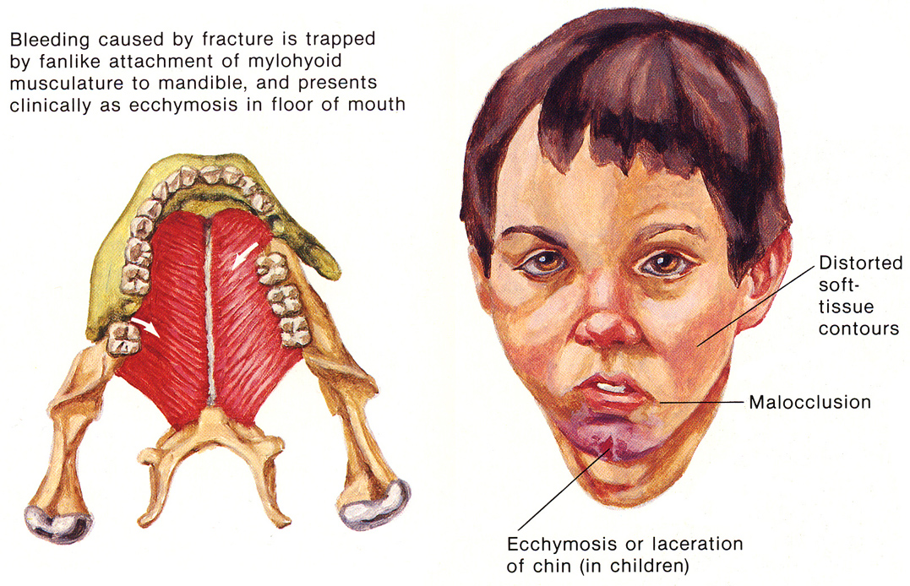
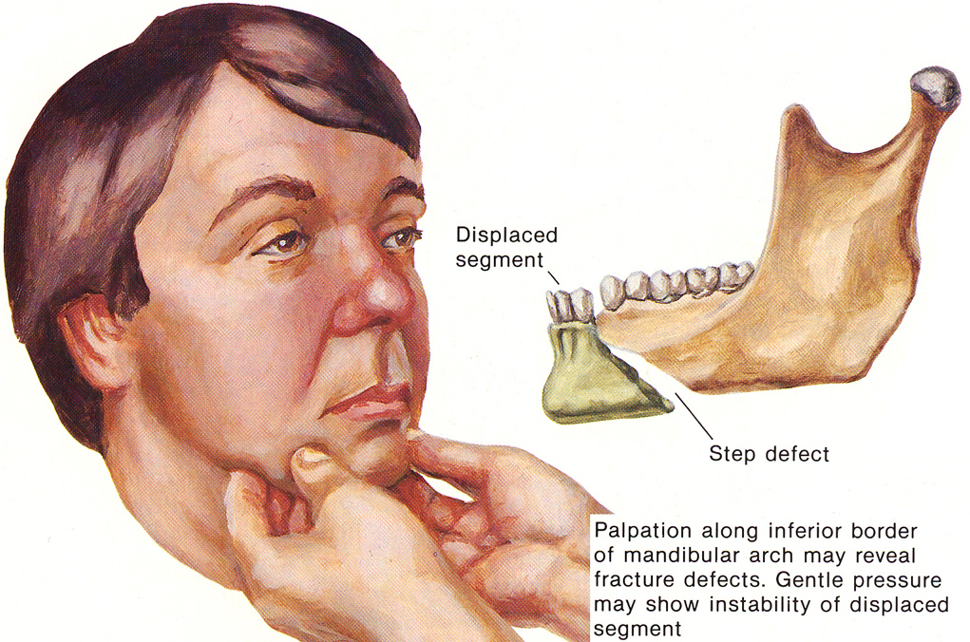
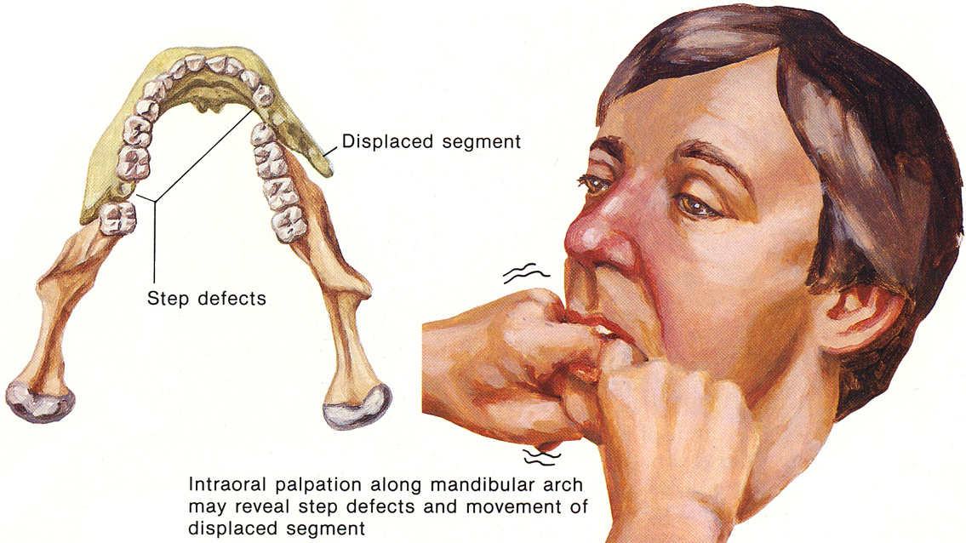
Source of pictures: Frank H. Netter “Clinical Symposia”; Ciba Pharmaceutical Company; Saunders >>

Diagnosis
- most mandibular fractures are best evaluated with panoramic X-ray films; if not available → standard views will suffice:
PA view - ramus, body, angle.
lateral oblique view - body, ramus, condyle, coronoid process.
occlusal view - symphysis.
N.B. all findings should be corroborated with clinical findings (X-ray findings may represent old fractures!).
- some condylar fractures, may be detected only by CT in coronal plane!
- dental models (if available) can provide valuable information about tooth and jaw relationships prior to injury.

Panoramic X-ray - fractures in area of left angle and right body (dental retainer appliance is in place on lower incisors):
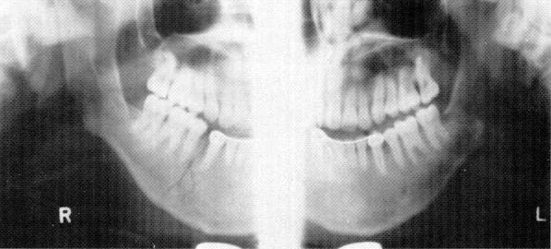

Treatment
- as precise and expeditious as possible (malocclusion is major long-term complication!!! + risk↑ of osteomyelitis and nonunion by extended period without reduction and fixation)
- location and direction of fracture line are critically important in degree of displacement and success of reduction maintenance.
- open fractures – give antibiotics, e.g. penicillin G or cefazolin (at least in interim between injury and reduction of fractures - bacterial colonization continues until fragments are reduced).

- Fractures in tooth-bearing bone:
- fractures that displace mandible forward (fracture line parallel to ramus - muscles help to stabilize fracture) → arch wire supports to teeth → diet of soft foods.
- fractures that displace mandible backward (fracture line perpendicular to ramus - muscles displace fracture) → intermaxillary (occlusion) fixation (attaching arch bars or splints to teeth and aligning upper and lower jaws in proper position).
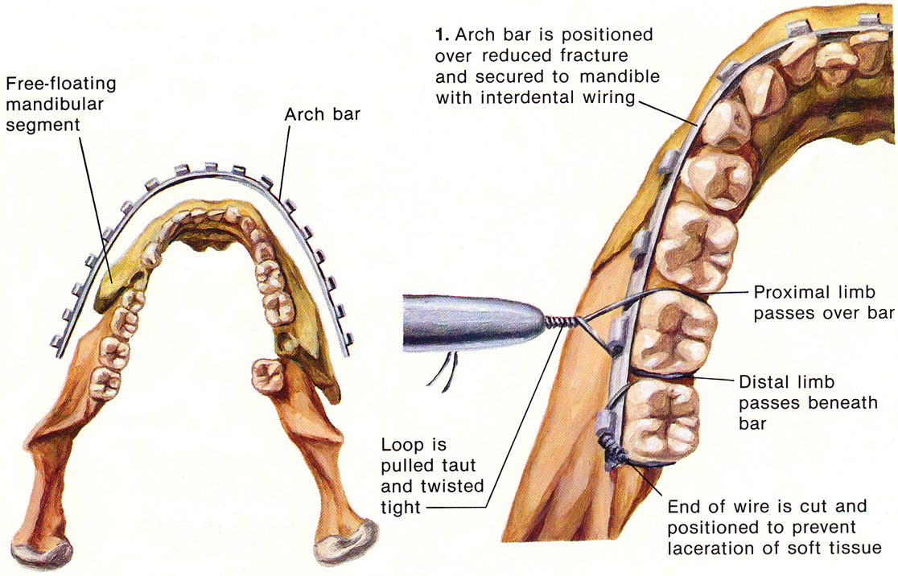
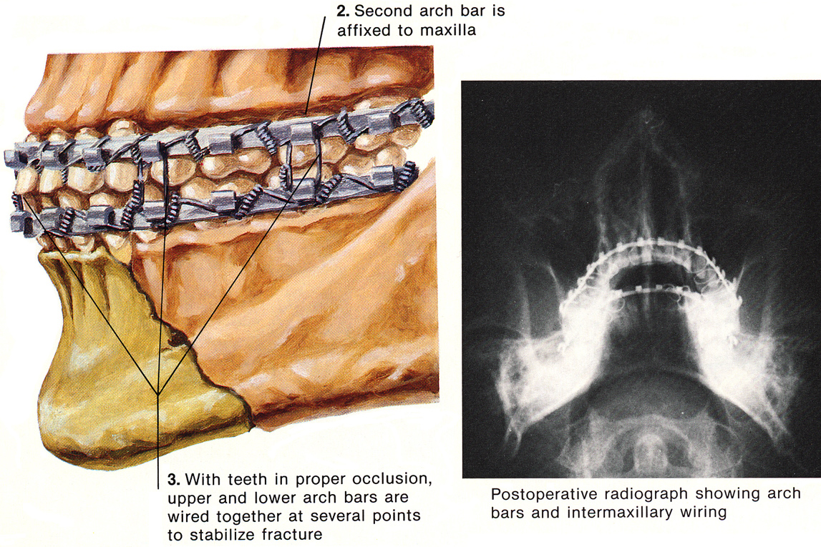
Source of picture: Frank H. Netter “Clinical Symposia”; Ciba Pharmaceutical Company; Saunders >>

- Fractures proximal to tooth-bearing area (cannot be stabilized by intermaxillary fixation; may be significantly displaced by pull from masticatory muscles) → open reduction → stabilization with stainless steel wiring, bone plates or compression plates.

- Condylar fractures:
  - in adult:
- treat conservatively (even though mandible may show some deviation on opening): soft diet + observe for development of malocclusion;
if malocclusion develops → intermaxillary fixation for ≈ 2 weeks → observe acquired occlusion; if still some shift in occlusion → wear elastic bands (for 2-3 weeks) during night to bring jaw into correct occlusal relationship.
- severely displaced, bilaterally fractured condyles → open reduction and fixation.
  - in child (condyle is area of mandible growth!; condylar fracture should not be rigidly immobilized - ankylosis may result!):
- elastic fixation for 5 days → jaw-opening exercises and check occlusion weekly; if malocclusion occurs → wear elastic bands during night + again check weekly for malocclusion.
- displaced fracture of condylar head below level of sigmoid notch of mandible (lateral pterygoid muscle displaces upper fragment anteriorly) → open reduction and fixation (ensures that mandible will grow vertically and maintains cartilaginous growth center in proper upright position).

- Fractures in edentulous jaws (decreased bone volume - reduced healing potential).
  - mucoperiosteum is not torn (displaced very little) → simple reduction → denture or immobilization with Gunning splint (constructed from impressions of upper and lower jaws).
  - markedly displaced fractures (e.g. bilateral fractures anterior to masseter muscle):
    - conservative treatment
    - plate osteosynthesis (if bone is sufficient to accept plates and screws) - large amount of periosteal stripping required (nonunion and infection are potential hazards).
    - extraskeletal pin fixation (when mandible is too thin and fragile) - two stainless steel pins placed percutaneously on each side of fracture line and connected by acrylic bar.

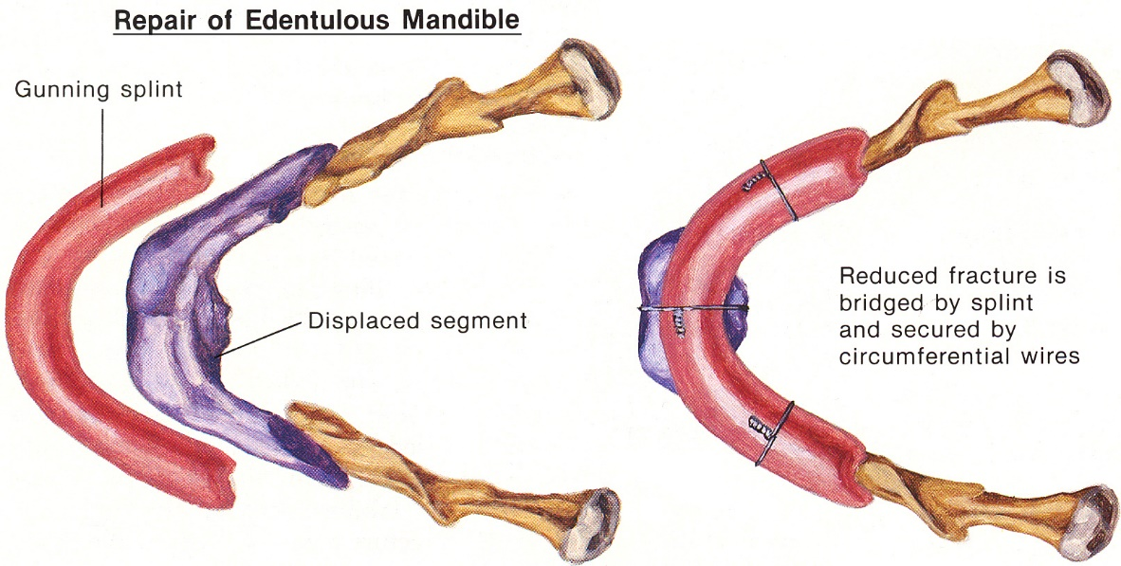
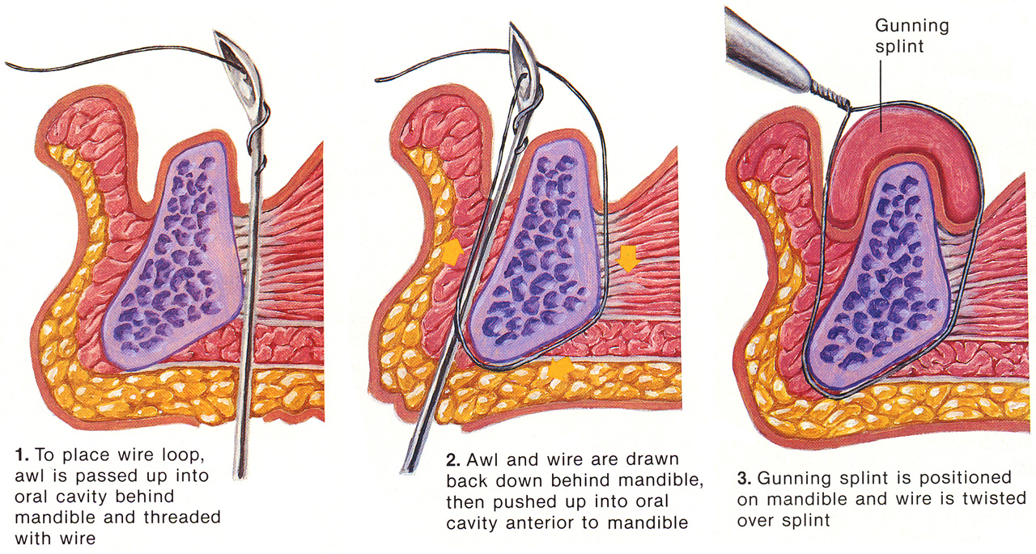
Source of picture: Frank H. Netter “Clinical Symposia”; Ciba Pharmaceutical Company; Saunders >>

Temporomandibular Joint Dislocation
- both unilateral and bilateral dislocations are seen.
- mandible dislocates forward and then superiorly.
- spasm of jaw muscles prevents condyles from returning to normal position.

Etiology
- trauma
- result of merely opening mouth (as with yawn).

Clinical Features
- markedly open mouth that cannot be closed; only most posterior teeth contact.
- patient is in moderate discomfort.
- if mandibular midline is deviated - dislocation is unilateral.
- make sure (by history) that this is not buccolingual phenothiazine reaction.

Diagnosis
- if dislocation is trauma-related → X-ray before reduction (to rule out condylar fracture).

Treatment
  - Injecting local anesthetic (e.g. 1% lidocaine 2-5 mL) into ipsilateral joint and into adjacent area of insertion of lateral pterygoid muscle may allow mandible to reduce spontaneously.
  - Manual reduction:
    - wrap gloved thumbs in gauze (for protection).
    - patient's head should be stabilized.
    - place thumbs on 3rd molars* with fingers curled under chin → downward pressure on molars, with slight upward pressure on symphysis (to lever condyles downward) → slight posterior pressure.
*or on external oblique line of mandible (lateral to 3rd molar area)
    - if muscle spasm prevents reduction → IV diazepam (5-10 mg) or midazolam (3-5 mg) ± meperidine (25 mg IV or 50 mg IM).
Longer mandible is dislocated, more difficult it is to reduce and greater likelihood of its becoming chronic problem.

Postreduction:
- first dislocation for patient → X-ray.
- discharge on NSAID and soft diet for several days + avoid yawning* or otherwise stressing temporomandibular ligaments (for at least 6 wk) ± Barton's bandage.
*when anticipating yawn, place fist under chin to prevent wide opening
- if significant pain, tenderness, spasm following reduction → admission and occlusal fixation.
- if patient has had more than one dislocation → oral-maxillofacial surgery:
- tighten (shorten) ligaments around temporomandibular joint.
- reduce articular eminence (makes future autoreductions easier).

Dental Trauma
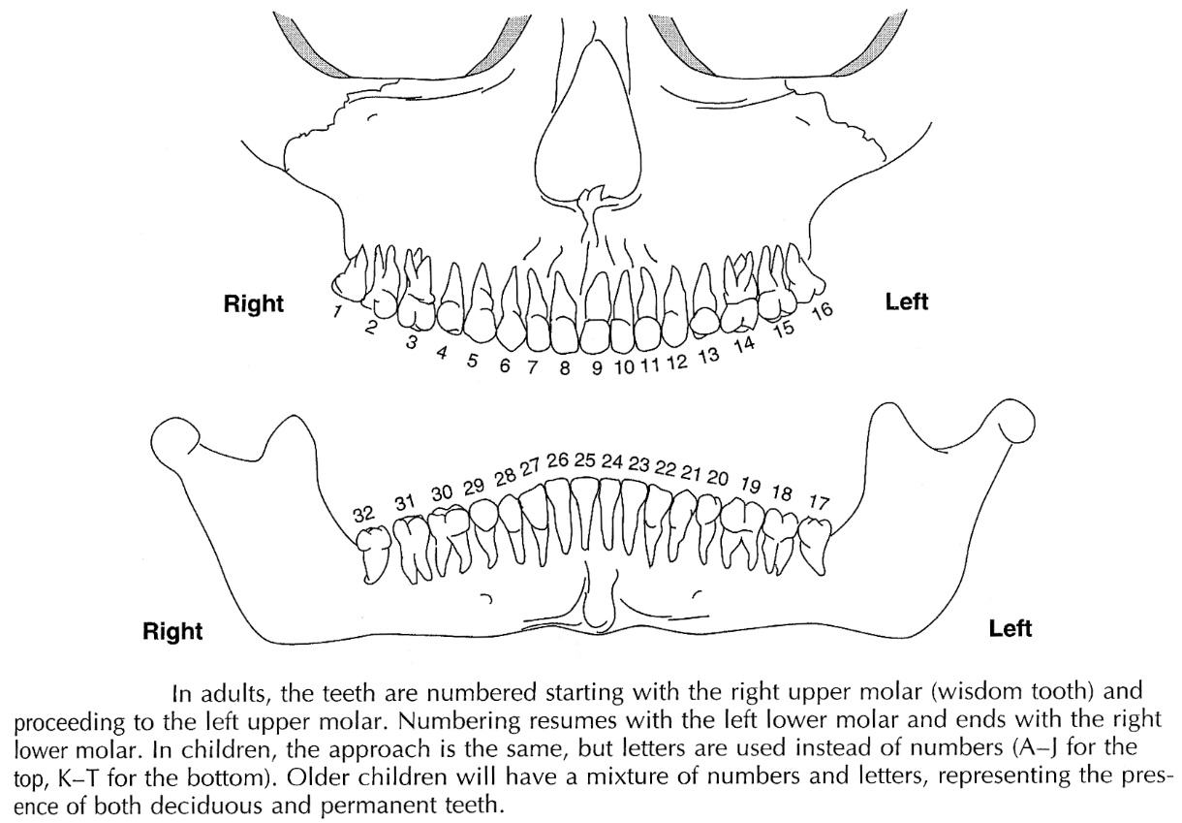
- root resorption may result from minor trauma.
- trauma to deciduous tooth may impair developing permanent tooth:
- hypoplastic enamel
- degenerated pulp cannot form dentin → failure of pulp chamber narrowing → wide pulp chamber (sign of childhood dental trauma!)
- excess dentin deposition → self-obliteration of pulp chamber.
- apical cyst.

Tooth Fracture
Ellis classification:  Ellis class I fracture - enamel is fractured; patient complains of sharp edge, but no pain.  Ellis class II fracture - enamel and dentin are fractured; patient complains of sensitivity to changes in temperature or to air; yellow spot (i.e. dentin) is visible in center of fracture.  Ellis class III fracture - enamel, dentin, and pulp are fractured; nerve is exposed – painful; fracture has pink center (bleeding from pulp). | 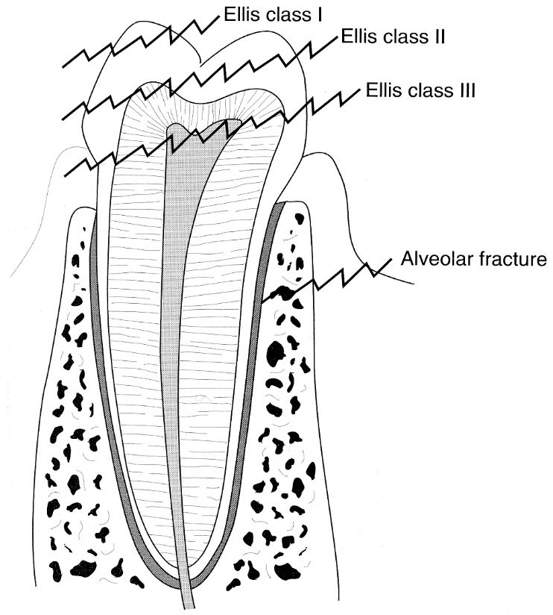
Diagnosis
- careful inspection
- tooth should be blotted (to improve visibility), but never probed (probing can introduce bacteria to exposed pulp!).
N.B. root fractures are often missed (tooth seems intact) - any tooth that is loose or painful after trauma should be evaluated radiographically and by dentist!

Therapy
Ellis class I fracture - do not require any treatment (bothersome sharp edge can be rounded with emery board) → dentist follow-up next day.
Ellis class II fracture:
- children → emergent treatment by dentist (to reduce risk of infection).
- older children and adults → cover with calcium hydroxide and aluminum foil → dentist follow-up next day for definitive care.
Ellis class III fracture → emergent treatment by dentist to reduce risk of infection (often root canal must be performed).

Tooth Avulsion
- tooth is knocked out of socket.
- differentiate from alveolar fracture.
- if avulsed tooth cannot be found, it may have been aspirated or swallowed → appropriate X-rays.
      - if aspiration has occurred, bronchoscopic removal is necessary.

Therapy
- reimplant avulsed tooth ASAP (best within 1 hour). prehospital management → see p. TrH25 >>
Each minute that tooth remains out of socket reduces likelihood of tooth surviving by 1%
      - deciduous teeth are not reimplanted! - often ankylose → permanent deformity.
      - if replacement is delayed, root resorption usually occurs (nevertheless, patient may be able to use tooth for several years).
- hold by crown and rinse with sterile water (but do not scrub!).
- replace in socket → stabilize with dental wax → immediately refer to dentist / oral surgeon for definitive treatment (splinting tooth into place).
- antibiotic for several days.
- if reimplantation is not possible – stop bleeding from socket (bite on adrenaline-soaked pad or use sutures).

Tooth Subluxation (Partial Avulsion)
- injured tooth is loose / displaced in socket (painful and maloccluded).
- blood in gingival crevice.
- evaluation requires dental radiographs.
- reposition under local anesthesia (lidocaine injection at root) → immobilize with dental wax → refer to dentist for definitive treatment ASAP (splinting tooth into place).

Tooth Intrusion
- tooth is impacted in socket.
- refer to dentist for definitive treatment ASAP.

Bibliography for ch. “Head Trauma” → follow this link >>

Viktor’s Notes℠ for the Neurosurgery Resident
Please visit website at www.NeurosurgeryResident.net

