Carotid-Cavernous Fistula
Last updated: January 7, 2022
Etiology 1
Pathophysiology 1
Classification 1
Clinical Features 1
Diagnosis 2
Treatment 3
Prognosis 3
Other AV fistulae 3

CCF - dural fistula characterized by A-V shunting within cavernous sinus.
- cavernous sinus is network of venous channels traversed by intracranial portion of internal carotid artery.

Etiology
- head trauma (75-80%) - blunt (esp. with temporal or sphenoid bone fractures) or penetrating (i.e. shearing or laceration of intracavernous ICA, incl. iatrogenic angiographic injury).
- spontaneous (≈ 20%) - associated with ⁽¹⁾ruptured intracavernous aneurysm, ⁽²⁾fibromuscular dysplasia, ⁽³⁾Ehlers-Danlos syndrome and other collagen vascular diseases, ⁽⁴⁾atherosclerotic vascular disease, ⁽⁵⁾pregnancy, ⁽⁶⁾straining.

Pathophysiology
- high-pressure arterial blood enters low-pressure venous cavernous sinus → interference with normal venous drainage → compromised blood flow within cavernous sinus (cerebral venous infarction may occur) and orbit (ophthalmic venous hypertension and orbital venous congestion).
- can be bilateral.

Classification
Direct type (70-90%):
Type A fistula - direct connection between intracavernous ICA and cavernous sinus.
- high-flow and high-pressure fistulas → fast progression of clinical features!!!
- more common in young males.
- most commonly traumatic etiology.

Dural types:
- low-flow.
- more common in women > 50 years (7:1 female-to-male ratio).
- most commonly spontaneous etiology.
Type B fistula - dural shunt between intracavernous branches of ICA and cavernous sinus.
Type C fistula - dural shunt between meningeal branches of ECA and cavernous sinus.
Type D fistula - combination of types B and C (i.e. dural shunts between ICA and ECA branches and cavernous sinus).

Diagrammatic representation of 4 types of fistulas:
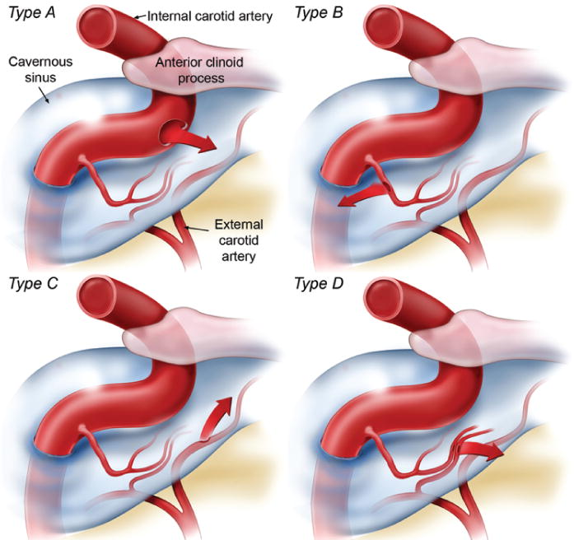

Clinical Features
- sudden onset:

- Ipsilateral ocular manifestations:
  - progressive pulsatile proptosis (→ corneal exposure → dehydration, traumatization), chemosis (dilated and tortuous episcleral and conjunctival vessels), arterialization of episcleral veins, edema of conjunctiva and periorbital soft tissues.
  - cranial nerve palsy (III-VI) ipsilaterally or bilaterally.
  - progressive (over days or weeks) monocular visual loss in late stages
  - dilatation of retinal veins, optic disc swelling, retinopathy.
  - central retinal vein occlusion → secondary open-angle glaucoma.

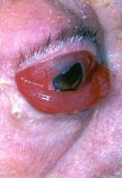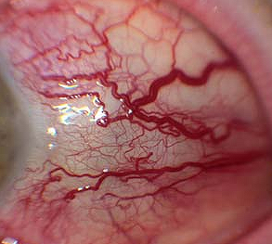

- Self-audible bruit synchronous with pulse (pulsatile tinnitus);
- many are also audible to examiner – at temple or orbit.
- reduced by manual occlusion of carotid artery in neck (recession of exophthalmos may also be observed).

- Headache (± other signs of ICP↑)

- Exsanguinating epistaxis (H: place Foley into nose and hold manual carotid compression on the side of bleed while transporting to OR)

Diagnosis
- CTA (look for dilated ophthalmic veins*, contrast extravasation).
*esp. superior ophthalmic vein (SOV)!
- Selective carotid angiography (high-speed digital subtraction imaging in multiple views of both bilateral ICA and ECA*) - diagnostic test of choice (confirms diagnosis): early filling of cavernous sinus and its draining tributaries (esp. ophthalmic veins).
*only for spontaneous fistulas
- Contrast CT of orbit - proptosis, swelling of extraocular muscles, dilation of superior ophthalmic vein (→ enlarged superior orbital fissure), enlarged cavernous sinus.
- Orbital ultrasound - findings as CT.
- Complete ophthalmologic workup: visual acuity, funduscopy (direct and indirect), intraocular pressure & gonioscopy.
Ask ophthalmologist to measure IOP!!!!

A–D (axial contrast CT): right cavernous sinus (A, thick black arrow) is enlarged, and large enhancing mass runs forwards into orbit through widened superior orbital fissure (B, arrowheads); sigmoid structure (open arrow in C) in upper part of right orbit represents greatly dilated superior ophthalmic vein (cf. normal left side in C, small white arrow); some extraocular muscles are thicker than on left, and there is marked right proptosis.
E (right ICA intra-arterial DSA, lateral projection, arterial phase) - contrast medium floods into cavernous sinus (S), and drains forwards into grossly dilated superior ophthalmic vein (V); there is also shunting posteriorly and via inferior petrosal sinus (P); intracranial arterial filling is poor.
F, G - after therapeutic detachment of balloon (B) in cavernous sinus (F, lateral projection), shunting particularly anteriorly, is greatly reduced, and intracranial filling much improved (G):
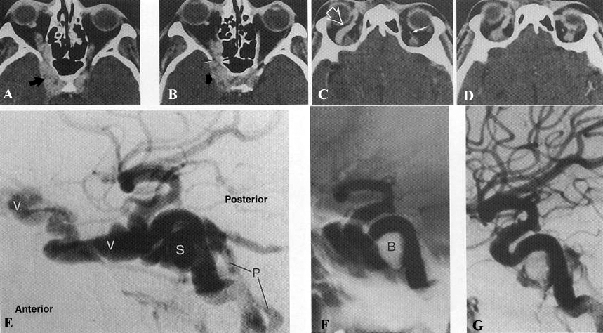
A. Left ICA (lateral DSA) - rapid opacification of cavernous sinus and both superior and inferior ophthalmic veins (arrows).
B. Following detachment of balloon (arrows) within cavernous sinus - fistula is occluded and ICA now appears normal.
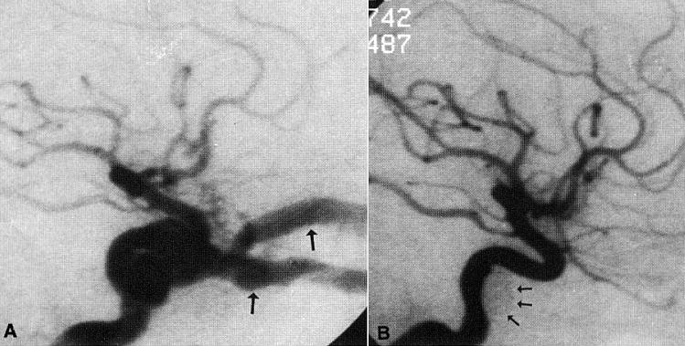

Carotid angiogram - large communication (vertical arrow) between ICA (above) and cavernous sinus; in addition to enlarged orbital veins that drain forward from cavernous sinus, there is backward drainage through petrosal sinus (horizontal arrow):
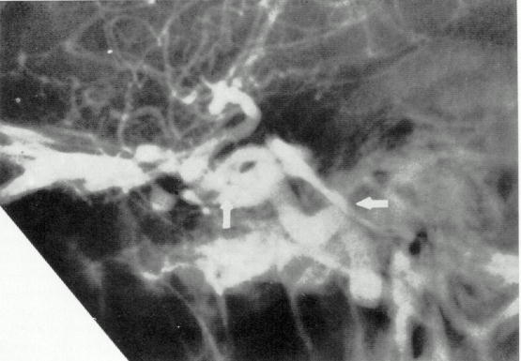

Treatment
Measure IOP – if > 20 → emergent treatment!
Cortical venous drainage → treat!
In acute setting of vision loss / CN paralysis, glucocorticoids (e.g. dexamethasone), Diamox may be used while waiting for definitive diagnosis and treatment.

Type-A fistulas rarely resolve spontaneously because of high flow (fistula enlarges, causing decreased chances of visual recovery).
- treatment indications - progressive visual loss (main complication!!!), intolerable bruit, cosmetic effects of proptosis.

Definitive management - obliteration of fistulous connection with preservation of ICA patency:
  - Endovascular approach - through arterial approach (N.B. ICA hole may be big – use balloon-assisted technique!)
    - detachable coils – preferred method (pack cavernous sinus as much as you can) for simple and complex fistulas
    - Onyx – if one simple cavity with one arterial feeder
    - detachable balloon
    - ICA stenting (pipeline) across fistula may have role.
  - Direct surgical exposure and obliteration of fistula (now rarely indicated).

- symptoms & signs improve within days after treatment, but complete resolution may take weeks to months.
- severely refractory fistulas → surgical or endovascular sacrifice of ICA (+ clipping of supracavernous segment proximal to PComA to prevent fistula from stealing blood from cerebral vasculature).

Type B, C, D fistulas have higher incidence of spontaneous resolution.
- carotid self-compression for 20-30 seconds 4 times per hour may lead to fistula thrombosis.
- patient is instructed to compress carotid artery on side of lesion using contralateral hand (should patient develop cerebral ischemia during compression, contralateral hand likely will be affected, releasing compression).
- if compression is not effective or if more rapid intervention is indicated → endovascular fistula embolization
N.B. may prefer venous approach (posterior approach via inferior petrosal sinus or transocular via superior ophthalmic vein*) *surgically expose vein to allow direct cannulation

Prognosis
- recurrence rate 1-3.9%.
- routine follow-up angiogram - to ensure that fistula has not recurred or that alternate fistulous pathways have not developed. (H: second balloon treatment)

Other AV fistulae
- abnormal communications between artery and vein secondary to:
- most common - traumatic laceration of vessels (esp. GSW – routine CTA for all GSW patients on day 10-12; if retained bullet gives obscuring artefacts – then angiography)
- aneurysm
- angiodysplasia
- treated via endovascular approach (balloons, PVA, liquid agents, coils).

Traumatic AV fistula:
A. Superselective arteriogram of a. occipitalis - two prominent branches draining directly to markedly dilated draining vein.
B. Arteriogram after embolization with PVA microparticles and coils - nonfilling of draining vein.
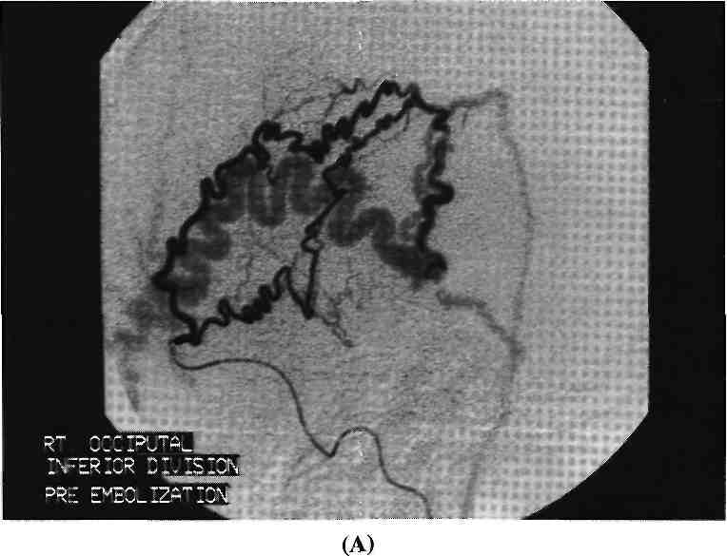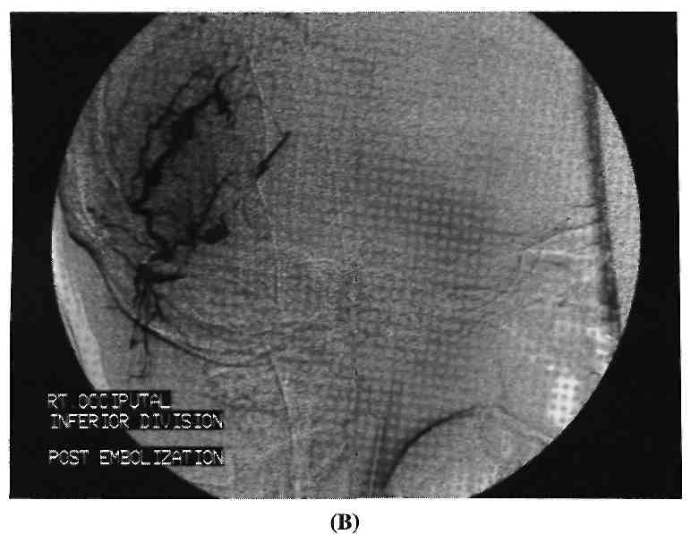

Bibliography for ch. “Head Trauma” → follow this link >>

Viktor’s Notes℠ for the Neurosurgery Resident
Please visit website at www.NeurosurgeryResident.net

