Anterior Pituitary Disorders
Last updated: April 12, 2020
HYPOSECRETION OF ANTERIOR PITUITARY 3
Generalized Hypopituitarism in Adult 3
Selective Pituitary Hormone Deficiencies 8
short stature 8
Pituitary Dwarfism 9
Short Stature Due To Miscellaneous Causes 11
HYPERSECRETION OF ANTERIOR PITUITARY 12
Gigantism, Acromegaly 12
Galactorrhea 17
Gonadotropin-Secreting Adenoma 19
TSH-Secreting Adenoma 19
ACTH-Secreting Adenoma 19
Hypophysitis – see p. Onc26 >>
posterior pituitary disorders (diabetes insipidus, etc.) → see genitourinary system

Hypothalamic-pituitary disorders present with:
- hypersecretion or hyposecretion of pituitary hormones.
- symptoms & signs of tumor (mass lesion) - headaches, compression of optic chiasm (esp. bilateral hemianopia), enlarged sella turcica. see Onc26 p. (nervous system)

Normal pituitary gland (larger portion, adenohypophysis, is toward top): left - superior aspect of pituitary with stalk; right - inferior aspect of pituitary:
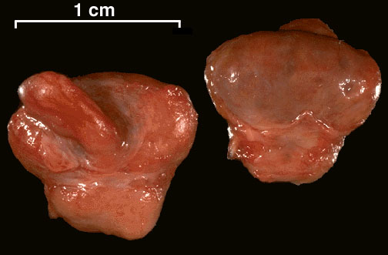

Normal pituitary gland (adenohypophysis is at right, neurohypophysis is at left):
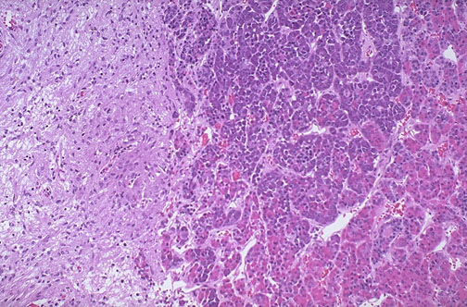

Normal adenohypophysis - three major cell types: acidophils, basophils, and chromophobes:
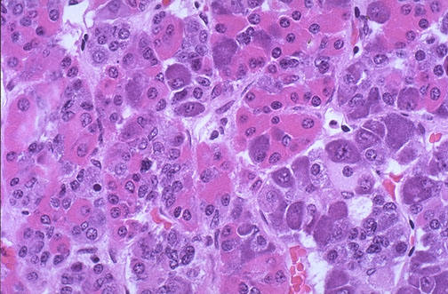

Normal neurohypophysis - resembles neural tissue (glial cells, nerve fibers, nerve endings, intra-axonal neurosecretory granules):
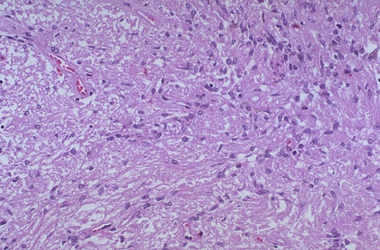

HYPOSECRETION OF ANTERIOR PITUITARY
  - generalized (panhypopituitarism)
  - selective

Generalized Hypopituitarism in Adult
etiology
Primary hypopituitarism:
- Pituitary tumors (adenomas, craniopharyngiomas)
- Ischemic necrosis: shock (esp. postpartum due to hemorrhage* – Sheehan’s syndrome, s. Simmonds disease), a. carotis int. thrombosis.
*most common cause of anterior pituitary insufficiency in adult females!!!
- Hemorrhagic infarction (pituitary apoplexy) – see Onc26 p.
- Inflammation (meningitis, pituitary abscess, sarcoidosis)
- Infiltration (Langerhans’ histiocytosis, hemochromatosis)
- Autoimmune (postpartum lymphocytic hypophysitis)
- Iatrogenic (surgical extirpation, irradiation)
- Idiopathic

Secondary hypopituitarism (hypothalamic disorders):
- Tumors
- Inflammation
- Trauma (esp. basal skull fracture)
- Surgical transection of pituitary stalk
- Idiopathic

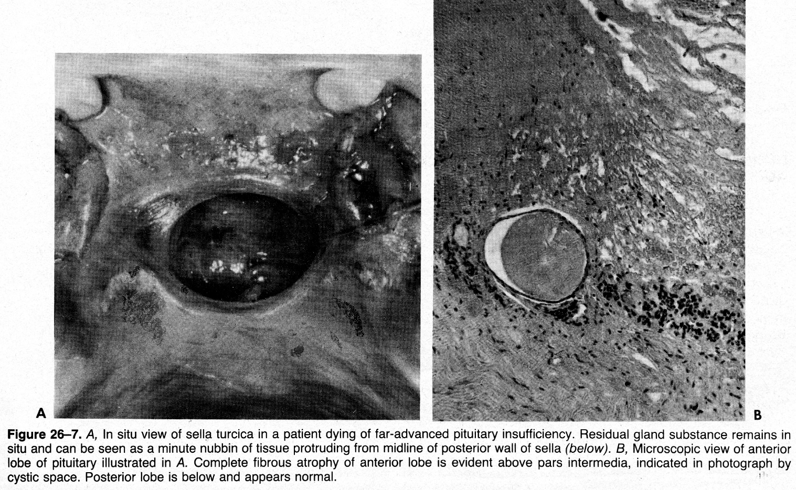
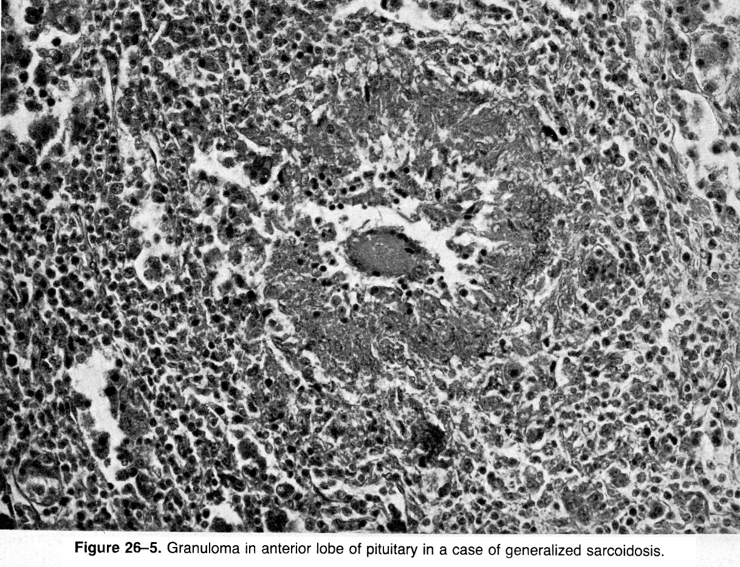

Symptoms and Signs
  - onset is usually insidious and may not be recognized by patient (but occasionally sudden or dramatic).
  - hormone loss sequence: gonadotropins → GH → TSH → ACTH → prolactin.
N.B. it is not clear that this sequence is correct.
- function of target glands decreases, glands atrophy:
1. LH and FSH deficiency:
    - women → amenorrhea, infertility, regression of secondary sexual characteristics (lose pubic and axillary hair – bet tam reikalingas concomitant adrenal androgens loss due to ACTH deficiency).
    - men → impotence, testicular atrophy, infertility, regression of secondary sexual characteristics.
- GH deficiency - not clinically detectable in adults (adipose tissue↑, lean body mass↓, hypercholesterolemia→ CAD↑); in children – growth retardation (pituitary dwarfism)
- TSH deficiency → secondary hypothyroidism
- ACTH deficiency → secondary hypoadrenalism (pagrinde nukenčia gliukokortikoidai - intolerance to stress; mineralkortikoidų sekrecija išlieka beveik normali - depends on angiotensin-renin axis).
N.B. persons with ACTH deficiency do not have hyperpigmentation (vs. primary adrenal failure)! netgi priešingai – pacientai atrodo išblyškę:
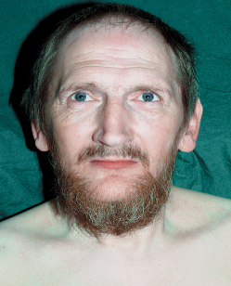
- vienintelis hormonas, kurio gali būti sekretuojama per daug, tai prolactin in hypothalamic disorders (hypothalamus nebegamina dopamino ir nebeslopina laktotropų) – hyperprolactinemia per se is associated with hypogonadotropism and secondary hypogonadism.
- padidėja jautrumas insulinui (nebėra GH, glucocorticoids); jei buvo, gali išnykti cukraligė.
N.B. pituitary insufficiency patients are well-nourished!!!
senoje literatūroje aprašyti kachektiški pacientai iš tikrųjų sirgo anorexia nervosa.
- ADH deficiency is rare in primary cases but is common with secondary (stalk and hypothalamic) lesions.
  - pilnai pašalinus hipofizę esti tik laikina poliurija; kodėl neišsivysto diabetes insipidus?:
1) GH deficitas slopina glomerular filtration rate
2) ACTH deficitas lėtina baltymų katabolizmą + TSH deficitas lėtina metabolizmą → šlapimo ultrafiltrate osmotinių dalelių↓ → diurezė↓
- first sign in Sheehan's syndrome - lactation does not develop postpartum.
- hipofizė esti rigidiškoje “dėžutėje” (sella turcica uždengta diaphragma sellae);
- hipofizė nėštumo metu padidėja iki 2 kartų (dėl laktotropų hiperplazijos) ir vystosi išemija;
- jei dar gimdant nukraujuoja → išeminis infarktas.
N.B. adenohipofizė neturi arterijų (gauna tik portalinį kraują)!

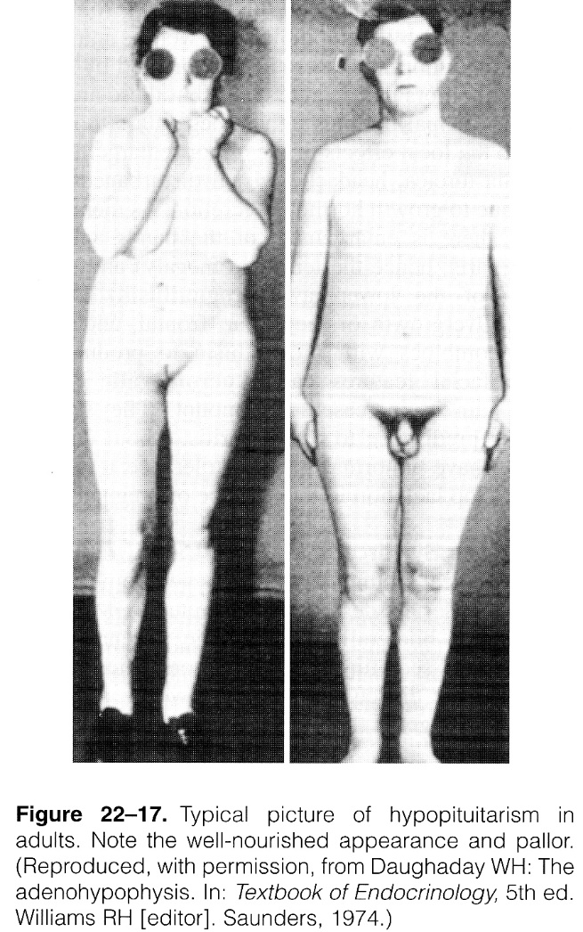 | 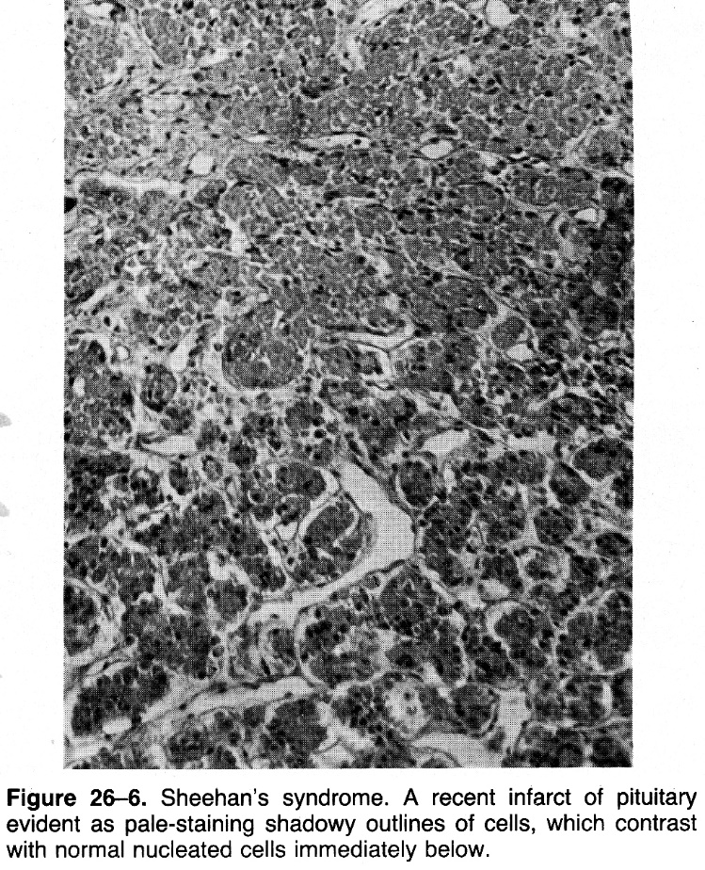

Diagnosis
Hypopituitarism must be established with certainty before committing patient to lifetime hormone replacement therapy!

Tyrimai siekia aptikti:
- Structural pituitary abnormalities (skull X-ray, CT, MRI). see Onc26 p.

- Hormonal deficiencies (initial evaluation should be aimed at detecting potentially life threatening TSH and ACTH deficiencies!):

- TSH:
      - low levels of T₄, T₃, and TSH.
      - failure to increase TSH levels in response to i/v TRH.

- ACTH:
  - basal serum cortisol levels may be within normal range.
  - decreased pituitary reserve is evaluated by insulin tolerance test: regular insulin 0.1 U/kg bolus i/v; venous blood samples (GH, cortisol, and glucose levels) are obtained before and 20, 30, 45, 60, 90 min later;
N.B. This test is hazardous in severe panhypopituitarism or diabetes mellitus and in elderly and is contraindicated in ischemic heart disease or epilepsy; medical attendant should be present during test!
- normally only transient perspiration, tachycardia, and nervousness occur.
- if patient loses consciousness or has seizure, test should be terminated promptly by giving 50% glucose IV.
- insulin tolerance test alone will not differentiate between primary (Addison's disease) and secondary (hypopituitary) adrenal insufficiency.
  - metyrapone test (inhibuoja reakciją 11-deoxycortisol → cortisol) – jei padidėja [11-deoxycortisol], vadinasi hipofizė normaliai sureagavo į cortisol trūkumą ir pagamino daugiau ACTH.

- Prolactin: elevated levels may be present!

- GH (also see pituitary dwarfism)

Adults - routine screening is not recommended (deficiency is not treated even when detected);
normal IGF-I levels in adults suggest that GH deficiency is not present; however, low values do not prove GH deficiency.
Children - GH measurements after provocative stimuli (GH levels may be undetectable under basal conditions in normal individuals!):
- insulin tolerance test - the most effective stimulus to GH release (GH levels peak after 30-90 min), but is dangerous (other tests are less dangerous, but also less reliable)
- arginine infusion
- oral levodopa
- sleep
- 20 min of vigorous exercise
- clonidine is potent stimulator and holds promise as alternative to insulin.
- GH after stimulus > 10 ng/mL or rise > 5 ng/mL is sufficient to rule out GH deficiency.
- increases < 5 ng/mL or to levels < 10 ng/mL are difficult to interpret.
- all provocative tests occasionally produce misleading results - no single test is 100% effective - at least two different tests should be performed in absence of GH response.
- provocative testing may not detect subtle defects in GH release regulation (e.g. in children with short stature secondary to GH secretory dysfunction, provocative testing is usually normal. However, serial determinations of GH levels over 12-24 h indicate abnormally low 12- or 24-h integrated GH secretion).
N.B. GH responses are abnormal in diminished thyroid or adrenal function - testing should be conducted only after adequate hormone replacement therapy!!!
- value of exogenous GHRH is not established - variability in pituitary responsiveness to GHRH is consistent with hypothesis that intermittent hypothalamic somatostatin secretion is responsible for modulating pituitary GH output.

- LH and FSH: basal LH and FSH levels are not helpful - levels are low in panhypopituitarism, but overlap exists with normal ranges.
- exogenous GnRH is not helpful in distinguishing hypothalamic from primary pituitary disorders.

Most effective is to test all pituitary hormone reserves simultaneously – administer IV insulin, TRH, GnRH → check serum concentrations: glucose, cortisol, GH, TSH, prolactin, LH, FSH, ACTH.
- may use GHRH and ACTH-RH instead of insulin

Treatment
- Replacing hormones of hypofunctioning target glands.
  - treatment of GH deficiency in adults is unnecessary!
  - mėnesines, libido, potenciją atstato sex steroids;
vaisingumui (ovuliacijoms) atstatyti reikia skirti GnRH pulsais kas 90-120 min (pastoviai skiriamas GnRH veikia priešingai – inhibuoja gonadotropinų sekreciją).

- If cause is pituitary tumor – neurosurgery, radiotherapy. see Onc26 p.

Selective Pituitary Hormone Deficiencies
- may represent early stage of generalized panhypopituitarism - observe for other pituitary hormone deficiencies, and sella turcica should be evaluated radiographically at intervals for signs of pituitary tumor.
- most true selective pituitary hormone deficiencies are due to hypothalamic pathology!

I. Gonadotropin deficiency occurs in both men and women.
- most cases involve deficiencies of both LH and FSH (only rarely single gonadotropin is affected).
- klinika - hypogonadotropic hypogonadism (eunuchoid habitus with microphallus, bet šiaip manifestuoja kaip failure of puberty to occur, impotence, amenorrhea, etc).
- difkė:
- primary hypogonadism (elevated levels of LH and FSH)
- excessive prolactin secretion (inhibits FSH and LH secretion and leads to secondary hypogonadism).
- hypogonadotropic amenorrhea secondary to exercise, diet [anorexia nervosa], psychologic stress.
- constitutional delay of puberty (nėra specifinio testo jam ekskliuduoti)

Kallmann's syndrome - specific lack of GnRH. see also 2581 p.
- etiology - KALIG-1 (Kallmann's syndrome interval gene 1 localized in X chromosome) defect.
  - GnRH neurons develop in olfactory placode and migrate up olfactory nerves into hypothalamus.
  - KALIG-1 regulates adhesion proteins facilitating this neuronal migration.
- most common in men; associated with midline facial defects (incl. anosmia!!!, color blindness, and cleft lip or palate).

II. ACTH deficiency - hypoadrenalism without hyperpigmentation.
- no cortisol elevation after insulin-induced hypoglycemia.
- response to ACTH treatment.

III. TSH deficiency - hypothyroidism with low TSH levels (levels measured by immunoassay, are not always lower than normal, suggesting that secreted TSH is biologically inactive).
- exceedingly rare.
- klinika lengvesnė negu primary hypothyroidism.

IV. Prolactin deficiency - low basal prolactin levels without response to provocative stimuli such as TRH.
- failure of normal lactation (taip pat infertility, impotence?)

V. GH deficiency → pituitary dwarfism.
- common age-related GH decline plays role in sarcopenia.

short stature
I. Constitutional delay of growth and development
II. Intrinsic short stature (s. primordial growth failure):
    - Genetic (familial, chromosomal aberrations, skeletal dysplasia, syndromes with primary growth failure)
    - Intrauterine growth retardation (placental abnormalities, maternal disorders)
III. Systemic disorders:
    - Endocrine:
    - Hypothyroidism
    - Cushing’s syndrome
    - Rickets, pseudohypoparathyroidism
    - IGF deficiency:
        - hypothalamic dysfunction (postinfectious, postradiation, tumors, histiocytosis, psychosocial, idiopathic)
        - hypopituitarism (pituitary dwarfism)
        - GH insensitivity:
- primary: Laron syndrome, GH receptor or postreceptor defect (e.g. African pygmy), IGF synthesis or receptor defect
- secondary: autoantibodies to GH or GH receptors, malnutrition (IGF synthesis↓), other (chronic renal failure, liver disease, glucocorticoid excess, chronic inflammatory diseases)
    - Nutritional, gastrointestinal (celiac disease, Crohn’s disease)
    - Cardiac (cyanotic congenital heart disease), pulmonary
    - Renal (renal tubular acidosis, uremia)
    - Psychosocial deprivation
    - Drugs
    - Other chronic diseases (poorly controlled diabetes mellitus, severe rheumatoid arthritis)

- most children with height < 3rd percentile and retarded bone age have normal circulating levels of GH and IGF-I (i.e. do not have GH deficiency) – gydymo nereikia; e.g.:
  - constitutional (familial) delay of growth and puberty - deviate from normal growth curve in early childhood, thereafter grow at normal rate, and have delayed pubertal growth spurt, galutinis ūgis esti normalus (šeimos ir giminaičių ribose);
jei vėluoja lytinis brendimas, galima skirti trumpą (4-6 mėn.) sex steroids kursą; šiaip gydymo nereikia.
  - hereditary (familial, genetic) short stature – bent vienas iš tėvų irgi yra mažo ūgio; sulėtintas augimas, bet lytinis brendimas laiku, todėl taip ir lieka mažo ūgio.
N.B. some particularly short children may belong to both groups.
- dėl mažo ūgio labiau pergyvena berniukai.

Pituitary Dwarfism
- short stature due to hypopituitarism.
- sudaro tik 5% visų vaikų besikreipiančių pas endokrinologus dėl short stature.

Etiology
- Pituitary tumor (most commonly craniopharyngioma)
- CNS irradiation; spine radiation may further impair growth potential of vertebrae.
- Langerhans' histiocytosis (combination of bone or skull lytic lesions + diabetes insipidus)
- Idiopathic (džn. defektas in hypothalamus) – majority of GH deficiency cases.
smulkiau dar žr. panhypopituitarism etiology (aukščiau)
- hypothalamic or pituitary deficiency may occur in association with midline defects:
- cleft palate
- septo-optic dysplasia [absence of septum pellucidum, optic nerve atrophy, and hypopituitarism]).
N.B. GH deficiency (either alone or in association with other abnormalities), rarely is hereditary!

Symptoms, Signs
N.B. GH nereikalingas for fetal growth – naujagimiai esti normalaus dydžio!
- naujagimiams galima symptomatic hypoglycemia!
- abnormally slow growth (< 6 cm/yr before age 4 yr, < 5 cm/yr from age 4 to 8 yr, and < 4 cm/yr before puberty);
  - skeletal maturation retardation > 2 yr behind chronologic age (skeletal maturation is delayed to the same extent as height).
- short stature (< 3rd–5th percentile) – išryškėja tik ≥ 2 m. amžiuje.
- normal proportions.
- fail to begin pubertal development (but delayed pubertal development may occur).

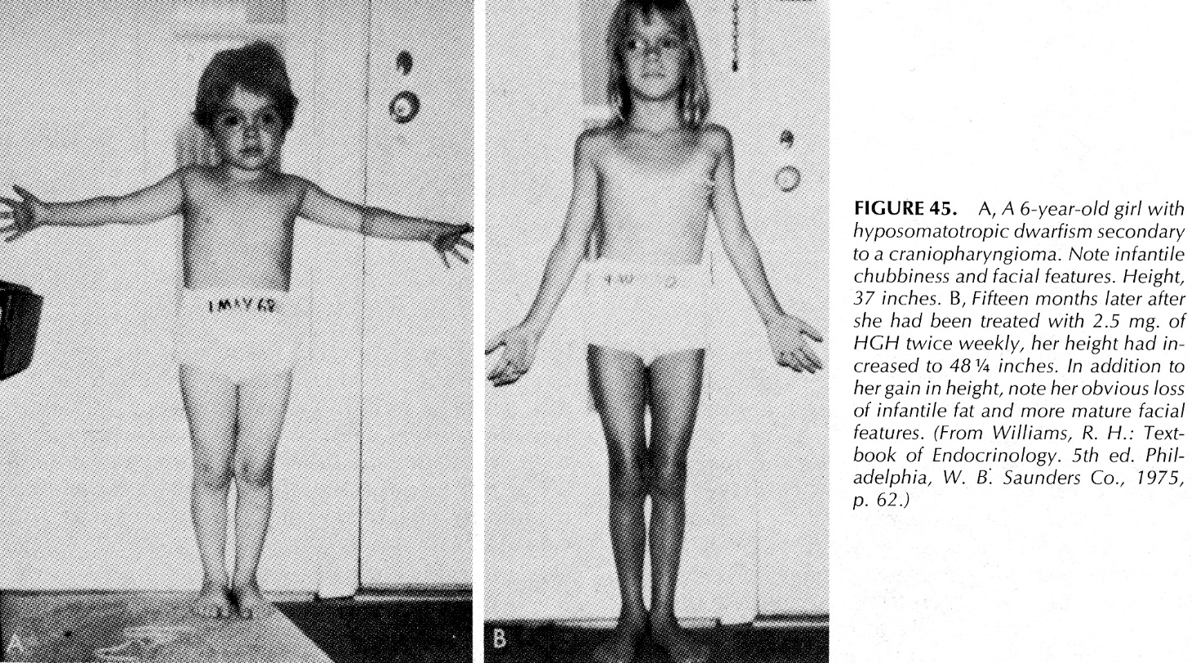

Diagnosis
- Physical measurements - growth data (height and weight) should be plotted on growth chart (auxologic assessment).
  - ūgis matuojamas stovint su stadiometer; < 24 mėn. amžiaus vaikams ūgis matuojamas gulint.
  - taip pat matuojama: arm span, upper-to-lower body segment ratio.

- Laboratory criteria:
  - bone age determined from X-ray of left hand (by convention).
  - pituitary gland CT or MRI to rule out calcifications and neoplasia; sella turcica is abnormally small in 10-20% of patients.
  - IGF-I should be measured to screen for GH deficiency.
- IGF-I levels rise significantly from infancy to puberty:
  - in infants and younger children, IGF-I levels are normally low;
  - in mid- to late childhood, normal IGF-I excludes GH deficiency!!!
N.B. IGF-I levels are also low in conditions other than GH deficiency (e.g. psychosocial deprivation, malnutrition, hypothyroidism).
  - IGF binding protein type 3 (IGFBP-3) is less nutritionally dependent than IGF-I!
  - if levels of IGF-I and IGFBP-3 are low → provocative testing of GH release – GH release is low or absent in pituitary dwarfism (dar žr. diagnosis of panhypopituitarism);
[GH] < 7 ng/ml after two provocative tests indicates classic GH deficiency.
N.B. normal basal GH levels (except after sleep onset) are usually low or undetectable and thus useless as indicators of GH deficiency! However, provocative testing is nonphysiologic, subject to laboratory error, poorly reproducible, and interpretation of data relies on arbitrary definitions of "normal" that vary by age and sex.

- svarbiausia difkė – hypothyroidism – tirk T₄ ir TSH visiems, net jei nėra jokio klinikinio įtarimo!!!

Treatment
Biosynthetic GH (somatotropin, somatrem – see 2714 (5) p.) - indicated for all children with short stature who have documented GH deficiency.
- dosing 0.03-0.05 mg/kg/day sc.
- height velocity increases to 10-12 cm/yr in 1st year, and slower thereafter.
- therapy is continued until acceptable height is reached or growth rate falls < 2.5 cm/yr.
- jeigu short stature yra dėl hipofizės auglio radioterapijos, tai GH therapy carries theoretic risk of causing cancer recurrence, tačiau current belief is that GH replacement can be safely instituted at least 1 yr after anticancer therapy.

It is controversial whether short children with clinical features of GH deficiency but with normal GH secretion and normal IGF-I levels should be treated with GH:
- many experts recommend GH therapy trial for 6-12 mo.
- others object to this approach - expensive, experimental, medicalizes otherwise healthy child, raises ethical and psychosocial concerns that feed into bias of "heightism".

N.B. cortisol and thyroid hormone should be replaced (throughout childhood and adolescence) if levels are low!
- when puberty fails to occur normally (at age 14 years), gonadal sex steroids are indicated.

Short Stature Due To Miscellaneous Causes
Psychosocial deprivation (functional GH deficiency) – ūgis pilnai atsistato (catch-up growth) vaiką patalpinus normalioje aplinkoje.

Chronic renal insufficiency - GH therapy is effective (in addition to good nutrition and metabolic control).
- išlieka neaišku, ar GH can oppose exogenous glucocorticoids growth-inhibiting effects after renal transplantation.

Short stature in Turner syndrome is universal finding (N.B. karyotypic evaluation should be included when assessing short girl with no obvious cause of short stature!).
- mechanizmas - intrinsic skeletal dysplasia (not GH deficiency).
- GH therapy is effective.
- GH therapy is continued until estrogen replacement is initiated for induction of puberty (usually when bone age reaches 12-13 yr).

Laron syndrome (GH insensitivity) - proportionate growth retardation, elevated GH levels, low IGF-I and IGFBP-3 levels, and distinct phenotype (craniofacial abnormalities).
- unresponsive to GH therapy but respond to IGF-I.

mecasermin (INCRELEX™) - rhIGF-1 (human IGF-1 produced by recombinant DNA technology).
- indicated for long-term treatment of severe primary IGF-1 deficiency or GH gene deletion who have developed neutralizing antibodies to GH.
- not intended for secondary forms of IGF-1 deficiency (such as GH deficiency, malnutrition, hypothyroidism, chronic treatment with steroids).
Not a substitute for GH treatment!

HYPERSECRETION OF ANTERIOR PITUITARY
Dažniausiai - prolactin, GH, ACTH. also see pituitary adenomas in Onc26 p. (nervous system)

Gigantism, Acromegaly
- GH-secreting pituitary adenomas (most contain G_{s} protein mutation - bypasses GHRH need to stimulate GH secretion).
- Ectopic GHRH-producing tumors – only few cases have been described.

Excellent article: http://www.medscape.com/viewarticle/730662?src=mp&spon=26&uac=121060BZ

Symptoms & Signs
GH hypersecretion can begin at any age but most commonly starts in 3rd – 5th decades:

Rarely begins in childhood (before closure of epiphyses) → exaggerated skeletal growth (pituitary gigantism) with little bony deformity.
- soft tissue swelling occurs and peripheral nerves are enlarged.
- delayed puberty or hypogonadotropic hypogonadism is frequently present → eunuchoid habitus.

When begins after epiphyseal closure, earliest clinical manifestations are:
- Coarsening of facial features - photographs of patient are important in delineating disease course.
- Hand & feet soft tissue swelling (acromegaly) - larger rings, gloves, shoes are needed.
- augimas vyksta ten, kur yra kremzlių ir osteoblastų (periosteal appositional bone growth).

Other changes also occur:
    - coarse body hair, skin thickened and frequently darkened, size and function of sebaceous and sweat glands↑ (perspiration↑, offensive body odor).
    - mandible overgrowth (prognathism) → teeth malocclusion, increased interdental spaces.
[in GH deficit esti priešingai – maxillary prognathism]
    - enlarged and furrowed tongue.
    - cartilaginous proliferation of larynx → deep, husky voice.
    - articular cartilaginous proliferation then necrosis and erosion → crippling degenerative arthritis.
    - mild proximal muscle weakness (no atrophy – muscles enlarged!).
Although patients have bulky appearance, they are generally weak as result of associated myopathy!
    - compression of edematous nerves by adjacent fibrous tissue + endoneural fibrous proliferation → peripheral neuropathies (esp. carpal tunnel syndrome), lumbar spinal stenosis.
    - increase in endoneurial and perineurial connective tissue → palpably enlarged peripheral nerves.
    - costal growth → barrel chest.
    - GH itself is potent lactogenic hormone → galactorrhea;
bet 1/3 pacientų kartu esti ir hiperprolaktinemija!
    - ↓gonadotropin secretion often occurs in association with GH-secreting tumors → sexual immaturity in gigantism, impotence (1/3 of men), menstrual irregularities or amenorrhea (nearly all women) in acromegaly.
    - heart, liver, kidneys, spleen, thyroid, parathyroid glands, and pancreas are also larger than normal (visceromegaly);
- hypertension, coronary heart disease occurs in 1/3, acromegalic cardiomyopathy (risk of cardiovascular death is generally doubled!).
- GI tract malignancy risk is increased twofold-threefold.
- GH increases tubular reabsorption of phosphate → mild hyperphosphatemia.
- glucose intolerance occurs in 50%, but diabetes mellitus occurs in only 10%.

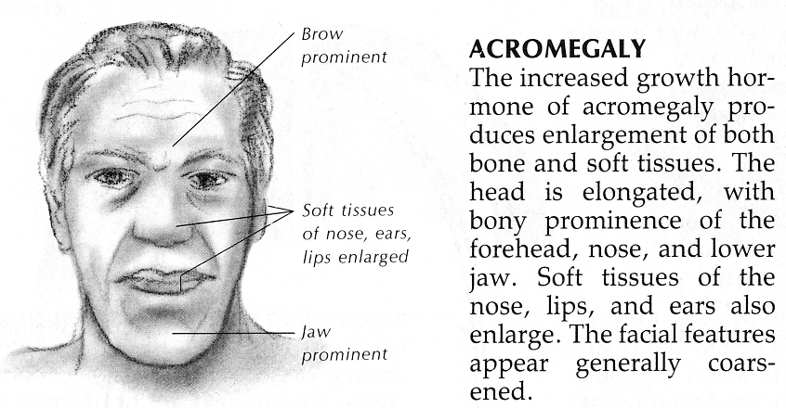
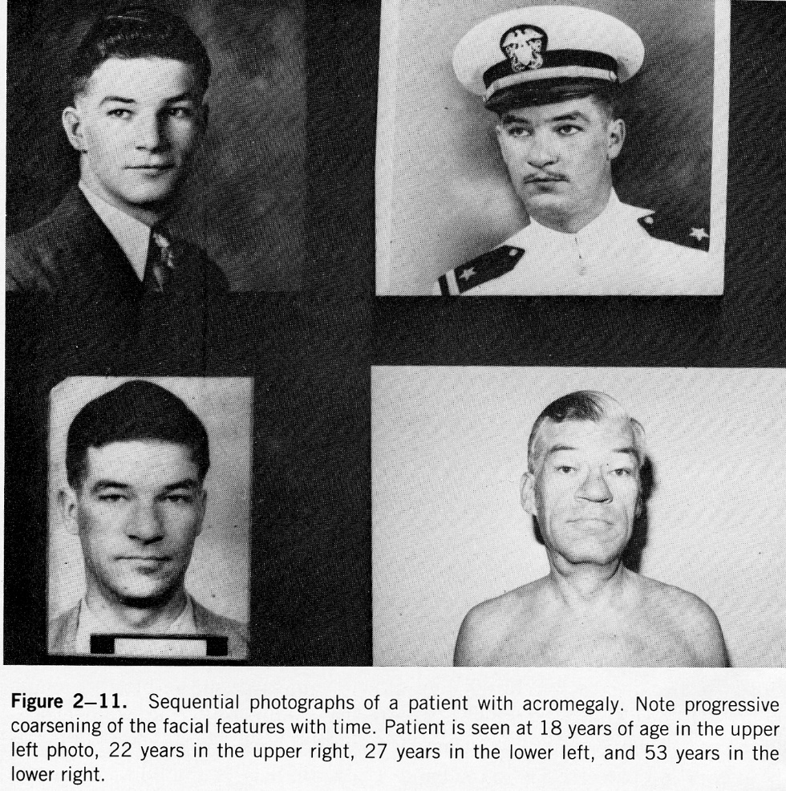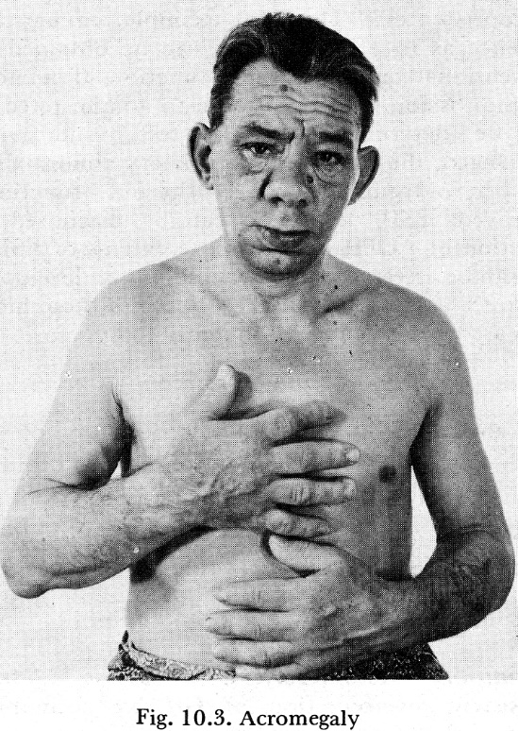

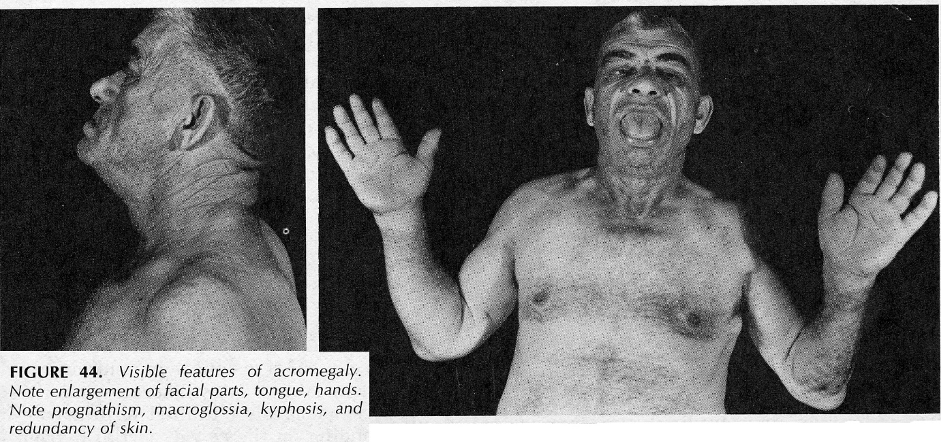

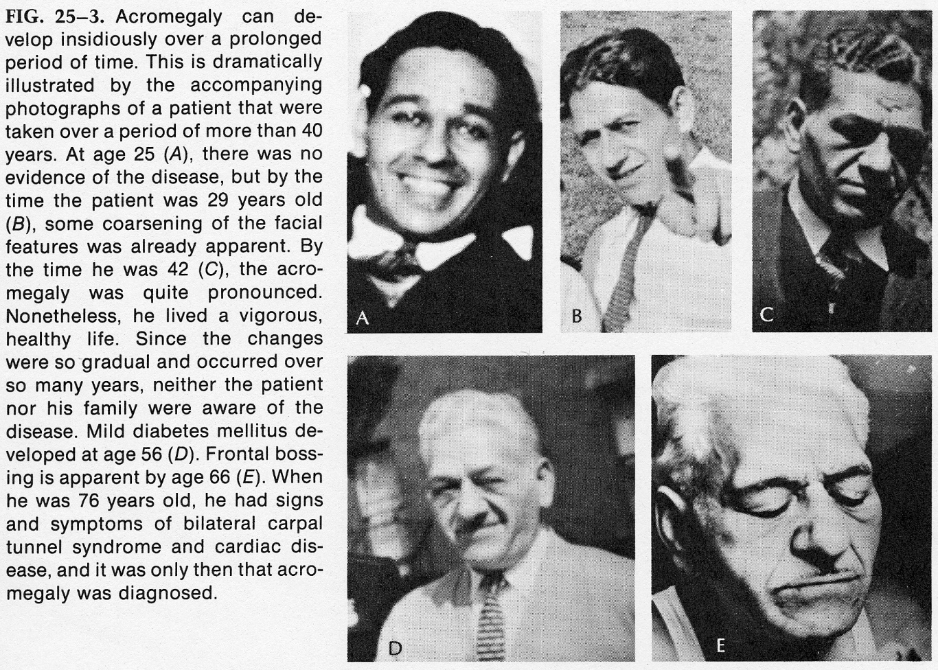

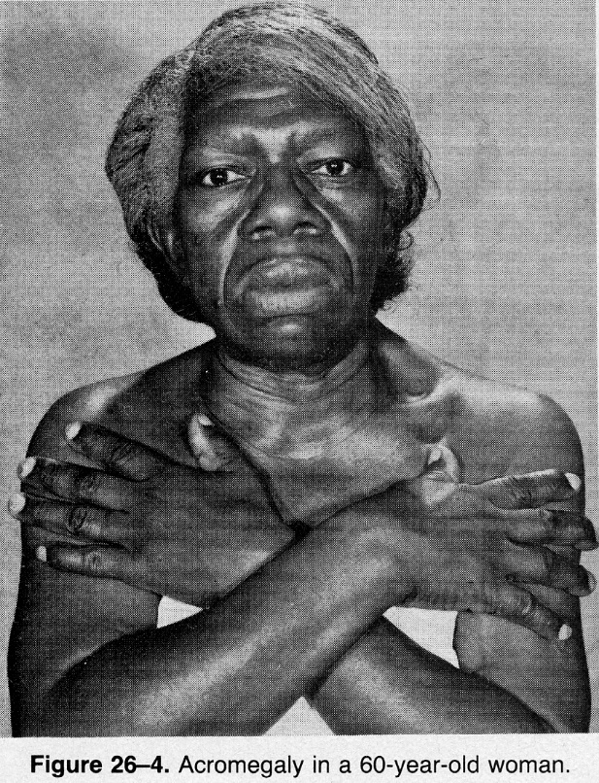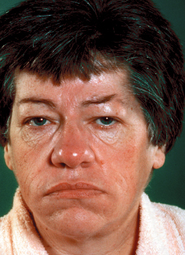

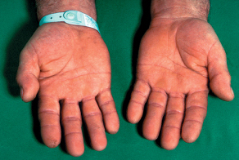

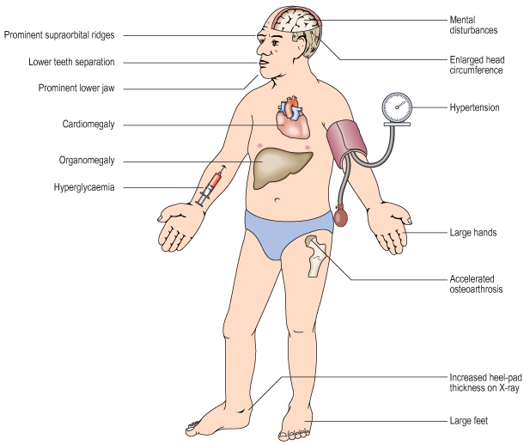

Diagnosis
Shorter life span makes early diagnosis crucial!
- Skull X-rays - cortical thickening, enlargement of supraorbital ridge and frontal sinuses, enlargement and erosion of sella turcica.
- Hand X-rays - tufting of terminal phalanges (spade-like fingers), soft tissue thickening.
- Glucose intolerance.
- Plasma GH levels (can fluctuate significantly - single value is not sufficient to make diagnosis):
- ↑ in basal state (before patient arises from bed and eats breakfast) - can be used to monitor response to therapy.
- no suppression to < 1-2 mcg/L in response to 50-100 g glucose load - standard definitive test for diagnosing acromegaly; TRH 200 mcg can be given to increase test's accuracy.
- Plasma IGF-1↑ 3-5 times (reflects GH concentration in last 24 hours - may be best endocrinologic test for acromegaly!; can be used to monitor response to therapy).
- Serum phosphate↑.
- If no pituitary tumor is visible on CT / MRI → seek for ectopic GHRH secretion (plasma GHRH↑).

- difkė – familial tall stature, hyperthyroidism, Marfan syndrome, homocystinuria.

Treatment
Ablative therapy of adenoma – surgery and/or radiotherapy. see Onc26 p.
- operation is technically difficult because of greater distance from patients' lip to sphenoid sinus.
- if radiation is used alone, GH levels fall over several years!
- hypopituitarism several years after irradiation is common.
- if GH levels after glucose i/v fall to < 2 ng/mL, "cure" has likely been effected, whereas levels > 10 ng/mL indicate need for medical therapy.

Medical therapy is indicated:
- if ablative therapy is contraindicated or have failed.
- while waiting for radiotherapy to work.
- Dopamine agonists (e.g. bromocriptine) are effective in only few patients.
N.B. bromocriptine čia veikia paradoksiškai (normoje jis skatina GH sekreciją)!
- Somatostatin analogues (e.g. octreotide) are effective in all refractory cases, but is expensive and administered sc (todėl yra antro pasirinkimo vaistas); gallstones are frequent complication of somatostatin-analogue therapy!
naujesnis preparatas (FDA approved for acromegaly) – lanreotide.
- GH receptor antagonist (pegvisomant). see 2714 p.

Galactorrhea
Lactation in:
- men
- not breastfeeding women

Etiology
I. Prolactinomas (the most common secretory tumors of pituitary!!!)
- majority in women are microadenomas.
- in men majority are macroadenomas (because of later recognition).
Prolactinomas occur in up to 40% of MEN-I syndromes.
Serum prolactin > 200 μg/L in pituitary adenoma > 10 mm is diagnostic of prolactinoma; levels < 200 μg/L suggest hyperprolactinemia secondary to hypothalamic / stalk compression!
II. Antidopamine drugs:
    - psychoactive (phenothiazines, tricyclic antidepressants, butyrophenones)
    - antihypertensives (reserpine, α-methyldopa).
III. Primary hypothyroidism (TRH↑ stimulates TSH and prolactin secretion).
IV. Hypogonadotropism (hiperprolaktinemijos mechanizmas neaiškus).
V. Other:
- head trauma
- pituitary stalk section
- hypothalamic disorders (tumors, sarcoidosis, etc.)
- liver disease
- chronic renal failure, hypernephroma
- breast manipulation
- estrogens may cause galactorrhea, but prolactinoma should be suspected if amenorrhea and galactorrhea persist for > 6 months after oral contraceptive use is discontinued.

Symptoms & Signs
- Galactorrhea – esti tik ≈ 30% hiperprolaktinemijos atvejų.
- Obesity

Hyperprolactinemia somehow leads to lowered LH and FSH levels → hypogonadism:
- Amenorrhea is almost always present in women:
- three galactorrhea-amenorrhea syndromes:
- Chiari-Frommel syndrome - persistent galactorrhea-amenorrhea after pregnancy (without pituitary tumor)
- Ahumada-del Castillo syndrome - galactorrhea-amenorrhea not associated with pregnancy (without pituitary tumor)
- Forbes-Albright syndrome - galactorrhea-amenorrhea caused by chromophobe pituitary adenoma (prolactinoma)
- frequent symptoms of estrogen deficiency (hot flushes and dyspareunia, later osteoporosis).
- other menstrual disturbances are possible (oligo-ovulation, corpus luteum dysfunction).
- Men note loss of libido and potency (šiaip vyrams gali būti asimptomiška).

Diagnosis
- documentation of hyperprolactinemia in basal state.
- gonadotropin and estradiol levels are either low or normal.
- tyrimai pituitary adenoma aptikti (high-resolution CT or MRI) ir dydžiui įvertinti (visual field examination).

N.B. pregnancy test is mandatory in all female patients with hyperprolactinemia:
  - hyperprolactinemia may be caused by pregnancy.
  - prolactinomas may be worsened by pregnancy (all women with macroprolactinomas should have quantitative visual field testing before pregnancy and must be observed closely).

Treatment
Many tumors do not require treatment!

A. Dopamine agonists - bromocriptine – indikacijos:
- normal CT or MRI (i.e. no adenoma) and:
  - hypoestrogenemia (osteoporosis risk); exogenous estrogen also can be given.
  - embarrassing galactorrhea.
- microadenomas
- macroadenomas up to 2 cm (even with extremely high prolactin levels) - if prolactin falls and compression by tumor abates, no other therapy may be necessary; if no → ablative therapy.
- shrink tumor before surgery
- vartojamas visą gyvenimą.
- bromocriptine is safe during pregnancy.
- periodic monitoring - basal prolactin levels + CT / MRI of sella turcica.
- naujesni (efektyvesni) dopamino agonistai – cabergoline, pergolide (withdrawn from US market March 29, 2007, because of heart valve damage)

B. Surgery

c. Radiotherapy - only in progressive disease not responding to other forms of therapy.
N.B. hypopituitarism often occurs several years after therapy!

Gonadotropin-Secreting Adenoma
- inefficient secretor of gonadotropins – tumoras manifestuoja kaip macroadenoma su mass effect (visual loss, hypopituitarism, headache); endokrininiai sindromai nebūdingi.
- treatment - surgical removal.

TSH-Secreting Adenoma
- likely cause of many cases of primary hyperthyroidism – pacientai klaidingai gydomi with antithyroid measures.
- treatment - surgery and radiation therapy.

ACTH-Secreting Adenoma
- causes 70% cases of Cushing's disease.
- treatment - surgical resection (remission is achieved in 50-88% cases);
if ACTH hypersecretion persists → redo resection / SRS* ± lifetime medical therapy (ketoconazole, cabergoline, pasireotide, mitotane, or mifepristone)
if severe ACTH hypersecretion persists → add adrenalectomy (risk of adrenal crisis and Nelson-Salassa syndrome)
*whenever possible, a margin dose of 25 Gy or more (ideally, 50 Gy – per Dade Lunsford) is prescribed while limiting the maximum radiation dose to the optic nerves and chiasm to < 12 Gy
- kartais klaidingai diagnozuojama bilateral adrenal hyperplasia ir antinksčiai pašalinami, o hipofizės adenoma nepastebima – gali išsivystyti Nelson’s syndrome (hipofizės adenoma pradeda greitai augti → extremely high ACTH → hyperpigmentation).

Panaudota literatūra:
Merck Manual 1999
Abeloff: Clinical Oncology, 2nd Ed., 2000 (1172-1174 p.)

