CPR

Last updated: June 26, 2016

Cardiac Arrest 1

Etiology, Pathophysiology 1

Symptoms & Signs 2

Respiratory Arrest 2

Symptoms & Signs 2

Cardiopulmonary Resuscitation (cpr) 2

Use of Social Media 2

Good Samaritan Law 2

Terminating resuscitation 2

BLS Primary Survey 3

Algorithm 3

Airway Opened (A) 4

Unconscious person 5

Foreign bodies in airways 5

Breathing Restored (B) 7

Circulation Restored (C) 8

External (closed-chest) cardiac compressions 8

Įpūtimų ir paspaudimų kombinacija 9

Open-chest cardiac compression 10

Defibrillation (D) 10

Conductive Materials 10

Procedure 11

Forceful precordial thump (mechanical defibrillation) 11

ACLS Secondary Survey 11

ACLS Team 11

Drug Therapy 12

Drug access sites 12

Pulseless Arrest 12

Ventricular fibrillation (VF), pulseless ventricular tachycardia (VT) 13

Pulseless electrical activity (PEA) 14

Asystole 14

Symptomatic Bradycardia 14

Tachycardias with Pulses 15

Unstable Tachycardia 15

Stable Tachycardia 16

Mechanical Resuscitation Devices 16

Airway Support 17

Barrier devices 17

Basic Airway Adjunct 17

Advanced Airways 18

Surgical Airways 19

Airway Suctioning 20

Circulatory Support 20

Postresuscitative Care 20

Chain of Survival 21

Special Circumstances 21

Electrical shock (electrocution) 21

Klinika-patofiziologija 21

Tyrimai 21

Prevencija 21

Treatment 21

Lightning 22

Klinika 22

Treatment 22

(Near)-drowning 22

Pathology 22

Klinika 23

Gydymas 23

Trauma 23

Pregnancy 23

Pediatric Cardiopulmonary Resuscitation 23

Newborn resuscitation → see p. Ped9

**Hanging, Strangulation** – see p. TrS21

Fundamental difference between children and adults:

**children** – dažniausiai cardiac arrest įvyksta dėl *poor ventilation* – kraujas esti blogai oksigenuotas – todėl gaivinant labai svarbu kokybiški įpūtimai.

**adults** – dažniausiai cardiac arrest įvyksta dėl *heart disease* – kraujas esti gerai oksigenuotas – pradžioje gaivinant kurį laiką pakanka tik chest compressions.

Cardiac Arrest

- *absent / inadequate* ***ventricular contraction*** *that immediately results in systemic circulatory failure*.

**Medical emergency** that ***overrides all others*** except exsanguinating external hemorrhage or airway obstruction, which should be controlled simultaneously.

Leading cause of death in North America!

Etiology, Pathophysiology

**I. Electrical dysfunction** - most common mechanism (80%):

1. **ventricular fibrillation** (VF) - major rhythm in prehospital cardiac arrest (70% of patients).
2. sustained **ventricular tachycardia** (VT) - best prognosis in resuscitation & survival.
3. **asystole** - absence of electrical activity on ECG, with absent perfusion; worst prognosis.

* causes:

1. severe generalized myocardial ischemia
2. ventricular rupture
3. hyperpolarization of cardiac cell membranes (severe hyperK+ or hyperMg+2).

**II. Electromechanical dissociation (s. mechanical failure)** - organized electrical depolarization ***without mechanical contractions***.

* causes:

1. cardiac rupture
2. cardiac tamponade
3. global ischemia, acute MI
4. obstructing intracardiac tumor / thrombus.

**Pulseless electrical activity (****PEA)** is circulatory collapse despite satisfactory electrical complexes, i.e. ***myocardium may still contract*** but insufficiently to allow pulse detection (i.e. pulseless electrical activity is not necessarily synonymous with electromechanical dissociation – prie PEA *invasive* BP monitoring can detect low-amplitude pulse waveforms).

* any organized rhythm (even sinus) without detectable pulse.

exceptions: VF, VT, asystole

* causes – **Hs & Ts**: PEA is most common rhythm following defibrillation!

1. hypovolemia
2. hypoxia
3. hypothermia
4. hypoglycemia
5. hydrogen ion (acidosis)
6. hypo-/hyper-kalemia
7. toxins - drug overdose (tricyclic antidepressants, digitalis, β-blockers, Ca blockers)
8. tension pneumothorax
9. tamponade, cardiac
10. thrombus (coronary, pulmonary, intracardiac impacted)
11. trauma

**III. Circulatory shock** has many causes, however, ***diastolic arterial hypotension*** is common denominator leading to impaired coronary artery blood flow → myocardial electrical instability → cardiac arrest.

**IV. Abnormalities in ventilation** → significant respiratory acidosis (cardiopulmonary arrest).

N.B. although either heart or lungs may fail first, both events usually are closely related!

Symptoms & Signs

1. loss of **consciousness**
2. absent **heart** sounds, profound arterial hypotension.
3. rapid, shallow **breathing** → (rapidly) → apnea

* within several minutes, tissue hypoxemia results → vital organ injury.

Respiratory Arrest

*- absence of* ***spontaneous ventilatory movement***.

**I. Primary respiratory arrest**

1. ***airway obstruction***
2. ***absent respiratory drive***
3. ***respiratory muscle failure***.

**II. Secondary respiratory arrest** results from ***circulatory insufficiency***.

Symptoms & Signs

* impending respiratory arrest is characterized by:

1. depressed sensorium
2. gasping, irregular respirations
3. tachycardia, diaphoresis
4. relative hypertension (due to agitation and CO2 accumulation).

* if respiratory arrest is prolonged, progressive hypoxemia impairs cardiac function→ **cardiac arrest**.

Cardiopulmonary Resuscitation (cpr)

“Child” (if not age specified) means from 1 yr to puberty

Speed & efficiency directly relate to successful neurologic outcome - **tissue anoxia for > 4-6 min can result in irreversible brain damage / death**!

N.B. prognosis varies widely depending on age, cause of arrest, and clinical circumstances!

* limiting factor in resuscitation is ***brain & myocardium perfusion***.
* transportation of cardiac arrest ***victim with continuing CPR*** to ED is justified only if required specific interventions (e.g. internal rewarming) can not be performed out-of-ED.

Use of Social Media

* given the low risk of harm and the potential benefit of such notifications, it may be reasonable for communities to incorporate, where available, social media technologies that summon rescuers who are willing and able to perform CPR and are in close proximity to a suspected victim of OHCA. (Class IIb, LOE B-R)

Good Samaritan Law

Each of the 50 states has enacted what are known as the "Good Samaritan Laws" These laws give legal protection to people that give emergency care to an ill or injured person without accepting anything in return. It’s very important that you understand that no compensation of any kind can be accepted for performing emergency care or the Good Samaritan Laws may no longer protect you! These laws vary from state to state and usually protect citizens that act in the same way that a "reasonable and prudent person" would if that person were in the same situation. Developed to encourage people to help, these laws require the "Good Samaritan" to:

1. Act in Good Faith
2. Not be deliberately negligent or reckless
3. Act within the scope of his/her training
4. Not abandon the person after starting to give care

Terminating resuscitation

*Resuscitation can be discontinued if no ROSC (of any duration) occurs during* ***20 minutes***

CPR must be continued until:

1. cardiopulmonary system is *stabilized*
2. resuscitation *cannot be continued* (rescuer exhaustion).
3. patient is pronounced *dead* (deep unconsciousness or absence of spontaneous respiration, circulation, and brain stem reflexes) – arrest persists (> 20 mins) despite adequate trial of advanced cardiac life support and no reversible cause of arrest is identified

**Death** = loss of *heartbeat* + *respirations* + *cerebral function*

N.B. in ***profound hypothermia*** (e.g. prolonged cold-water submersion), CPR should be continued until ***total body core is rewarmed*** (patients needing CPR for as long as 3 h have recovered!).

DNR (do not resuscitate) situations: also see p. 4651, 4656 (3-4) (*public health*)

1. DNR order has been established prior to arrest
2. irreversible cause of arrest

*American Heart Association guidelines* divide CPR into:

**primary survey** (basic life support, BLS)

**secondary survey** (advanced cardiac life support, ACLS + continuing BLS).

BLS Primary Survey

Previous guidelines called for Airway-Breathing-Chest Compressions (ABC). This has been changed in recent guidelines since 2010 and continues in 2015 guidelines:

The correct procedure is **C-A-B** for victims of any age!!!

Chest Compressions, Airway, Breathing.

“Adult victim” includes adolescents – chest or axillary hair in **males**, any breast development in **females**.

Infant is < 1 yr old (except newborn in delivery room)

2015 AHA guidelines:

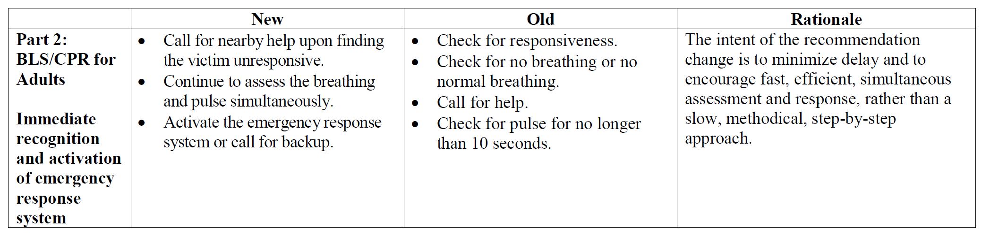

Algorithm

1. Make sure *scene is safe* for you & victim
2. Establish victim *unresponsiveness* (tap / shake victim’s shoulder* and shout “Are you all right?”); no movement, no response →

* for infants < 1 yr – foot or make noise with hand clapping

1. Yell for *help*:
2. no one responds → *activate emergency response system / call 911*\* → *get AED* → return to victim
3. another rescuer responds → send him to *activate emergency response system / call 911* & *get AED*

* do not hang up the phone - place it next to the victim so operator can hear what's going on.
* note exact *time* of arrest (if known); when exact cardiac arrest *duration is uncertain*, victim (unless in terminal stage of incurable condition) should be given benefit of doubt.

N.B. before CPR*, you must establish unresponsiveness+ activate EMS + get AED

1. Position victim *supine* *horizontally* on *flat* *hard* surface (if in bed – pakišk board or move to floor) →
2. Begin BLS following mnemonic for all ages **CAB** + **D** ASAP (defibrillation for VF or pulseless VT):

* open victim’s **airway** and **check** **breathing** (for > 5 seconds but no more than 10 seconds)

at the same time ↑ and ↓

* **check** **pulse** (for > 5 seconds but no more than 10 seconds; adults – carotid, child – carotid or femoral, infant - brachial):

N.B. 2010 AHA update - de-emphasis of pulse check (because it may be difficult to feel even for healthcare providers)!

* 1. ***if no adequate breathing but you feel pulse*** → give 1 breath q 6 seconds (rescue berthing) + recheck pulse q 2 minutes
  2. ***if you do not feel definite pulse*** within 10 seconds or ***< 60/min in child with signs of poor perfusion*** (e.g. poor color) → start 2 : 30 cycles of ventilations & compressions*; when **AED** arrives and pads are placed – stop CPR & **check** rhythm (for < 10 sec):

N.B. attach AED only if no pulse!

shockable rhythm → 1 shock → immediately resume CPR for 5 cycles (2 mins) → check rhythm again

nonshockable rhythm → immediately resume CPR for 5 cycles (2 mins) → check rhythm again

organized rhythm → check pulse *you check pulse only if you see organized rhythm*

N.B. always first **check**, then, if needed, perform action; CPR must be started within 10 seconds of recognition of cardiac arrest

*exceptions:

1. jei vaikas rastas unresponsive (vs. witnessed sudden collapse)

N.B. **infant or child victim – start CPR and only then call 911**!

1. if adult is likely victim of asphyxia, i.e. respiratory arrest (e.g. drowning)
2. if you are EMS rescuer who did not witness cardiac arrest and arrived > 4-5 mins after call

* pradžioje reikia atlikti 5 CPR ciklus, o tik tada bėgti aktyvuoti emergency response system, pastverti AED ir atlikti defibriliaciją; visais kitais atvejais – use AED as soon as it is available

N.B. for infants < 1 yr, AED is generally not used – continue CPR until ALS team takes over; bėgant aktyvuoti emergency response system, pastverk nesužeistą mažą vaiką su savim – galėsi pradėti CPR iš karto after phone call!

Adult algorithm (old)

pediatric algorithm (old)

Airway Opened (A)

- the first priority in BLS.

Evaluate **airway patency** – place your ear near victim’s mouth & nose while observing victim’s chest – look, listen, feel for air exchange (patient without spontaneous respirations requires attempt at ventilation to assess airway patency):

Evaluate **airway protection** – ar veikia paciento nervų sistemos apsauga:

1. gag reflex
2. pooled secretions in oropharynx (inability to swallow)

* gaivinami pacientai dažnai *vemia* – būtina greitai išsiurbti ryklę ir paguldyti į left lateral decubitus position.

Unconscious person

- most common cause of upper airway obstruction - due to ***posterior tongue displacement*** into oropharynx secondary to muscular tone loss - galima naudoti tris metodikas:

|  |  |
| --- | --- |
| 1. **Head tilt-chin lift** – main and most efficient maneuver;  * place one hand on victim's forehead and push with your palm to tilt head back. * place II-III fingers (not thumb!!!) of second hand under mandible rim near chin (do not press deeply into soft tissue under chin – this might obstruct airway). * lift chin forward (vertically upwards) until teeth are brought almost together (but not closing mouth!): | use169 |

for infants < 1 yr, do not hyperextend (will block airways) – bring into neutral neck position only (i.e. external ear canal in level with shoulder top):

1. **Head tilt-neck lift** – place one hand on victim's forehead, lift neck straight up with other hand while tilting head back – no longer recommended method.

|  |  |
| --- | --- |
| 1. **Jaw thrust** *without head tilt* - preferred method in suspected *cervical spine injuries*.  * rescuer stands or kneels at victim's head, placing hands at sides of victim's face and using fingertips to lift mandible forward (plus, retract lower lip with your thumbs). * usually two rescuers are needed to apply it and ventilate. * if jaw thrust does not open airways → use ordinary head tilt-chin lift. | use170 |

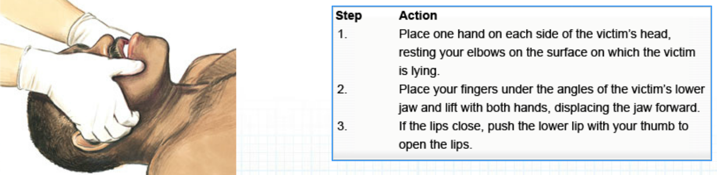

N.B. all trauma victims should be placed in protective ***cervical spine collar*** during transportation!

(endotrachėjinę intubaciją ar kitas manipuliacijas patogiau atlikti kuomet apykaklė nuimta ir ašinė trakcija palaikoma rankomis)

***Dentures should be left in place*** because removing them may make mouth-to-mouth seal more difficult during rescue breathing.

Foreign bodies in airways

Someone who is choking may use ***universal distress sign***:

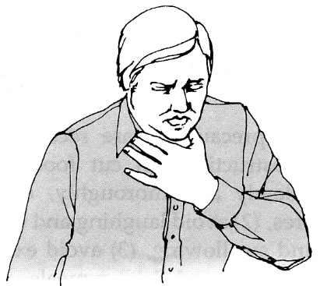

If patient is *breathing adequately* (partial airway obstruction – may wheeze) → encourage spontaneous forceful coughing with leaning forward; if partial airway obstruction persists → activate emergency response system.

If *stridor and respiratory difficulty* coexist or *loss of consciousness* occurs:

Ask victim if he/she is choking; if victim nodes yes and cannot talk → ask if you can help (to avoid touching patient without consent) → activate emergency response system →

|  |  |
| --- | --- |
| I. Heimlich maneuver (subdiaphragmatic thrusts).   * taikomas for **adults** & **children > 1 yr age**. * galimos dvi pozicijos:   **a) standing / sitting position** - for *conscious* victims   * + - * + stand (viena koja į priekį tarp paciento kojų, kita atgal – išlaikysime griūvantį pacientą) or kneel behind victim or, if victim very tall, priremti nugara prie sienos ir spausti iš priekio.         + apglėbus pacientą iš užpakalio;         + make fist; hold thumb side of fist against upper abdomen (midway between navel and xiphoid);         + grasp your fist with other hand;         + quick upward thrusts; stay in midline!         + you may have to thrust hard enough to literally lift the victim off his or her feet | merck 2290-2 |
| merck 2290-1 | **b) lying position** - for *unconscious* victims when you witnessed loss of consciousness (if you didn’t – you won’t know the cause → start normal CPR):   * sit astride [angl. apsižergti raitomis] victim and place heel of hand in ***upper abdominal area below xiphoid process*** (to avoid damage to chest structures and liver, hand should never be placed on xiphoid process or over lower rib cage!); * other hand is placed on top of first and firm *upward* thrust is delivered.   N.B. *straight downward thrust may injure aorta!* |

According to BLS course materials: if victim becomes unresponsive (so, you know the cause) → activate emergency response system* (if not done so) → open mouth wide, remove object if you see it → begin CPR** (every time you open mouth for breath – check for foreign body in mouth until airways are clearly open)

*for children, only after 5 cycles of CPR

\*\**you do chest compressions even if pulse is present*! – tikslas išstumti svetimkūnį iš kvėpavimo takų, o ne širdies masažas

If you did not witness event, so you don’t know the cause – you will feel airway resistance when trying to give blow – your cheeks will puff.

* 6-10 thrusts may be necessary to dislodge foreign body.
* in pregnant or extremely obese patients, ***chest thrusts*** should be used - similar to that used for cardiac compression:

**Infants < 1 yr** – use combination of **back slaps** and **chest thrusts**:

N.B. kūdikiams Heimlich manevras netaikomas – lengvai sužalojami vidaus organai!!!

1. Kneel or sit with infant in your lap; hold prone infant in head-down position while rescuer delivers up to 5 forceful **back slaps** (direction – slightly cephalad) between shoulder blades using hand heel:

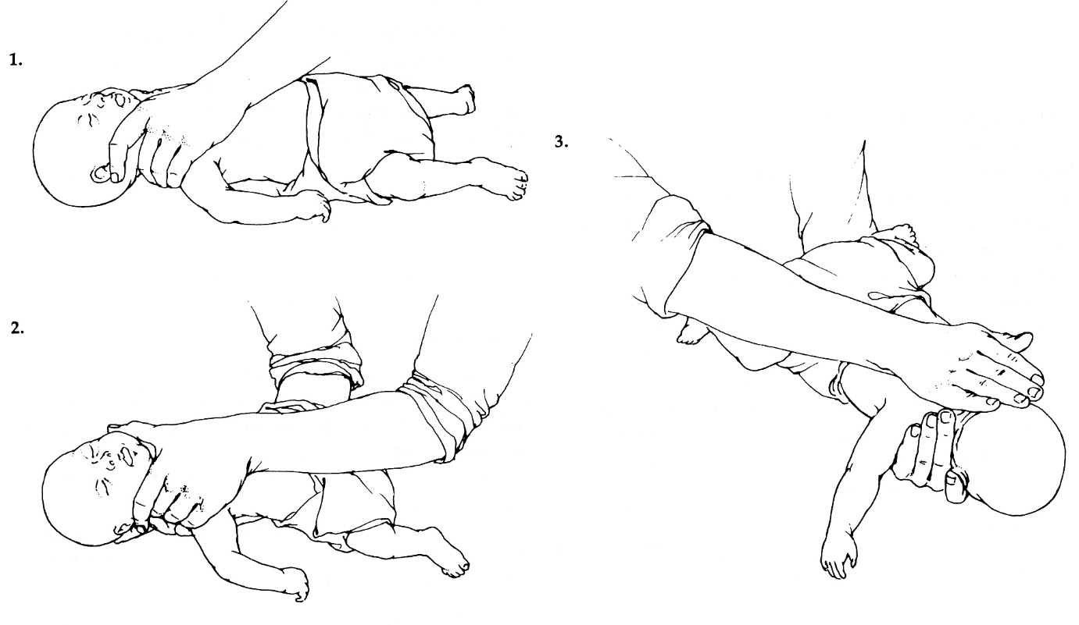

1. After 5 back slaps, place your free hand on infant’s back, supporting back of head with your palm; turn infant as unit into supine head-down position → deliver up to 5 **chest thrusts** (as in normal CPR).
2. Repeat.

* if infant becomes ***unresponsive***, stop back slaps and chest thrusts → start normal **CPR** including attempts to remove visible object (each time you open infant’s mouth for breath).

II. Blind finger sweeps**:** foreign body may also be removed by sweeping index finger along cheek through mouth and pharynx (after tongue and lower jaw have been displaced forward).

N.B. care should be taken not to dislodge foreign body further into airway!

* not recommended in children (but if obstructing object can be seen, it should be carefully removed!).

III.If obstruction persists, cricothyrotomy must be performed.

After airway is opened:

* *seek for spontaneous ventilation* (watch rise and fall of chest while listening for airflow at mouth, feeling exhaled air on rescuer's cheek) and *pulse*:

if either absent → normal CPR.

if both present → place victim into recovery position and wait for EMS.

USE THE RECOVERY POSITION FOR ANY VICTIM WHO IS UNRESPONSIVE AND BREATHING

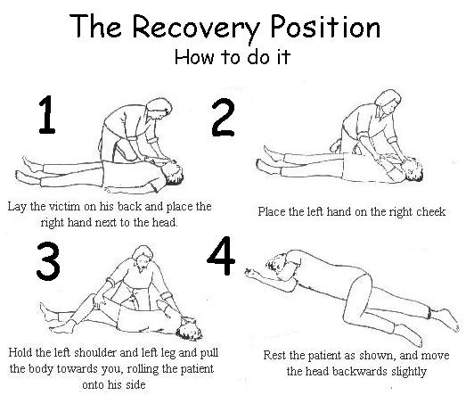

You can also reverse the procedure and place the victim in the recovery position by rolling the victim away from you:

* Extend the victim's arm that is farther away from you straight out or slightly above the victim's head.
* Position the victim's other arm across the chest.
* Bend the victim's nearer leg at the knee.
* Put the forearm that is nearer the victim's head under the victim's nearer shoulder, with your hand under the hollow of the neck.
* Carefully roll the victim away from you by pushing on the victim's flexed knee and lifting with your forearm while your hand stabilizes the head and neck. The victim's head is now supported on the arm.
* While continuing to support the head and neck, position the victim's hand palm-down with fingers over the arm and supporting the chin. This can be modified and the hand can be placed under the armpit with forearm on the surface at 90 degrees to the body
* With victim now in position, check the airway and open the mouth to allow drainage.

<https://youtu.be/oWUDwRCDBHA>

* all victims who have received Heimlich maneuver should be examined by healthcare provider to rule out ***internal organ damage*** + observed for delayed ***upper airway swelling***!

Breathing Restored (B)

*Dažna klaida – per daug įpučiama oro –* ***avoid hyperventilation****!*

*(too forceful, too quick breaths* → *decreased venous return to heart + gastric inflation)*

* **rescuer’s** exhaled **air contains ≈ 17% O2 and 4% CO2.**

**Always use barrier device (e.g. pocket mask) if available!**

##### **Mouth-to-mouth resuscitation**

- preferred method (except for infants < 1 yr)

* place heel of one hand against victim's forehead (to keep head tilted backward).
* pinch nostrils shut using thumb and index finger.
* beginning ventilation: rescuer regularly (not deeply!) inhales, makes tight seal with victim's mouth, and blows **two full breaths** → start chest compressions

pagal kai kuriuos šaltinius – **4 full breaths** without allowing time for full lung deflation between breaths – this maintains positive pressure in airways and helps fully inflate lungs.

for children – start from > 2 breaths – children typically have more pronounced hypoxia

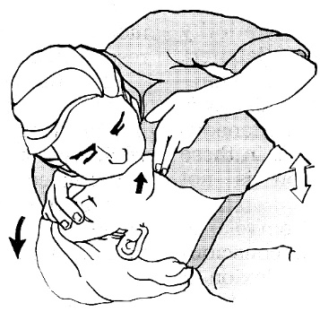

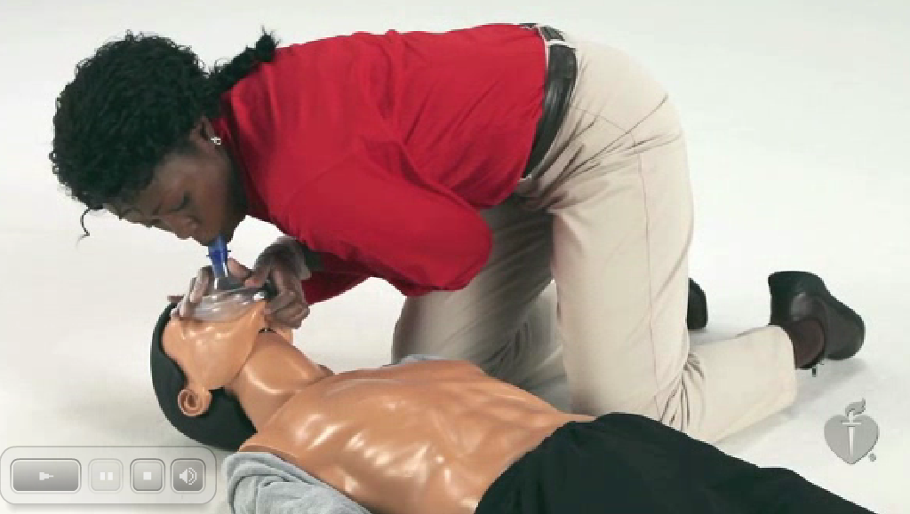

* allow adequate time: 1 sec for inhalation (not faster - avoids gastric inflation), 1-2 sec for exhalation.
* įpūtimų dydis – enough air to make chest rise (**adults** ≈ **1 litras**, t.y. dvigubai daugiau negu normalus tidal volume; **infants** - only small puffs from rescuer's cheeks)
* adequacy is assessed by seeing *victim's chest rise & fall* and by *hearing & feeling passive exhalation* - jei to nėra, pakartok head tilt-chin lift; no effect → Heimlich maneuver.
* įpūtimų skaičius - žr. lentelę žemiau.
* if rescuer develops ***hyperventilation alkalosis*** (manifested by dizziness, numbness, ear ringing, paresthesias), respiratory rate should be slowed or amplitude of each breath decreased.
* if unable to give adequate ventilations after 2 attempts, promptly move to chest compressions.

1. **Mouth-to-nose resuscitation** is indicated *when mouth-to-mouth resuscitation is not possible*.

|  |  |
| --- | --- |
| * rescuer's hand should push lower jaw forward, closing mouth (but allow victim's mouth to open during passive exhalation). * tight seal is made around victim's nose and deep breath is delivered. | merck 1744-c |

1. **Mouth-to-mouth-and-nose resuscitation** - preferred for *infants & small children* (when tight mouth seal cannot be maintained).

* in general, in children ≥ 8 yr of normal body size, adult CPR techniques can be used.

**Cricoid pressure (Sellick maneuver)** should be applied continuously to occlude esophagus:

1. minimizes gastric inflation; gastric inflation provokes regurgitation (if gastric distention occurs, **nasogastric tube** should be inserted; nasogastric tube indikuotinas visiems, kuriems taikoma mechaninė ventiliacija).
2. minimizes aspiration risk.

* for Sellick maneuver you need extra (third) rescuer dedicated only for that.
* use thumb and index finger to apply firm pressure in cricoid (only if no gag / cough reflex is present).
* indications:

1. BLS when third rescuer is available
2. during ET intubation (release cricoid pressure only after cuff inflation).

AHA 2010 update – Sellick maneuver may impede ventilation and its routine use is not recommended!

Circulation Restored (C)

External (closed-chest) cardiac compressions

*Chest compressions – CPR priority!*

*Rate + Depth + Chest Recoil*

While tilting victim's head nuslysk pirštais nuo gerklų lateralyn į griovelį (patogiau toje pusėje, kur pats esi) - gently ***palpate carotid pulse*** for 5-10 sec (may be irregular, weak)

* **for *children* pulse is palpated** at:

***base of umbilical cord*** (newborn)

***brachial*** *or femoral* ***artery*** (< 1 yr) – palpate with 2-3 fingers inside of upper arm

***carotid artery*** (≥ 1 yr).

If no pulse is felt → immediately begin external cardiac compressions:

**Adults**

* victim must be placed *horizontally supine* on *flat hard surface*.
* if found prone, roll to supine when maintain neck in line
* position yourself at victim’s side.
* move / remove all clothing covering victim’s chest – you must see skin!
* put heel of one hand on sternum at nipple line:
* put heel of other hand on top of first hand.
* if your hands / wrists are arthritic, grasp wrist of your compressing hand with your other hand for support
* 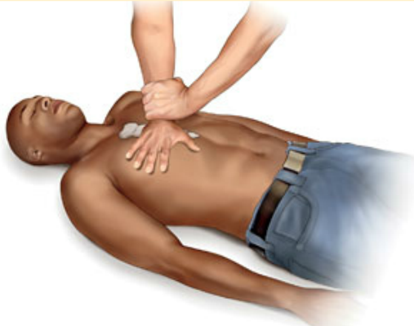

N.B. never push *xiphoid process*!

* rescuer should be positioned directly over victim (shoulders over hands) and, keeping arm straight (locked elbows), should exert sufficient force *directly downward* over sternum (to avoid rib fractures):

Push hard and fast!

* fingers may be extended or interlocked but must be kept off chest wall!
* ***push sternum at least 2 inches (5 cm) but no more than 2.4 inches (6 cm)*** straight down.

A compression depth of approximately 5 cm is associated with greater likelihood of favorable outcomes compared with shallower compressions. While there is less evidence about whether there is an upper threshold beyond which compressions may be too deep, a recent very small study suggests potential injuries (none life-threatening) from excessive chest compression depth (greater than 2.4 inches/6 cm). Compression depth may be difficult to judge without use of feedback devices, and identification of upper limits of compression depth may be challenging. It is important for rescuers to know that chest compression depth is more often too shallow than too deep.

**PUSH HARD and FAST at rate 100-120 compressions per minute** (Class IIa, LOE C-LD)

*100-120 per minute – it is rate, not actual number of compressions!*

A single large registry series suggested that as the compression rate increases to more than 120/min, compression depth decreases in a dose-dependent manner. For example, the proportion of compressions of inadequate depth was about 35% for a compression rate of 100 to 119/min but increased to inadequate depth in 50% of compressions when the compression rate was 120 to 139/min and to inadequate depth in 70% of compressions when the compression rate was more than 140/min.

* **allow time for full chest recoil to resting position** (compression time ≈ release time)

**Allow full chest recoil after each compression (i.e. release completely)**

* avoid leaning on the chest between compressions to allow full chest wall recoil.

Full chest wall recoil occurs when the sternum returns to its natural or neutral position during the decompression phase of CPR. Chest wall recoil creates a relative negative intrathoracic pressure that promotes venous return and cardiopulmonary blood flow. Leaning on the chest wall between compressions precludes full chest wall recoil. Incomplete recoil raises intrathoracic pressure and reduces venous return, coronary perfusion pressure, and myocardial blood flow and can influence resuscitation outcomes.

* rescuer's hands *remain on sternum* during release phase.
* incomplete recoil is harmful (impedes venous return).
* compression and recoil times should be about equal.
* move victim only if absolutely necessary (e.g. toxic environment, very uncomfortable position).

**Minimize *interruptions*** (do not interrupt compressions for more than 10 seconds, e.g. for ventilation; except for intended care - intubation, defibrillation, moving victim from danger)

*Studies show that professional rescuers give compressions only ≈ ½ of time during resuscitation.*

* for adults in cardiac arrest who receive CPR without an advanced airway, perform CPR with the goal of a chest compression fraction as high as possible, with a target* of at least 60%.

*proportion of total resuscitation time that compressions are performed

* cycle should be repeated **smoothly** (jerky compressions increase chance of injuries).
* **counting out loud** helps to monitor progress and coordinate team actions.
* although cardiac output is only **25-40% of normal**, compressions should produce palpable radial pulse (systolic BP > 80 mmHg) with each compression.
* tikslas – **return of spontaneous circulation (ROSC)** – tam reikia kad *koronarų perfūzinis spaudimas* (aortic diastolic pressure minus DPr pressure) pasiektų 15-30 mmHg; deja, masažuojant širdį *koronarų perfūzinis spaudimas* tepasiekia 1-8 mmHg - išoriniam širdies masažui naudinga papildomai skirti epinephrine – padidina “diastolinį” spaudimą aortoje veikdamas α-receptorius – pagerėja koronarų perfūzija.

N.B. β-agonistai (vazodilatoriai – dopamine, isoproterenol) gaivinant yra žalingi!

|  |  |
| --- | --- |
| **Children 1 yr - puberty**  * depth ***1/3 of AP diameter of chest (about 2 inches or 5 cm)*** * rate of 100-120/min – same as in adults! * for small children - use heel of ***one or two hand(s)*** * compress lower sternum (but not as low as in adult); new rec – same as for adults – between nipples.   Summary – only difference from adults – depth 1/3 chest diameter! | merck 2283-c |

**Infant (< 1 yr)**

* heart is higher in chest, and chest wall is more pliable.
* depth ***1/3 of AP diameter of chest (approx. 1.5 inch or 4 cm)***
* rate of 100-120/min – same as in adults!
* **one rescuer** - use tips of ***two fingers*** (middle and ring) placed just below inter-nipple line (i.e. lover half of sternum).

**two rescuers** - use ***2-thumbs-encircling hands*** technique - thumbs in parallel or overlapping on each other (thumbs are placed just below inter-nipple line) with other fingers around chest – i.e. all fingers perform compressions.

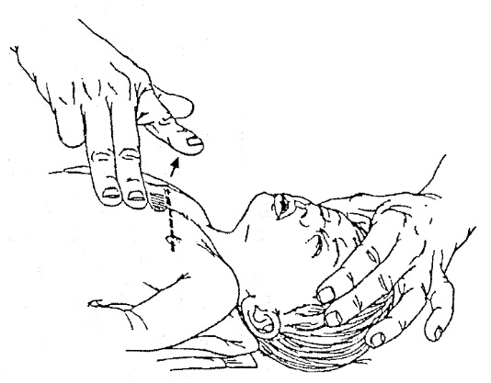 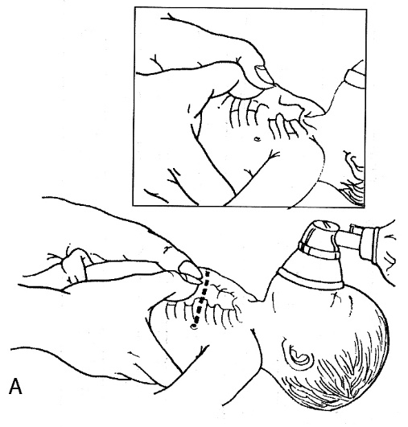

Įpūtimų ir paspaudimų kombinacija

|  |  |  |  |  |
| --- | --- | --- | --- | --- |
|  | **One rescuer** | **Two rescuers** | Ventilation rate | Compressions rate |
| **Adults** | 2 : 30 | 2 : 30 | Rescue ventilation (i.e. pulse present): 10-12 / min for adults, 12-20 / min for children  With advanced airway: 8-10 / min without coordination with compressions | 100-120 / min |
| **Child 1 yr - puberty** | 2 : 15 |
| **Infants** |

New recommendation – ratio 2 : 30 for everyone!

When taking BLS test at VCU for infant – rescuer does 2:30 using fingers for compressions; when second rescuer arrives, switch roles (second rescuer gives 15 compressions by 2 thumb–encircling hands technique, first rescuer bag-ventilates)

* for children, more frequent ventilations are required; also for head injury or asphyxia, increase rate by 25% (for premature infants - 50%).
* first exhalation occurs between two breaths, second – during first chest compression.
* two rescuers should switch roles every 5 cycles (i.e. q 2 mins; use < 5 seconds for switch); rescuer doing compressions counts out loud (to attract additional help if someone was passing by around the corner)

AHA 2005 guidelines recommend for **adult (in out-of-hospital setting) who has suddenly collapsed**:

1. Conventional 2:30 CPR
2. Hands-OnlyTM CPR - tik chest compressions*! (for adults in sudden cardiac arrest by CPR-untrained person; not recommended for children) *įpūtimus pradėti tik po 400 paspaudimų (t.y. po 4-6 minučių)

* avoid compression-only CPR if you can (esp. kids – most commonly asphyxial arrest, i.e. not cardiac arrest)
* if anytime CPR is interrupted in middle of cycle, begin CPR again from start of cycle.

Mechanism of action of closed chest compressions:

1. **cardiac pump theory** – heart is squeezed between sternum and spine (→ forward flow due to valves) and fills passively between compressions.
2. **thoracic pump theory** – intrathoracic veins collapse during compressions and fill passively between compressions.

First 5 compression build-up BP, next 25 compressions restore circulation.

Effectiveness of CPR should be monitored periodically:

1. check **carotid pulse**: 1 min after beginning BLS, after arrival of second rescuer, and q 4-5 min.
2. **pupillary responsiveness** is sign of adequate brain oxygenation;

persistently dilated pupils do not prove brain damage or death because high doses of cardioactive drugs, other drugs, or cataracts may modify pupil size and reaction.

1. **instrumentinis monitoringas** (rutiniškai netaikomas!):
2. *invasive blood pressure monitoring*
3. *central venous oxygen saturation*
4. *capnometry* (end-tidal CO2 concentration correlates directly with cardiac output when ventilation is constant)

Complications

1. **Liver** **laceration** is most serious (sometimes fatal) complication.

* caused by pressing too low on sternum.

1. **Gastric distention** → regurgitation and **aspiration**, **stomach rupture** after forcible abdominal thrusts.

* attempts to relieve gastric distention should wait until suction equipment is available;

if marked gastric distention interferes with ventilation, victim should be positioned on side, epigastrium compressed, and airway cleared.

1. **Costochondral separation** and **fractured ribs** (30%) sometimes cannot be avoided;

* rib fractures make *chest compressions less effective* and may induce *pneumothorax* by puncturing pleura!

N.B. concern for these injuries should not deter or modify appropriately performed CPR!!!

Modifications of closed chest compressions:

* **interposed abdominal counterpulsations** - alternating standard chest compressions with abdominal compressions (increase aortic pressure – gerėja perfūzija).
* **circumferential chest compressions** using pneumatic vest (increase intrathoracic pressures).
* **active decompressions** using hand-held suction cup device.
* **high-impulse CPR** – standard chest compressions at higher rate (120-150/min) – cardiac output increases linearly with compression rate; disadvantages – operator fatigue, rib fractures.

Open-chest cardiac compression

* pasiekia cardiac output iki **55% normalaus** (vs. closed compressions – only 25-40%)
* requires thoracotomy and is best performed only in extreme circumstances.
* **indications** - penetrating or crushed chest trauma, cardiac tamponade, cardiac arrest in operating room with patient's chest already open.
* širdis spaudoma tarp delnų nuo base link apex.

Defibrillation (D)

also see 1384 p. (*cardiovascular system*)

Initial call for help should result in prompt ***arrival of someone with defibrillator*** → *quick look* with defibrillator paddles to identify convertible arrhythmias (ventricular fibrillation* and tachycardias)

*most common rhythm in sudden cardiac arrest

Conditions for AED: no response + no breathing* + no pulse

*agonal gasping is not breathing

Time between **AED arrival** and **first shock** must be < 90 sec

* success of defibrillation is time-dependent (decline in success rate 7-10% per minute of cardiac arrest without CPR; 3-4%/min if adequate CPR is given) – nustačius shockable rhythm, defibriliuojama nelaukiant IV access ir intubacijos!

**Use AED ASAP!** (certain exceptions – *see above*)

**Resume CPR immediately after AED use!**

When taking BLS test, rescuers should SWITCH (one for breathing, one for compressions) when the second rescuer arrives and after each AED use.

* **automated external defibrillators (AED)** patys nustato ritmą ir skiria šoką jei reikia – tam nereikia jokio įsikišimo.
* **semiautomated external defibrillators (AED)** [dabar tokių dauguma] patys nustato ritmą ir tik duoda „advise“, o operatorius turi nuspausti mygtuką „SHOCK“.
* operatorius įsitaiso iš aukos šono ir pasideda šalia AED (kitas gelbėtojas kitoje aukos pusėje sėkmingai tęsia CPR).

AHA 2010 update for **infants** – preferred defibrillation: manual > AED with pediatric dose attenuator > regular AED

AHA 2015 update:

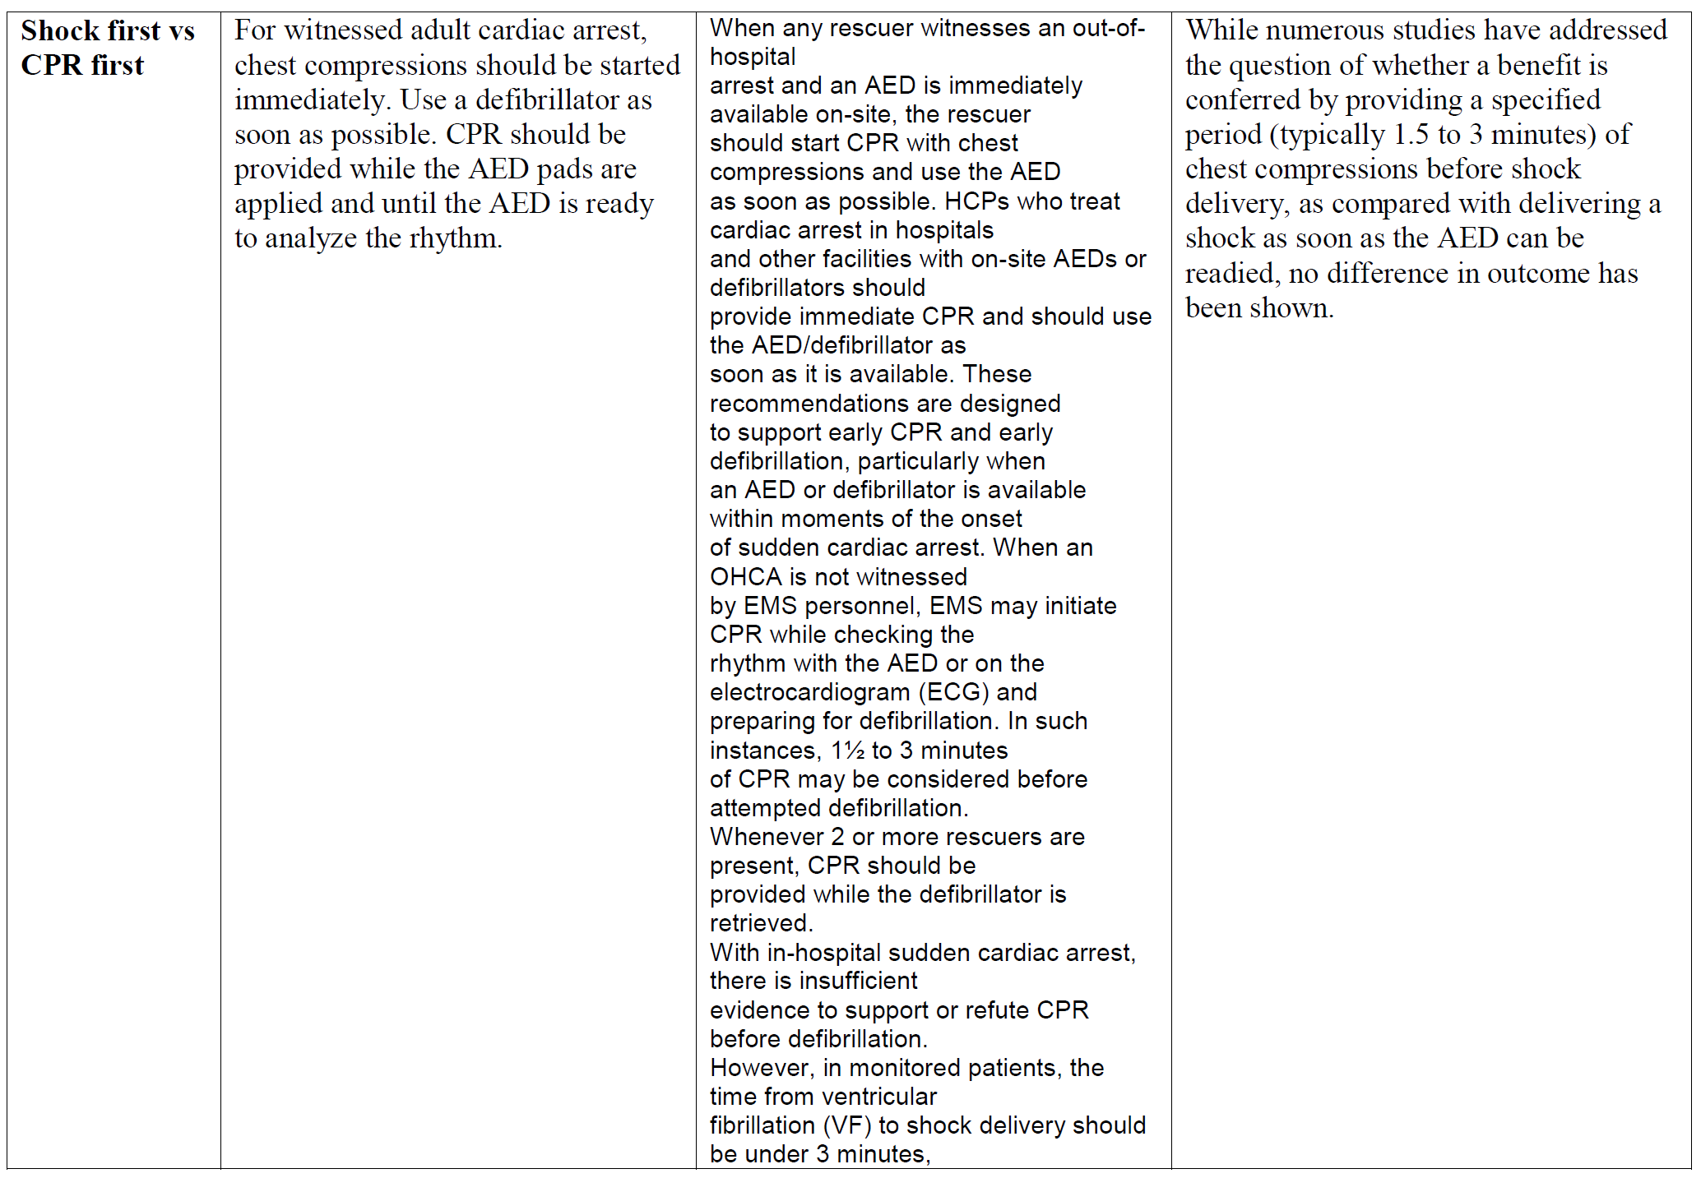

Conductive Materials

- to reduce transthoracic impedance:

1. **Paddles** with **electrode paste**
2. **Gel pads**
3. **Self-adhesive pads** – most convenient and routinely recommended!

* peel backing away from **electrode pads**
* for **victim > 8 yrs**, only with adult pads
* for **children 1-8 yrs / < 55 lbs**, try to obtain child electrode pads and/or use “child” switch on AED (if not available, you can use adult pads and deliver adult doses for children; if adult pads overlap then place apex pad on child’s back)
* for **infants < 1 yr** there was not enough evidence to recommend for or against use of AED; new guidelines – AED is recommended using pediatric pads (adult pads are OK if peds pads not available).

N.B. do not cut or fold adult pads trying to make them like “pediatric pads”!

* **electrode pads** are placed to victim’s bare chest:
  1. **right** - over 2nd intercostal space along right sternal border (right upper chest, just below clavicle).
  2. **left** - over 5-6th intercostal space at heart apex (to left and below nipple, few inches below left arm pit).
* ***hairy chest*** (AED says „check electrodes“): press down firmly on pads → pull of pads (depilation) ± shave with razor (in AED carrying case) → put on new set of pads.

N.B. don’t waste pads for depilation – better use shaving razor!

* do not use AED in ***water***, but if victim is lying in small puddle or snow it is OK (quickly wipe victim’s chest if it is covered with water or sweat).
* if victim has ***implanted defibrillator*** (bump in upper chest or abdomen with overlying scar), place pads ≥ 1 inch to either side of implanted device and use AED as normally; if device is also delivering shocks (victim’s muscles contract), allow 30-60 seconds for implanted device to complete treatment cycle.
* do not place pads over ***transdermal medication patches*** – remove them → wipe area clean → attach AED pad.

Procedure

* sušukti “all clear” – AED 5-15 sekundžių **nustatinės ritmą** (tam gali tekti paspausti mygtuką ANALYZE) – svarbu, kad tuo metu niekas neliestų aukos.

If you can interpret ECG rhythms, use **manual defibrillator** (vs. **AED**) – shorter CPR interruptions to deliver shocks (no need to spend 5-15 seconds for analysis); new manual defibrillators charge in < 10 seconds (if you have older model with *charging time > 10 seconds – during that time resume CPR*)

* jei AED nustato ***non-shockable*** ritmą, jis nepasikraus ir neleis pasiūsti šoko (t.y. automatinė apsauga).
* prieš siunčiant šoką vėl reikia sušukti “all clear” – visually check kad niekas nesiliestų prie ligonio ar metalinių neštuvų, ± išjunk deguonies tiekimą (svarbu, kad deguonis neitų ant paciento krūtinės).

N.B. aim for < 10 seconds between last compression and shock

* ***countershocks*** are delivered without interruption for pulse check or drug therapy:
* after initial countershock, patient immediately* receives CPR for 2 minutes (do not check pulse even if displayed rhythm looks “normal”); then AED will prompt you to check rhythm again; if shock is not advised → resume CPR for 2 minutes

*Shock – CPR – check rhythm* cycle is 2 minutes

*even after successful defibrillation, spontaneous rhythm is slow and barely perfusing

* defibrillating paddles should be immediately recharged after each countershock without removal from chest wall.
* naudojama energija priklauso nuo *defibriliatoriaus modelio*:

monophasic defibrillator – always use 360 J

manual biphasic defibrillator – device specific: 150-200 J with biphasic truncated exponential waveform; 120 J with rectilinear waveform; if you are not sure – use 200 J.

for *narrow QRS tachyarrhythmias* pradedama nuo 50 J (0.5-1 J/kg)

* synchronized mode – šokas siunčiamas po milisekundžių po R dantelio (kad nepataikyti į absoliutų refrakterinį periodą); indikacijos:
  1. narrow-QRS tachycardias.
  2. VT kai yra pulsas

unsynchronized mode – šoko impulsas nederinamas su ECG; indikacijos:

1. VF
2. pulseless VT.

N.B. unsynchronized shock narrow-QRS tachycardias atveju gali sukelti VF!

* if patient is *awake* – taikoma **sedacija** benzodiazepinais (e.g. midazolam) ± morphine/fentanyl

N.B. be ready for assisted ventilation!

* širdį pasiekiančio impulso stiprumas priklauso nuo *transthoracic resistance* – jį sumažinti galima:
  + 1. conduction gel + paddles with large area
    2. firm pressure on paddles
    3. shock on end-expiration phase
* if rapid defibrillation is unsuccessful, BLS should be resumed, and drug therapy is based on secondary survey.

***Never delay chest compressions to troubleshoot AED!***

* jei *quick look* nustato non-DC-convertible rhythm, reikia staigiai tirti toliau:
  1. 12-lead ECG
  2. stat K+ level
  3. bedside ultrasound
* if defibrillation is successful and victim became responsive, do not remove pads and leave AED on (victim is not protected from developing cardiac arrest again).

Forceful precordial thump (mechanical defibrillation)

– firm blow to center of sternum.

* can convert VF or VT into functional cardiac rhythm (but, conversely, it can convert organized cardiac rhythm into VF, VT, or asystole!).
* is advised only when defibrillator is not available; contraindicated in children.

ACLS Secondary Survey

**Secondary survey** = advanced cardiovascular life support (ACLS) + BLS.

* secondary survey follows similar ABCD sequence as BLS does.

**Return of spontaneous circulation (ROSC)** is *intermediate* goal of resuscitation.

*Final* goal – **return of intact neurologic function**.

Goal of BLS – **ROSC** or **take over by ACLS team**.

ACLS includes:

1. drug therapy
2. cardiac monitoring (ECG diagnosis)
3. adjunctive special resuscitation devices (for oxygenation and circulation).

N.B. ACLS should not interrupt BLS (ventilations & cardiac compressions) for > 15-30 sec.!

ACLS Team

Team leader clearly assigns roles and responsibilities for each team member.

* essential role of team leader is periodic reevaluation & summarizing.
* ***ask for a different role*** if you feel that task is too difficult for you; also ***ask for help early*** if you anticipate difficulties!

**Closed-Loop Communication** – team leader gives message → team member gives clear response and good eye contact that message was heard → team member clearly informs that task was performed → team leader acknowledges “Thanks, good job” → assigns another task.

**Clear Messages**

* only one person speaks at any time.
* don’t mumble, yell, scream, shout – speak in friendly controlled tone – mutual respect!

**Information Sharing** – when resuscitative efforts are ineffective, ask team:

“Well, we’ve gotten the following on the ACLS Secondary Survey… Have we missed something?”

Drug Therapy

* anksčiau, esant prolonged arrest (> 10 min) būdavo rutiniškai skiriama bicarbonates;

dabar tai nebetaikoma, nes gali sukelti *paradoxical acidosis*;

dabartinės indikacijos bicarbonate skyrimui:

1. hyperK+
2. TCA (tricyclic antidepressants) overdose
3. severe persistent bicarbonate-responsive acidosis despite adequate ventilation

* calcium chloride - only in clearly defined circumstances, e.g. Ca-blocker overdose, hypoCa+2, hyperK+, hyperMg+2.

Drug access sites

- priorities:

1. IV (peripheral veins)
2. IO (intraosseous)
3. ET – absorption is poor, optimal dosing unknown.

IV

* two **IV lines** (14-16 G catheters) should be started; antecubital veins are initial preferred sites.
* flow is limited by catheter (not size or location of vein cannulated).
* drugs reach central circulation in 1-2 mins; H: drug bolus → 20 ml bolus of IV fluid → elevate extremity for 10-20 secs.

N.B. *central lines are not recommended*! (need to interrupt CPR; central noncompressible IV line is CI for thrombolysis)

IO

* feasible for any IV drug /fluid (incl. all blood products)
* can be established in 30-60 secs in any age group.

Access sites: Twist, don’t push the needle!

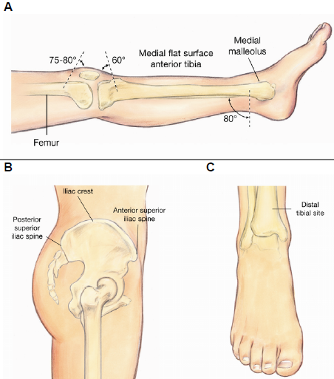

ET

* drugs may be given **via endotracheal tube** at 2-2.5 times IV dose (dozė turi būti praskiesta iki 5-10 ml tūrio in saline / water, kad pasiektų distal airways).

*ET administration should not be delayed if starting IV line is difficult!*

N.B. į trachėją netinka skirti *sodium bicarbonate*, *bretylium tosylate, etc*!

**BBB** – į **B**ronchus netinka **B**ikarbonatai ir **B**retylium

* drugs that definitely can be administered by ET – “NAVEL”:

Naloxone, Atropine, Vasopressin, Epinephrine, Lidocaine

Intracardiac Injection - not recommended (unless IV or airway routes are inaccessible) because of pneumothorax, coronary artery laceration, cardiac tamponade, and prolonged interruptions of CPR.

Pulseless Arrest

- most important algorithm to know!

N.B. CPR and shocks are priorities!

Advanced airways and drugs are of secondary importance

* *no drug given during cardiac arrest has been shown to improve survival or neurological function* (but *improve ROSC*)
* give drugs during CPR (do not stop CPR for drugs)

Ventricular fibrillation (VF), pulseless ventricular tachycardia (VT)

also see p. 1383-1385 >>

* VT usually degenerates to VF; VF – to asystole.
* VF / pulseless VT are treated by **high-energy unsynchronized shocks**. *see above* >>

Give 1 shock → CPR 5 cycles (older guidelines recommended 3 consecutive shocks) → analyze rhythm; if shockable → continue CPR while defibrillator is charging → repeat

**Refractory (persistent) VF/VT**:

After 2nd shock*, when IV/IO access becomes available → administer **vasopressors** during CPR:

epinephrine 1 mg rapidly IV/IO q 3-5 min – veikimas kaip α-agonist

* high or escalating epinephrine doses are not recommended.
* vietoj pirmos ar antros epinephrine dozės galima skirti **vienkartinę dozę** vasopressin 40 U IV/IO.

Role of steroids:

*Mentzelopoulos SD, Malachias S, Chamos C, Konstantopoulos D, Ntaidou T, Papastylianou A, et al. Vasopressin, steroids, and epinephrine and neurologically favorable survival after in-hospital cardiac arrest: a randomized clinical trial. JAMA. Jul 17 2013;310(3):270-9*

In a randomized trial involving 268 patients with in-hospital cardiac arrest, treatment with a combination of vasopressin, steroids*, and epinephrine (VSE) during CPR followed by treatment of survivors with daily steroids was associated with a greater likelihood of being discharged with a neurologically favorable outcome compared with standard care with epinephrine alone. VSE patients also had improved hemodynamics and central venous oxygen saturation, as well as less organ dysfunction.

*methylprednisolone 40 mg → IV hydrocortisone 300 mg daily for 7 days

Patients in the VSE group had a significantly higher probability of return of spontaneous circulation of 20 minutes or longer after CPR (83.9% of patients vs 65.9% in the control group) and a higher chance of survival to hospital discharge with a neurologically favorable outcome (13.9% vs. 5.1%). Among patients surviving after CPR but with post-resuscitation shock, those in the VSE group had a higher probability of survival to hospital discharge with a favorable neurologic outcome.

After 3rd shock*, consider **antiarrhythmics** (also can be used postresuscitation):

amiodarone 300 mg IV/IO once; consider additional 150 mg IV/IO once after 3-5 min – increases survival to hospital admission

*or*

lidocaine 1-1,5 mg/kg IV/IO → 0,5-0,75 mg/kg IV/IO q 5-10 min (max 3 mg/kg) – no proven efficacy; alternative when amiodarone is not available

*or*

magnesium sulfate 1-2 g IV/IO over 5-20 mins (diluted in 10 mL D5W) – for *torsades de pointes, hypoMg2+ (alcoholism, malnutrition)*

* if additional team member is available, he should anticipate and prepare drugs in advance.

*optimal number of CPR & shock cycles before giving drugs is not determined

Hypothermia – give only **one shock**!

Defer next shocks & drugs until core t-re **> 30° C (86°F)**

When core t-re is **30-34° C (86-93°F)** – give shocks & drugs spaced at longer intervals

**Postresuscitation** – continue drug that was successful during resuscitation

Pulseless electrical activity (PEA)

Svarbiausia – gydyti priežastį, o ne ECG ritmą!

(IV/IO access is priority over advanced airway)

Treatment as for VF, except:

1. no shocks are given
2. for *slow rhythms* – consider atropine 1 mg rapidly IV/IO q 3 min, max. 3 doses
   * bradiaritmijoms dar tinka isoproterenol, dopamine.
   * vaikams dažniausia bradiaritmijų priežastis – *hipoksemija* → **ventilate & oxygenate**.

+ BLS/ACLS is combined with **treating underlying cause**: for causes see above >>

Obtain 12-lead ECG if possible!

1. initial treatment (esp. for narrow-QRS tachycardia) is **IV volume infusion** (minimum 500 ml kristaloidų bolus if left ventricular failure is not evident) – tai pirmas žingsnis! (**hypovolemia** is the most common cause of reversible PEA)

* if arterial hypotension is unresponsive, following drugs are useful by continuous infusion with titration as needed to restore BP:

1. inotrope dopamine beginning at 3-5 µg/kg/min
2. inotrope and vasoconstrictor epinephrine at 2-10 µg/min
3. vasoconstrictor norepinephrine at 2-16 µg/min
4. vasoconstrictor phenylephrine at 0.1-1.5 µg/kg/min

N.B. vasoactive drugs should be used in minimal doses - they may increase vascular resistance → organ perfusion↓ (esp. in mesenteric bed).

1. bicarbonate for **bicarbonate-responsive acidosis**, **hyperkalemia** or **TCA overdose**.
2. for **hyperkalemia** (↑ T waves, widened QRS): bicarbonate + glucose & insulin + CaCl2 + Kayexalate / sorbitol + albuterol ---- > dialysis
3. for **hypokalemia** (↓ T waves, U waves, widened QRS tachycardia): potassium & magnesium
4. for **cardiac tamponade**: **pericardiocentesis** + IV volume infusion
5. for **tension pneumothorax** (tracheal deviation, difficult to ventilate, no pulse with CPR): **needle decompression**.

Asystole

- flat line on ECG is most commonly due to **operator error**! – diagnosis must be confirmed in **≥ 2 leads**.

* most common masquerading rhythm – VF.
* survival is very poor! (asystole is final rhythm)

Treatment as for PEA!

N.B. modern guidelines do not recommend transcutaneous pacing for asystole!

* formerly, if neither epinephrine nor atropine restores regular ECG complexes → **temporary transcutaneous pacing**;
* alternatives: transvenous pacing, percutaneous pacing (electrodes placed subcostally).
* pacing is less successful the longer the cardiac arrest (pacing reikia pradėti < 20 min bėgyje nuo arrest pradžios).
* ***defibrillation of asystole is discouraged*** - can result in profound parasympathetic discharge.

N.B. if it is unclear is it asystole or VF → defibrillate

Symptomatic Bradycardia

- mainly due to high-degree AV blocks (II° type 2, III°). see p. 1387-1390 >>

Bradycardia is < 60/min, i.e. ≥ 5 large squares between successive R waves

Poor perfusion secondary to bradycardia → **transcutaneous pacing (TCP)** ASAP

* while awaiting pacemaker, consider ***first-line drug*** atropine IV 0.5 mg (may repeat q 3-5 min to total 3 mg); if atropine ineffective, start pacing. N.B. atropine 0.5 mg (vs. 1 mg for PEA)
* if pacing is ineffective, consider IVI ***catecholamines at chronotropic doses***: epinephrine 2-10 μg/min and/or dopamine 2-10 μg/kg/min.
* most modern AED have pacing mode.
* set **rate** to 60/min, then titrate (high heart rate exacerbates myocardial ischemia!)
* pacing can be painful (consider analgesics, sedatives – narcotics and benzodiazepines).
* effective pacing – electrical and mechanical capture (caution - carotid pulse can be mimicked by muscle jerking!); set pacing **current** to 2 mA above current at which consistent capture is observed.

|  |
| --- |
| Core **symptoms** of symptomatic arrhythmias:   1. Chest pain* 2. Dyspnea 3. Weakness, fatigue 4. Mental status↓ (presyncope, syncope)*   Core **signs** of symptomatic arrhythmias:   1. Hypotension up to shock* 2. CHF, pulmonary edema 3. Poor perfusion – central (heart & brain), peripheral (diuresis↓, cyanosis, etc) |

*unstable symptoms & signs

Tachycardias with Pulses

Tachycardia is > 100/min, i.e. ≤ 3 large squares between successive R waves

Rhythms:

**Narrow-complex** (QRS < 0,12 sec)

* + 1. Sinus tachycardia - never treated per se! rather treat systemic cause of it (tachycardia may be compensatory attempt to maintain required cardiac output; decreasing HR → patient deterioration)
    2. AF (atrial fibrillation)
    3. Atrial flutter
    4. Reentry SVT (supraventricular tachycardia) ← sensitive to adenosine
    5. Ectopic atrial tachycardia
    6. Junctional tachycardia

**Wide-complex** (QRS ≥ 0,12 sec)

1. Monomorphic VT - regular & uniform for VT – see p. 1378-1382 >>
2. Polymorphic VT
3. Wide-complex tachycardia of uncertain type ← VT until proven otherwise

Unstable Tachycardia

= heart rate > 100 + pulse is present + patient is unstable

Core question – is *tachycardia causing symptoms*\* or *tachycardia is due to patient’s condition*\*\*?

*unlikely if rate < 150 in healthy heart

**most likely if sinus tachycardia with rate 100-130

Pathophysiology:

1. reduced time for diastolic fill (usually at ventricular rates > 150)
2. dyscoordination between atria and ventricles

Treatment: **O2** & SaO2 + BP & ECG → immediate **cardioversion**

N.B. drugs are not used (except sedation if patient is ***conscious*** & time permits)!!!

N.B. no need to analyze ECG (except to see that rhythm is > 100)

* establish **IV access**.

**polymorphic VT, deteriorating / pulseless patient** → **defibrillation** (i.e. high-energy unsynchronized shocks)

**Narrow-complex tachycardia**\*, **monomorphic VT** → **synchronized** **cardioversion**

*give adenosine 6 mg IV while preparing for cardioversion

* switch AED to operate as cardioverter; use monophasic waveform.
* attach **monitor leads**: “white to right, red to ribs, what’s left over to left shoulder”
* attach **electrode pads**.
* press SYNC (look for markers on each R wave – adjust monitor gain if necessary)
* select ENERGY LEVEL - increasing doses (until effective): 100 J, 200 J, 300 J, 360 J

*for atrial flutter, SVT you may start with 50 J*

* press CHARGE
* press SHOCK
* shock is delivered just after R wave (thus, after pressing SHOCK, there is delay until shock - device analyzes rhythm), because low-energy shock on T wave may precipitate VF!
* check monitor if tachycardia persists; if yes → increase energy level, press SYNC again (many AED automatically default back to unsynchronized – to deliver immediate defibrillation if cardioversion produces VF), press SHOCK

N.B. if any doubt (monomorphic vs. polymorphic) or synchronization fails* → **defibrillation**

Low-energy shocks must always be delivered as synchronized!

*be aware - many devices do not synchronize through hand-held quick-look paddles!

Stable Tachycardia

Treatment: **O2** & **SaO2** + **BP** & **ECG** + establish **IV access**.

Is QRS narrow? Is rhythm regular?

**Wide-complex** **regular rhythm** → transport & monitor → expert consultation:

amiodarone 150 mg IV over 10 minutes (→ elective cardioversion)

**Wide-complex** **irregular rhythm** → transport & monitor → expert consultation:

consider amiodarone 150 mg IV over 10 minutes

**Narrow-complex irregular rhythm** → transport & monitor → expert consultation:

control rate with diltiazem / **β-blocker**

**Narrow-complex regular rhythm**:

1. **Vagal maneuver** (effective in 20-25% cases): Valsalva*, carotid sinus massage

↓

1. adenosine 6 mg rapid IV push (over 1 second into large vein + 20 mL flush + elevate extremity); if no conversion within 1-2 mins, give 12 mg rapid IV push (may repeat 12 mg once)
   * adenosine slows AV conduction (effective for reentry SVT); contraindicated in wide-complex tachycardias.
   * safe in pregnancy.
   * use 3 mg starting dose if: transplanted heart, via central line, taking dipyridamole / carbamazepine.
   * may cause bronchospasm.

*for infants, insert finger into rectum → reflexive Valsalva

Mechanical Resuscitation Devices

* used to replace manual methods:

1. during sustained resuscitation
2. when patient must be moved.

* ypač svarbu to replace rescue mouth-to-mouth breathing in areas where risk of HIV, hepatitis, or other infection is high.

Airway Support

* artificial airways should be used only for ***unconscious patient without gag/cough reflex*** (vomiting and aspiration may occur if forced into conscious or stuporous patient's mouth!).
* stimulation of hypopharynx may cause vomiting as consciousness is regained.
* visiems būtinas O2 100% tiekimas – adjust flow to **keep** SaO2 **> 90%.**

Barrier devices

1. **Face masks – tinka tiek ir gaivinant (kad nereiktų pūsti tiesiai į burną – infekcijos pavojus, taigi, čia mask veikia kaip barrier device), tiek ir spontaniškai kvėpuojantiems pacientams.**

* must fit well, ideally be transparent (kad matyti takų būklę, pvz. vėmalus).
* some masks have 1-way valve and oxygen inlet – to deliver O2 concentration of 50% with O2 flow 10 L/min.
* most effective:

if 1 rescuer – rescuer stays at victim’s side

if 2 rescuers – rescuer stands at victim’s head

* ensure firm seal while airway is kept open by head tilt and mandibular jaw thrust:
* place the mask on the victim’s face, using the bridge of the nose as a guide for correct position.
* using your hand that is closer to top of victim’s head, place index finger and thumb along mask border
* place thumb of your other hand along lower margin of mask; place remaining fingers along bony margin of mandibula and lift jaw (while pressing firmly mask to face).
* types:

1. ***simple (standard) mask*** – O2 is delivered to cone-shaped face piece from which patient inhales and exhales through exhalation ports.
2. ***nonrebreathing mask*** has O2 reservoir bag and one-way inhalation and exhalation valves (can deliver highest tracheal O2 concentrations - up to 90% - but nonadjustable vs. Venturi).
3. ***Venturi mask*** – allows precise O2 concentration delivery (ypač svarbu COPD ligoniams, kuriems respiratory drive vykdo tik deguonis).

N.B. in emergency ventilations, ***disposable masks*** are recommended (instead of mouth-to-mouth resuscitation) because of AIDS risk!

1. **Bag-mask devices** (resuscitator bags, Ambu bag) = self-inflating bag attached to face mask ± nonrebreathing valve.

|  |  |
| --- | --- |
| * standard for apneic nonintubated patients (best used with artificial airways) – laikina priemonė iki intubacijos. * used with supplemental O2. * jei užtrunka ilgėliau, patartinas *nasogastric tube* to vent air forced into stomach. * position yourself directly above victim‘s head. * I ir II pirštais apimama kaukė, o III-V pirštais suimamas mandible (**E-C clamp technique**): * plaučiams išpūsti pakanka 15-20 cmH2O; jei tenka naudoti 25-30 cmH2O daug oro patenka į skrandį. * įpūtimas trunka ≈ 1 sekundę. * jei yra ***two rescuers*** – vienas naudoja **E-C clamp** abiem rankomis, o kitas spaudinėja maišą: | use202 |

Viskas, kas toliau, priklauso ACLS:

Frequently reconfirm proper airway placement:

Physical examination

Exhaled CO2 detector → consider capnography ± SaO2

Esophageal detector device

Suction airways as needed!

Basic Airway Adjunct

- insert ASAP if ***unconscious*** patient has ***no gag / cough reflex*** and basic maneuvers (head tilt-chin lift / jaw thrust) ***fail to provide / maintain open airway***

1. **Oropharyngeal airway (OPA)**

* curved shape – lifts tongue forward.
* labai svarbu parinkti tinkamą dydį – pridedama prie veido šono ir matuojama nuo ***lūpų kampo*** iki ***just beyond angulus mandibulae***.
* tongue should be held anteriorly (grasped with towel clip or sponge) as OPA is placed.
* difficult to use - rescuer's fingers must seal victim's lips around tube while thumb clamps nose.
* gali būti įkišamas dviem būdais:

*Clear pharynx using rigid pharyngeal suction cup, if available*

|  |  |
| --- | --- |
| 1. ***inverted technique*** (preferable) – kišama apverstas iki galiukas pasiekia posterior wall of pharynx; tuomet apsukama 180° ir kišama iki galo: | b) ***direct vision technique*** – kišama naudojant tongue depressor. |
| use172 | use173(1) |

|  |  |
| --- | --- |
| N.B. neteisingai įkišus būklę galima tik pabloginti! | use173(2) |

1. **Nasopharyngeal airway (NPA, nasal trumpet) – soft 15-20 cm rubber / plastic tube, passed through open nasal passage so that distal tip lies behind tongue.**

* **NPA gali toleruoti ir sąmoningi pacientai!!!**
* **proper size:**
* **outer diameter must be ­≈ inner aperture of nares (not to cause blanching of nares).**
* **length: from nose tip to earlobe.**
* **lubricate! (e.g. anesthetic jelly).**
* **insert gently – easily traumatizes soft tissues.**
* **if insertion difficult: rotate slightly, use other side.**
* **NPA has small diameter - *prone to obstruction*** by soft tissue of pharynx or by mucus / blood that collect and dry by inspissation – frequently evaluate ± suction (often clinician relaxes once tube is in place, and patient can die if occlusion is overlooked!).
* **naudojama kuomet negalimas OPA.**

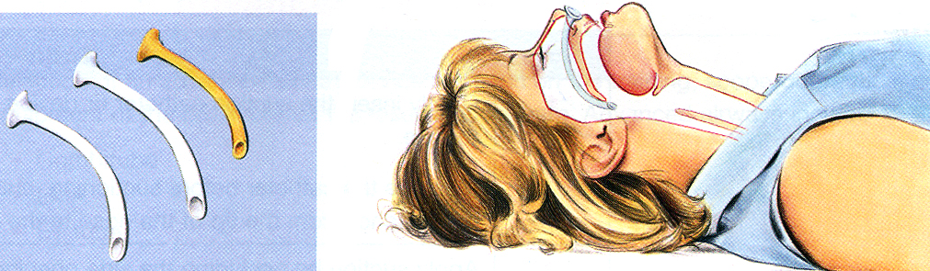

****Advanced Airways****

|  |
| --- |
| **N.B. ventilations become rarer and single; 2015 AHA guideline –** single blow q 6 seconds (10/min) **for all ages – and *no longer synchronized* with chest compressions! (ideally, breath in during chest recoil)**   * **advanced airway placement requires interruption of chest compressions; so, if bag-mask ventilation is adequate, defer advanced airway.**  1. **Cuffed endotracheal tubes** – most secure airway - indicated in all comatose patients and if artificial ventilation is required.  * *orotracheal* intubation is faster. * *nasotracheal* intubation is possible in awake patient. * when orotracheal intubation is not possible → blind *nasotracheal* intubation. * bag-valve-mask devices with adaptors can be fitted to endotracheal tubes.  1. **Laryngeal mask airway (LMA) – mask with inflatable rim (fits over larynx the same way face mask fits over nose and mouth) attached to 15-20 cm tube.**  * **very easy to place but *does not protect airway against aspiration* (should be replaced with endotracheal tube ASAP).**        1. **Esophageal-tracheal tube (Combitube)**  * complications: esophageal perforation, excessive gastric distention. * before esophageal obturator airway is removed, patient should have endotracheal tube inserted and be turned on side (suction should be available).     **Combitube in esophagus:** |

Surgical Airways

1. **Transtracheal jet** **insufflation**

* oxygenation and ventilation can be achieved ***for several hours***, but airway remains unprotected and catheter movement during insufflation is not well tolerated by conscious patients.
* needle cricothyrotomy → insert 12-14 G plastic cannula attached to high-pressure O2 source.
* O2 is delivered with manually controlled intermittent insufflation.

*Insufflating oxygen under 50 psi via misplaced catheter would immediately obscure landmarks and further compromise airway.*

* contraindications:

1. significant airway obstruction (→ overinflation of lungs → rupture → tension pneumothorax).
2. airway penetration → insufflated air will escape into surrounding soft tissue (emphysema).
3. **Surgical cricothyrotomy** – indication: *inability to intubate*.

* **cricothyroid membrane** is *the most accessible route* for emergency surgical airway management – avascular, easy accessible and identifiable (palpated as indentation between thyroid and cricoid cartilages).
* naudojamas No. 5-6 tracheostominis vamzdelis.
* transverse or longitudinal incision through cricothyroid membrane; hole is dilated with hook or forceps and tracheostomy tube inserted.

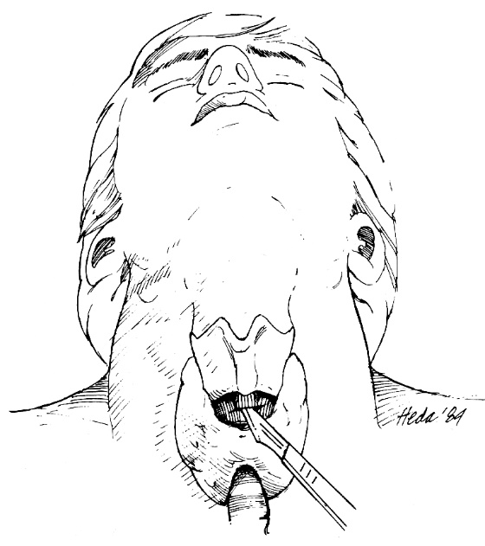 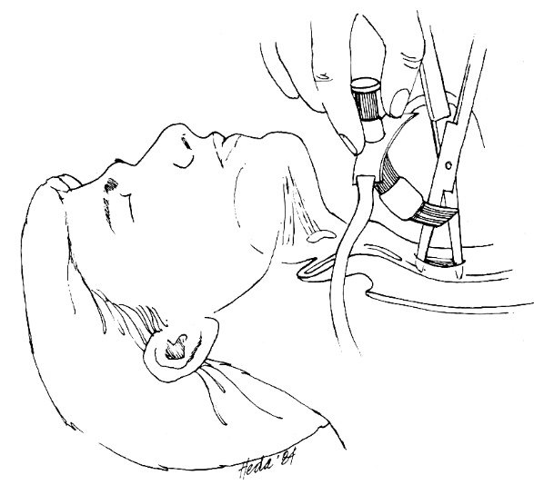

* late complication – subglottic stenosis.

N.B. cricothyroid approach is inappropriate for small children because cricoid cartilage is the only rigid support of anterior tracheal wall – use **tracheostomy** instead!

|  |  |
| --- | --- |
| 1. **Needle cricothyrotomy** – temporary measure *when surgical cricothyrotomy is unavailable*.  * naudojamas 12-14 G plastic catheter inserted at 60° angle at midline; held in place manually until more definitive airway control. * ventiliacijai per kateterį naudojamos dvi technikos:   ***a) jet insufflation*** – with high-flow oxygen source and manual insufflation (by intermittent occlusion of attached Y connector).  ***b) positive pressure ventilation*** – with bag-valve device.   * expiration is limited (hypercarbia persists) | use190 |

Airway Suctioning

* ≈ -100 mmHg **suction power** is needed (wall-mounted units provide up to -300 mmHg).
* two types of catheters:

rigid – for thick secretions in oropharynx

soft flexible – for anything else.

* suction (by occluding side opening) while withdrawing catheter with rotating motion.
* limit suction to < 10 seconds.
* monitor patient during suctioning: if bradycardia develops or SaO2↓ – stop suctioning + administer O2
* to avoid hypoxia – **administer O2** before and following suction.

Suctioning ET tube:

* use sterile technique.
* insert catheter not beyond tip of ET tube – measure before insertion.
* to remove thick secretions: instill 1-2 mL sterile saline into airway → ventilate (to disperse) → suction.

Circulatory Support

1. **Military antishock trousers** **(MAST)** - increase central blood volume in shock.

* also raise peripheral resistance → coronary blood flow↑.
* idealiausia dėti ant nuogo kūno.
* have separate ***lower extremity*** and ***abdominal*** compartments; when in place, they should be inflated and deflated sequentially (abdominal compartment is last inflated and first deflated).
* teisingai pripūtus, kojose ištinka veninė kongestija; dėl pilvo kompresijos gali pasišlapinti, pasituštinti, apsivemti.
* deflation should be slow (15-20 min, periodically checking blood pressure) and only after normovolemia restored.
* abdominal compartment should not be above costal margin (impairs respiration).

N.B. MAST may cause pulmonary congestion and heart failure when intravascular volume is adequate and myocardial function is poor!

* absolute contraindication to MAST is pulmonary edema due to heart failure.

1. **Intra-aortic balloon counterpulsation** - augments coronary artery perfusion during **diastole** and decreases afterload during **systole**.

* introduced *via* *femoral artery* (percutaneously or by arteriotomy), retrograde into thoracic aorta *just distal to left subclavian artery*.
* indication - *cardiogenic shock* due to potentially surgically *correctable lesions* (e.g. acute MI with acute mitral insufficiency or ventricular septal defect, severe aortic insufficiency due to acute vascular lesions).

Postresuscitative Care

* until EMS arrives, place victim into **recovery (NATO) position** and keep monitoring pulse and breathing.
  + not recommended for *small children* – without head support airway can be blocked
* visiems (nepriklausomai nuo arrest etiologijos) monitoruojama:
  1. **blood pressure** (noninvasively); mean arterial pressure should be normalized or raised slightly above normal.
  2. 3-lead **ECG**
  3. **central pressures** (dynamics of systemic blood flow or intravascular volume may be uncertain after cardiac arrest).
  4. **pulse oximeter**
* VF or VT may recur in postresuscitation period - lidocaine 1-1.5 mg/kg by rapid IV injection is given routinely after successful cardioversion from VT or VF (even if lidocaine was not used during resuscitation)!
* supraventricular tachycardias are frequent (due to high catecholamine state [both endogenous and exogenous] associated with cardiac arrest and resuscitation efforts) - should be monitored but not treated in otherwise stable (normotensive) patient.
* jei atgaivintas cardiac arrest pacientas išlieka komoje, rekomenduojama 12-24 val. skirti **hipotermiją** (iki 90 F).

Chain of Survival

- AHA metaphor for critical elements:

**Adult Chain of Survival**: early access* → early CPR → early defibrillation → early advanced care.

**Pediatric Chain of Survival**: prevention of arrest → early CPR → early access* → early advanced care.

*activation of emergency response system

Special Circumstances

E****lectrical shock (electrocution)****

Klinika-patofiziologija

* elektros srovė sukelia masyvią depoliarizaciją → **cardiac arrest**:

*low-voltage* AC shock → VF

*high-voltage* AC shock → asystole

* **respiratory arrest** priežastys:
  1. direct damage to CNS respiratory center
  2. tetany of respiratory musculature – todėl AC (alternating current) yra pavojingesnė negu DC (direct current)
* dažnai respiratory arrest trunka ilgiau negu cardiac arrest (!!!) → secondary hypoxic cardiac arrest.
* **AC vs. DC**:
  + dėl ***skeleto raumenų tetanuso*** (AC) žmogus pats nepajėgia atsitraukti nuo el. srovės šaltinio → prolonged exposure (burns, etc.).
  + DC sukelia staigų skeleto raumenų truktelėjimą – žmogų “nusviedžia” nuo el. srovės šaltinio.
  + AC yra 3-5 kartus pavojingesnė negu tokio paties voltažo ir amperažo DC!!!
  + buitinė AC 50-60 Hz yra pavojingesnė negu high-frequency currents.
  + dėl raumenų kontrakcijos galimos įv. avulsijos, išnirimai, lūžimai (bet gali būti ir dėl to kad nukentėjusysis pargriūna!).
* ***threshold of perception*** (for current entering hand):

5-10 mA for DC, 1-10 mA for AC at 60 Hz.

* ***let-go current*** (maximum amperage that causes flexors contraction but allows person to release his hand from current source):

75 mA for DC, 15 mA for AC

* svarbu **srovės tekėjimo kryptis** (*hand-to-hand* pavojingiau negu *hand-to-foot*);
* pakanka kad sekundės dalį *per krūtinę* pratekėtų 60-100 mA AC ir jau gali sukelti ventricular fibrillation (for DC reikia 300-500 mA).
* srovės pratekėjimas *per galvą* sukelia loss of consciousness, seizures, respiratory arrest, intraventricular hemorrhages, cataracts (can be delayed for several years!).
* *pagrindinė varža yra odoje*: sausos sveikos gerai keratinizuotos odos varža 20,000-30,000 ohms/cm2, drėgnos plonos odos – 500 ohms/cm2; gleivinių ar pažeistos odos varža – 200-300 ohms/cm2.
* jei *oda sausa*, būna **dideli nudegimai** (entry & exit wounds) – džn. sharply demarcated and extending well into deep tissues (N.B. visible tissue necrosis represent only small portion of destroyed tissue!).
* jei *oda šlapia* (e.g. “bathtub accidents”) – **cardiac arrest** be nudegimų.
* electrical current proceeds through tissues with lowest resistance (nerves, blood vessels, muscles).
* tekant srovei audiniais, ***išsiskiria daug šilumos*** (proporcinga voltažui, amperažui, trukmei) → *tissue damage* (protein coagulation, dehydration, hemolysis, thrombosis);
* dėl venų trombozės ir masyvios raumenų edemos galimi compartment syndromes.
* hypotension, myoglobinuria → renal failure.
* *toddlers mėgsta čiulpti extension cords* → **mouth burns** (not only cosmetic problems, but also may result in teeth-mandible-maxilla growth abnormalities); 7-10 parą atsiskiriant eschar gali masyviai kraujuoti iš a. labialis!

**Low-voltage injury** (110-220 volts) is similar to ***thermal injury*** without transmission to deeper tissues; worst are those involving mouth edge (oral commissure) sustained when children gnaw on household electrical cords.

**High-voltage injury** - varying degrees of cutaneous burn at entry & exit sites + ***hidden destruction of deep tissue*** ± cutaneous burns (associated with clothing ignition from electrical current discharge).

Tyrimai

* 1. CBC, urinalysis
  2. ECG monitoring, cardiac enzymes (if patients have no cardiac dysrhythmias on initial ECG or recent history of cardiac arrest, no further monitoring is necessary!)
  3. jei yra sąmonės sutrikimas - CT, MRI, serial neurologic evaluations (to detect any early or late neuropathology).

N.B. most serious derangements occur in the first 24 hours after injury.

Neurologic deficits may be delayed:

**CNS** effects (cortical encephalopathy, hemiplegia, aphasia, brain stem dysfunction) have been reported up to 9 months after injury.

Delayed **peripheral nerve** lesions (demyelination with vacuolization and reactive gliosis).

Prevencija

– **ground-fault** **circuit breakers** (sureaguoja į 5 mA current leak to ground).

Treatment

* avoid shock to yourself - be certain that victim is no longer in contact with electrical source:
* geriausias būdas yra išjungti el. srovę;
* jei tai neįmanoma, reikia save izoliavus nuo žemės, bandyti su izoliuota medžiaga bandyti auką atitraukti nuo el. srovės šaltinio.

N.B. *if line could be* ***high-voltage****, no attempt to disengage victim should be made until power is shut off!*

* taikomas **standartinis gaivinimas** (ABC taisyklė, etc.); gaivinimą apsunkina dažni dislocations & fractures, nervous system injures.
* jei yra mioglobinurija – taikyk osmotinę diurezę su alkalinizacija.
* nudegimai (žr. 2219 p. burns).

Lightning

* 10-30 mln DC volts – trunka tik 0,1-1 ms – per trumpai kad sukeltų sužalojimus!
* *oda geras izoliatorius* – srovė praeina kūno paviršiumi (“flashover phenomenon”), gali nuplėšti rūbus; jei oda drėgna, skystis staigiai išgaruoja ir gali sukelti nudegimus.
* kills 30% victims.

Klinika

* 1. **Cardiopulmonary arrest** – žaibas sukelia asistolę, kuri trunka neilgai, bet respiratory arrest užtrunka gerokai ilgiau → secondary cardiac arrest from arrhythmias.
  2. **Burns** – *superficial* (unless clothing is ignited) with pathognomonic *arborescent* pattern;

N.B. muscle damage is rare; entry and exit wounds (as in AC electrical burns) are unusual!

* 1. **Tympanic membrane ruptures**.
  2. **Eye injures** – ocular trauma, cataracts; pupils initially are unreactive or unequal.
  3. **Fractures & dislocations**
  4. **Neurologic injures**:

i) confusion & amnesia (jei yra coma – prognozė bloga).

ii) transient paralysis (dėl vascular spasm, nerve instability), bet galimas ir permanent paralysis from spinal cord injury.

iii) long term sequelae – neuropsychological damage, pain syndromes, sympathetic nervous system damage.

Treatment

* gelbėtojai turi atsiminti, kad žaibas gali pakartotinai trenkti į tą pačią vietą.
* vykdomi standartiniai BLS ir ACLS; vienintelė išimtis – ***vykdant triage, priority is to victims without signs of life*** (vs. įprastai triage liepia negaišti laiko su beviltiškais pacientais) – dažniausiai pakanka tik trumpai paventiliuoti kol praeis respiratory arrest!
* toliau gydant reikalingas *fluid restriction* dėl potential for brain edema.

(Near)-drowning

**Drowning – *death* by suffocation from submersion in liquid medium (usually water);**

**secondary drowning – *eventual death* from drowning after initial brief period of recovery (< 24 hours).**

* **second most common cause (after motor vehicle accidents) of unintentional death in pediatry; *pikai* – 1-5 years (males : females = 5:1; black : whites = 3:1) ir 10-19 years (only boys)**
* **aplink visus in-ground pools turi būti įrengtos minimum 1.2 m aukščio tvorelės su savaime užsidarančiais varteliais; moksleiviai turi būti mokomi plaukti.**
* **nesimaudyti prisivalgius, neblaiviam.**
* **prognozė geriausia jei vandens temperatūra 4-21°C – hipotermija prailgina smegenų hipoksijos toleranciją.**

**Near-drowning – *survival* for at least 24 hours after submersion.**

**Immersion syndrome – *sudden death* as result of contact with very cold water (vagally induced bradycardia-asystole); alcohol is important predisposing factor!**

**Postimmersion syndrome (seen in near-drowning victims within 72 hours) – *ARDS* caused by surfactant inactivation / washout ± alveolar capillary membrane damage.**

Sequence of events in drowning:

1. initial panic and struggle
2. breath-holding
3. water swallowing and vomiting
4. inability to suppress respiratory drive – water aspiration

N.B. 10-20% drownings occur without aspiration - due to intense laryngospasm!

1. hypoxia → loss of consciousness, asphyxiation

**fresh water vs. salt water drowning:**

**Fresh water is rapidly absorbed into circulation → plasma hypotonicity → hemolysis → hyperkalemia, hemoglobinuria (bet tai laikina ir gydymo nereikalauja); svarbiausia – surfactant loss → pulmonary edema.**

**Salt water is not absorbed but attracts water into alveoli → pulmonary edema; hypovolemia with hemoconcentration and hyperNaCl are not significant.**

**N.B. end result is the same – *pulmonary edema* with shunting and hypoxemia - complications and treatment are the same for both types of drowning!**

* ***mammalian diving reflex* (geriau išreikštas mažiems vaikams) – bradycardia and vasoconstriction.**

Pathology

Bilateral petrous ridge hemorrhages:

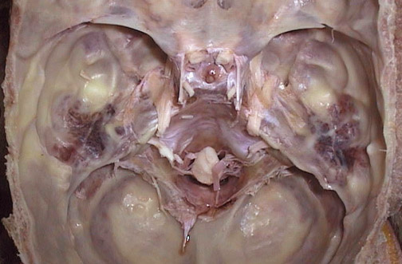

child drowned in a fresh water canal, and some of the plant material in the water was aspirated into a bronchus:

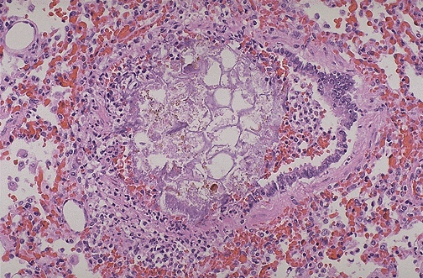

Klinika

1. pulmonary edema (due to alveolar hypoxia as in high-altitudes, not cardiogenic!) and atelectasis (due to surfactant loss)
2. cardiac arrhythmias
3. severe hypoxia, mental status↓ (hypoxia, cerebral edema); full impact on brain may not be known for days or weeks!

N.B. *consciousness is not synonymous with recovery* – pulmonary injury may develop several hours after submersion!

1. hypothermia
2. acute renal failure (iki 80%, bet praeina per 10 dienų)
3. associated traumas (e.g. cervical spine injures)

Gydymas

**1. Removal from water**

* spinal precautions!
* artificial ventilation may be started in shallow water, but chest compression cannot be done (placing victim on surfboard or float may help).

**2. CPR**

* no drainage procedure is necessary to remove water from lungs (unless *large amount of salt water* → briefly lower patient’s head and upper torso to allow dependent drainage)

**3. Hospital management**

* *rewarming*
* *high supplemental O2 concentrations* (until blood gas analysis confirms adequate oxygenation).
* *PEEP (or CPAP)* – to decrease pulmonary edema and expand atelectatic alveoli.
* *hyperventilation* – to decrease cerebral edema (vaikams rekomenduojamas ICP monitoringas); gal net hyperbaric oxygenation.
* steroidai, a/b rutiniškai neskiriami (nors kai kas juos rekomenduoja - juk tai aspiration pneumonitis!)
* jei nėra hipoksijos požymių ir išlieka asimptomiškas kelias valandas – galima išrašyti namo; visi kiti hospitalizuojami sekimui.

Trauma

* *cervical spine injury* → modification of airway-maintenance techniques.
* *facial injuries* may make mouth-to-mouth resuscitation impossible without adjunctive devices (e.g. endotracheal intubation).

Pregnancy

* pirmas žingsnis nėščiosioms su hipotenzija – ***paguldyti ant kairio šono***, nes pati dažniausia hipotenzijos priežastis yra *gimdos spaudimas į v. cava inf*.
* jei gaivinimas nesėkmingas ≥ 5 minutes, skubiai atliekamas **perimortem cesarean section** - išgelbimas fetus (dažnai ir pati nėščioji).

Pediatric Cardiopulmonary Resuscitation

Newborn resuscitation → see p. Ped9

* in *adults*, cause is almost always secondary to severe diffuse CAD with superimposed malignant **ventricular tachyarrhythmia**.
* in *children*, hypoxemia and airway difficulties are major precipitants, resulting in **bradyarrhythmias and asystole** - in children, routine, rapid defibrillation is not ordinarily needed!

N.B. only 10% of arrhythmias in children are **ventricular tachyarrhythmias** – dažniausia priežastis yra drug (sympathomimetics, anticholinergics) ingestion!

* **weight** must be estimated accurately to allow calculation of drug doses.

*dozės jau paskaičiuotos lentelėje in “Merck Manual 1999” 2292-2297 p.*

* **upper airway anatomy** is different in children:
* **oropharyngeal airway** should be inserted using tongue depressor (if depressor is not available, airway should be inverted inside mouth - using posterior portion of curved body as tongue depressor - and rotated into proper position as it reaches posterior oropharynx).
* early endotracheal intubation is technique of choice.
* the most narrow portion is below vocal cords at cricoid ring (vs. in adults narrowest portion is vocal cords) - allowing use of *uncuffed* endotracheal tubes.
* in younger children, *straight* laryngoscope blade is generally easier to use than curved blade.
* larynx is more cephalad and anterior.
* **selection of airway** is difficult, yet vital:

5 sizes of airways

6 sizes of masks (cuffed / uncuffed)

3 sizes of ventilation bags

4 sizes of laryngoscope blades

9 sizes of endotracheal tubes simple formula: (16 + age in years) / 4

6 sizes of suction catheters

(*smulkiau žr. lentelė in “Merck Manual 1999” 2284-2285 p*.).

* large surface area relative to body mass and less subcutaneous tissue **(**than in adults) - greater **susceptibility to heat loss**; *neutral external thermal environment* (crucial during CPR) is 36.5° C (97.7° F) in newborn and 35° C (95° F) in child.
* **cardiac compression rate** varies 80-100/min, using two hands, one hand, two fingers or thumbs.
* ***pulse is palpated*** at base of umbilical cord (newborn), brachial or femoral artery (< 1 yr), or carotid artery (≥ 1 yr).
* **vascular access** - *central venous cannulation* is theoretically preferable in all age groups.
* two large-bore *peripheral catheters* are acceptable alternative.
* *needle placement in tibial bone marrow* *space* in children < 6 yr allows safe and effective delivery of all solutions and all CPR drugs.
* in newborn, cannulation of *umbilical vein* is relatively simple.
* direct invasive **arterial BP monitoring** is mandatory in severely compromised children;

*lower level of normal systolic BP* (for children > 2 yr) is 70 + twice age in years;

*normal systolic BP* at the 50th percentile is 90 + twice age in years.

* ***shock can be rapidly fatal*** (children have extensive compensatory mechanisms - BP drop is late sign).

Bibliography:

Merck Manual, 1999

NMS Emergency Medicine, Pediatrics, Surgery

American Heart Association 2006 Manuals: BLS, ACLS

[Viktor’s Notes℠ for the Neurosurgery Resident](http://www.neurosurgeryresident.net/)

[Please visit website at www.NeurosurgeryResident.net](http://www.neurosurgeryresident.net)