Vascular Dissection (Carotid, Vertebral)
Last updated: May 19, 2019
Pathophysiology 1
Etiology 1
Clinical Features 1
Complications 1
Diagnosis 1
Treatment 2

Pathophysiology
- tear within arterial wall → blood extravasation (longitudinal dissection) into medial or subintimal layers → expanded arterial wall → lumen compromise.
- dissection can produce second intimal tear, allowing blood clot to reenter lumen → embolization.
- clot is absorbed within several weeks, and lumen usually returns to its normal size.
- most commonly involved – ICA high in neck (between C₂ and skull base) - carotid artery is stretched over transverse process of C₂ by any injury involving hyperextension and rotation of head and neck.
- less frequently involved – vertebrobasilar system (most mobile V₁ and V₃ segments), intracranial ICA, MCA.

Etiology
– trauma (blunt*, penetrating, or even trivial**; see also p. TrS21 >>), but may occur spontaneously.
*e.g. fall on popsicle in mouth, abuse with whiplash-shake injuries
**e.g. prolonged neck holding in eccentric position, chiropractic manipulation, coughing
- usually occur in young people.
- associated conditions (congenital / degenerative changes in vessel wall) - fibromuscular dysplasia (!), Marfan's syndrome, Ehlers-Danlos type IV syndrome, pseudoxanthoma elasticum, atherosclerosis, migraine, pronounced vessel tortuosity, moyamoya, cystic medial degeneration, pharyngeal infections, α₁-antitrypsin deficiency, luetic arteritis.

Clinical Features
- Pain (important symptom that helps to diagnose this cause of brain ischemia!!!):
carotid dissections → ipsilateral throbbing headache (forehead, eye, face), intense local sharp pain in neck.
vertebral dissections → pain in occiput, posterior neck.
- Ischemia – TIAs (due to luminal compromise), stroke (due to embolization within first few days).
Arterial dissection is important cause of ischemic strokes in young people!
- Other associated symptoms:
  - Horner syndrome (in carotid dissection)
N.B. in ICA dissection Horner syndrome is incomplete – sympathetic fibers to face sweat glands and blood vessels travel along ECA (esp. to lower face) see p. Eye19 >>
  - self-audible bruits (but auscultation is poor screening tool)
  - tenderness over neck
  - pulsatile tinnitus.

Complications
- if dissection extends between media and adventitia:
- dissecting aneurysms → space-occupying lesions (compress adjacent cranial nerves, brain parenchyma), SAH. see p. Vas25 >>
- tears through adventitia → SAH.

Diagnosis
CT / MRI can directly visualize intramural bleeding and expansion.
- MRI after few days - rim of high signal (subacute intramural hematoma) expanding outer diameter of artery and narrowing its lumen.
- MRI in acute stage - intramural hematoma is isointense to muscle - difficult to detect.

CTA – most reliable noninvasive diagnosis!

Left vertebral artery intimal flap (arrow) secondary to vertebral artery dissection:
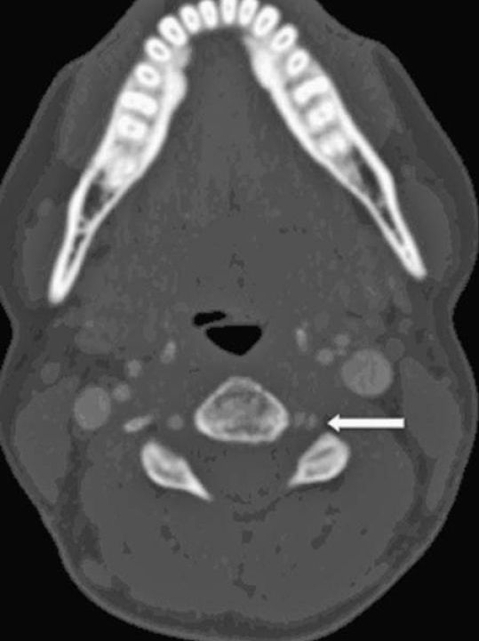

Ultrasound - reliable screening tool:
B-mode ultrasound - tapering of ICA lumen, irregular membrane crossing lumen, true and false lumens.
Duplex scans - decreased pulsatility, intravascular abnormal echoes, decreased flow.
TCD - effect of neck pathology on poststenotic intracranial circulation:
Diminished intracranial velocities in young patients who have normal ICA bifurcations → diagnosis of dissection is quite likely.

MRA - reliable noninvasive diagnosis for extracranial ICA.

ICA dissection (3D TOF MRA):
A. Focal narrowing as ICA enters skull base (arrow).
B. Axial image through that level - flow void in residual vessel lumen (arrow) and high signal crescent, which represents intramural hematoma (arrowhead).
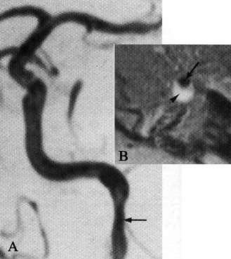

Conventional angiography (more useful for VA);
- regions of severe narrowing ("string sign") or total occlusion beginning > 2 cm distal to ICA origin, sparing siphon, and having gradually tapering segment.
- aneurysmal sacs or outpouchings.
Any trauma patient having focal neurological deficits (esp. with Horner's syndrome) that cannot be explained from imaging studies → early angiography to diagnose carotid artery dissection!

Treatment
Most extracranial dissections heal spontaneously!
- if complete occlusion has occurred, arteries often do not recanalize.
- arteries that retain some residual lumen invariably heal and become normal.

Anticoagulants / Antiplatelets shortly after dissection should prevent stroke;
N.B. risk of embolization exists only during acute period! TIAs often precede infarction, leaving time for therapeutic intervention!
- do not seem to increase extent of dissection.
- heparin → warfarin is continued until lumen is not severely compromised (e.g. for 3-24 months; target INR 2-3) → antiplatelet agents for at least 2 years.
- anticoagulation is contraindicated in intracranial dissections complicated by SAH.

Surgical repair indications:
  - SAH
  - persistent high-grade (s. flow-limiting) stenosis
- location high in neck makes surgical carotid repair difficult.

Endovascular stenting is a modern option.
- stenting in mobile neck carries the risk of stent fracture (cf. intracranial stenting or stenting VA ostia – much less vessel movement); solution might be a softer stent (e.g. pipeline).
- carotid dissections:
with complete occlusion - observation (continue ASA for life)
with slight contrast wisp (high grade stenosis):
  - high intracranial - do not touch it if brain is well perfused (risk of even slightest dissection extension and may occlude PComA ostia --> massive stroke); if brain hypoperfused - document it with pCT and proceed with stenting
  - low in neck (proximal) - OK to stent (e.g. pipeline)
- indications for carotid dissection stenting:
    - worsening exam on antiplatelets
    - worsening pseudoaneurysm on repeat angio
    - brain perfusion asymmetry on angio (i.e. flow limiting dissection)

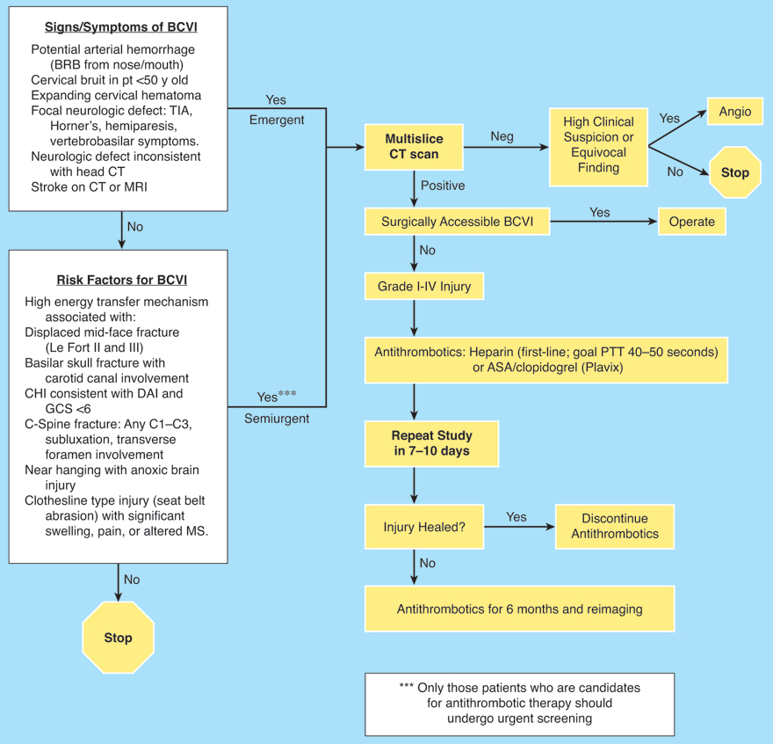

Bibliography for ch. “Neurovascular Disorders” → follow this link >>

Viktor’s Notes℠ for the Neurosurgery Resident
Please visit website at www.NeurosurgeryResident.net

